DECLARATION OF EMERGENCY
Department of Wildlife and Fisheries
Wildlife and Fisheries Commission
Chronic Wasting Disease Management Zones

On May 21, 2026, the Legislature of Louisiana adopted Senate Concurrent Resolution No. 24 of the 2026 Regular Session (SCR No. 24), which, pursuant to R.S. 49:969, amended LAC 76:V.137 to replace the former “Control Area” framework with a “CWD management zone” framework comprised of a CWD 5-mile zone and a CWD 15-mile zone. SCR No. 24 directs that the establishment, modification, or removal of a CWD management zone be executed via declaration of emergency by the secretary, subject to ratification or amendment by the commission at its next regular meeting, and publication of the map on LDWF's website. LAC 76:V.137.B.3, as amended by SCR No. 24, requires the secretary to act by declaration of emergency to establish and define CWD management zones, and LAC 76:V.137.B.4 directs that LDWF utilize public roads, geopolitical boundaries, water ways, visible rights-of-way, and other natural or manmade features that serve as identifiable boundaries, and endeavor to establish the 5-mile zone and 15-mile zone as closely to each zone's respective actual radius as practicable. As a result, the department finds that immediate action is necessary to conform the CWD management zones to the framework adopted by SCR No. 24, and to reflect confirmed CWD detections.

Therefore, the secretary of the Department of Wildlife and Fisheries, exercising the authority delegated by SCR No. 24 of the 2026 Regular Session and LAC 76:V.137.B, and under the emergency provisions of R.S. 49:962, hereby declares and adopts the following Emergency Rule, subject to ratification or amendment by the Wildlife and Fisheries Commission, to establish and define the CWD Management Zones and to implement the supplemental feeding, baiting, surveillance, sampling, and export restrictions provided by LAC 76:V.137, as amended.

In accordance with the emergency provisions of R.S. 49:962 and 56:6.1, the secretary of the Department of Wildlife and Fisheries hereby establishes and defines the CWD Management Zones as follows:
(Exhibit A)

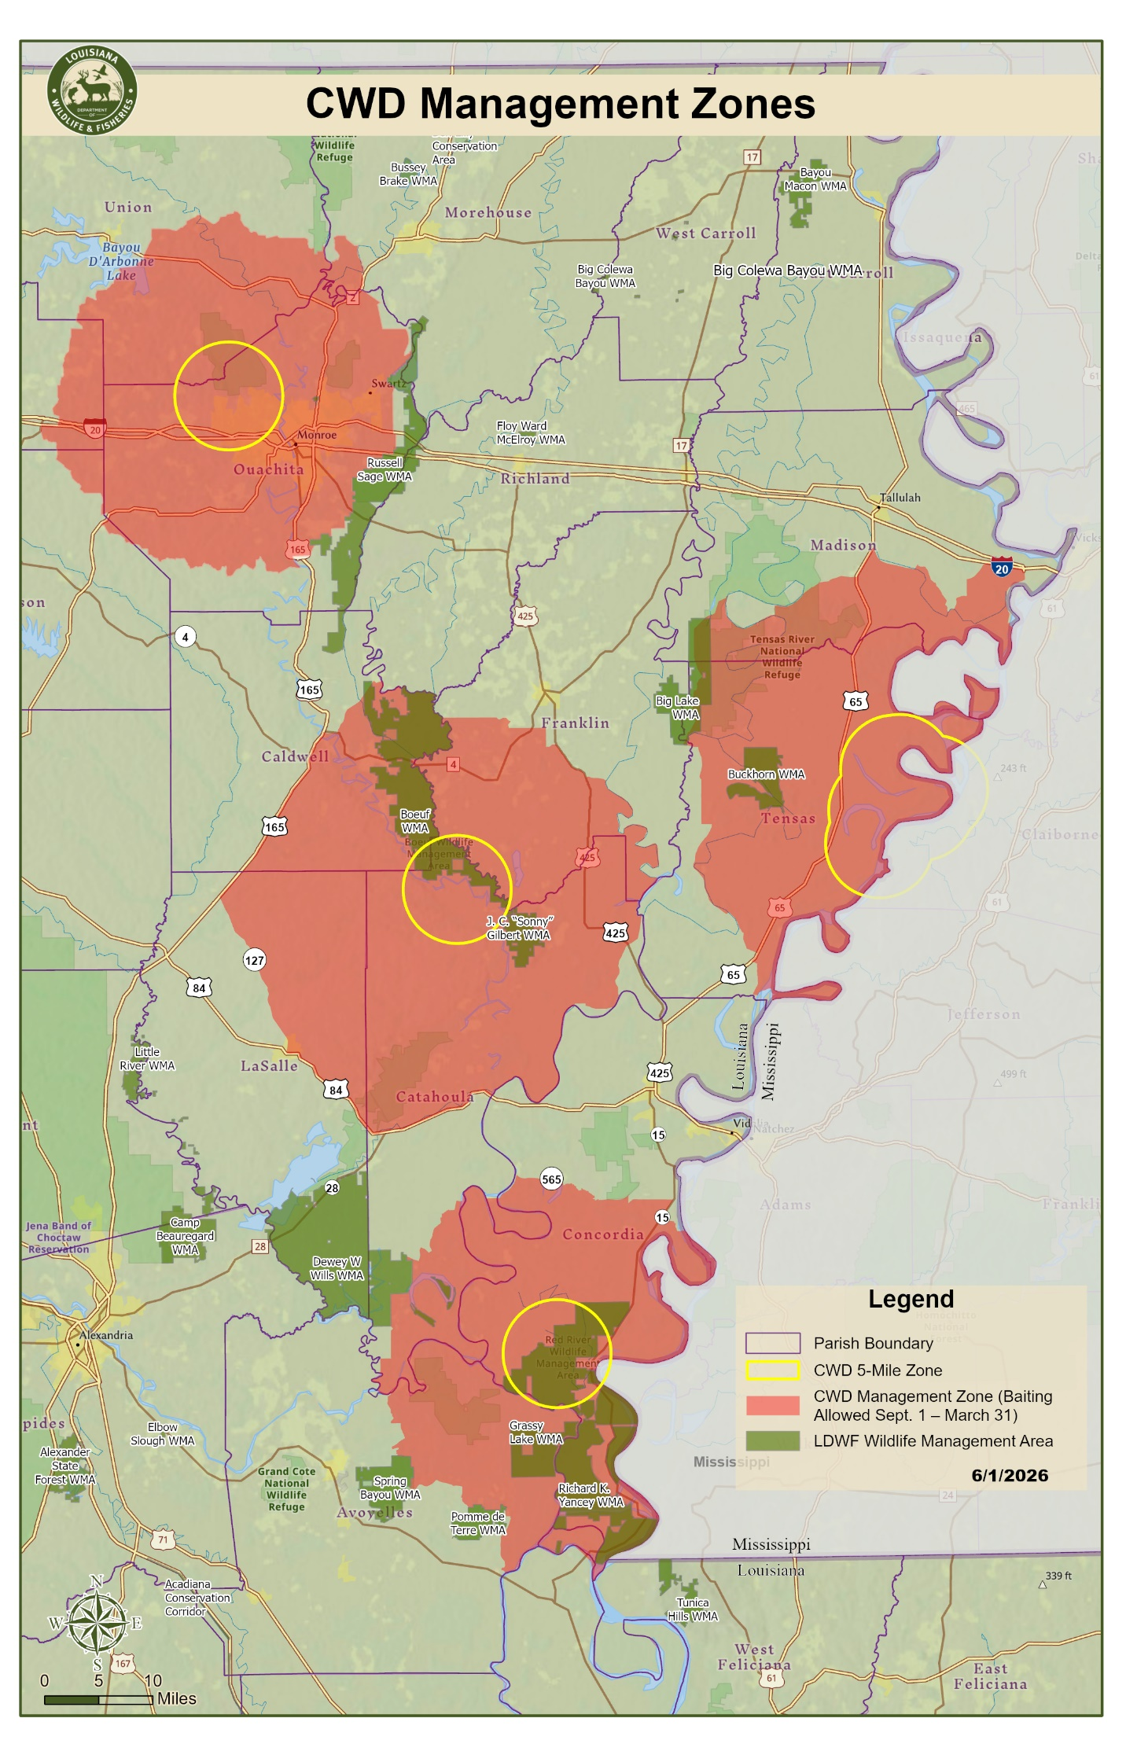

This Declaration of Emergency is effective upon adoption by the secretary (June 2, 2026) and shall remain in effect until rescinded, amended, or superseded, whichever occurs first. This Declaration is subject to ratification or amendment by the Louisiana Wildlife and Fisheries Commission at its next regular meeting, in accordance with LAC 76:V.137.B.3. The CWD Management Zones Map attached as Exhibit A shall be published on the LDWF website and shall control the boundaries of the management zones established herein.

Tyler M. Bosworth
Secretary
2606#015

