Part XXVII. State Lands
Subpart 1. Land Information Mapping and Map Records System
Chapter 1. Introduction 1
§101. General 1
§103. Submission of a Rulemaking Petition 1
§105. Consideration of a Rulemaking Petition 2
Chapter 3. Mapping Accuracy 2
§301. General Requirements 2
§303. Area Classifications 2
§305. Map Scale 2
§307. Horizontal Accuracy 2
§309. Vertical Accuracy 3
§311. Map Accuracy Test 3
Chapter 5. Ground Control 4
§501. General Requirements 4
§503. Horizontal Datum 4
§505. Vertical Datum 4
§507. Measurement Standards 4
§509. Permanent Monumentation 5
§511. Horizontal Control 5
§513. Vertical Control 6
§515. Target Panels 6
§517. Survey Adjustments 6
§519. Survey Records 6
§521. Appendix A―Permanent Horizontal Control Monuments 8
§523. Appendix B―Typical Photogrammetric Target Configuration 9
§525. Appendix C―Survey Mark Report Form 10
§527. Appendix D―Sample Control Data Description Form 12
Chapter 7. Aerial Photography 13
§701. General Requirements 13
§703. Conditions during Photography 13
§705. Scale of Aerial Photography Negatives 13
§707. Flight Plan 13
§709. Re-Flights 13
§711. Spacing of Photographs 14
§713. Endlap 14
§715. Sidelap 14
§717. Crab 14
§719. Tilt 14
§721. Aircraft 14
§723. Flying Requirements 14
§725. Aerial Camera 14
§727. Aerial Film 15
§729. Disposition of Aerial Film 15
§731. Roll Film Containers 15
Chapter 9. Photo Laboratory Procedures 15
§901. Image Quality 15
§903. Film Labeling 15
§905. Photo Index 16
§907. Aerial Photography Contact Prints 16
§909. Aerial Photography Diapositives 16
Chapter 11. Aerial Triangulation 16
§1101. General Requirements 16
§1103. Coordinate Object Space 17
§1105. Coordinate Image Space 17
§1107. Accuracy Requirements 17
§1109. Passpoints 17
§1111. Checkpoints 17
§1113. Diapositives 18
§1115. Monocomparator Requirements 18
§1117. Stereocomparator Requirements 18
§1119. Analytical Plotter Requirements 18
§1121. Aerial Triangulation Report 18
Chapter 13. Digital Mapping Requirements 19
§1301. General Requirements 19
§1303. Data Definitions 19
§1305. Digital Accuracy 21
§1307. Data Exchange Format 22
§1309. Appendix A―Planimetric Map―Layer Categories and Feature Elements 22
§1311. Appendix B―Topographic Map―Layer Categories and Feature Elements 23
§1313. Appendix C―Parcel Map―Layer Categories and Feature Elements 23
§1315. Appendix D―Figures 1, 2, 3, 4, and 5 25
Chapter 15. Geographic Base Map 30
§1501. General Requirements 30
§1503. Stereo Photogrammetric Instrumentation 30
§1505. Interactive Graphics System 30
§1507. Map Scale 30
§1509. Planimetric Mapping 30
§1511. Topographic Mapping 31
§1513. Map Labels 31
§1515. Grid System 32
§1517. Map Sheet Requirements 32
§1519. Field and Office Edit 33
§1521. Final Base Map Production 33
§1523. Photo Atlas Sheets 33
§1525. Ownership of Information 34
§1527. Appendix A―Primary Features to be Mapped―Planimetric and Topographic Mapping 35
§1529. Appendix B―Map Grid Numbering System―Basic Modular Units 37
§1531. Appendix C―Geographic Base Map Sheet Layout 38
§1533. Appendix D―Sample Title Block Layout―All Scales 39
§1535. Appendix E―Photo Atlas Sheet Layout―All Scales 40
Chapter 17. Parcel Mapping 41
§1701. General Requirements 41
§1703. Existing Record Information 41
§1705. Source Document Collection 41
§1707. Individual Parcel Index Records 41
§1709. Map Sheet Requirements 42
§1711. Preliminary Parcel Map Construction 43
§1713. Ownership Map Compilation 43
§1715. Dimensions 45
§1717. Area Calculations 45
§1719. Permanent Parcel Numbering System 46
§1721. Field Edits and Conflicting Ownerships 47
§1723. Title Block and Margin 47
§1725. Final Parcel Map Production 47
§1727. Relational Data Base 48
§1729. Ownership of Information 49
§1731. Appendix A―Parcel Map Sheet Layouts―Figures 1, 2, 3, and 4 50
§1733. Appendix B―Glossary of Terms and Abbreviations for Property Parcel Maps 55
§1735. Appendix C―Parcel Index Record Format 56
§1737. Appendix D―Parcel Record File―ASCII Files 62
§1739. Appendix E―Parish Code Numbers and Louisiana Coordinate Grid Zones 64
Chapter 19. Map Features 65
§1901. General Requirements 65
§1903. Element Types 65
§1905. Graphics and Text Requirements 65
§1907. Linear Patterns 65
§1909. Cells 66
§1911. Text 66
§1913. Digitization 66
§1915. Appendix A―Map Text Requirements 67
§1917. Appendix B―Layer Category 1―Margin and Grid Feature Elements 71
§1919. Appendix C―Layer Category 2―Transportation Feature Elements 74
§1921. Appendix D―Layer Category 3―Hydrology Feature Elements 83
§1923. Appendix E―Layer Category 4―Terrain Feature Elements 87
§1925. Appendix F―Layer Category 5―Structure Feature Elements 90
§1927. Appendix G―Layer Category 6―Utility Feature Elements 99
§1929. Appendix H―Layer Category 7―Topographic Feature Elements 105
§1931. Appendix I―Layer Category 8―Parcel Feature Elements 108
Subpart 2. Use and Management of State Lands
Chapter 21. Reclamation Projects 115
§2101. Class A and Class E Permits 115
Chapter 23. Permitting and Leasing Encroachments onto State Owned Property 116
§2301. Class B, Class C and Class D Permits 116
Chapter 25. General Regulations Regarding all Permits 118
§2501. General Permit Conditions 118
Chapter 27. Rights-of-Way 119
§2701. Granting of Rights-of-Way to Corporations or Individuals 119
Chapter 29. Fees for Certified Copies 120
§2901. Fees for Certified Copies 120
Chapter 31. Best Use of Nonessential Property 120
§3101. Rules and Regulations Providing for Designation of Immovables as Nonessential
Property 120
§3102. Best Use or Disposition of Property 121
§3103. Recommendations Approved by the Appropriate Committees Shall Be Implemented by
the State Land Office 121
§3104. Procedure 121
Chapter 32. Receipt of Donation of Immovable Property 122
§3201. Submission of Offers of Donation 122
§3202. Evaluation of Offers of Donation 122
§3203. Approval of Offers of Donation 122
§3204. Notifications to the Legislature 123
Chapter 33. Tax Land Sales 123
§3301. Sales through Real Estate Brokerage Firms 123
Chapter 35. Notice of Publication for Mineral Leasing 124
§3501. Notice of Publication Booklet 124

Title 43
NATURAL RESOURCES

Part XXVII. State Lands

Subpart 1. Land Information Mapping and Map Records System

Chapter 1. Introduction

§101. General

A. It is well recognized that a substantial amount of work expended by state and local government relates to the location, characteristics, resources, use and value of land. Parish assessors and political subdivisions of the state have developed various systems to assist in the collection, development, storage and retrieval of land data. Traditionally these have been manual systems which include an abundance of records consisting of paper maps, survey plats, property record cards, log books and index files. A variety of numbering schemes and procedures have evolved to maintain such systems. The combination of these various records, numbering schemes and procedures form the framework of many land information systems currently in use.

B. The public entities that maintain these systems recognize many shortcomings. Existing hard-copy maps are of inconsistent scale, land information cross-referencing is inadequate, retrieval is time-consuming, and many of the existing records are old, deteriorating, voluminous, and outstripping available storage space. On their own initiative, many parishes and agencies have introduced improvements such as updated map products, revised numbering schemes, mechanized file storage and retrieval, microfilm records, and various computerized information systems. Notwithstanding these improvements, fundamental underlying problems such as inconsistent map accuracy, ambiguous title descriptions, and dissimilar record indexing systems continue to impede efficient and effective data manipulation.

C. The Louisiana Land Information Mapping and Map Records Standards set forth herein have been structured to promote and ensure compatible, uniform and cost effective development of a modern Land Information System (LIS) to accommodate the collection, maintenance, sharing and retrieval of land information by authorized public entities throughout the state.

D. The primary focus of these standards is directed toward the development of accurate, complete and compatible geographic base map products which form the framework and foundation to facilitate subsequent land parcel mapping activities. Major topics addressed under these standards include uniform requirements for map accuracy, ground control densification, aerial photography, photo laboratory procedures, analytic aerial triangulation, digital mapping, geographic base map preparation, land parcel mapping, associated relational database development, and standardized map feature elements. These standards outline the orderly development of each major phase of work to be accomplished in connection with the implementation of a Land Information System and establish minimum criteria necessary for acceptable completion of each phase.

E. It is recognized that the implementation of the various phases of work set forth herein will normally require several years to accomplish. For this reason, it is the intent of these standards that usable LIS products developed during the course of implementation be made available to authorized public user agencies as soon as practical prior to final completion. This early dissemination of land information data should help to promote efficient sharing, retrieval and utilization of available land information in the most timely and cost-effective manner possible.
AUTHORITY NOTE: Promulgated in accordance with R.S. 50:171.
HISTORICAL NOTE: Promulgated by the Office of the Governor, Division of Administration, State Land Office, LR 17:968 (October 1991).

§103. Submission of a Rulemaking Petition

A. In accordance with R.S. 49:953(C)(1), any interested person may petition an agency to adopt a new rule, or to amend or repeal an existing rule.

B. To petition an agency within the Division of Administration for changes to the agency’s current rules, or for the adoption of new rules within the agency’s purview, an interested person shall submit a written petition to the Division of Administration, Office of the Commissioner. The petition shall include:

1. the petitioner's name and address;

2. the name of the promulgating agency for the rule in question;

3. specific text or a description of the proposed language desired for the adoption or amendment of a rule, or the specific rule and language identified for repeal;

4. justification for the proposed action; and

5. the petitioner's signature.

C. The rulemaking petition shall be submitted by certified mail and addressed to:
Office of the Commissioner, Division of Administration
Re: Rulemaking Petition
P.O. Box 94095, Capital Station
Baton Rouge, LA 70804-9095

AUTHORITY NOTE: Promulgated in accordance with 50:171 and 49:953, et seq.
HISTORICAL NOTE: Promulgated by the Office of the Governor, Division of Administration, Office of State Lands, LR 46:333 (March 2020).

§105. Consideration of a Rulemaking Petition

A. Upon receipt, a rulemaking petition shall be forwarded to the promulgating agency for review.

B. Within 90 days of receipt of the rulemaking petition, the agency shall either:

1. initiate rulemaking procedures to adopt a new rule, or to amend or repeal an existing rule; or

2. notify the petitioner in writing of the denial to proceed with rulemaking, stating the reason(s) therefore.
AUTHORITY NOTE: Promulgated in accordance with 50:171 and 49:953, et seq.
HISTORICAL NOTE: Promulgated by the Office of the Governor, Division of Administration, Office of State Lands, LR 46:333 (March 2020).

Chapter 3. Mapping Accuracy

§301. General Requirements

A. All mapping prepared and developed under these standards shall conform to the minimum accuracy requirements set forth within the "United States National Map Accuracy Standards," as prepared by the National Cartographic Information Center, U.S. Geological Survey, inclusive of any and all revisions in effect at the time such mapping is conducted, except as otherwise superceded by specific map accuracy requirements established herein.

B. These standards address the definitions of spatial accuracy as they pertain to large-scale planimetric, topographic and land parcel maps to be developed in conjunction with the Louisiana Land Information Mapping and Map Records System.
AUTHORITY NOTE: Promulgated in accordance with R.S. 50:171.
HISTORICAL NOTE: Promulgated by the Office of the Governor, Division of Administration, State Land Office, LR 17:968 (October 1991).

§303. Area Classifications

A. The following area classifications are hereinafter defined based upon current or potential land use.

1. Class A―Dense Urban. Highly developed central business district, commercial and residential properties containing relatively small individual property parcels.

2. Class B―Urban or Suburban. The majority of land located within or adjoining a city, town or village which includes moderately developed commercial and industrial properties, residential subdivisions, areas employed for single family residential use, townhouses, apartments, and other multi-unit developments.

3. Class C―Rural. Sparsely densified rural neighborhoods, cultivated farmland and undeveloped areas outside of the urban and suburban areas which may have a potential for future development.

4. Class D―Woodlands and Marshes. Lands which normally lie in remote areas with difficult terrain and usually have limited potential for future development.
AUTHORITY NOTE: Promulgated in accordance with R.S. 50:171.
HISTORICAL NOTE: Promulgated by the Office of the Governor, Division of Administration, State Land Office, LR 17:968 (October 1991).

§305. Map Scale

A. The minimum required final map scale for each area to be mapped, as classified above, shall be as follows.
Area Classification | Scale Ratio | Map Scale
Class A | 1:600 | 1" = 50'
Class B | 1:1,200 | 1" = 100'
Class C | 1:2,400 | 1" = 200'
Class D | 1:4,800 | 1" = 400'

B. The use of a Class A 1" = 50' map scale within or adjacent to any dense urban areas to facilitate subsequent geographic base map and parcel map development is optional and subject to the discretion of the responsible contracting authority.
AUTHORITY NOTE: Promulgated in accordance with R.S. 50:171.
HISTORICAL NOTE: Promulgated by the Office of the Governor, Division of Administration, State Land Office, LR 17:968 (October 1991).

§307. Horizontal Accuracy

A. Ninety percent of all well defined planimetric features shall be plotted so that their positions on the final map and associated digital database shall be accurate to within one fortieth of an inch (0.025") of their true coordinate positions. None of the features shall be displaced on the final map and associated digital database by more than one twentieth of an inch (0.05") from their true position. These limits of accuracy shall apply in all cases to positions of well-defined points only. Well-defined points are points that are easily visible or recoverable from the aerial photography and are free from any overhead obstructions that may impair proper photo-interpretation. Examples of well defined points include property boundary monuments, intersections of roads and sidewalks, railroad intersections, corners of buildings or structures, manhole covers, power poles, and related features.

B. Limiting horizontal positional errors for each respective map area classification and map scale ratio to be developed under these standards are tabulated below.
Planimetric Coordinate Accuracy Requirements Ground (X or Y) for Well-Defined Points
Area Classification | Scale Ratio | Planimetric (X or Y) Accuracy (Limiting Positional Error)
Area Classification | Scale Ratio | 90% of Points at 1/40 Inch | Remaining 10% of Points at 1/20 of an Inch
Class A | 1:600 | 1.3' | 2.5'
Class B | 1:1,200 | 2.5' | 5.0'
Class C | 1:2,400 | 5.0' | 10.0'
Class D | 1:4,800 | 10.0' | 20.0'

C. Multiple horizontal accuracies on the same map sheet to depict different contiguous area classifications are allowed provided that a diagram is included which clearly relates segments of the map with each respective area classification and associated accuracy.
AUTHORITY NOTE: Promulgated in accordance with R.S. 50:171.
HISTORICAL NOTE: Promulgated by the Office of the Governor, Division of Administration, State Land Office, LR 17:968 (October 1991).

§309. Vertical Accuracy

A. The development of vertical data necessary for the establishment of contour lines, spot elevations or related vertical information is optional except as necessary to facilitate survey network adjustments, analytic aerial triangulation, and related phases of final map compilation.

B. In the event that development of vertical data necessary for the establishment of contour lines, spot elevations or related vertical information is required for inclusion on final topographic map products, the final map accuracy shall be such that 90 percent of the elevations determined from solid-line contours shall have an accuracy with respect to true ground elevation of one half the contour interval or better, and the remaining 10 percent shall not be in error by more than one contour interval. A contour which can be brought within the stated vertical tolerance by shifting its horizontal location by not more than one fortieth of an inch (0.025") will be considered acceptable. Solid line contour accuracies for various representative contour intervals developed under these standards are tabulated below.
Contour Line Accuracy Requirements
Contour Interval | 90% of  Contours Within | Remaining 10% of Contours Within
1' | +0.5' | +1.0'
2' | +1.0' | +2.0'
5' | +2.5' | +5.0'
10' | +5.0' | +10.0'

1. In densely wooded areas where heavy tree or brush cover fully obscures the ground and the contours are shown as dashed lines, 90 percent of the elevations determined from dashed-line contours shall have an accuracy with respect to true ground elevation of one contour interval or one fourth the average height of the ground cover, whichever is greater.

C. At least 90 percent of all spot elevations shown on the final map shall be accurate within one fourth of the contour interval, and the remaining 10 percent shall be accurate to within one half the contour interval. Required spot elevation accuracies for various representative contour intervals developed under these standards are tabulated below.
Spot Elevation Accuracy Requirements
Contour Interval | 90% of Spot Elevations Within | Remaining 10% of Spot Elevations Within
1' | +0.25' | +0.50'
2' | +0.50' | +1.00'
5' | +1.25' | +2.50'
10' | +2.50' | +5.00'

D. Ninety percent of auxiliary heights determined for buildings, trees, houses and related objects shall have an accuracy with respect to true ground elevation of two times the contour interval or better, and the remaining 10 percent shall not be in error by more than four times the contour interval.
AUTHORITY NOTE: Promulgated in accordance with R.S. 50:171.
HISTORICAL NOTE: Promulgated by the Office of the Governor, Division of Administration, State Land Office, LR 17:968 (October 1991).

§311. Map Accuracy Test

A. Testing for horizontal accuracy compliance shall be performed by comparing the planimetric (X and Y) coordinates of well-defined ground points to the coordinates of the same points as determined by a horizontal check survey of higher accuracy. The check survey shall be designed according to the Federal Geodetic Control Committee (FGCC) 1984 Standards and Specifications for Geodetic Control Networks to achieve standard deviations equal to or less than the one third of the limiting positional error selected for the map. The distance between control points used in the FGCC Standards for the design of the survey shall be the horizontal ground distance across the diagonal dimension of the map sheet.

B. Testing for vertical accuracy compliance shall be performed by comparing the elevations (Z coordinates) of well-defined points as determined from the map to corresponding elevations determined by a survey of higher accuracy. For purposes of checking elevations, the map position of the ground point may be shifted in any direction by an amount equal to twice the limiting horizontal error in position. The vertical check survey shall be designed according to FGCC Standards to achieve errors in elevation differences at check point locations no larger than one tenth of the contour interval. The distance between vertical benchmarks used in the FGCC Standard for the design of the vertical check survey shall be the horizontal ground distance across the diagonal of the map sheet.

C. Discrepancies between the X, Y or Z coordinates of ground points as determined from the map and by the check survey that exceed the limiting error shall be considered unacceptable and will be corrected before the map is considered to meet these standards. The same survey datums, both horizontal and vertical, must be used for both the project and the check control surveys.

D. At least three percent of the total area mapped shall be selected at random and tested for compliance with these standards. A minimum of 20 checkpoints shall be established throughout the area covered by each map sheet selected. At least 20 percent of the checkpoints shall be located in each quadrant of the map sheet and these points shall be spaced at intervals equal to at least 10 percent of the map sheet diagonal.

E. All maps produced according to this accuracy standard shall include the following statement in the title block:
"THIS MAP COMPLIES WITH NATIONAL MAP ACCURACY STANDARDS."

F. Individual map sheets checked and found to conform to this accuracy standard shall include the following statement in the title block:
"THIS MAP WAS CHECKED AND FOUND TO CONFORM TO NATIONAL MAP ACCURACY STANDARDS."

G. When a published map is an enlargement of an original map manuscript or associated digital database, that fact shall be stated in the legend. For example:
"THIS MAP IS AN ENLARGEMENT OF A 1:1,200 ORIGINAL MAP MANUSCRIPT."
AUTHORITY NOTE: Promulgated in accordance with R.S. 50:171.
HISTORICAL NOTE: Promulgated by the Office of the Governor, Division of Administration, State Land Office, LR 17:968 (October 1991).

Chapter 5. Ground Control

§501. General Requirements

A. Sufficient horizontal and, if applicable, vertical control surveys shall be established within and adjacent to the project area to serve as a basis for all subsequent analytic aerial triangulation and photogrammetric mapping.

B. Existing horizontal and vertical control monumentation which is published by the National Geodetic Survey (NGS) as part of the National Geodetic Reference System shall be used exclusively as the basis for the extension and densification of any and all additional horizontal or vertical control that may be required.

C. All ground control surveys shall be performed by or under the supervision of a Professional Land Surveyor registered in accordance with the requirements established by the Louisiana State Board of Registration for Professional Engineers and Land Surveyors.
AUTHORITY NOTE: Promulgated in accordance with R.S. 50:171.
HISTORICAL NOTE: Promulgated by the Office of the Governor, Division of Administration, State Land Office, LR 17:968 (October 1991).

§503. Horizontal Datum

A. All horizontal control densification shall be based upon the Louisiana State Plane Coordinate System, North and South Zones, 1701 and 1702, respectively, and referenced to the North American Datum of 1983 (NAD 83), latest adjustment, as established and published by the National Geodetic Survey (NGS).

B. Optional survey references may be established between the NAD 83 datum and the previous NAD 27 datum for correlation of archival horizontal control data. However, coordinate transformation programs or computational techniques shall not be used to convert coordinates from one datum to another without local field survey network verification.
AUTHORITY NOTE: Promulgated in accordance with R.S. 50:171.
HISTORICAL NOTE: Promulgated by the Office of the Governor, Division of Administration, State Land Office, LR 17:968 (October 1991).

§505. Vertical Datum

A. All vertical control densification shall be based upon the National Geodetic Vertical Datum of 1929 (NGVD 29), latest adjustment, as established and published by NGS.

B. Following final development and publication of the new North American Vertical Datum of 1988 (NAVD 88), all subsequent vertical control densification shall be based on the NAVD 88 datum.

C. Optional survey references may be established between the NGVD 29 and subsequent NAVD 88 datum for correlation of archival vertical control data. However, coordinate transformation programs or computational techniques shall not be used to convert elevations from one datum to another without local field survey network verification.
AUTHORITY NOTE: Promulgated in accordance with R.S. 50:171.
HISTORICAL NOTE: Promulgated by the Office of the Governor, Division of Administration, State Land Office, LR 17:968 (October 1991).

§507. Measurement Standards

A. All measurements shall be expressed in International Meters and/or U.S. Survey Feet, as applicable and specified within subsequent sections of these standards.

B. The established and adopted relationship between these units of measurement is as follows:
1 Meter = 3,937 / 1,200 (i.e., 3.2808333333) Feet
or

1 Foot = 0.30480061 Meters
AUTHORITY NOTE: Promulgated in accordance with R.S. 50:171.
HISTORICAL NOTE: Promulgated by the Office of the Governor, Division of Administration, State Land Office, LR 17:968 (October 1991).

§509. Permanent Monumentation

A. The density and distribution of permanent horizontal control monumentation within each project area shall be sufficient to provide local horizontal control to facilitate the implementation of land parcel corner ties, map accuracy check surveys, map updates, and related surveying and mapping activities. The required combined average density of existing and/or new permanent horizontal control monuments to be recovered or otherwise established within each separate area classification pursuant to these standards shall be as follows.
Area Classification | Average Permanent Horizontal Control Monument Density
Class A | 1 per | 1 square mile
Class B | 1 per | 2 square miles
Class C | 1 per | 4 square miles
Class D | 1 per | 16 square miles

B. All existing horizontal control monumentation within the project area and up to 1/2 mile beyond the limits of the project area which is published by NGS as part of the National Geodetic Horizontal Reference System shall be recovered and paneled prior to flying of aerial photography.

C. All new horizontal control monumentation established in conformance with the average density requirements set forth above shall be constructed in accordance with the applicable guidelines set forth within NOAA Manual NOS NGS 1, Geodetic Bench Marks, latest edition. Unless otherwise superceded by more stringent project requirements, all new permanent horizontal control monuments shall be minimum 10 inches diameter by
36 inches deep cast-in-place or precast concrete with embedded brass disc as shown in §521, Appendix A. All new horizontal control monuments shall be paneled prior to flying of aerial photography.

D. All new permanent horizontal control monuments established shall be set in intervisible pairs consisting of a horizontal control monument and companion azimuth mark to provide local azimuth. Azimuth marks may consist of clearly definable existing features such as the tops of towers, spires or other existing points which are visible from the closest adjacent permanent control monument and which can be satisfactorily described, referenced and recovered. In the absence of clearly definable existing features within the vicinity of any new permanent control monument, a companion azimuth mark shall be constructed in conformance with the requirements set forth within §521, Appendix A. All azimuth marks should be located at least 1,500 feet away from adjacent permanent horizontal control monuments whenever possible.
AUTHORITY NOTE: Promulgated in accordance with R.S. 50:171.
HISTORICAL NOTE: Promulgated by the Office of the Governor, Division of Administration, State Land Office, LR 17:968 (October 1991).

§511. Horizontal Control

A. All horizontal control surveys shall be established by conventional triangulation, traverse, or Global Positioning System (GPS) techniques, including any combination thereof, as dictated by specific project requirements.

B. Triangulation and traverse surveys shall be performed in accordance with applicable requirements set forth within the Standards and Specifications for Geodetic Control Networks, as prepared by the Federal Geodetic Control Committee (FGCC), dated September, 1984, inclusive of any and all subsequent revisions in effect at the time such surveys are conducted.

C. GPS surveys shall be performed in accordance with applicable requirements set forth within FGCC publication Geometric Geodetic Accuracy Standards and Specifications for Using GPS Relative Positioning Techniques, Version 5.0, revised August 1989, inclusive of any and all subsequent revisions in effect at the time such surveys are conducted.

D. All horizontal control established shall conform to the minimum requirements for Second Order Class II surveys as set forth within the FGCC Standards and Specifications, and shall result in a minimum distance closure accuracy of 1:20,000. Any surveys originated from sparse or distant existing horizontal control monumentation shall be performed to a higher order of accuracy as may be required to ensure compliance with these standards.

E. Horizontal control surveys performed for the purpose of establishing new permanent horizontal control monuments will be submitted to NGS for verification and publication as part of the National Horizontal Reference Network. Strict compliance to FGCC Blue Book Specifications must be adhered to and all data shall be submitted in accordance with NOAA Manual NOS NGS 2, Input Formats and Specifications of the National Geodetic Survey Database; Volume 1―Horizontal Control Data.

F. All additional temporary photo control points required for photogrammetric control and analytic aerial triangulation shall be established and pretargeted prior to photography. All temporary control points established shall be clearly documented by appropriate descriptions referenced to landmarks and identified by field survey ties to three or more discrete photo image points in the immediate vicinity. In the absence of discrete reference points in the immediate vicinity, collateral ties shall be made to recoverable markers or stakes set and established adjacent thereto.

G. Both conventional and GPS surveys shall start and end on existing NGS control. All field traverses will be a closed loop or otherwise shall close on an adjacent existing NGS horizontal control station. If a new station or temporary photo control point is established in the vicinity of an existing horizontal control monument, direct observations between the two positions must be made whenever the distance between them is less than 20 percent of the shortest distance as measured over the proposed and/or established survey lines (20 percent rule).

H. The spatial distribution, quantity and configuration of all pretargeted horizontal ground control positions established shall be sufficient to facilitate analytic aerial triangulation and subsequent digital map compilation in conformance with these standards. Regardless of terrain configuration, the minimum spatial distribution of pretargeted horizontal ground control positions to be established within and adjacent to any project area shall be such that photo-identifiable ground control points will be established along every other flight line at intervals not to exceed five contiguous photogrammetric stereo models regardless of scale.
AUTHORITY NOTE: Promulgated in accordance with R.S. 50:171.
HISTORICAL NOTE: Promulgated by the Office of the Governor, Division of Administration, State Land Office, LR 17:968 (October 1991).

§513. Vertical Control

A. All required vertical control shall be extended from existing NGS or U.S. Geological Survey Benchmarks which are published by NGS as part of the National Geodetic Vertical Reference System.

B. All vertical control established shall conform to the minimum requirements for third order surveys as set forth within the FGCC Standards and Specifications, and shall result in a minimum vertical closure accuracy of 0.05 feet times the square root (in miles) of individual level lines run.

C. Existing vertical control monuments and photogrammetric control points necessary for the establishment of contour lines, spot elevations or related vertical information may be either pretargeted prior to photography or field located following completion of photography depending on project requirements. Nontargeted control points will be pinpricked in the field on the appropriate aerial photograph following completion of aerial photography. The location of each pinpricked control point shall be referenced and precisely described on the back of each photograph.
AUTHORITY NOTE: Promulgated in accordance with R.S. 50:171.
HISTORICAL NOTE: Promulgated by the Office of the Governor, Division of Administration, State Land Office, LR 17:968 (October 1991).

§515. Target Panels

A. All pretargeted ground control points shall be continuously monitored and maintained until the aerial photography has been completed and confirmed by the project photogrammetrist. Any areas resulting in photogrammetric target capture less than the minimum required for satisfactory analytic aerial triangulation and map compilation shall be subsequently retargeted and reflown.

B. All target panels shall conform to the required size, configuration, color contrast and spatial distribution established and approved by the project photogrammetrist prior to aerial photography. Typical target configurations of variable dimensions based upon required photography scales and associated flying heights are included within §523, Appendix B.
AUTHORITY NOTE: Promulgated in accordance with R.S. 50:171.
HISTORICAL NOTE: Promulgated by the Office of the Governor, Division of Administration, State Land Office, LR 17:968 (October 1991).

§517. Survey Adjustments

A. Individual horizontal closed traverse loops or individual traverse lines originating from and returning to existing permanent horizontal control monuments, shall be adjusted to proportionally distribute any discrepancies by either compass rule or least squares adjustment methods, at the discretion of the surveyor.

B. Integrated traverse, triangulation and/or GPS loop network configurations resulting in potential conjugate redundancy shall be properly evaluated and adjusted to minimize residual discrepancies by minimally constrained
3-D least squares adjustment methods only.

C. Individual closed level line loops or individual level lines originating from and returning to existing permanent vertical control benchmarks shall be adjusted to proportionally distribute discrepancies along the length of individual level lines run.
AUTHORITY NOTE: Promulgated in accordance with R.S. 50:171.
HISTORICAL NOTE: Promulgated by the Office of the Governor, Division of Administration, State Land Office, LR 17:968 (October 1991).

§519. Survey Records

A. Field Notebooks. Field notebooks shall be carefully and neatly prepared, identified, indexed and preserved. All data regarding the establishment and extension of horizontal and vertical control, including descriptions of all established and recovered monuments, shall be recorded. Where existing control monuments are recovered in extending the basic control, the field notebooks shall contain the following:

1. recovery descriptions of all monuments recovered. Descriptions will be prepared on the Report on Condition of Survey Mark Form included under §525, Appendix C;

2. exact letter and numbers stamped (not cast in) on the mark and amended description, if applicable;

3. additional reference tie data, if any;

4. a sketch of the location of the monument as appropriate to facilitate future recovery. The field notebooks shall contain the name and address of the party chief, the identity of the survey instruments or equipment, and the latest calibration dates of all instruments and equipment. Each field notebook shall be numbered and marked with a brief description of the contents on the cover, shall be carefully indexed, and shall have all pages numbered. Each horizontal baseline loop and vertical control line shall be identified by number and brief description in the field book. The first page used on each day of fieldwork shall be dated. Upon completion of the project, all field books shall be delivered to the responsible contracting authority.

B. Control Data. The following information shall be furnished on all new permanent control monuments and/or temporary photogrammetric control points established:

1. information required on control points established to be furnished on control data description forms as shown in §527, Appendix D;

2. designation of control point (parish name and sequential identification number);

3. name of party responsible for establishing control point;

4. date of establishment:

a. horizontal and/or vertical control data;

b. complete description of the nature and location of the point to include a "to reach" description referenced to nearby landmarks and identified by field survey ties to three or more definable photo image points or established reference points in the immediate vicinity.

C. Computations. All computations and adjustments of control data shall be referenced to the field notebooks by book and page number. Following completion of computations and adjustments, a copy of the following data shall be submitted to the responsible contracting authority for all horizontal and vertical control established:

1. individual horizontal baseline loop sketches showing designation of monuments or control points established, designation of existing published monuments and azimuth marks occupied, recorded and reduced average distances and angles measured, error of closure tolerances, astronomic observation measurements and computations, and related information;

2. horizontal baseline loop adjustment computations showing both unadjusted and adjusted bearings, distances and coordinate positions of control points established, sea level and scale factor corrections applied in conformance with Louisiana conformal conic projection requirements, unadjusted coordinate positions of all existing published control monuments and azimuth marks, and designation of both constrained and check verification monuments used in adjustment;

3. individual vertical level loop sketches showing designation of control points established, designation of existing published benchmarks occupied, error of closure tolerances, level line loop adjustment computations showing both unadjusted and adjusted elevations, unadjusted elevations of all existing published benchmarks, and designation of both constrained and check verification benchmarks used in adjustment;

4. summarized tabulation of all adjusted horizontal control monument and photogrammetric target coordinate locations reduced to the nearest 0.01 feet and 0.001 meters (northing and easting) based on the Louisiana State Plane Coordinate System (north or south zone, as applicable);

5. summarized tabulation of all established vertical control elevations reduced to the nearest 0.01 feet and
0.001 meters.

D. Control Diagram. The surveyor shall furnish with the survey records a schematic control diagram prepared on USGS Topographic Quadrangle Map Sheets, 7.5 Minute Series, showing all basic horizontal and vertical control established. This diagram shall show all existing and established control points properly identified in their approximate location, including all primary survey baselines and their connections to existing and established control point locations.
AUTHORITY NOTE: Promulgated in accordance with R.S. 50:171.
HISTORICAL NOTE: Promulgated by the Office of the Governor, Division of Administration, State Land Office, LR 17:968 (October 1991).

§521. Appendix A―Permanent Horizontal Control Monuments
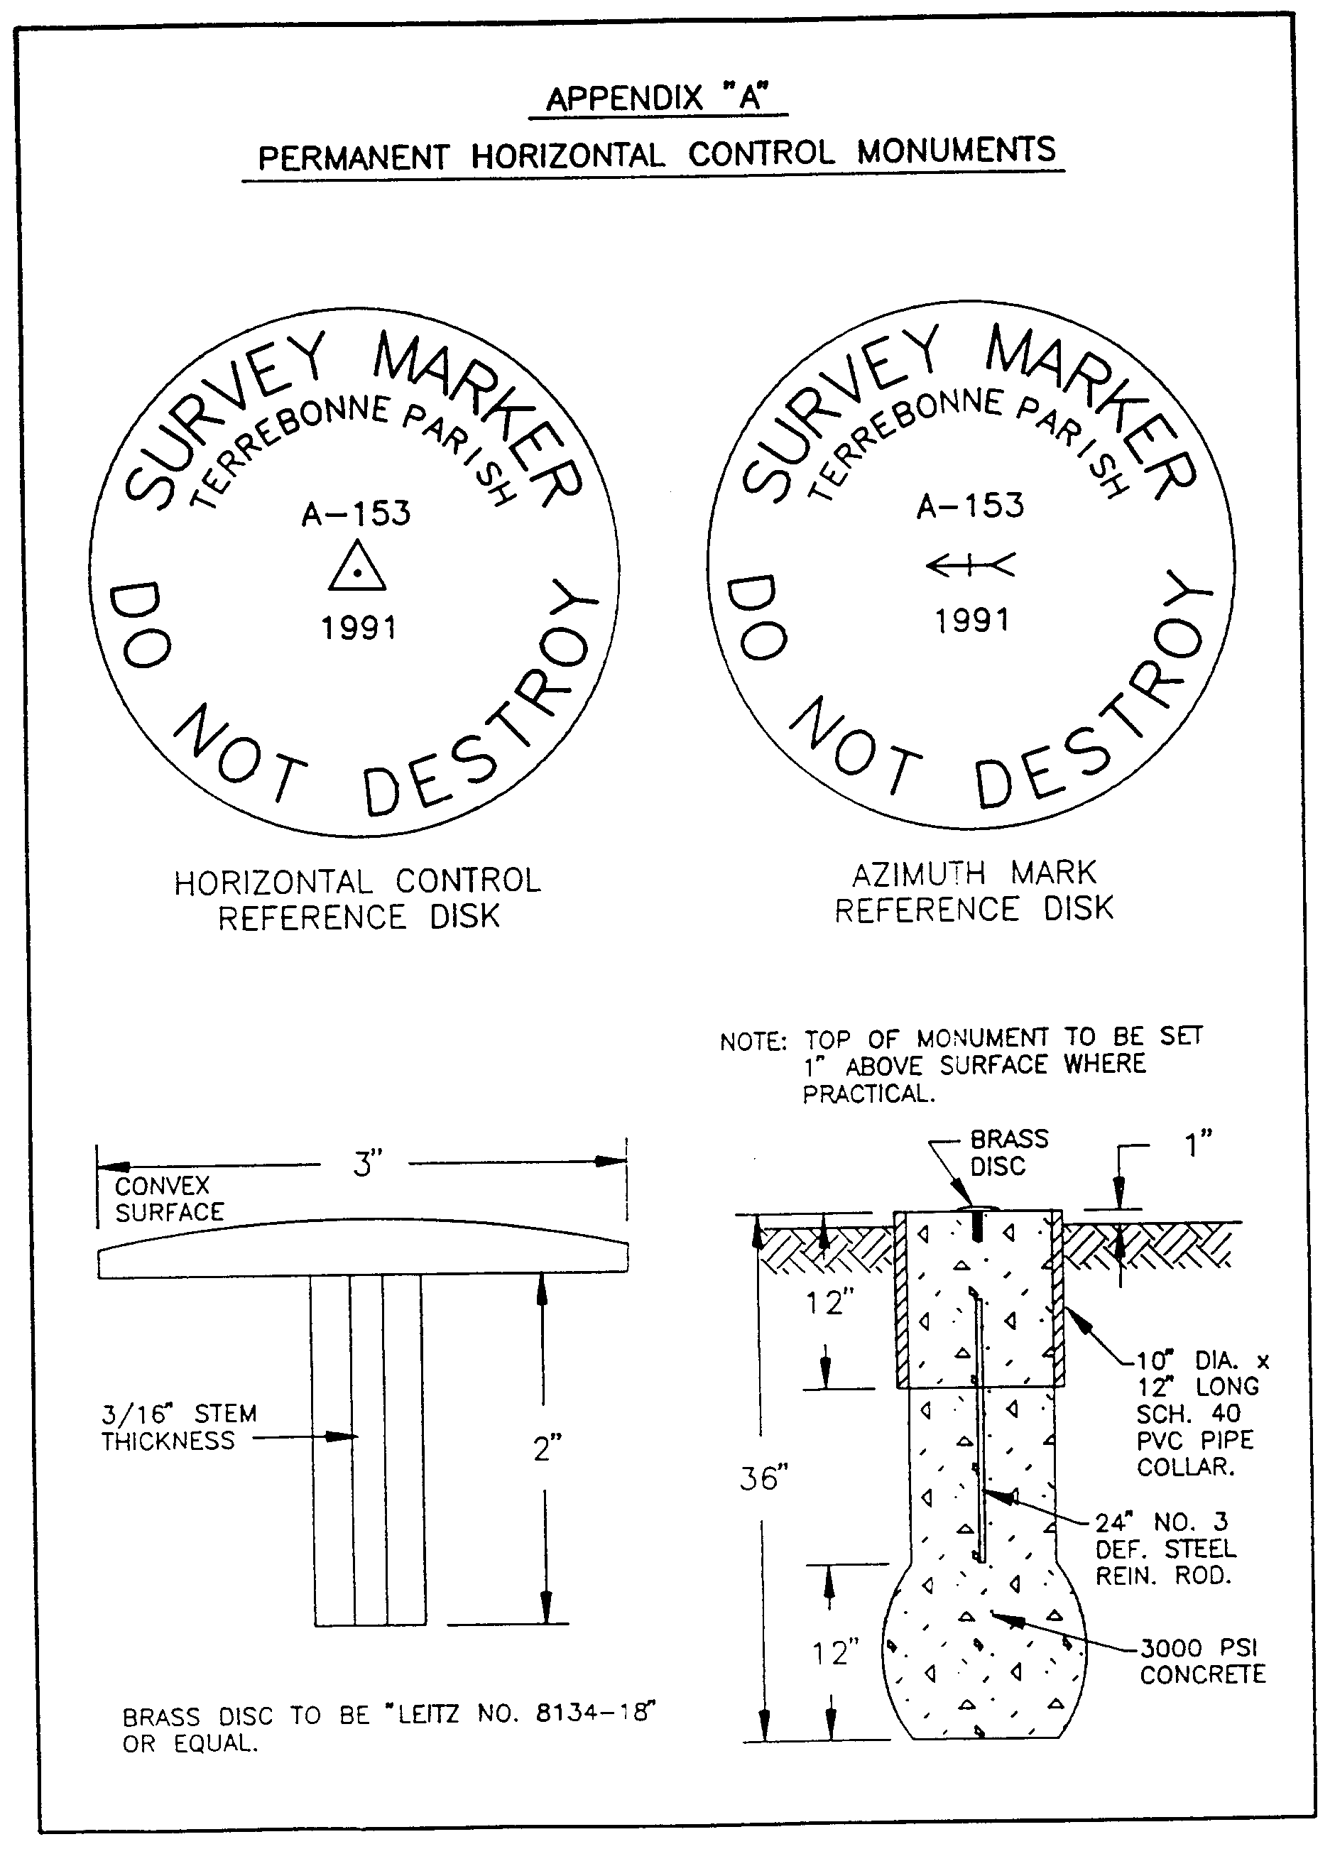

AUTHORITY NOTE: Promulgated in accordance with R.S. 50:171.
HISTORICAL NOTE: Promulgated by the Office of the Governor, Division of Administration, State Land Office, LR 17:968 (October 1991).

§523. Appendix B―Typical Photogrammetric Target Configuration
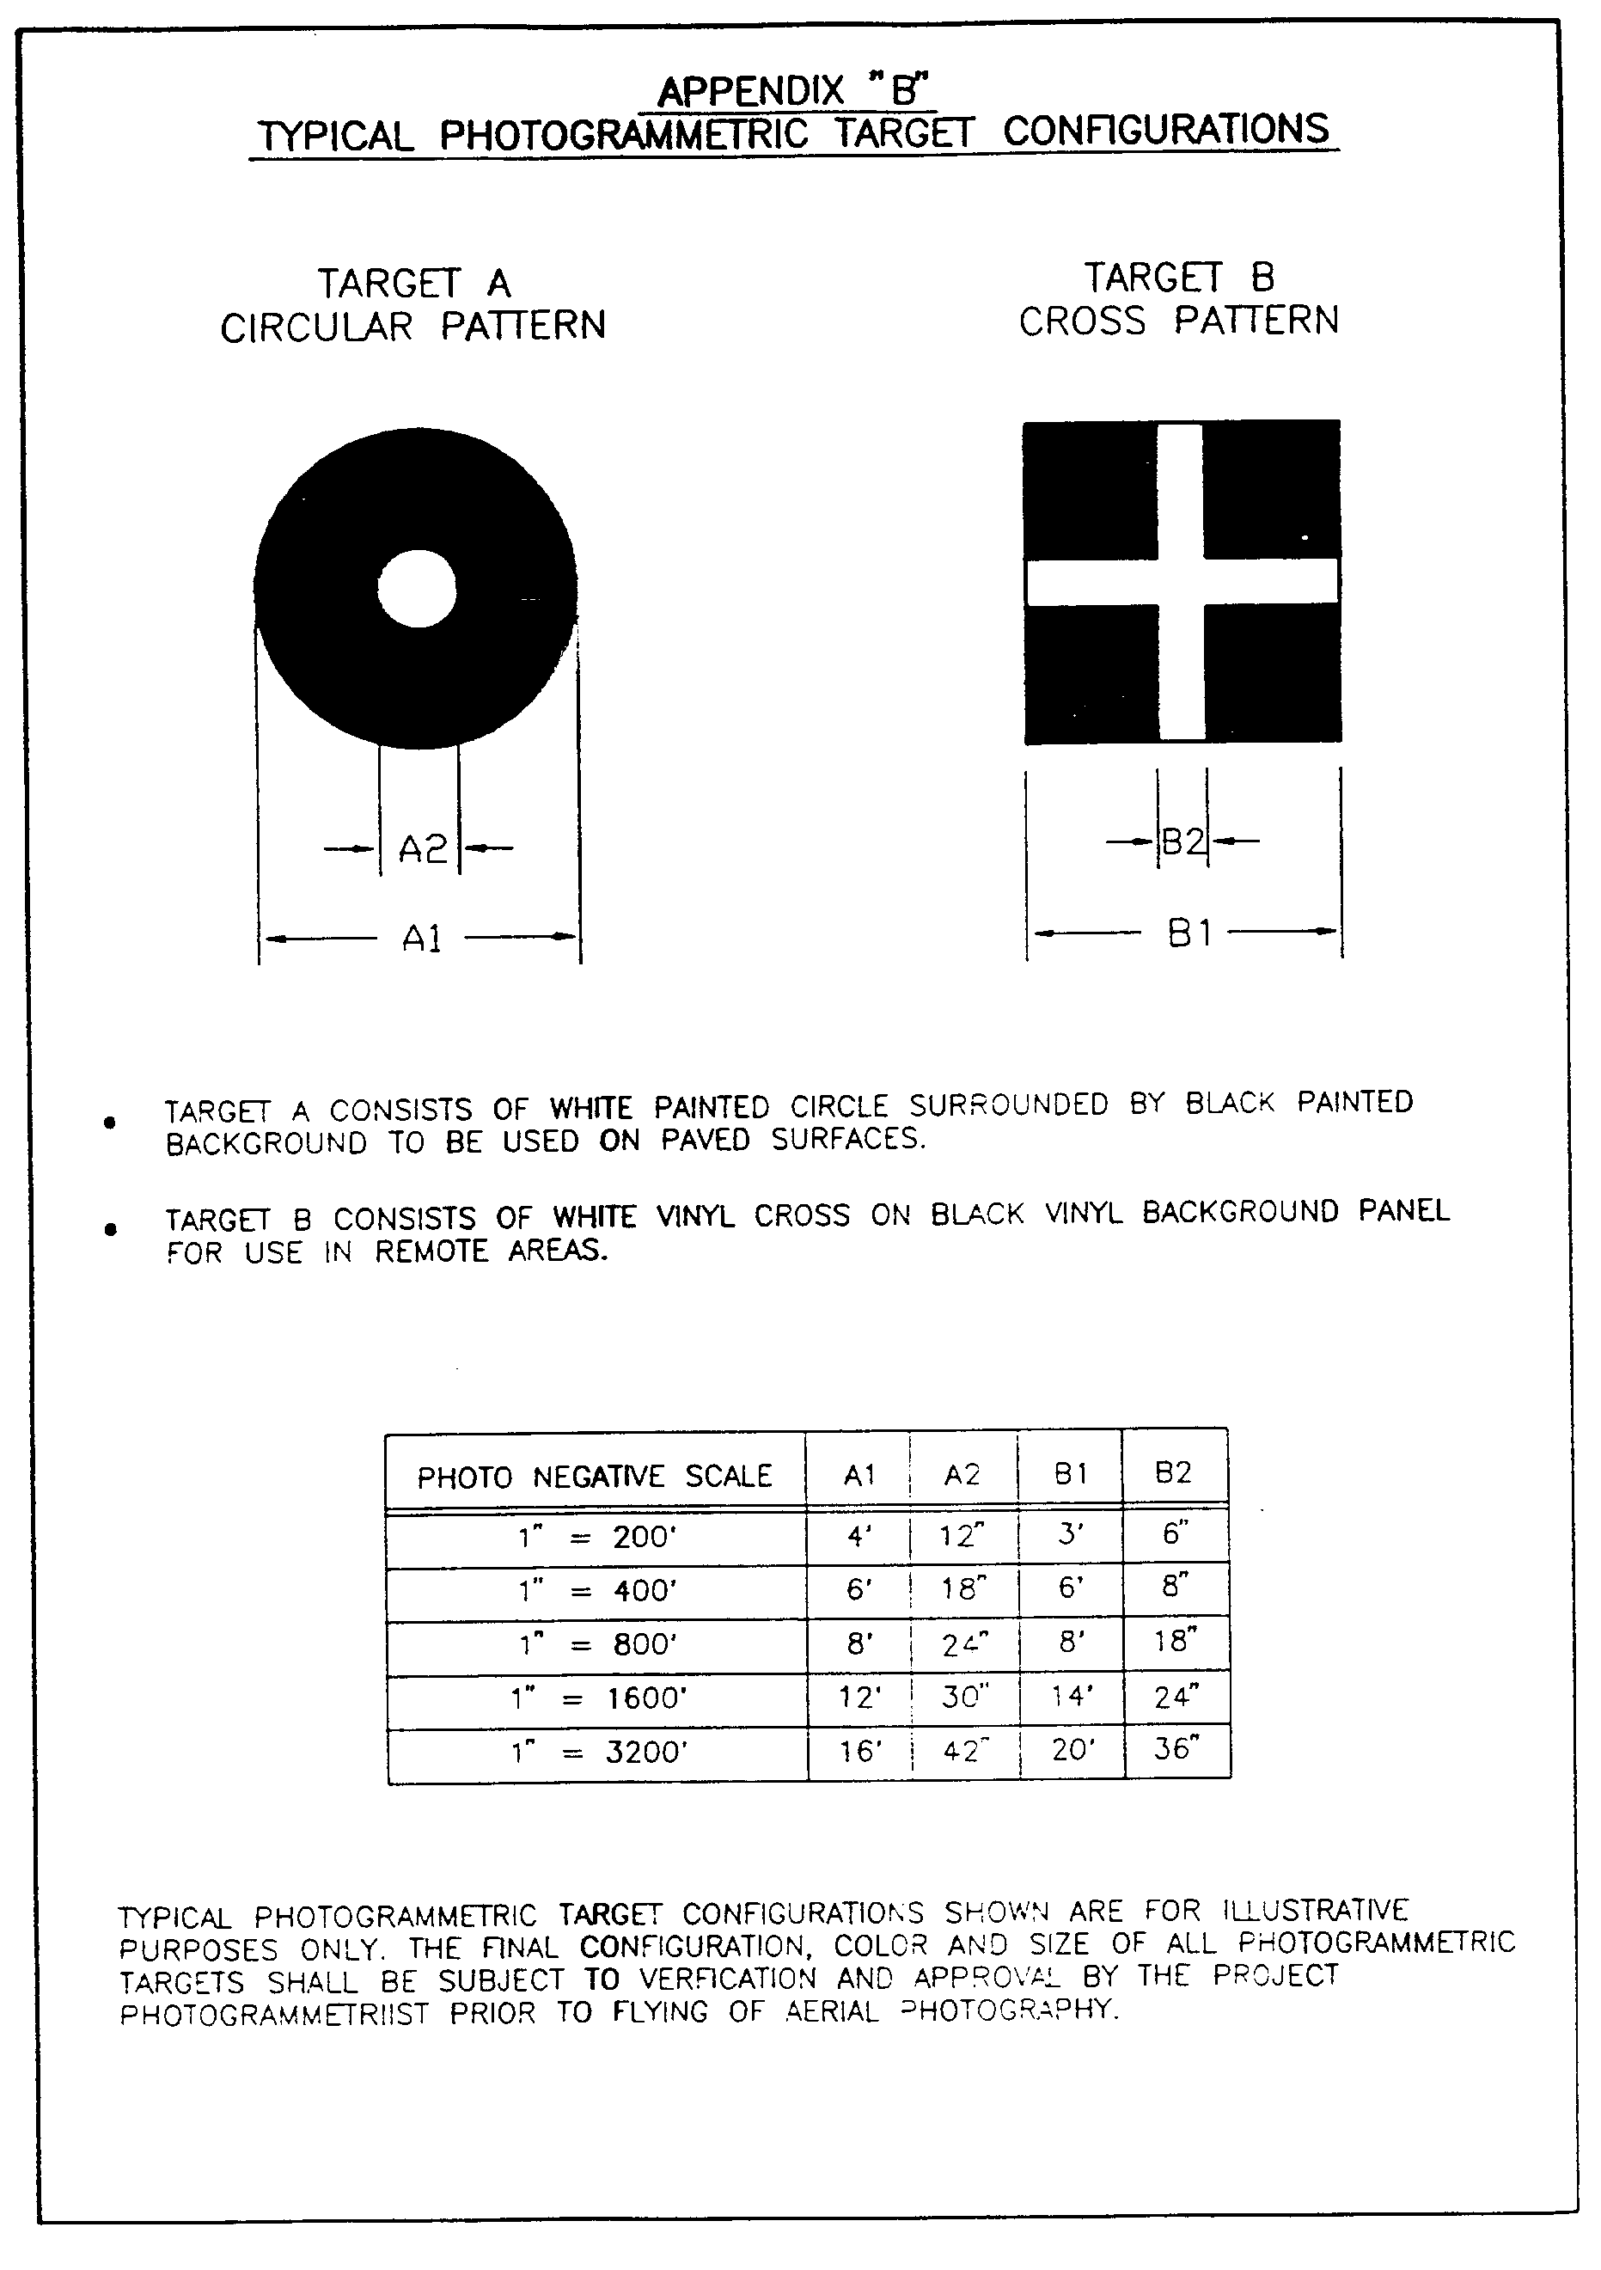

AUTHORITY NOTE: Promulgated in accordance with R.S. 50:171.
HISTORICAL NOTE: Promulgated by the Office of the Governor, Division of Administration, State Land Office, LR 17:968 (October 1991).

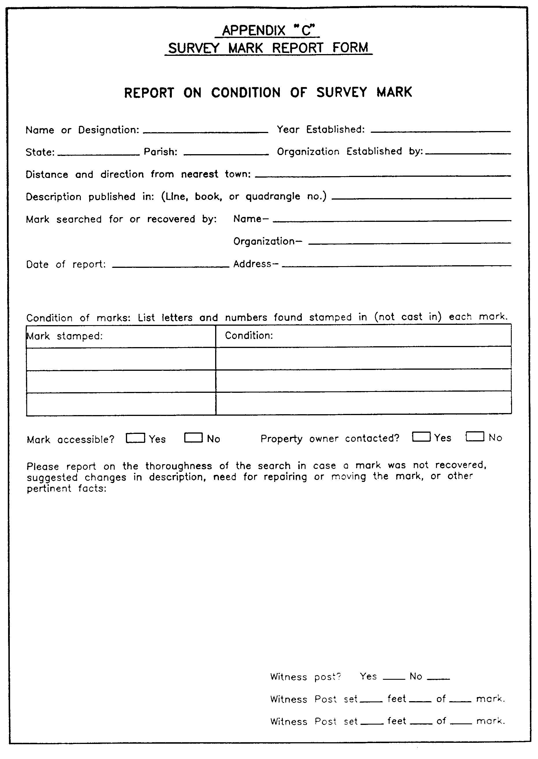
§525. Appendix C―Survey Mark Report Form

AUTHORITY NOTE: Promulgated in accordance with R.S. 50:171.
HISTORICAL NOTE: Promulgated by the Office of the Governor, Division of Administration, State Land Office, LR 17:968 (October 1991).

§527. Appendix D―Sample Control Data Description Form
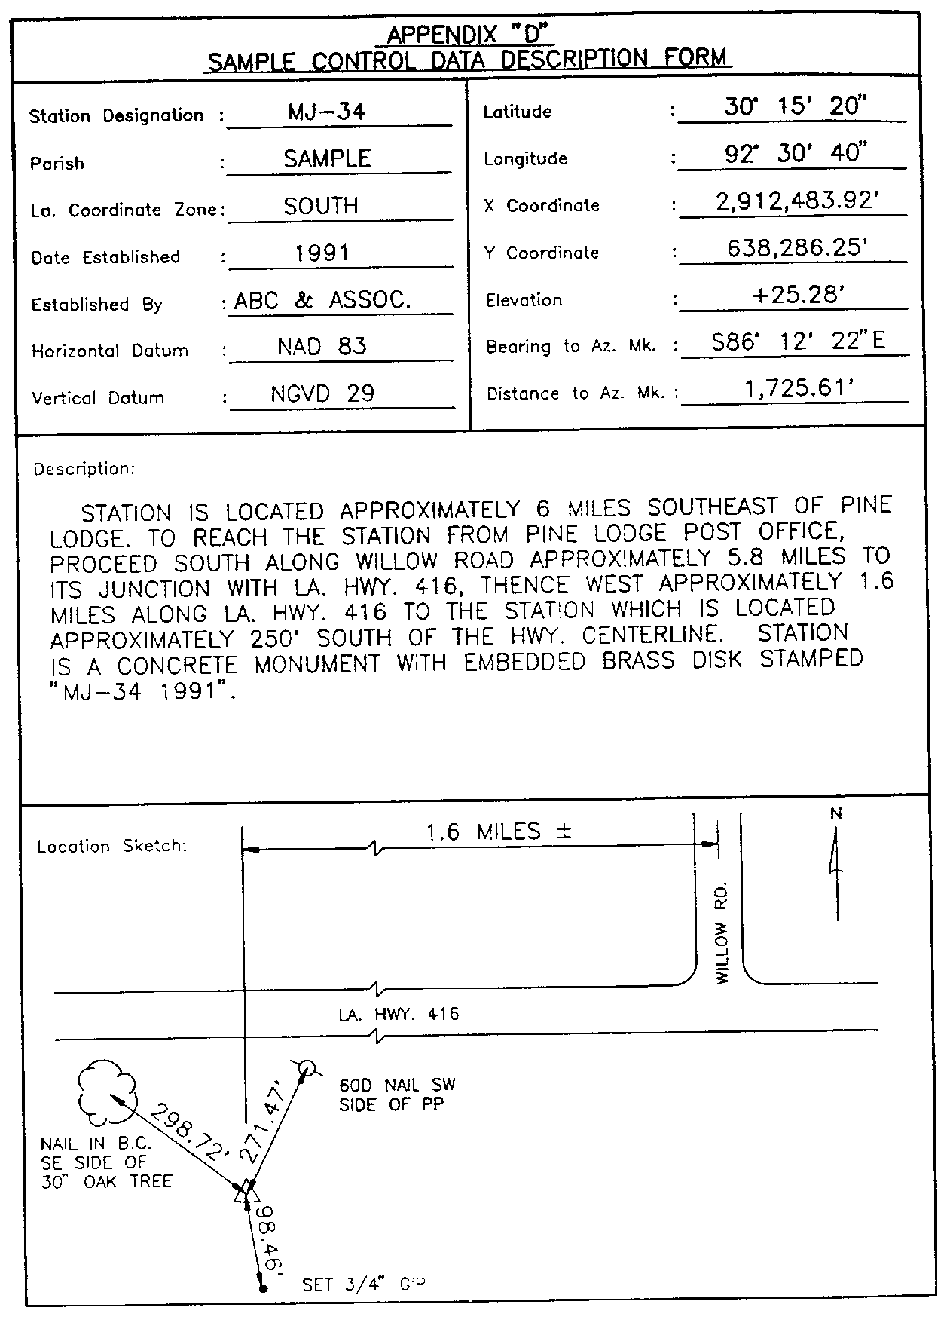

AUTHORITY NOTE: Promulgated in accordance with R.S. 50:171.
HISTORICAL NOTE: Promulgated by the Office of the Governor, Division of Administration, State Land Office, LR 17:968 (October 1991).

Chapter 7. Aerial Photography

§701. General Requirements

A. The general location of the areas to be photographed within and adjacent to any parish shall be clearly outlined on a planimetric base map at a standard 7.5 minute USGS quadrangle scale of 1" = 2000'. The areas to be photographed shall be extended a minimum of 200 feet beyond the outlined area. The planimetric base map outlining the areas to be photographed shall be designated as the Project Contract Map and shall be attached to and made a part of any contractual agreement to provide aerial photography within any parish area.

B. Following selection of the aerial photography contractor, the final flight plan proposed by the contractor shall be outlined on a copy of the Project Contract Map and submitted to the responsible contracting authority for approval prior to beginning work.

C. All photography required for map compilation under these standards shall be vertical aerial photography.
AUTHORITY NOTE: Promulgated in accordance with R.S. 50:171.
HISTORICAL NOTE: Promulgated by the Office of the Governor, Division of Administration, State Land Office, LR 17:968 (October 1991).

§703. Conditions during Photography

A. Vertical aerial photography will be accomplished during the period when deciduous trees are as barren as local climatic conditions permit and when the sun angle is not less than 30 degrees above the horizon. Photography will not be undertaken when the ground is obscured by snow, haze, fog or dust; when streams and rivers are not within their normal banks; or when the clouds or cloud shadows will appear on more than 5 percent of the areas in any one photograph. The photographs shall not contain objectional shadows caused by low solar altitude.

B. Photogrammetric targets shall be installed to mark ground control points for subsequent aerial triangulation and control of base map compilation. Care shall be taken to coordinate photographic flight schedules and ground target maintenance to ensure that a minimum of 95 percent of all targets set show up on the aerial photography.
AUTHORITY NOTE: Promulgated in accordance with R.S. 50:171.
HISTORICAL NOTE: Promulgated by the Office of the Governor, Division of Administration, State Land Office, LR 17:968 (October 1991).

§705. Scale of Aerial Photography Negatives

A. The altitude above average natural ground elevation for all aerial photography shall be such that the photographic negatives produced for each respective area classification shall conform to the minimum scale requirements specified within these standards.

B. Aerial photography for planimetric maps which are developed to depict horizontal features only may be flown at higher (more compressed) negative scale altitudes to reduce cost.

C. Aerial photography for topographic maps which are developed to depict both horizontal and vertical features must be flown at lower (more expanded) negative scale altitudes to facilitate accurate compilation.

D. The following schedules specify the minimum required photographic negative scales for each respective area classification based upon the type of mapping (planimetric or topographic) to be developed. The negative scales shown are subject to enlargement based upon specific project requirements. Any negatives deviating by more than 5 percent of the final project scale specified shall be rejected.
Schedule 1
Photographic Negative Scales Planimetric Mapping
Area Classification | Map Scale | Photo Scale
A | 1" = 50' | 1" = 400'
B | 1" = 100' | 1" = 800'
C | 1" = 200' | 1" = 1600'
D | 1" = 400' | 1" = 3200'

Schedule 2
Photographic Negative Scales Topographic Mapping
Area Classification | Map Scale | Contour Interval | Photo Scale
A | 1" = 50' | 1' | 1" = 200'
B | 1" = 100' | 1' | 1" = 400'
B | 1" = 100' | 2' | 1" = 800'
C | 1" = 200' | 2' | 1" = 800'
C | 1" = 200' | 5' | 1" = 1600'
D | 1" = 400' | 10' | 1" = 3200'
AUTHORITY NOTE: Promulgated in accordance with R.S. 50:171.
HISTORICAL NOTE: Promulgated by the Office of the Governor, Division of Administration, State Land Office, LR 17:968 (October 1991).

§707. Flight Plan

A. The aerial photography contractor shall prepare a proposed flight plan on a copy of the Project Contract Map showing the flight lines to be flown and the ground control points which will be utilized. Each flight line will be flown continuously across the project area. The principal points of the first two exposures of each flight strip shall fall outside the boundaries of the area to be mapped, and all side boundaries shall be covered by a minimum of 25 percent of the photo image format.
AUTHORITY NOTE: Promulgated in accordance with R.S. 50:171.
HISTORICAL NOTE: Promulgated by the Office of the Governor, Division of Administration, State Land Office, LR 17:968 (October 1991).

§709. Re-Flights

A. Unacceptable aerial photography shall be corrected by the contractor at no additional cost, with re-flight coverage overlapping the accepted photography by a sufficient amount to provide for continuous stereoscopic coverage.

B. All required re-flights shall be executed as close as possible calendar-wise to the original flights to the maximum extent permitted by weather conditions suitable for photography.
AUTHORITY NOTE: Promulgated in accordance with R.S. 50:171.
HISTORICAL NOTE: Promulgated by the Office of the Governor, Division of Administration, State Land Office, LR 17:968 (October 1991).

§711. Spacing of Photographs

A. Overlapping photographs in each flight line shall provide full stereoscopic coverage of the area to be mapped.
AUTHORITY NOTE: Promulgated in accordance with R.S. 50:171.
HISTORICAL NOTE: Promulgated by the Office of the Governor, Division of Administration, State Land Office, LR 17:968 (October 1991).

§713. Endlap

A. Photographs used as stereoscopic pairs shall have endlap of between 55 percent and 65 percent in the respective frames.
AUTHORITY NOTE: Promulgated in accordance with R.S. 50:171.
HISTORICAL NOTE: Promulgated by the Office of the Governor, Division of Administration, State Land Office, LR 17:968 (October 1991).

§715. Sidelap

A. Sidelap shall not be less than 20 percent nor more than 40 percent, and shall average approximately 25 percent to 30 percent. The average percentage of sidelap shall be governed by the photo negative scale and the size of the rectified photo atlas sheets.
AUTHORITY NOTE: Promulgated in accordance with R.S. 50:171.
HISTORICAL NOTE: Promulgated by the Office of the Governor, Division of Administration, State Land Office, LR 17:968 (October 1991).

§717. Crab

A. Crab in excess of 3 degrees may be cause for rejection of a flight line or any portion thereof in which the excess crab occurs.
AUTHORITY NOTE: Promulgated in accordance with R.S. 50:171.
HISTORICAL NOTE: Promulgated by the Office of the Governor, Division of Administration, State Land Office, LR 17:968 (October 1991).

§719. Tilt

A. Tilt of the camera from the vertical at the instant of exposure shall not exceed 3 degrees, nor shall it exceed
5 degrees between successive exposure stations. Average tilt over the entire project shall not exceed 1 degree.
AUTHORITY NOTE: Promulgated in accordance with R.S. 50:171.
HISTORICAL NOTE: Promulgated by the Office of the Governor, Division of Administration, State Land Office, LR 17:968 (October 1991).

§721. Aircraft

A. The aircraft to be used shall be equipped with all essential navigational and photographic instruments and be operated by a well-trained and experienced crew. Performance of the aircraft shall be adequate to complete the proposed project in accordance with the technical specifications.
AUTHORITY NOTE: Promulgated in accordance with R.S. 50:171.
HISTORICAL NOTE: Promulgated by the Office of the Governor, Division of Administration, State Land Office, LR 17:968 (October 1991).

§723. Flying Requirements

A. The contractor shall comply with the laws of the United States and of the state of Louisiana pertinent to aircraft operation and the licensing of pilots, mechanics and other personnel.

B. Required clearances for necessary flying over restricted areas will be obtained by the contractor.
AUTHORITY NOTE: Promulgated in accordance with R.S. 50:171.
HISTORICAL NOTE: Promulgated by the Office of the Governor, Division of Administration, State Land Office, LR 17:968 (October 1991).

§725. Aerial Camera

A. Each aerial camera used shall be a precision aerial mapping camera of equivalent or better quality than a Wild RC-10, Zeiss RMKA, or Jena LMK equipped with a low distortion, high resolution lens and image motion compensation. A USGS Camera Calibration Report on each camera used shall be submitted to the responsible contracting authority, and only the camera and magazine reported in the Calibration Report shall be used for photography. Each report shall not be more than four years old before the photography is flown.

B. The mean radial lens distortion (D0) as defined by the USGS Camera Calibration procedures, is the average distortion for a given field angle from 7.5 degrees through and including 40 degrees. The calibrated focal length shall be 153 millimeters + 3 millimeters (nominal 6-inch focal length). The Area-Weighted Average Resolution (AWAR) of each camera lens shall not be less than 45 lines as determined by the USGS Camera Calibration Report. The two surfaces of the filter on each camera used for aerial photography shall be within 10 arc seconds of being parallel as verified by the USGS.

C. Each camera used shall expose a minimum of four midside fiducials. The mechanical precision of the perpendicularity of the midside fiducials shall be within at least one arc minute of exactly 90 degrees. Each magazine used for each camera must have a platen that does not depart from a true plane by more than 0.005 inches. Image Motion Compensation must be in proper operating condition for all photography flown.
AUTHORITY NOTE: Promulgated in accordance with R.S. 50:171.
HISTORICAL NOTE: Promulgated by the Office of the Governor, Division of Administration, State Land Office, LR 17:968 (October 1991).

§727. Aerial Film

A. Aerial film for the development of planimetric maps or topographic maps may be either black and white or color film at the discretion of the responsible contracting authority.

B. Black and white aerial film shall be KODAK or approved equal fine grain, high-speed black and white photographic emulsion on a dimensionally stable base. Specific emulsions used are at the discretion of the Contractor based upon his experience, equipment configurations, and chemistry familiarity. All film shall be stored and handled in specific accordance with manufacturer's instructions. Only one type of black and white film shall be used for the entire project, and the film type shall be approved in advance by the responsible contracting authority. All film used shall be suitable for the production of true black and white film diapositives, contact prints and photographic enlargements with minimal loss of resolution. Outdated film shall not be used.

C. Color aerial film shall be KODAK or approved equal fine grain, high-speed color photographic emulsions on a dimensionally stable base. An emulsion suggested, but not mandatory, is KODAK AEROCOLOR Negative Film 2445. Specific emulsions used are at the discretion of the contractor based upon his experience, equipment configurations, and chemistry familiarity. All film shall be stored and handled in strict accordance with manufacturer's instructions. Only one type of color film shall be used for the entire project and the film type shall be approved in advance by the responsible contracting authority. All film used shall be suitable for the production of true color film diapositives, contact prints and photographic enlargements with minimal loss of resolution. Outdated film shall not be used.
AUTHORITY NOTE: Promulgated in accordance with R.S. 50:171.
HISTORICAL NOTE: Promulgated by the Office of the Governor, Division of Administration, State Land Office, LR 17:968 (October 1991).

§729. Disposition of Aerial Film

A. The aerial film is the property of the responsible contracting authority and shall be stored by the contractor for no less than five years following the termination of the contract. After this period, the aerial film shall then be either delivered to the responsible contracting authority or continue to be stored by the contractor at the option of the responsible contracting authority.
AUTHORITY NOTE: Promulgated in accordance with R.S. 50:171.
HISTORICAL NOTE: Promulgated by the Office of the Governor, Division of Administration, State Land Office, LR 17:968 (October 1991).

§731. Roll Film Containers

A. The container for each roll of aerial film shall be made of plastic, shall not exceed 6 inches in diameter, shall contain no more than 250 feet of film, and shall be the property of the responsible contracting authority. It shall be clearly labeled with the name of the contracting authority, name of the contractor, name of the aerial photography firm (if performed by a subcontractor), date of photography, flight and exposure numbers (sequential numbers of the first and last exposures), type and serial number of the camera, the type, serial number and calibrated focal length (in millimeters) of the camera lens, serial number of the magazine, film roll number and the nominal scale of the negatives.
AUTHORITY NOTE: Promulgated in accordance with R.S. 50:171.
HISTORICAL NOTE: Promulgated by the Office of the Governor, Division of Administration, State Land Office, LR 17:968 (October 1991).

Chapter 9. Photo Laboratory Procedures

§901. Image Quality

A. Images on the aerial negatives shall be clear and sharp in detail and free from light streaks, static marks, scratches and other blemishes. Special care shall be exercised to insure proper development and thorough fixing and washing of all film, and to avoid in any way distorting it during processing or drying. Film shall be exposed and processed with a target density range of 1.0 ± 0.2, as measured with a densitometer with a scale range of 0.0 to 3.0, should not be less than 0.3, and the maximum density not greater that 1.5. All fiducial mark images shall be clear and sharp. Plots of Log E curves shall be submitted to the responsible contracting authority for each roll of film along with values of base fog for each roll.
AUTHORITY NOTE: Promulgated in accordance with R.S. 50:171.
HISTORICAL NOTE: Promulgated by the Office of the Governor, Division of Administration, State Land Office, LR 17:968 (October 1991).

§903. Film Labeling

A. Each exposure shall be clearly labeled by mechanical means in ink (or foil transfer if using a film titler) at the edge of the negative just inside the image area, and on the north edge for north-south flights or the west edge for east-west flights. This labeling shall include the following information at a minimum:
Date of Photography | Scale of Photography | Project Name | Flight Strip | Exposure Number

B. The Scale of Photography shall be given in inches and feet, e.g., 1" = 400', etc. Flight strip numbers are not to be repeated anywhere within the photographic coverage of the contract, but will be numbered consecutively starting with strip number 1 and continued sequentially over all flight lines and scales. Exposure numbers for any flight strip will be numbered consecutively from exposure number 1 and continuing sequentially to the end of that flight line.
AUTHORITY NOTE: Promulgated in accordance with R.S. 50:171.
HISTORICAL NOTE: Promulgated by the Office of the Governor, Division of Administration, State Land Office, LR 17:968 (October 1991).

§905. Photo Index

A. The contractor shall prepare a photo index for each scale and coloration (i.e., black and white or color) of aerial photography flown by stapling together the contact prints (or reduced size prints), trimmed to the image area. The prints shall be carefully matched so that the corresponding images overlap and all photo numbers are visible. This original composite of contact prints shall be photographically copied, reduced in scale, and reproduced in uniform size sheets not to exceed 42 inches high by 42 inches wide. The reduction of the photo index scale may be to any appropriate size, but in no case smaller than four times the scale of the contact print or 1" = 1 mile, whichever is the larger scale. The index shall contain the names of prominent geographic features for orientation purposes. Each index shall also include title information identifying the project, date and scale of the project, name of the contractor, date and scale of the aerial photography, type of camera and focal length of its lens, the scale of the photo indexes, and a north arrow. In the event two or more photo indexes are required at any one scale, a diagram will be drawn in each photo index's margin. Photo indexes shall be oriented to the north, and the title information should appear in the south or east margin of each index. A photo index negative, three mylar-based screen positives and three photographic double weight semi-matte paper copies will be required for each scale of aerial photography.
AUTHORITY NOTE: Promulgated in accordance with R.S. 50:171.
HISTORICAL NOTE: Promulgated by the Office of the Governor, Division of Administration, State Land Office, LR 17:968 (October 1991).

§907. Aerial Photography Contact Prints

A. Three sets of contact prints of the original aerial negatives for each scale and coloration of aerial photography flown will be prepared by the contractor on double-weight, semi-matte paper or equivalent weight resin-coated paper. All prints will be clear and free from chemicals, stains, blemishes, fog, streaks, or any defects which would render them unusable. One set of contact prints will be delivered to the responsible contracting authority for a quality control inspection as soon as they can be made available.
AUTHORITY NOTE: Promulgated in accordance with R.S. 50:171.
HISTORICAL NOTE: Promulgated by the Office of the Governor, Division of Administration, State Land Office, LR 17:968 (October 1991).

§909. Aerial Photography Diapositives

A. The contractor shall furnish one set of film or glass diapositives for each scale and coloration of aerial photography flown for use during subsequent analytic aerial triangulation and map compilation.

B. All diapositives will be printed from original aerial negatives (not from duplicate negatives). All film diapositives shall be printed on cut sheets of KODAK 7-mil Estar Base film or approved equal with a printer having a flat platen. All glass diapositives shall be produced using KODAK Ultra Flat plates or approved equal. Outdated emulsions shall not be used.

C. The printing and processing of all diapositives including development, fixation, washing and drying must produce diapositives free from tears, scratches, abrasion, light fog, light streaks, static marks, finger marks, stains, spots or blemishes of any kind excepting those originating on the original negative. Extreme care will be exercised to prevent lint from collecting on both the original negatives and the diapositives. Furthermore, clean, lint-free cotton gloves shall be used whenever diapositives are handled for any purpose. The diapositives shall be individually stored in polycarbonate sleeves or similar material that has a coefficient of hardness less that the emulsion on the diapositive. To the extent permitted by the original aerial negatives, all diapositives will be clear and sharp in detail, have uniform tone and a degree of contrast permitting ground details to show clearly in dark-toned and high-light areas as well as in the middle tones between the dark and light, with particular emphasis on legibility in the shadows.
AUTHORITY NOTE: Promulgated in accordance with R.S. 50:171.
HISTORICAL NOTE: Promulgated by the Office of the Governor, Division of Administration, State Land Office, LR 17:968 (October 1991).

Chapter 11. Aerial Triangulation

§1101. General Requirements

A. Analytical Aerial Triangulation by Bundle Adjustment shall be employed to provide a cost effective control solution for all areas to be mapped subject to the requirements stated below.

B. Techniques of high-to-low aerial triangulation may be used subject to the approval of the responsible contracting authority.

C. Semi-analytical aerial triangulation methods shall not be employed for any mapping developed under these standards.
AUTHORITY NOTE: Promulgated in accordance with R.S. 50:171.
HISTORICAL NOTE: Promulgated by the Office of the Governor, Division of Administration, State Land Office, LR 17:968 (October 1991).

§1103. Coordinate Object Space

A. Aerial triangulation shall be performed in a Local Space Rectangular System based on the Geodetic Reference System 1980 (GRS 80) ellipsoid. Geoid separation from the ellipsoid shall be established for each project area and referenced to NAD 83 for photogrammetric purposes. The Local Space Rectangular System shall be configured as secant at its origin and shall have a negative ellipsoid height at origin as established for the specific project area.

B. Elevations shall be referenced to the National Geodetic Vertical Datum of 1929, or subsequent NAVD 88 datum, as applicable, and shall be assumed to be in perfect coincidence with the ellipsoid surface (no geoid slope). The input and output coordinate systems shall be in geodetic coordinates (NAD 83) of Latitude, Longitude and Orthometric Height to ensure proper utilization of the Local Space Rectangular (LSR) System for the aerial triangulation computational solution. Separate transformations shall then be performed on the triangulated positions to index elevations back to NGVD 1929 or NAVD 88 datum and to express horizontal coordinates in the Louisiana State Plane Coordinate System, NAD 83, North or South Zone, as applicable.

C. For each aerial triangulation block solution performed, the contractor shall take extraordinary care to record and preserve the LSR system origin used for the solution. Variance-covariance matrices should be referenced to the LSR system for both camera stations and triangulated ground points if supplied with the aerial triangulation report. However, an error propagation of the bundle adjustment will not be required. The responsible contracting authority may perform an error analysis independently to validate the contractor's work.
AUTHORITY NOTE: Promulgated in accordance with R.S. 50:171.
HISTORICAL NOTE: Promulgated by the Office of the Governor, Division of Administration, State Land Office, LR 17:968 (October 1991).

§1105. Coordinate Image Space

A. All input image space coordinates (plate coordinates) shall be reported and referenced to a plate-centered coordinate system, corrected for film shrinkage, comparator calibration, atmospheric refraction, and lens distortion such that the fiducial coordinates correspond exactly to the USGS Camera Calibration Report.
AUTHORITY NOTE: Promulgated in accordance with R.S. 50:171.
HISTORICAL NOTE: Promulgated by the Office of the Governor, Division of Administration, State Land Office, LR 17:968 (October 1991).

§1107. Accuracy Requirements

A. The positional and elevation accuracy of the aerial triangulation solution shall be such that the accuracy requirements set forth within Chapter 3 may be achieved during the subsequent stereocompilation and digital base map preparation phase of the project.
AUTHORITY NOTE: Promulgated in accordance with R.S. 50:171.
HISTORICAL NOTE: Promulgated by the Office of the Governor, Division of Administration, State Land Office, LR 17:968 (October 1991).

§1109. Passpoints

A. Passpoint locations will be manually selected by reviewing the control photographs in stereo. Selected passpoints shall be located, symbolized and labeled on the image side of the control photographs. All selected locations will lie on unobscured level ground whenever topographic conditions permit. Particular care shall be taken in selection of passpoints so that in built-up urban areas (and rural when possible), points shall be selected that are field recoverable. Field recoverable points are defined as discrete intersections of linear features such as two sidewalks, sidewalks and curbs, slab corners (parking lots, driveways, etc.), and discrete point features such as manholes, storm drain gratings and other small manmade features.

B. For analytical aerial triangulation, individual frames will carry a minimum of nine passpoints, with the exception of end frames of flight lines which will carry a minimum of six passpoints. One point will lie in the corner of each neat model, and one point will lie near each nadir position of each neat model. It is recognized that deviation from the ideal distribution may be necessary for those photographs covering bodies of water and/or areas of heavy ground cover. Tie points between strips will occur with a frequency of at least one per frame. As a general rule, wing passpoints within lines of flight will also serve as tie points between strips.
AUTHORITY NOTE: Promulgated in accordance with R.S. 50:171.
HISTORICAL NOTE: Promulgated by the Office of the Governor, Division of Administration, State Land Office, LR 17:968 (October 1991).

§1111. Checkpoints

A. Checkpoints are horizontal control points that have been established by ground control procedures throughout the block for accuracy checking purposes. Checkpoint use is left to the contractor's discretion.
AUTHORITY NOTE: Promulgated in accordance with R.S. 50:171.
HISTORICAL NOTE: Promulgated by the Office of the Governor, Division of Administration, State Land Office, LR 17:968 (October 1991).

§1113. Diapositives

A. Clean, lint-free cotton gloves shall be used whenever diapositives are handled for aerial triangulation. The diapositives shall be individually stored in proper containers furnished.

B. All point marking will be performed on the diapositives. Under no circumstances will any marking be performed on the original aerial photography negatives. As a general rule, all targets will be marked with the exception of targets which are exceptionally well defined on the diapositives.
AUTHORITY NOTE: Promulgated in accordance with R.S. 50:171.
HISTORICAL NOTE: Promulgated by the Office of the Governor, Division of Administration, State Land Office, LR 17:968 (October 1991).

§1115. Monocomparator Requirements

A. If a monocomputer is used for aerial triangulation, all passpoints, checkpoints and drop points (if any) will be marked stereoscopically with WILD PUG or equipment of equal or better precision on every frame on which points appear, and dove prisms shall be used in all four positions for each point marked. The only exception to this requirement will be applicable to points falling in side-laps which are not intended to be used as strip tie points. The maximum diameter of the mark shall be 40 micrometers, with every effort to use a mark of lesser diameter, emulsion permitting.

B. All ground control points, passpoints, checkpoints, drop points (if any) and four corner fiducials will be measured with a comparator having a least count of no greater that 1 micrometer and a root mean square (rms) intrinsic accuracy (calibration applied) of no worse than
2 micrometers. The comparator calibration coefficients shall be included in the aerial triangulation delivery.
AUTHORITY NOTE: Promulgated in accordance with R.S. 50:171.
HISTORICAL NOTE: Promulgated by the Office of the Governor, Division of Administration, State Land Office, LR 17:968 (October 1991).

§1117. Stereocomparator Requirements

A. If a stereocomparator is used for aerial triangulation, all passpoints may be marked monoscopically with a WILD PUG or equipment of equal or better precision on only the central three points along the cross-flight axis of the photo. Strip tie points, checkpoints, drop points (if any) and control points shall be marked stereoscopically. The maximum diameter of the mark shall be 40 micrometers, with every effort made to use a mark of lesser diameter, emulsion permitting.

B. All ground control points, passpoints, drop points (if any) and four corner fiducials will be measured with a stereocomparator having a least count of no greater than
1 micrometer and a rms intrinsic accuracy (calibration applied) of no worse that 2 micrometers for each stage. Dove prisms shall be used in all four positions for each point measured in stereo. The only exception to this requirement will be applicable to points falling in side-laps which are not intended to be used as strip tie points. The comparator calibration coefficients shall be included in the aerial triangulation delivery for each stage of the instrument.
AUTHORITY NOTE: Promulgated in accordance with R.S. 50:171.
HISTORICAL NOTE: Promulgated by the Office of the Governor, Division of Administration, State Land Office, LR 17:968 (October 1991).

§1119. Analytical Plotter Requirements

A. If an analytical plotter is used for aerial triangulation, it shall be used only in the Monocomparator mode or in the Stereocomparator mode. In such cases, §1115 and §1117 shall apply.

B. An analytical plotter may not be used for aerial triangulation in the Semi-Analytical mode.
AUTHORITY NOTE: Promulgated in accordance with R.S. 50:171.
HISTORICAL NOTE: Promulgated by the Office of the Governor, Division of Administration, State Land Office, LR 17:968 (October 1991).

§1121. Aerial Triangulation Report

A. Immediately following completion of all aerial triangulation work or sub-block portions thereof, the contractor shall prepare a formal aerial triangulation report for submission to and approval by the responsible contracting authority. This report will include but not necessarily be limited to the following.

1. Photo index overlays:

a. flight line and exposure stations;

b. all control points and checkpoints used, appropriately labeled with station designations, computer designations (if different), agency responsible for establishing the stations, orders of accuracy, and an indication of whether individual points were targeted or photo identifiable;

c. all misclosures (DX, DY, DZ) at ground control and check points appropriately labeled with station designations;

d. note that overlays §1121.A.1.a, b, and c above may be combined all onto one single overlay at the contractor's option if the resultant product is clear and legible. Misclosures in DX and DY may be symbolized as vectors to some appropriate scale if the contractor so chooses.

2. Aerotriangulation results:

a. tabulation of all misclosures at ground control points used in the solution;

b. computed coordinates of all control points, passpoints and checkpoints;

c. computed coordinates of all resected camera stations with their orientations;

d. comparator coordinates of all points measured (including fiducials) sorted or arranged by individual frame. Plate-centered coordinates may be substituted for comparator coordinates if the contractor so chooses;

e. post adjustment plate residuals of all image coordinates used in the solution;

f. coordinates of LSR origin used for solution;

g. comparator calibration coefficients if comparator coordinates are furnished instead of plate-centered coordinates;

h. variance-covariance matrices of all triangulated positions and altitudes if an error propagation analysis was performed on the adjustment solution.

3. Narrative. The report shall include a brief narrative trying together §1121.A.1 and 2, and including descriptions of laboratory equipment, procedures and computer programs used. If comparator coordinates are furnished by the contractor, the comparator calibration correction equations shall be documented in the narrative to allow the responsible contracting authority to evaluate the coefficients supplied as well as to compute plate coordinates. Root-Mean-Square (rms) error summaries will be given for bundle adjustment residuals of all control points. Furthermore, misfits encountered at control points that required corrective action shall be clearly described along with descriptions of corrective actions taken.

B. Section 1121.A.2.a-h shall be submitted on acceptable PC-DOS or MS-DOS formatted computer transfer media in ASCII file format subject to the discretion and approval of the responsible contracting authority.
AUTHORITY NOTE: Promulgated in accordance with R.S. 50:171.
HISTORICAL NOTE: Promulgated by the Office of the Governor, Division of Administration, State Land Office, LR 17:968 (October 1991).

Chapter 13. Digital Mapping Requirements

§1301. General Requirements

A. The purpose of this Section is to establish guidelines and requirements for computerized digital mapping in accordance with these standards. These guidelines and requirements provide descriptions of terminology, data structure, accuracy and data exchange specifications.

B. In order to capture information for use in a digital mapping system, it is necessary to store X and Y Louisiana State Plane Coordinates (North or South Zone), including applicable vertical coordinate data, for every point that is used to define the graphic aspects of the map. Thus, a road would be represented in digital format by a number of points (X and Y coordinate pairs) that define its location. The digital mapping system would then be able to depict the road by plotting straight or curved lines between the points. The process of capturing the coordinate points and storing them in a computer or computer-readable format is called digitizing. Digitization may be accomplished by the use of coordinate geometry, by using electronic tables that record coordinate points, by manually tracing over source map information, or by using automatic scanning (digitizing) devices.

C. The digitization of planimetric and topographic base maps shall be accomplished by digital stereo-compilation of controlled aerial photography. The digitization of parcel ownership maps will be based upon existing map sources and record information combined with cartographic features derived from planimetric and topographic base map imagery.
AUTHORITY NOTE: Promulgated in accordance with R.S. 50:171.
HISTORICAL NOTE: Promulgated by the Office of the Governor, Division of Administration, State Land Office, LR 17:968 (October 1991).

§1303. Data Definitions

A. The following definitions of digital map data are presented to clarify their usage and meaning under these standards.

1. Layer. A layer can be either a complete digital map or any single component overlay for a map. Layers may contain one or more components. A planimetric map, a topographic map overlay, and a parcel map overlay would each be considered an aggregated map layer consisting of various layer categories, with each category consisting of designated component layers to allow for inclusion or deletion of specific feature elements. Sections 1309-1313, Appendices A, B, and C include a general listing of layer categories and feature elements to be included within the digital database framework for all planimetric, topographic and parcel maps to be developed under these standards.

2. Component. A component is a discrete type of feature element that, in combination with other feature elements, creates a layer. Examples of feature elements include highway route numbers, contour lines, parcel identification numbers, and map grid lines. Each feature element is composed of objects that graphically represent a component's extent (lines, configuration or area) or that present information (symbols or text).

3. Objects. Objects are the base graphic elements that represent map features. They are interrelated in a topological data structure that defines the relationship of the elements to one another. The primary objects used to create components are points, nodes, lines, and areas. Because geographic spatial data handling is still a relatively new science, a number of different terms have been used in the past to report these objects. The terminology used here draws on the current working documents from the National Committee for Digital Cartographic Data Standards. To facilitate understanding, the object definitions presented herein are simplifications of that framework (see §1315.A, Appendix D, Figure 1).

a. Points. Points are used to represent the location of objects. In some cases, these are feature points or objects that can be identified on the surface of the earth (e.g., manhole covers, pretargeted benchmarks, etc.). In other cases, they are arbitrarily placed label points (e.g., locations for the placement of text, symbology, etc.). In still other cases, they are attribute points for areas or lines (e.g., parcel dimensions, parcel identification numbers, etc.). The locations of attribute points may or may not have to be calculated.

b. Nodes. Nodes represent the intersection of lines (linear objects). Each node must represent the intersection or beginning/ending point of at least one line as a minimum. A node should reference each line that intersects it and whether it is the beginning or ending point of that line.

c. Lines. Lines are strings of coordinates that run between nodes. Each line has a minimum of two X and Y Louisiana State Plane Coordinate pairs. Beginning and ending node numbers and identifiers of areas (when applicable) on the right and left of the line will also be associated with each line.

d. Areas. Areas are polygons, which are defined by a series of lines. Areas also include references to attribute points and other associated data. The boundary of an area is defined by a listing of the lines that comprise the area's border. The number of areas and a list of lines composing each area are also recorded.

4. Topological Data Structure. Topology is the mathematical relationship of how points and lines on a map interact with one another to define geographic areas. The use of a topological data structure is essential for the effective creation and manipulation of geographic data. Topology allows the interrelationships of graphic objects to be specified. It also prevents the storage of repetitive data. Thus, one line can represent a stream and the boundary of two adjacent areas or parcels. This structure allows the generation of areas based on node and line information. Topological structures are necessary if analysis of lines or areas is undertaken. Thus, road networks stored in a format with topological structure can be used for data aggregation, maintenance inventories, school bus routing, or emergency service dispatching.

5. Digital Data Sets. Digital data sets are computer files that store geographic files that store geographic data. Each data set may contain a number of components. For example, a data set containing contour line components would also contain contour labels. A street and roads data set could include pavement extent, pavement and base course thickness, average daily traffic volume, right-of-way limits, route labels, and related information.

6. Digital Labeling. Important differences exist between the attribute points of lines and areas as opposed to label points. Attribute points and associated information are stored or linked to each line, area, or feature point. They allow users to select the specific objects that they wish to plot, report on, or analyze. Thus, all of the line segments that constitute Louisiana Highway No. 30 could be extracted and plotted. Label points are used to label an object or a series of objects on a map. Thus, two different label points may be used to identify Highway No. 30 as it crosses a map, where 13 lines, each with an associated attribute point, are used to plot Louisiana Highway No. 30 on the map (see §1315.B, Appendix D, Figure 2).

7. Edge Matching. Edge matching is the matching of lines and areas between map sheets. With digital data the match implies that each line ends with a node which is either the same node or has the same coordinates of the node of the line that continues onto the adjoining map sheet (see §1315.C, Appendix D, Figure 3).

8. Digital Mapping Product. The product of digital mapping will be topologically structured digital data sets that store map objects using Louisiana State Plane Coordinates and associated attribute information with each object. The digital mapping product that a parish or other user produces or receives may include a number of individual data sets, or all data may be integrated in a single database. Attribute data may be stored as part of the geographic data set or in an associated database. Each graphic object will be attributed according to a specified labeling scheme. Thus, a road could have only the road name stored as an attribute of a road line (e.g., Louisiana Highway No. 30), or it could have road name, type of road, road owner, right-of-way width, and other related information for each line that represents the road. Similarly, an area representing a parcel might only have the parcel identification number associated with it or it might have all information that the parish or other users maintain on that property. Associated information may be keyed in or merged into a data set from information that has already been stored in a computer readable format.

9. Coincident Features. Coincident features are those which are in common between two or more data layers. For example, if a political boundary is formed by a river bank, the river bank and political boundary are coincident features. Coincident features must be digitized only once. Regardless of the care taken in digitizing, slight differences are inevitable if a feature is digitized more than once. These differences lead to problems resulting in small "slivers" if the layers are topologically joined. Coincident features, digitized once, can be placed into master template coverages from which they can be retrieved when needed for incorporation into another layer, or they can be taken directly from the original coverage. In the above example, if the river was digitized first, the arcs necessary for the political boundary can be selected and placed in the new coverage.

10. Topological Editing. Topological editing builds polygon and arc node topology by identifying areas enclosed by arcs and creates a list of arcs which define each polygon boundary. During editing, two or more coordinates within a specified tolerance of each other (i.e., fuzzy tolerance) are snapped together and become the same coordinate point. No distinction is made between interior arc coordinates and nodes or between arcs. Because the fuzzy tolerance actually moves arc vertices, understanding its relationship to coverage resolution is important. A dangling node refers to the unconnected node of a dangling arc. Every arc begins and ends at a node point. So if an arc does not close properly, or was digitized past an intersection, it will register as a dangling node. During editing, all unacceptable dangling nodes within a specified tolerance must be removed. In some cases, a dangling node may be acceptable. For example, in a street centerline map, cul-de-sacs are often represented by dangling nodes.
AUTHORITY NOTE: Promulgated in accordance with R.S. 50:171.
HISTORICAL NOTE: Promulgated by the Office of the Governor, Division of Administration, State Land Office, LR 17:968 (October 1991).

§1305. Digital Accuracy

A. A number of requirements must be addressed and complied with to ensure the accuracy of the final digital product. These accuracy requirements are separate from those that are considered throughout the preceding ground control, aerial photography and analytic aerial triangulation phases of the map compilation process. Each of the following digital accuracy requirements must be fully complied with to ensure final product acceptability.

1. Grid Control. Grid control refers to the establishment of coordinate grid lines and pretargeted horizontal control points referenced to the Louisiana State Plane Coordinate System. All coordinate grid lines and pretargeted horizontal control points shall be established by direct keyboard entry of numeric coordinate values carried to the nearest one hundredth of a foot (0.01') at final ground scale. Manual digitization of grid line and horizontal control point locations shall not be allowed.

2. Geographic Registration. A minimum of four registration points shall be located in each of the four corners of each manuscript map. All registration points shall be established through direct keyboard entry of numeric coordinate values derived from analytical aerial triangulation and carried to the nearest one hundredth of a foot (0.01') at final ground scale. Manual digitization of registration points shall not be allowed.

3. Root Mean Square Error Tolerance. The Root Mean Square Error Tolerance (RMS) defines the error incurred when predefined ties are used to register a map during the digitizing process. The RMS error is an important tolerance because it indicates, in part, the accuracy with which the digitizing technician captures the locations of the registration points of a map in both the X and Y directions. In order to preserve the spatial integrity of map features during the automation process, it is extremely important to keep the RMS error as low as possible when a map is registered on the digitizing tables. The limiting RMS error for digital map products to be developed under these standards shall not exceed five thousandths of an inch (0.005") at final map scale.

4. Fuzzy Tolerance. Fuzzy tolerance defines the minimum distance separating arc or line segment coordinates, which is limited to two thousandths of an inch (0.002") at final map scale (see §1315.D, Appendix D, Figure 4).

5. Dangle Length Tolerance. Dangle length tolerance defines the minimum length of a dangling arc or line segment, which is limited to one tenth of an inch (0.10") at final map scale (see §1315.E, Appendix D, Figure 5).

6. Digitizing Accuracy. Digitizing accuracy refers to the accuracy of a digitized feature in relation to the same feature on the stereo model or original source map. Careful, consistent and systematic digitizing combined with thorough verification are essential to ensure satisfactory point, line and polygon development during the digitizing process. In order to achieve the limiting positional map accuracy requirements set forth within Chapter 3, the following digitization tolerances should be closely adhered to during final map compilation:

a. at least 90 percent of well-defined planimetric features on the digital map should be within one hundredth of an inch (0.01") of the centerline of that feature on the stereo model or original source map when plotted at final map scale;

b. 100 percent of all well-defined planimetric features should be plotted within two hundredths of an inch (0.02") at final map scale. The one hundredth of an inch (0.01") nominal tolerance interval is equivalent to a standard 0.010 plotter pen width. When a proof hardcopy plot of the digital map is overlayed on the original base manuscript, discrepancies will be seen as an open space between the plotted feature and the original manuscript. In establishing criteria for accuracy, it is important to consider the resources for storing statewide digital data. In order to facilitate the most efficient use of computer storage, it is necessary to encode only the minimum number of coordinate vertices needed to capture the essence of a cartographic feature within the one hundredth of an inch (0.01") digitization tolerance.

7. Topological Accuracy. All digital map products should be topologically clean and free of errors. The topology of all maps must be verified and free of overshoots, undershoots, slivers, open polygons, unlabeled polygons, and unresolved line segment intersections.

8. Attribute Labeling Accuracy. After a map file is attributed, it should be checked for accuracy, and all errors should be corrected. Testing for accuracy should be accomplished by the creation of test plots with labels that can be placed over the base map and checked for accuracy. All errors should then be corrected. The resulting final labeling accuracy should be less than 0.3 percent, or three errors in 1,000 labels. The error tolerance reflects the accuracy of the digital labeling to the stereo model or source map.

9. Edge Matching Accuracy. Map features should not extend beyond coverage boundaries. Line segments or arcs which intersect the boundaries of a coverage area must be accurately edge matched with the corresponding line segment in adjacent coverages. Computer edge matching techniques ensure an exact match. In lieu of an exact match, line segments or arcs must be matched to within one hundredth of an inch (0.01"), centerline to centerline. Line segments or arcs must not extend beyond (overshoot) or fall short of (undershoot) the coverage boundary.
AUTHORITY NOTE: Promulgated in accordance with R.S. 50:171.
HISTORICAL NOTE: Promulgated by the Office of the Governor, Division of Administration, State Land Office, LR 17:968 (October 1991).

§1307. Data Exchange Format

A. Digital data shall be provided on acceptable MS-DOS formatted computer transfer media in DXF file format. Each planimetric, topographic or parcel feature, as identified by a unique feature code, shall be either on a separate component layer or assigned level for viewing and plotting purposes.

B. Map data shall be stored on an acceptable interim digital format at the mapping consultant's facility until the responsible contracting authority and/or other responsible participants or users select and install their respective geographic information systems. Final map data must be compatible with the geographic information system in use or to be selected by the responsible contracting authority and/or other responsible participants and users.
AUTHORITY NOTE: Promulgated in accordance with R.S. 50:171.
HISTORICAL NOTE: Promulgated by the Office of the Governor, Division of Administration, State Land Office, LR 17:968 (October 1991).

§1309. Appendix A―Planimetric Map―Layer Categories and Feature Elements

PLANIMETRIC MAP

LAYER CATEGORIES AND FEATURE ELEMENTS

The following Layer Categories and Feature Elements shall be included on Planimetric Maps:

MARGIN CATEGORY
- Map Sheet and Image Area Border
- Coordinate Grid Lines
- Planimetric Map Title
- Map Number and Parish
- Louisiana State Plane Coordinate Zone
- State Plane Coordinate Grid Values (NAD 1983)
- Map Scale and North Arrow
- Match Note Index
- Planimetric Legend and Symbols
- Horizontal Control Point Locations
- Reference Horizontal Control Data

TRANSPORTATION CATEGORY
- Roads, Streets, and Highways
- Curbs and Edges of Traveled Ways
- Bridges, Overpasses, and Tunnels
- Railroads
- Airports
- Related Features
- Transportation Labels

HYDROLOGY CATEGORY
- Rivers, Bayous, Streams, Ponds, and Lakes
- Drainage Ditches and Canals
- Levees and Dams
- Shorelines
- Drainage Pump Stations
- Drainage Control Structures
- Related Features
- Hydrology Labels

TERRAIN CATEGORY
- Cultivated Areas
- Woodlands
- Land Fills and Excavations
- Swamps and Wetlands
- Related Features
- Terrain Labels

STRUCTURE CATEGORY
- Houses and Buildings
- Cemeteries
- Parking Lots
- Industrial Plant Facilities
- Fences and Retaining Walls
- Parks and Playgrounds
- Storage Tanks
- Ballfields, Tennis Courts, and Recreation Areas
- Towers
- Docks and Wharves
- Bulkheads and Revetments
- Related Features
- Structure Labels

UTILITY CATEGORY
- Utility Poles
- Power Transmission Lines
- Communication Facilities
- Manholes and Valve Boxes
- Catch Basins and Drain Inlets
- Hydrants
- Sewer and Water Pumping Stations
- Surface Expression of Underground Utilities
- Elevated and Ground Water Storage Tanks
- Pipelines
- Oil or Gas Wellheads
- Related Features
- Utility Labels

AUTHORITY NOTE: Promulgated in accordance with R.S. 50:171.
HISTORICAL NOTE: Promulgated by the Office of the Governor, Division of Administration, State Land Office, LR 17:968 (October 1991).

§1311. Appendix B―Topographic Map―Layer Categories and Feature Elements

TOPOGRAPHIC MAP

LAYER CATEGORIES AND FEATURE ELEMENTS

In addition to any or all of the Planimetric Layer Categories and Feature Elements designated within preceding §1309, Appendix A, the following Layer Categories and Feature Elements shall also be included on Topographic Maps:

MARGIN CATEGORY
- Topographic Map Title
- Topographic Legend and Symbols
- Reference Vertical Benchmark Data

TOPOGRAPHIC CATEGORY
- Index Contour Lines
- Intermediate Contour Lines
- Spot Elevations
- Ridgelines and Depressions
- Auxiliary Heights
- Related Features
- Topographic Labels

AUTHORITY NOTE: Promulgated in accordance with R.S. 50:171.
HISTORICAL NOTE: Promulgated by the Office of the Governor, Division of Administration, State Land Office, LR 17:968 (October 1991).

§1313. Appendix C―Parcel Map―Layer Categories and Feature Elements

PARCEL MAP

LAYER CATEGORIES AND FEATURE ELEMENTS

In addition to any or all of the Planimetric and Topographic Layer Categories and Feature Elements designated within preceding §§1309, Appendix A, and 1311, Appendix B, the following Layer Categories and Feature Elements shall also be included on Parcel Maps:

MARGIN CATEGORY
- Parcel Map Title
- Subdivision Index
- Disclaimer Note
- Parcel Map Legend and Symbols
- PARCEL CATEGORY
- State and Parish Boundary Lines
- City, Town, or Corporate Limit Lines
- Government Reservation or National Forest Boundaries
- District, Ward, and Precinct Lines
- Highway, Road, and Street Rights-of-Way
- Property Lines Excluding Rights-of-Way
- Rights-of-Way and Parcel Line Dimensions
- School and Municipal Sites
- Park, Playground, and Recreational Sites
- Pipeline and Powerline Easements
- Utility Easements
- Railroad Rights-of-Way
- Tied-in Property Line Corners
- Township and Section Lines
- Map Block Numbers
- Parcel Identification Numbers
- Related Features
- Parcel Map Labels

AUTHORITY NOTE: Promulgated in accordance with R.S. 50:171.
HISTORICAL NOTE: Promulgated by the Office of the Governor, Division of Administration, State Land Office, LR 17:968 (October 1991).

§1315. Appendix D―Figures 1, 2, 3, 4, and 5

A. Figure 1

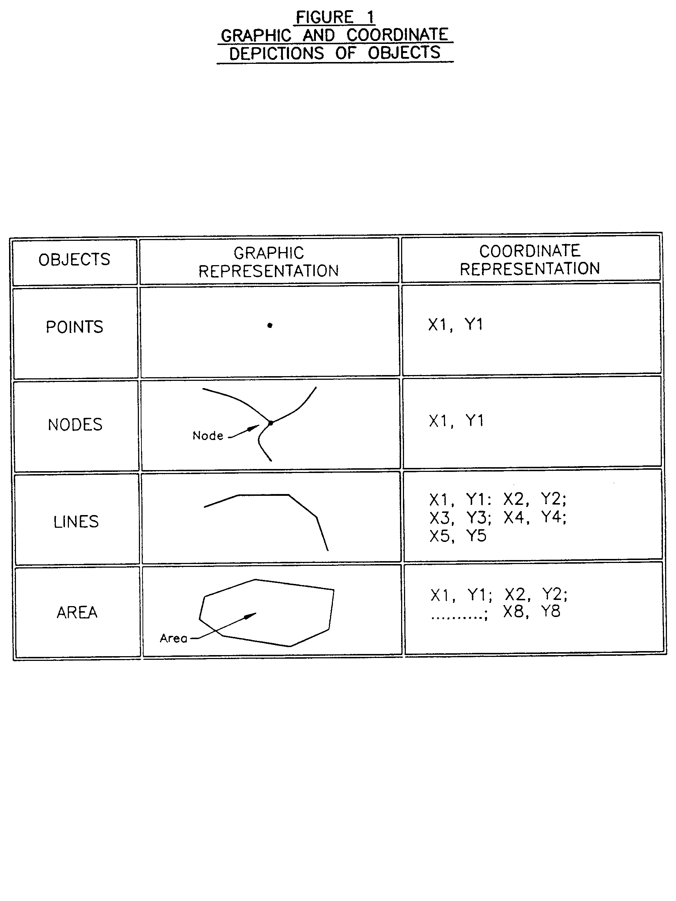

B. Figure 2

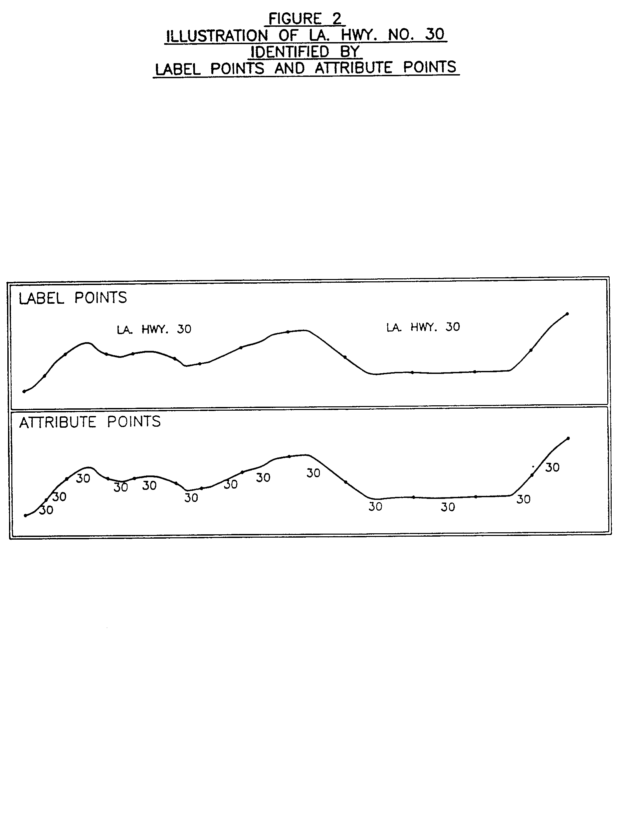

C. Figure 3

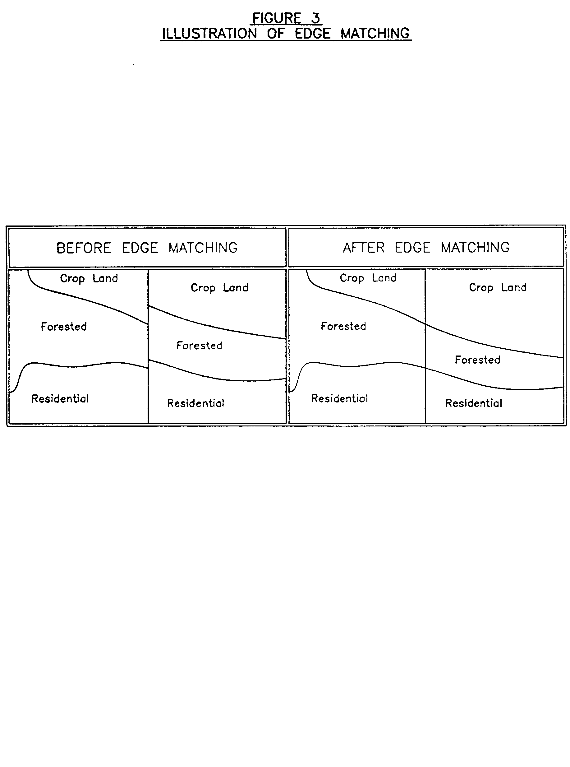

D. Figure 4

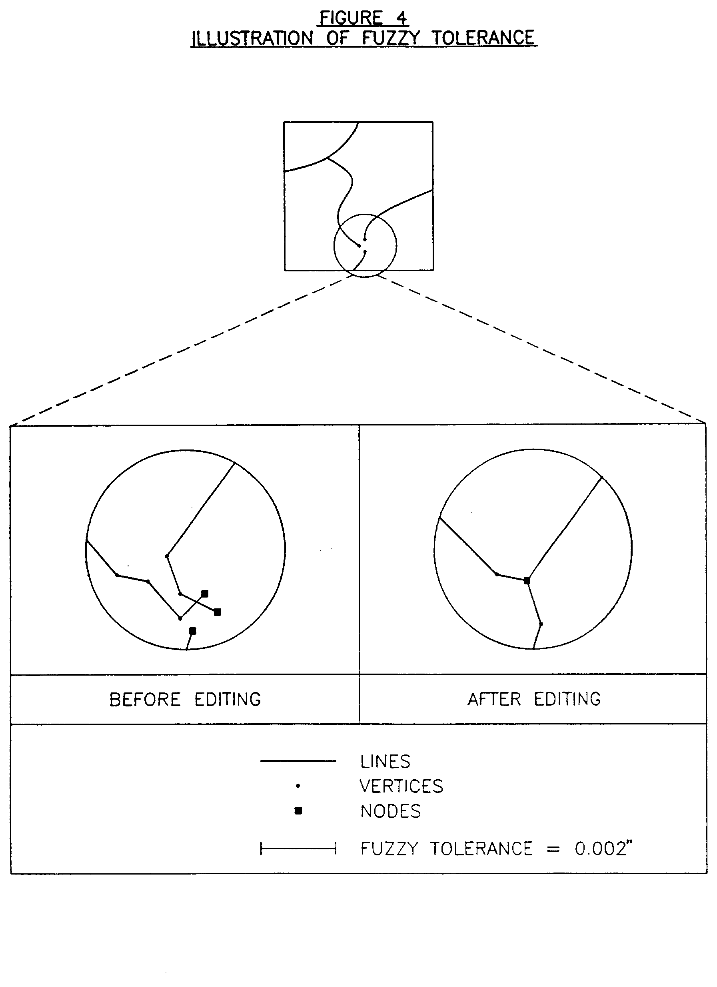

E. Figure 5

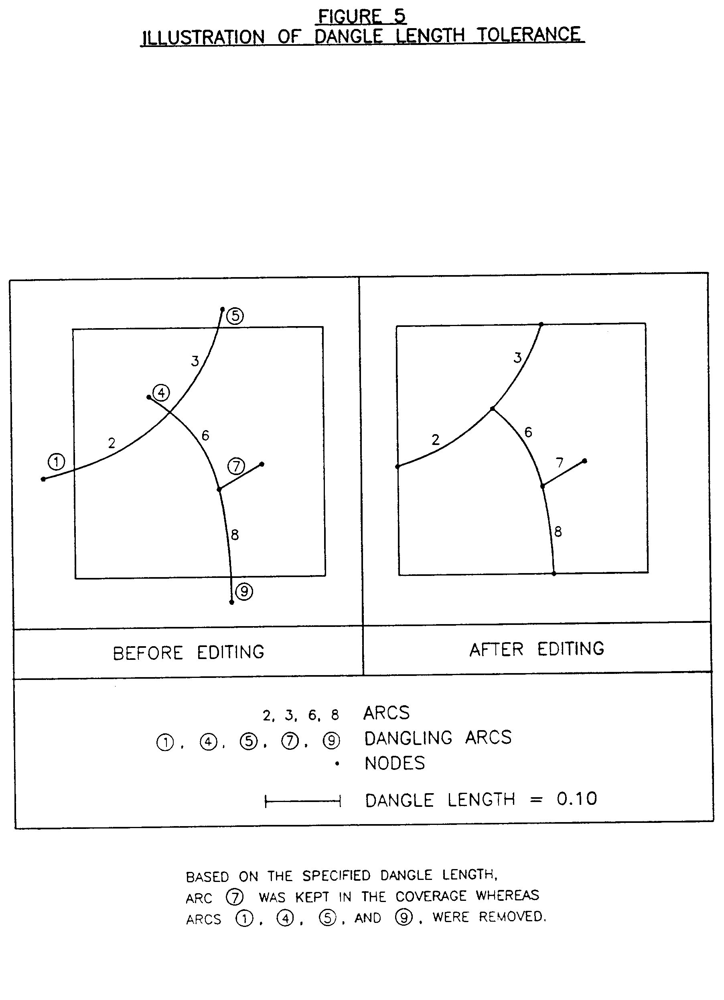

AUTHORITY NOTE: Promulgated in accordance with R.S. 50:171.
HISTORICAL NOTE: Promulgated by the Office of the Governor, Division of Administration, State Land Office, LR 17:968 (October 1991).

Chapter 15. Geographic Base Map

§1501. General Requirements

A. The following requirements provide for digital stereo compilation of aerial photography and preparation of geographic base maps in accordance with these standards. Geographic base maps shall consist of either planimetric maps or topographic maps which are generally defined and described as follows:

1. planimetric maps depict only the horizontal positions for features represented, such as rivers, lakes, transportation routes, woodlands, farms, railroads, building outlines, and other photo identifiable features;

2. topographic maps depict both the horizontal and vertical positions of features represented, and are distinguished from planimetric maps by the addition of vertical relief data in measurable form such as contour lines, spot elevations, and related vertical information.

B. Geographic base maps conforming to either planimetric or topographic requirements, at the discretion of the responsible contracting authority, shall be prepared to cover the entire limits of the project area as depicted on the Project Contract Map. All required planimetric features and vertical features, if required, shall be included on the geographic base map. These features shall be digitized, coded, assembled and stored on acceptable computer transfer media from which this data can be retrieved, viewed and/or plotted on the Geographic Information System in use or selected by the responsible contracting authority and/or other participants and users.
AUTHORITY NOTE: Promulgated in accordance with R.S. 50:171.
HISTORICAL NOTE: Promulgated by the Office of the Governor, Division of Administration, State Land Office, LR 17:968 (October 1991).

§1503. Stereo Photogrammetric Instrumentation

A. All geographic base maps shall be prepared by stereo photogrammetric methods. Only recognized high order precision type analytical stereo-plotting instruments (Wild BC Series, Zeiss C Series, Kern DSR Series, or equivalent) or second order analogue stereo-plotting instruments (Kern PG-2, Wild B8, Wild AG-1, or equivalent) shall be used to produce a product conforming to the mapping accuracy requirements set forth within preceding Section II. Stereo-plotting instruments employed shall be equipped with and shall use three axis encoders to measure and record coded digital map data. The mapping consultant shall provide copies of calibration reports of all photogrammetric instruments used on the project for archive purposes. Should any instrumentation used be recalibrated during the course of the project, applicable recalibration reports shall be submitted also.
AUTHORITY NOTE: Promulgated in accordance with R.S. 50:171.
HISTORICAL NOTE: Promulgated by the Office of the Governor, Division of Administration, State Land Office, LR 17:968 (October 1991).

§1505. Interactive Graphics System

A. The recording, formatting, adjustment and editing of the digital cartographic data shall be done with an Interactive Graphics System of the mapping consultant's choice. The system must be capable of producing digital files compatible with the Geographic Information System to be selected by the responsible contracting authority and/or other users and participants.
AUTHORITY NOTE: Promulgated in accordance with R.S. 50:171.
HISTORICAL NOTE: Promulgated by the Office of the Governor, Division of Administration, State Land Office, LR 17:968 (October 1991).

§1507. Map Scale

A. As set forth in Chapter 3, the required final map scale of each respective area classification to be mapped is specified as follows.
Area Classification | Description | Map Scale
Class A | Dense Urban | 1" = 50'
Class B | Urban and Suburban | 1" = 100'
Class C | Rural | 1" = 200'
Class D | Woodlands and Marshes | 1" = 400'
AUTHORITY NOTE: Promulgated in accordance with R.S. 50:171.
HISTORICAL NOTE: Promulgated by the Office of the Governor, Division of Administration, State Land Office, LR 17:968 (October 1991).

§1509. Planimetric Mapping

A. Planimetric maps within the limits of the project area shall be prepared in conformance with the map scale specified for each respective area classification required. All planimetric maps shall be prepared by stereo photogrammetric methods using the aerial photography, ground control and analytical aerial triangulation data set forth within preceding chapters of these standards.

B. The primary planimetric features to be mapped are identified on §1527, Appendix A, included herewith. Photo identifiable features not specifically listed in §1527, Appendix A, shall also be captured and categorized.

C. Each planimetric feature mapped will be identified and stored digitally by a specific feature code as listed and described within Chapter 19.

D. All specified planimetric features shall be correctly identified and mapped as imaged, subject to the following conditions:

1. traveled ways shall consist of curb lines or edge lines which define the limits of streets, roads, avenues, parkways, highways, roads, cul-de-sacs, alleys and pathways within the project area. No curb line breaks shall be shown at private driveways. In areas where curb lines have not been constructed, the traveled roadway or pathway edges shall be shown;

2. coordinate positions for all street intersections in the project area shall be determined for the center of all intersections if required by the responsible contracting authority. For streets containing medians (neutral grounds), coordinate positions shall be determined for intersections on each side of the street (i.e., the intersection of two streets with medians shall have four coordinate positions);

3. railroads shall be represented by a double coded line pattern per tract line;

4. drainage canals shall be differentiated between paved and unpaved;

5. linear features in excess of one twenty-fifth of an inch at map scale shall be mapped as a double-sided feature. All other linear features shall be mapped as a single line;

6. buildings 100 square feet and larger shall be represented in their correct roof configuration. Buildings smaller than 100 square feet in size may be mapped in either their correct roof configuration or as symbols;

7. manholes and related features such as catch basins, valve boxes, etc., shall be identified when possible from the aerial photography depending on final map scale. The responsible contracting authority may, at its discretion, elect to pre-paint selected manholes and related features in order to aid in the photo interpretation and stereo compilation of utility features in order to identify key locations of underground lines for future network delineation;

8. larger individual trees, if required by the responsible contracting authority, will be identified as photo-identifiable features by size and shape.

E. Photo-identifiable features are defined as those features which are clearly definable in location from the aerial photography and/or which may be identified in the list of feature elements included within Chapter 19. Any features when identifiable which are not included within the list of feature elements shall be defined by appropriate outline, symbol and/or annotation by using feature code additions to the data aggregation.
AUTHORITY NOTE: Promulgated in accordance with R.S. 50:171.
HISTORICAL NOTE: Promulgated by the Office of the Governor, Division of Administration, State Land Office, LR 17:968 (October 1991).

§1511. Topographic Mapping

A. In addition to the requirements for planimetric maps set forth above, topographic maps shall be prepared to include the following information:

1. contour lines shall be shown at vertical intervals established and specified by the responsible contracting authority. Every fifth contour line will be coded as an index contour which can be symbolized as a line of heavier weight than that of intermediate contours and shall be expressed as a heavier weight line on the digital data base hard-copy delivery maps. Index contours shall be labeled inside a "break" in the line every 6 to 12 inches at map scale. In those areas where vegetation prohibits accurate plotting of contour line elevations, the contour line elevations will be interpolated as accurately as possible from spot elevations measured photogrammetrically in places where the ground is visible. All contour lines will be solid and unbroken except where they pass through dense ground cover, in which case dashed lines must be used;

2. spot elevations will be determined photogrammetrically and shall be placed at hilltops, saddles, ridgelines, bottoms of depressions, intersections of principal streets, intersections of highways, ends of bridges, and water levels of lakes, reservoirs and ponds. Spot elevations shall also be determined and placed at maximum 400-foot intervals along the tops of all levees and floodwalls within the project area. In areas where contours are more than one inch apart at map scale, additional spot elevations shall be shown at approximately 1-inch intervals to accurately portray the character of the topography throughout the project area;

3. auxiliary heights shall consist of the photogrammetric determination of the heights of buildings, wooded areas, signs, billboards, towers and other specified features at the discretion of the responsible contracting authority. Auxiliary heights are intended to be an approximate representation of the vertical character of such features for nonprecision applications.

B. The primary topographic features to be mapped are identified within §1527, Appendix A, included herewith. Photo identifiable features required by the responsible contracting authority and not specifically listed in §1527, Appendix A, shall also be captured and categorized.

C. Each topographic feature mapped will be identified and stored digitally by a specific feature code as listed and described within Chapter 19. Any topographic features when identifiable which are not included within the list of feature elements shall be defined by appropriate outline, symbol and/or annotation by using feature code additions to the data aggregation.
AUTHORITY NOTE: Promulgated in accordance with R.S. 50:171.
HISTORICAL NOTE: Promulgated by the Office of the Governor, Division of Administration, State Land Office, LR 17:968 (October 1991).

§1513. Map Labels

A. The names of cities, towns, villages, rivers, lakes, railroads, major highways and related principal features shall be labeled according to the U.S.G.S. Geographic Names Information System (GNIS) for the State of Louisiana (U.S.G.S. Professional Paper Number 1200) available from the U.S. Geological Survey.

B. The names of all local roads, streets, political districts, schools, churches, parks, fire stations, government facilities, and related local features shall be labeled according to information furnished by the responsible contracting authority.

C. All street name labels on 1" = 50' scale and 1" = 100' scale planimetric or topographic maps shall be centered within the street or roadway whenever practical. Street name labels on 1" = 200' scale and 1" = 400' scale maps shall be placed outside of the apparent street or roadway right-of-way.

D. Route shields designating interstate, U.S., state and parish highways shall be placed outside of and adjacent to the highway alignment.
AUTHORITY NOTE: Promulgated in accordance with R.S. 50:171.
HISTORICAL NOTE: Promulgated by the Office of the Governor, Division of Administration, State Land Office, LR 17:968 (October 1991).

§1515. Grid System

A. All horizontal ground positions determined by stereo photogrammetric methods will be based on the North American Datum of 1983 (NAD 83), Louisiana State Plane Coordinate System (North or South Zone, as applicable) with X and Y values expressed in feet. All vertical ground positions will be based on the National Geodetic Vertical Datum of 1929 (NGVD 29), latest adjustment, and subject to pending final development and publication of NAVD 88 as set forth in Chapter 5, with all Z (vertical coordinate) values expressed in feet.

B. The U.S. Survey Foot (1 meter = 3.2808333333 feet) shall be used in all conversions of Louisiana State Plane Coordinates from meters to feet or feet to meters. The datum and coordinate system used will be noted on any map sheets bearing coordinates.
AUTHORITY NOTE: Promulgated in accordance with R.S. 50:171.
HISTORICAL NOTE: Promulgated by the Office of the Governor, Division of Administration, State Land Office, LR 17:968 (October 1991).

§1517. Map Sheet Requirements

A. Map Scale. Final hard copy maps shall be at a scale of 1" = 50', 1" = 100', 1" = 200' or 1" = 400' based upon respective area classifications as set forth within Chapter 3.

B. Map Grid System. The map grid system established by these standards is based on a 1" = 400' basic regional map which is designated the "Basic Modular Unit." The Basic Modular Unit concept provides for a series of maps corresponding to each respective area classification at four separate scales which are defined as follows.

1. 1" = 400'. The boundaries of each Basic Modular Unit shall be the grid lines of the Louisiana State Plane Coordinate System (North or South Zone) evenly divisible by 10,000 feet in north-south and east-west directions.

2. 1" = 200'. Each map shall be one quarter of a Basic Modular Unit (see §1517.B.1 and accompanying §1529, Appendix B). The neat image area of this map unit shall be bounded by the Louisiana State Plane Coordinate System (North or South Zone) grid lines, with values of easting and northing evenly divisible by 5,000 feet.

3. 1" = 100'. Each map shall be one sixteenth of a Basic Modular Unit (see §1517.B.1 and §1529, Appendix B). The neat image area of this map unit shall be bounded by the Louisiana State Plane Coordinate System (North and South Zone) grid lines with values of easting and northing evenly divisible by 2,500 feet.

4. 1" = 50'. Each map shall be one sixty-fourth of a Basic Modular Unit (see §1517.B.1 and §1529, Appendix B). The neat image area of this map unit shall be bounded by the Louisiana State Plane Coordinate System (North or South Zone) grid lines with values of easting and northing evenly divisible by 1,250 feet. The orientation of all maps will be such that the north boundary of any map sheet is parallel with the top border of each sheet.

C. Grid System Numbering. Each Basic Modular Unit Map shall be identified by a map number derived from selected paired digits of the east and north coordinates of the southwest corner of the module. For example, a map with hypothetical lower left coordinates of E = 640,000 and N = 530,000 will be known as Map Number 6543. The digit "6" in the 100,000th place of the east coordinate is paired with the digit "5" in the 100,000th place of the north coordinate; the digit "4" in the 10,000th place of the east coordinate is paired with the digit "3" in the corresponding position in the north coordinate. These four digits uniquely define the modular map units within the area of jurisdiction of each parish. In parishes where the coordinate values equal or exceed 1,000,000 feet, the digit in the millionth place is redundant and will be dropped. However, the map must be clearly identified with its proper parish name and zone (north and south) of the Louisiana State Plane Coordinate System. Thus, a map in Orleans Parish having coordinates for the southwest corner of E = 3,700,000 and N = 540,000 can be identified as Orleans Parish Map Number 7504, Louisiana State Plane Coordinate System (South Zone). The map numbers at the 1" = 400' scale will contain only four digits. The map numbers at the 1" = 200' scale, the 1" = 100' scale and the 1" = 50' scale will contain only six digits. For these larger scales, the first four digits shall be those of the Basic Modular Unit with the addition of a two-digit suffix as shown in §1529, Appendix B. There will be a decimal point between the four digits of the Basic Modular Unit and the suffix. For example, a 1" = 200' map of Orleans Parish would be numbered 7504.03, a 1" = 100' map would be numbered 7504.15, and a 1" = 50' map would be numbered 7504.47 as shown in §1529, Appendix B.

D. Map Size. The outside edge dimensions of all hard-copy maps shall be 28 inches high by 36 inches long. The neat image area shall be 25 inches high by 25 inches long. A typical geographic base map sheet layout is included within §1531, Appendix C.

E. Map Title. A title to be prepared and approved by the responsible contracting authority shall be shown on each map sheet. The title shall denote as a minimum whether the map is planimetric or topographic, and the particular parish represented. A sample title block layout is included within §1533, Appendix D.

F. Grid Lines. Grid lines of the Louisiana State Plane Coordinate System (North or South Zone, as applicable) shall be plotted at 5-inch intervals. These grid lines shall be shown by solid black lines throughout the neat image area. The Louisiana State Plane Coordinates of the grid lines shall be printed in feet at 5-inch intervals in the margin along the image area border at the north, east, south and west sides of the map. Corresponding coordinate values in meters (rounded to the nearest millimeter) shall be printed along the image area border at the northeast, southeast, southwest and northwest corners of the map.

G. Graticule Ticks. Computer generated graticule ticks will be shown at the 10 second intervals of latitude and longitude at map scale along the image area border. The graticule ticks will appear as dashed black lines on the finished map sheets with appropriate values of latitude and longitude given for each graticule tick mark based on the Lambert Conformal Conic Projection defined by the NAD 83 Louisiana State Plane Coordinate System parameters.

H. Sheet Index. A sheet index diagram shall be included on each map sheet to indicate the map numbers of the adjoining sheets. This index will be placed in the margin outside the image area.

I. Legend and Margin Information. A legend of principal map symbols, north arrow, graphic bar scale, map number, horizontal and vertical control descriptions, and related margin data will appear in the right hand margin of the map sheet. All margin information will be placed on the geographic base map in such a fashion so that when this map is overprinted or layered with its companion parcel map, all marginal information from both maps will be clearly legible.
AUTHORITY NOTE: Promulgated in accordance with R.S. 50:171.
HISTORICAL NOTE: Promulgated by the Office of the Governor, Division of Administration, State Land Office, LR 17:968 (October 1991).

§1519. Field and Office Edit

A. Field checks and office reviews shall be performed as necessary to verify all photointepretation performed during the stereocompilation process and to ensure completeness and accuracy of all planimetric and/or topographic features mapped.

B. All corrections and additions made as a result of the editing process shall be incorporated into the coded digital files and final map products prior to delivery.
AUTHORITY NOTE: Promulgated in accordance with R.S. 50:171.
HISTORICAL NOTE: Promulgated by the Office of the Governor, Division of Administration, State Land Office, LR 17:968 (October 1991).

§1521. Final Base Map Production

A. Final hard-copy maps shall be plotted on double-matted 4 mil mylar with black liquid ink via an accurate CADD Mapping System and shall correspond to the requirements set forth within these standards. An index of all maps developed showing the parish boundary, map boundaries and map numbers shall be produced on double-matted four mil mylar.

B. Digital data shall be provided on acceptable MS-DOS formatted computer transfer media in DXF file format. Each planimetric or topographic feature, as identified by a unique feature code, shall be on a separate component layer or assigned to the feature element levels indicated within Chapter 19 for viewing and plotting purposes.

C. Map data shall be stored on an acceptable digital format at the mapping consultant's facility until the responsible contracting authority and/or other responsible participants or users select and install their respective geographic information systems. Final map data must be compatible with the geographic information system in use or to be selected by the responsible contracting authority and/or other responsible participants and users.
AUTHORITY NOTE: Promulgated in accordance with R.S. 50:171.
HISTORICAL NOTE: Promulgated by the Office of the Governor, Division of Administration, State Land Office, LR 17:968 (October 1991).

§1523. Photo Atlas Sheets

A. In order to verify base map compilation and facilitate subsequent parcel map preparation, rectified vertical aerial photographic negative and positive photo atlas sheets shall be produced for each scale of planimetric or topographic base maps to be developed. Photo atlas sheets will be positioned so that each 1" = 50', 1" = 100', 1" = 200' or 1" = 400' base map plot will have a corresponding photo atlas sheet of the same scale, size and orientation as the companion base map. The total sheet size will be 28 inches high by 30 inches wide and will be printed within the same border area as the companion base map imagery. The photo image area of each sheet will be 25 inches by 25 inches and will extend past the edges of the base map plots by 1 inch, which results in a 2-inch overlap between adjacent photo atlas sheets. All photo atlas sheets will be properly rectified so that the edge match between the base map plot and the corresponding photo atlas sheet will be within 1 percent of the total sheet distance (i.e., the match borders will not be off by more that 0.25 inches). A typical photo atlas sheet layout is included within §1535, Appendix E.

B. All rectified aerial photo atlas sheets shall be made directly from the aerial photography negatives. The rectified positives shall have fine grain quality and uniform density, shall preserve the clarity and detail of the original negatives to the maximum extent possible, and shall be free of dust, marks, scratches, fog, streaks, stains and blemishes of any kind. The photo atlas sheets may be screened or unscreened at the discretion of the responsible contracting authority.

C. One set of photo atlas sheets shall be provided on dimensionally stable double-matted 4 mil film material formatted to each companion base map sheet. All sheets will be printed with the right reading side opposite the emulsion side. Each sheet shall have grid ticks which appear as
1/2 inch (0.50") long black intersecting lines on the final imagery at 5-inch intervals.
AUTHORITY NOTE: Promulgated in accordance with R.S. 50:171.
HISTORICAL NOTE: Promulgated by the Office of the Governor, Division of Administration, State Land Office, LR 17:968 (October 1991).

§1525. Ownership of Information

A. The complete final geographic base map products shall constitute the property of the responsible contracting authority. During performance of the project, map products may remain in the custody of the mapping consultant and will be accessible to the responsible contracting authority at all times. Upon completion of the project, the mapping consultant shall return all aerial triangulation reports, photographic contact prints, diapositives, and other related data used in development of the project to the responsible contracting authority.
AUTHORITY NOTE: Promulgated in accordance with R.S. 50:171.
HISTORICAL NOTE: Promulgated by the Office of the Governor, Division of Administration, State Land Office, LR 17:968 (October 1991).

§1527. Appendix A―Primary Features to be Mapped―Planimetric and Topographic Mapping

PRIMARY FEATURES TO BE MAPPED―PLANIMETRIC AND TOPOGRAPHIC MAPPING

FEATURE DESCRIPTION MAPPING REQUIREMENTS
- Airports and Related Features Outline
- Athletic Fields Apparent Limits
- Bridges and Overpasses Outline
- Buildings Rooflines
- Bulkheads Outline or Symbol
- Catch Basins and Drain Inlets Outline or Symbol
- Cemeteries Apparent Limits
- Contour Lines Interpreted Locations
- Cultivated Areas Apparent Limits
- Culverts and Cross-drains Outline or Symbol
- Curbs and Edges of Traveled Ways Outline
- Docks and Piers Outline
- Drainage Ditches and Canals Outline
- Fences and Retaining Walls Outline or Symbol
- Floodwalls and Floodgates Outline or Symbol
- Highways, Roads and Streets Outline
- Hydrants Symbol
- Industrial Facilities Outline
- Land Fills and Excavations Apparent Limits
- Levees Apparent Limits
- Manholes Symbol
- Parking Lots Outline
- Parks and Playgrounds Apparent Limits
- Pipeline Corridors Apparent Limits
- Power Transmission Lines Outline
- Pumping Stations Outline
- Railroads and Related Features Outline and Symbols
- Rivers, Bayous, Lakes and Ponds Water's Edge
- Shorelines Water's Edge
- Slabs and Foundations Outline
- Spillways, Dams and Reservoirs Outline
- Spot Elevations and Auxiliary Heights Measure or Interpret
- Storage Tanks and Silos Outline
- Surface Expression of Underground Features Outline or Symbols
- Survey Control Symbol
- Swamps and Wetlands Apparent Limits
- Swimming Pools Outline
- Tennis and Other Courts Outline
- Towers Outline or Symbol
- Tunnel Entrances Outline
- Utility Poles Symbol
- Utility Substations Outline
- Wooded Areas and Brushlines Apparent Limits
- Other Photo Identifiable Features As Applicable

AUTHORITY NOTE: Promulgated in accordance with R.S. 50:171.
HISTORICAL NOTE: Promulgated by the Office of the Governor, Division of Administration, State Land Office, LR 17:968 (October 1991).

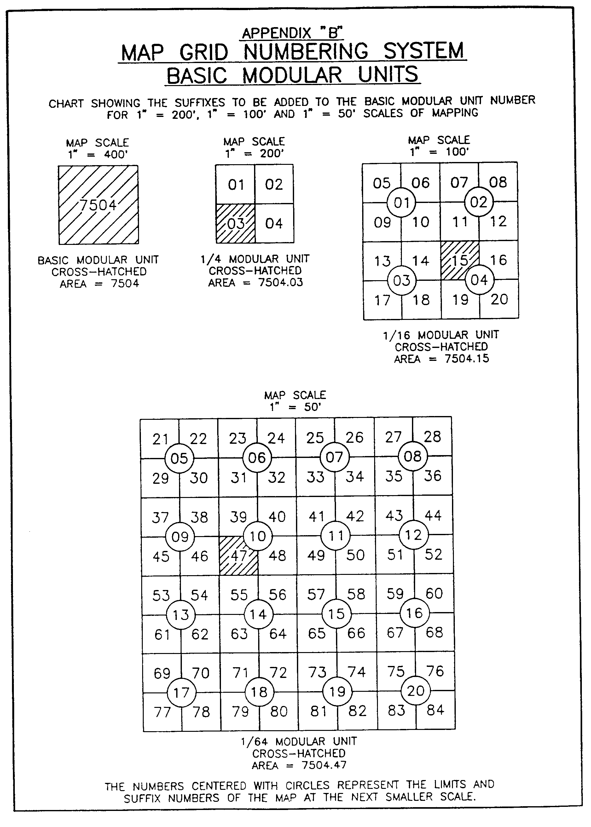
§1529. Appendix B―Map Grid Numbering System―Basic Modular Units

AUTHORITY NOTE: Promulgated in accordance with R.S. 50:171.
HISTORICAL NOTE: Promulgated by the Office of the Governor, Division of Administration, State Land Office, LR 17:968 (October 1991).

§1531. Appendix C―Geographic Base Map Sheet Layout

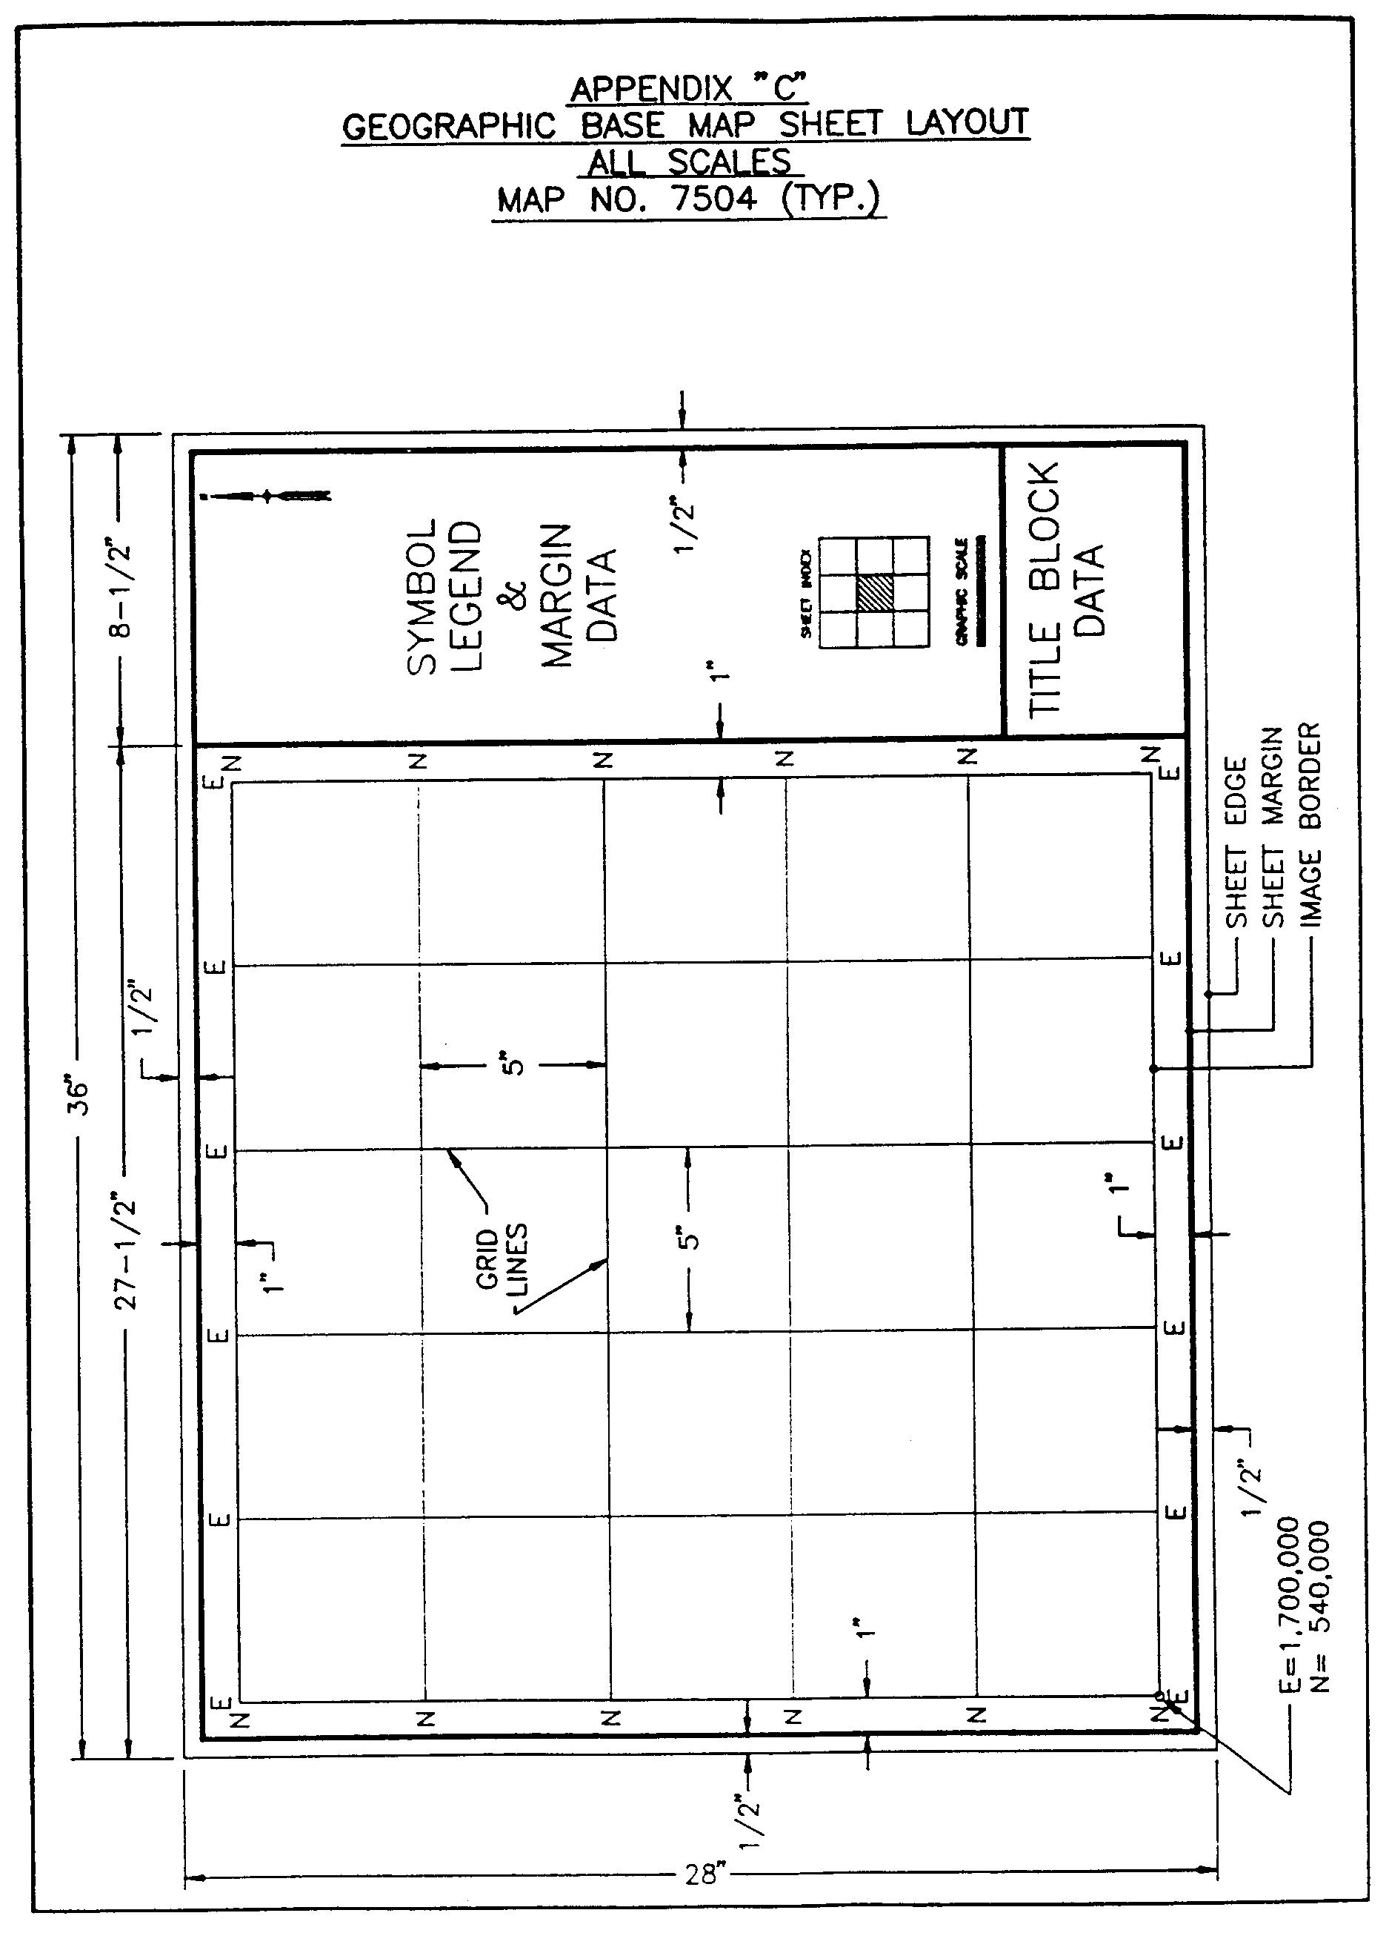

AUTHORITY NOTE: Promulgated in accordance with R.S. 50:171.
HISTORICAL NOTE: Promulgated by the Office of the Governor, Division of Administration, State Land Office, LR 17:968 (October 1991).

§1533. Appendix D―Sample Title Block Layout―All Scales

AUTHORITY NOTE: Promulgated in accordance with R.S. 50:171.
HISTORICAL NOTE: Promulgated by the Office of the Governor, Division of Administration, State Land Office, LR 17:968 (October 1991).

§1535. Appendix E―Photo Atlas Sheet Layout―All Scales

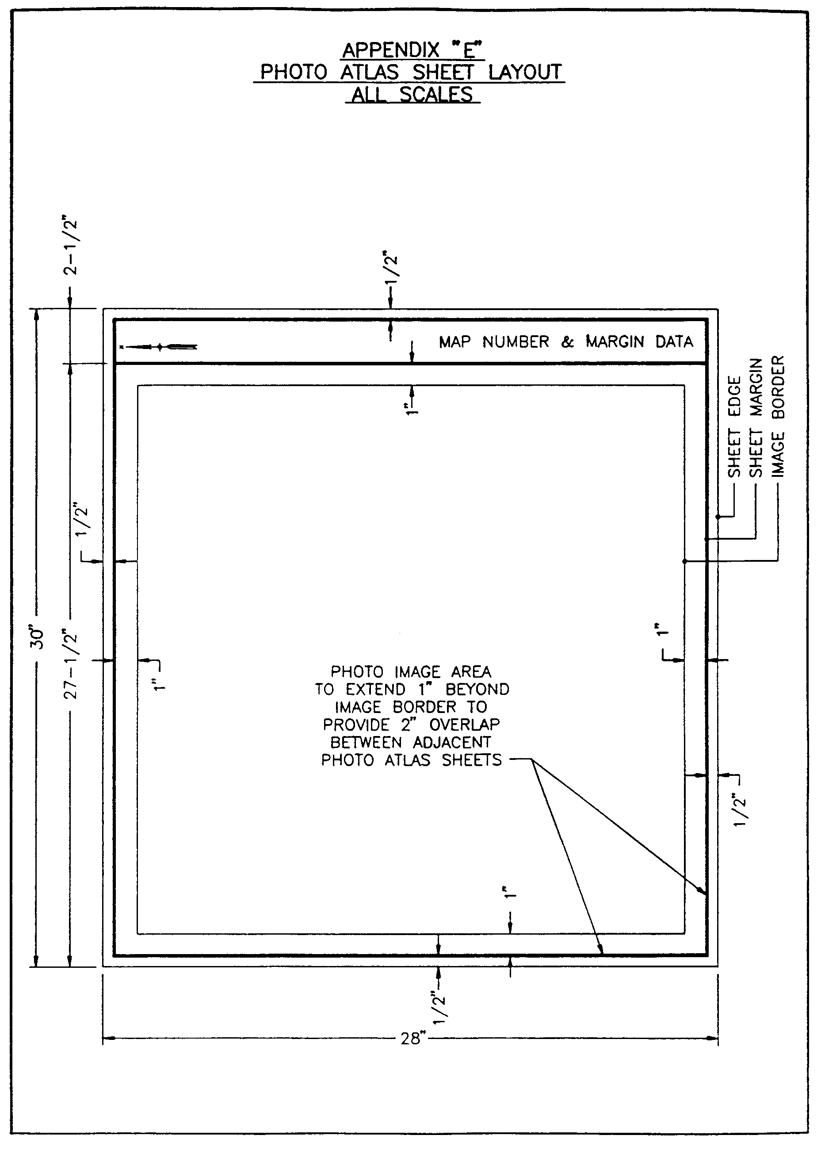
AUTHORITY NOTE: Promulgated in accordance with R.S. 50:171.
HISTORICAL NOTE: Promulgated by the Office of the Governor, Division of Administration, State Land Office, LR 17:968 (October 1991).

Chapter 17. Parcel Mapping

§1701. General Requirements

A. The following requirements provide for digital parcel map preparation and relational data base development in accordance with these standards.

B. The state of Louisiana has adopted the following definition of a parcel for the purpose of these mapping standards―a parcel is a contiguous area of land under one ownership that can be included under one description for assessment or appraisal purposes after consideration of all legal and practical elements.

C. A parcel map is defined as a scale depiction of the parcel boundaries within a governmental jurisdiction, as covered by the map's image area. It is normally a multi-purpose record designed to show real property ownership within its jurisdiction, the basis for real property valuation and taxation, and geographical information for use by planners, governmental agencies, and the general public.

D. Major elements of information to be included on any parcel map and associated relational database are as follows:

1. name, boundaries and identification of all land parcels, tracts and subdivisions;

2. parish, township, section, municipality, public land boundaries, and associated identification;

3. boundaries of all known rights-of-way, servitudes and easements;

4. delineation and identification of all streets, highways, alleys, railroads, lakes, rivers, streams and related features.
AUTHORITY NOTE: Promulgated in accordance with R.S. 50:171.
HISTORICAL NOTE: Promulgated by the Office of the Governor, Division of Administration, State Land Office, LR 17:968 (October 1991).

§1703. Existing Record Information

A. Adequate research shall be conducted to determine the deed, title or other means of description for each and every parcel of property within the project area. Sources of existing record information to be evaluated for construction of parcel maps shall include, but are not necessarily limited to, the following:

1. parish clerk of court's office vendor and vendee indexes, conveyance books, and/or microfilm, microfiche or aperture cards for making deed copies;

2. clerk of court's office mortgage books;

3. clerk of court's office field and recorded maps, plats, subdivision plans and surveys;

4. probate court's office will books and records;

5. assessor's office records consisting of any existing lot books, tract books, assessed descriptions, property record cards, index cards, and related information;

6. clerk of court's, assessor's, parish council or municipal offices records of annexations, street or alley closings or openings, taxing district boundaries and descriptions, assessment rolls, transfer books, and any current taxing unit map showing the number and metes and bounds description of every taxing unit or any portion of a taxing unit located within the parish;

7. any other state or parish office, agency, or department that has recorded information relating to political subdivision boundaries including, but not limited to district courts, city clerk's office, city engineer's or city surveyor's offices, planning and zoning commissions, and related entities.
AUTHORITY NOTE: Promulgated in accordance with R.S. 50:171.
HISTORICAL NOTE: Promulgated by the Office of the Governor, Division of Administration, State Land Office, LR 17:968 (October 1991).

§1705. Source Document Collection

A. Adequate efforts shall be made to locate and obtain copies of all required source document information to aid in the implementation of the parcel mapping process. Information and data sources to be utilized shall include, but are not necessarily limited to, the following:

1. original township plats and surveyor's field notes used in the establishment of township, range and section lines;

2. rights-of-way maps, acquisition surveys or alignment plans for all federal, state, city, and parish roads, streets and highways which currently exist or are proposed within the parish;

3. 1:24,000 United States Geological Survey (USGS) 7 1/2 minute series topographic quadrangle map sheets covering the entire parish;

4. rights-of-way, servitudes and easements for all railroads, pipelines and utility lines within the parish.
AUTHORITY NOTE: Promulgated in accordance with R.S. 50:171.
HISTORICAL NOTE: Promulgated by the Office of the Governor, Division of Administration, State Land Office, LR 17:968 (October 1991).

§1707. Individual Parcel Index Records

A. An individual parcel index record shall be prepared for each parcel of land to be mapped. The most current and complete assessment rolls, land records and property record data shall be used as the initial source of information to prepare the parcel index record. The information to appear on the parcel index record should include, but not necessarily be limited to, the following:

1. an area designated for the permanent uniform parcel identification number to be assigned;

2. existing archival parcel number and parcel account number if applicable;

3. parish code number and Louisiana Coordinate Zone;

4. the property owner's name (or names) and taxpayer's name if different from owner of record;

5. the property owner's address (or addresses) and taxpayer's address if different from owner of record;

6. the date parcel was acquired by current owner of record;

7. the parcel's location by address, route, and/or house number if available;

8. the original section number, township and range in which the parcel is located;

9. the name of the nearest public street, highway, and/or waterway abutting or adjacent to the parcel;

10. the taxing district, ward number, ownership code and applicable municipal code assigned to the parcel;

11. the deed source and page numbers or recordation reference to vesting instruments if available;

12. the original tract, realty or subdivision name, block and lot number from which the parcel originated;

13. the designation of any existing plat, map or index number of reference;

14. the record parcel description, dimensions and acreage as contained in the assessment records, land rolls or property record files;

15. the assessed deed acreage;

16. any other information as may be contained on the assessment records or land rolls which would facilitate the parcel mapping program.

B. The parcel index record should be designed and organized so that additional information can be added as each parcel encounters the various phases of the mapping program. Examples of additional information which would be applicable are as follows:

1. an area for calculated map acreage;

2. an area for the date of latest field survey and resulting field surveyed acreage, if applicable;

3. an area for updated property descriptions, where necessary;

4. an area to accommodate an explanation of ownership or boundaries so that, if different from the conveying instrument, assessment records, or field call information, this data can be recorded.

C. Any elements of information which are unknown, unavailable or would otherwise require considerable time and expense to obtain may be omitted from the parcel index record subject to the discretion of the responsible contracting authority.
AUTHORITY NOTE: Promulgated in accordance with R.S. 50:171.
HISTORICAL NOTE: Promulgated by the Office of the Governor, Division of Administration, State Land Office, LR 17:968 (October 1991).

§1709. Map Sheet Requirements

A. Map Size. The outside edge dimensions of all hard-copy parcel overlay maps shall be 28 inches high by
36 inches long. The neat image area shall be 25 inches high by 25 inches long. All parcel maps will be the same size and layout as the Geographic Base Map Sheets, and shall always bear the same sheet numbers as defined in Chapter 15.

B. Map Scale. Final hard copy parcel maps shall be at a scale of 1" = 50', 1" = 100', 1" = 200', or 1" = 400' based upon respective area classifications as set forth within Chapter 3.

C. Legend and Margin Information. A legend of principal map symbols, north arrow, disclaimer note, map index, bar scale, map number, and chart for record of revisions will appear in the right hand margin of the map sheet. All marginal information will be placed on the parcel map in such a fashion so that when this map is overprinted or layered with its respective base map, all marginal information from both maps will be clearly legible. The map number on the parcel map will be, in all cases, the same as the map number for its respective, or matching, base map.

D. Block Lines and Numbers. On all scales of parcel maps, the neat image area will be subdivided into "map blocks" for the purpose of building the Parcel Identification Number (PIN). The map block will be a 1,000 foot square whose boundaries will conform to the even 1000-foot divisions of the Louisiana State Plane Coordinate System and will be delineated by fine block/grid lines running north-south and east-west across the entire neat image area. A two-digit block number, derived from the PIN system, will be printed in the center of each block using "hollow" numbers. See accompanying §1731, Appendix A, for parcel map layout and block number designations for each respective map scale.

E. Grid Ticks. On parcel maps at a scale of 1" = 50' and 1" = 100', the 25" by 25" neat image area will be further sub-divided with block lines or "grid ticks" (1/2" crosses) placed where theoretical north-south and east-west lines drawn every 5 inches on the image area would run or intersect. Grid ticks will be shown on those points where intersecting block lines do not appear. Grid ticks will appear as block lines on the finished (positive) maps.

F. Adjoining Parishes. Any parish contemplating the development of parcel maps under these standards shall determine if any of its adjoining parishes have already been mapped in conformance with these state standards. If so, the responsible contracting authority for the parish shall obtain digital records of all such existing parcel map sheets adjoining its boundaries for use as source materials. The adjoining parish's map data and the map data at the contracting parish's borders shall be matched to the maximum extent possible, but in no case less than the edge matching accuracy requirements set forth within Chapter 13.
AUTHORITY NOTE: Promulgated in accordance with R.S. 50:171.
HISTORICAL NOTE: Promulgated by the Office of the Governor, Division of Administration, State Land Office, LR 17:968 (October 1991).

§1711. Preliminary Parcel Map Construction

A. Prior to the final determination or delineation of individual property ownership lines or boundaries, a preliminary parcel map shall be constructed on 2 mil, dimensionally stable, single-matte transparent film material or the equivalent for each final property ownership map in the parish. The preliminary parcel map shall consist of an overlay of the aerial photography and geographic base map of the project area.

B. No points or lines shall be constructed on the photography or geographic base map, other than the initialization of registration marks on the four corners of the image area. These registration marks will also be placed on the preliminary parcel map as well as the final edited parcel map. During the preliminary parcel map compilation phase, the following detail shall be plotted:

1. using the rights-of-way maps, acquisition surveys, or alignment plans, all public road, street and highway rights-of-way will be made to register and coincide with the physical and cultural features on corresponding photogrammetric or base map enlargements of the aerial photography and associated geographic base map to the fullest extent possible. Indications of the location of section, township and range lines, or corners shown on the rights-of-way plans will be considered in verifying the apparent location of lines and corners shown on the aerial photography and/or geographic base map, or plotting same when not shown;

2. using the original township plats, surveyor's field notes, and USGS topographic maps as a guide, satisfactory efforts shall be implemented to verify or confirm the location of section, township and range lines and corners. The section, township and range lines, and proportionate division lines of sections, shall be made to register with any associated physical and cultural features on the corresponding photogrammetric or base map enlargements as often as possible;

3. using available plans or surveys, all railroad, pipeline or utility line rights-of-way, servitudes or easements will be established and made to register with the physical and cultural features on their respective photogrammetric or base map enlargement as often as possible;

4. all recorded surveys and subdivision plats shall be plotted to the proper property ownership mapping scale. All plotted acreages, overall parcel dimensions, original lot and block numbers, and subdivision names will be shown. The recorded surveys and subdivision plats will be made to register and coincide with the physical and cultural planimetric features on their corresponding screened enlargements as often as possible;

5. a Parish Index Map shall be developed during the preliminary parcel map construction phase, delineating and assigning a permanent map number to the various 1" = 400', 1" = 200', 1" = 100', and 1" = 50' scale property ownership mapping areas of the parish. The index map shall be developed utilizing the parish highway base map layer to depict all road networks and other major planimetric detail. A separate index of the areas enlarged to 1" = 200', 1" = 100' and 1" = 50' scales shall be developed in the same manner as the master Parish Index Map. Each enlarged area shall be labeled according to the name of the city, town, village or area it represents. Permanent map numbers shall be depicted on all index maps within the map area itself.

C. Once the preliminary parcel map construction phase has been completed, a listing of all recorded subdivisions in the parish shall be developed. Each subdivision shall be listed in alphabetical order indicating the following:

1. name of subdivision;

2. map or map number where subdivision is shown;

3. plat books and page numbers where subdivision is legally recorded.
AUTHORITY NOTE: Promulgated in accordance with R.S. 50:171.
HISTORICAL NOTE: Promulgated by the Office of the Governor, Division of Administration, State Land Office, LR 17:968 (October 1991).

§1713. Ownership Map Compilation

A. The following guidelines shall be considered and adhered to as closely as possible during the preliminary ownership map compilation phase of parcel map development:

1. tax district or taxing unit boundaries shall split contiguous ownership into separate parcels. A dashed land hook shall be used across the district or unit boundary line to indicate contiguous ownership, but separate parcels. Exceptions to this rule are subdivided lots that are already described in their smallest legal division. When a taxing district or unit line cuts through a subdivision lot, it shall be parceled in the district where the largest volume of land occurs or where the improvement is located, wherever practical;

2. on 1" = 400' scale and 1" = 200' scale maps, all large rural tracts of land described under the U.S. Government Land Office Sectionalized Survey System that are split by a right-of-way (road, railroad, utility) and physical features (rivers, bayous, creeks) shall be considered one parcel;

3. on 1" = 100' scale and 1" = 50' scale maps, rights-of-way shall split contiguous ownership into separate parcels;

4. if a tract of property crosses a section line, a new parcel shall be created and tied to the other parcel with the use of a dashed land hook. The exception to this shall be where a small part of a tract (2 acres or less, not subject to further division) extends into an adjoining section. In this case, the section line shall be shown in a dashed form where it goes through the parcel;

5. smaller subdivided lots shall not normally be split by a section line;

6. several subdivision lots covered by a single improvement and under one common ownership shall be considered one parcel;

7. an entire subdivision block of lots, used as a unit and under one common ownership, shall be considered one parcel;

8. an area covered by an industrial plant, hospital, or parish or city entity, even though the tract encompasses different subdivisions as well as sectionalized land, would be considered one parcel;

9. any vacant undeveloped subdivision with all lots in one block in the name of one common owner shall be considered one parcel. Where the parish has determined that several blocks of a subdivision are under one common ownership, all blocks may be combined into one parcel for appraisal purposes;

10. quarter-section lines or other divisions of the section do not constitute a separate parcel, even though the properties were acquired at different times under separate deeds. All tracts contiguous and under one ownership within a section shall be considered one parcel, where practical;

11. on maps where the map boundary is a quarter-section line or match line and the parcel cannot be depicted in its entirety on a single map sheet, the parcel shall be controlled on one sheet (usually where the largest area of land exists or where the improvements are located). The area of the parcel on the adjoining map shall be included with the area on the map where the parcel is controlled and "see notes" shall be shown on both maps indicating the controlling map number and the map number for balance of area of the parcel;

12. improvements on leased land that require a separate appraisal and assessment for which proper documentation is provided should be assigned a separate parcel number, subject to the discretion of the responsible contracting authority;

13. for mineral interests or mineral rights that are severed from ownership of the surface rights and require a separate appraisal and assessment and where proper documentation for those severed rights or interests are provided, a separate parcel number should be assigned, subject to the discretion of the responsible contracting authority;

14. condominiums should be treated the same as any other tract of real property. Each condominium unit should be assigned a separate parcel number, where applicable, subject to the discretion of the responsible contracting authority;

15. although other variations of parcel configurations exist, such as (a) contracts for deeds, (b) parts of properties or tracts that are mortgaged to a lending institution,
(c) portions of a tract of land that are put into trusts, and (d) life estates that are reserved to the grantor or where life estates are granted, it is the intent of these standards that parcel configurations be limited to the definition and requirements stated above as much as possible.

B. The location and the plotting of parcels shall be accomplished through the use of existing source maps and the description as contained in the vesting instrument or assessment records in conjunction with the delineation of the parcels' boundaries and limits, as distinguished from the physical and cultural features shown on the aerial photography and geographic base map. All parcels shall be plotted from the vesting instrument description. A copy of this instrument shall be attached or otherwise referenced to the parcel index record. The exception to this shall be parcels with whole lot and block descriptions in subdivisions where deed books and page references exist. Those parcels with parts of lot descriptions shall have a deed attached to the index record. In the event a parcel ownership boundary cannot be delineated or determined through the use of existing source maps, assessment record descriptions, recorded survey plats, or vesting instrument descriptions, the following priorities of calls shall be used:

1. possession;

2. natural boundaries;

3. man-made boundaries;

4. contiguous owners;

5. distance;

6. course (bearing or direction);

7. area;

8. coordinates.

C. If in the process of locating and plotting the parcels it becomes evident to the compiler that the property description as contained on the assessment records, tax rolls, land roll, or parcel index record does not adequately locate and describe the parcel, the compiler shall write a new property description in the space provided on the parcel index record. That portion of the legal description contained in the vesting instrument used in the plotting of the parcel shall be highlighted, bracketed, or underlined during this process for future verification and editing. Property descriptions shall be written in brief, specific terms, but should be adequate to locate and describe each parcel exactly as it is depicted on the map. A disclaimer should be included on the parcel index record indicating that it is specifically understood that the property description included thereon is used to locate, identify, and inventory each parcel of land within the taxing jurisdiction for appraisal and taxing purposes only, and is not to be construed as a legal description.

D. All parcel ownership mapping shall be limited to the absolute "fee simple" state. All public utility, pipeline and other cross-country easements determined to affect the value of any "fee simple" parcel shall be mapped showing dimensions and limits of the easements.

E. In the event property ownership or parcel boundaries cannot be determined from the procedures described in the preceding Subsections, a field interview shall be required. Every effort shall be made to contact the owner or someone knowledgeable about the ownership and boundaries of the parcel or parcels in question. Field interview notes shall be added to the parcel index record for the parcel or parcels in question. The notes shall describe and explain the efforts made by the compiler in order to resolve the problem or discrepancy. This information shall be delivered to the parish periodically so that they may try to resolve the problems. In the event the parish cannot resolve the discrepancy, the compiler's notes shall be kept for future reference.

F. All information to appear on the property ownership maps shall be in a standard format and shall include, but not be limited to the following:

1. all property lines (limits of ownership) shall be delineated by solid lines. Where a water's edge is the property boundary, the symbology or line configuration for the water's edge shall be shown along the apparent water boundary;

2. all original U.S. Survey lot divisions and subdivision lot lines shall be shown, together with block numbers, the original lot numbers, and the government survey, section, township and range, and U.S. Survey lot identification, when appropriate;

3. all dimensions of all platted parcels shall be indicated to the nearest 1/10 of a foot, regardless of area;

4. all state, parish, city, town, village, township, and section lines shall be shown and labeled at their approximate locations on the map based upon the best information available;

5. taxing unit boundaries shall be shown and labeled at their approximate location only when they divide properties into separate parcels;

6. all cemeteries, churches, hospitals, public buildings, public lands, and parks (federal, state, parish, city, town, and village) shall be shown and indicated by their names, when known;

7. all state, parish, city, town and village lines shall be shown and labeled on the ownership maps by their appropriate names. The labels shall appear on the inside of the line that they encompass;

8. all railroads, roads, streets, and rights-of-way shall be shown and labeled by their correct names or numbers, when known. All U.S., state, and parish highways shall be shown and labeled by their correct symbols, route numbers, or names, when known. All railroads, roads, streets, and utility rights-of-way shall show dimensions, when known;

9. all drainage features shall be shown and labeled by their correct names when known. Drainage features shall be such items as lakes, rivers, reservoirs, ponds, dams, streams, bayous and swamps;

10. each ownership map sheet shall have a title block containing the map number, the map scale, the mapping date, a north arrow, the adjoining map block, a mapping legend, and revision block to indicate future maintenance;

11. the permanent parcel identification numbering system shall be shown with the correct number assigned to each parcel.
AUTHORITY NOTE: Promulgated in accordance with R.S. 50:171.
HISTORICAL NOTE: Promulgated by the Office of the Governor, Division of Administration, State Land Office, LR 17:968 (October 1991).

§1715. Dimensions

A. The dimensions of parcels shall be obtained from the assessment records, the recorded map references, or the deed of record when used in the preparation of new ownership maps. All parcel dimensions shall be verified by coordinate geometry (COGO) or electronic digitization, as applicable.

B. In the absence of deed or record dimensions, or in the event the deed or record dimensions are ambiguous, unclear or in error, the parcel dimensions shall be computed to the nearest 1/10 of a foot followed by the symbol (c) shown beside each computed dimension. Example: 125.2(c) x 175.4(c).
AUTHORITY NOTE: Promulgated in accordance with R.S. 50:171.
HISTORICAL NOTE: Promulgated by the Office of the Governor, Division of Administration, State Land Office, LR 17:968 (October 1991).

§1717. Area Calculations

A. The areas of parcels shall be obtained from the assessment records, the recorded map references, or the deed of record when used in the preparation of new ownership maps. All parcel areas shall be verified by coordinate geometry (COGO) or electronic digitization, as applicable, and rounded to the nearest 1/100 of an acre with the symbol (d) shown beside the recorded deed acreage. Example: 12.26ac(d).

B. In the absence of recorded deed areas, or in the event the recorded deed areas are ambiguous, unclear or in error, the parcel shall be computed to the nearest 1/100 of an acre with the symbol (c) shown beside the computed acreage. Example: 12.26(c).

C. Areas determined from the latest recorded field survey of any property parcel shall be rounded to the nearest 1/100 of an acre with the symbol (s) shown beside the field surveyed acreage. Example: 12.26(s).

D. The numeric values of all recorded deed acreages, computed acreages and available recorded field survey acreages for each property parcel shall be included on the parcel index record for subsequent incorporation into the relational data base. The inclusion of recorded deed, computed, and/or field survey acreages on the final parcel map manuscript is optional and subject to the discretion of the parish.
AUTHORITY NOTE: Promulgated in accordance with R.S. 50:171.
HISTORICAL NOTE: Promulgated by the Office of the Governor, Division of Administration, State Land Office, LR 17:968 (October 1991).

§1719. Permanent Parcel Numbering System

A. The permanent parcel ownership map and parcel numbering system, as herein described, shall be used to identify all properties within the parish. It is designed to provide instant location of each parcel geographically within the parish, as well as within each ownership map sheet. The numbering system shall be incorporated into the parish's assessment records and shall be used to facilitate computerization of all parcels inventoried within the parish.

B. The parcel numbering system will consist of three basic parts: the map number, the block number, and the centroid number. These three basic parts shall form the unique Parcel Identification Number (PIN) to be assigned to every separate land parcel within the parish.

C. An example derivation of a Parcel Identification Number (PIN) for a specified property parcel is as follows:

1. hypothetical grid coordinates of a particular parcel centroid, taken from the Louisiana State Plane Coordinate System (North or South Zone) would be:
"X" (easting) coordinate = 3,702,147
"Y" (northing) coordinate = 540,316

2. the digits in each coordinate value are paired together by taking each digit separately from the east-coordinate and matching it with the corresponding digit of the north-coordinate:
30 7504 20 1341 76

3. forming the above seven pairs of digits into adjacent groupings, the following subtitles may be applied:
30 | 7504 | 20 | 1341 | 76
Redundant Numbers | Map Number | Block Number | Centroid Number | Redundant Numbers

4. the Louisiana Standard "Parcel Identification Number" (PIN) is then obtained by recording the middle three sets of numbers (middle 10 digits), which is written as follows:
7504 20 1341

5. based upon the 1,000 foot square map block designation previously developed, the block number and associated respective centroid numbers would place the PIN centroid of any parcel within a 10 foot square of the actual geometric centroid for any map scale in use.

D. Splits. Once the final parcel map has been completed and permanent parcel numbers have been established for each parcel, the map shall be considered to be part of the ongoing maintenance. Any split-off shall be assigned a new PIN for both the original and split-off portion based upon the revised geometric centroid of each new parcel resulting from the split.

E. Duplicate Centroids. In remote cases, identical parcel centroid numbers may be mathematically derived from contiguous parcels having uniquely peculiar geometric characteristics, such as a smaller tract centered within or otherwise partially surrounded by a larger tract. In such cases, the derived PIN shall be assigned to the smaller interior tract, and a new PIN shall be generated at any appropriate location within the surrounding larger tract in order to uniquely identify each contiguous parcel.

F. Condominiums. The tract of land or lot on which a condominium complex or similar development is located should be assigned a whole number as a permanent parcel identification number. Each condominium unit within the complex should be assigned a decimal number to identify each unit. As an example, a tract of land containing condominium units is assigned PIN 7504 20 1341. One condominium unit located on this tract should be assigned the number 7504 20 1341.01, a second 7504 20 1341.02, and so on through the last unit in the complex.

G. Leasehold Improvements. Buildings or improvements located on land that is under a documented lease, as provided by parish, and requiring separate appraisals and assessments should have a parcel identification number assigned to them. The land being leased for the improvements should be indicated on the map sheet with the use of a dashed line to encompass the leasehold. The area under lease should be assigned the number from the original parcel with the addition of a decimal number to identify the leasehold. As an example, the tract of land where the lease occurs has been assigned PIN 6793 61 9429. That portion being leased should be assigned PIN 6793 61 9429.01, where applicable. If the entire parcel is being leased for an improvement, the same concept would apply; a parcel number for the landowner and a parcel number for the leasehold improvement.

H. Mineral Rights. In those instances where mineral rights ownership is severed from the surface rights ownership and proper documentation is provided, a parcel identification number should be assigned to the severed rights. All severed mineral rights ownerships, continuous within a section, should constitute one mineral rights parcel, regardless of the number of the surface rights parcels the severed rights encompasses.

I. Ownership Codes. The parcel index record shall be designed to accommodate an ownership code number to identify the different variations of real property ownership as follows.

0 = Ownership code number for fee simple title (to be used for split-offs of fee simple also).

1 = Ownership code number for identifying leasehold improvements.

2 = Ownership code number for identifying condominium unit ownership.

3 = Ownership code number for identifying mineral rights ownerships.
AUTHORITY NOTE: Promulgated in accordance with R.S. 50:171.
HISTORICAL NOTE: Promulgated by the Office of the Governor, Division of Administration, State Land Office, LR 17:968 (October 1991).

§1721. Field Edits and Conflicting Ownerships

A. The compiler shall resolve and/or record any discrepancies found in the preparation of the ownership maps as follows.

1. A field edit shall be made to locate, delineate, and determine the ownership of the properties not presently listed in the assessment records and any unresolved problems found in the compilation of the parcel ownership maps.

2. The compiler shall verify each listing on the current land roll (tax roll) used during the mapping project. Each listing shall be identified by a map and parcel identification number.

3. A list shall be prepared of any and all properties not accounted for on the land roll (tax roll), and a copy of the list shall be delivered to the parish before final approval.

4. A list shall be prepared of any and all doubly assessed property found to exist, and said list shall be delivered to the parish before final approval.

5. A list shall be prepared of all taxable and exempt parcels contained on the land roll (tax roll) that cannot be located or reconciled on the parcel ownership maps.
Note: The compiler shall make every effort possible in an attempt to resolve any problems described in Paragraphs 1-5 above and shall record those efforts in the proper space on the parcel index record in the same manner as described in preceding sections of these standards.
AUTHORITY NOTE: Promulgated in accordance with R.S. 50:171.
HISTORICAL NOTE: Promulgated by the Office of the Governor, Division of Administration, State Land Office, LR 17:968 (October 1991).

§1723. Title Block and Margin

A. Minimum information to be contained in the title block and margin area for each parcel map sheet shall be as follows:

1. parish name;

2. Louisiana;

3. name and address of mapping consultant;

4. scale bar and north arrow;

5. block index showing particular respective area classifications mapped;

6. date of map;

7. date of photography;

8. symbols and definitions used in construction of maps;

9. revision block;

10. disclaimer note (a statement to the effect that the parcel map is for tax purposes only and is not intended for use in transacting conveyances or preparing legal descriptions of properties);

11. a subdivision plat index, where applicable.
AUTHORITY NOTE: Promulgated in accordance with R.S. 50:171.
HISTORICAL NOTE: Promulgated by the Office of the Governor, Division of Administration, State Land Office, LR 17:968 (October 1991).

§1725. Final Parcel Map Production

A. Plotting. All hard-copy parcel maps shall be mechanically ink drafted using automatic pen plotters. Final parcel map sheets shall be prepared on 4 mil, dimensionally stable, double-matte polyester film such as Mylar, Cronflex, or the equivalent.

B. Sheet Size. The sheet size of the final parcel maps shall be 36 inches wide by 28 inches high and shall have a neat image area 25 inches wide by 25 inches high as shown within §1731, Appendix A.

C. Terms and Abbreviations. A glossary of terms and abbreviations to be included on final parcel maps is included within accompanying §1733, Appendix B.

D. Digital Drafting Standards. To assure uniformity of feature elements, line weight, lettering, numbers, and symbology, the uniform digital drafting standards set forth within Chapter 19 shall apply to the production of all final parcel maps developed under these standards.

E. Digital Data. Digital parcel map data shall be provided on acceptable MS-DOS formatted computer transfer media in DXF file format. Each parcel mapping feature, as identified by a unique feature code, shall be on a separate component layer or assigned to the feature element levels indicated within Chapter 19 for viewing and plotting purposes. Map data shall be stored on an acceptable digital format at the mapping consultant's facility until the responsible contracting authority and/or other responsible participants or users select and install their respective land information systems. Final map data must be compatible with the land information system in use or to be selected by the responsible contracting authority and/or other responsible participants and users.

F. Parcel Numbers. Parcel identification numbers should be located at or near the parcel centroid wherever possible. All parcel numbers should be parallel to the bottom of the map. When drafting consecutive parcels, all numbers should be kept in line. Parcel identification numbers ascribed to individual parcels on final map plots may be annotated to contain only the four digit centroid number to conserve label space provided that accompanying map and block numbers are clearly delineated on each respective map sheet.

G. Original Lots. Original lot lines shall be represented by dotted lines. Original lot numbers should be centered near the rear of the lot. Should a property line prevent this, the lot number can be moved up or down. A guideline should be used to keep the lot numbers in line. The lot numbers should be drafted parallel to the lot line.

H. Churches, Schools, and Landmarks. All identifying public buildings and related landmarks should be shown by name, when known. No symbols should be used. Names of these buildings and landmarks should be plotted parallel to the bottom where possible.

I. Acreage. The acreage should be centered under the parcel identification number where required and should read parallel to the bottom of the map sheet. If a parcel has both a deed acreage and calculated acreage, the deed acreage should be shown on top with a small (d) following it. The calculated acreage should be centered under the deed acreage with a small (c) following it. Field surveyed acreage, if applicable, should be similarly centered with a small (s) following it.

J. Dimensions. On all parcels requiring dimensions, the dimensions should be located in the center of the length of the line. When both a deed dimension and a calculated dimension are necessary, the deed dimension should be shown first with a small (d) after it, followed by the calculated dimension with a small (c). On 1" = 400' and 1" = 200' scale maps, when the parcel has the same rear dimension as the front dimension, and each side dimension is the same, only the front dimension and one side dimension are necessary. On 1" = 100' and 1" = 50' scale maps, when consecutive lots of the same size are being dimensioned, all front dimensions should be shown along with the first and last side dimensions.

K. Block Numbers. Map block numbers should be located near the center of each block. Each block number should be drafted to read parallel with the bottom of the map.

L. Subdivision Boundary Ticks. Subdivision ticks are used to show the boundary of each subdivision on the map. Ticks should be placed at all major corners of each subdivision on the map and numbered. The number is then placed in the appropriate space in the subdivision index on the border of the map sheet.

M. Land Hooks. When a land hook can be shown perpendicular to the line it crosses, it should be so plotted. Each side should be approximately the same length. The angle of the hook should be approximately 30 degrees and should point counterclockwise. Dashed land hooks will be used across division lines to denote separate parcels, but same ownership. Solid land hooks are used to denote same ownership, same parcel across roads, bayous, creeks, and so on.

N. "See Notes." "See notes" are used to show that
a portion of the map is being mapped at another scale. On
1" = 400' maps, reference to 1" = 50', 1" = 100', and
1" = 200' maps should be shown. The scale and the map number should also be shown.

O. Conflicts. When there is a conflict of ownership, the conflicting property lines should be dashed instead of solid, and the word "conflict" should be written within the property in question.

P. Subdivision Names. All subdivision names, along with the plat book and page number, should be shown along with a numerical listing in the subdivision index on the map border. The corresponding numbers should be placed inside the subdivision boundary ticks on that portion of the map that it applies to.
AUTHORITY NOTE: Promulgated in accordance with R.S. 50:171.
HISTORICAL NOTE: Promulgated by the Office of the Governor, Division of Administration, State Land Office, LR 17:968 (October 1991).

§1727. Relational Data Base

A. Final parcel index records for all property parcels mapped shall be furnished by the compiler to the parish following completion of the project in conformance with the standard format set forth within accompanying §1735 Appendix C. Each parcel index record shall contain the assigned uniform parcel identification number and required individual parcel data elements as outlined within §1735, Appendix C. Any additional parcel data elements required by the parish to facilitate parcel identification, cross-referencing or data augmentation may be added in numerical sequence following the last field number specified in the parcel index record.

B. Parcel index records shall be furnished on acceptable PC-DOS or MS-DOS formatted computer transfer media in ASCII file format as set forth within §1737, Appendix D.

C. A tabulation of parish code numbers and applicable Louisiana coordinate grid zone designations to be included on all parcel index records is included within accompanying §1739, Appendix E.

D. All information contained on the parcel index records shall be incorporated into a computerized relational data base system of sufficient capacity and capability to satisfactorily accommodate efficient storage, retrieval, maintenance and transfer of any data element(s). The relational data base system shall be configured to facilitate both active and inter-active graphic query and retrieval of data element(s) associated with any individual parcel of land within the digital parcel map.

E. Parcel index record information shall be stored in an acceptable digital format at the compiler's facility until the parish and/or other responsible participants or users install their respective land information systems. Final parcel index record information and the associated relational data base containing this information must satisfactorily interface and be compatible with the land information system in use or to be selected by the parish and/or other authorized participants and users.
AUTHORITY NOTE: Promulgated in accordance with R.S. 50:171.
HISTORICAL NOTE: Promulgated by the Office of the Governor, Division of Administration, State Land Office, LR 17:968 (October 1991).

§1729. Ownership of Information

A. The completed final parcel map products shall constitute the property of the responsible contracting authority. During performance of the project, parcel map products may remain in the custody of the mapping consultant and will be accessible to the responsible contracting authority at all times. Upon completion of the project, the mapping consultant shall return all existing record information, source documents, individual parcel index records, and other related data used in development of the project to the responsible contracting authority.
AUTHORITY NOTE: Promulgated in accordance with R.S. 50:171.
HISTORICAL NOTE: Promulgated by the Office of the Governor, Division of Administration, State Land Office, LR 17:968 (October 1991).

§1731. Appendix A―Parcel Map Sheet Layouts―Figures 1, 2, 3, and 4

A. Figure 1
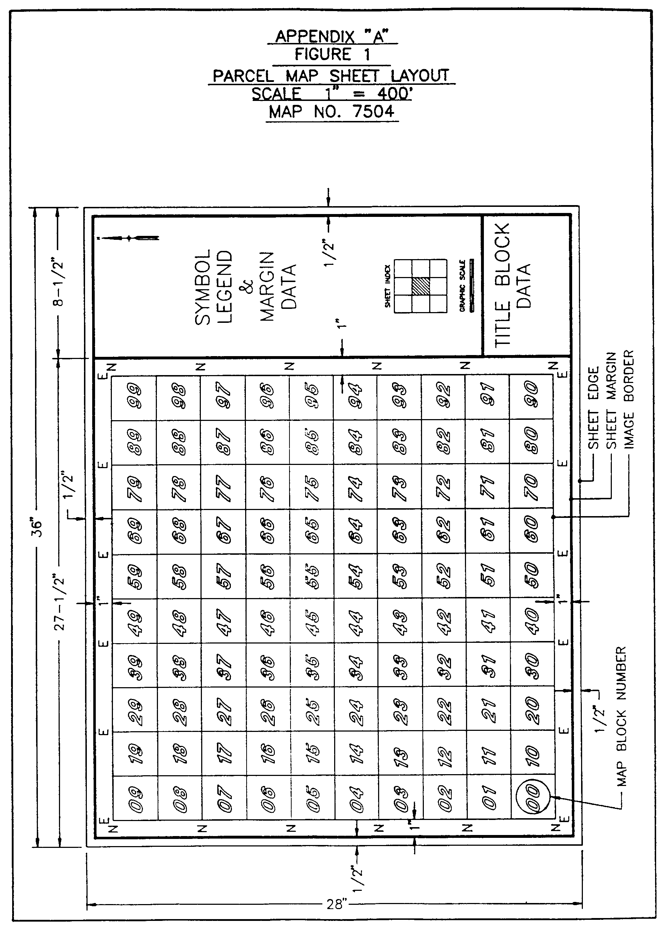

B. Figure 2
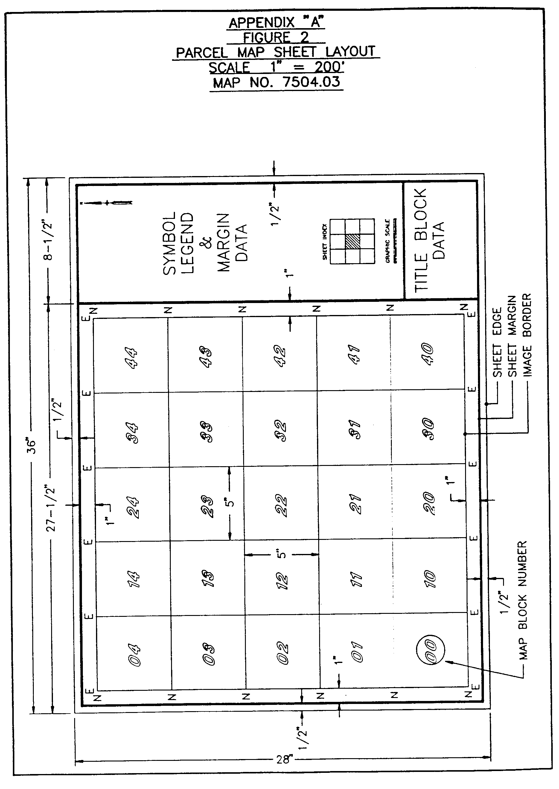

C. Figure 3

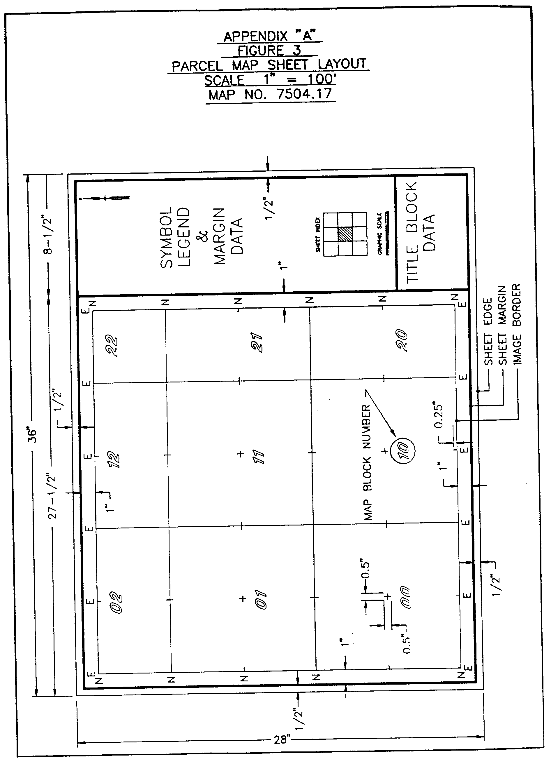

D. Figure 4
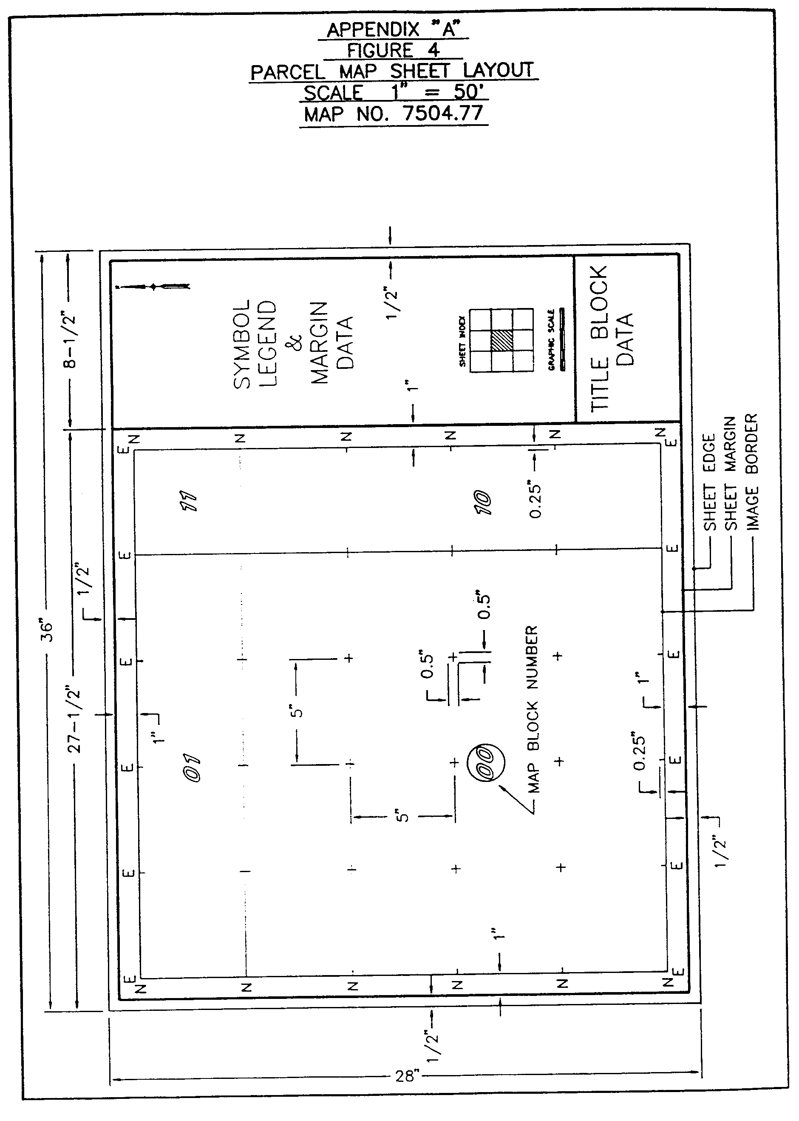

AUTHORITY NOTE: Promulgated in accordance with R.S. 50:171.
HISTORICAL NOTE: Promulgated by the Office of the Governor, Division of Administration, State Land Office, LR 17:968 (October 1991).

§1733. Appendix B―Glossary of Terms and Abbreviations for Property Parcel Maps

GLOSSARY OF TERMS AND ABBREVIATIONS

FOR PROPERTY PARCEL MAPS

Acre | Ac | Not Recorded | NR
Addition | Add | North | N
Avenue | Ave | Number | No
Baptist | Bapt | Page | Pg
Boulevard | Blvd | Place | Pl
Catholic | Cath | Plat Book | PB
Cemetery | Cem | Presbyterian | Presby
Circle | Ci | Property | Prop
Court | Ct | Railroad | RR
Creek | Ck | Range | R
District | Dist | Revised | Rev
Drive | Dr | Right-of-Way | R/W
Easement | Ease | Road | Rd
East | E | Section | Sec
Estate | Est | South | S
Extension | Ext | Street | St
Exempt | Ex | Subdivision | S/D
Highway | Hwy | Township | T
Heights | Hgts | Trail | Tr
Lane | La | Village | Vill
Methodist | Meth | West | W

AUTHORITY NOTE: Promulgated in accordance with R.S. 50:171.
HISTORICAL NOTE: Promulgated by the Office of the Governor, Division of Administration, State Land Office, LR 17:968 (October 1991).

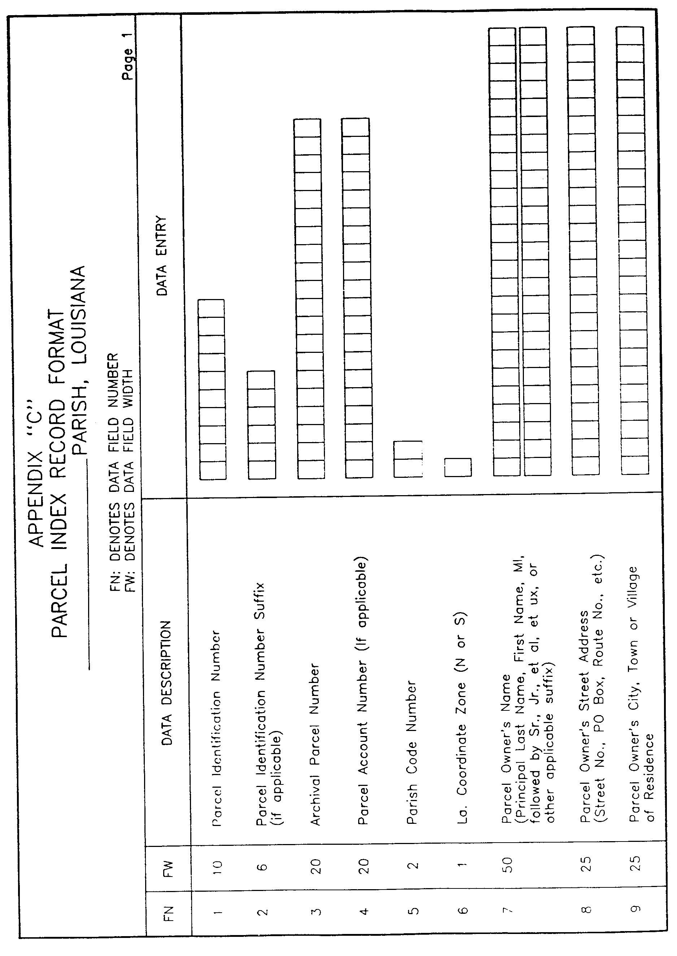
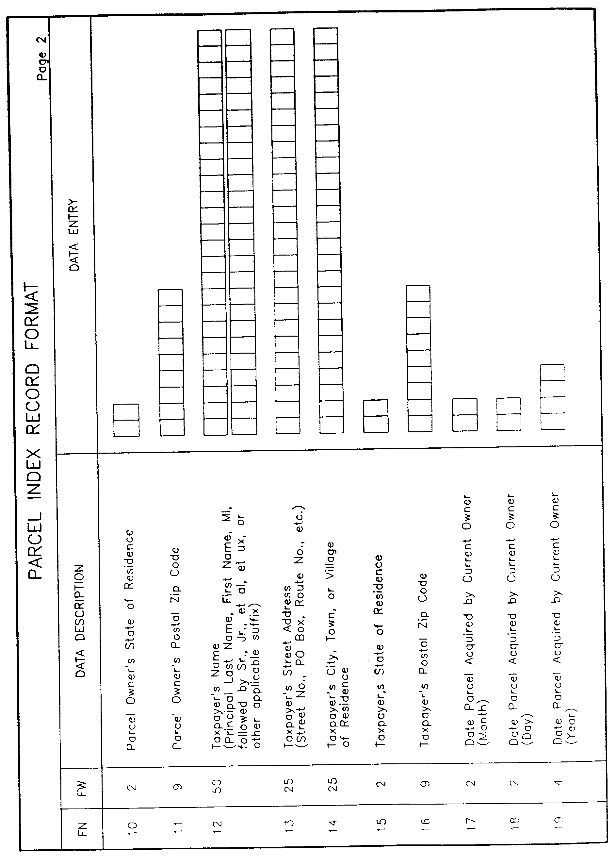
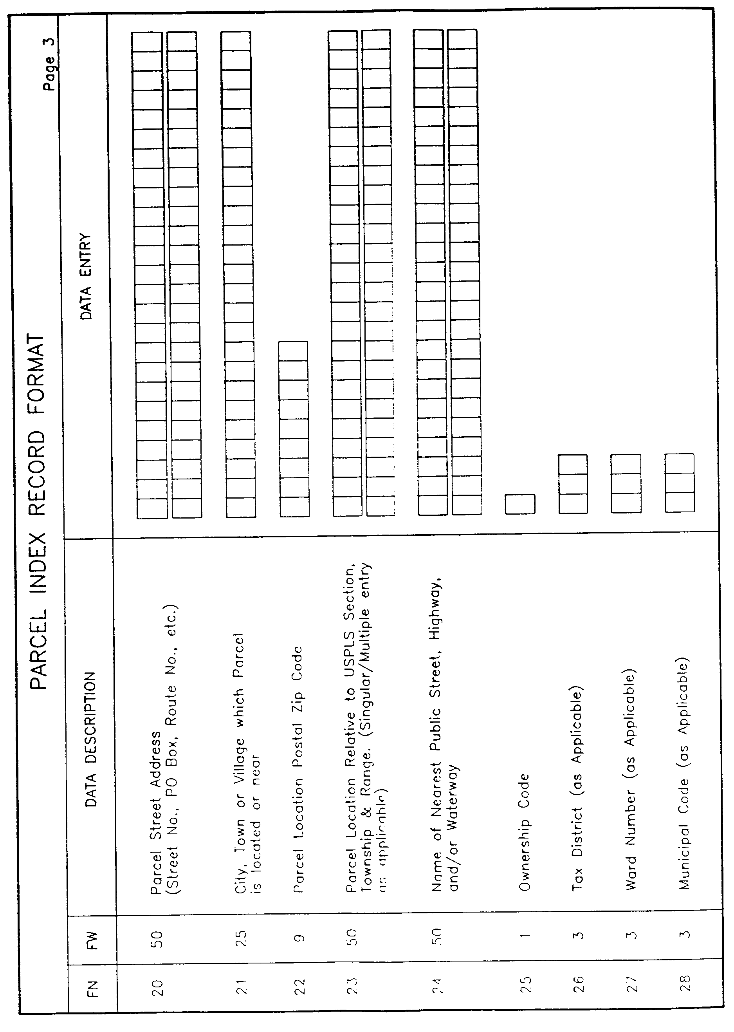
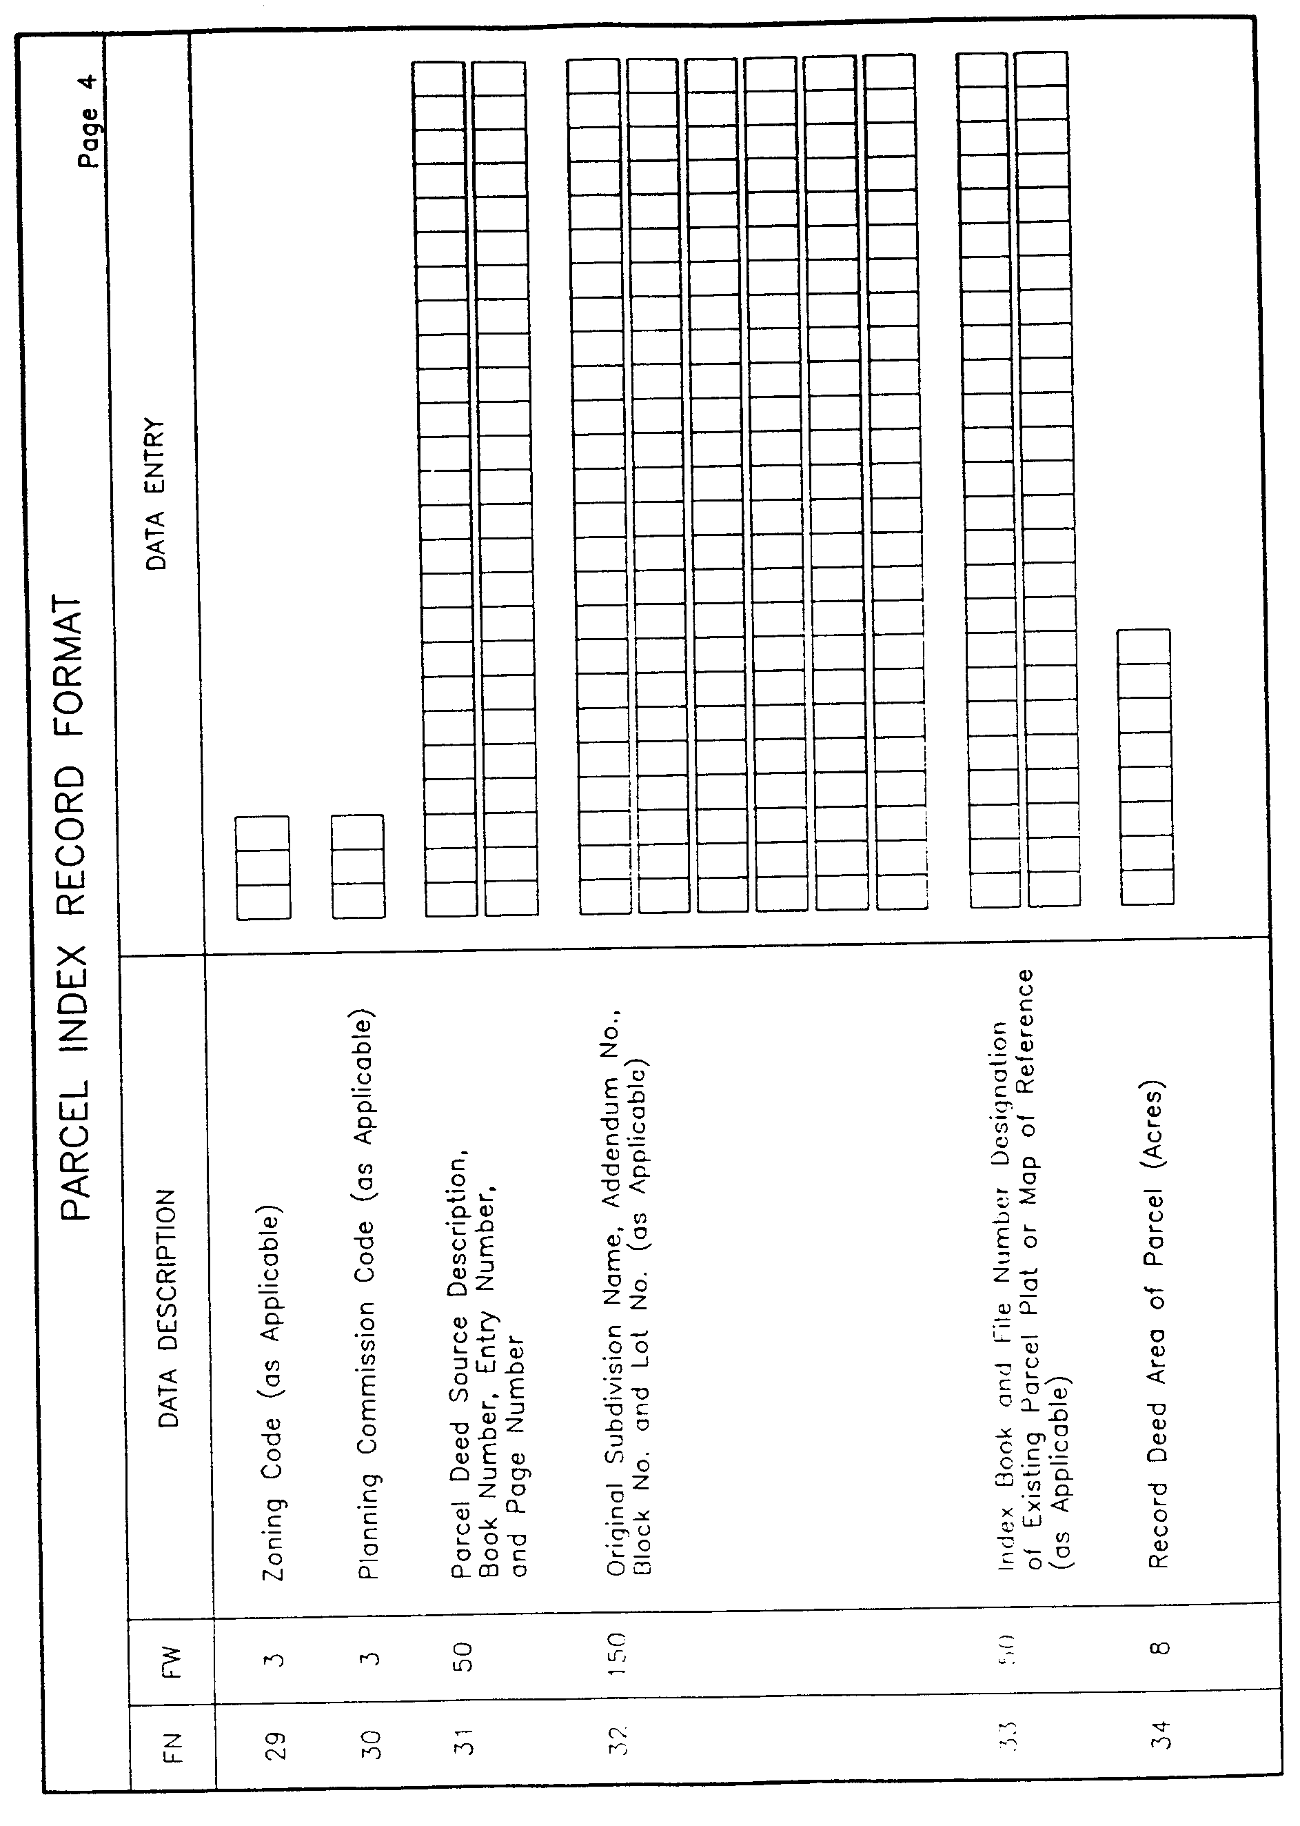
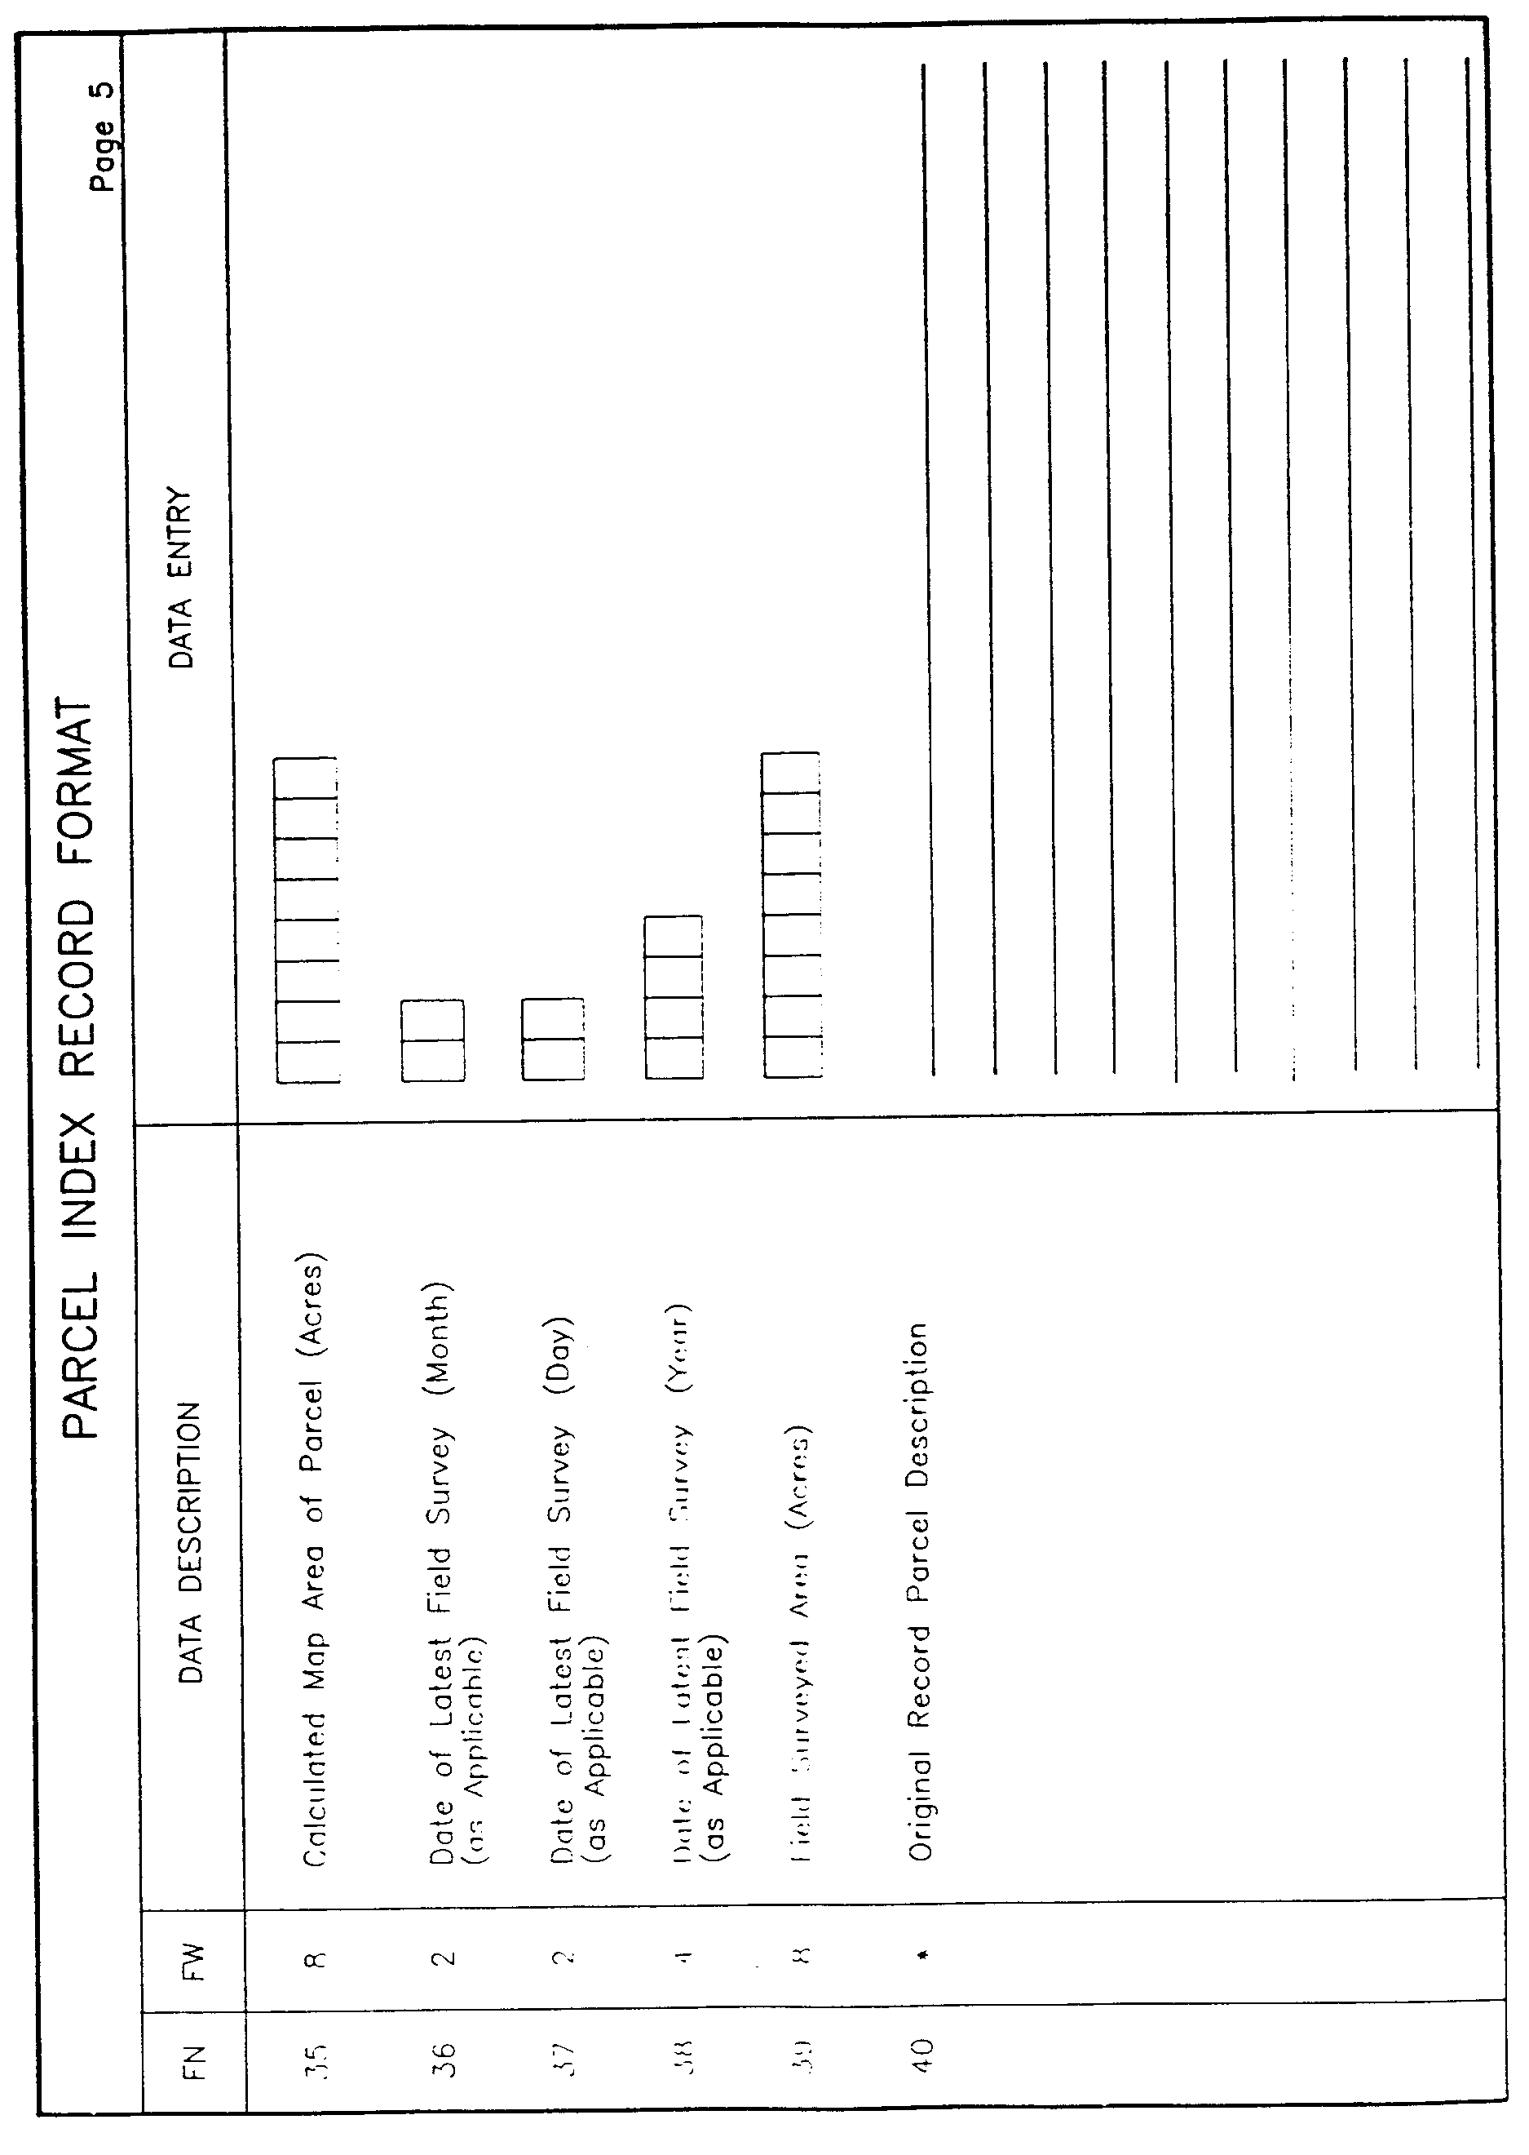
§1735. Appendix C―Parcel Index Record Format

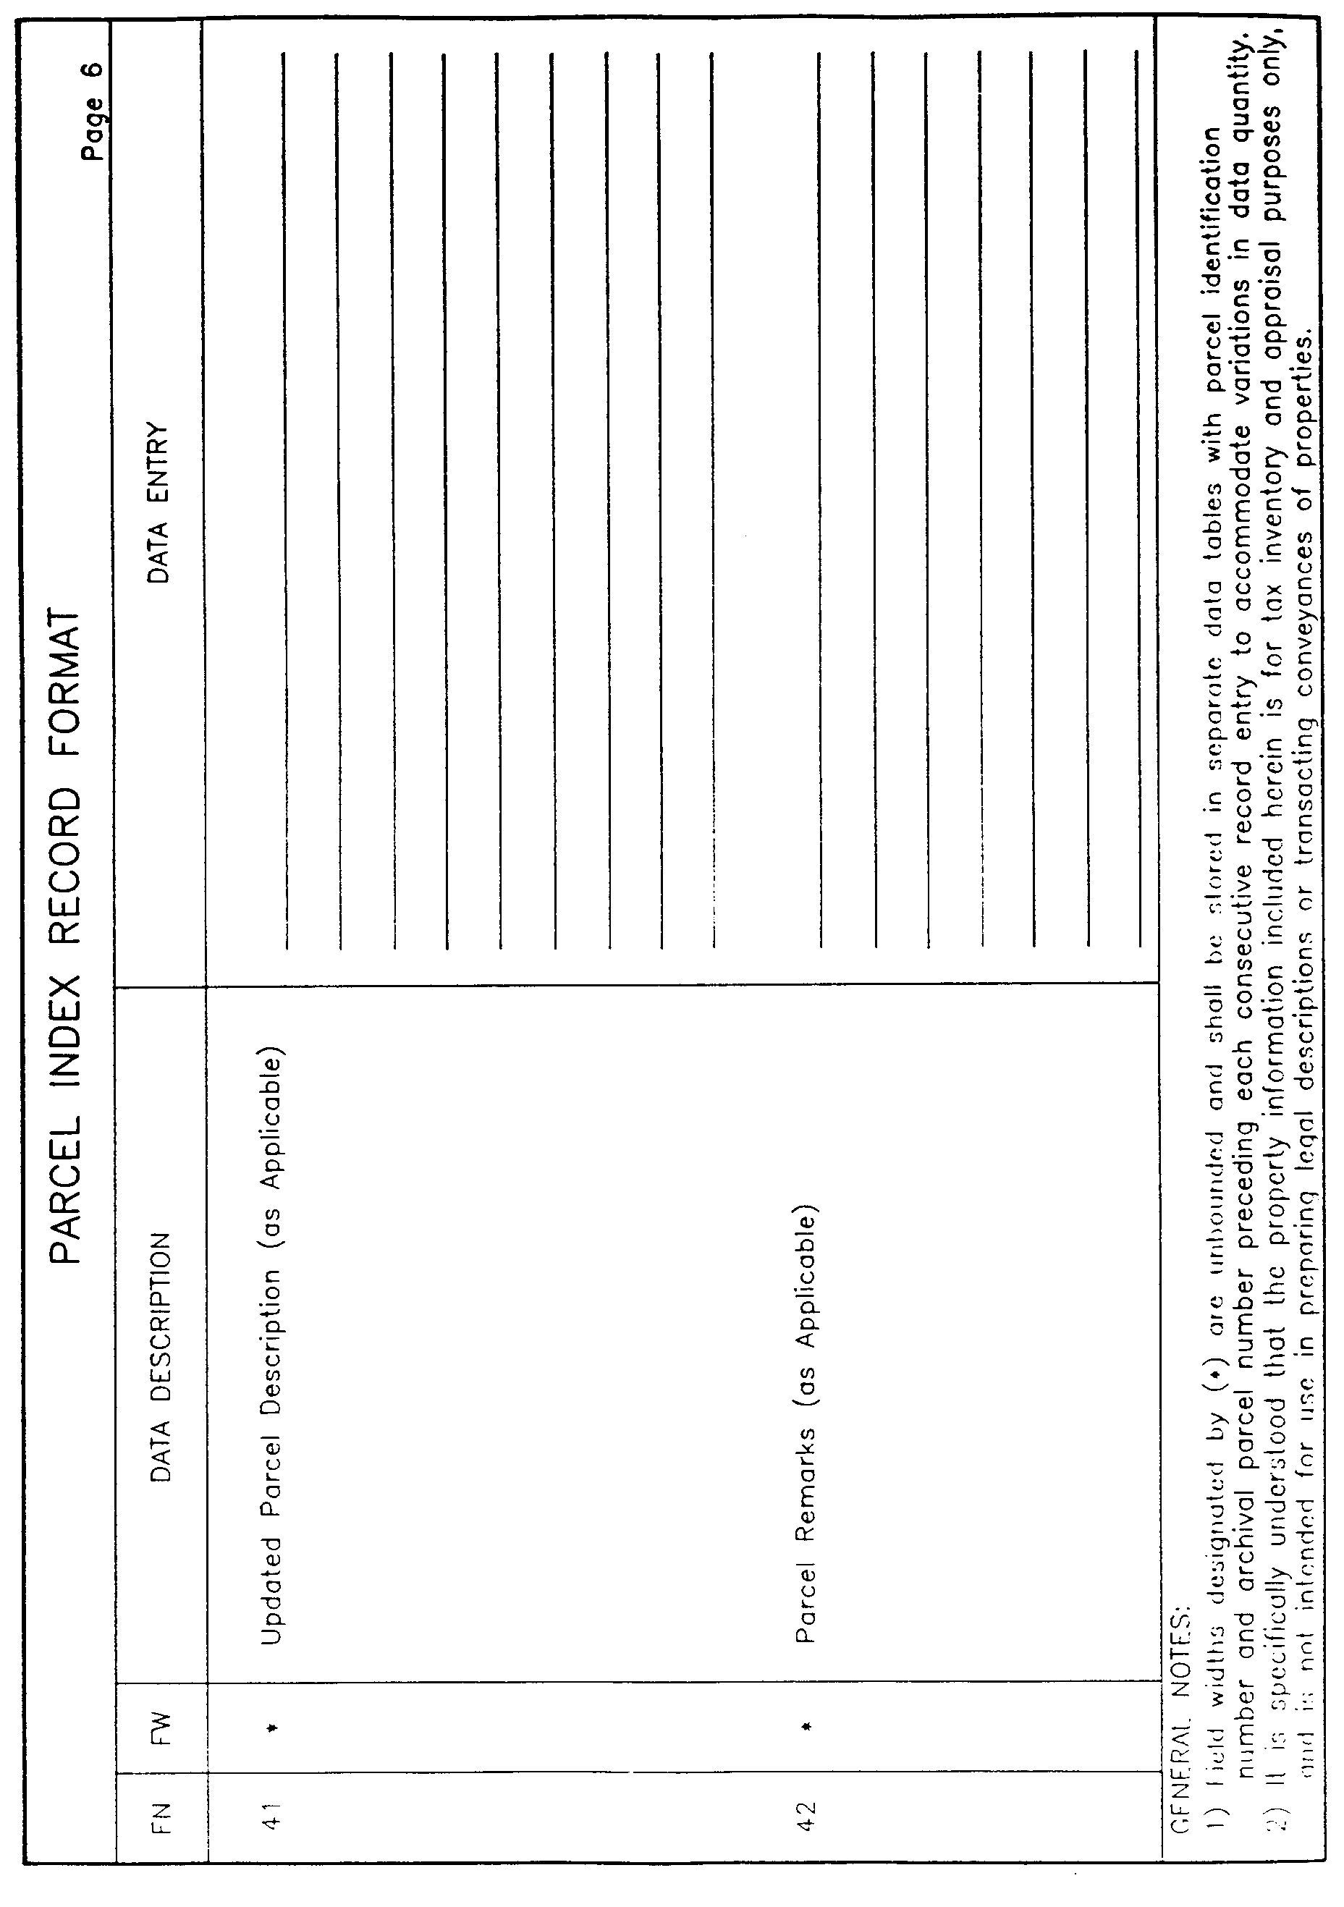

AUTHORITY NOTE: Promulgated in accordance with R.S. 50:171.
HISTORICAL NOTE: Promulgated by the Office of the Governor, Division of Administration, State Land Office, LR 17:968 (October 1991).

§1737. Appendix D―Parcel Record File―ASCII Files

PARCEL RECORD FILE

ASCII FILE LAYOUT

Field Number | Field Name | Field Width | From Col. | To Col.
1 | Parcel Identification Number | 10 | 1 | 10
2 | Parcel Identification Number Suffix | 6 | 11 | 16
3 | Archival Parcel Number | 20 | 17 | 36
4 | Parcel Account Number | 20 | 37 | 56
5 | Parish Number | 2 | 57 | 58
6 | Louisiana Coordinate Zone (N or S) | 1 | 59 | 59
7 | Parcel Owner's Name | 50 | 60 | 109
8 | Parcel Owner's Street Address | 25 | 110 | 134
9 | Parcel Owner's City | 25 | 135 | 159
10 | Parcel Owner's State | 2 | 160 | l61
11 | Parcel Owner's Zip Code | 9 | 162 | 170
12 | Taxpayer's Name | 50 | 171 | 220
13 | Taxpayer's Street Address | 25 | 221 | 245
14 | Taxpayer's City | 25 | 246 | 270
15 | Taxpayer's State | 2 | 271 | 272
16 | Taxpayer's Zip Code | 9 | 273 | 281
17 | Date Parcel Acquired―Month | 2 | 282 | 283
18 | Date Parcel Acquired―Day | 2 | 284 | 285
19 | Date Parcel Acquired―Year | 4 | 286 | 289
20 | Parcel Street Address | 50 | 290 | 339
21 | Parcel City | 25 | 340 | 364
22 | Parcel Zip Code | 9 | 365 | 373
23 | Parcel USPLS Section, Township and Range | 50 | 374 | 423
24 | Nearest Street, Highway and/or Waterway | 50 | 424 | 473
25 | Ownership Code | 1 | 474 | 474
26 | Tax District | 3 | 475 | 477
27 | Ward Number | 3 | 478 | 480
28 | Municipal Code | 3 | 481 | 483
29 | Zoning Code | 3 | 484 | 486
30 | Planning Commission Code | 3 | 487 | 489
31 | Deed Source Book Description | 50 | 490 | 539
32 | Original Subdivision Name Block and Lot Number | 150 | 540 | 689
33 | Index to Existing Map of Reference | 50 | 690 | 739
34 | Record Deed Area of Parcel (Acres) | 8 | 740 | 747
35 | Calculated Map Area of Parcel (Acres) | 8 | 748 | 755
36 | Latest Field Survey―Month | 2 | 756 | 757
37 | Latest Field Survey―Day | 2 | 758 | 759
38 | Latest Field Survey―Year | 4 | 760 | 763
39 | Field Surveyed Area (Acres) | 8 | 764 | 771

ORIGINAL RECORD PARCEL DESCRIPTION FILE

ASCII LAYOUT

Field Number | Field Name | Field Width | From Col. | To Col.
1 | Parcel Identification Number | 10 | 1 | 10
2 | Archival Parcel Number | 16 | 11 | 26
3 | Parcel Description Text | 54 | 27 | 80

UPDATED PARCEL DESCRIPTION FILE

ASCII LAYOUT

Field Number | Field Name | Field Width | From Col. | To Col.
1 | Parcel Identification Number | 10 | 1 | 10
2 | Archival Parcel Number | 16 | 11 | 26
3 | Parcel Description Text | 54 | 27 | 80

PARCEL REMARKS FILE

ASCII LAYOUT

Field Number | Field Name | Field Width | From Col. | To Col.
1 | Parcel Identification Number | 10 | 1 | 10
2 | Archival Parcel Number | 16 | 11 | 26
3 | Parcel Remarks Text | 54 | 27 | 80

PARCEL RECORD FILE

SAMPLE ASCII FILE
72046317520000001462934750 B431772964 55SHUTCHINSON, EUGENE, L., SR., ET AL
123 WEST 5TH ST. HOUMA LA70360 HUTCHINSON, MARGIE
, C. P. O. BOX 116 GIBSON LA70360
07061981RTE. 1 - BOX 24 HOUMA 70
360 SEC. 8, 29 & 102, T16S, R17E LA. HWY. 56 / BAYOU GRAND CAILLO
U 0 02 10 3 3 3C0B 613, ENTRY NO. 902/629 PG. 526
MAP VOL. INDEX 8, ENTRY NO. 176/4
28, PG. 316 97.00 95.6206121983 95.62

8926173052000000439172107563 AC1391270 40NWILLIAMSON, JOHN M. ET UX.
126 W. 5TH ST. MONROE LA71203 PINEVILL
E REALTY CORP. P. O. BOX 1209 PINEVILLE LA71360
125702171986RT. 1 - BOX 320C ALEXANDRIA 71
301 SEC. 8, T12N, R14E US HWY. 165
OC15 6M1OR4 12 COB 244, ENTRY NO. 425/116, PG. 123
MAP BK. L18, ENTRY NO. 24456, PAG
E 148. 8.00 8.2609241989 8.26

24612038940000006643128B IP6125772 O1SBREAUX, ELWOOD J., ET. AL.
RT. 6 - BOX 117A CROWLEY LA70526 BREAUX,
ELWOOD J., ET. AL. RT. 6 - BOX 117A CROWLEY LA70526
12141988RT. 6 - BOX 117A CROWLEY
SEC. 31, T21S, R11W LA. HWY. 343
0 11 R1 COB 743, ENTRY NO. 622/524, PG. 51 HOPEV
ILLE SUBDIVISION, ADDENDUM 7
PLAT DRAWER 118, ENTRY 5669, MC 1
69342. 0.6207121984 0.62

ORIGINAL PARCEL DESCRIPTION FILE

SAMPLE ASCII FILE
72046317521462934750 TRACT OF LAND SITUATED IN THE PARISH OF TERREBONNE ON
72046317521462934750 THE LEFT DESC BK OF BAYOU GRAND CAILLOU APPROX 4 MILES
72046317521462934750 BELOW THE CITY OF HOUMA, LOCATED IN SECS 8, 29 & 102,
72046317521462934750 T16S, R17E, MEASURING 3 ARP FRONT X 40 ARP DEPTH (M/L)
72046317521462934750 ; BND W BY BAYOU, BND N BY FLORENCE KLIBERT ET AL, BND
72046317521462934750 E BY OAKLAND CORP, BND S BY HENRY THIBODAUX, CONTAINI
72046317521462934750 NG 100 AC (M/L) CB 613/425; LESS TRACT 200' FRONT X 80
72046317521462934750 0' DEPTH SOLD TO JOHN BOURG 12/14/79 CONTAINING APPROX
72046317521462934750 3 AC (M/L) CB 879/217.
8926173052439172107563 NE 1/2 OF NW 1/4 OF SEC 8, T12N, R14E, ALEXANDRIA, RAP
8926173052439172107563 IDES PARISH, LA., BD FRONT 0R EAST BY US HWY 165, S BY
8926173052439172107563 OAKRIDGE PLANTATION, W BY EFFIE JENKINS, AND N BY CRO
8926173052439172107563 WN PAPER CORP. CONTAINING 80 AC (M/L) CB 714/016.
24612038946643128B ALL OF LOT 6 AND W 1/2 OF LOT 7, BLK 2, ADD 7, HOPEVIL
24612038946643128B LE S/D, CROWLEY, ACADIA PARISH, LA., BND ABOVE OR N BY
24612038946643128B LA HWY 343, E BY HAROLD BROUSSARD, S BY JOHN HEBERT, A
24612038946643128B ND W BY FELIX MOUTON, CONTAINING 0.62 AC AS SHOWN ON P
24612038946643128B LAT ENTITLED "ADDENDUM 7, HOPEVILLE SUBDIVISION, ACADI
24612038946643128B A PARISH, LA." PREPARED BY ABC CONSULTANTS, INC. DATED
24612038946643128B 07/12/84 CB 412/918.

UPDATED PARCEL DESCRIPTION FILE

SAMPLE ASCII FILE
72046317521462934750 TRACT "ABCDEFA" AS SHOWN ON PLAT ENTITLED "SURVEY OF
72046317521462934750 PROPERTY BELONGING TO EUGENE HUTCHINSON, SR., ET AL, L
72046317521462934750 OCATED IN SECS. 8, 29 & 102, T16S, R17E, TERREBONNE PA
72046317521462934750 RISH, LA." , DTD 06/12/83, END W BY BAYOU, BND N BY RON
72046317521462934750 ALD KLIBERT OR ASSIGNS, BND E BY OAKLAND LAND CORP, BN
72046317521462934750 D S BY HENRY THIBODAUX & JOHN BOURG, CONTAINING 95.62
72046317521462934750 AC CB 902/629.

PARCEL REMARKS FILE

SAMPLE ASCII FILE
72046317521462934750 1) SEE BNDRY AGREEMENT BETWEEN EUGENE HUTCHINSON & OAK
72046317521462934750 LAND LAND CORP DTD 08/22/83 CB 903/406.
72046317521462934750 2) SEE LADOTD R/W SURVEY FOR SP 407-55-62 LA. HWY. 56
72046317521462934750 DTD 03/12/85 CB 927/104.

AUTHORITY NOTE: Promulgated in accordance with R.S. 50:171.
HISTORICAL NOTE: Promulgated by the Office of the Governor, Division of Administration, State Land Office, LR 17:968 (October 1991).

§1739. Appendix E―Parish Code Numbers and Louisiana Coordinate Grid Zones

PARISH CODE NUMBERS

AND

LOUISIANA COORDINATE GRID ZONES

Parish Name | Code No. | Grid Zone
Acadia | 01 | S
Allen | 02 | S
Ascension | 03 | S
Assumption | 04 | S
Avoyelles | 05 | N
Beaureguard | 06 | S
Bienville | 07 | N
Bossier | 08 | N
Caddo | 09 | N
Calcasieu | 10 | S
Caldwell | 11 | N
Cameron | 12 | S
Catahoula | 13 | N
Claiborne | 14 | N
Concordia | 15 | N
De Soto | 16 | N
East Baton Rouge | 17 | S
East Carroll | 18 | N
East Feliciana | 19 | S
Evangeline | 20 | S
Franklin | 21 | N
Grant | 22 | N
Iberia | 23 | S
Iberville | 24 | S
Jackson | 25 | N
Jefferson | 26 | S
Jefferson Davis | 27 | S
Lafayette | 28 | S
Lafourche | 29 | S
La Salle | 30 | N
Lincoln | 31 | N
Livingston | 32 | S
Madison | 33 | N
Morehouse | 34 | N
Natchitoches | 35 | N
Orleans | 36 | S
Ouachita | 37 | N
Plaquemines | 38 | S
Pointe Coupee | 39 | S
Rapides | 40 | N
Red River | 41 | N
Richland | 42 | N
Sabine | 43 | N
St. Bernard | 44 | S
St. Charles | 45 | S
St. Helena | 46 | S
St. James | 47 | S
St. John the Baptist | 48 | S
St. Landry | 49 | S
St. Martin | 50 | S
St. Mary | 51 | S
St. Tammany | 52 | S
Tangipahoa | 53 | S
Tensas | 54 | N
Terrebonne | 55 | S
Union | 56 | N
Vermilion | 57 | S
Vernon | 58 | N
Washington | 59 | S
Webster | 60 | N
West Baton Rouge | 61 | S
West Carroll | 62 | N
West Feliciana | 63 | S
Winn | 64 | N

LEGEND

N: Denotes North Zone
S: Denotes South Zone
AUTHORITY NOTE: Promulgated in accordance with R.S. 50:171.
HISTORICAL NOTE: Promulgated by the Office of the Governor, Division of Administration, State Land Office, LR 17:968 (October 1991).

Chapter 19. Map Features

§1901. General Requirements

A. The following requirements establish uniform criteria and guidelines for the development of map feature elements to be included on all planimetric, topographic and/or parcel maps to be prepared under these standards.

B. All map feature elements are grouped into eight general layer categories as discussed in Chapter 13 and hereinafter defined as follows.
Layer Category | Category Description
1 | Margin and Grid
2 | Transportation
3 | Hydrology
4 | Terrain
5 | Structure
6 | Utility
7 | Topographic
8 | Parcel

1. A tabulation of all feature elements contained within each category together with associated feature code numbers, graphic representations, element types, and graphics and text requirements are set forth within accompanying §§1917-1931, Appendices B-I, inclusive.

C. All feature elements should be accurately digitized to scale whenever possible rather than symbolized in order to facilitate subsequent GIS applications. Whenever symbolization is necessary, the actual size of the symbol should be no larger than required to provide satisfactory visual interpretation at the final map manuscript scale. Relatively small feature elements which can not be satisfactorily photo-interpreted on reduced scale map imagery should not be plotted.
AUTHORITY NOTE: Promulgated in accordance with R.S. 50:171.
HISTORICAL NOTE: Promulgated by the Office of the Governor, Division of Administration, State Land Office, LR 17:968 (October 1991).

§1903. Element Types

A. Various element types used to define the graphic representation of each feature element are defined as follows.
Element Type | Element Description
L | Line
CI | Circle
LS | Line String
CS | Curve String
LP | Linear Pattern
C | Cell
TN | Text Node
AUTHORITY NOTE: Promulgated in accordance with R.S. 50:171.
HISTORICAL NOTE: Promulgated by the Office of the Governor, Division of Administration, State Land Office, LR 17:968 (October 1991).

§1905. Graphics and Text Requirements

A. Graphics and text requirements applicable to screen display and/or plotter output modes for each feature element are defined as follows.
Column Code | Requirement Description | Screen Display | Plotter Output
LV | Level or Component layer. Each feature element shall be stored on a separate component layer or assigned to the levels indicated for viewing and plotting purposes. | X | X
WT | Line Weight (See §1915.A, Appendix A, Table 1). |  | X
LC | Line Configuration (See §1915.B, Appendix A, Table 2). | X | X
CO | Line or Text Color (See §1915.C, Appendix A., Table 3). | X
FT | Alpha-Numeric Text Font (See §1915.D, Appendix A, Table 4). | X | X
TH | Alpha-Numeric Text Height expressed in hundredths of an inch for all map scales except where noted. Text width = 1.0 X TH. | X | X
AUTHORITY NOTE: Promulgated in accordance with R.S. 50:171.
HISTORICAL NOTE: Promulgated by the Office of the Governor, Division of Administration, State Land Office, LR 17:968 (October 1991).

§1907. Linear Patterns

A. All linear patterns shall have a pattern angle of 90 degrees with respect to the line string or curve string represented. Lines digitized for linear patterning comprised of several elements (e.g., lines and curves) shall be created as connected strings. A connected string is a complex element comprised of single elements with common junction coordinates.

B. Pattern interval (PI) is the map distance separating repetitive pattern elements at a standard pattern scale (PS) of 1.00 for 1" = 50' scale maps as defined for each respective feature element. Pattern intervals shall vary inversely for other mapping scales (i.e., PS = 0.50 for 1" = 100' scale maps, PS = 0.25 for 1" = 200' scale maps, and PS = 0.125 for 1" = 400' scale maps). Thus, a specified pattern interval of 0.80" at the 1" = 50' scale would be plotted 0.40" at
1" = 100' scale, 0.20" at 1" = 200' scale, and 0.10" at
1" = 400' scale.
AUTHORITY NOTE: Promulgated in accordance with R.S. 50:171.
HISTORICAL NOTE: Promulgated by the Office of the Governor, Division of Administration, State Land Office, LR 17:968 (October 1991).

§1909. Cells

A. All cells, except as noted, are shown at actual size (AS) at an object scale (OS) of 1.00 for 1" = 50' scale maps as defined for each respective cell element. Cells shall be scaled inversely proportional for other mapping scales (i.e., OS = 0.50 for 1" = 100' scale maps, OS = 0.25 for 1" = 200' scale maps, and OS = 0.125 for 1" = 400' scale maps). Thus, a specified cell size of 0.40 inches at the 1" = 50' scale would be plotted 0.20 inches at 1" = 100' scale, 0.10 inches at 1" = 200' scale, and 0.05 inches at 1" = 400' scale. All cells for point features are point cells and shall have center origins. All cells, except as noted, shall be placed horizontal relative to the bottom map margin.

B. Relatively small features such as manholes, catch basins, power poles and related objects shall be shown at a minimum exaggerated size as necessary to provide satisfactory visual interpretation on hard copy manuscript maps. The outside edges of all photo-identifiable features having dimensions in excess of the minimum size specified shall be digitized to actual scale in order to properly depict the relative size and configuration of the feature.
AUTHORITY NOTE: Promulgated in accordance with R.S. 50:171.
HISTORICAL NOTE: Promulgated by the Office of the Governor, Division of Administration, State Land Office, LR 17:968 (October 1991).

§1911. Text

A. All annotation text, except as noted, shall be specified in accordance with the font and text height as defined for each respective feature element regardless of final map scale.

B. All annotation text for point features and area features shall be placed horizontal relative to the bottom map margin and shall have the text justification point close to the feature. Annotation text for linear features shall be orientated along the feature.

C. Constrained text annotation such as roadway labels between street blocks on relatively small scale maps may be appropriately reduced where necessary to avoid conflict with adjacent features.
AUTHORITY NOTE: Promulgated in accordance with R.S. 50:171.
HISTORICAL NOTE: Promulgated by the Office of the Governor, Division of Administration, State Land Office, LR 17:968 (October 1991).

§1913. Digitization

A. All linear features shall be digitized in point-to-point mode except shorelines, natural waterways, contour lines, and related irregular features, which shall be digitized in stream mode.

B. All features digitized shall have junctions with common coordinates when changing from line to curve.
AUTHORITY NOTE: Promulgated in accordance with R.S. 50:171.
HISTORICAL NOTE: Promulgated by the Office of the Governor, Division of Administration, State Land Office, LR 17:968 (October 1991).

§1915. Appendix A―Map Text Requirements

A. Table 1

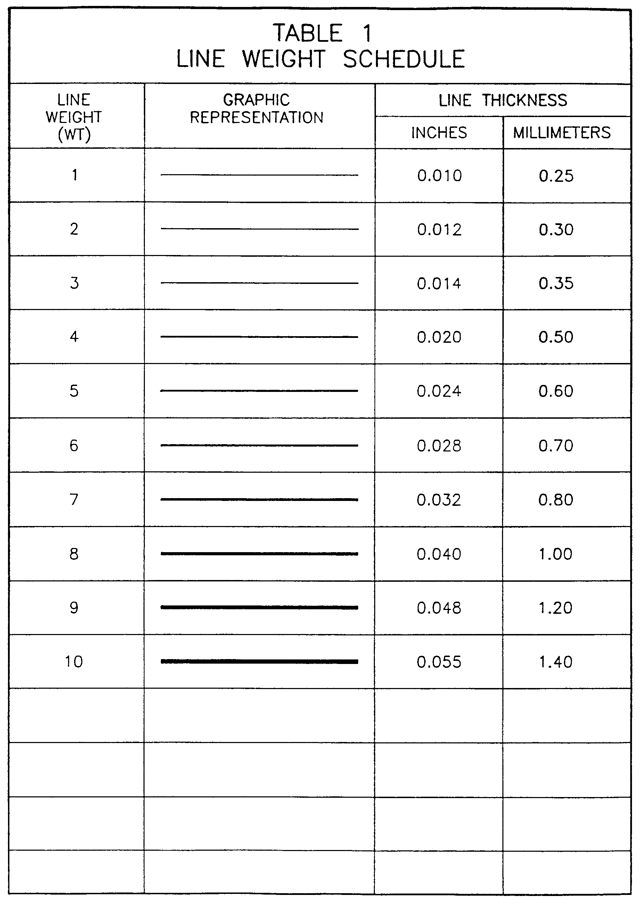

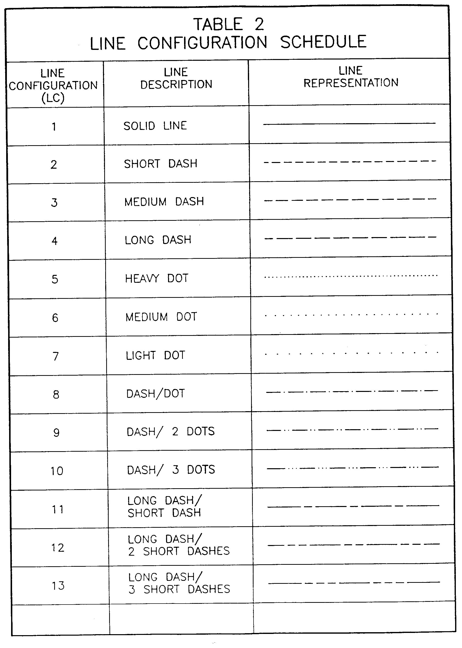
B. Table 2

C. Table 3

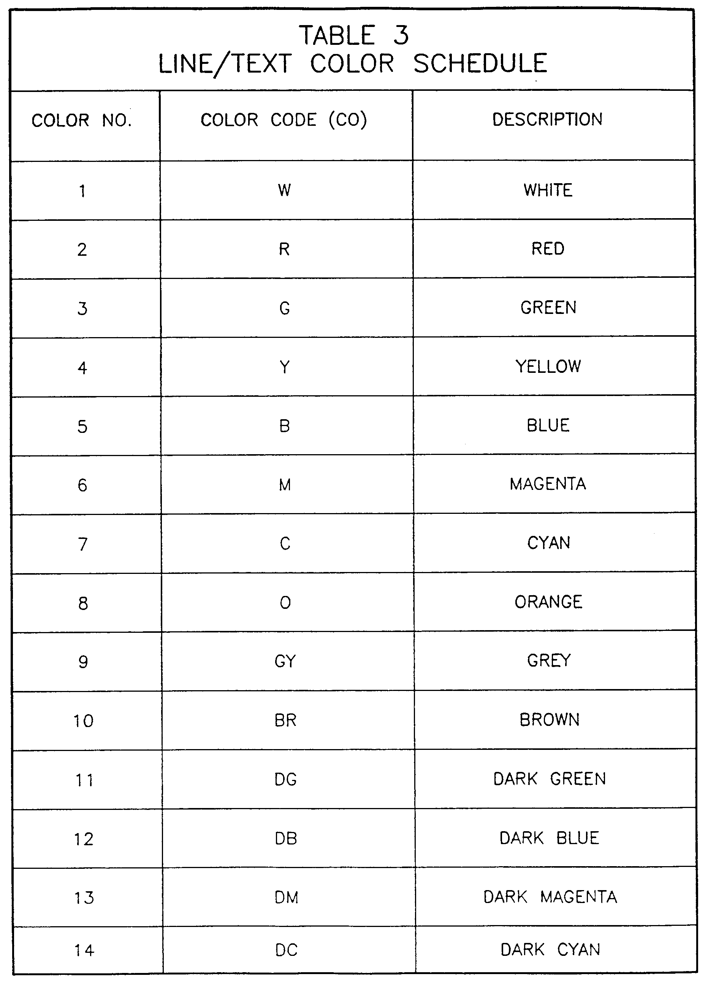
D. Table 4

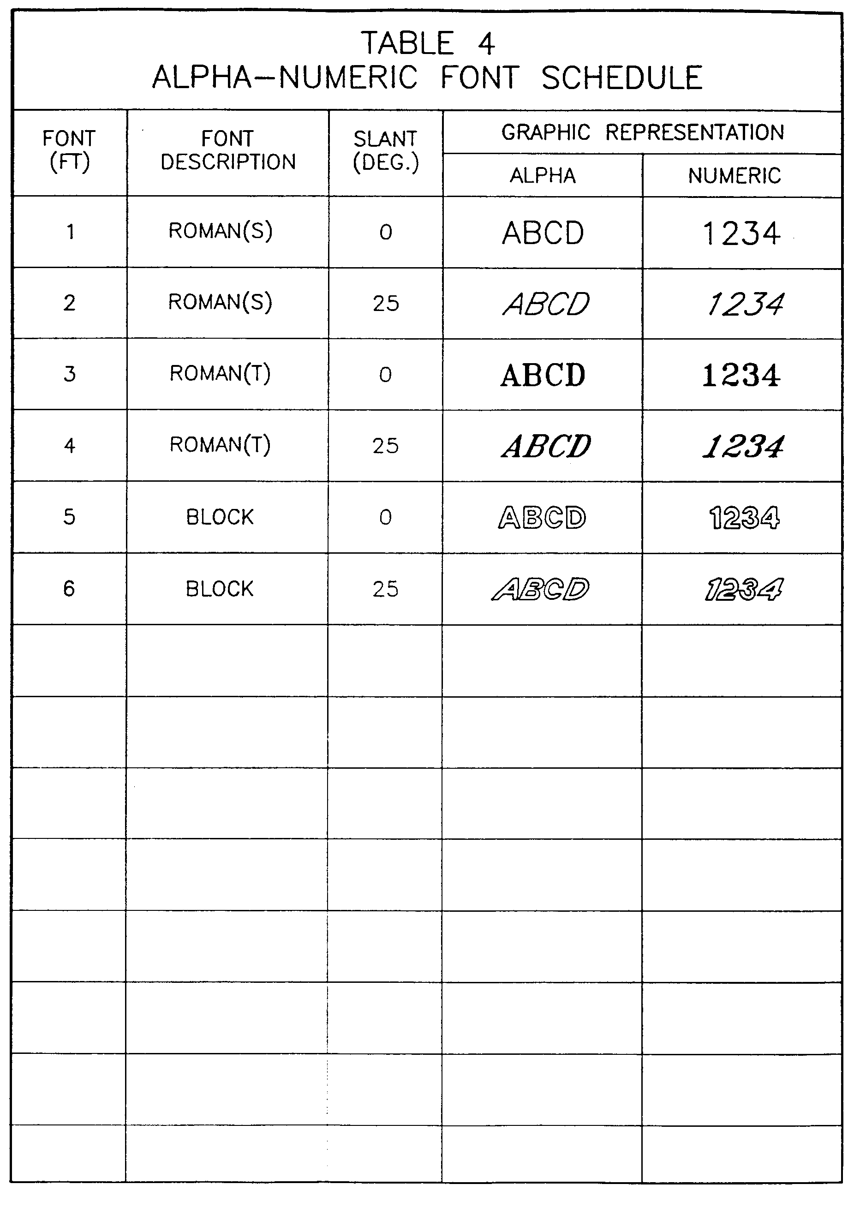

AUTHORITY NOTE: Promulgated in accordance with R.S. 50:171.
HISTORICAL NOTE: Promulgated by the Office of the Governor, Division of Administration, State Land Office, LR 17:968 (October 1991).

§1917. Appendix B―Layer Category 1―Margin and Grid Feature Elements

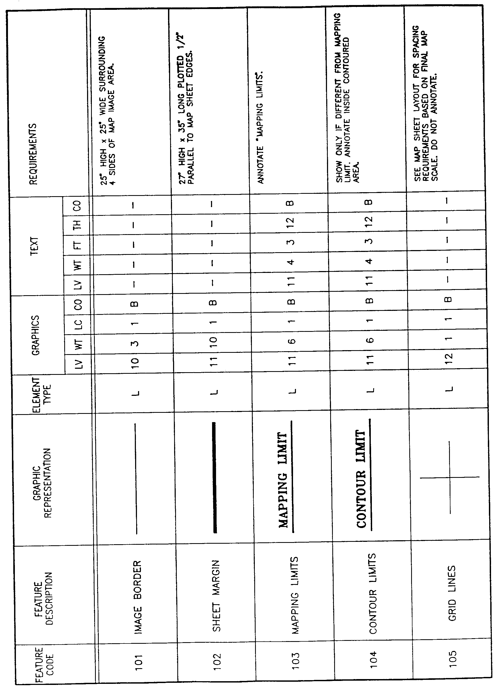

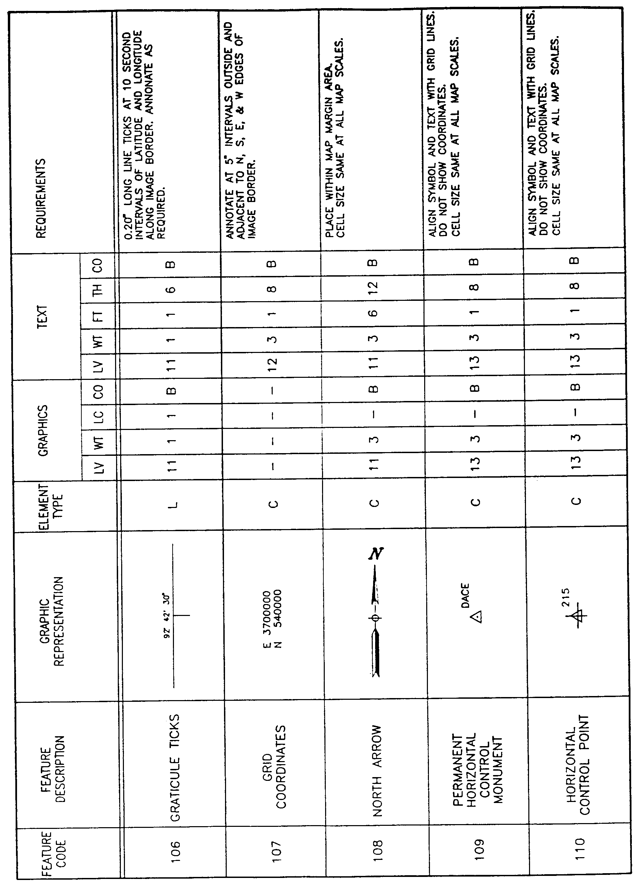
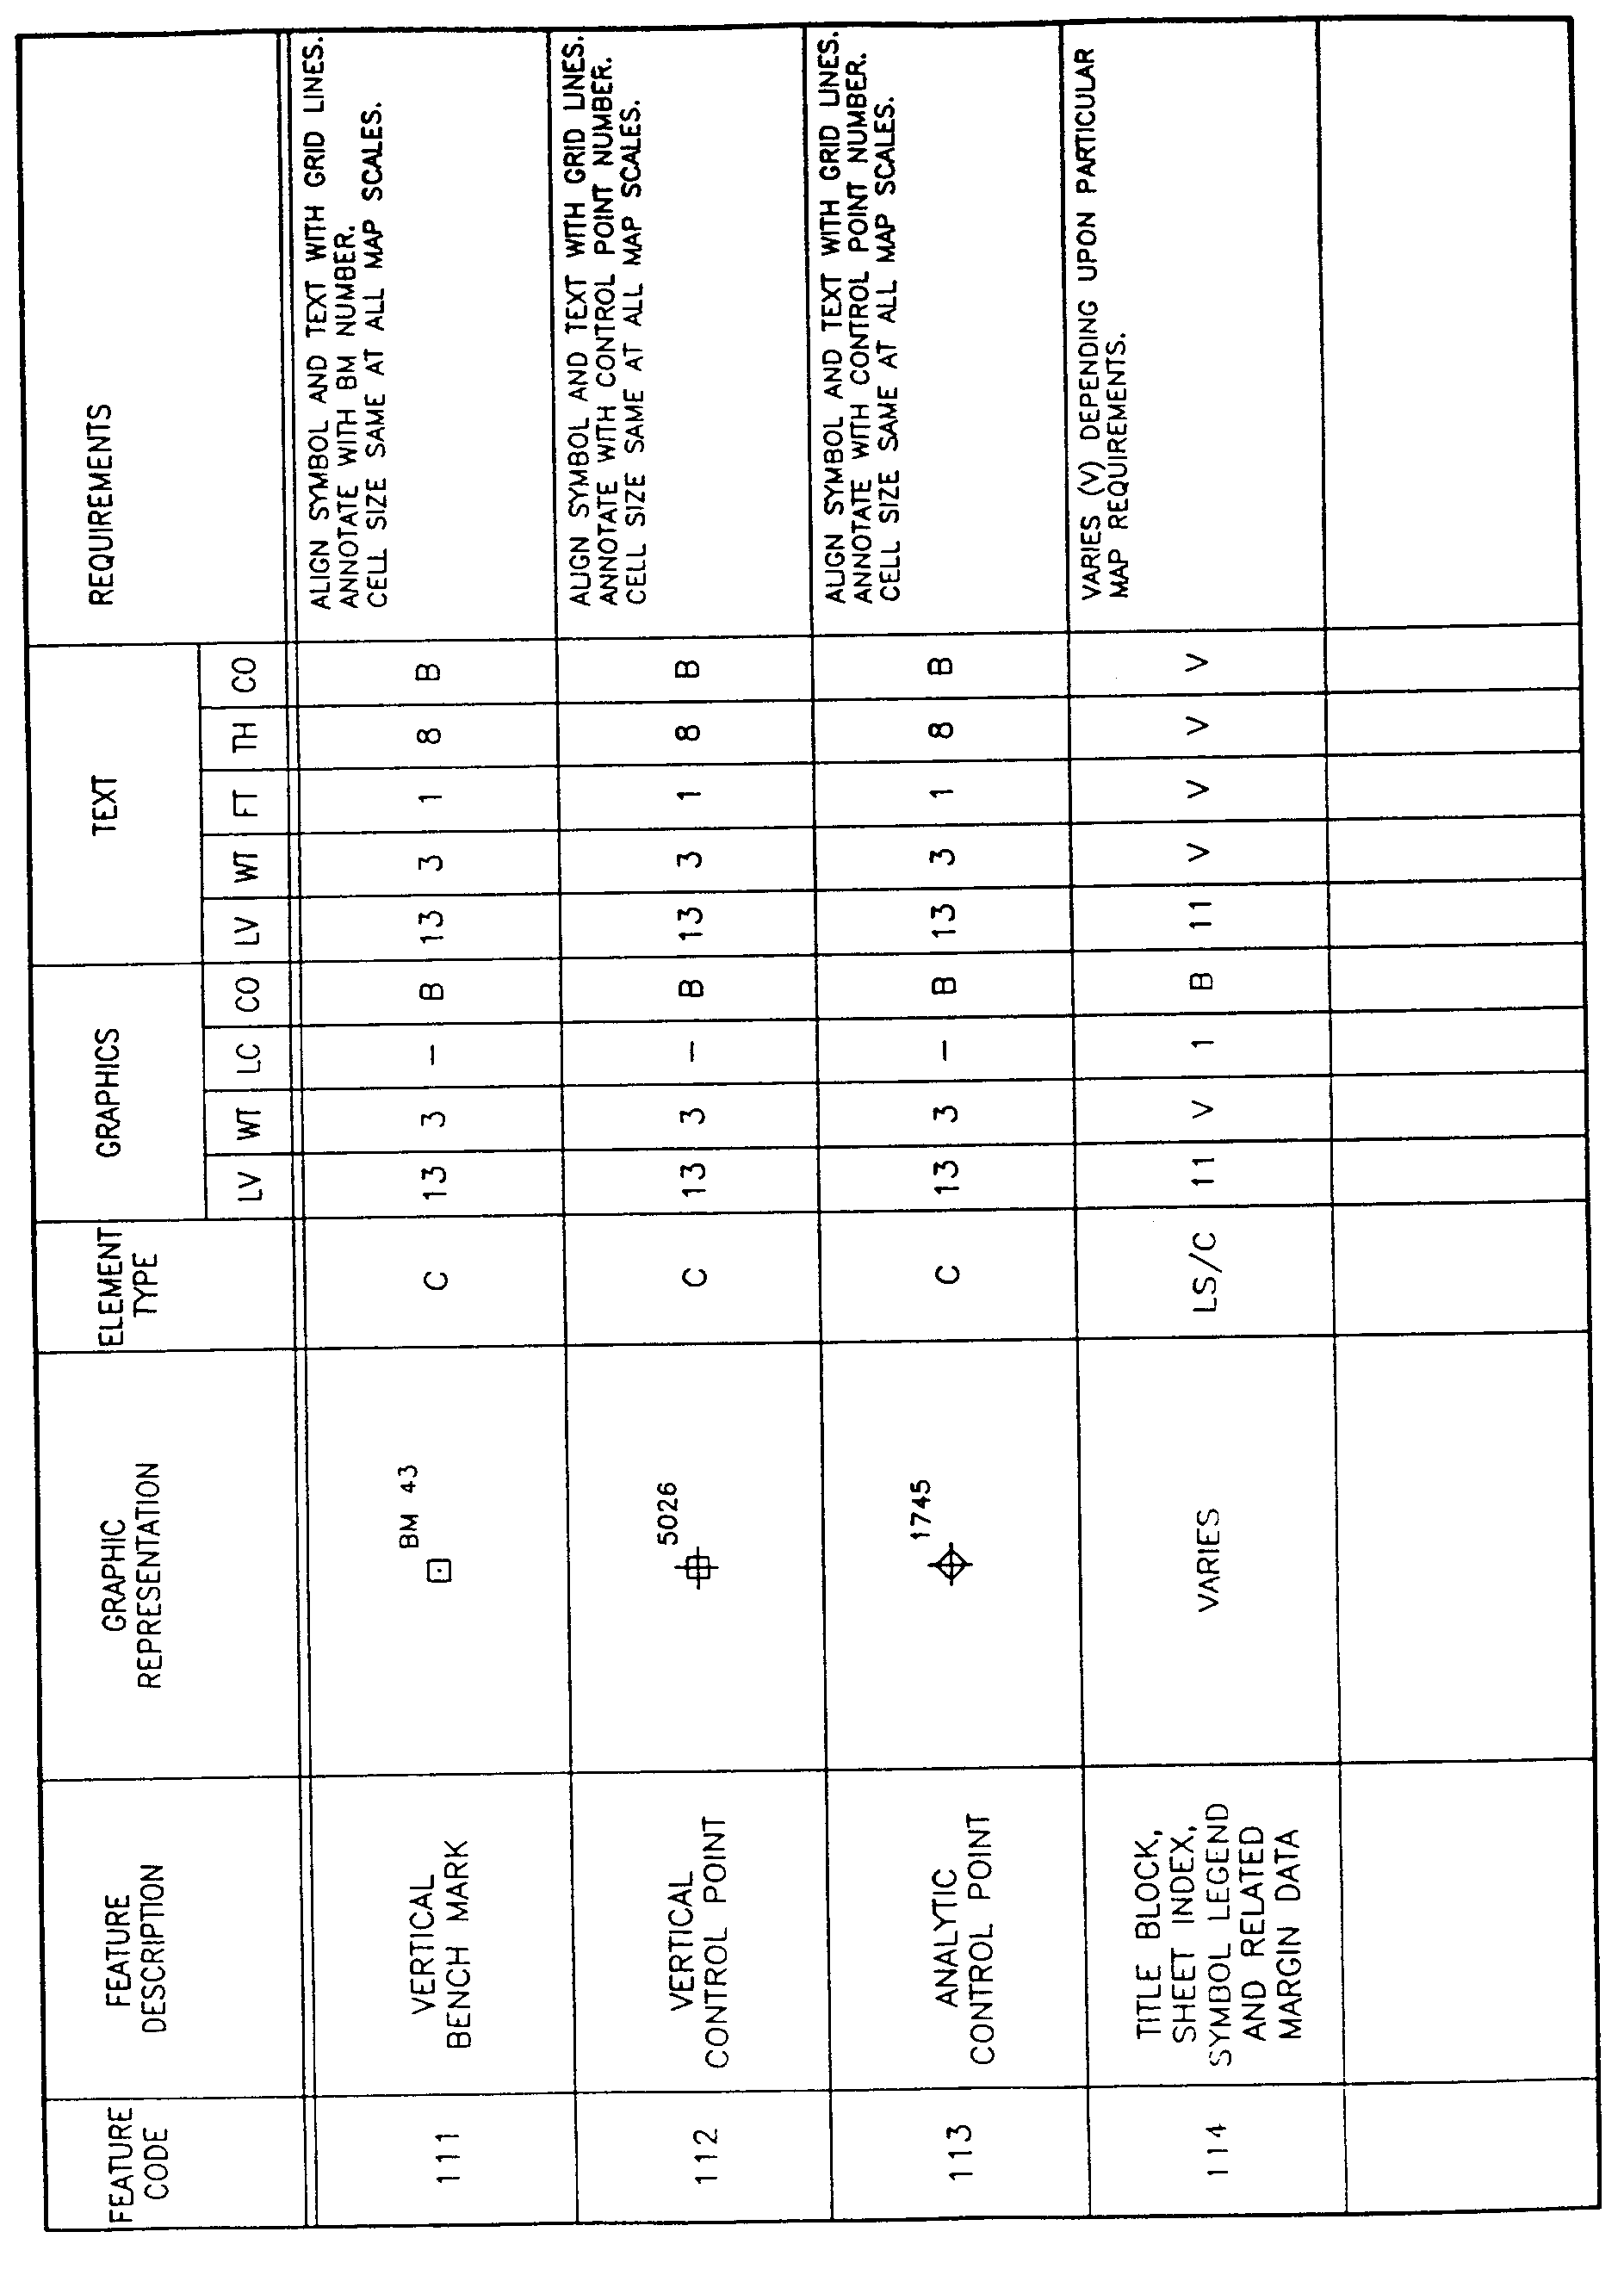
AUTHORITY NOTE: Promulgated in accordance with R.S. 50:171.
HISTORICAL NOTE: Promulgated by the Office of the Governor, Division of Administration, State Land Office, LR 17:968 (October 1991).

§1919. Appendix C―Layer Category 2―Transportation Feature Elements
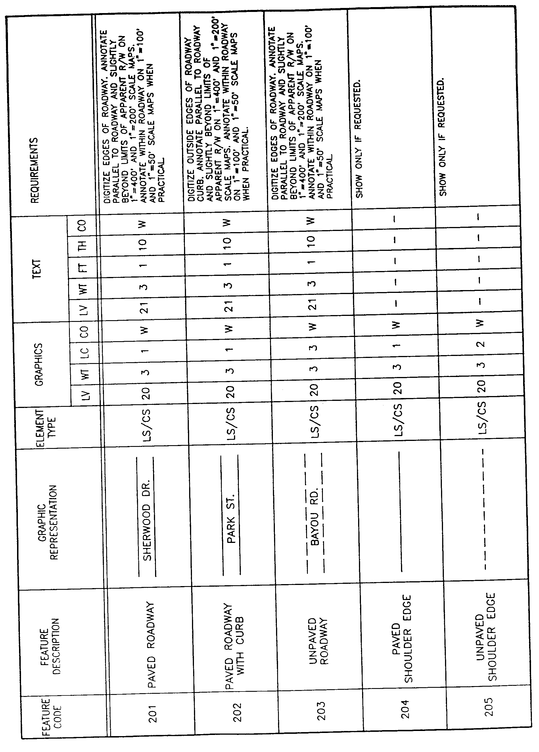
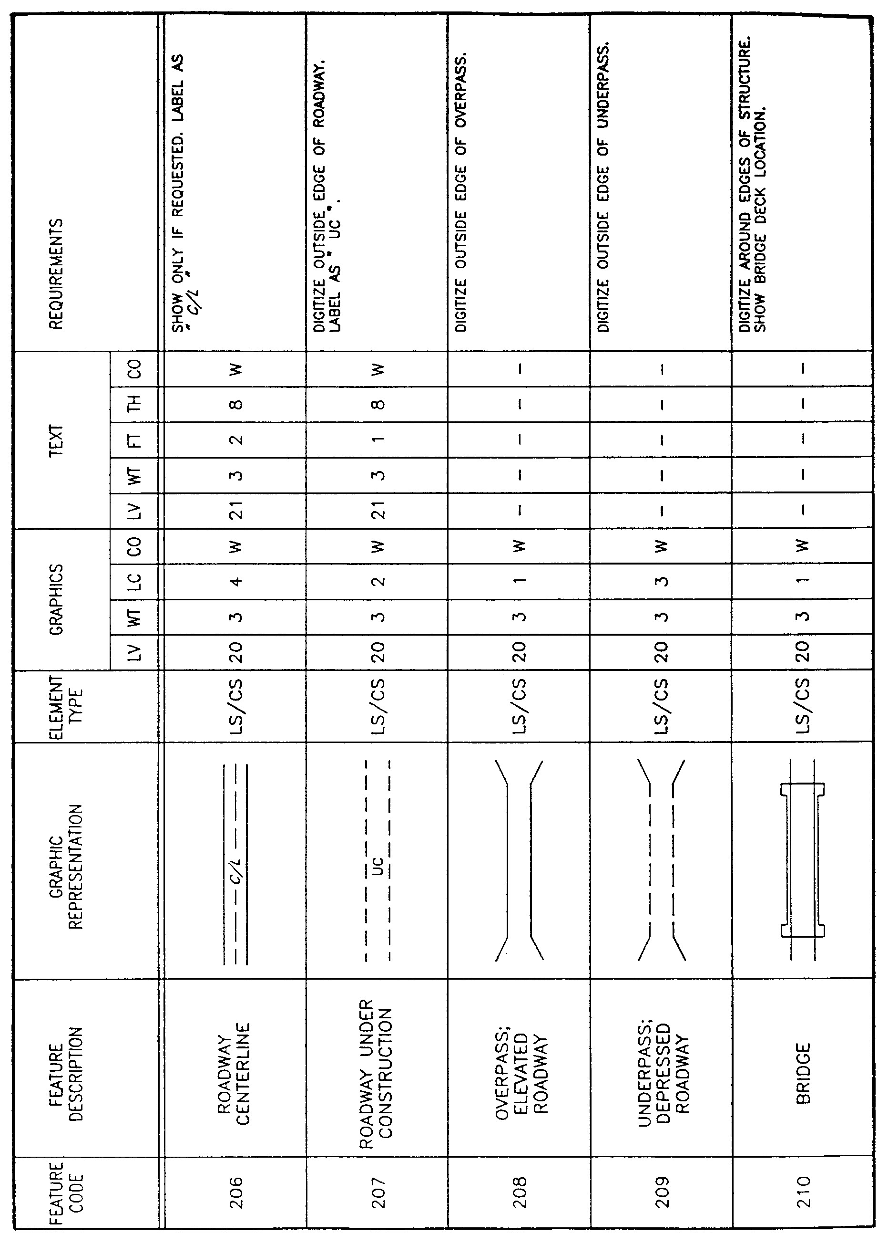
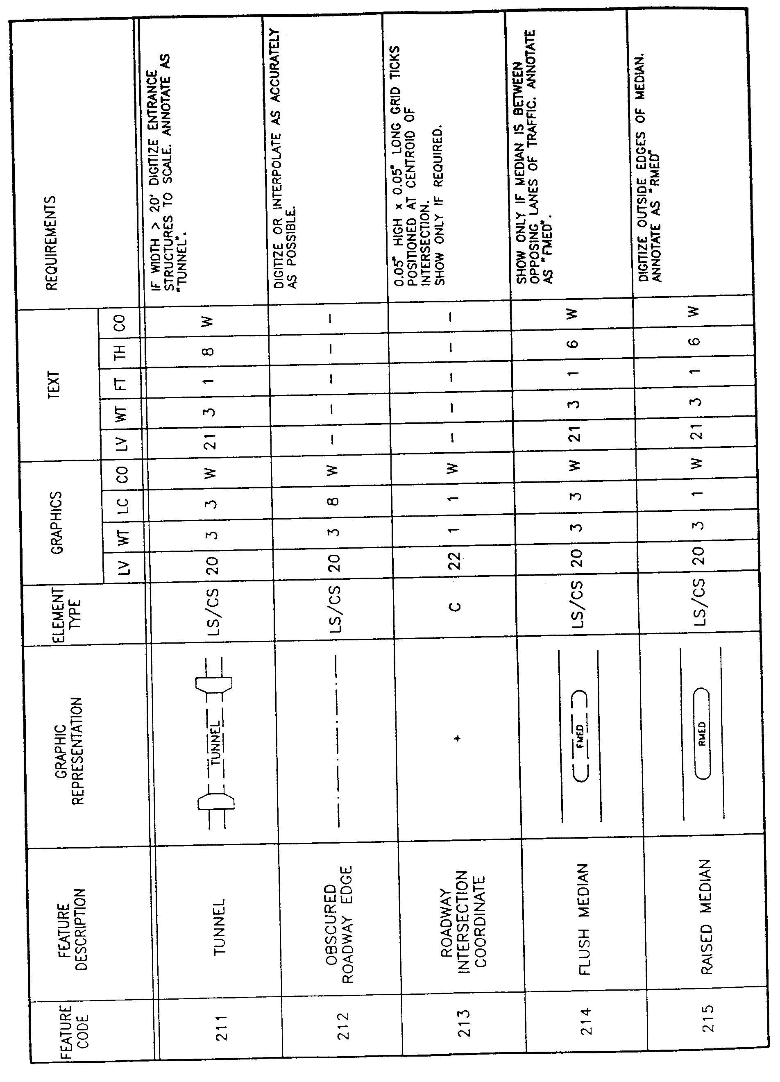
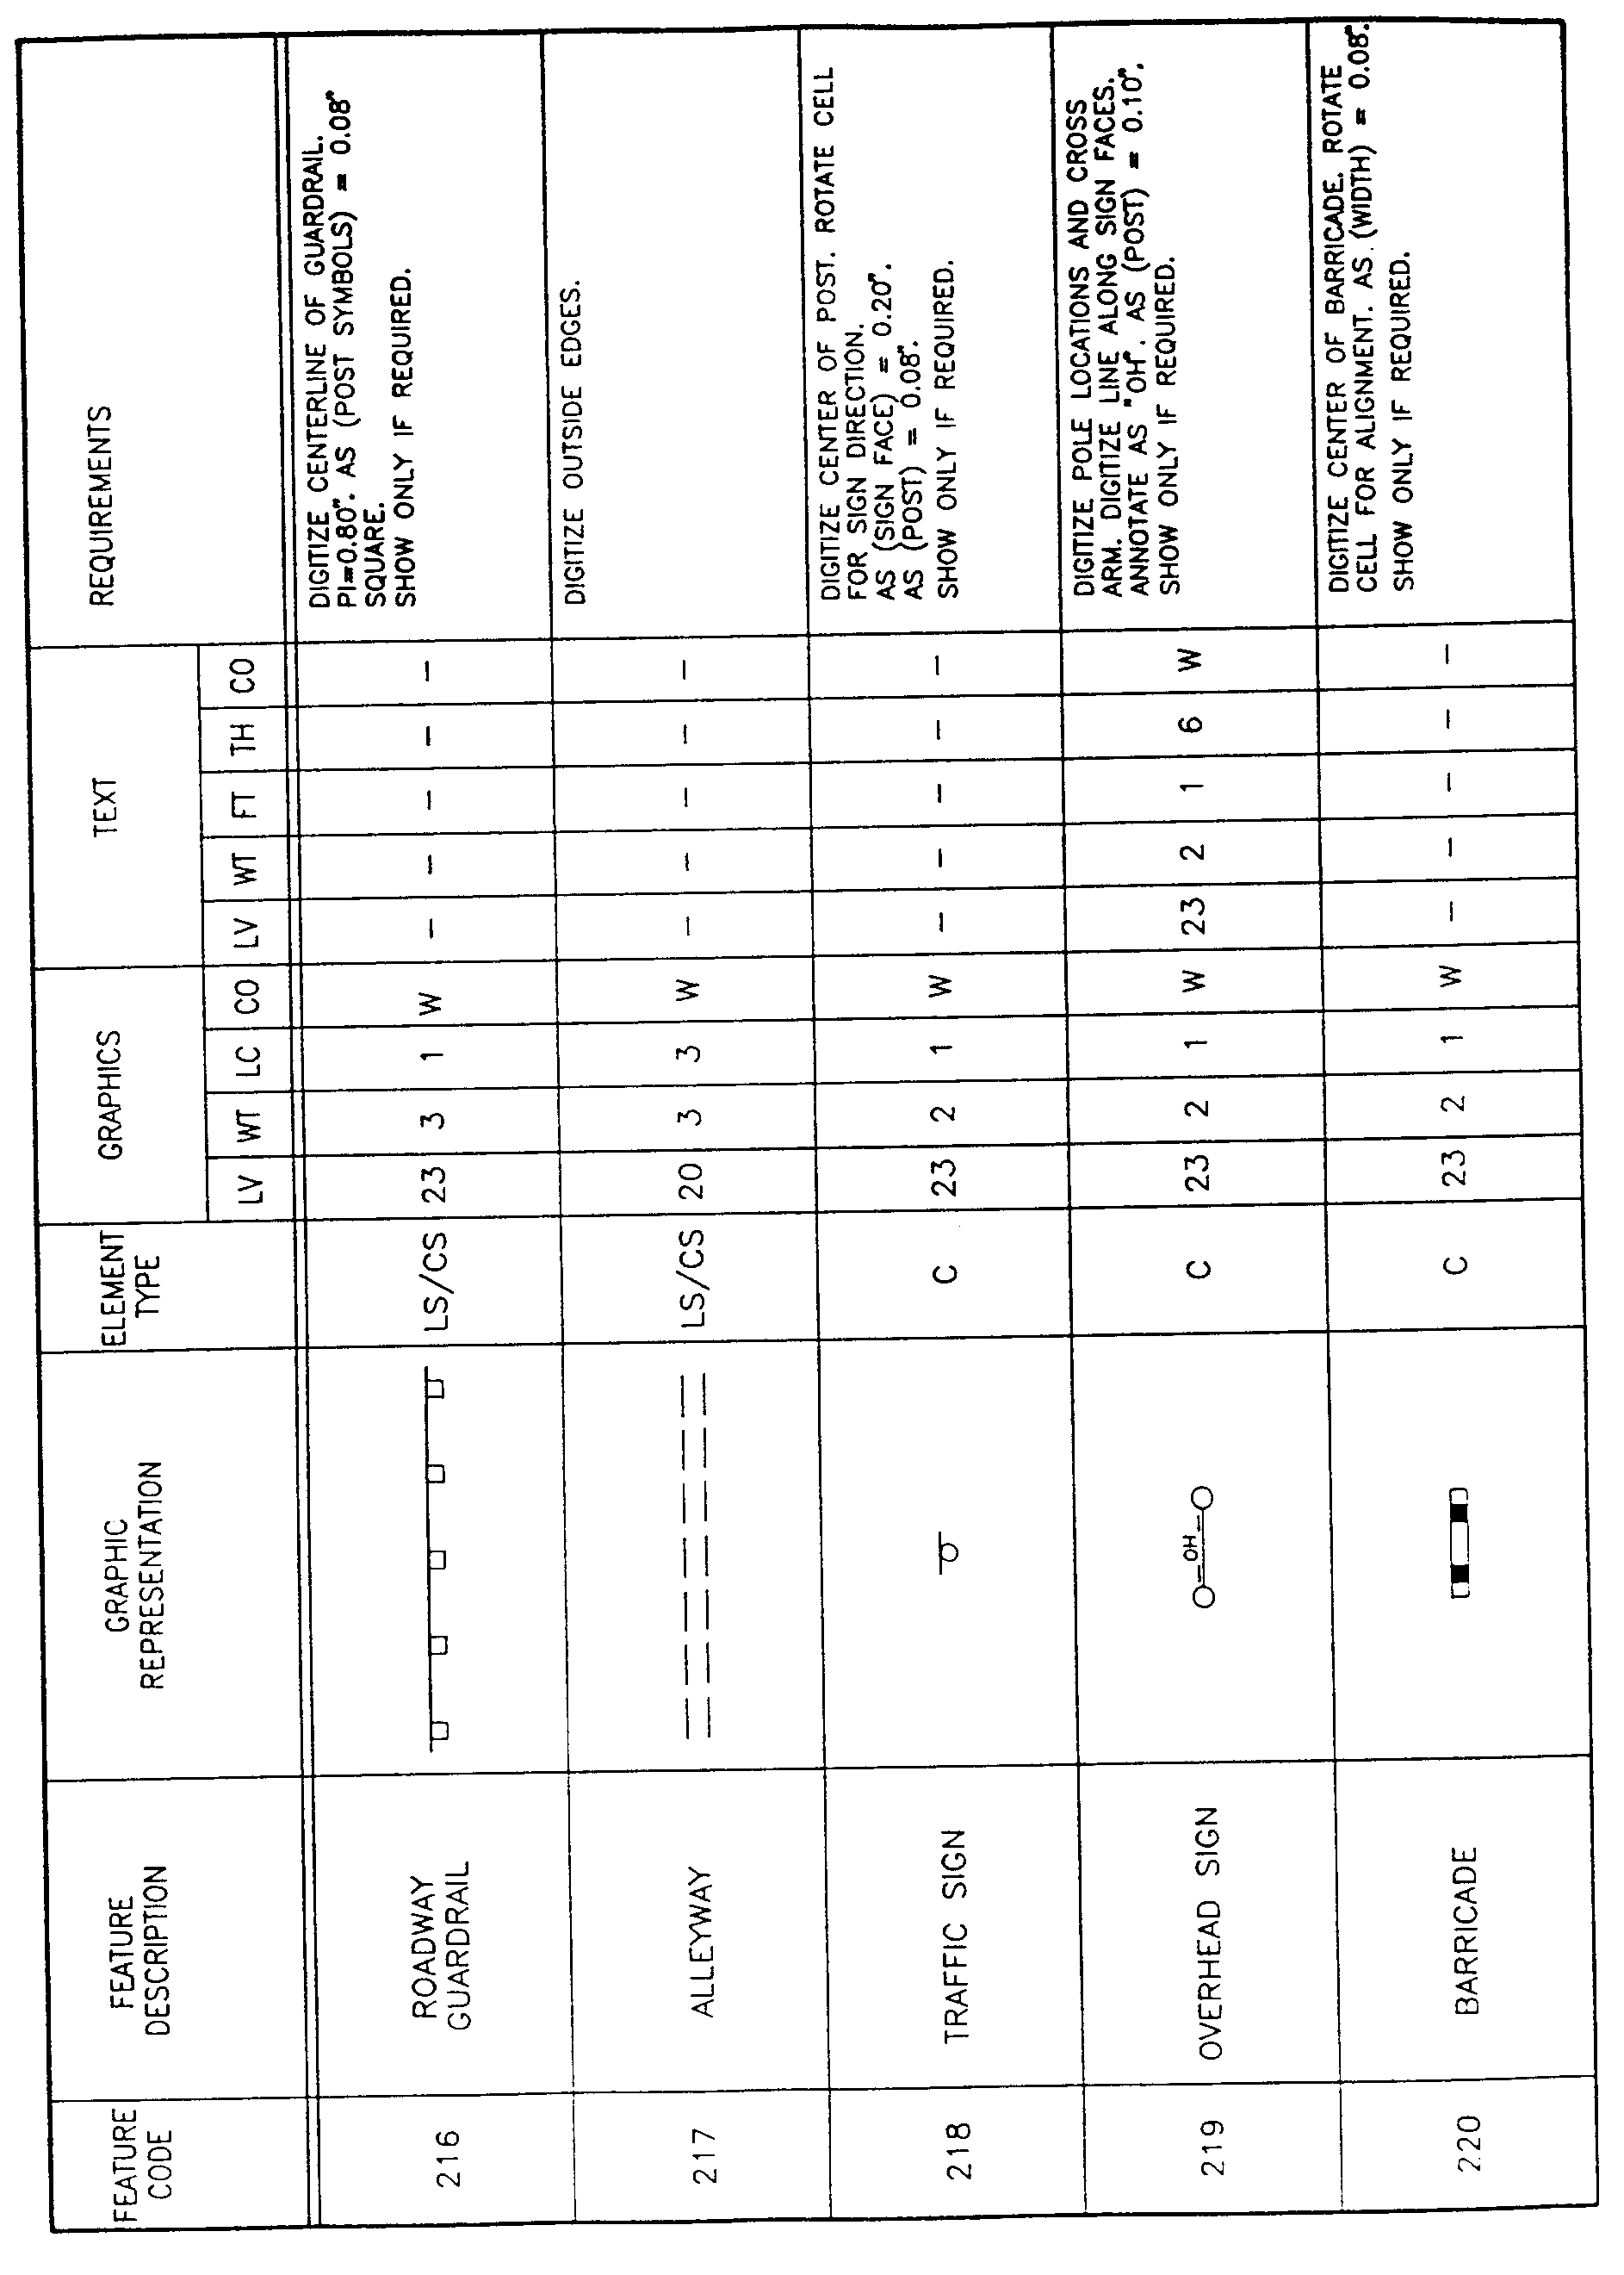
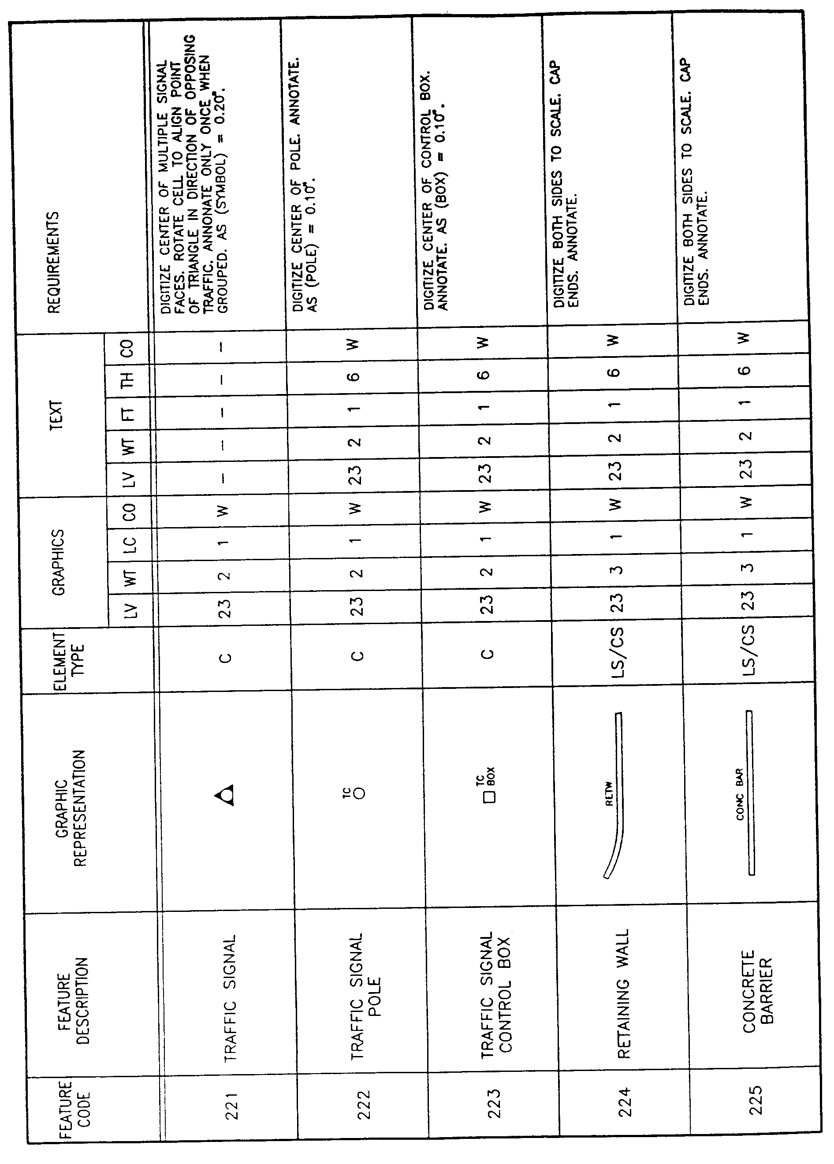
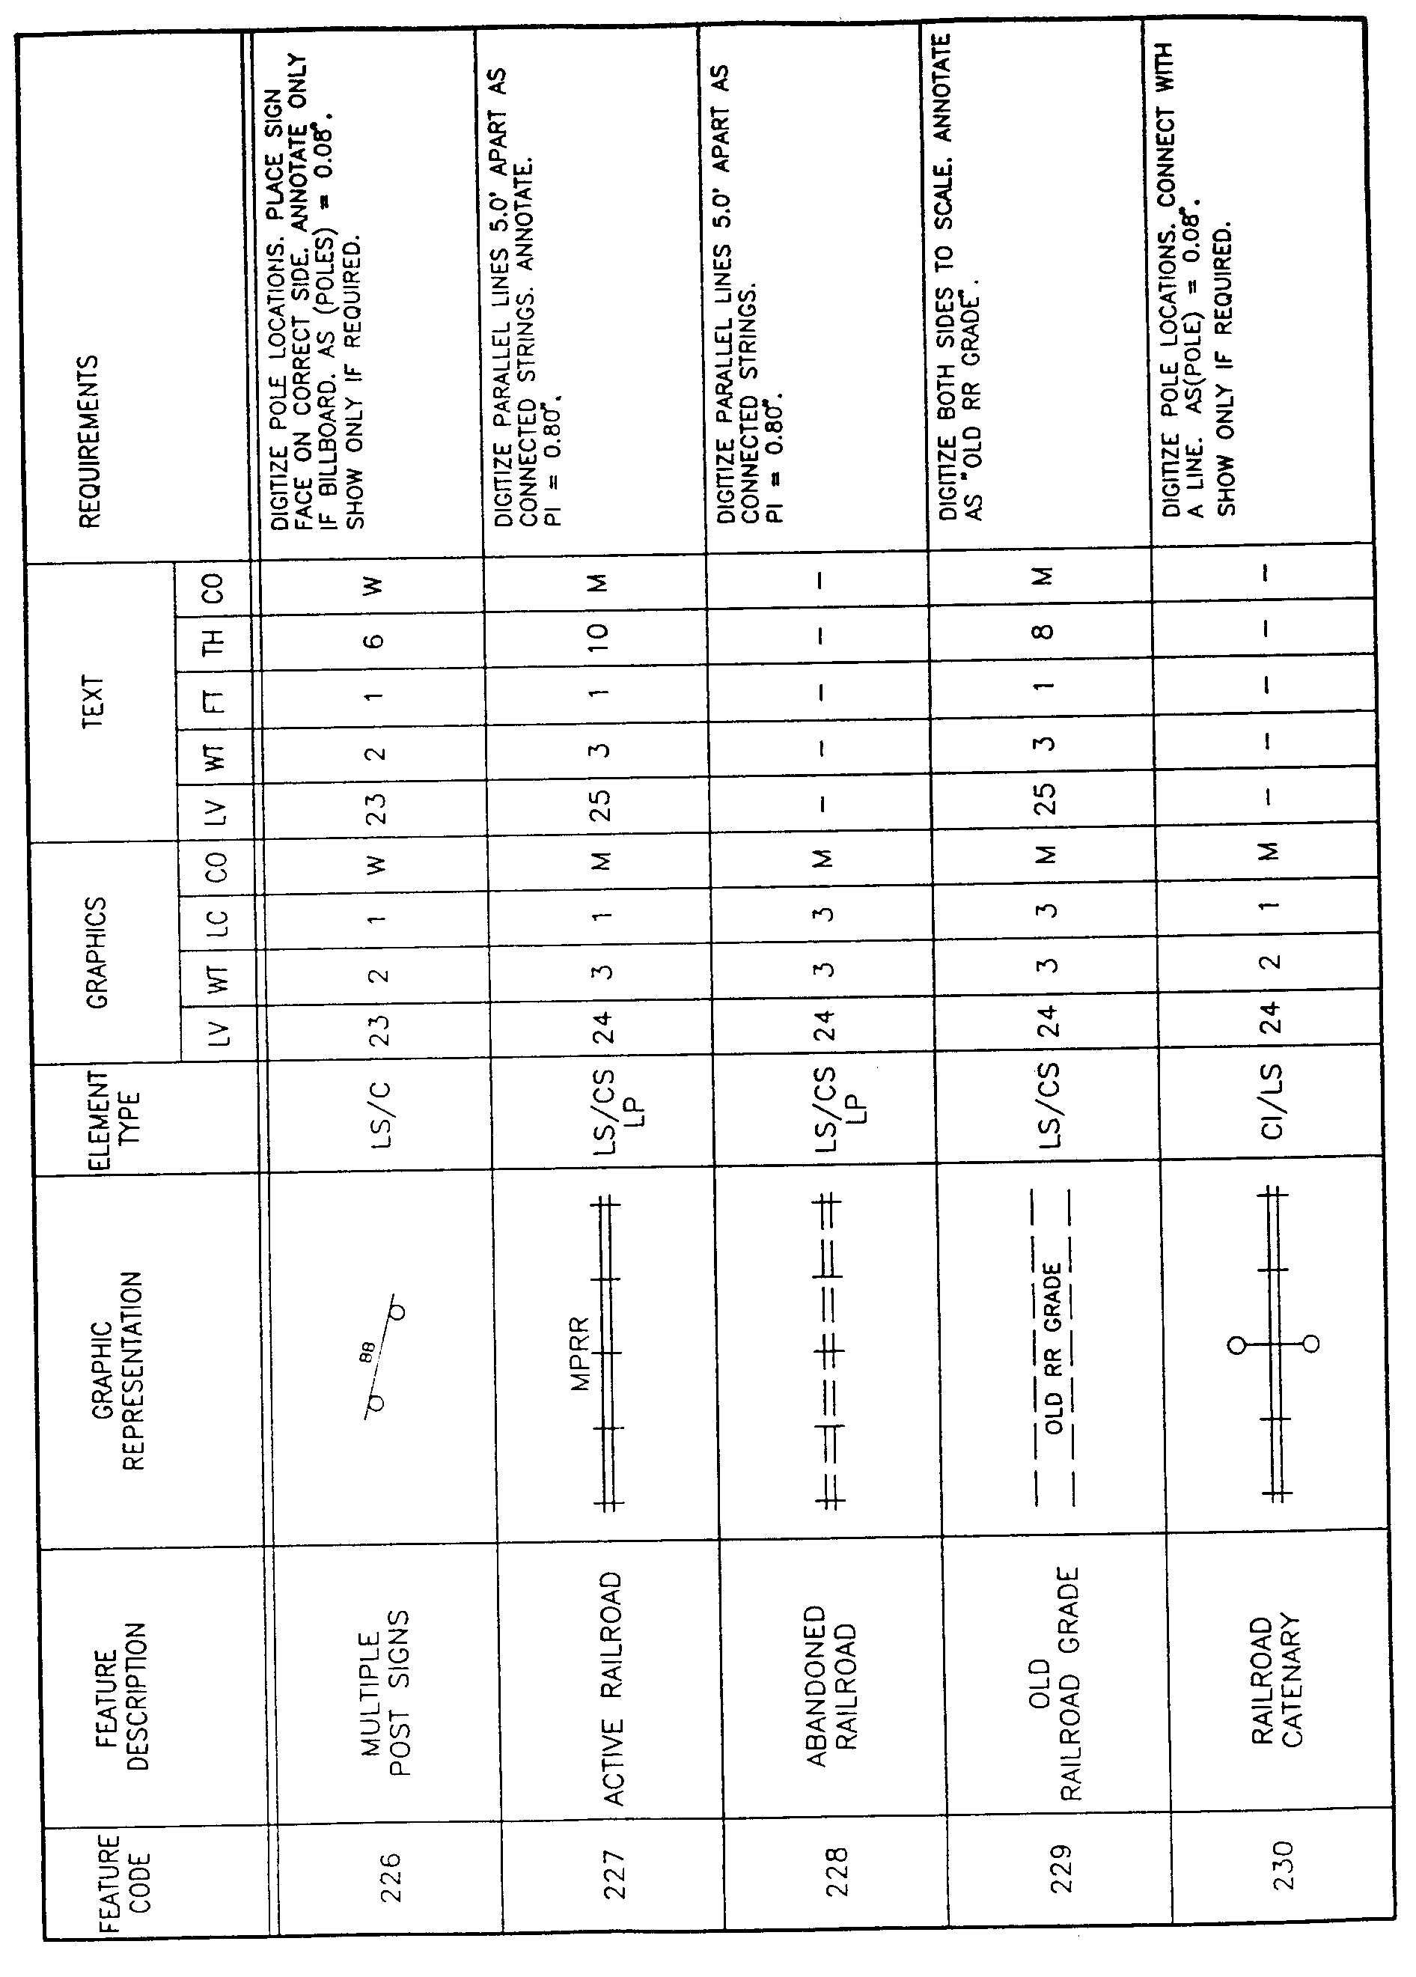
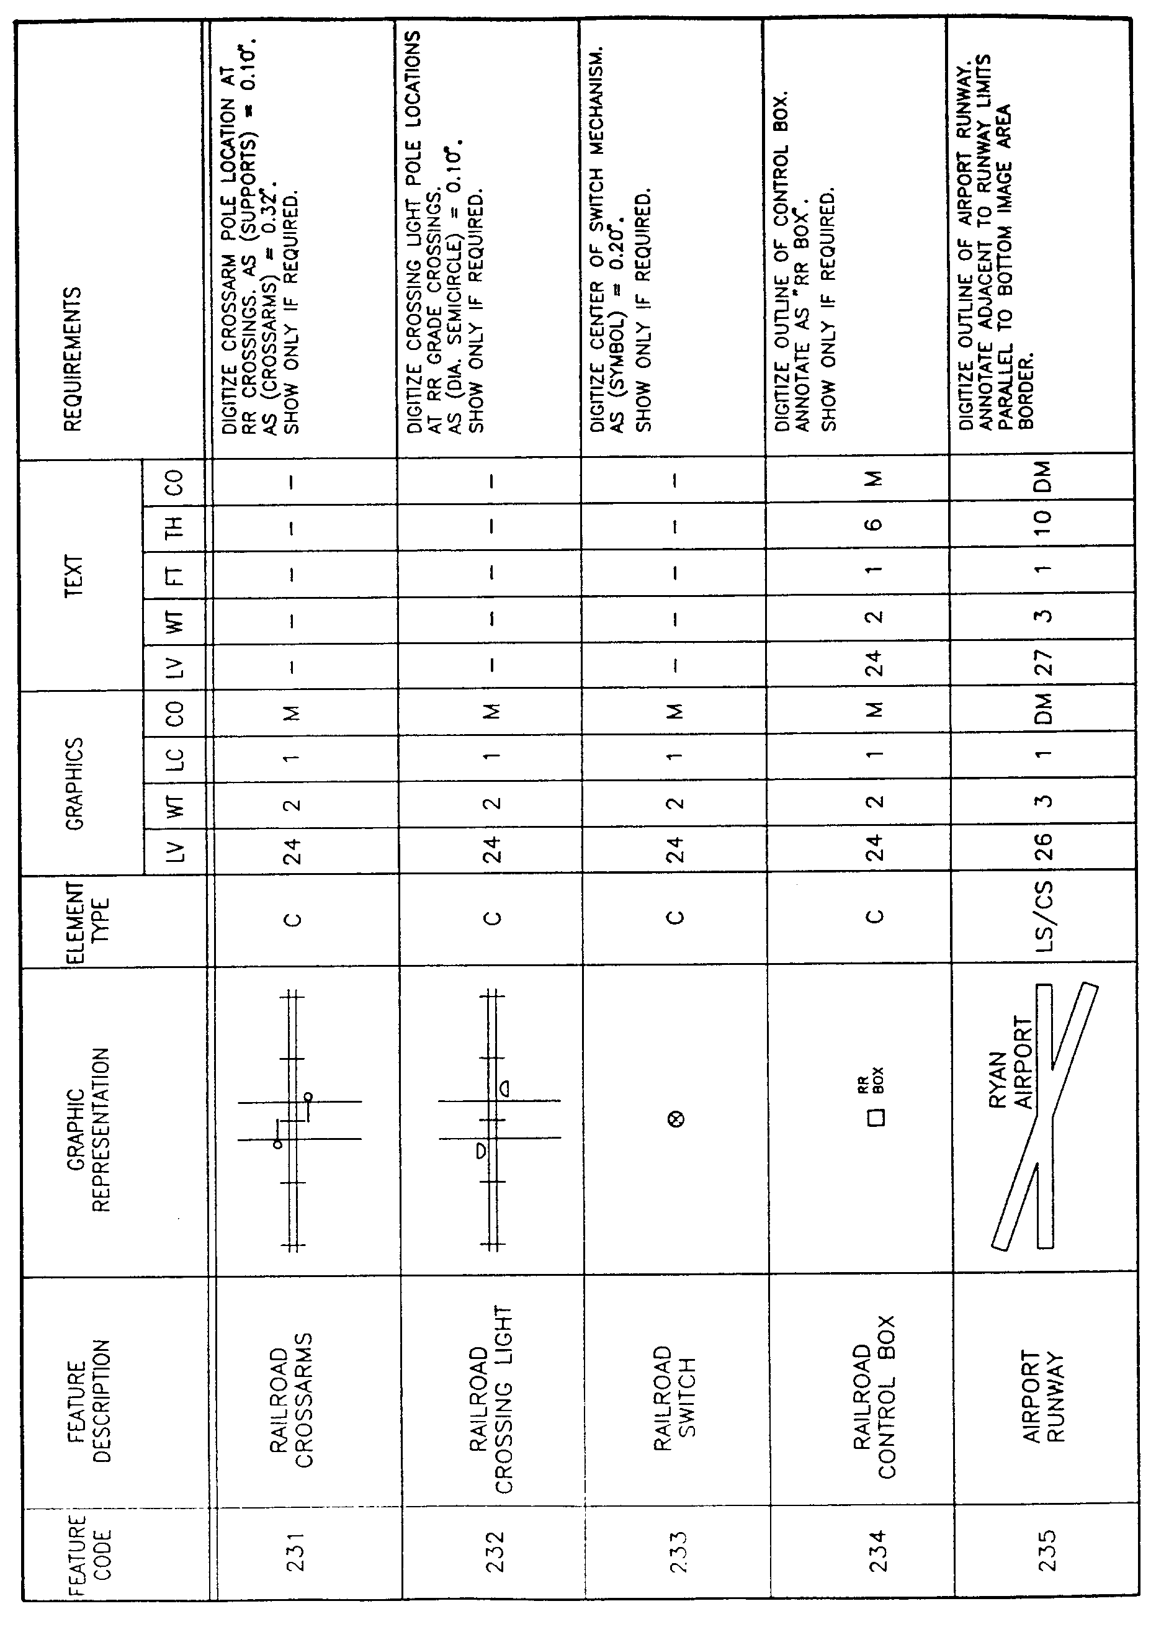
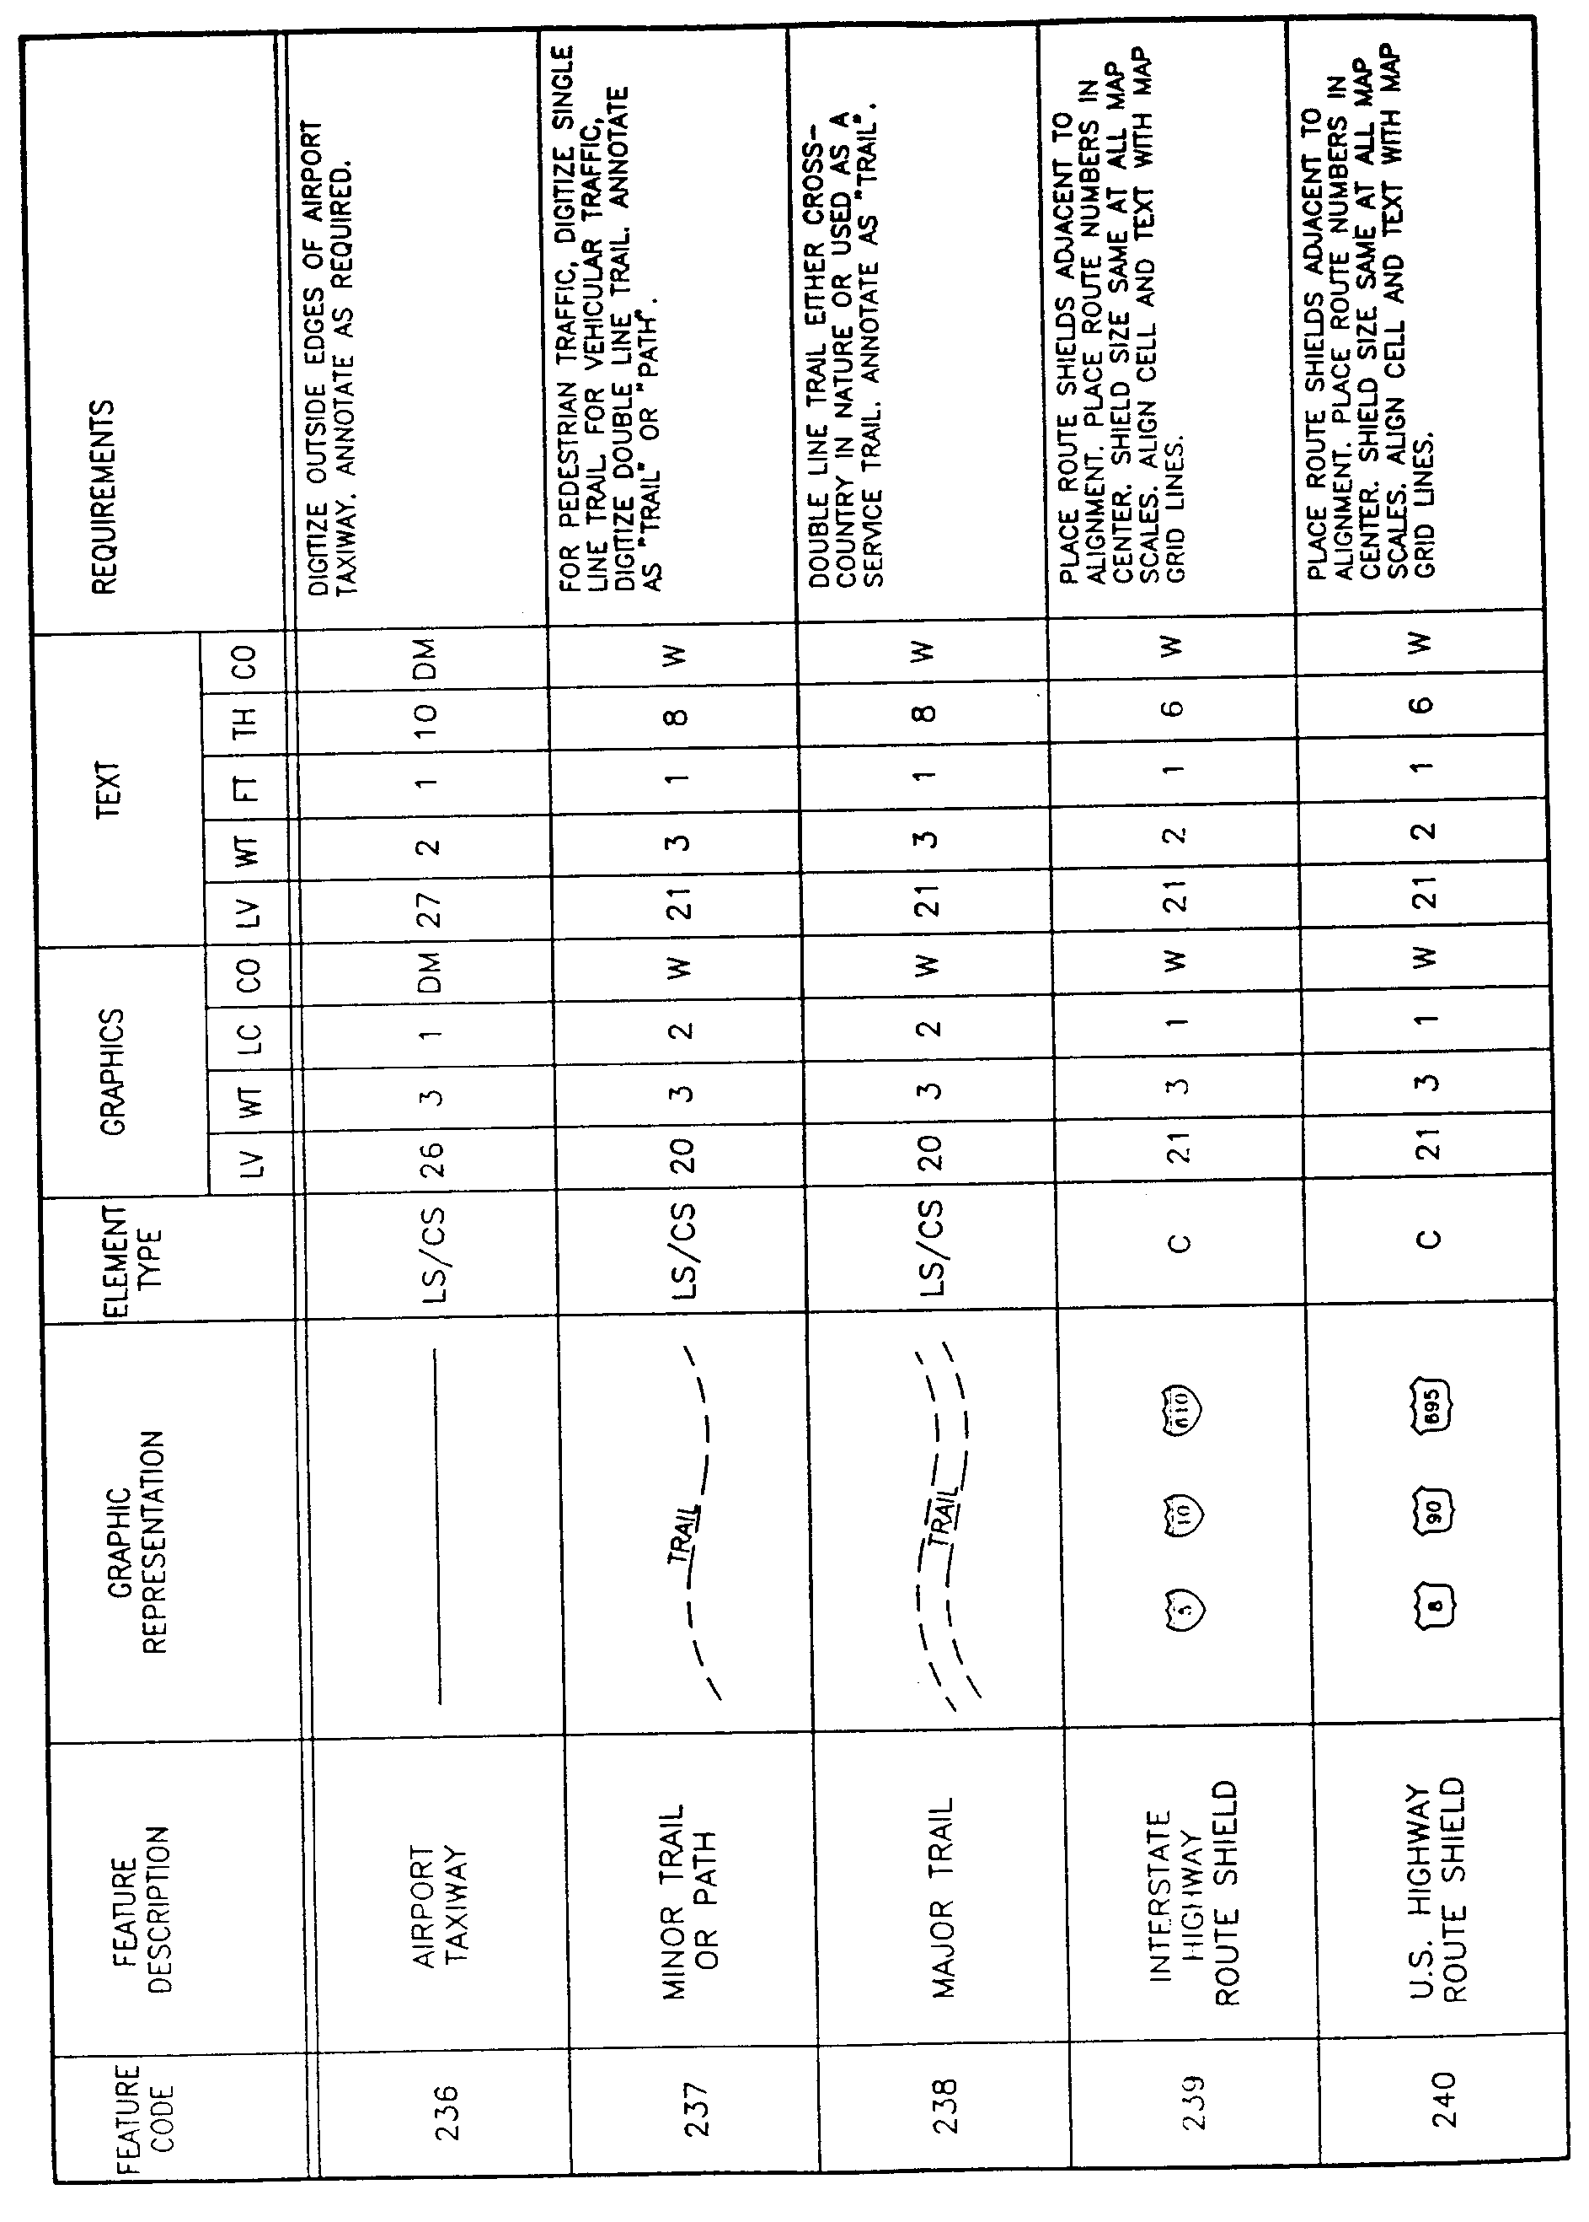

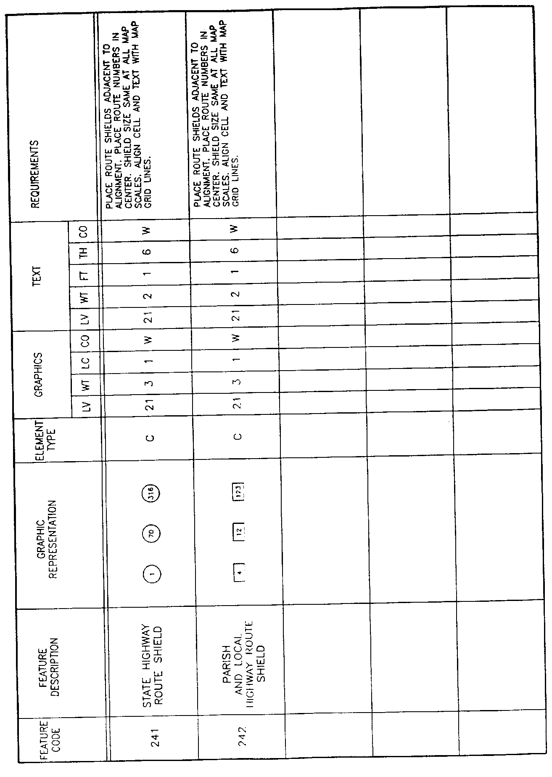

AUTHORITY NOTE: Promulgated in accordance with R.S. 50:171.
HISTORICAL NOTE: Promulgated by the Office of the Governor, Division of Administration, State Land Office, LR 17:968 (October 1991).

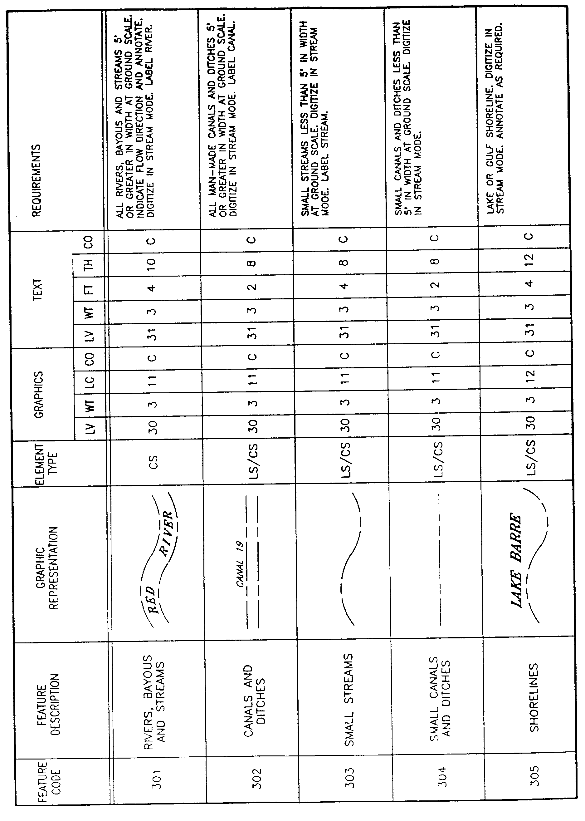
§1921. Appendix D―Layer Category 3―Hydrology Feature Elements
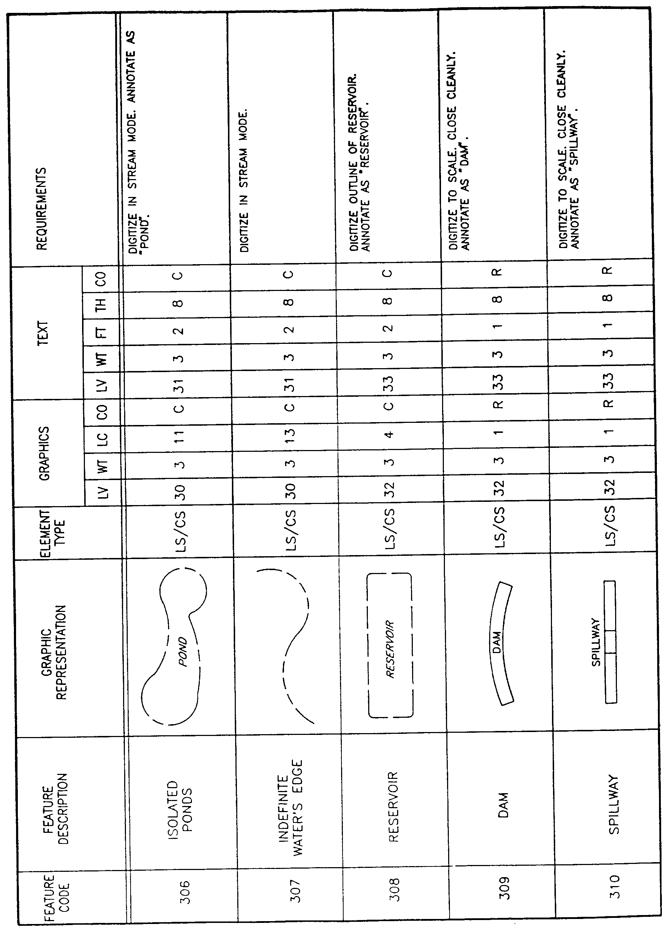
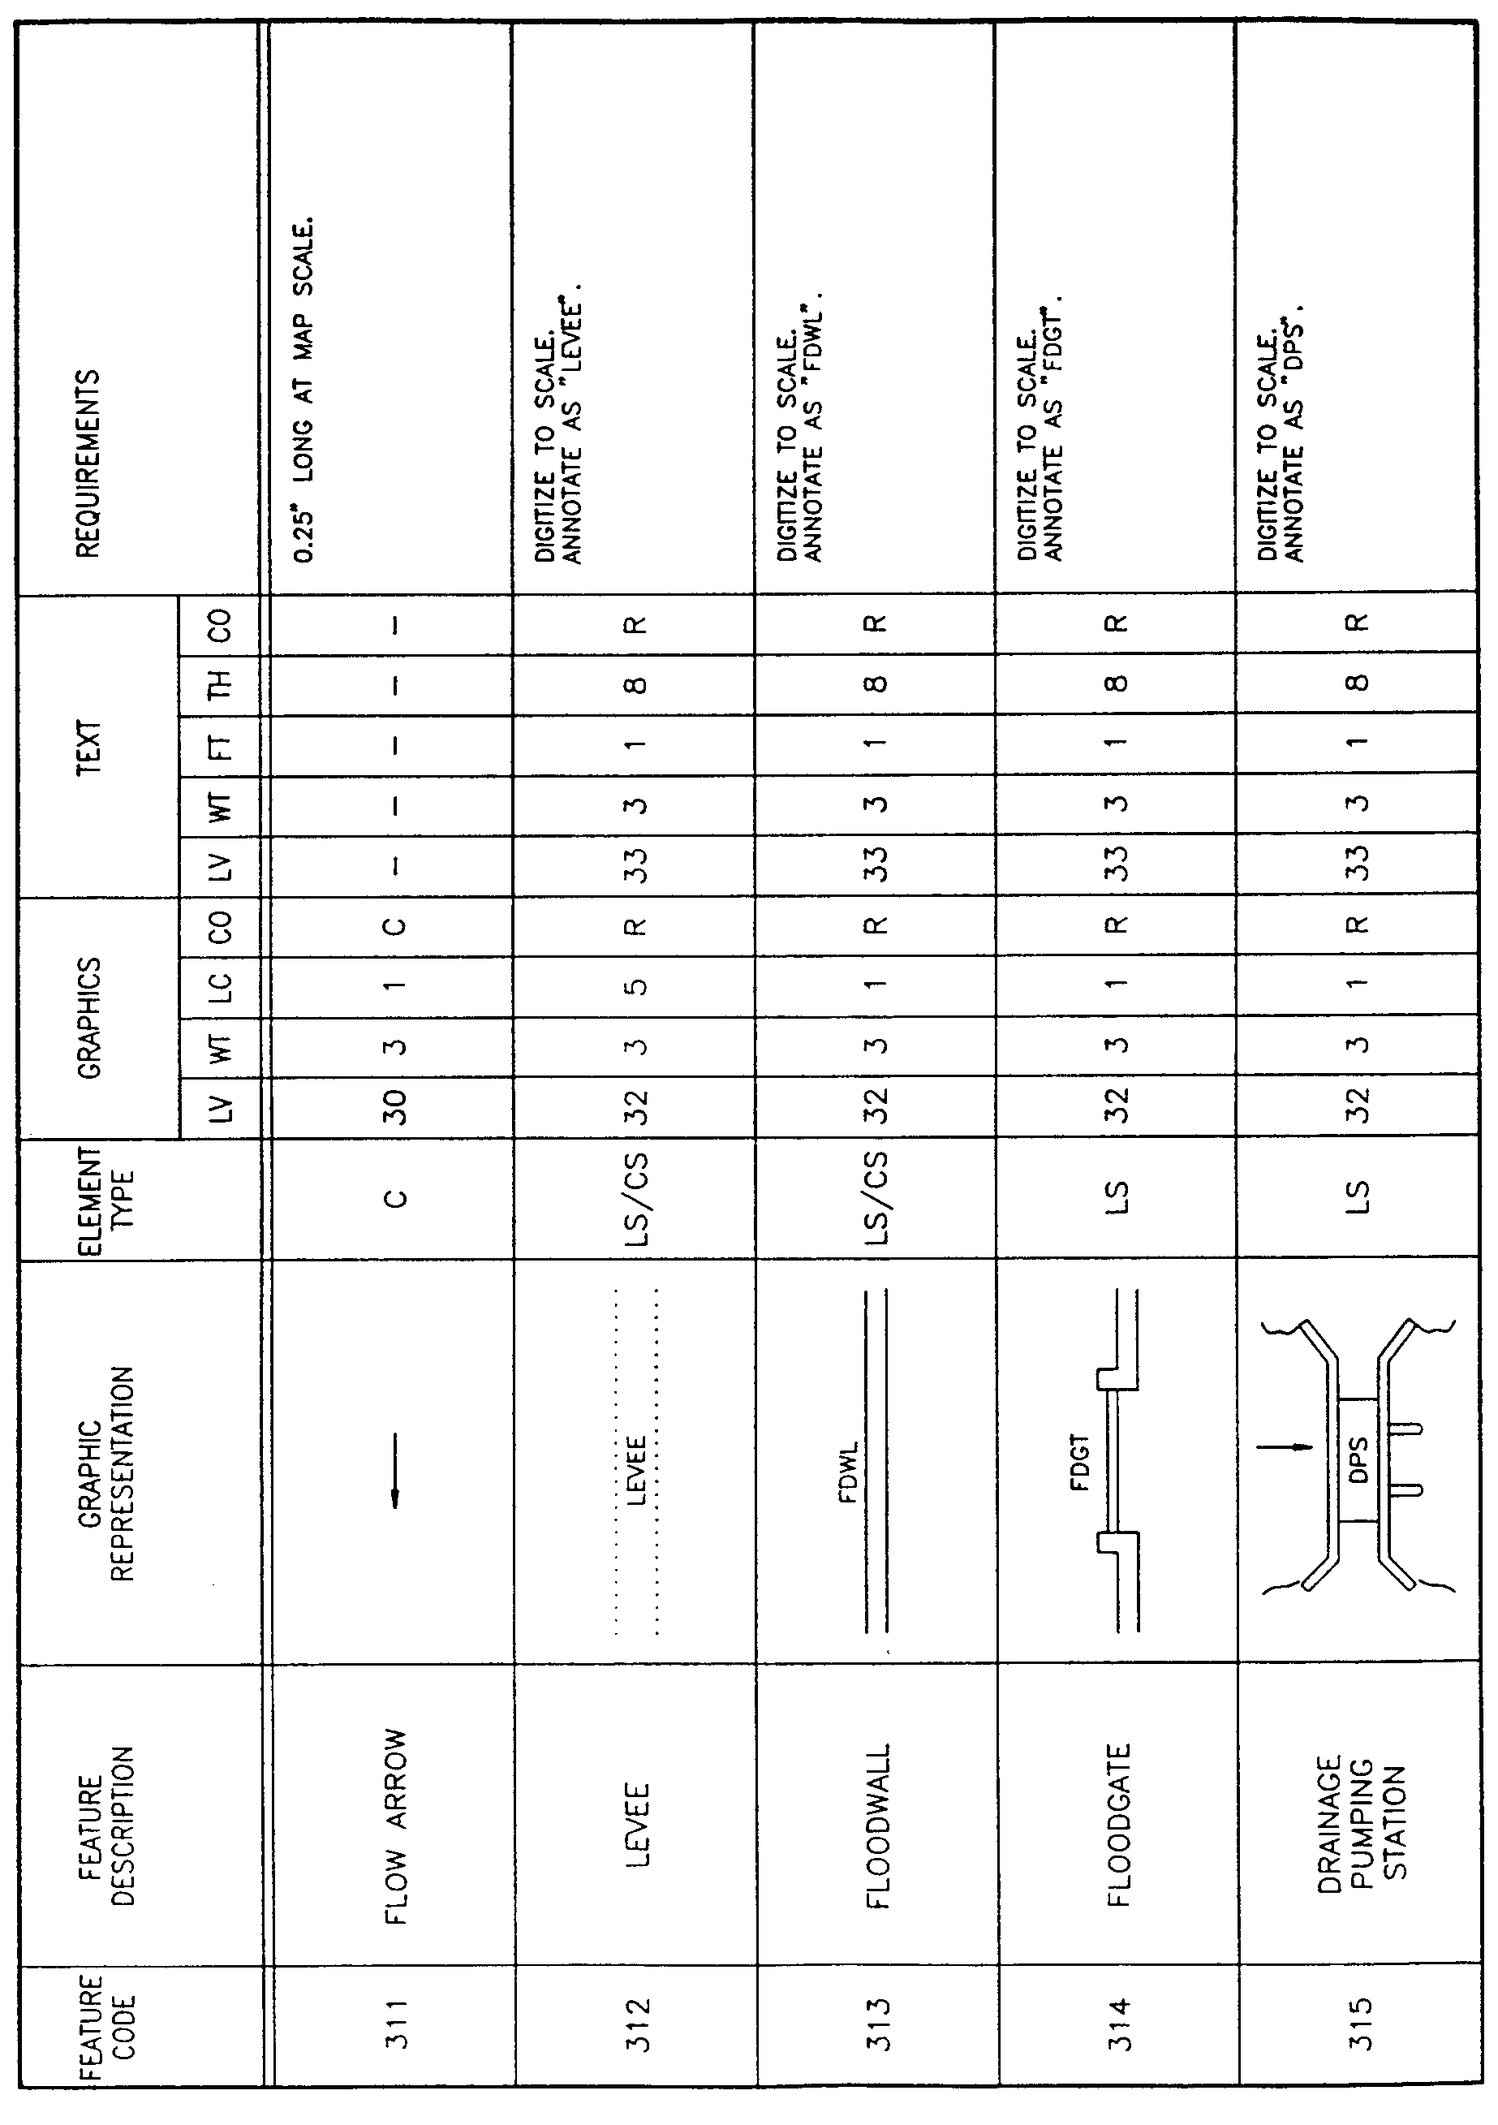
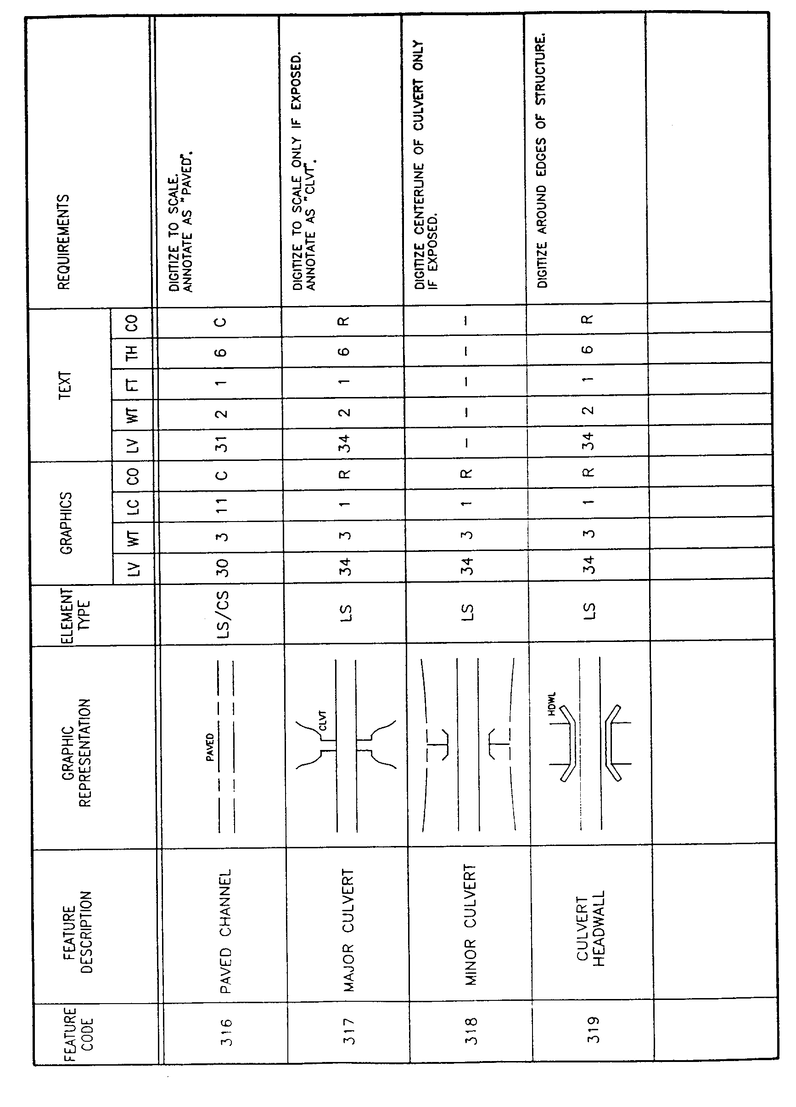
AUTHORITY NOTE: Promulgated in accordance with R.S. 50:171.
HISTORICAL NOTE: Promulgated by the Office of the Governor, Division of Administration, State Land Office, LR 17:968 (October 1991).

§1923. Appendix E―Layer Category 4―Terrain Feature Elements

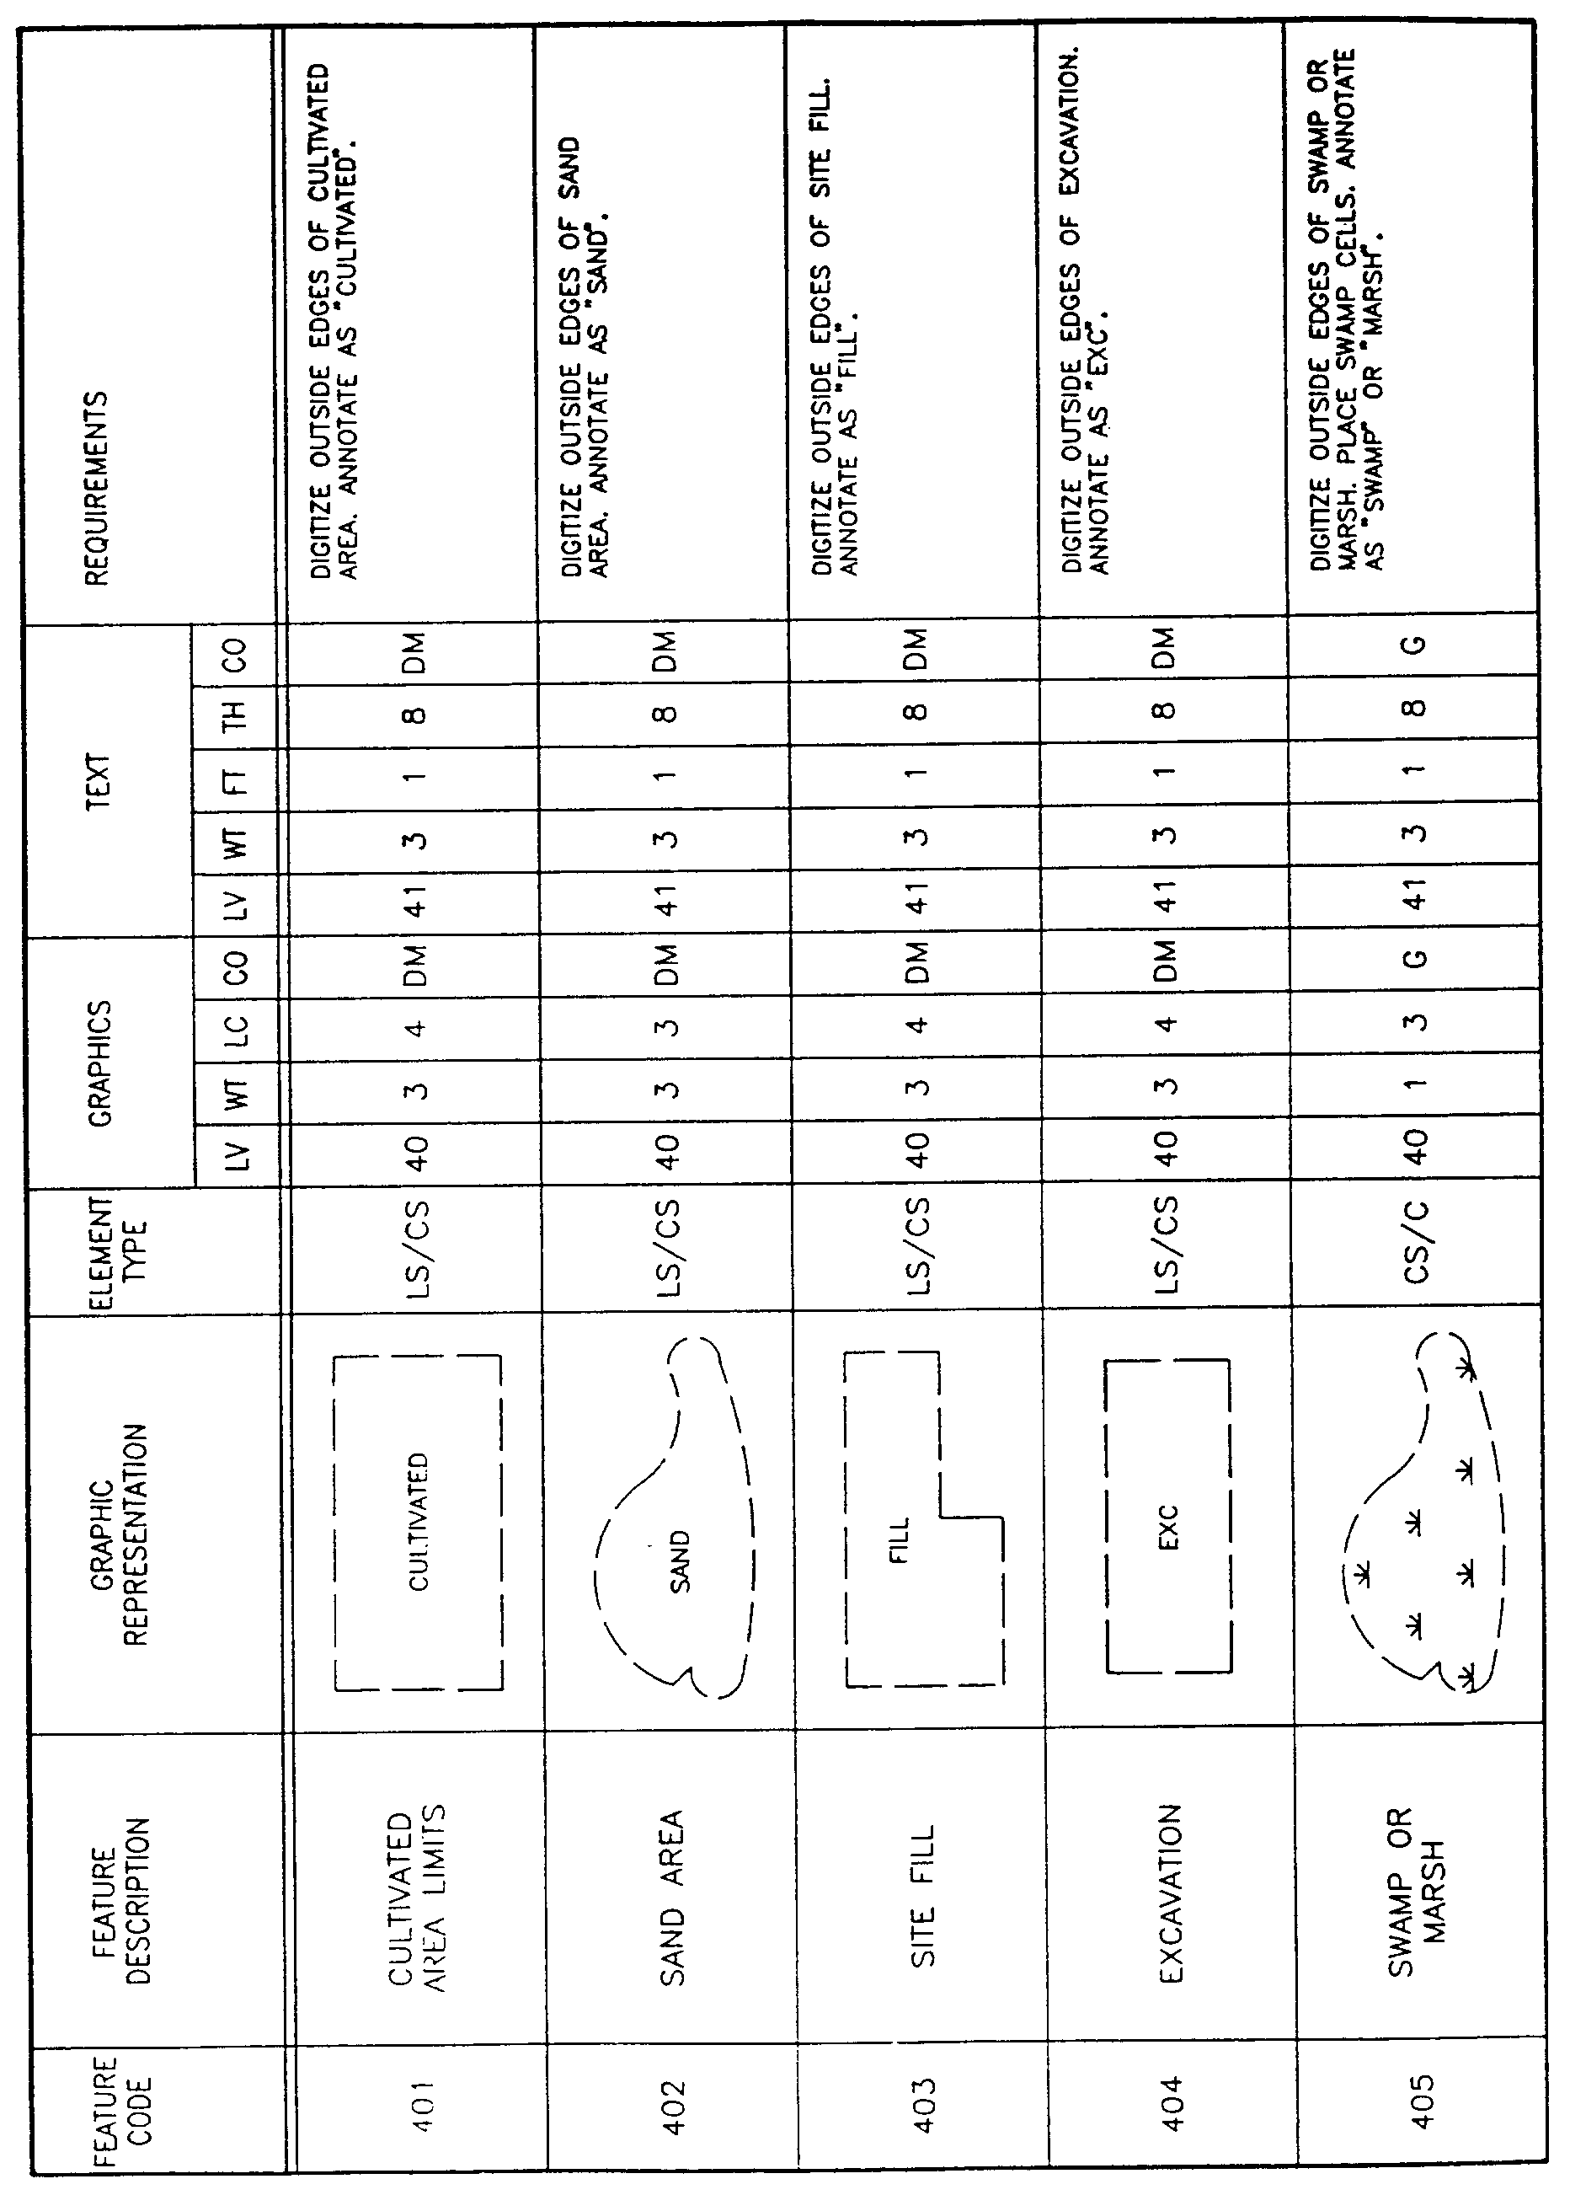
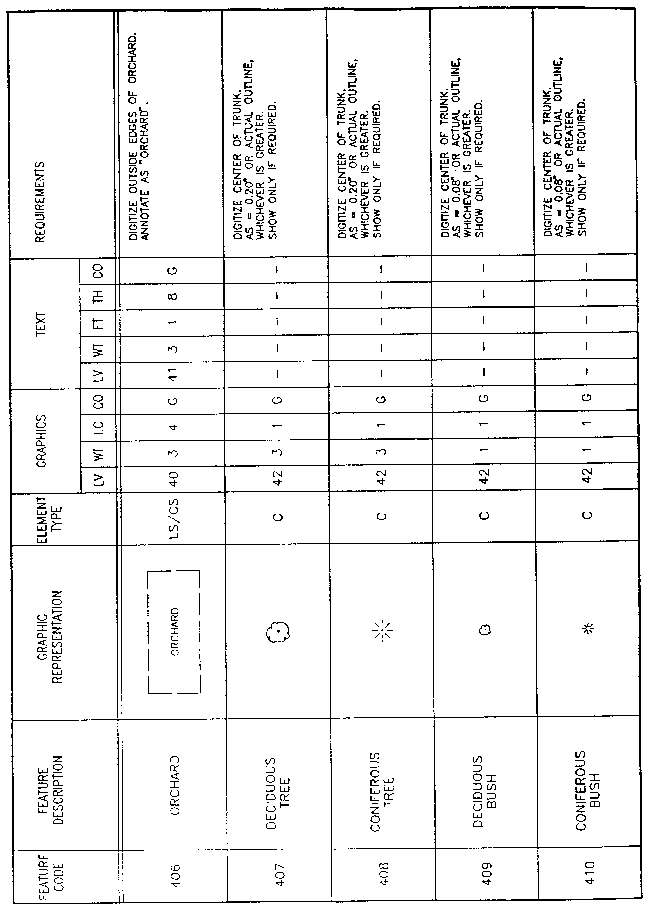
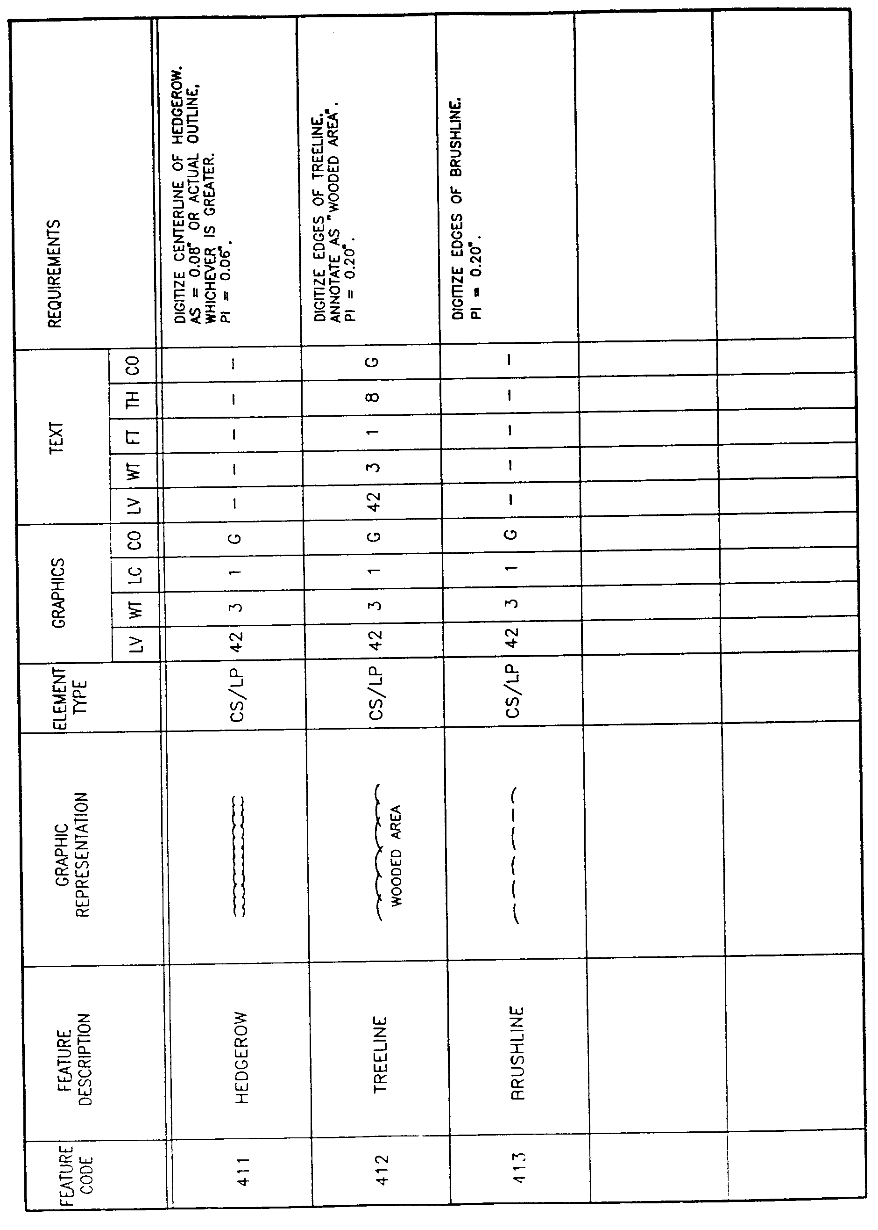
AUTHORITY NOTE: Promulgated in accordance with R.S. 50:171.
HISTORICAL NOTE: Promulgated by the Office of the Governor, Division of Administration, State Land Office, LR 17:968 (October 1991).

§1925. Appendix F―Layer Category 5―Structure Feature Elements
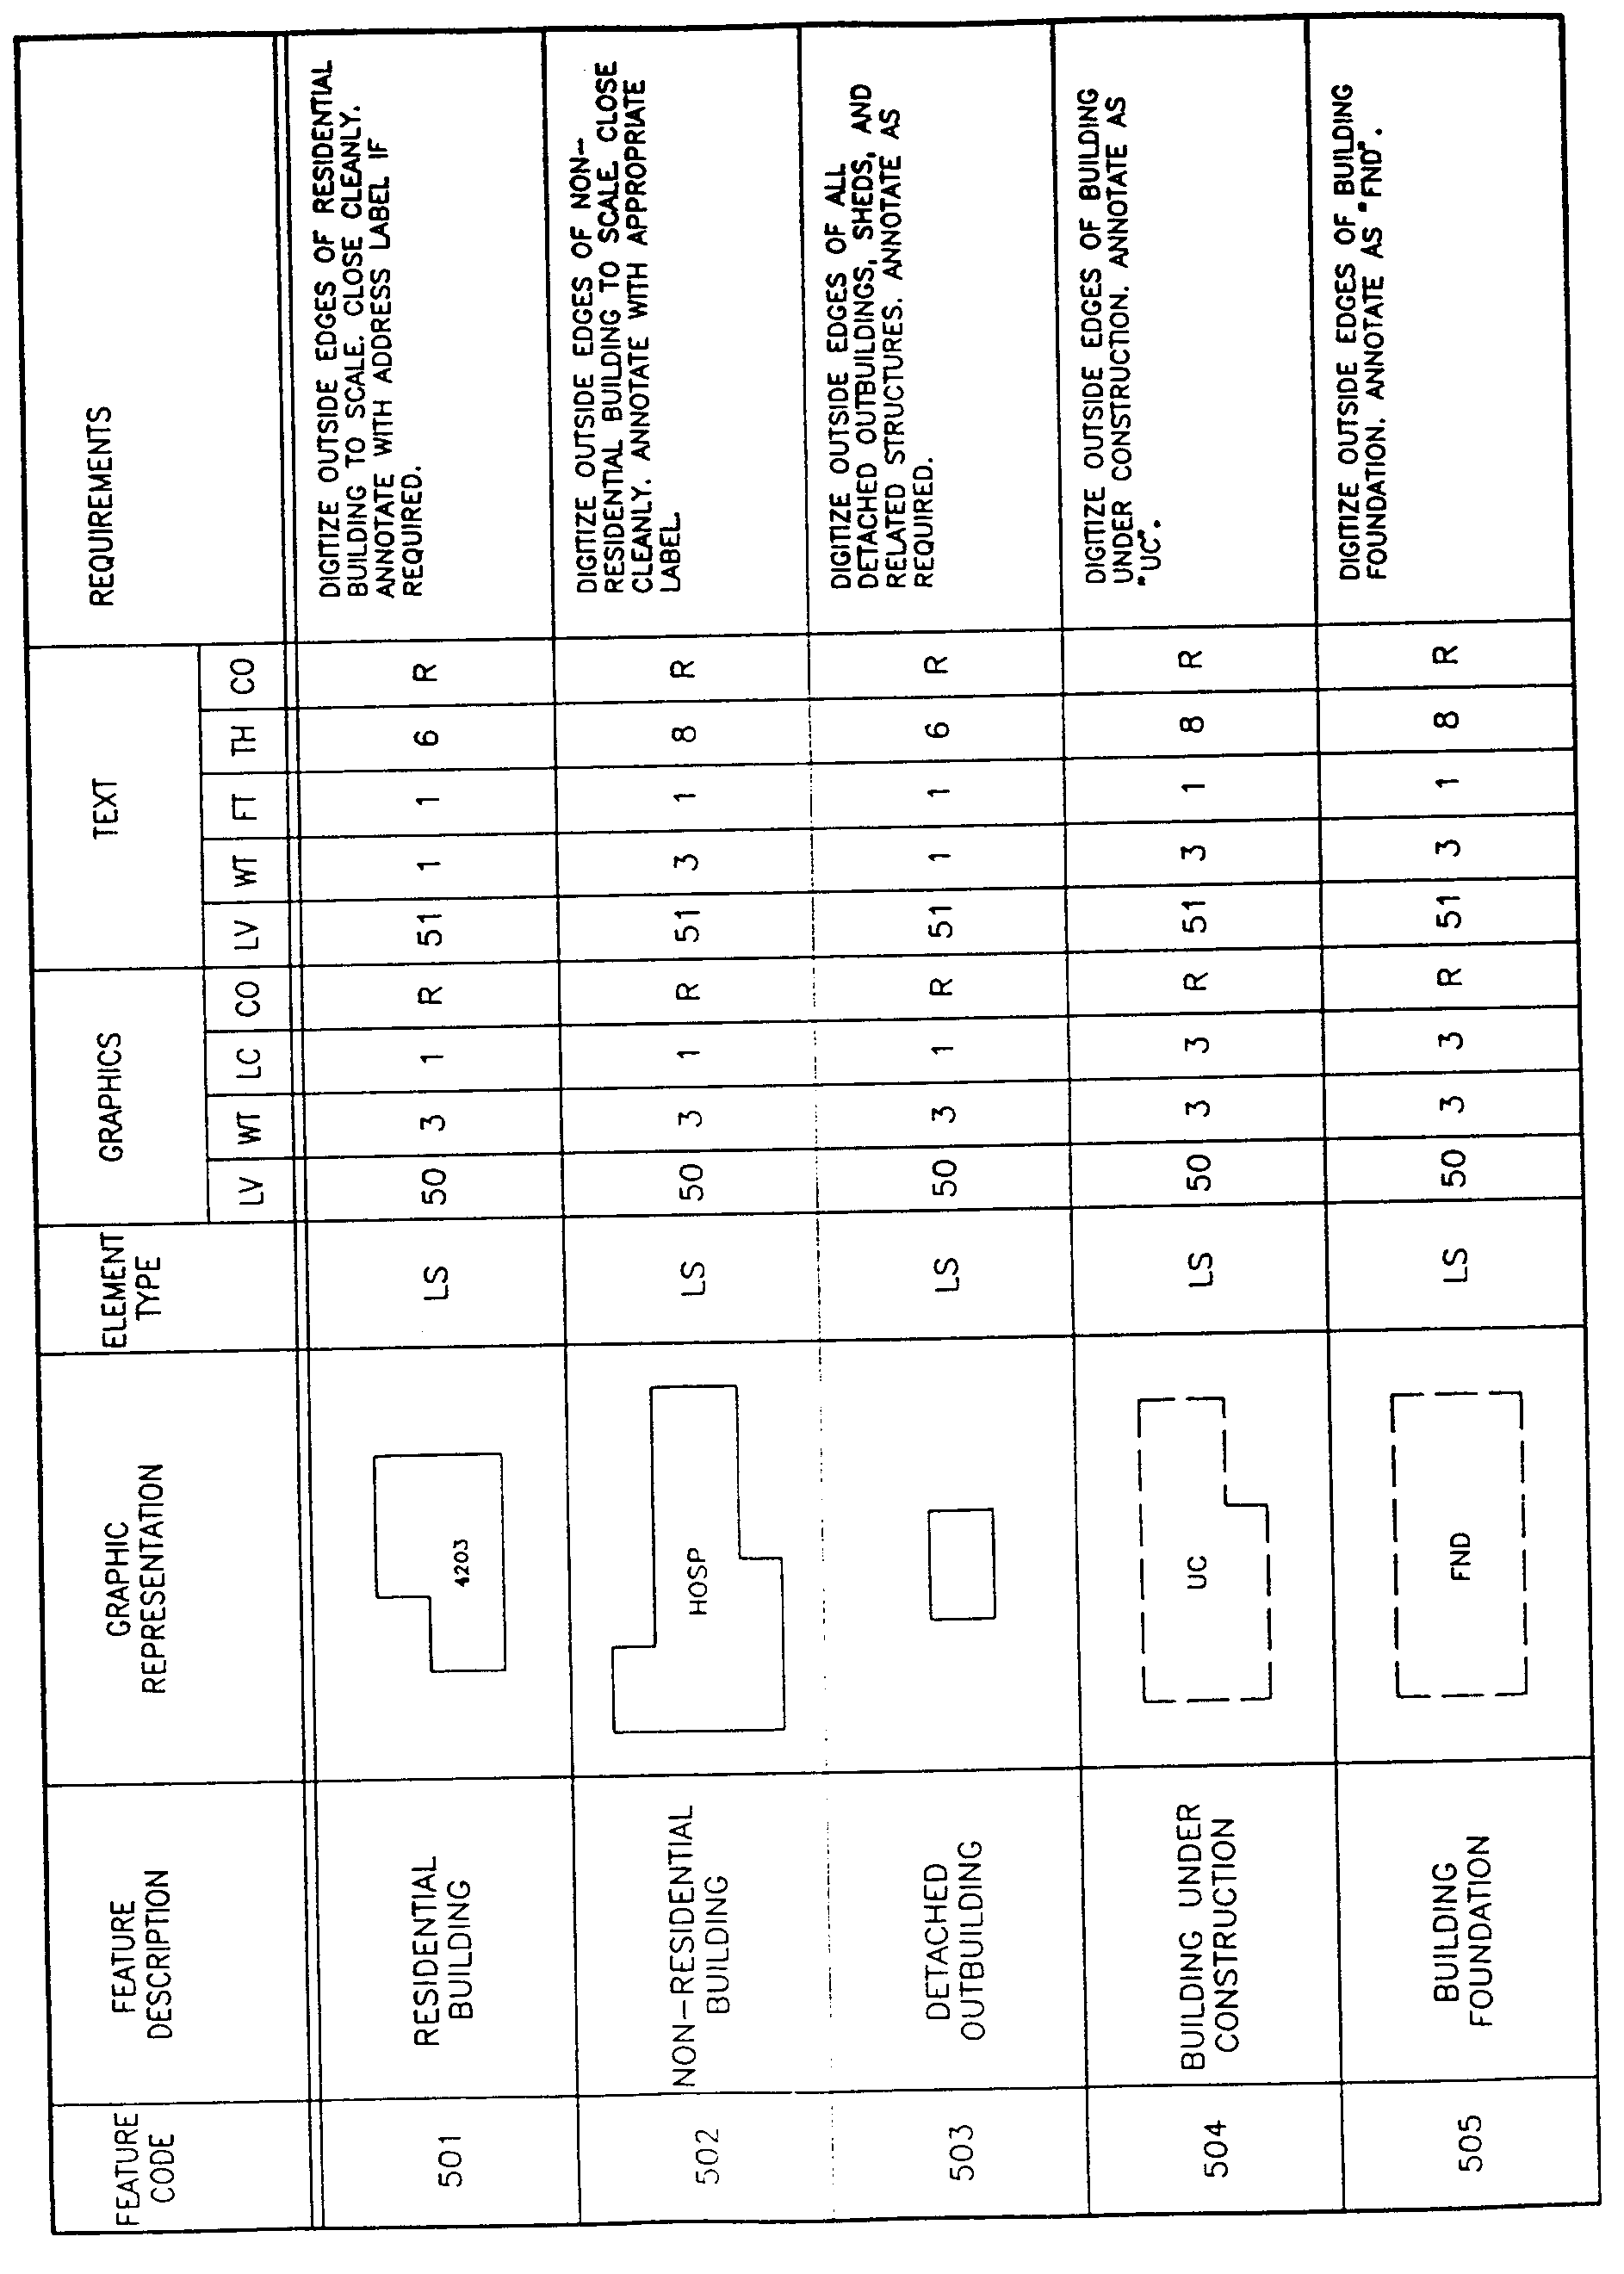
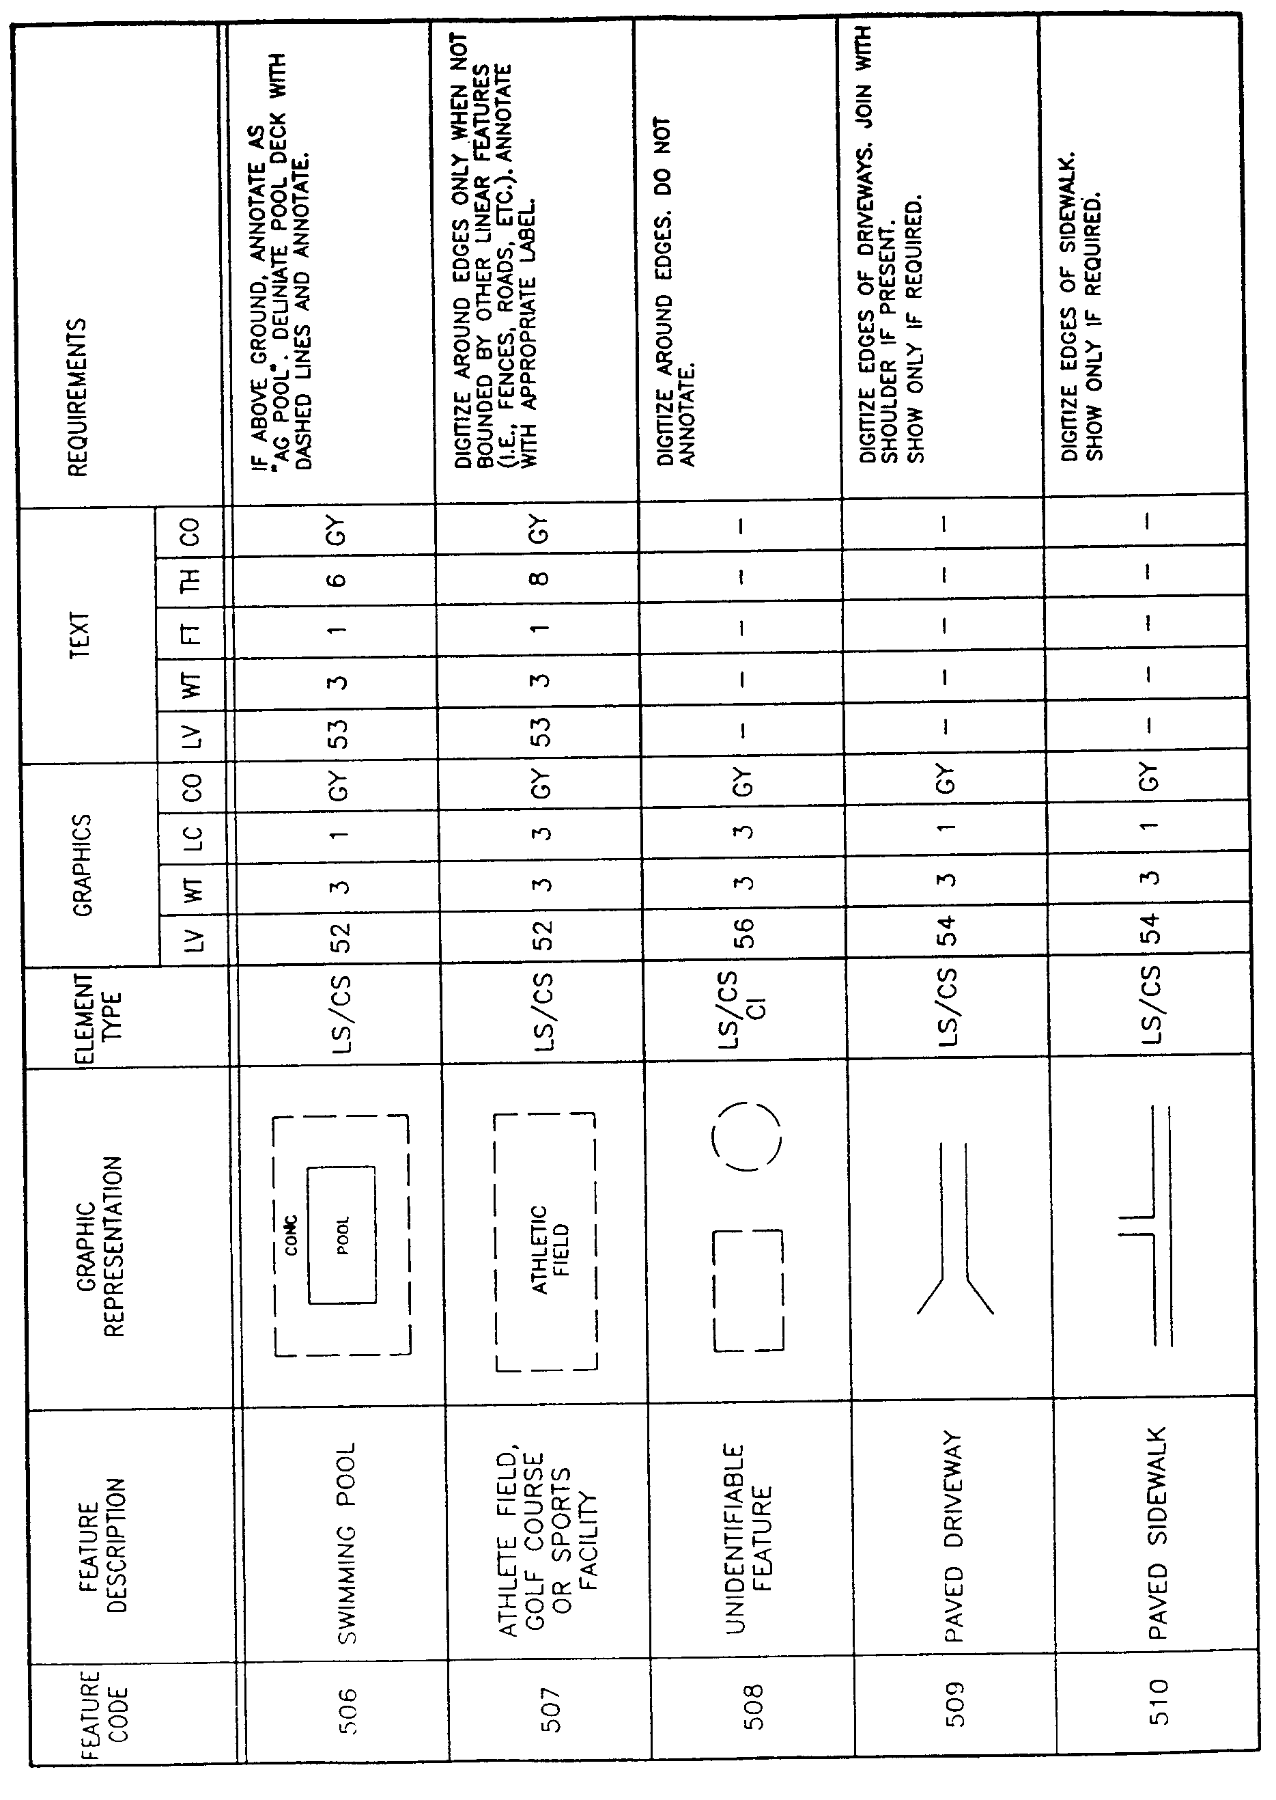
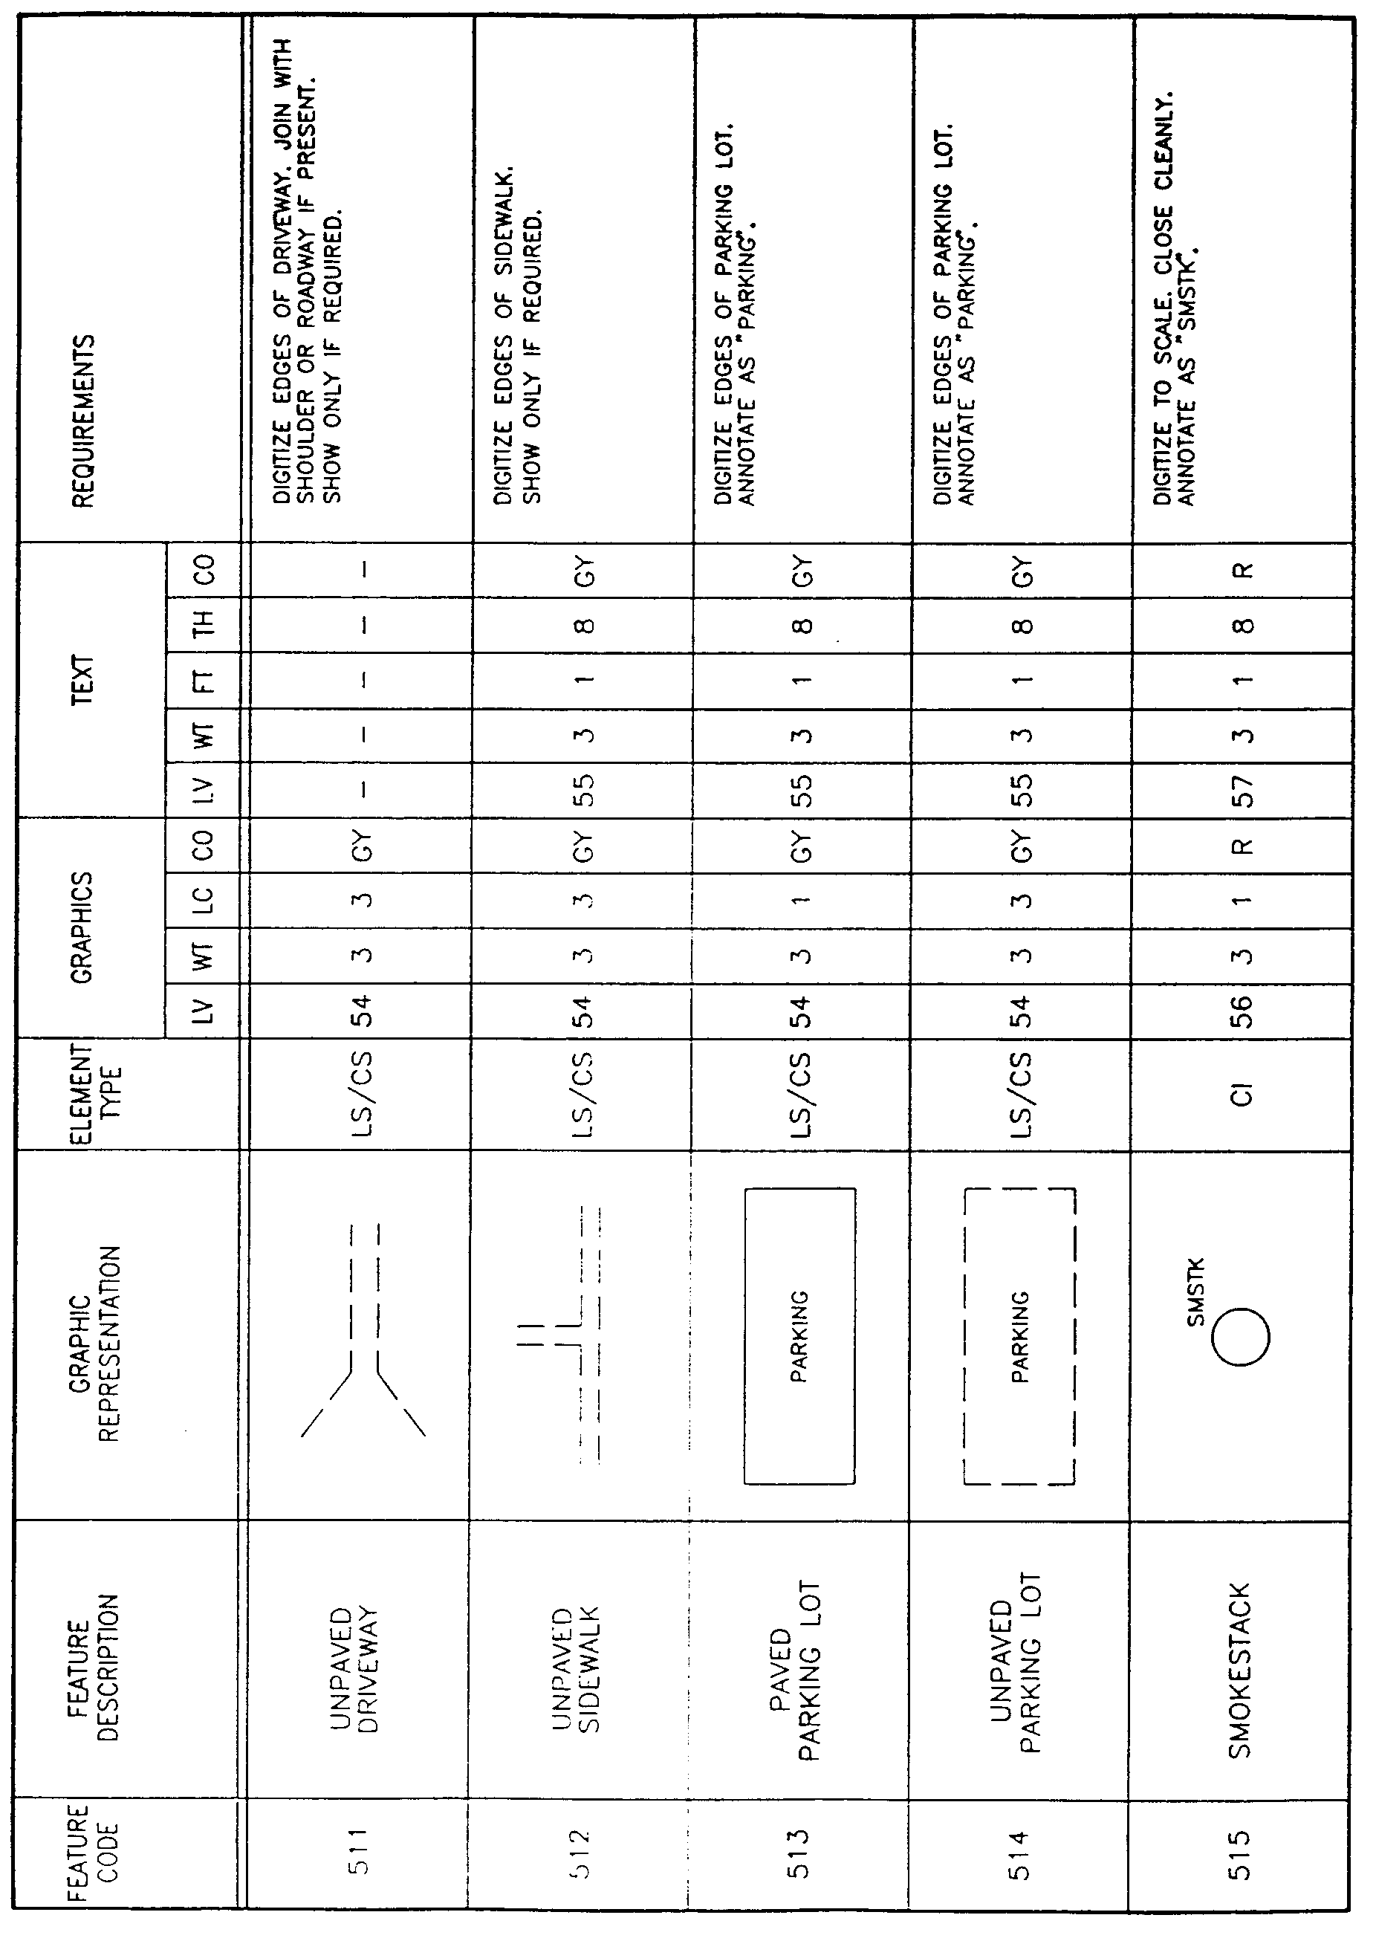
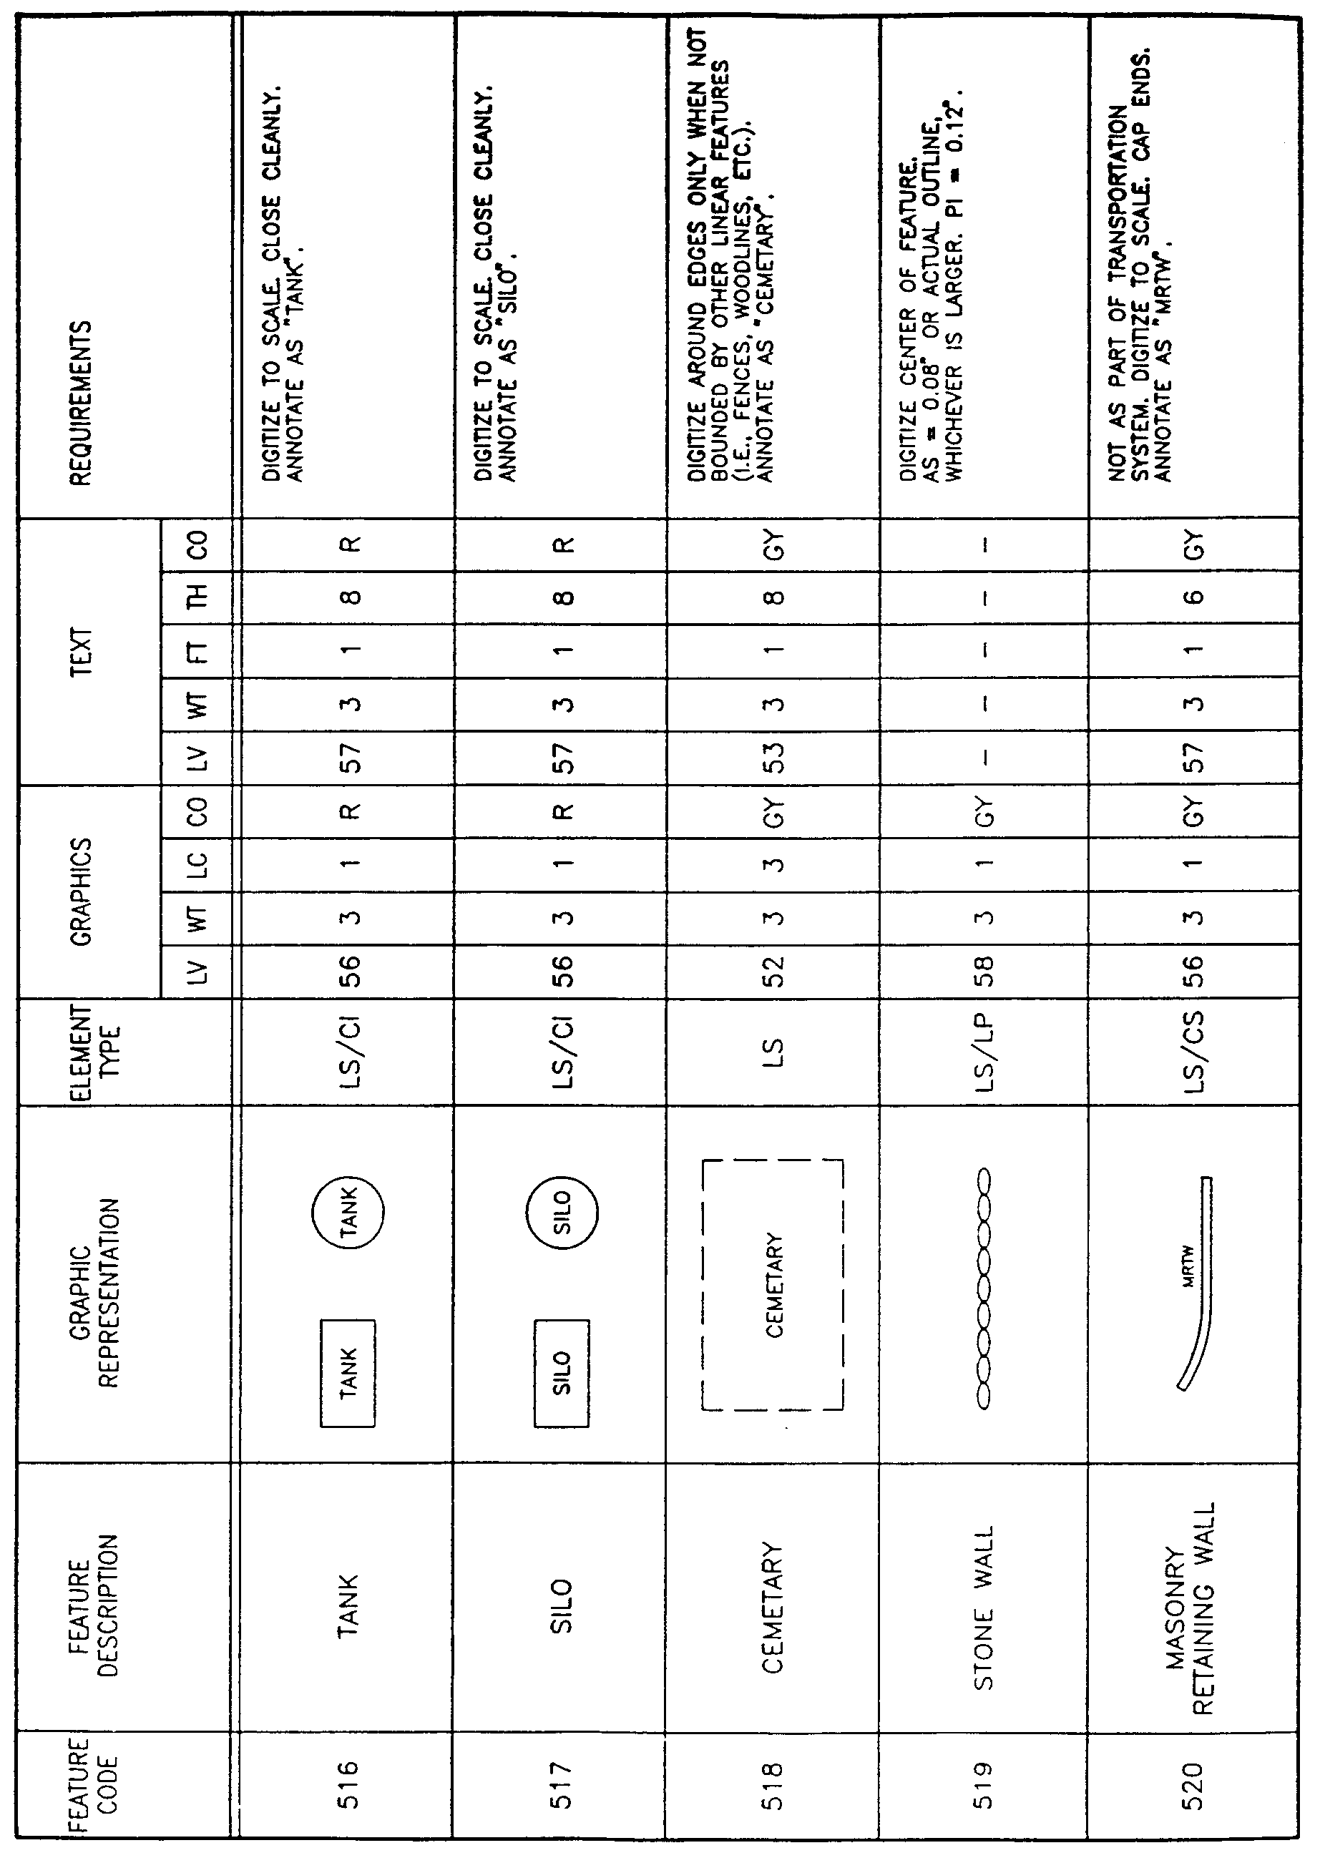
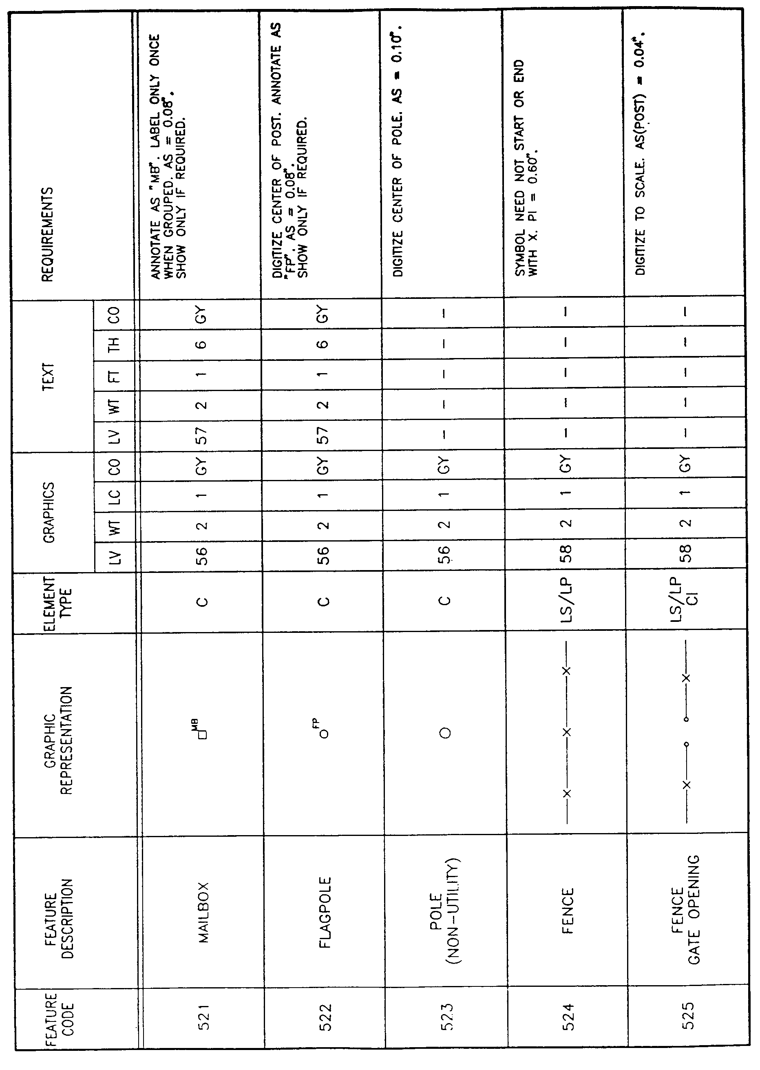
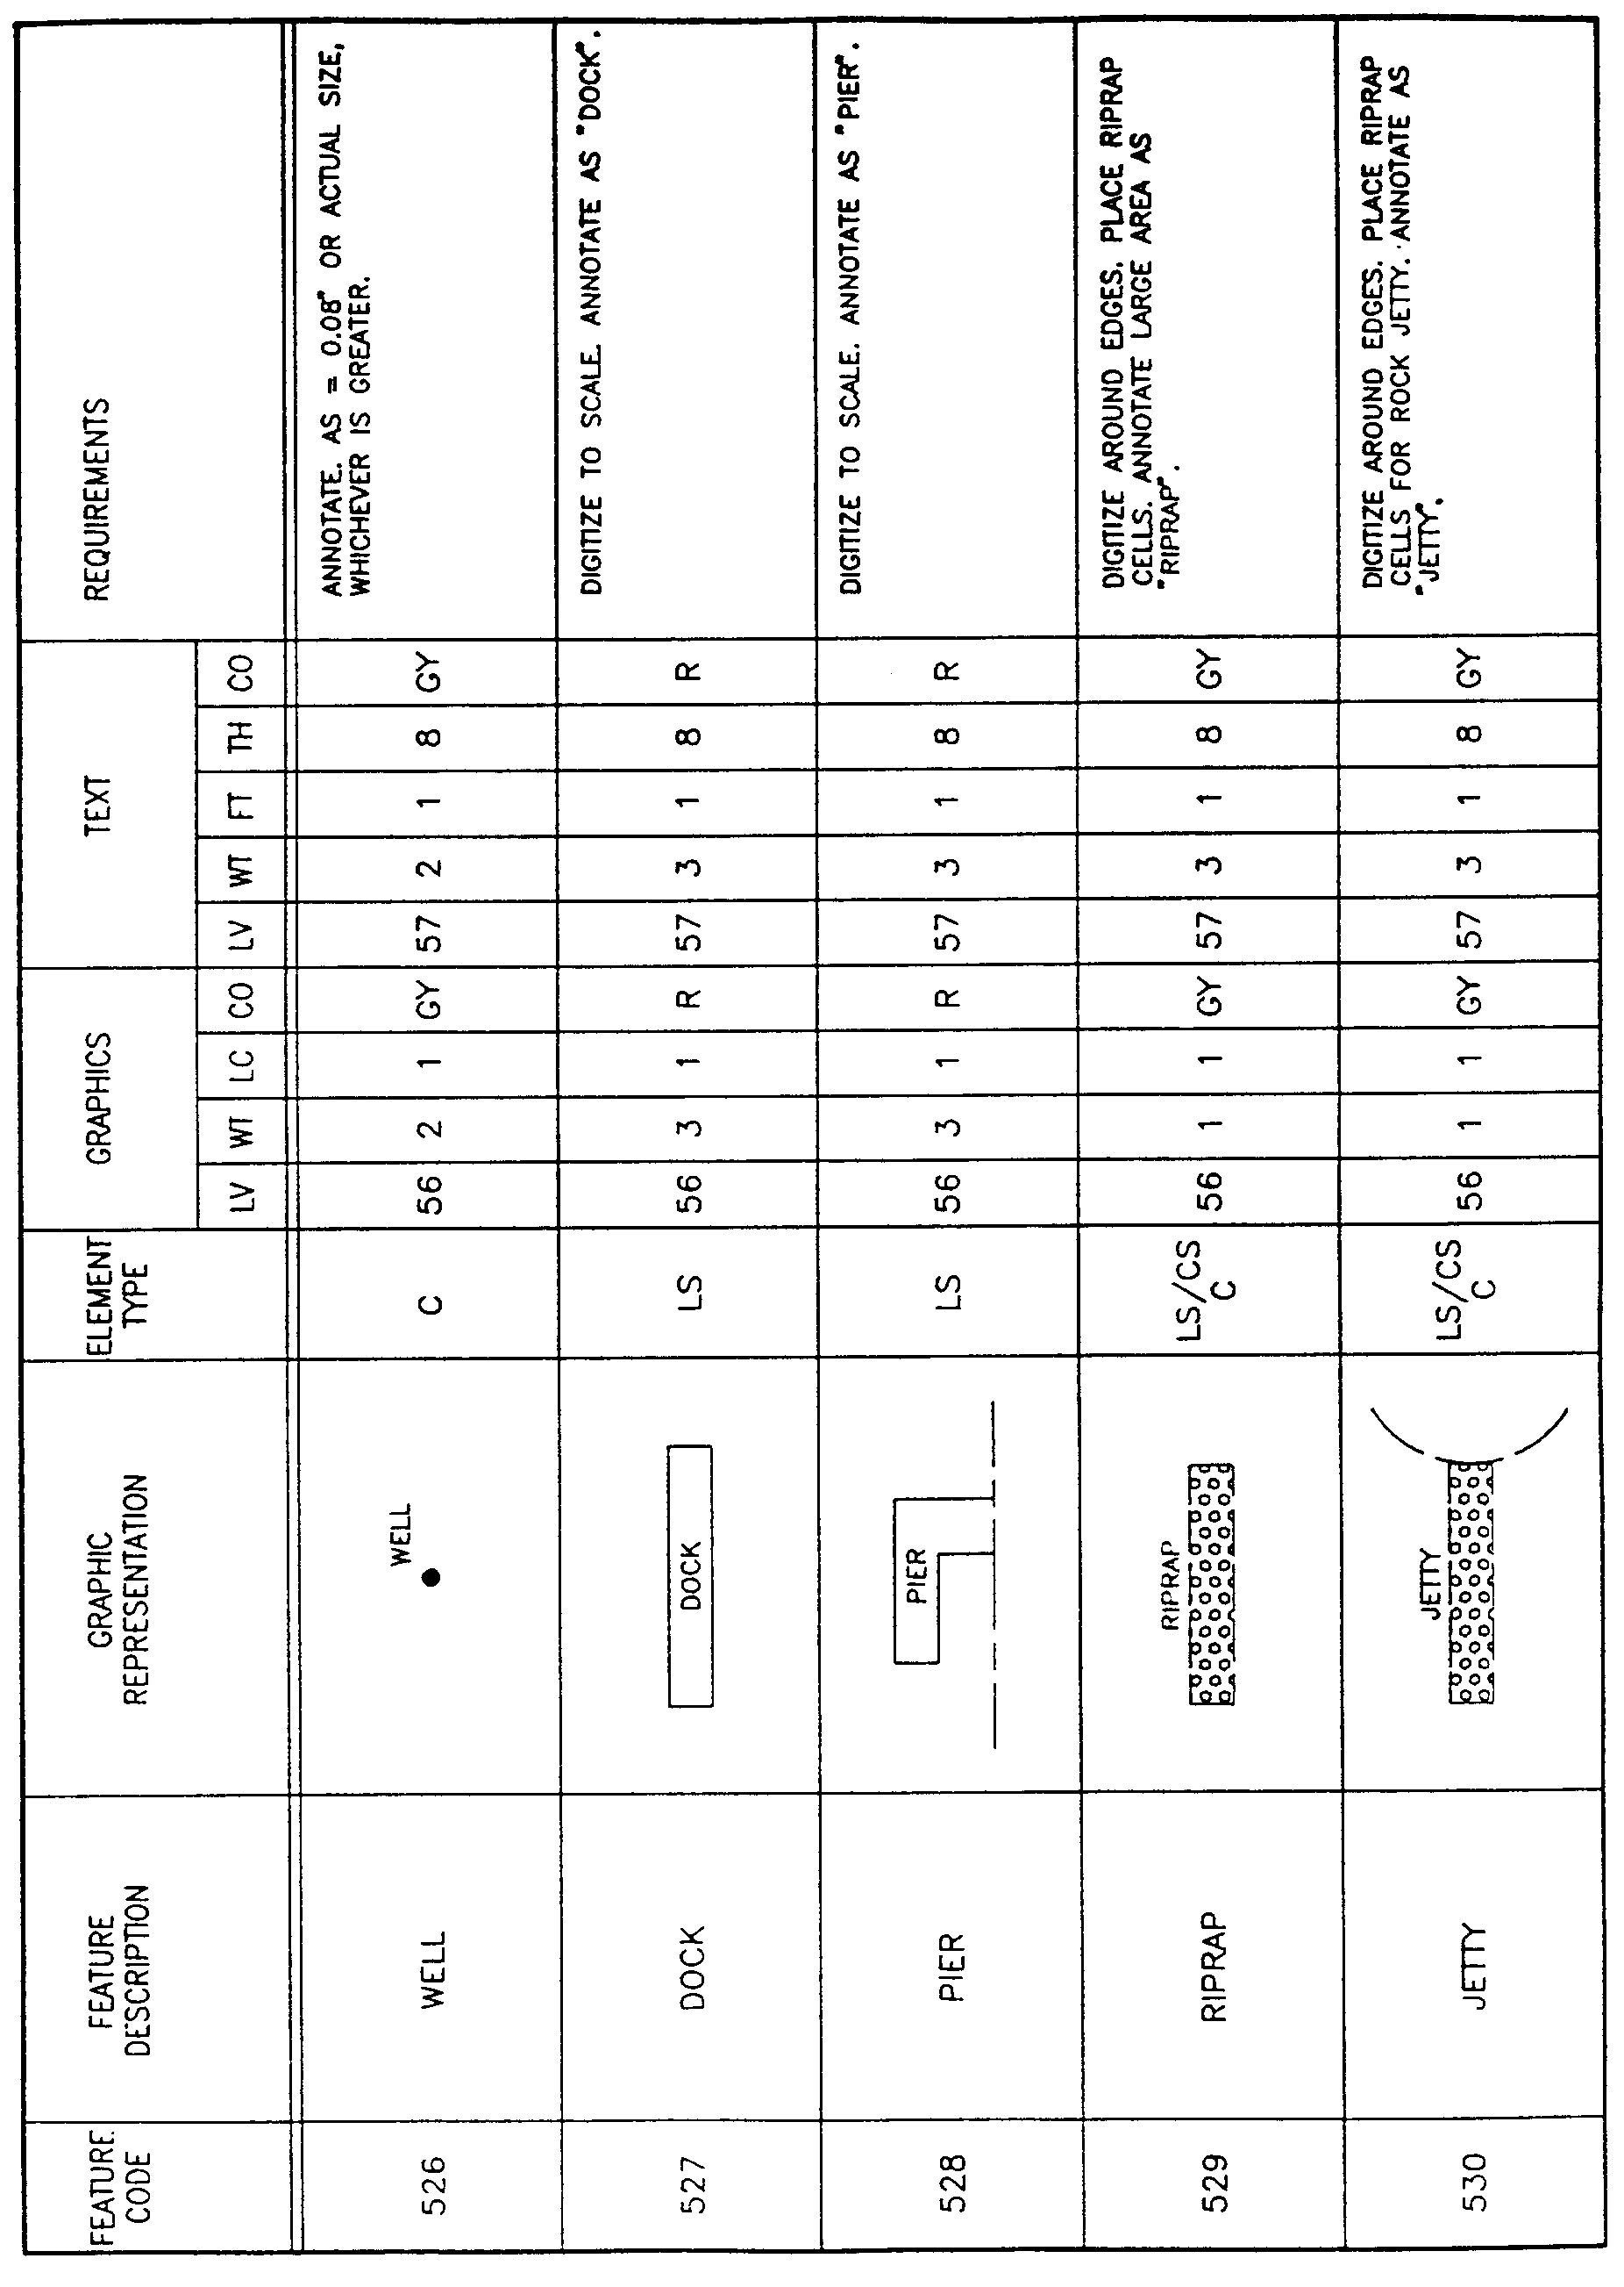
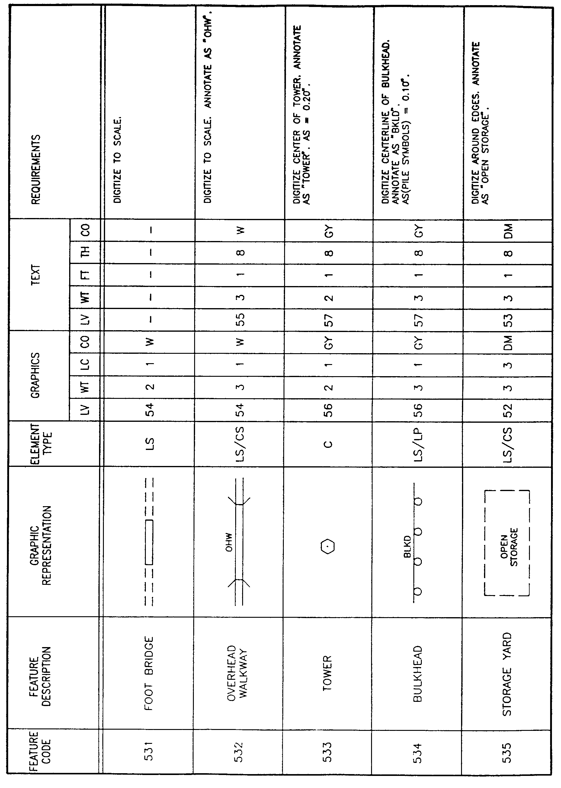
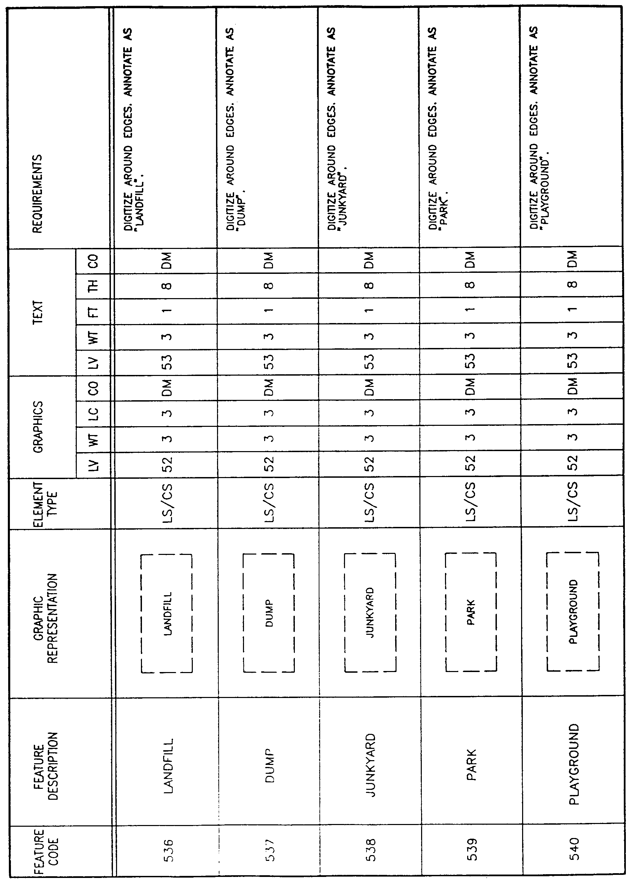
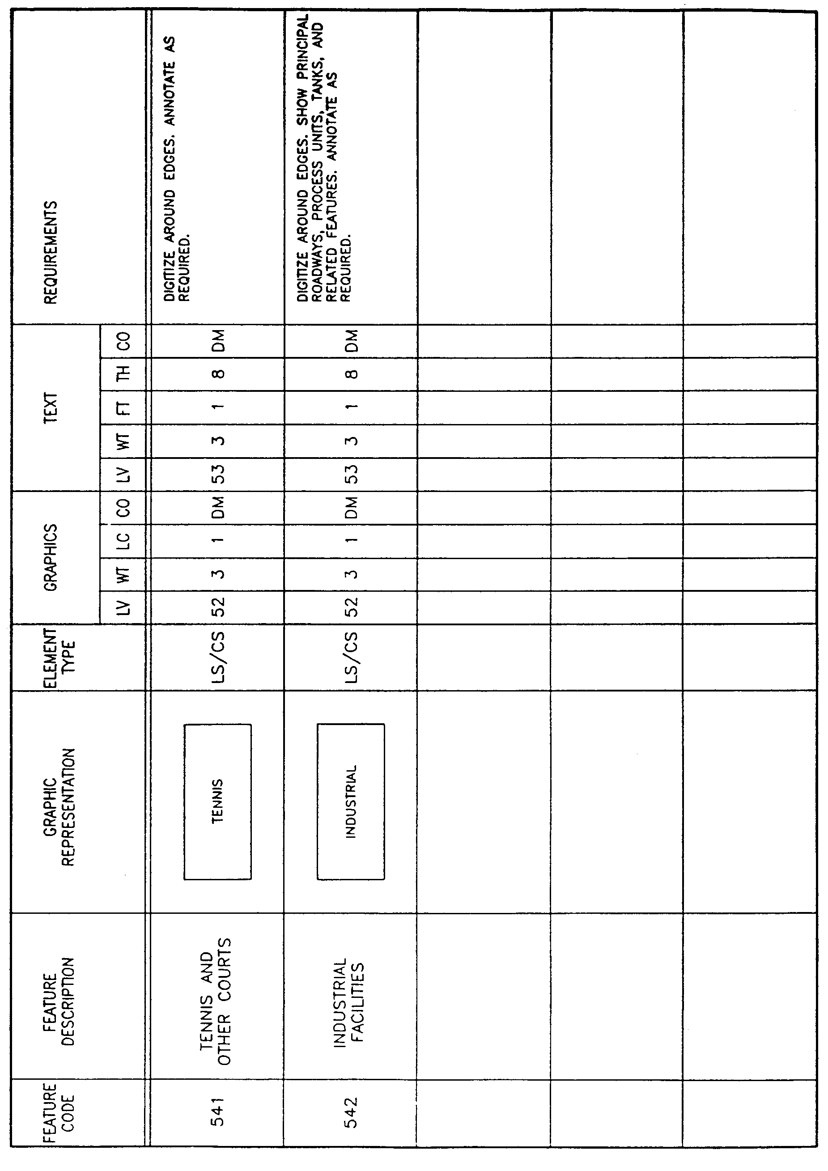

AUTHORITY NOTE: Promulgated in accordance with R.S. 50:171.
HISTORICAL NOTE: Promulgated by the Office of the Governor, Division of Administration, State Land Office, LR 17:968 (October 1991).

§1927. Appendix G―Layer Category 6―Utility Feature Elements
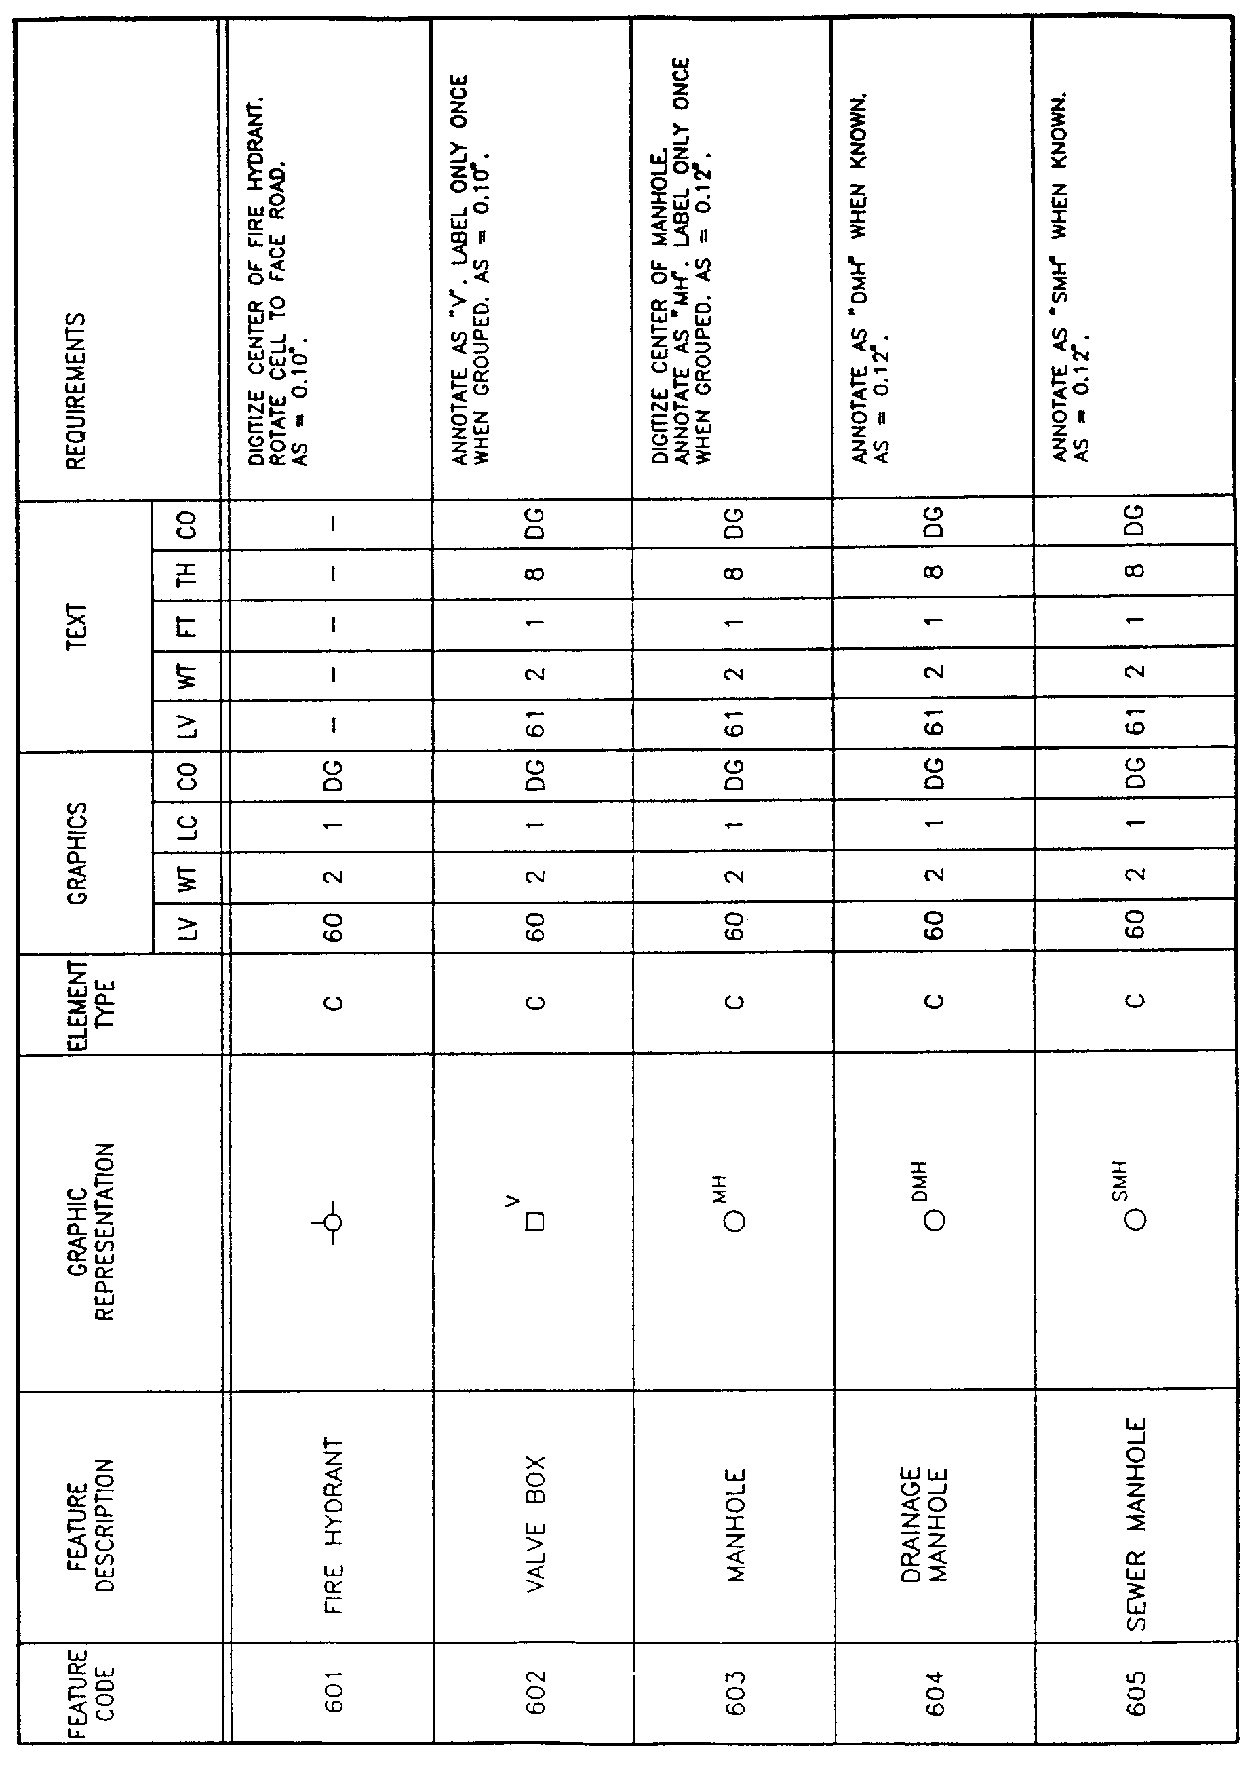
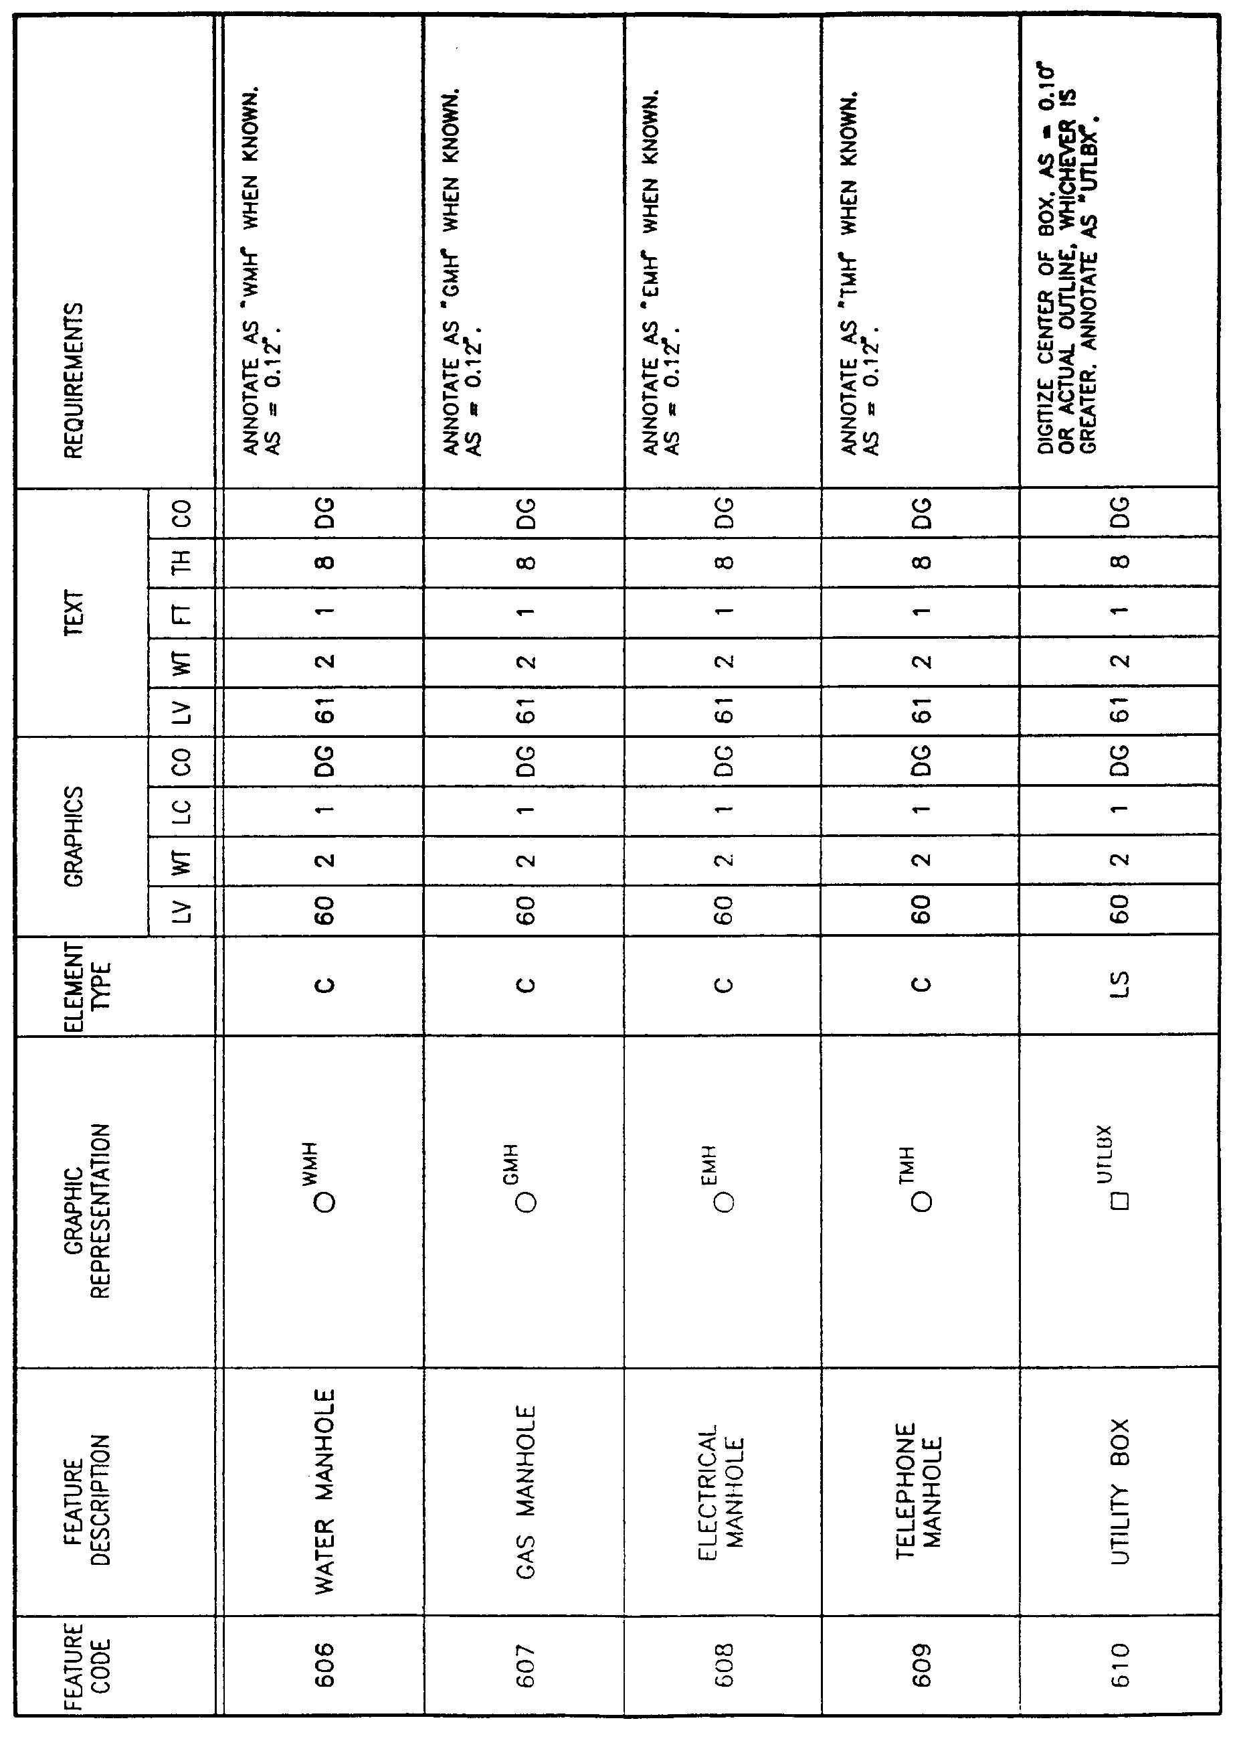
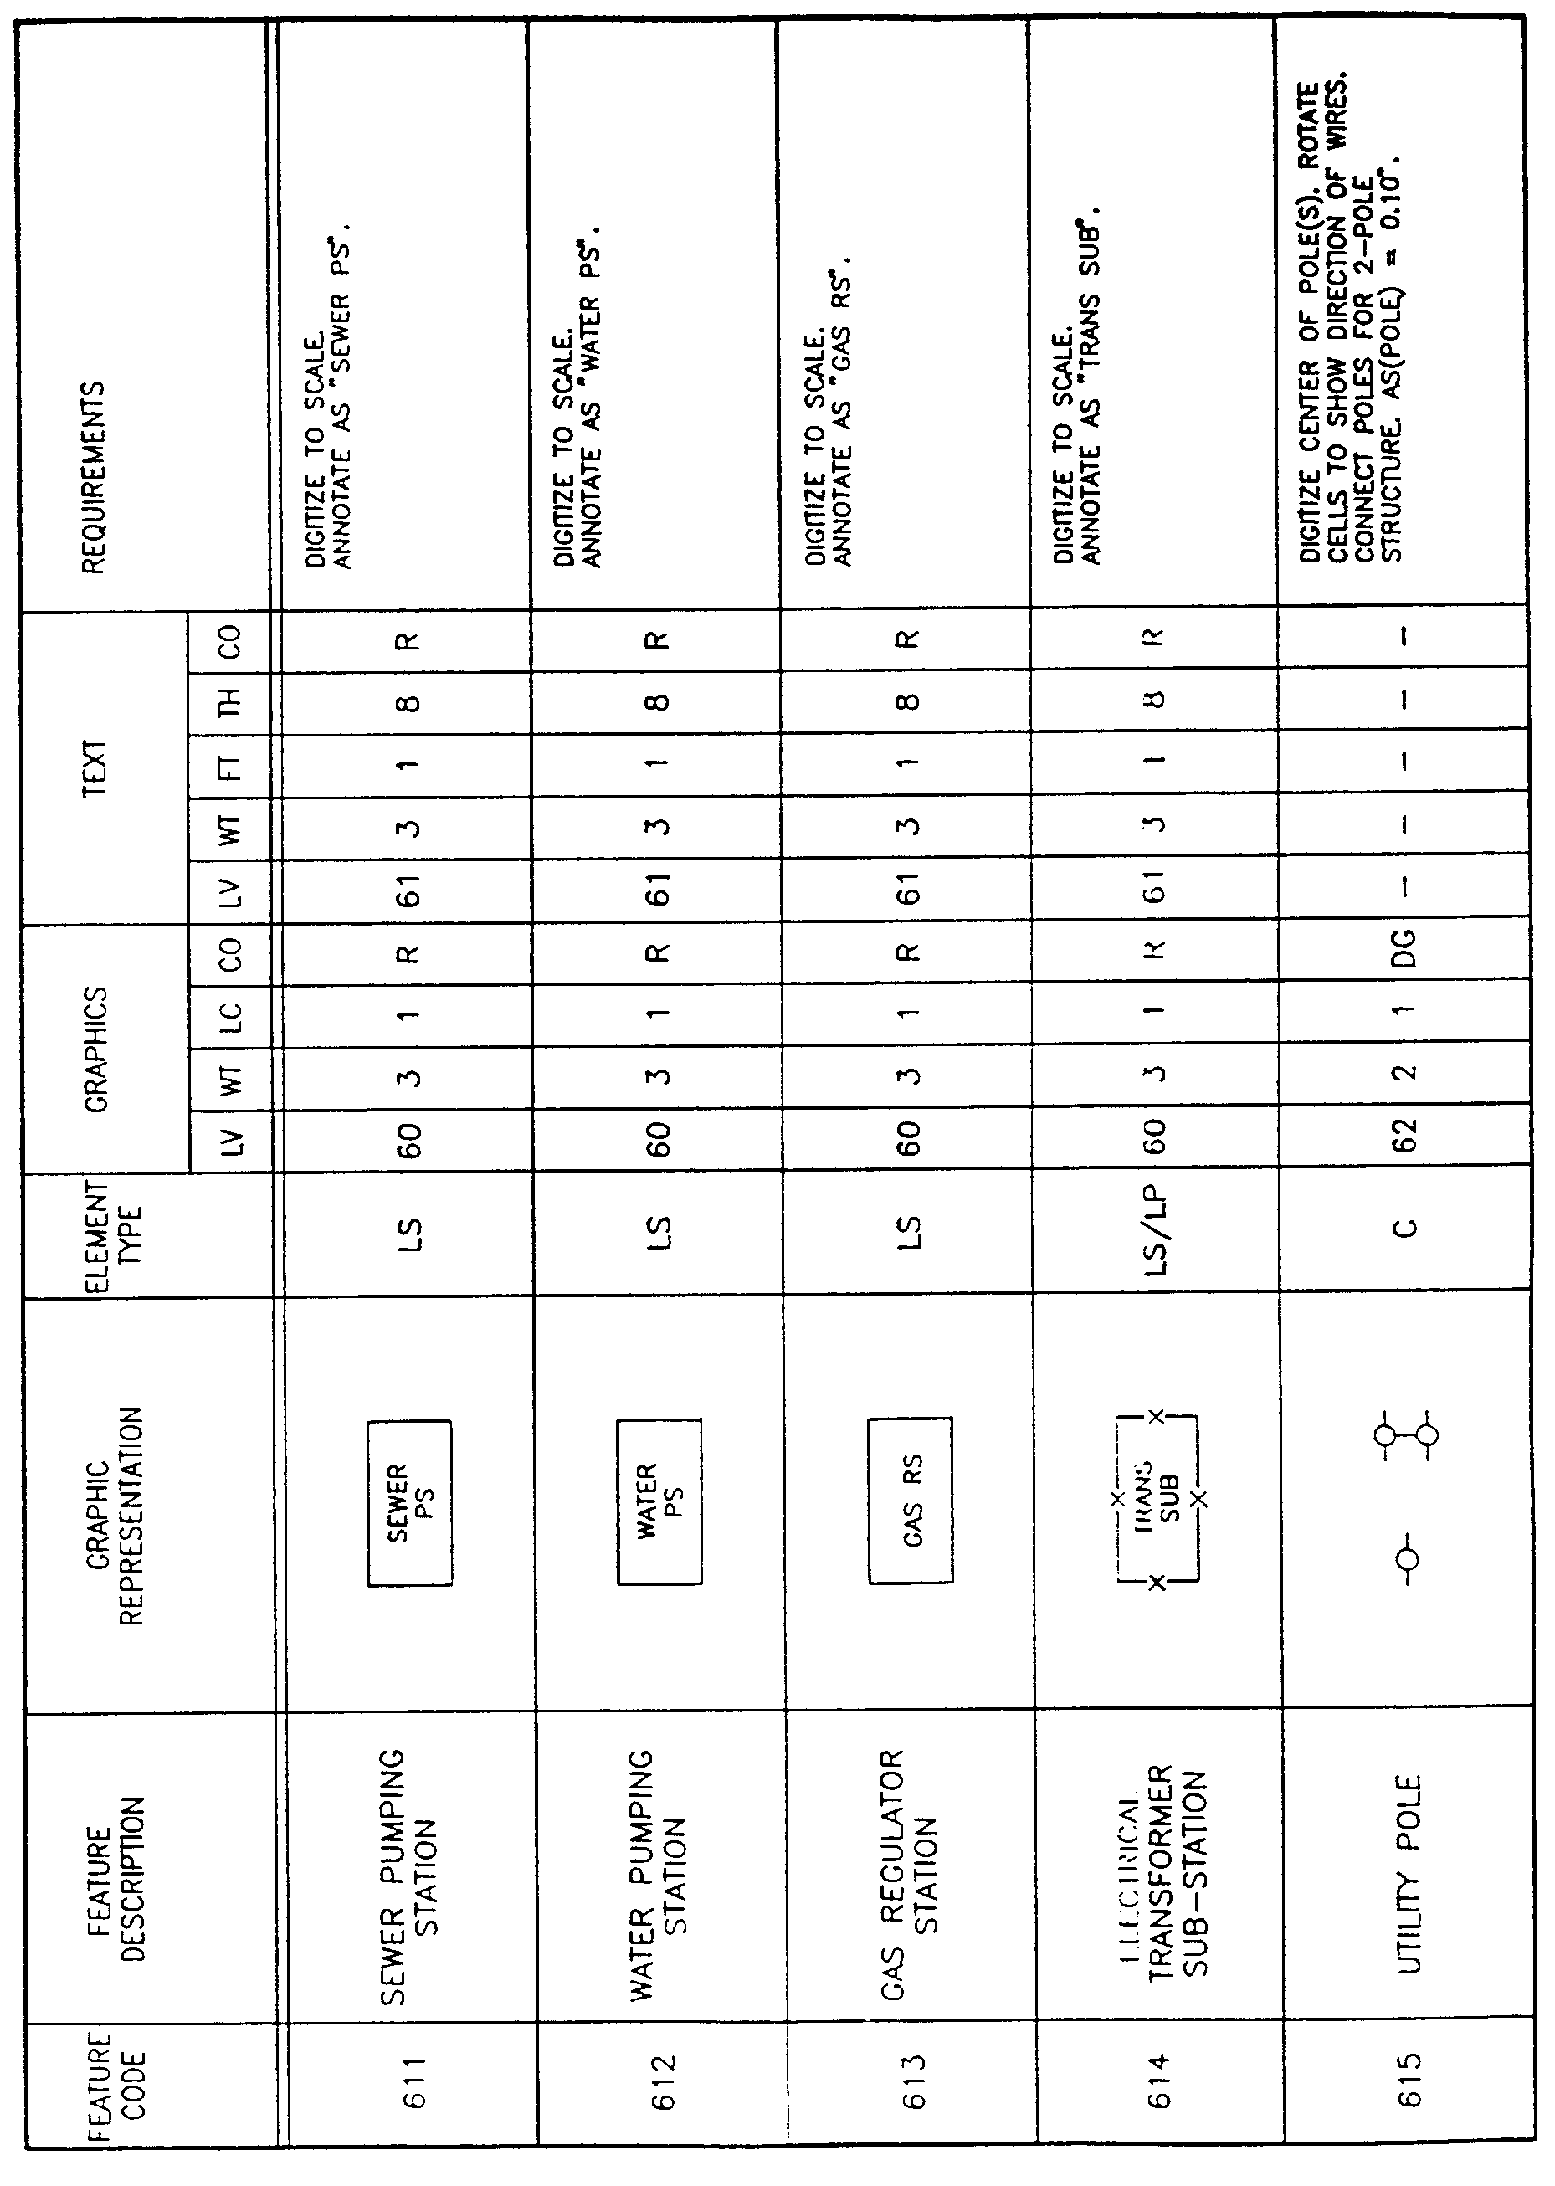
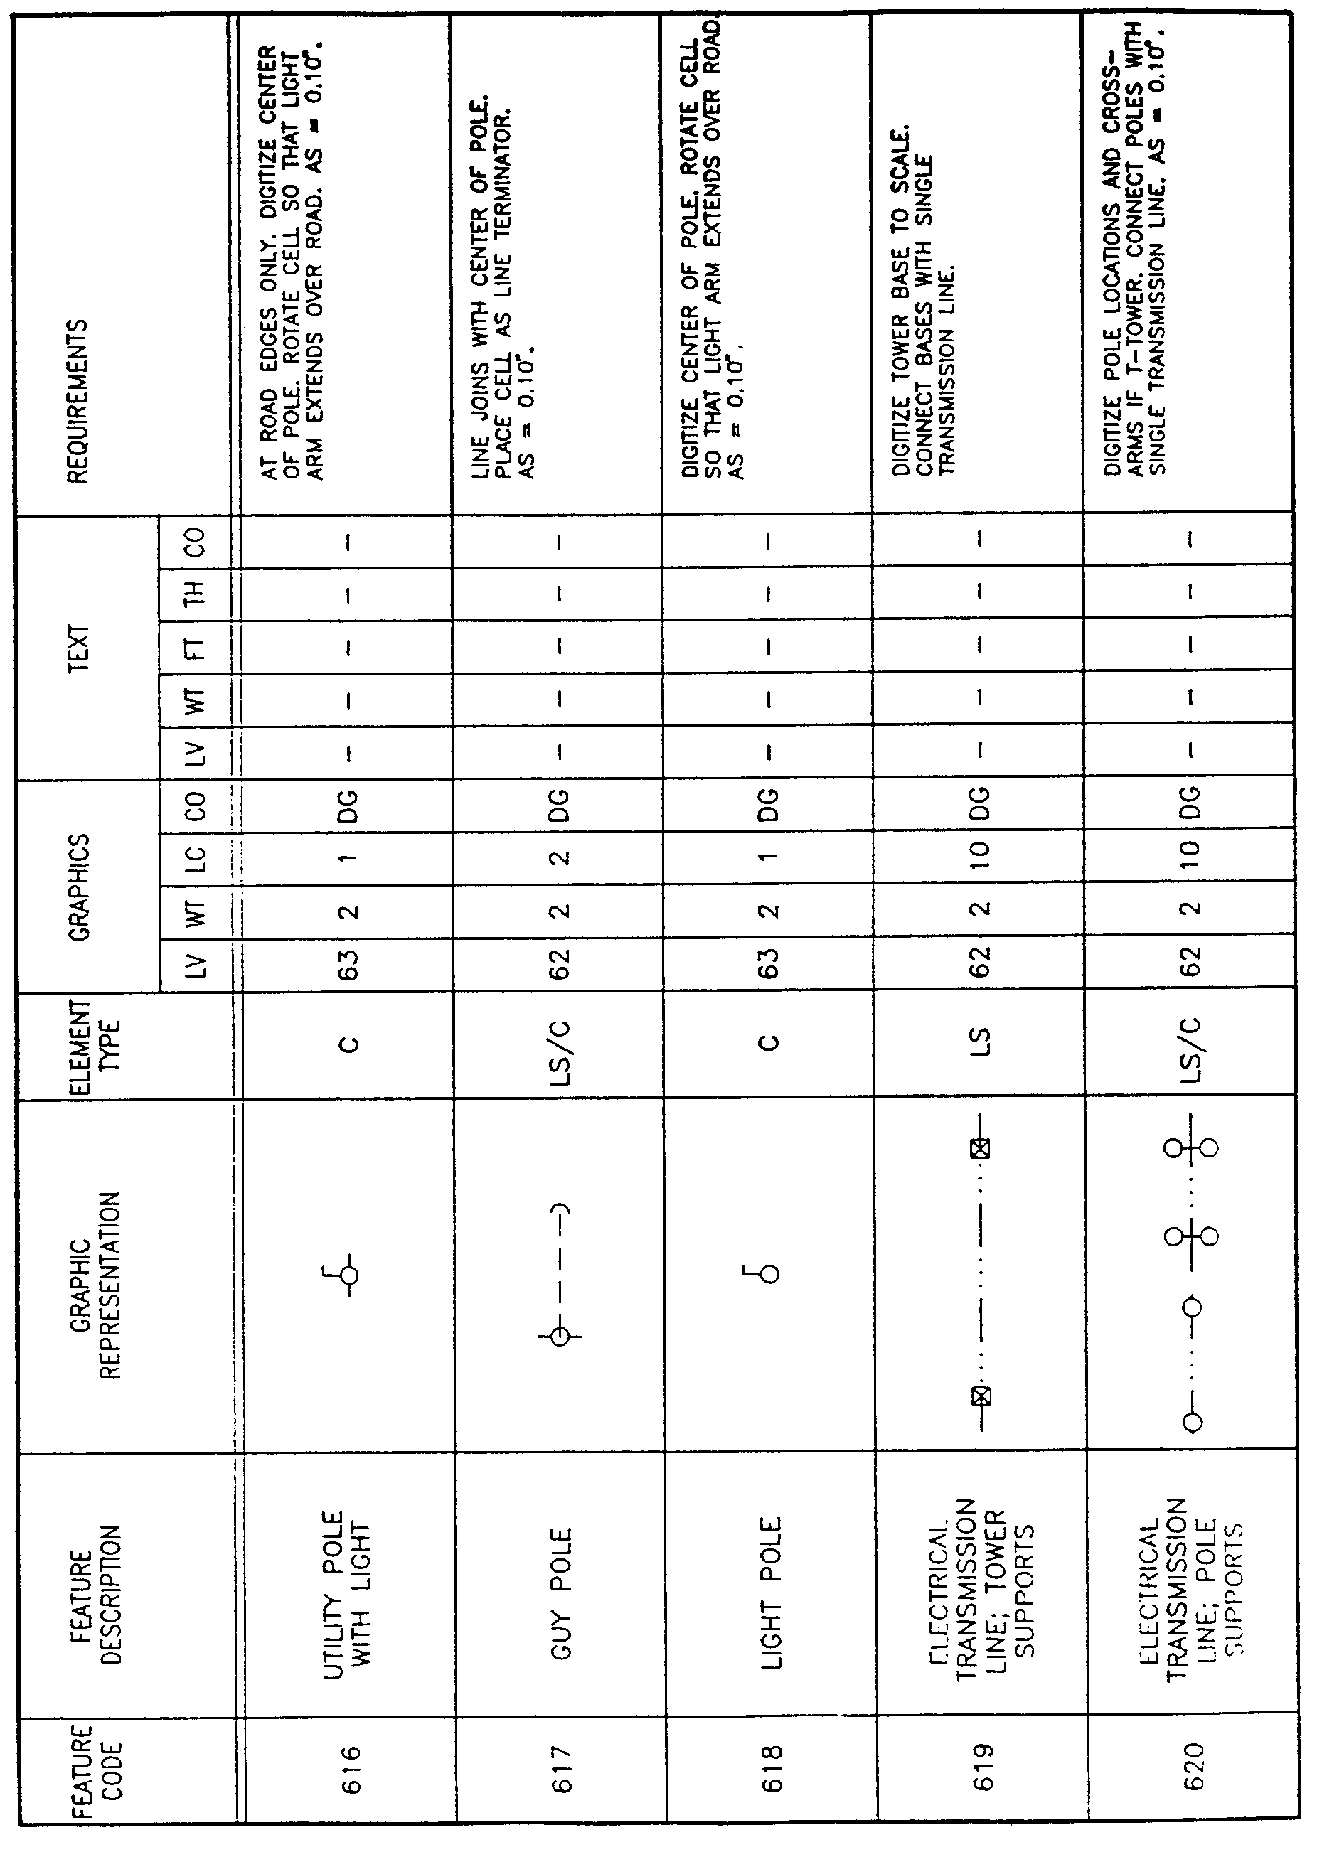
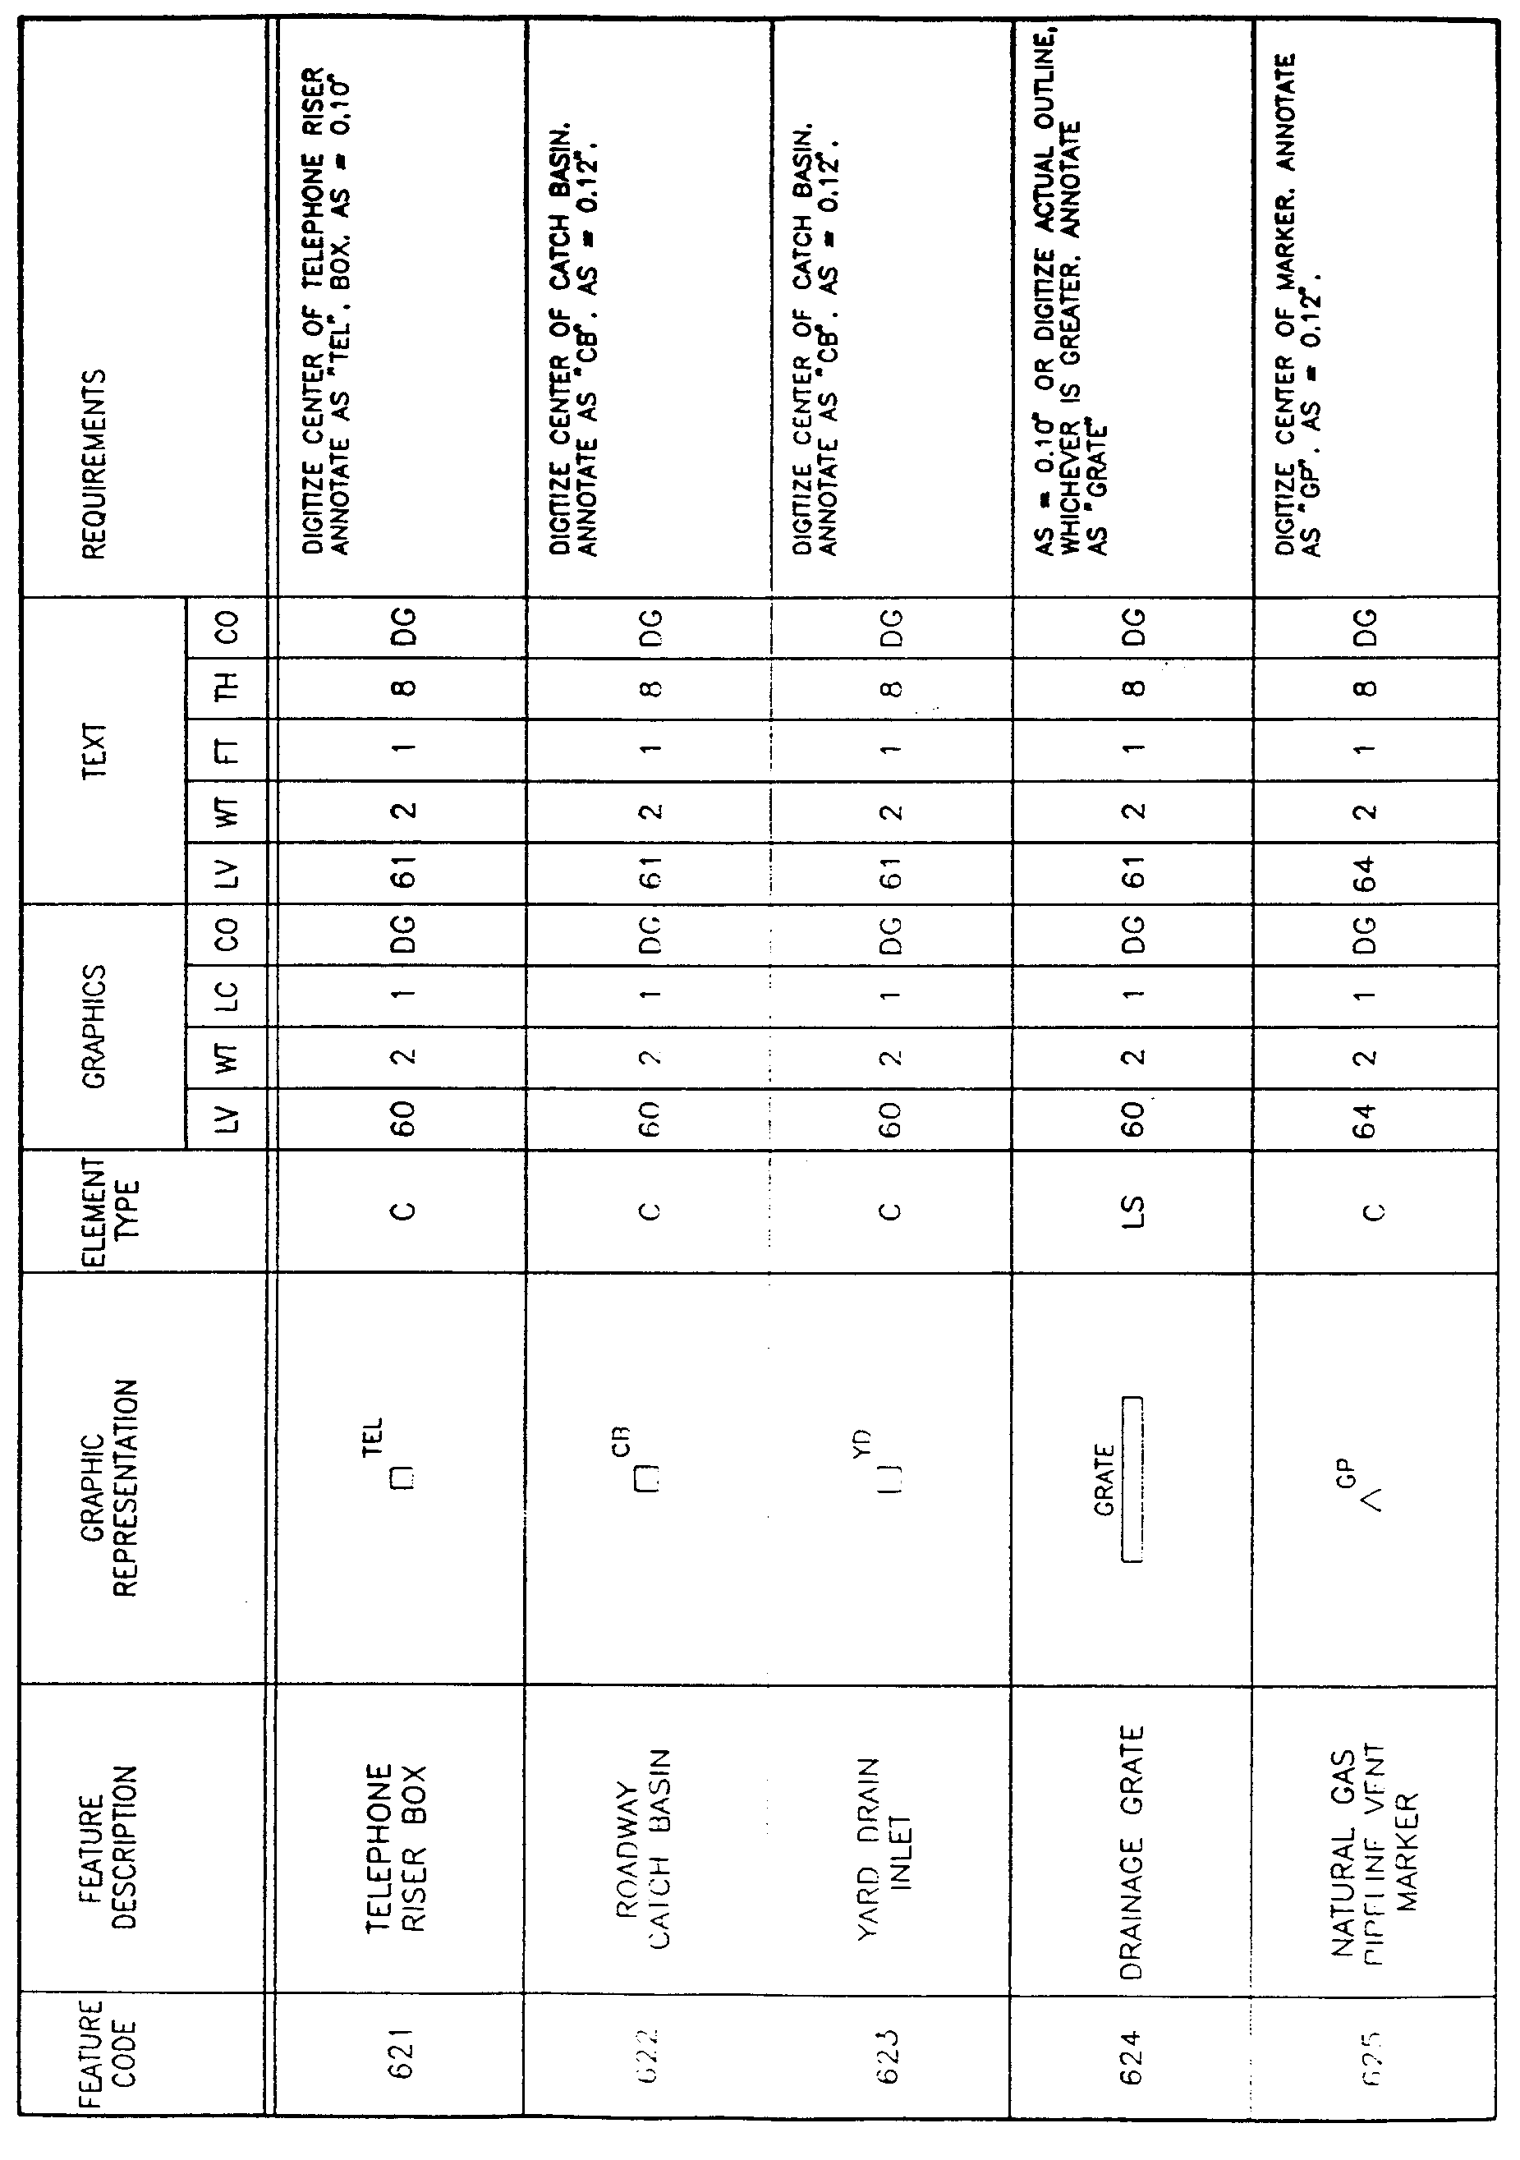

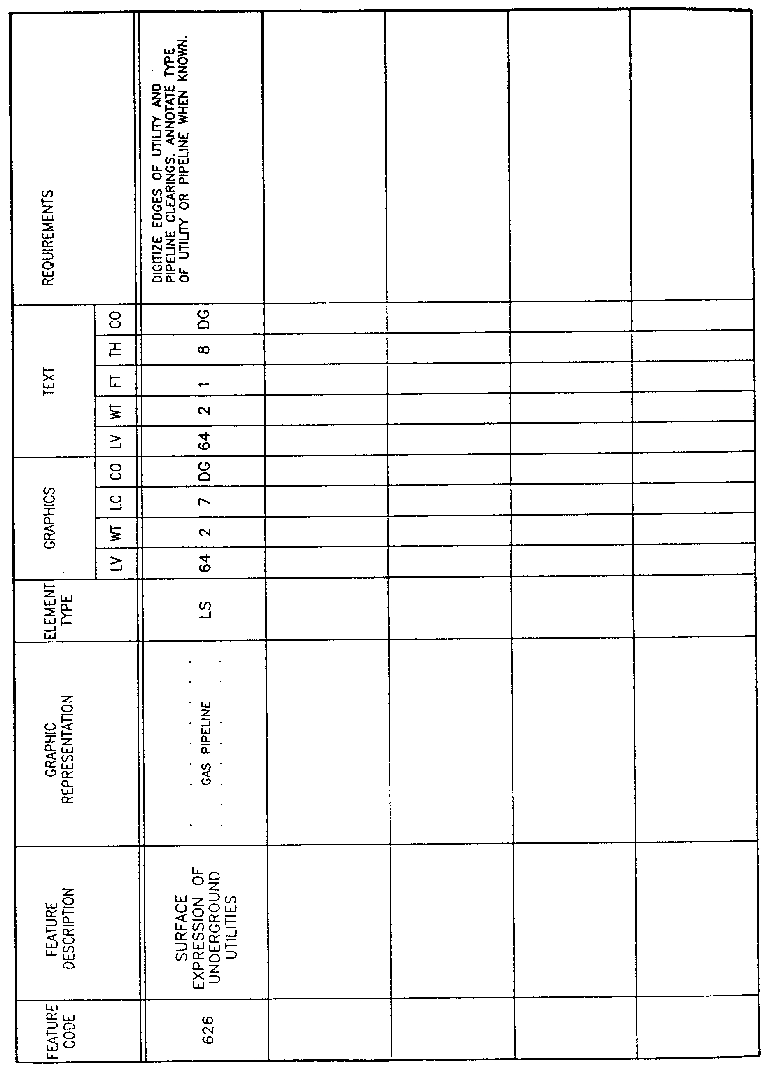
AUTHORITY NOTE: Promulgated in accordance with R.S. 50:171.
HISTORICAL NOTE: Promulgated by the Office of the Governor, Division of Administration, State Land Office, LR 17:968 (October 1991).

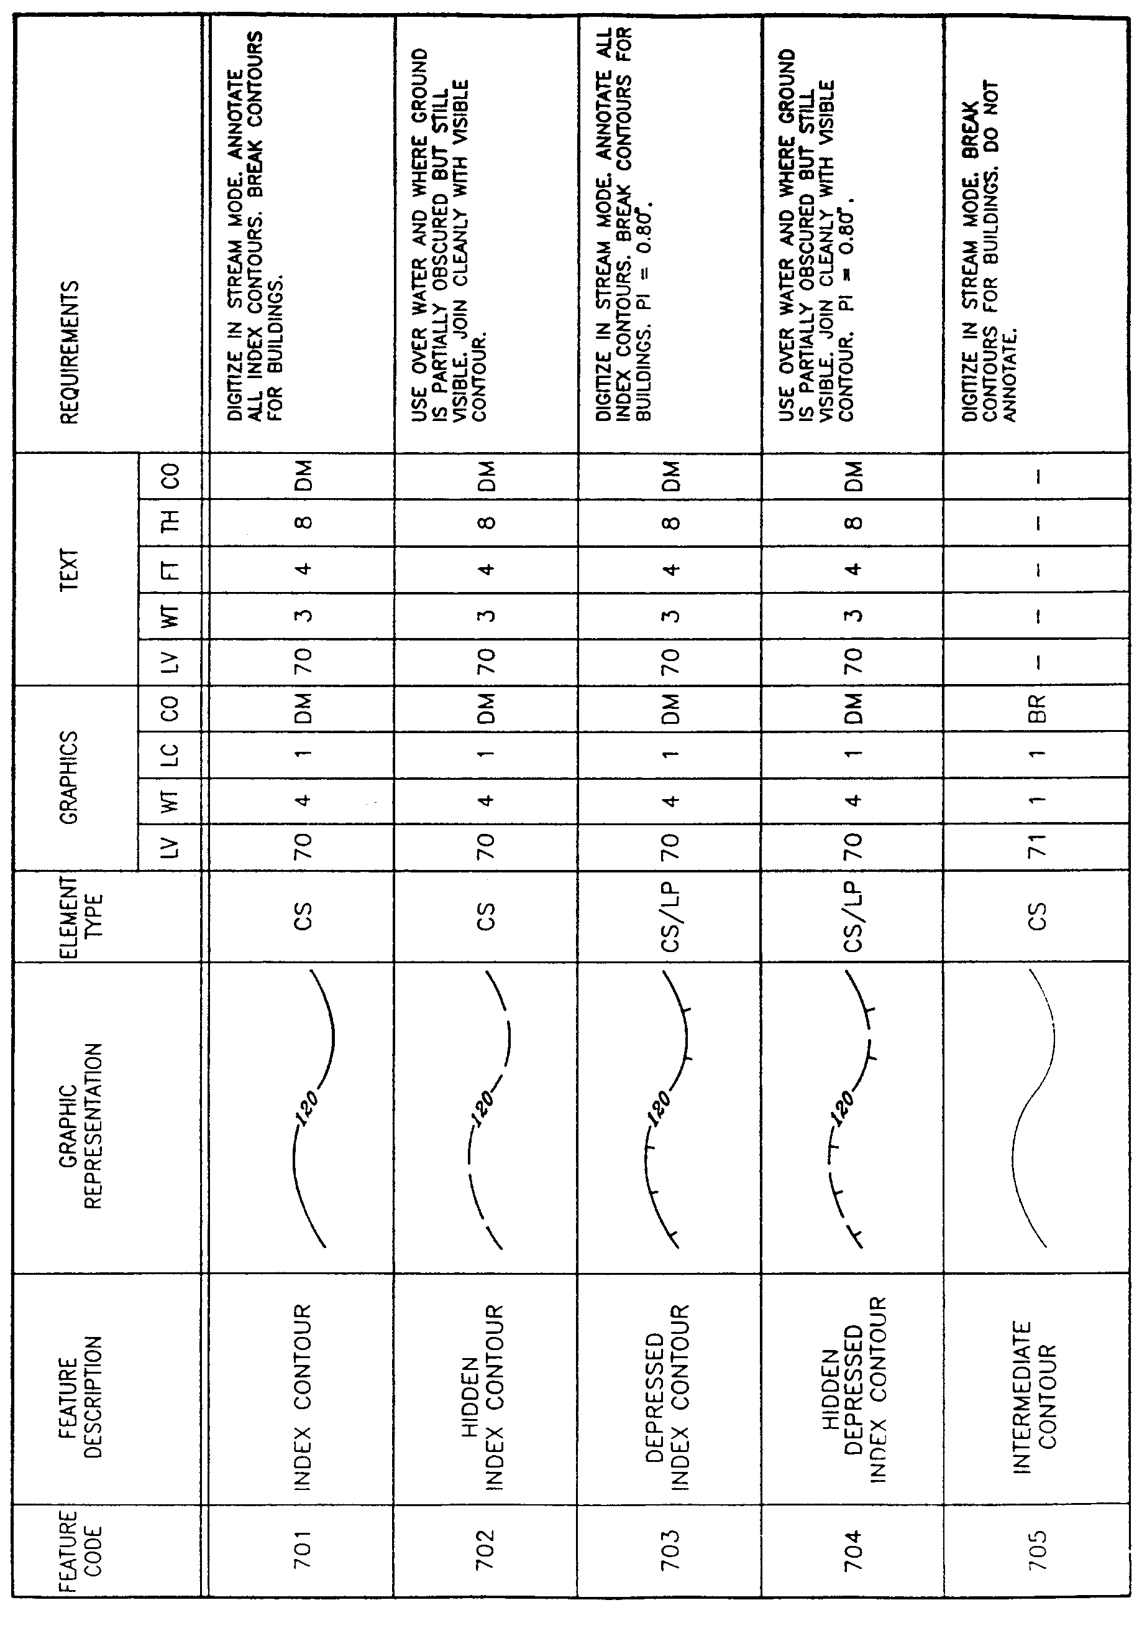
§1929. Appendix H―Layer Category 7―Topographic Feature Elements
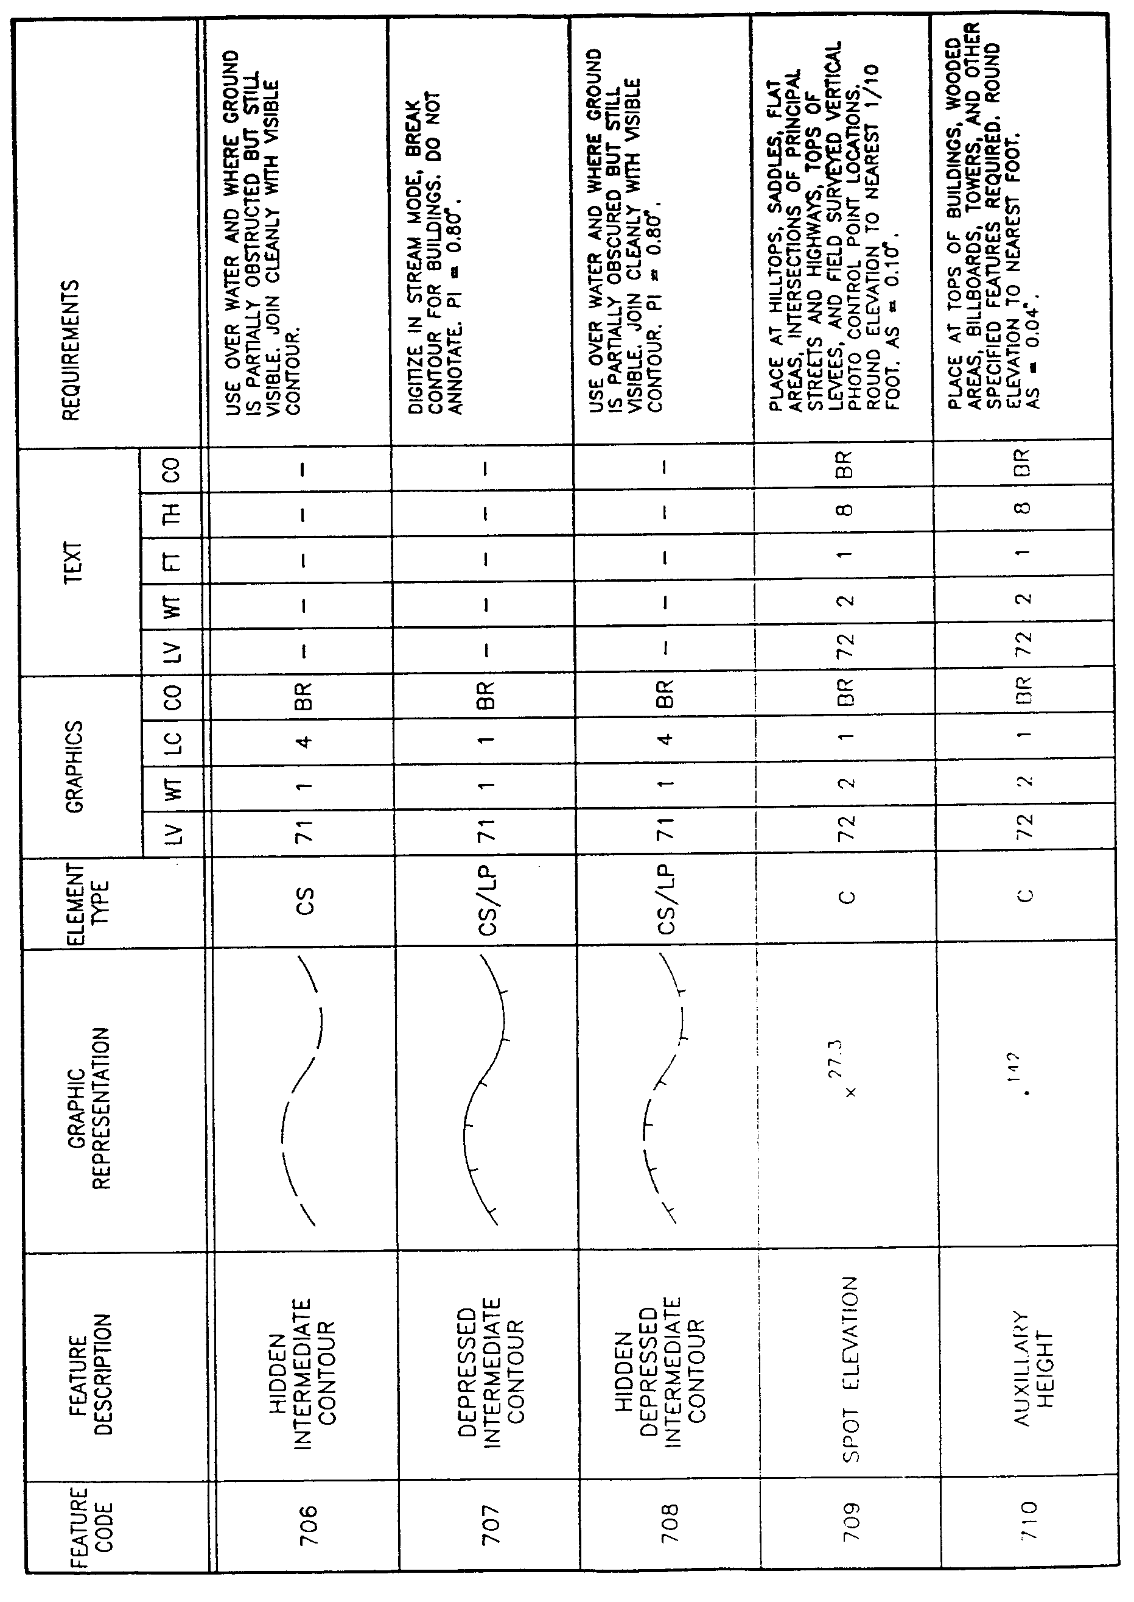

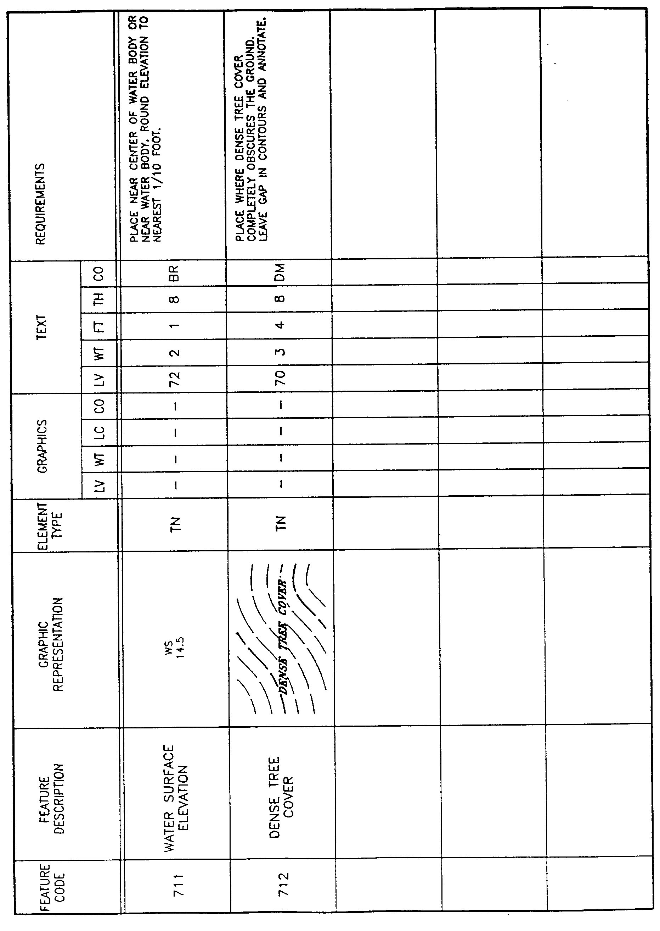

AUTHORITY NOTE: Promulgated in accordance with R.S. 50:171.
HISTORICAL NOTE: Promulgated by the Office of the Governor, Division of Administration, State Land Office, LR 17:968 (October 1991).

§1931. Appendix I―Layer Category 8―Parcel Feature Elements

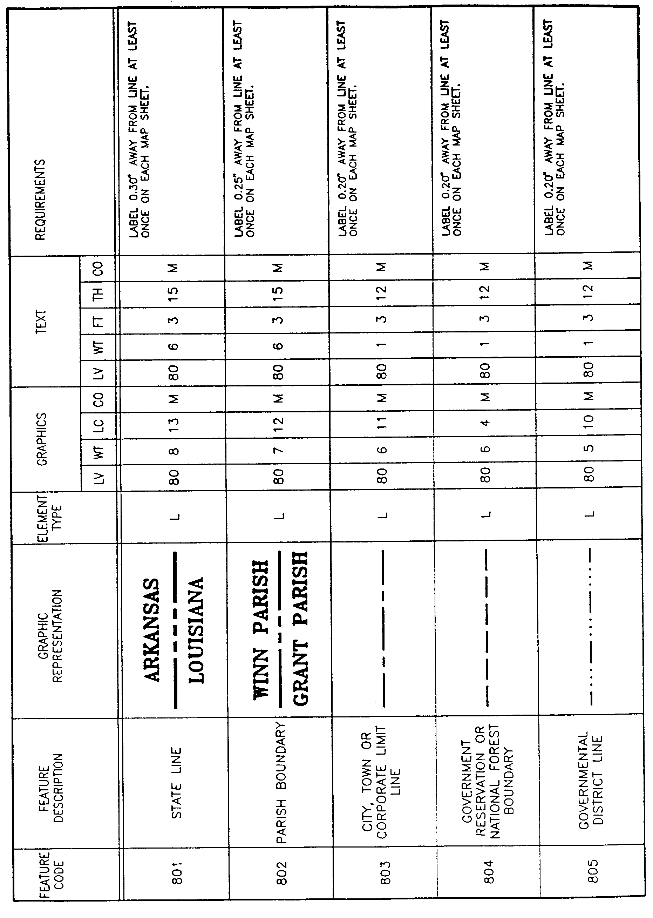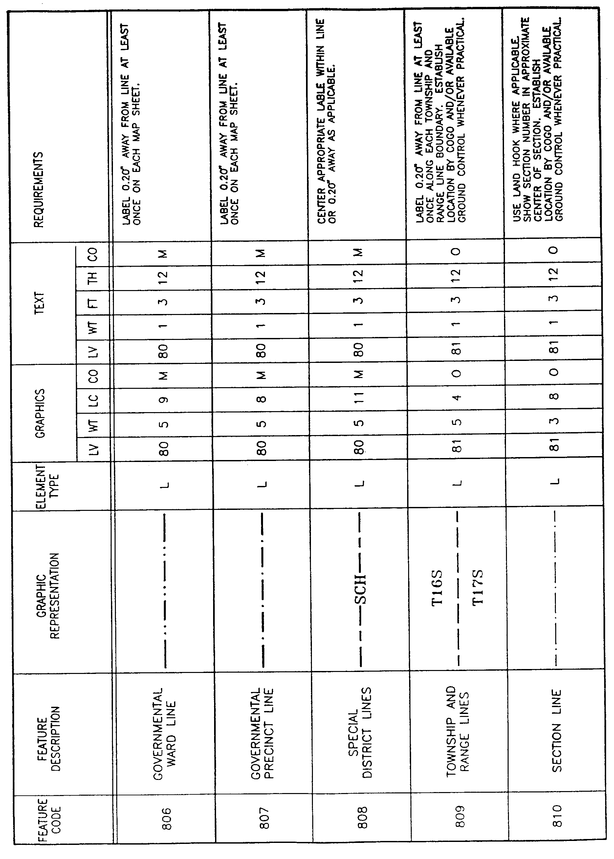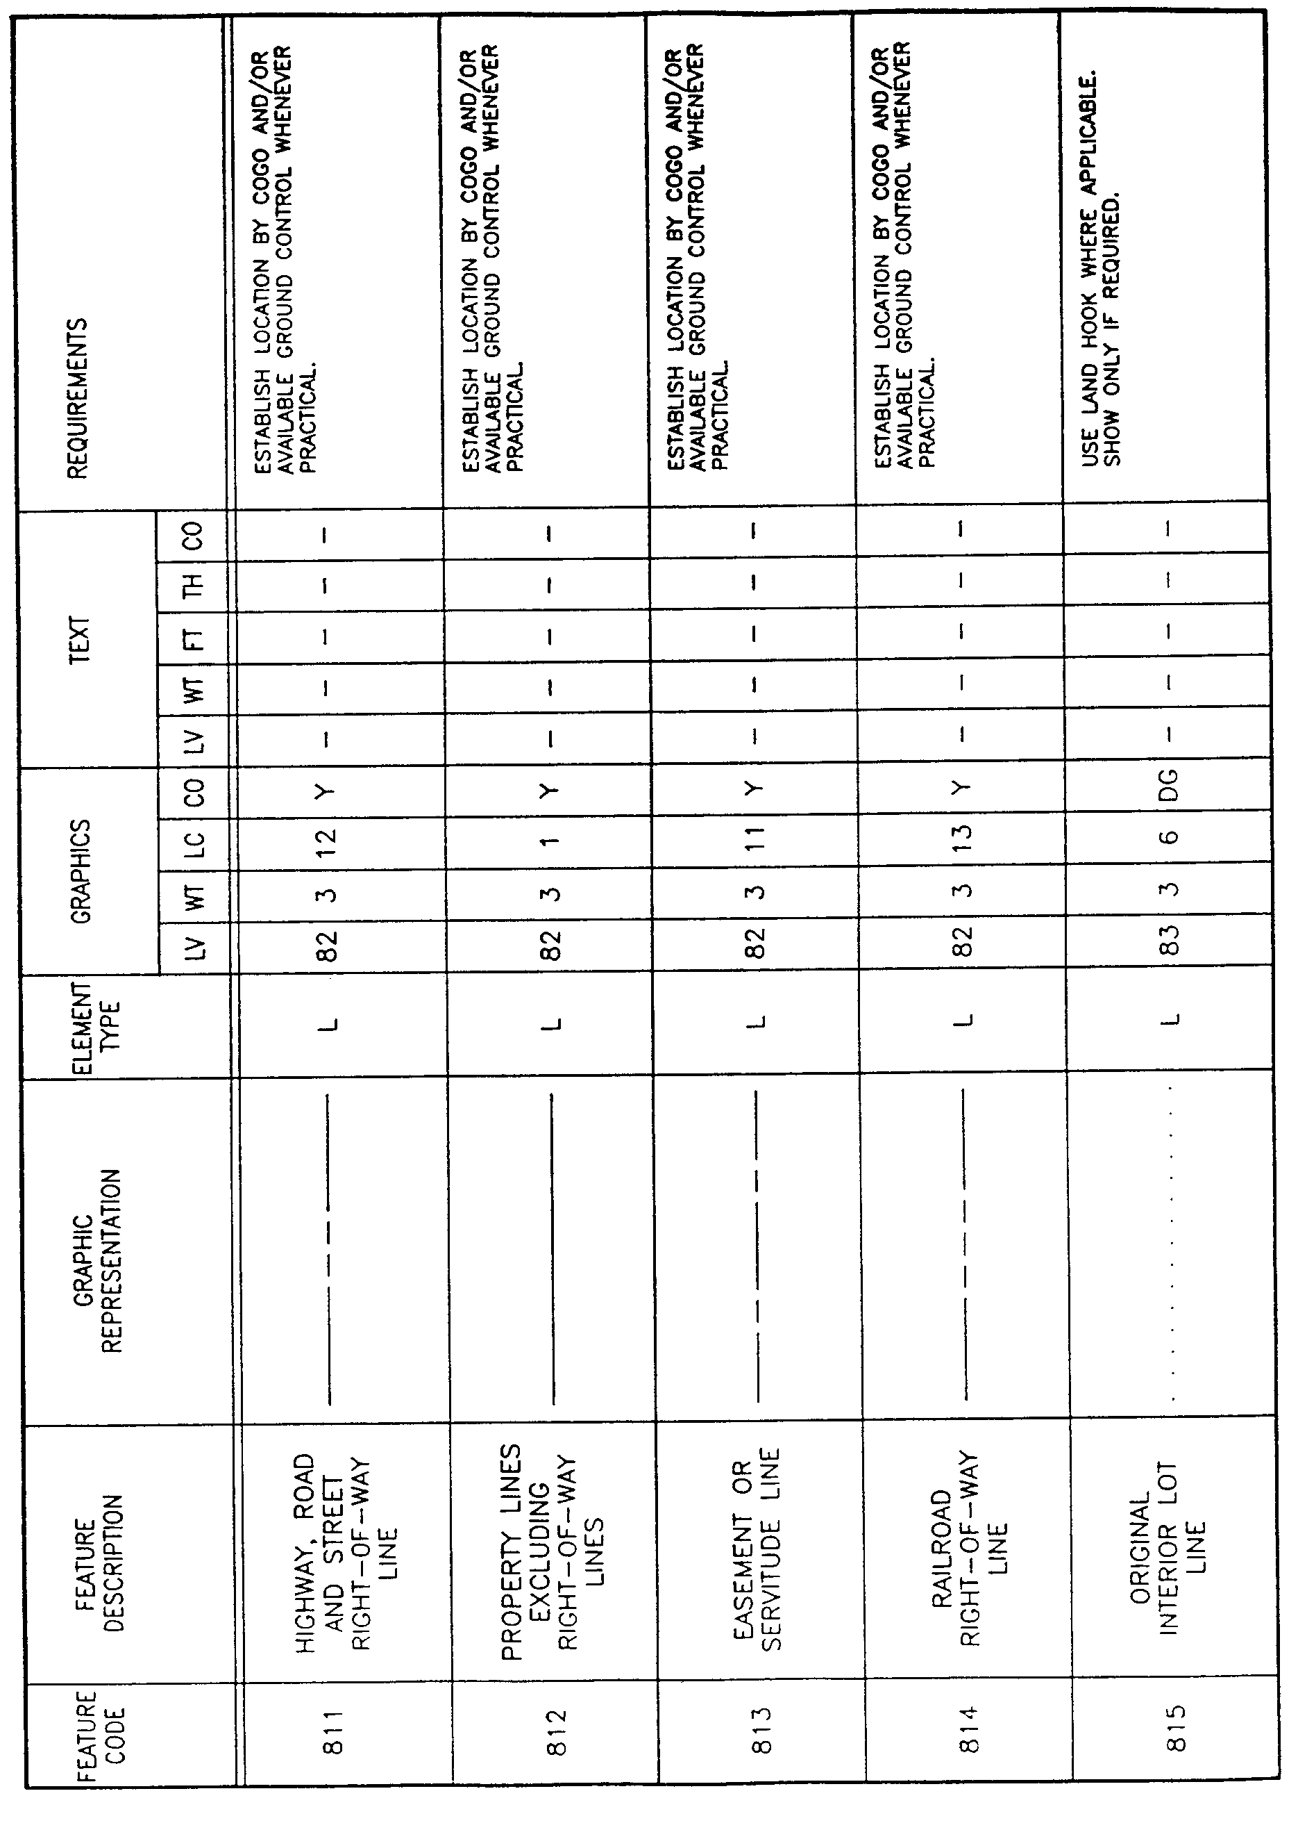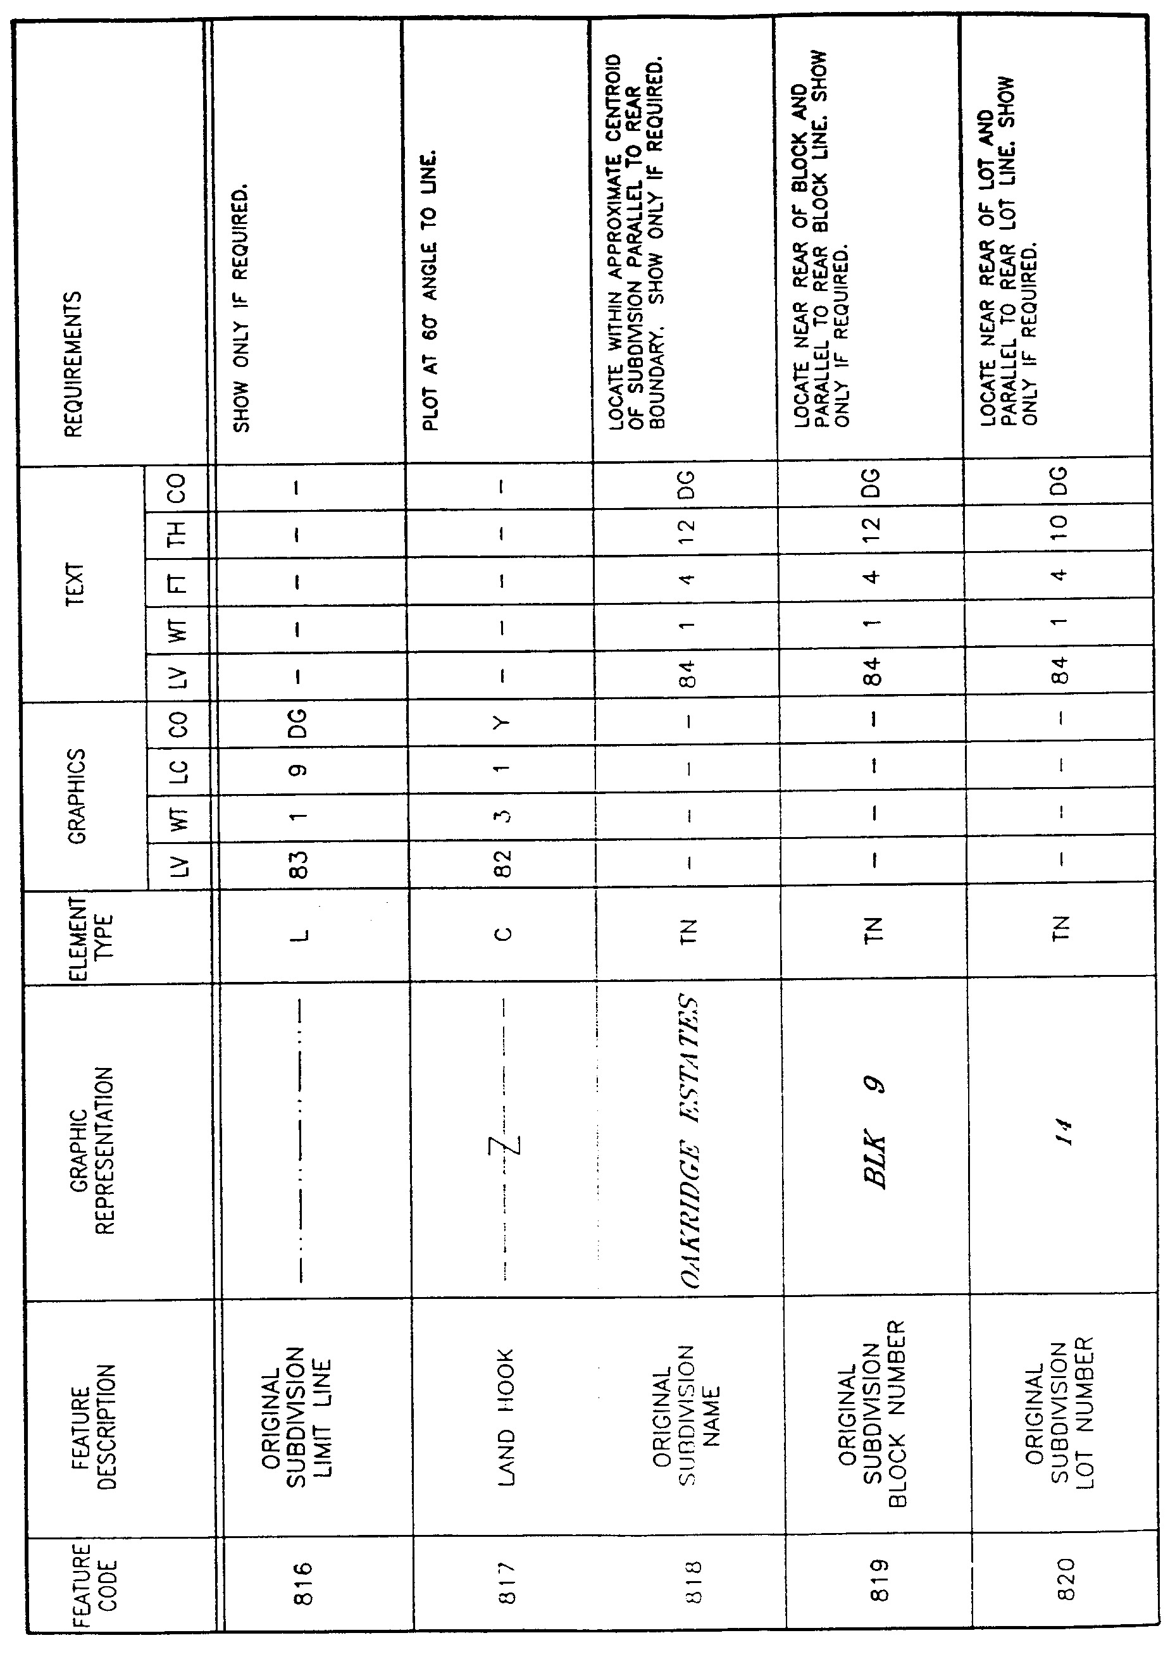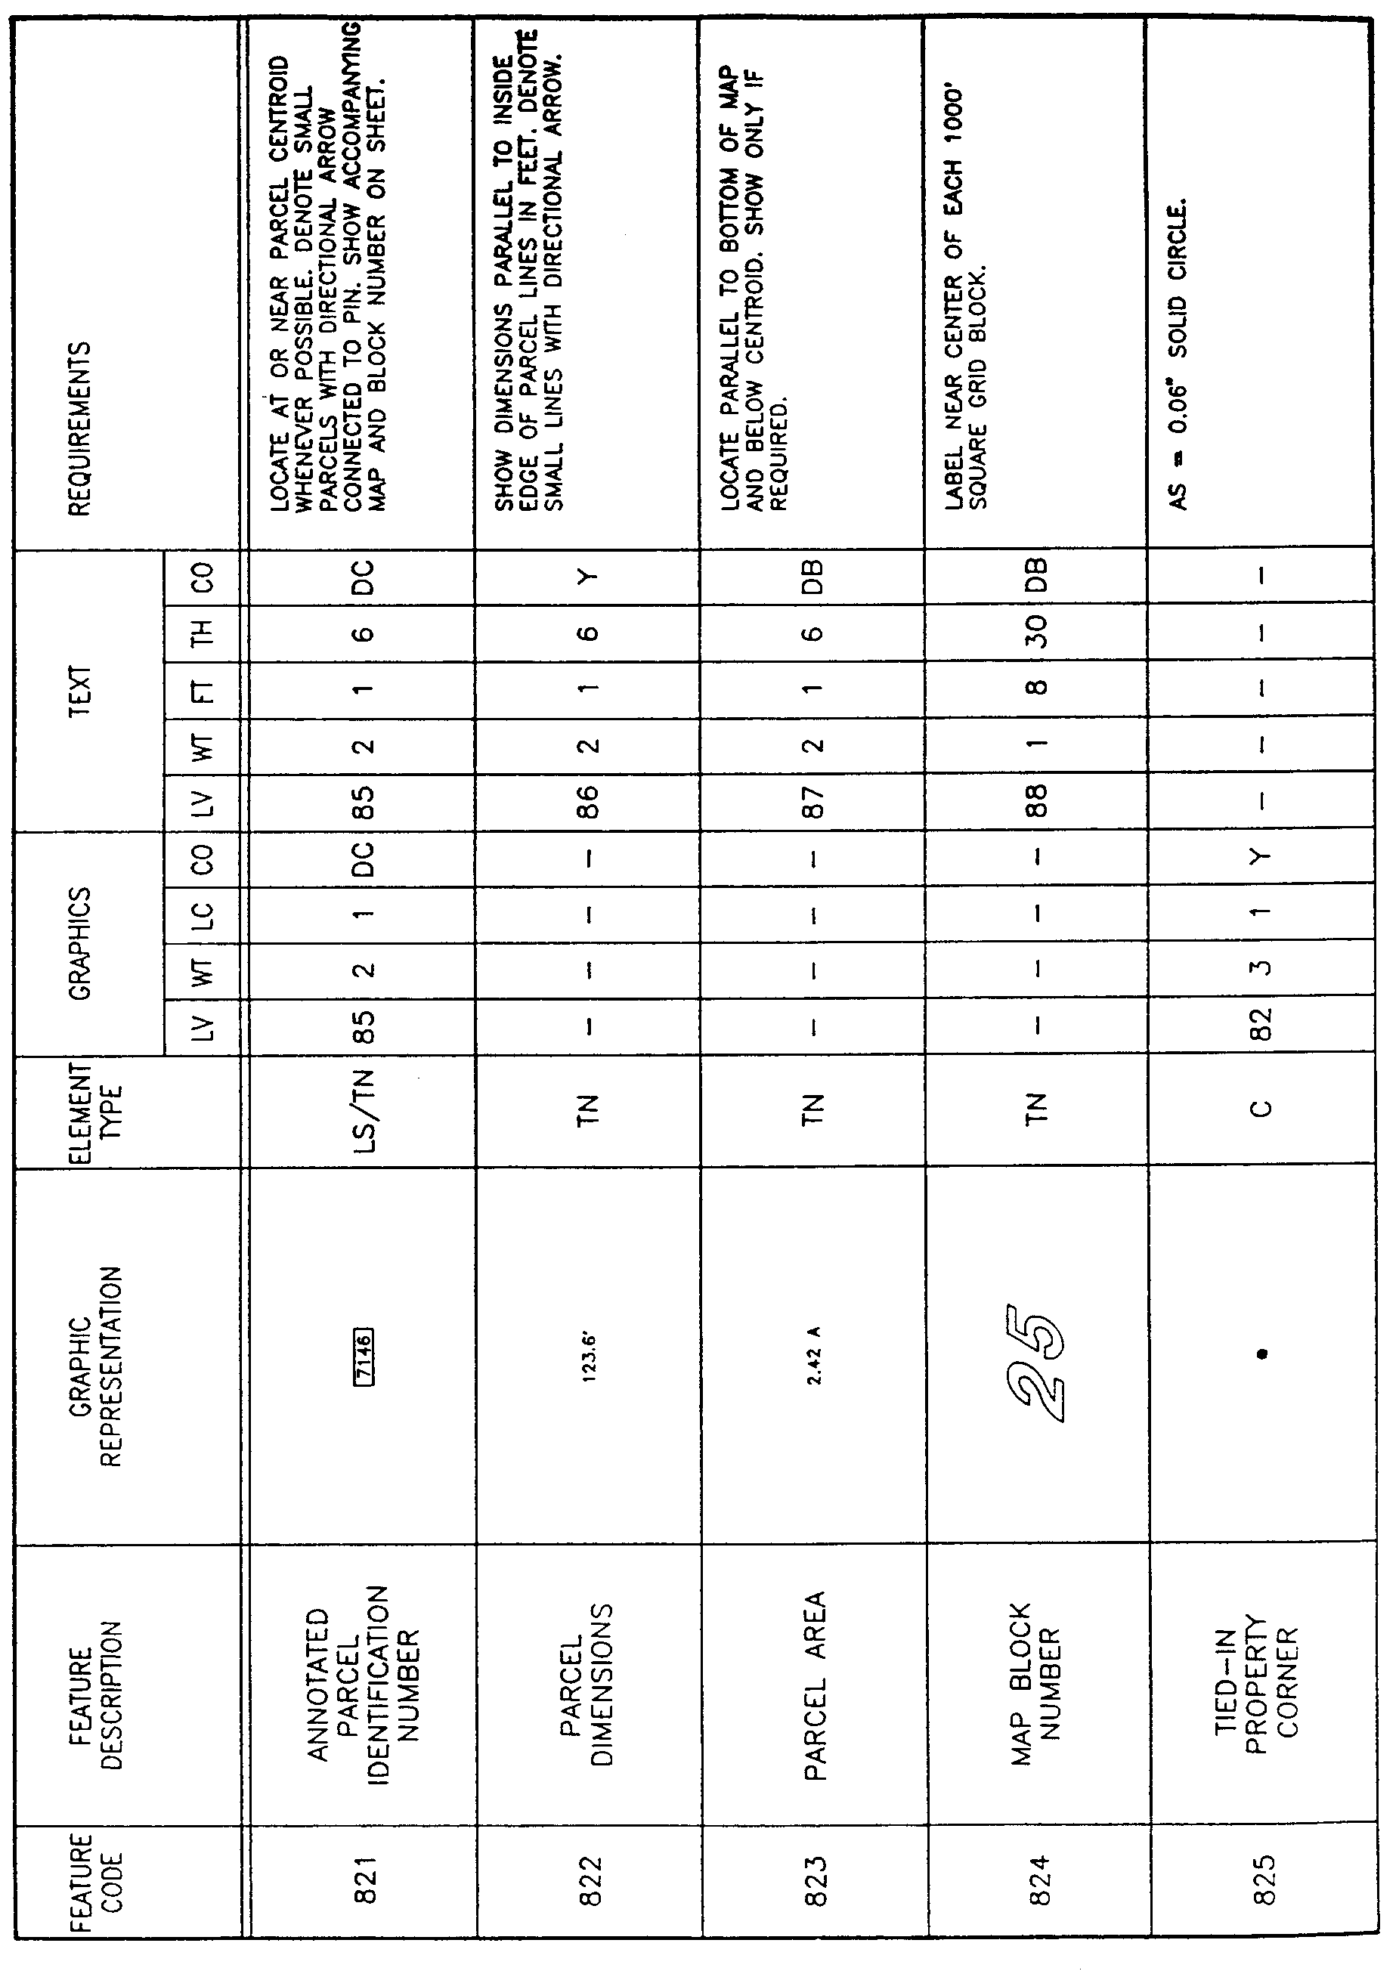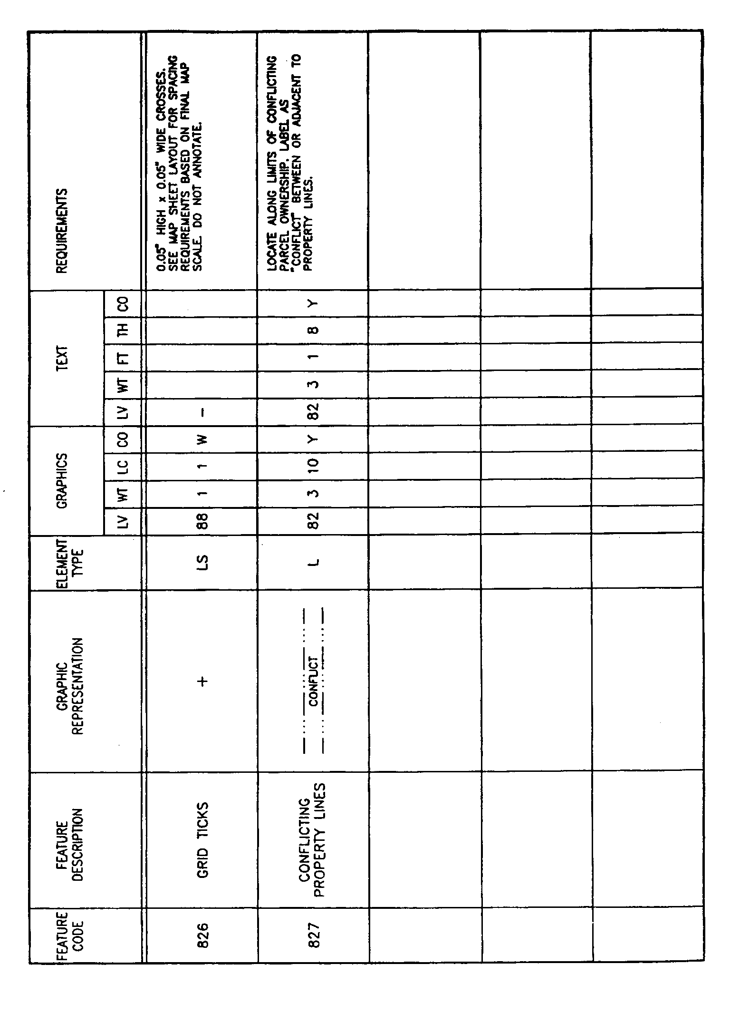

AUTHORITY NOTE: Promulgated in accordance with R.S. 50:171.
HISTORICAL NOTE: Promulgated by the Office of the Governor, Division of Administration, State Land Office, LR 17:968 (October 1991).

Title 43
NATURAL RESOURCES
Part XXVII. State Lands

Subpart 2. Use and Management of State Lands

Chapter 21. Reclamation Projects

§2101. Class A and Class E Permits

A. Permits may be granted to owners of land contiguous to and abutting navigable waterbottoms belonging to the state to construct landfills either for the purpose of reclaiming or recovering land lost through erosion by action of the water body if said erosion occurred on and after
July 1, 1921, or for the purpose of maintaining an encroachment on non-eroded state lands. A Class A permit shall be issued for reclamation of lands eroded on or after July 1, 1921. Lands reclaimed shall be subject to the procedures as set forth in Boundary Agreements of these rules and regulations. A Class E permit shall be issued for reclamation of non-eroded lands. Landfills constructed on non-eroded state lands shall be subject to the procedures as set forth in "Leases: Reclamation" of these rules and regulations.

B. Submitting Procedures. Applicant shall notify the commissioner of the Division of Administration in writing of his intent to apply for a permit for work contemplated. Such letter shall contain a description of the proposed physical work to be performed, materials to be used and identity of the body of water involved. Upon receipt of applicant's letter, the commissioner shall forward the appropriate permit form to the applicant with a copy of these regulations. Upon completion of the appropriate form the applicant shall:

1. apply to the governing authority of the parish or parishes within which the work or structures will be located for their approval or permit for the project;

2. apply to the U.S. Corps of Engineers for the appropriate federal permit, and in the event that the Corps of Engineers declines jurisdiction over the proposed work, and does not publish notice;

3. cause to have published at least once, notice of the application in the official journal of the parish or parishes.

C. Fees

1. An application for a Class A or E permit shall be accompanied by a nonrefundable administrative and processing fee of $50.

2. In the event that review of the application requires special work in the field such as special field examination or survey, the applicant shall be required to pay for such special work, the price of which shall be fixed by the commissioner based on his estimate of the cost of special work to the state. The commissioner shall notify the applicant of the estimated cost of such special work and shall not proceed until the estimated cost of same is paid.

D. Application requirements for Class A or E permits issued under Act 645 of 1978. Applications must be submitted in triplicate to the commissioner of the Division of Administration, and each application must include the following:

1. application form as provided by the Division of Administration;

2. approval of the parish governing authority for the project;

3. a certified deed of ownership* (of the lands contiguous to public lands);

4. if the applicant is not the owner, a certified copy of the deed or other instrument* under which the owner holds title plus written permission for the applicant to carry out the project;
Note: Should the encroachment be located wholly upon state waterbottoms and not proximate to any bank or shore, no deeds of ownership or written permission need be furnished provided that the letter of intent contains details of ingress and egress for such structure;

5. map or plat showing:

a. location of the activity site including section, township, and range;

b. Louisiana grid coordinates of all corners and angle points;

c. name of waterway;

d. all applicable political (parish, town, city, etc.) boundary lines;

e. name of and distance of local town, community or other identifying location;

f. names of all roads in the vicinity of the site;

g. graphic scale;

h. north arrow;

6. plan view showing:

a. existing shorelines;

b. ebb and flood in tidal waters and direction of flow in rivers;

c. mean high water line;

d. mean low water line;

e. water depth around the project;

f. extent of land area reclaimed or filled shown in square feet;

g. extent of encroachment beyond applicable water lines;

h. waterward dimensions from an existing permanent fixed structure or object;

i. location of structures, if any, in navigable water immediately adjacent to the proposed activity;

7. elevation and/or section view showing:

a. same water elevations as in the plan view;

b. depth at waterward face of proposed work;

c. dimensions from applicable water lines for proposed float or pile supported platform;

d. graphic or numerical scale;

e. detailed drawings of construction including plot plan, cross section and profile;

8. nonrefundable administrative and processing fee of $50;

9. letter of intent.

E. Where a permit application contemplates any form of landfill or reclamation, the map or plat submitted must be prepared by a professional land surveyor currently registered by the State Board of Registration for Professional Engineers and Land Surveyors.

F. Verification of Work. Upon completion of the project, the applicant is required to submit verification of the work completed to the commissioner of the Division of Administration within 60 days. The applicant is required to submit a final certified map or plat prepared by a professional land surveyor currently registered by the State Board of Registration for Professional Engineers and Land Surveyors as verification.

G. Boundary Agreements and Leases

1. After fulfilling the requirements for verification of work completed pursuant to a reclamation permit, the applicant and the commissioner of the Division of Administration shall enter into an agreement fixing the definitive boundary between the reclaimed land area and the waterbottoms. No definitive boundary shall be fixed nor shall title be vested unless and until proof is made that the reclaimed land is raised to a minimum height of six inches above mean high water and is stabilized along the newly created bank or shore by masonry, concrete mats, riprap, sheet piling, bulkheads, or similar constructions to reasonably insure permanence as required by law.

2. Upon completion of a Class E permit construction and verification, a lease is required as follows:

a. after fulfilling the requirements for verification of work completed pursuant to a landfill the applicant and the commissioner of the Division of Administration shall enter into a lease agreement to operate or maintain the encroachment. Such leases will not be subject to competitive bidding except in those cases where the best interest of the state and applicant will be served. The consideration for such leases shall be based upon the size and nature of the encroachment. The lease shall be assessed at 5 percent of the appraised value of the land for noncommercial use and at
7.5 percent of the appraised value for commercial uses with a minimum fee of $100 per year. The property will be reappraised at the expiration of the primary term of the lease;

b. leases entered into shall be for a term of five years and subject to renewal by lessee for nine successive terms. In no case shall the maximum term of such leases exceed 50 years. At the end of a 50-year maximum period, lessees may apply for a new lease for the subject encroachment.
*Only one certified copy of deed or instrument is required.
AUTHORITY NOTE: Promulgated in accordance with R.S. 41:1701-1714 and R.S. 41:1131.
HISTORICAL NOTE: Promulgated by the Department of Natural Resources, Office of the Secretary, LR 3:248 (May 1977), amended LR 5:8 (January 1979), LR 7:342 (July 1981), LR 12:440 (July 1986), LR 17:777 (August 1991), repealed and repromulgated by the Office of the Governor, Division of Administration, State Land Office, LR 19:489 (April 1993).

Chapter 23. Permitting and Leasing Encroachments onto State Owned Property

§2301. Class B, Class C and Class D Permits

A. A Class B Permit shall be issued to construct bulkheads or flood protection structures in proximity to the bank or shore. Permits and leases may also be granted for the construction and/or maintenance of commercial structures which are permanently attached to public lands by pilings or other means. Such structures shall include, but not be limited to wharves, piers, storage docks, camps, warehouses, residences, bulkheads, restaurants, dams, bridges, etc. A Class C permit shall be issued to construct wharves and piers and a Class D permit shall be issued for those structures other than wharves and piers. Exempted from permit and lease requirements are commercial and noncommercial wharves and piers less than 50 linear feet whose surface area does not exceed 150 square feet, unless part of another encroachment or unduly interferes with public interests, navigation or fishery. Structures constructed on state lands shall be subject to the procedures as set forth in "Leases: Structures" of these rules and regulations.

B. Submitting Procedures. Applicant shall notify the commissioner of the Division of Administration in writing of his intent to apply for a permit for work contemplated. Such letter shall contain a description of the proposed physical work to be performed, materials to be used and identity of the body of water involved. Upon receipt of applicant's letter, the commissioner shall forward the appropriate permit form to the applicant with a copy of these regulations. Upon completion of the appropriate form the applicant shall:

1. apply to the governing authority of the parish or parishes within which the work or structures will be located for their approval or permit for the project;

2. apply to the U.S. Corps of Engineers for the appropriate federal permit, and in the event that the Corps of Engineers declines jurisdiction over the proposed work, and does not publish notice;

3. upon request of the governing authorities of the parish cause to have published at least once, notice of the application in the official journal of the parish or parishes.

C. Fees

1. An application for a permit shall be accompanied by a nonrefundable administrative and processing fee of $10.

2. In the event that review of the application requires special work in the field such as special field examination or survey, the applicant shall be required to pay for such special work the price of which shall be fixed by the commissioner based on his estimate of the cost of special work to the state. The commissioner shall notify the applicant of the estimated cost of such special work and shall not proceed until the estimated cost of same is paid.

D. Application Requirements for Class B, C, or D permits. Applications must be submitted in triplicate to the commissioner of the Division of Administration, and each application must include the following:

1. application form as provided by the Division of Administration;

2. approval of the parish governing authority for the project;

3. a certified deed of ownership* (of the lands contiguous to public lands);

4. if the applicant is not the owner, a certified copy of the deed or other instrument* under which the owner holds title plus written permission for the applicant to carry out the project;
Note: Should the encroachment be located wholly upon state waterbottoms and not proximate to any bank or shore, no deed of ownership or written permission need be furnished provided that the letter of intent contains details of ingress and egress for such structure;

5. map or plat showing:

a. location of the activity site including section, township and range;

b. name of waterway;

c. all applicable political (parish, town, city, etc.) boundary lines;

d. name of and distance of local town, community or other identifying location;

e. names of all roads in the vicinity of the site;

f. graphic scale;

g. north arrow;

6. plan view showing:

a. existing shorelines;

b. ebb and flood in tidal waters and direction of flow in rivers;

c. mean high water line;

d. mean low water line;

e. water depth around the project;

f. extent of encroachment beyond the applicable water lines;

g. waterward dimensions from an existing permanent fixed structure or object;

h. location of structures, if any, in navigable water immediately adjacent to the proposed activity;

7. elevation and/or section view showing:

a. same water elevations as in the plan view;

b. depth at waterward face of proposed work;

c. dimensions from applicable water lines for proposed load or pile supported platform;

d. graphic or numerical scale;

e. detailed drawings of construction including plot plan, cross section and profile;

8. nonrefundable administrative and processing fee of $10;

9. letter of intent.

E. If the proposed project falls under the United States Army Corps of Engineers jurisdiction and permit(s) are being sought from that agency, the applications submitted to the Corps of Engineers may be submitted to the Division of Administration in lieu of the above, providing that all copies are clear and legible and the Corps permit application does in fact contain all of the information described above.

F. Leases

1. All Class C and D permits are accompanied by a lease agreement described as follows:

a. after fulfilling the requirements for a structure permit, the applicant and the commissioner of the Division of Administration shall enter into a lease agreement to operate or maintain the encroachment. Such leases will not be subject to competitive bidding except in those cases where the best interest of the state and applicant will be served. The consideration for such leases shall be based upon the size and nature of the encroachment;

b. annual rentals on leases for commercial wharves, piers, and other structures issued pursuant to R.S. 41:1201-1215 lying outside of the jurisdiction of deep water port commissions shall be levied at 2 cents per square foot of state owned land or waterbottom enclosed or utilized by the structures and associated vessels. Those lands so utilized shall include the pier, wharf or dock itself, all associated piles, dolphins, structures, and waters adjacent and contiguous to the above structures occupied by vessels docking at said structures. The waters so utilized by vessels and included in the lease shall be measured in 10-foot increments adjacent to and adjoining the structures
(10, 20 or 30 feet) depending upon the size of the vessels docking at that particular pier, dock or wharf. Any contiguous area of water where boats may be moored shall be assessed according to the following schedule:

i. boats less than 35 feet in length require a
10-foot wide berthing;

ii. boats 35 to 75 feet in length require a 20-foot wide berthing;

iii. boats greater than 75 feet in length require a 30- foot wide berthing.

2. In no instance shall the consideration be less than $100 per annum.

3. Leases entered into shall be for a term of five years and subject to renewal by lessee for nine successive terms. In no case shall the maximum term of such leases exceed
50 years. At the end of a 50-year maximum period, lessees may apply for a new lease for the subject encroachment.
*Only one certified copy of deed or instrument is required.
AUTHORITY NOTE: Promulgated in accordance with R.S. 41:1701-1714 and R.S. 41:1131.
HISTORICAL NOTE: Promulgated by the Department of Natural Resources, Office of the Secretary, LR 3:248 (May 1977), amended LR 5:8 (January 1979), LR 7:342 (July 1981), LR 12:440 (July 1986), LR 17:777 (August 1991), repealed and repromulgated by the Office of the Governor, Division of Administration, State Land Office, LR 19:491 (April 1993).

Chapter 25. General Regulations Regarding all Permits

§2501. General Permit Conditions

A. Approval of Local and Other State Authorities. No permits shall be issued nor shall any work commence until the application has first been approved by the governing authority of the parish wherein the property is located, Office of Public Works, Department of Wildlife and Fisheries, State Mineral Board, Coastal Management Section (if the project is in the coastal zone) and such other parochial or state agencies which may have jurisdiction over such matter. Coordination and dissemination among the several agencies will be performed by the commissioner of the Division of Administration.

B. Objections and Public Hearings

1. Objections shall be received by the commissioner of the Division of Administration for a period of 30 days from date of published notice, to correspond with the delays established by the U.S. Corps of Engineers. In the event that opportunity for public hearing is deemed necessary by either the state, through the commissioner of the Division of Administration, or the U.S. Corps of Engineers, all efforts will be made by the state to accommodate the applicant by holding one hearing together with the federal authorities at whatever time and place the latter stipulates.

2. At the end of the prescribed period for objections, or after the public hearing if necessary, the governing authority of the parish or parishes shall either approve or object to the application, with reasons, and forward their determination to the commissioner of the Division of Administration, together with all required attachments and evidence of publication of notice by either the Corps of Engineers or the applicant, for processing as provided herein.

C. Reasons for Denial or Limitation. No reclamation, encroachment or lease shall be allowed if in the determination of the Office of Public Works, Department of Wildlife and Fisheries, State Mineral Board or the commissioner of the Division of Administration, such activity would obstruct or hinder the navigability of any waters of the state, impose undue or unreasonable restraints on the state or public rights which have vested in such areas pursuant to Louisiana law, or result in unacceptable adverse impacts to the environment of the coastal zone, and to that extent the land area sought to be reclaimed, or the structure or construction, may be limited.

D. Hold Harmless. All permits and leases approved and issued hereunder shall be conditioned upon applicant's agreement to hold the State of Louisiana and her agencies and subdivisions harmless for applicant's acts or omissions in reclaiming and maintaining eroded lands and constructing or maintaining any structures and bulkheads, though the permit or lease for the same subsequently expires or is revoked.

E. Encumbrances. A permit will be issued subject to and encumbered with any right-of-way or servitude, or any mineral, geothermal, geopressure, or any other lease acquired or granted by the state for a lawful purpose while the reclaimed land was an eroded area. Nothing in these regulations shall prevent the leasing of state lands or waterbottoms for mineral or other purposes.

F. Maximum Permit Term. All permits issued pursuant to these provisions shall be effective for a period not to exceed two years from the date of issuance and shall thereupon expire. All work remaining or any additional work may be completed only by a new permit application.

G. Vested Rights. No permit or lease shall be construed to vest any proprietary rights or title in any private owner except as to lands actually reclaimed and maintained, pursuant to Act 645 of 1978. Eroded lands contiguous to the coast of the Gulf of America as defined in the Decree of the United States Supreme Court dated July 16, 1975, in United States vs. Louisiana, No. 9 Original, may be reclaimed under reclamation permits, out to the coastline.

H. Copies to Local Governments. A copy of the permit issued, along with the pertinent plats attached and the documentation required to be submitted 60 days after completion of work shall be filed with the clerk of court of the parish or parishes affected. A copy of the above shall also be furnished the assessor of the parish or parishes for assessment purposes.
AUTHORITY NOTE: Promulgated in accordance with R.S. 41:1701-1714 and R.S. 41:1131.
HISTORICAL NOTE: Promulgated by the Department of Natural Resources, Office of the Secretary, LR 3:248 (May 1977), amended LR 5:8 (January 1979), LR 7:342 (July 1981), LR 12:440 (July 1986), LR 17:777 (August 1991), repealed and repromulgated by the Office of the Governor, Division of Administration, State Land Office, LR l9:492 (April 1993).

Chapter 27. Rights-of-Way

§2701. Granting of Rights-of-Way to Corporations or Individuals

A. Applicants are to use the state right-of-way form provided by the State Land Office. A special form is used for escrow agreement permits.

B. The right-of-way form must be submitted in triplicate with a legal size plat(s) attached to each copy.

C. The description contained in the right-of-way form must indicate section, township and range, or area and block number(s) if offshore; name of the body of water to be crossed; the size of the pipe and the length of the right-of-way in rods.

D. The plat(s) must reveal the following:

1. station numbers at the mean low water elevation on a river; the station number at the mean high water elevation on a lake, bay or Gulf of America; or station number at ingress and egress of state properties. Said plat, when illustrating the mean low water line of a river or the mean high water line of a lake or the Gulf, will be authoritative only as to the date of the application for calculation of the state's consideration. The limits of state property reflected on said plat are illustrative only and recognized solely and only for computing the fee for this grant, and are not intended and shall not be construed as determinative of actual title for the benefit of any adjoining owners, whether a grantee herein or a third party;

2. the section, township and range if in an area that has been surveyed;

3. the product to be transported;

4. the location of the pipeline with respect to the right-of-way.

E. Names of adjoining landowners cannot be shown on the plat unless necessary for legal description.

F. The right-of-way form must be accompanied by a letter of intent which shall contain the following information:

1. initiating and terminating point of the pipeline;

2. point of origination of product to be transported as a result of this construction;

3. capacity or if a loopline added capacity as a result of this construction;

4. estimated volume of product to be transported as a result of this construction;

5. a detail of construction;

6. pipe specifications including size, wall thickness and type;

7. the proposed and maximum operating pressures.

G. Where state mineral leases are traversed, an applicant will furnish the commissioner of the Division of Administration a copy of the letter of notification (with signed, certified returned receipt attached) which has been sent to the mineral lessees.

H. It is necessary that permission or clearance be obtained from the United States Corps of Engineers; State Office of Public Works, Department of Transportation and Development; Louisiana Department of Environmental Quality, Water Pollution Control Division; The Louisiana Department of Wildlife and Fisheries and both the Coastal Management Division and the Office of Conservation of the Department of Natural Resources if the operation is within their respective jurisdictions and from any other agency having permit authority over the proposed project.

I. Clearance shall be obtained from the Secretary of the Department of Wildlife and Fisheries, New Orleans, Louisiana, when oyster leases are to be traversed.

J. Written consent must be obtained from the Secretary of the Department of Wildlife and Fisheries if the proposed right-of-way crosses a state or federal preserve. Similar clearance is required from any agency having jurisdiction over surface rights of state lands being crossed.

K. The state requires payment for all grants across state lands or navigable streams, regardless of size.

L. The proposed route of the pipeline shall be subject to approval of the Commissioner of the Division of Administration.

M. Fees for permits shall be as follows:

1. class 1: pipe 2 inches up to 19 inches outside diameter with a minimum of 75 feet right-of-way during construction to revert to 35 after construction is completed with the additional right of ingress and egress for the purpose of maintenance, repairs, removal or modification⎯$50 per rod;

2. class 2: pipe 19 inches up to 36 inches outside diameter with a maximum of 100 feet right-of-way during construction to revert to 50 feet after construction is completed with the additional right of ingress and egress for the purpose of maintenance, repairs, removal or modification⎯$70 per rod;

3. class 3: pipe over 36 inches outside diameter with a maximum of 200 feet right-of-way during construction to revert to 60 feet after construction is completed with the additional rights of ingress and egress for the purpose of maintenance, repairs, removal or modification⎯$90 per rod;

4. The minimum fee for any application processed shall be $50 with a $100 fee assessed for any assignment of permit thereafter.

N. Contract Term. Twenty years with option to renew for additional 20-year term. The option to renew shall be on the same terms and conditions as the original agreement except that the consideration shall be adjusted to reflect the percentage of increase or decrease in the cost of living index as established by the Consumer Price Index for Urban Wage Earners and Clerical Workers published by the Bureau of Labor Statistics of the United States Department of Labor or any revision or equivalent of any such index published by the United States Government, which has occurred from date of this instrument to the date of renewal provided, however, that in no event shall consideration of such renewal be less than the consideration paid herein for the original term.

O. There shall be no above-ground installations, i.e., valve setting, tie-overs, platforms, etc., without the express consent and approval of the Commissioner of the Division of Administration. The secretary shall have authority to establish the basis of compensation (which amount shall be in addition to the per-rod consideration referred to in these rules) for such above-ground installation. The application for pipeline rights-of-way shall contain a concise description of any such above-ground facility together with appropriate drawing, showing location of same and profile of design and style.

P. All pipelines constructed under permits granted by the state of Louisiana shall be in accordance with Parts 191, 192 and/or 195 of Title 49 of the Code of Federal Regulations, as amended, and other federal and state laws not in conflict therewith.

Q. The state of Louisiana is held free from any and all liabilities.

R. A copy of the right-of-way grant, along with a pertinent plat(s) attached, must be filed with the Clerk of Court of the parish or parishes affected and the Division of Administration furnished recordation data.
AUTHORITY NOTE: Promulgated in accordance with R.S. 41:1173.
HISTORICAL NOTE: Adopted by the State Land Office, LR 1:147 (February 1975), amended by the Department of Natural Resources, Office of the Secretary, LR 3:314 (July 1977), repealed and repromulgated by the Office of the Governor, Division of Administration, State Land Office, LR 19:493 (April 1993), amended by the Office of the Governor, Division of Administration, Office of State Lands, LR 43:48 (January 2017).

Chapter 29. Fees for Certified Copies

§2901. Fees for Certified Copies

A. Fees charged by the State Land Office for providing certified copies of various matters pertaining to tax adjudicated lands, patents, and official township plats are as follows:
1. | original redemption certificates | $10;
2. | original cancellation certificates | $10;
3. | original patents | $50;
4. | copies of official township plats | $10;
5. | copies of field notes | $1 per page;
6. | copies of patents | $1 per page;
7. | each certification of copies named above | $5;
8. | copies of any other State Land Office document | $1.
AUTHORITY NOTE: Promulgated in accordance with R.S. 41:8.
HISTORICAL NOTE: Promulgated by the Department of Natural Resources, Office of the Secretary, LR 13:29 (January 1987), repealed and repromulgated by the Office of the Governor, Division of Administration, State Land Office, LR l9:494 (April 1993).

Chapter 31. Best Use of Nonessential Property

§3101. Rules and Regulations Providing for Designation of Immovables as Nonessential Property

A. Definitions

Best Use of Nonessential Property―the use which is possible physically, feasible financially and permissible legally.

Nonessential Property―land and immovable structures thereon, the use of which is not indispensable to fulfillment of an agency's legally established functions.

B. All state agencies shall review their property inventories in order to designate as nonessential property which could be transferred to the State Land Office (hereinafter referred to as the State Land Office). Land, and immovable structures thereon, the use of which is not indispensable to fulfillment of an agency's legally established functions, shall be considered nonessential property; designated thusly, it shall be expendable immediately from the agency's inventory.

C. In order to designate property as nonessential, one of these criteria must be met:

1. property has been closed, abandoned or neglected by the agency; or

2. the controlling agency formally acknowledges that another agency would derive greater benefits from use of the property.

D. Transfer of Property from the Agency to the Department

1. Following designation of property as nonessential, the secretary, or head of the agency, shall prepare a written request for the transfer of property from the agency to the State Land Office.

2. The State Land Office and the agency shall execute an agreement which transfers the agency property to the State Land Office. Copies of this agreement shall be retained by the agency and the State Land Office and also shall be filed with the clerk of court for the Parish of East Baton Rouge and the clerk of court for the parish in which the property is located. Additionally, one copy shall be sent to the Office of the Governor, Division of Administration.
AUTHORITY NOTE: Promulgated in accordance with R.S. 41:140.
HISTORICAL NOTE: Promulgated by the Department of Natural Resources, Office of the Secretary, LR 13:411 (July 1987), repealed and repromulgated by the Office of the Governor, Division of Administration, State Land Office, LR 19:494 (April 1993).

§3102. Best Use or Disposition of Property

A. Upon the transfer of nonessential property to the State Land Office, they shall prepare a land management evaluation report setting forth recommendations for the best use or other disposition of the property.

B. The use which is possible physically, feasible financially, and permissible legally shall be considered the best use implementable by the State Land Office. Sale, transfer, lease or management of the property are examples of best use.

C. The land management evaluation report and recommendations prepared by the State Land Office shall contain the following:

1. copy of transfer to the State Land Office;

2. property appraisal prepared by or reviewed by the public lands appraiser;

3. provision for a minimum acceptable bid, which shall be 90 percent of the appraisal in §3102.C.2 above;

4. timber appraisal if applicable;

5. map of the property;

6. complete legal description of the property;

7. recommendations for best use or disposition of property;

8. method of sale, if applicable, and reasons therefore;

9. blank approval letter, to be completed by the House and Senate Natural Resources Committees and returned to the State Land Office.

D. Within 10 days of completion, the land management evaluation report shall be filed with the Division of Administration, the House and Senate Natural Resources Committees and the representative and senator in whose district the property is located.

E. In order to initiate implementation of its recommendation for best use or other disposition of the property, the State Land Office must receive the written approval of both House and Senate Natural Resources Committees not more than 90 days following receipt of the recommendation by the committees.
AUTHORITY NOTE: Promulgated in accordance with R.S. 41:140.
HISTORICAL NOTE: Promulgated by the Department of Natural Resources, Office of the Secretary, LR 13:411 (July 1987), repealed and repromulgated by the Office of the Governor, Division of Administration, State Land Office, LR 19:495 (April 1993).

§3103. Recommendations Approved by the Appropriate Committees Shall Be Implemented by the State Land Office

A. The sale of property shall be through public bid, whether by auction or sealed bids, in accordance with R.S. 41:131-134 or 47:2189.

B. The lease of property shall be through public bid in accordance with R.S. 41:1221 et seq., and other applicable statutes.

C. Property not disposed of by the department shall be utilized in such a manner as to derive maximum revenue from the property.

D. Sales and leases shall be recorded with the clerk of court for the parish in which the property is located, and a copy retained by the State Land Office.
AUTHORITY NOTE: Promulgated in accordance with R.S. 41:140.
HISTORICAL NOTE: Promulgated by the Department of Natural Resources, Office of the Secretary, LR 13:411 (July 1987), repealed and repromulgated by the Office of the Governor, Division of Administration, State Land Office, LR l9:495 (April 1993).

§3104. Procedure

A. Transfer

1. Request for transfer

2. Inspection by State Land Office

3. Transfer to State Land Office

B. Report

1. Appraisal

2. Minimum bid

3. Copy of transfer

4. Maps

5. Legal description

6. Recommendations and best use

7. Method of sale

8. Approval letter

9. Cover letter

C. Approval

D. Best Use or Disposition

1. Transfer

2. Lease

3. Land management

4. Sale

a. Public auction

b. Sealed bids
AUTHORITY NOTE: Promulgated in accordance with R.S. 41:140.
HISTORICAL NOTE: Promulgated by the Department of Natural Resources, Office of the Secretary, LR 13:411 (July 1987), repealed and repromulgated by the Office of the Governor, Division of Administration, State Land Office, LR 19:495 (April 1993).

Chapter 32. Receipt of Donation of Immovable Property

§3201. Submission of Offers of Donation

A. Prior to acceptance by a state agency of any offer of donation of immovable property, that offer shall be submitted in writing to the Commissioner of Administration or his designee for evaluation in accordance with §3202 of these rules and shall be reviewed and approved in full accordance with §3203 of these rules. For the purposes of these rules, state agency shall mean any agency that meets the definition set forth in R.S. 39:2(2). However, notwithstanding anything contained in these rules, these rules shall not apply to any offer of donation of immovable property made to a state agency that is exempt by law from the operation of R.S. 41:151.

B. The written submission of an offer of donation to the Commissioner of Administration or his designee shall set forth:

1. the identification of the state agency that is the proposed donee;

2. the identification of the proposed donor;

3. the legal description of the property that is the subject of the proposed donation, including a statement of the total acreage of the property and a survey map, if available;

4. any proposed terms, conditions and/or reservations to which the proposed donation would be subject;

5. a statement of the public interest that acceptance of the donation would serve;

6. a statement of any financial or other burdens that acceptance of the donation would impose on the state; and

7. a statement of the appraised fair market value of the property that is the subject of the proposed donation.

C. In addition to the information described in §3201.B of these rules, a state agency submitting a proposed donation shall provide the commissioner of administration or his designee with any supplementary information that he requests.
AUTHORITY NOTE: Promulgated in accordance with R.S. 41:151.G.
HISTORICAL NOTE: Promulgated by the Office of the Governor, Division of Administration, Office of State Lands, LR 32:612 (April 2006).

§3202. Evaluation of Offers of Donation

A. The Commissioner of Administration or his designee shall evaluate proposed donations of immovable property submitted pursuant to these rules and shall determine whether such proposed donations are in the best interest of the state.

B. In conducting an evaluation pursuant to these rules, the Commissioner of Administration or his designee shall weigh the extent to which acceptance of a proposed donation would serve the public interest and the burden, if any, that acceptance of that donation would impose on the state.

C. Based upon his evaluation conducted pursuant to these rules, the Commissioner of Administration or his designee shall determine whether acceptance or refusal of a proposed donation is in the best interest of the state, and shall provide the proposed donee his determination in writing. Such written notification may set forth terms and conditions relating to his determination.

D. If the Commissioner of Administration or his designee determines that acceptance of a proposed donation is in the best interest of the state, he shall proceed to assist the donee in negotiating any appropriate terms and conditions of the proposed donation, in order to serve the public interests in such proposed donation. A proposed donation shall not be accepted unless the Commissioner of Administration or his designee has approved all such terms and conditions.
AUTHORITY NOTE: Promulgated in accordance with R.S. 41:151.G.
HISTORICAL NOTE: Promulgated by the Office of the Governor, Division of Administration, Office of State Lands, LR 32:613 (April 2006).

§3203. Approval of Offers of Donation

A. When the Commissioner of Administration or his designee determines that a proposed donation, including any terms and conditions of such donation negotiated pursuant to §3202.D of these rules, is in the best interest of the state, he or she shall prepare a written report, which shall set forth:

1. the identification of the state agency that is the proposed donee;

2. the identification of the proposed donor;

3. the legal description of the property that is the subject of the proposed donation, including a statement of the total acreage of the property and a survey map, if available;

4. any proposed terms, conditions and/or reservations to which the proposed donation would be subject;

5. a description of the evaluation conducted pursuant to §3202 of these rules, showing how the proposed donation would be in the best interest of the state; and

6. a statement of the appraised fair market value of the property that is the subject of the proposed donation.

B. The Commissioner of Administration or his designee shall submit the report identified in Subsection 3203.A of these rules to the House Committee on Natural Resources and the Senate Committee on Natural Resources at each committee's office in the state capitol by means of certified mail, return receipt requested, or by means of a messenger, who shall obtain a signature for receipt as proof of receipt of the report by each committee.

C. The committees shall, within 30 days of their receipt of the report submitted to them pursuant to Subsection 3203.B of these rules, meet jointly or separately to conduct hearings regarding the proposed donation that is the subject of the report. If the committees meet jointly, then a quorum of each committee shall be required to take action and a motion shall receive the favorable vote of a majority of those present in order to be adopted.

D. At the hearing or hearings identified in §3203.C of these rules, the committees shall evaluate the terms and conditions of the proposed donation and determine whether they are acceptable and whether acceptance of the proposed donation is in the best interest of the state.

E. If either committee determines that acceptance of a proposed donation is not in the best interest of the state, that committee may disapprove the proposed donation and shall give written notification of the disapproval to the Commissioner of Administration or his designee, summarizing its determinations. In such a case, either committee may recommend changes to the terms and conditions of the proposed donation, which recommendations shall not be binding on the proposed donor or on the Commissioner of Administration or his designee.

F. If a proposed donation is disapproved pursuant to §3203.E of these rules, the Commissioner of Administration or his designee may assist the proposed donee in renegotiating the terms and conditions of the proposed donation in light of the determinations and recommendations, if any, made by the committees. If such a renegotiation occurs, the Commissioner of Administration or his designee may submit to the committees an additional report, consistent with the requirements of Subsection 3203.A, describing the renegotiated proposal.

G. If both committees approve a proposed donation or if neither committee disapproves such proposed donation within 60 days of receipt of the report identified in §3203.A of these rules, then the Commissioner of Administration may accept the proposed donation on behalf of the state or authorize acceptance of the donation by the proposed donee.
AUTHORITY NOTE: Promulgated in accordance with R.S. 41:151.G.
HISTORICAL NOTE: Promulgated by the Office of the Governor, Division of Administration, Office of State Lands, LR 32:613 (April 2006).

§3204. Notifications to the Legislature

A. The Commissioner of Administration or his designee shall, on a quarterly basis, submit to the House Committee on Natural Resources and the Senate Committee on Natural Resources a report identifying any proposed donations that the Commissioner of Administration or his designee refused during the previous quarterly period. The quarterly report shall set forth the reasons for such refusal.

B. Notwithstanding the provisions of §3204.A of these rules, where a proposed donor has requested in writing that a proposed donation remain confidential if not accepted, the Commissioner of Administration or his designee shall not identify such proposed donation in his quarterly report.

C. The Commissioner of Administration or his designee shall, on annual basis, submit to the House Committee on Natural Resources and the Senate Committee on Natural Resources a report setting forth the amount of immovable property received by the state through donation, the estimated value of such property and the state agencies that received such property.
AUTHORITY NOTE: Promulgated in accordance with R.S. 41:151.G.
HISTORICAL NOTE: Promulgated by the Office of the Governor, Division of Administration, Office of State Lands, LR 32:613 (April 2006).

Chapter 33. Tax Land Sales

§3301. Sales through Real Estate Brokerage Firms

A. Any person and/or firm listed as a qualified and licensed broker by the Louisiana Real Estate Commission may nominate for sale a parcel or parcels of unredeemed property adjudicated to the state for unpaid taxes.

B. The nomination, to be submitted to the State Land Office, Box 44124, Baton Rouge, LA 70804, shall include the following information as certified by the broker:

1. a complete description of the property, the name of the tax debtor, and the year for which taxes were unpaid;

2. he/she completed or caused to be completed a thorough review of the records of the assessor's office of the parish where the property is located, and there are no dual assessments affecting the property. In the event the records reveal a dual assessment, the broker will furnish the name or names of the parties listed as owners;

3. he/she completed or caused to be completed a thorough search of the conveyance records of the parish where the property is located, and there are no transactions of record which resulted in alienation of the property;

4. current information regarding the owners of the property, and the last known addresses on file with the assessor's office;

5. a list of the names and mailing addresses of all holders of encumbrances recorded against the property.

C. The State Land Office will evaluate information submitted by the broker in order to determine the appropriateness of a sale.

D. In the event the State Land Office concludes that the best interests of the state would be served by redemption of the property, it will notify the broker, and commence efforts to locate parties with interest to redeem the property.

E. If no one with an interest initiates redemption proceedings within 35 days of the mailing of notification pursuant to §3301.B.4, the State Land Office will inform the broker that a sale is appropriate.

F. In addition to the requirements set forth in R.S. 47:2189, the broker also shall submit an appraisal, along with an on-site inspection.

G. Nothing herein shall prevent the State Land Office from conducting a second appraisal, where deemed appropriate by the department. In all instances, the State Land Office may use whichever appraisal it considers acceptable in arriving at the minimum price for the property.

H. Whenever practicable, the minimum price shall be sufficient to satisfy all taxes and other costs associated with the sale which must be paid pursuant to R.S. 47:2190.

I. The broker's commission, established by R.S. 47:2189.1 as a cost of the sale, shall be 6 percent of the amount received by the state treasurer pursuant to R.S. 47:2189.1.

J. The State Land Office shall provide the state treasurer with the broker's name, address and vendor's number, and the state treasurer shall remit the commission to the broker.
AUTHORITY NOTE: Promulgated in accordance with R.S. 47:2189.1.
HISTORICAL NOTE: Promulgated by the Department of Natural Resources, Office of the Secretary, LR 13:501 (September 1987), repealed and repromulgated by the Office of the Governor, Division of Administration, State Land Office, LR 19:495 (April 1993).

Chapter 35. Notice of Publication for Mineral Leasing

§3501. Notice of Publication Booklet

A. The State Land Office shall charge a fee of $120 annually ($10 per month) for subscription to the Notice of Publication.
AUTHORITY NOTE: Promulgated in accordance with Act 13, First Extraordinary Session 1988.
HISTORICAL NOTE: Promulgated by the Department of Natural Resources, LR 14:544 (August 1988), repealed and repromulgated by the Office of the Governor, Division of Administration, State Land Office, LR 19:496 (April 1993).

