Navigating LESA

Log In 1

Username/Password Reset 1

Add Users to LESA 2

LESA Dashboard 2

Search Function 4

LESA Terms 5

## Log In

* To log in to LESA visit louisiana.sourcing.ariba.com
* Type in your user name and password then hit submit
  + Your user name should be all lower case
  + Make sure there are no extra spaces or characters in either field

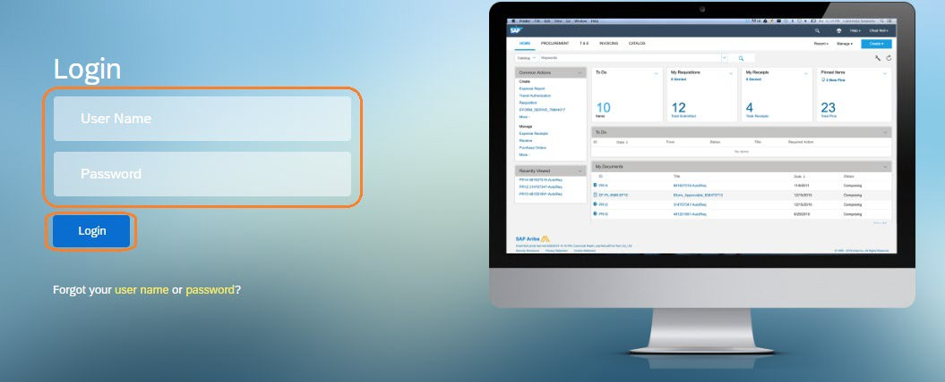

## Username/Password Reset

* Click on “Forgot your username or password?”

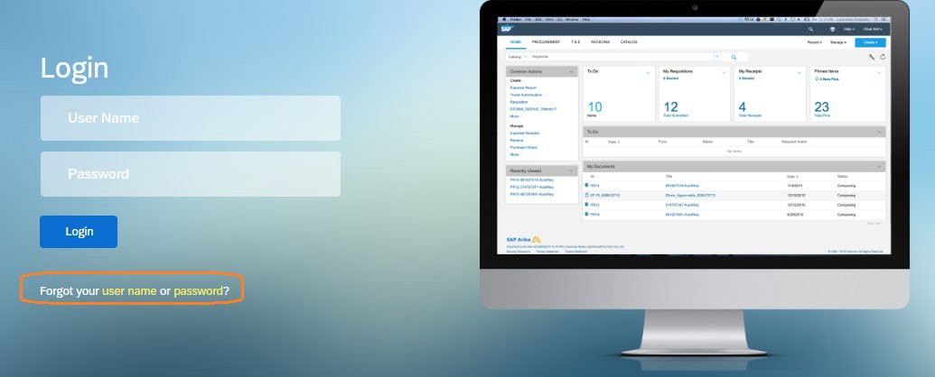

* Once you submit your request please wait for an email from Ariba. If after fifteen (15) minutes you have not received an email you may email your request to our LESA helpdesk at [LESA@la.gov](mailto:LESA@la.gov)

# Add Users to LESA

* If you would like to add more users from your agency to LESA please email the LESA helpdesk ([LESA@la.gov](mailto:LESA@la.gov)) with the following information for each user:
  + Full name
  + Email address
  + Phone number
  + Department ID number

# LESA Dashboard

* When you log into LESA you will see your home screen which is referred to as your Dashboard. This is fully customizable and each section can be moved around with a simple ‘drag and drop’.
* Some important sections to highlight are:
  + My Documents – the documents you create will be listed here

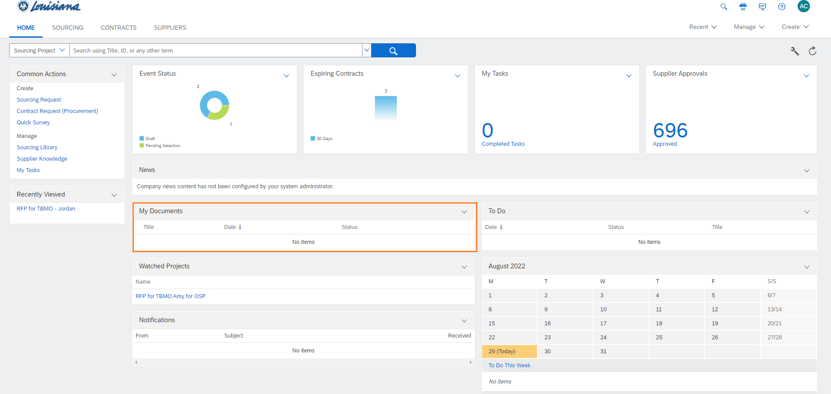

* + 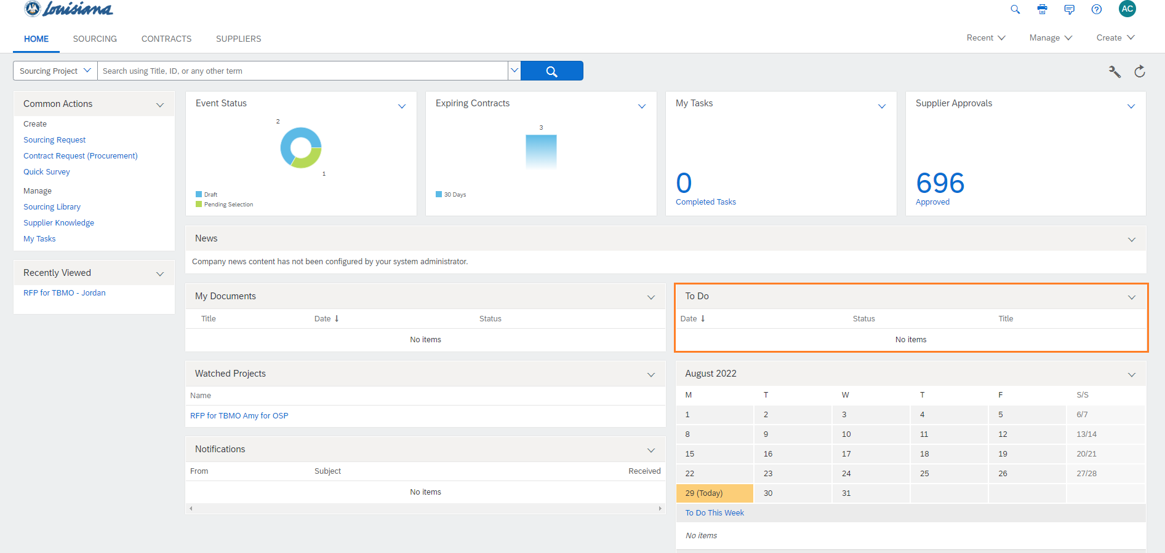To Do – shows tasks assigned to you
  + 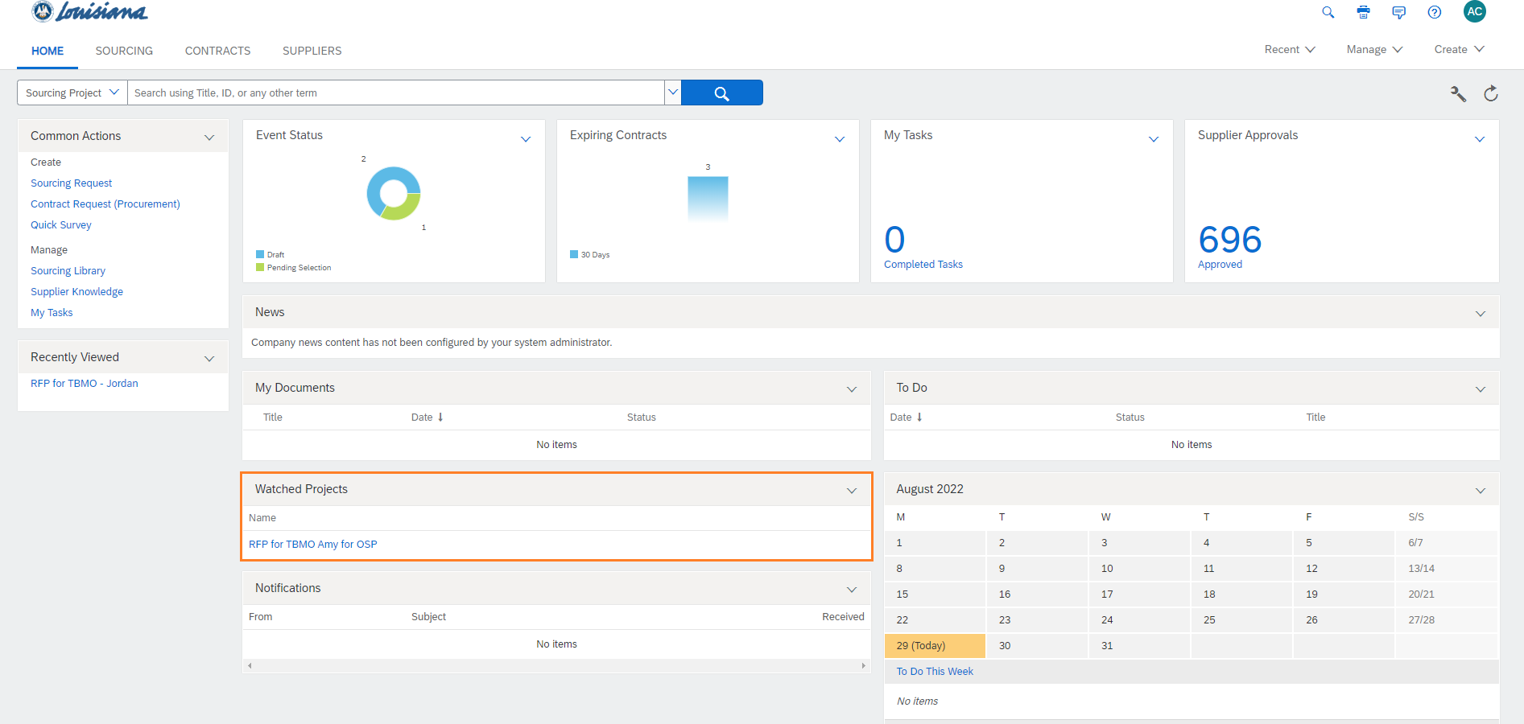Watched Projects – lists projects that have been manually added to the dashboard
  + Needs Review – items that require your review

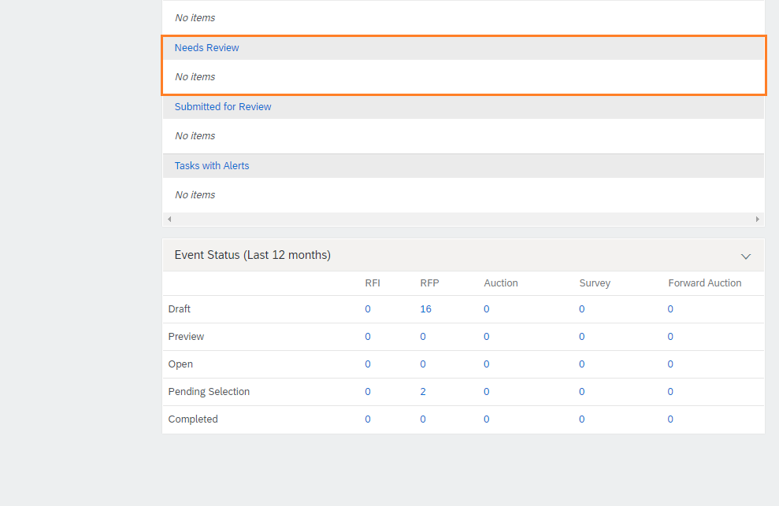

# Search Function

* Click on the drop down arrow next to the search bar to select which option you would like to search.
* In the search bar you can type the corresponding reference number or the name of the project and click the blue magnifying glass to search.

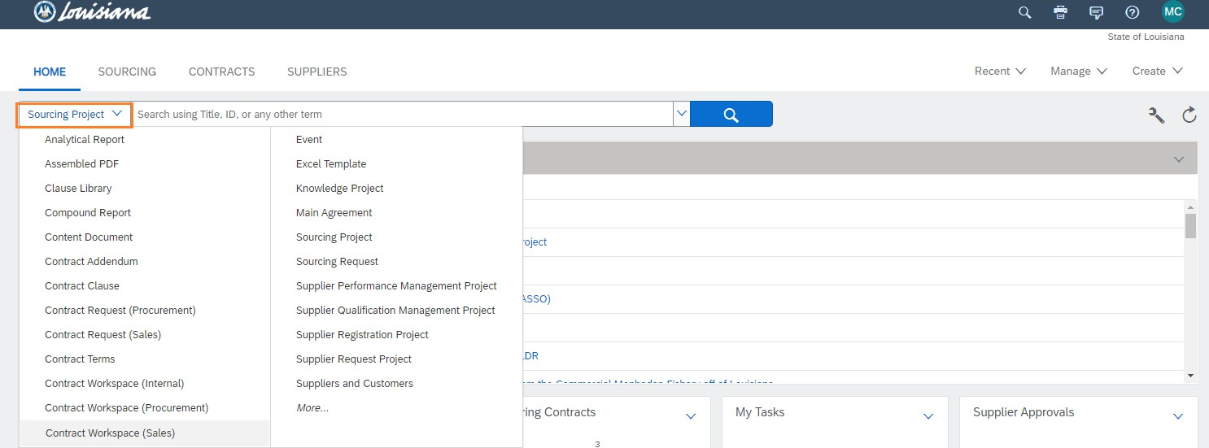

# LESA Terms

* Sourcing Request –the method of agency submission.
  + Activities include:
    - Writing the Scope of Work
    - Adding the Definitions and Acronyms
    - Contemplating Evaluation Factors
  + The reference number will begin with ‘SR’
  + This is similar to the transmittal number in Proact/Lagov or the shopping cart number in DocTracking
* Sourcing Project – where the RFP “lives”.
  + Activities include:
    - Customizing RFP content
    - Reviewing and Approving the RFP
    - Evaluating Proposals
    - Awarding the RFP
  + The reference number will begin with “WS”
* Sourcing Event – the RFP.
  + Activities include:
    - Answering inquiries
    - Receiving proposals
  + The reference number will begin with “Doc”
  + This is similar to the RFx number in Proact/Lagov/DocTracking
* Contract Workspace – where the contract “lives”.
  + Activities include:
    - Drafting the contract
    - Contract negotiation
    - Approving the contract
    - Contract management
  + The reference number will begin with “CW”