Certification by State or Local Official of PHA Plans Consistency with the Consolidated Plan or State Consolidated Plan
(All PHAs)


U.S. Department of Housing and Urban
Development
Office of Public and Indian Housing
0MB No. 2577-0226
Expires 09/30/2027

Certification by State or Local Official of PHA Plans Consistency with the Consolidated Plan or State Consolidated Plan


I, Heather Paul , the Community Development Director certify that the 5-Year PHA Plan for fiscal years 2025- 2029 and/or Annual PHA Plan for fiscal year 2025 of the [Name of Public Housing Authority] is consistent with the Consolidated Plan or State Consolidated Plan including the Analysis of Impediments (Al) to Fair Housing Choice or Assessment of Fair Housing (AFH) as applicable to the State of Louisiana pursuant to 24 CFR Part 91 and 24 CFR §903.15.
Provide a description of how the PHA Plan's contents are consistent with the Consolidated Plan or State Consolidated Plan.

The objectives and Priorities of the PHA are in accordance with those in the State's current Consolidated
Plan and Al.

I hereby certify that all the information stated herein, as well as any information provided in the accompaniment herewith. is true and accurate. Warnin1: HUD will prosecute false claims and statements. Conviction may result in criminal and/or civil penalties. (18 U.S.C. 1001, 10IO, l012: 31 U.S.C. 3729. 3802)
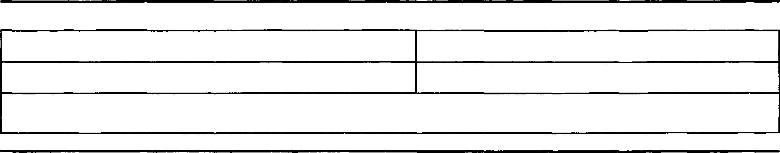
Name of Authorized Official:
Signature:
Heather Paul
Title: Community Development Dir
Date:

The United States Department of Housing and Urban Development is authorized to solicit the information requested in this form by virtue of Title 12, U.S. Code, Section 1701 et seq.• and regulations promulgated thereunder at Title 12, Code of Federal Regulations. Responses to the collection of information are required to obtain a benefit or to retain a benefit. The information requested does not lend Itself to confidentiality. This information is collected to ensure consistency with the consolidated plan or state consolidated plan.

Public reporting burden for this information collection is estimated to average 0.16 hours per year per response, including the time for reviewing Instructions. searching existing data sources, gathering and maintaining the data needed, and completing and reviewing the collection of information. HUD may not collect this information, and respondents are not required to complete this form, unless it displays a currently valid 0MB Control Number.

