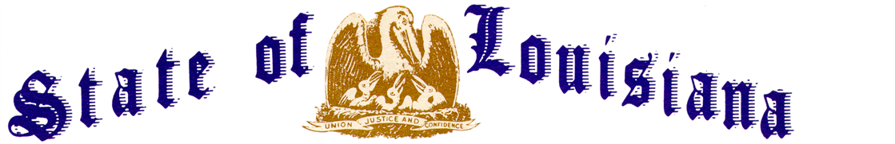
Executive Department

Executive Order Number JBE 2023-7
__________________________________________________________________________

FLAGS AT HALF-STAFF – RICHARD PHILLIP IEYOUB, SR.
__________________________________________________________________________

WHEREAS, Richard Phillip Ieyoub, Sr., a distinguished citizen and public servant, died on Monday, April 10, 2023, at the age of 78;

WHEREAS, he is survived by his loving wife Caprice Brown Ieyoub; and seven children, Amy, Nicole, Khoury, Anna, Brennan, Richard, Jr. (“Phillip”), and Christian;

WHEREAS, born to a Lebanese immigrant family on August 11, 1944, in Lake Charles, Louisiana, Richard Ieyoub graduated from McNeese State University in 1968 and earned his juris doctorate in 1972 from the Louisiana State University Law Center;

WHEREAS, upon becoming an attorney, he quickly entered public service, serving as a special prosecutor in the Louisiana Attorney General’s office;

WHEREAS, Ieyoub served the people of Calcasieu Parish as District Attorney from 1984-1992;

WHEREAS, in 1991, the people of Louisiana elected him to serve as the state’s 42nd Attorney General, and he served for three terms in that position, from 1992-2004;

WHEREAS, among his many accomplishments as Attorney General, Ieyoub brought accountability to the Tobacco industry, spearheading a campaign that resulted in a landmark settlement which secured $4.6 billion in funds to the state for education and healthcare;

WHEREAS, he also created the cutting-edge High Technology Crime Unit within the Louisiana Department of Justice, establishing the first computer forensic center in the state, which today is responsible for thousands of arrests and successful prosecutions of child exploitation;

WHEREAS, in 2016, Governor John Bel Edwards appointed Ieyoub to serve as Louisiana’s Commissioner of Conservation, in which position he served regulating the state’s oil and gas industry until his death;

WHEREAS, during his long and storied career in public service, Ieyoub worked tirelessly to protect the rights of Louisiana citizens, advance the cause of justice, and champion the rule of law; and he demonstrated unwavering commitment to his community and a deep love for the people of Louisiana, always striving to make our great state a better place to live and work; and

WHEREAS, Richard Phillip Ieyoub, Sr., lived a life of tremendous faith, integrity, and honor, and his tireless leadership as a public servant to the people of the state of Louisiana will long be remembered.

NOW THEREFORE, I, JOHN BEL EDWARDS, Governor of the State of Louisiana, by virtue of the authority vested by the Constitution and laws of the State of Louisiana, do hereby order and direct as follows:

SECTION 1: As an expression of respect and to honor Richard P. Ieyoub, Sr., the flags of the United States and the State of Louisiana shall be flown at half-staff over the State Capitol and all state buildings from sunrise until sunset on Friday, April 14, 2023.

SECTION 2: This Order is effective upon signature and shall remain in effect until sunset on Friday, April 14, 2023.

IN WITNESS WHEREOF, I have set my hand officially and caused to be affixed the Great Seal of Louisiana on this 12th day of April, 2023.

_______________________________________
GOVERNOR OF LOUISIANA
ATTEST BY THE
SECRETARY OF STATE

________________________________
SECRETARY OF STATE

