**COMPONENTS OF REQUESTS FOR PROPOSALS (RFPs) AND QUALIFICATIONS (RFQs)**

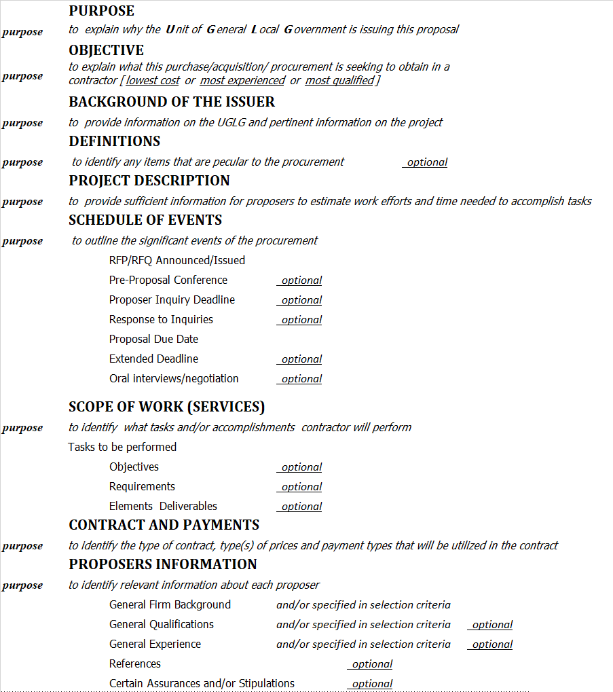

**COMPONENTS OF REQUESTS FOR POPOSALS AND QUALIFICATIONS continued**



**EVALUATION CRITERIA\***

