CHECKLIST FOR PUBLIC FACILITIES APPLICATIONS

This checklist should not be included in the submitted application. This checklist is only provided for informational purposes during application preparation. All forms listed on this page are required for public facilities applications.

|  |  |  |
| --- | --- | --- |
| **FORM** | **Page No**. | **Completed** |
| General Description Form | 21 |  |
| Budget/Cost Summary Form | 25 |  |
| Activity Beneficiary Information (including ABF for census) | 29 |  |
| Survey Information and Methodology | 35 |  |
| Household Income Limits by Applicant’s Parish (if applicable) | 39 |  |
| Household Survey and Beneficiary Documents | See website |  |
| Analysis of Household Survey Data Form (if applicable) | 40 |  |
| Maps | 42 |  |
| Project Description | 44 |  |
| System Information Form | 46 |  |
| Engineer’s Cost Estimate | 48 |  |
| Program Impact Certification Form | 57 |  |
| Cost Effectiveness Form | 61 |  |
| Engineering Costs Certification Form | 61 |  |
| Certification of Other Funds Form | 61 |  |
| Administrative Costs Certification Form | 65 |  |
| Proofs of Publication | 65 |  |
| Statement of Assurances | 67 |  |
| Disclosure Report | 73 |  |
| DEQ Notice of Application for LCDBG Sewer Project | 79 |  |
| Displacement Policy | 80 |  |

|  |  |  |  |  |
| --- | --- | --- | --- | --- |
| LOUISIANA COMMUNITY DEVELOPMENT BLOCK GRANT (LCDBG) PUBLIC FACILITIES PROGRAM  General Description Form | | | 1. Applicant Name | |
| 2. Type of Application – Circle One of the  Following:  New Sewer Sewer Rehab Sewer Treatment  Potable Water Streets | | | 3. Address | |
| 4. Name of City Clerk or Parish Secretary | | | 5. Applicant’s Email Address | |
| 6. Name and Phone Number of Administrative Consultant  Preparing Application | | | 7. Name and Phone Number of Engineering Firm Preparing Application | |
| 8. Administrative Consultant Email Address | | | 9. Engineering Firm Email Address | |
| 10. Target Area information  Census Tract / Block Group/Zip Code  system-wide [ ] _________________________________  target area(s) [ ]  name of target area _________________________________  name of target area _________________________________  name of target area _________________________________  name of target area _________________________________ | | | | |
| 11. Legislative Districts: State Senate: _______ State Rep.: _______ U.S. Congress: ______ _ | | | | |
| 12. National Objective Addressed:  [ ] Slum/Blight [ ] Low/Moderate Income [ ] Urgent Need | | | 13. Total Amount of LCDBG Funds  Requested  $ | |
| 14. Funds | Amount | Source of Funds | Fund Status | State Use Only |
| LCDBG | $ |  |  |  |
| Local Funds | $ |  |  |  |
| Private Funds | $ |  |  |  |
| State Funds | $ |  |  |  |
| Federal Funds | $ |  |  |  |
| Other Funds | $ |  |  |  |
| TOTAL COST | $ |  |  |  |
| 15. Signature (Chief Elected Official) | | | 16. Date | |
| 17. Typed Name/Title | | | 18. Telephone Number | |

INSTRUCTIONS

General Description Form

Item 1: Enter applicant name (municipality or parish).

Item 2: Type of Application – Circle the type of project for which you are applying.

Item 3: Enter mailing address of applicant (P.O. Box or street address, name of city, and zip code plus four digits). (Note: For the four digit number, please contact your local post office).

Item 4: Enter the name of the City Clerk or Parish Secretary.

Item 5: Enter an Email address for the applicant. If the applicant does not have an Email address, enter “Not Applicable”.

Item 6: Enter the name and phone number of the Administrative Consultant preparing the application. If the Consultant is self-employed, enter the individual’s name; otherwise, enter the name of the firm.

Item 7: Enter the name and phone number of the engineering **firm** preparing the application. Enter the name of the firm, not the name of an individual.

Item 8: Enter an Email address for the Administrative Consultant preparing the application. If the Administrative Consultant does not have an Email address, enter “Not Applicable”.

Item 9: Enter an Email address for the Engineer preparing the application. If the Engineer does not have an Email address, enter “Not Applicable”.

Item 10: Indicate an “x” as to whether the proposed project will involve a system-wide project or a target area(s). If a target area(s) is involved, enter the name(s) of the target area(s). Also list the census tract(s), block group(s), and nine-digit zip code for each target area.

Item 11 Enter the district number of each State Senator, State Representative, and U.S. Congressman representing the local governing body for community-wide projects. If the project involves a target area(s), enter the district numbers of only those representing the target area(s)

Item 12: Identify the national objective addressed by the proposed activity by placing an “x” in the [ ]. Mark only one national objective for the application.

* Principal benefit to low/moderate income persons is an objective that will be addressed by an activity whose beneficiaries will be at least fifty-one percent low/moderate income.
* In order to claim that the proposed activity meets the objective of elimination or prevention of slums and blight, the following must be included. An area must be delineated by the applicant that:
  + Meets the definition of slums and blight as defined in 24 CFR 570.483(c), and
* Contains a substantial number of deteriorating or dilapidated buildings or improvements throughout the area delineated.

The applicant must describe in the application the area boundaries (map), the conditions (number of deteriorated or dilapidated buildings or improvements) of the area at the time of its designation, and how the proposed activity will eliminate the conditions that qualify the area as slum and blight. Attach a narrative containing the above specifics as well as a map identifying the slum/blight area. If the slum/blight area is different from the target area, include a separate map.

* Meets the definition of urgent need as defined in 24 CFR 570.483(d).

Item 13: Enter the total amount of LCDBG funds being requested.

Item 14: Identify all funds that will be used for completion of the project. Include funds requested through this application and any other funding sources to be utilized. List amount of funds in each category and specific source of these funds. For example, "Local Funds" are any funds included in total project costs contributed by the unit of local government submitting the application. "Private Funds" are those from sources other than governmental entities such as private businesses, banks, etc. Any funds received through other state programs that are used for this specific project would be listed under “State Funds.” Any federal funds, such as EPA, USDA Rural Development, etc., should be listed under "Federal Funds." Any other funds not previously identified to be used for the project should be listed under "Other" and the source specified. For each funding source, indicate the status of the funds, i.e., application being prepared, application submitted, preliminary approval, final approval.

Item 15: The chief elected official must sign on line 15.

Item 16: Enter the date the application was signed by the chief elected official.

Item 17: Type or print the name and title of the chief elected official signing the application.

Item 18: Enter the applicant’s telephone number.

LCDBG PROGRAM

BUDGET/COST SUMMARY FORM APPLICANT NAME:

|  |  |  |  |  |  |  |
| --- | --- | --- | --- | --- | --- | --- |
| I. Costs by Activity (Read Instructions Before Completing) | | |  | | | |
| Activity  (A) | LCDBG  (B) | Other  (C) | Total  (D) | | Source of  Other Funds[1]  (E) | |
| 1. |  |  |  | |  | |
| 2. |  |  |  | |  | |
| 3. |  |  |  | |  | |
| 4. |  |  |  | |  | |
| 5. Administration |  |  |  | |  | |
| TOTAL |  |  |  | |  | |
|  |  |  |  | |  | |
| II. Line Item Budget – LCDBG Funds Only | | |  | | | **For State Use Only** |
| 1. Public Facilities – Water/Sewer/Streets (Total) | | | | $ | | $ |
| a. Construction Costs | | | | $ | | $ |
| b. Engineering Costs | | | | $ | | $ |
| c. Acquisition Costs | | | | $ | | $ |
| 2. Rehabilitation Loans and Grants (PF Hook-ups) | | | | $ | | $ |
| 3. Administration (Total) | | | | $ | | $ |
| a. Public Facilities | | | | $ | | $ |
| 4. Other | | | | $ | | $ |
| 5. Other | | | | $ | | $ |
| 6. TOTAL | | | | $ | | $ |

|  |  |  |
| --- | --- | --- |
| III. Contract Execution Dates (only if scheduled to be paid using LCDBG funds) | |  |
| Name of Administrative/Engineering Firm | Contract Execution Date | Amount of Contract |
|  |  |  |
|  |  |  |

INSTRUCTIONS

Budget/Cost Summary Form

Enter Name of Applicant.

SECTION I: COSTS BY ACTIVITY

Column A: List each activity on a separate line. Administration (including pre-agreement costs) is shown separately on line 5. Note that Acquisition is no longer a separate activity, and is now carried under the main Public Facilities activity.

Columns B,

C, D, & E: For each activity, complete the cost columns. Indicate the LCDBG money requested in Column B. Lump together all other funds that will be used to accomplish the activity and show these costs in Column C. Add together LCDBG (B) and Other (C) and record the result in Column D. In Column E, identify the sources of the funds listed in Column C.

Be sure to include all costs related to an activity in the cost columns. For example, if the project involves the construction of a new sewer treatment plant, costs to be included should include engineering costs, construction costs, inspection costs, etc.

If other funds are being injected into a public facilities project, please refer to the “Certification of Other Funds” form on page 63 and the corresponding instructions.

SECTION II: LINE ITEM BUDGET

Include LCDBG costs only in this budget. In this section, the costs shown in the LCDBG column of Costs by Activity in Section I should be broken down by the type of cost. Note: Acquisition is no longer a separate activity, and thus is now carried under the main Public Facilities activity. The total costs for the main activity would appear in Section II, Line 1. Construction costs, engineering costs and acquisition costs would appear in lines 1a, 1b, and 1c, respectively. Any costs associated with the construction of hook-ups or work done on private property would appear in Section II, Line 2.

NOTE: If the applicant is requesting reimbursement for pre-agreement costs for engineering and/or administrative consulting services, those funds must be identified on line 3a. In addition, the amount of funds requested for overall program administration must be identified on line 3b. The amount of funds requested for pre-agreement costs and overall program administration must be identified separately. The total amount of pre-agreement and overall program administration funds should be identified on line 3.

SECTION III: CONTRACT EXECUTION DATES

If LCDBG funds will be used to cover administrative and/or engineering costs, enter the name of the administrative consulting and/or engineering firm that the applicant has contracted with to perform services for the proposed project, the date the contract between the applicant and the firm was executed, and the dollar amount of the contract. **An executed contract must be in place prior to services being performed for the project when using LCDBG funds to pay for these services.** The program cannot reimburse the applicant for expenditures that are incurred prior to the existence of an executed contract between the applicant and the firm.

**ACTIVITY BENEFICIARY INFORMATION**

First, the target area(s) being served by the project must be determined, and beneficiary information obtained. If there is more than one target area, then the low- and moderate-income information must be determined for each target area independently of the others. Each target area must benefit at least fifty-one percent low- to moderate-income persons.

ACTIVITY BENEFICIARY FORM

Beneficiary information is shown on an Activity Beneficiary Form (ABF). For projects involving more than one target area, an individual ABF must be completed for each target area. Indicate target area (1, 2, etc.) to which the data on the form corresponds. The projected information from each target area’s individual ABF must be shown on a Combined ABF that includes data for all target areas. The number and percent of low/moderate income persons are determined by combining the number of persons shown on each individual target area’s ABF, and dividing by the total persons benefiting from the project. This methodology is also used in combining information from the data for a census area, and a smaller area that was surveyed.

Example: Target Area 1 Target Area 2

Total persons: 30 Total persons: 100

Low/mod persons: 17 or 57% Low/mod persons: 70 or 70%

Combined ABF

87

130 = 66.92% low/mod

The final ABF must be labeled as “System-Wide,” “Target Area,” or “Combined” in the space provided following “Target Area.” The information needed for the ABF will be determined from census data and/or a local random household survey.

System-wide versus Target Area Projects

In order to be classified as a “system-wide” project for rating purposes, the project must have at least 35% of the construction funds in a “system-wide” activity. If less than 35% of the construction funds are being spent in a “system-wide” activity, then the project will be considered a “target area” project for rating purposes. The project will be rated using the target area information, but the system-wide information will be used for reporting purposes if the project is funded. The costs must be distinguished on the cost estimate as “system-wide” or “target area” in order for the Office of Community Development Staff to verify the applicant’s status. For projects that include some funds in a “system-wide” activity, but not enough to be considered a “system-wide” project for rating purposes, one ABF must be submitted with target area information and a second ABF must be submitted with the system-wide information. All households connected to the utility system that is included in the application must be counted as beneficiaries of the project if the project is system-wide, including households that may be located outside the municipality corporate limits.

The applicant must utilize census data (if available). Census data for parishes, places (municipalities), and block groups is provided on HUD’s website at https://www.hudexchange.info/programs/acs-low-mod-summary-data/. Use the links for “all block groups” and “local government summaries.” Census maps must be checked to determine if a census tract(s), or block group(s) is generally contiguous with the target area(s). An applicant can go to http://factfinder.census.gov and select Reference Maps, then make selections from the dropdown lists to show the desired items on the map.

When a project area does not coincide with census tracts or block groups, an applicant must conduct a local survey or combine census data with a local survey. For instance, if a project area encompasses an entire block group area, but is larger than the block group area, (however does not encompass the entire neighboring block group area or the place), the applicant would utilize the census data for the block group area, and conduct a survey of the additional area(s) which are outside of the block group area and combine the data. An ABF would be completed for the block group area, a Survey Tabulation Form and ABF for the surveyed area(s), then an ABF combining the information from the two. If there is more than one outside area, and the areas are not contiguous with each other but are both contiguous with the block group or place area, one previou would cover both areas.

For target areas that are smaller than the block group area they are located in, generally, a random household survey would be conducted. If ten percent (10%) or less of the houses in the project area (where census data is available and the project area is generally contiguous with the census data area) are not currently served by nor will be served by the proposed project, census data, rather than survey data, must be used to determine the benefit to low/moderate income persons. For example, if there are 100 occupied houses in the project area and 10 of those houses are not connected to the system, the applicant must still utilize census data rather than a local survey to determine income data, (if census data is available for the project area).

If a random household survey is involved, the ABF must identify all beneficiaries, not just those surveyed. If all households were not surveyed, projections must be made based on the survey results. The Office of Community Development has developed excel workbooks, Household Survey Forms and Household Survey Instruction Forms, which provide forms and instructions. The workbooks are located on the OCD website at http://www.doa.la.gov/Pages/ocd/CDBG/ lcdbg_applications_and_forms.aspx.

The workbook includes Survey Forms, Tabulation Sheets, the Survey Tabulation Form, Projected Occupied Households Sheet, and Projection Sheet: From the Survey Tab Form to the ABF, and the ABF. **A separate workbook must be completed for each target area**.

NOTE: Each target area must benefit at least fifty-one percent low- and moderate-income persons.



**ACTIVITY BENEFICIARY FORM INSTRUCTIONS (for census data)**

If using census data, fill out this ABF and submit it with the application. If a survey is involved instead of census data, use the survey form(s) and ABF provided in the Household Survey Forms document found on our website:

<http://www.doa.la.gov/Pages/ocd/CDBG/lcdbg_applications_and_forms.aspx>.

**ACTIVITY BENEFICIARY FORM DEMONSTRATION: ONE TARGET AREA, TWO ABFs**

The following diagram illustrates the flow of information for combining census data with household survey results when the census data alone is not sufficient.

Combined ABF using both data types

ABF using

Census Data

ABF using Household Surveys

Survey Tabulation Form

Census Data

Survey Forms

Portion of Target Area that must rely on Household Surveys

Portion of Target Area that can rely on Census Data

Target Area

SURVEY TABULATION FORM

If conducting a local random survey is necessary, a complete set of survey forms must be submitted with the application as well as the Survey Tabulation Form. **If there are multiple target areas, a survey of each target area must be conducted independently of the others and a Survey Tabulation Form for each target area must be completed.** Survey data must be submitted on the forms provided in the excel workbook, Household Survey Forms, located on the OCD website under the Applications and Forms tab in the order specified in the Survey Form and Methodology section of this application package.

**Household surveys conducted for the previous applicant cycle are acceptable.**

SURVEY INFORMATION AND METHODOLOGY

For guidance purposes, a memorandum from the U. S. Department of Housing and Urban Development regarding survey methodology is provided on the Office of Community Development’s website at <http://www.doa.la.gov/pages/ocd/cdbg/lcdbg_resources.aspx>.

The survey form provided by the Office of Community Development must be used for Public Facilities projects that require a survey. The form and instructions are included in the excel workbooks, Household Survey Forms and Household Survey Instruction Forms, available on the OCD’s website under the Applications and Forms tab. In addition to those instructions, the following applies to the survey process.

User Fee – Enter the projected monthly user fee that will be imposed on the users of a new utility system. When surveying the houses, inform the surveyed person of the projected fee and enter “y” for yes or “n” for no, indicating whether or not the user is willing to pay the fee. If 25% or more of the persons surveyed indicate they would not be willing to pay the user fee, then the applicant should consider a different project application to be submitted.

Household Income – The income category for households/persons must be determined based upon the number of persons in the household. The surveyor should determine the income range that corresponds to the household’s annual income with consideration to the number of persons in the household by using current income limits data obtained from HUD’s website as described below.

The Income Limits Summary is located on HUD’s website at: <http://www.huduser.org/portal/datasets/il.html>. On that webpage, click on the appropriate links to access the most recent Income Limits for the applicant’s parish (county) in the State of Louisiana.

Refer to the sample chart for Acadia Parish on the following pages as an example. If there are five persons in a household located in Acadia Parish and the annual household income is $45,000, then the household would be classified as high income. If that same household had an annual income of $41,000, then the household would be classified as low/moderate income.

**A copy of the applicant’s parish Income Limit Chart from the HUD website must be included in the application if a household survey is conducted.**

The income limits as shown on the HUD website form have different category terminology than the CDBG terminology. This is due to the fact that the terminology used on the charts are those applied in the HUD Section 8 Housing Choice Voucher Program. The differences in terminology are as shown below:

**Section 8 Limits CDBG Limits**

80% Low Moderate

50% Very Low Low

30% Extremely Low Extremely Low

Family Size Adjustments

The income limit statute requires adjustments for family size. The same family size adjustments are used for all income limits. They are as follows:

**Number of Persons in Family and Percentage Adjustments**

1 2 3 4 5 6 7 8

70% 80% 90% Base 108% 116% 124% 132%

For each person in excess of eight, the four-person income limit should be added by an additional 8 percent. (For example, the nine-person limit equals 140 percent [132 + 8] of the relevant four-person income limit.) Income limits are rounded to the nearest $50. Local agencies may round income limits for nine or more persons to the nearest $50, or may use the un-rounded numbers.

The following should be noted when conducting surveys:

* Persons in correctional institutions cannot be counted as program beneficiaries.
* Camps that are used for recreational purposes, weekend retreats, etc. will be counted as occupied households for projects seeking funds for public infrastructure.
* If there is a group home located in the target area, contact Traci Watts at the Office of Community Development in order to determine if the residents of the home should be counted as beneficiaries.

All surveys must be accompanied by a corresponding map. The survey for sewer, water, or street improvement applications must be conducted using a map identifying all structures in the area. **Customer lists are not allowed to be utilized.** A detailed map of the target area(s) that corresponds to the survey must be included in the application. An example is demonstrated on page 38. See the instructions for Maps on page 43 for more details. Applicants may choose to complete a separate map of each street identifying each structure, but would also need a map of the area that shows all streets in the area. This will enable the State to verify that no street was omitted from the individual street maps. The map must identify which structures are commercial or exempt. Then, all residential structures (occupied *and* vacant) on the map or the list are numbered in a consecutive order. The total number of residential structures will be the **POPULATION** size.

In order to determine the survey sample size, go to http://www.surveysystem.com/sscalc.htm. Enter the Population size with a Confidence Level of 95% and a Confidence Interval of 5, then click the Calculate button to obtain the required number of surveys. Print a copy of the screen and include the printout in the application. **The number of surveys obtained for each surveyed area(s) as required by the survey sample size chart must be exact.** **Any target areas with a Population size of 50 or below must be 100 percent surveyed.**

In order to identify the households within the Population that are required to be surveyed, go to https://www.random.org/sequences/. In the area identified as Sequence Boundaries, enter the “Smallest Value” as 1 and the “Largest Value” as the total number of your Population. Choose the number of columns that is preferred by the applicant for the output of the random numbers sequence, then click the Get Sequence button. The OCD does not have a preference for number of columns. **Print a copy of the sequence list. A copy of original printout of the sequence list must be included in the application.**

The applicant should count down the sequence list equal to the number of required surveys identified in the previous step. Those numbers would be the required numbers and households that correspond with those numbers on the map must be surveyed. If any of those households cannot be surveyed for any reason, then the next number on the sequence list would be used to replace the original required number. For example, if the required number of surveys is 100, then the households that correspond to the first 100 numbers on the sequence list would be required as surveys. If one of those households are vacant, then the 101st number on the sequence list would be used to replace the vacant household in the surveys, and so on. **Note: if the sample size cannot be reached due to too many vacant households, then a 100 percent survey is required.**

**The data on the Household Survey Forms that are submitted with the application must be in the same order as identified on the sequence list. The data cannot be in numerical order. If this is not done correctly, the application will not be rated.**

An occupied house where no one is home is one that cannot be surveyed after three separate attempts were made to obtain the survey. Surveys should be attempted at different times of the day and on different days of the week if the first attempt to obtain the survey is unsuccessful. If the first attempt is made during normal working hours, other attempts must be made at times other than normal working hours. If all three attempts were made during normal working hours, the applicant will be required to repeat the survey process for that particular home. Documentation of the survey attempts (including dates and the time of day the visits occurred) must be maintained. If more than 10% of the survey results show houses where no one is home, this documentation must be submitted. Otherwise, this documentation does not have to be submitted with the application, however, the OCD may request the documentation if necessary.

**NOTE: If there are multiple target areas, each target area must have a minimum of fifty-one percent low- and moderate-income persons benefiting. Each target area must have census data reported and/or survey data reported independently of the others. The number of required surveys for each target area depends on the Population size of the area being surveyed.**

In the past, OCD did not allow any municipalities to conduct a household survey if the HUD low/mod-income summary data indicated the low/mod percentage for a municipality was below 51.0.  The current HUD data includes the margin of error for the low/mod percentage.  This information was not available previously.  Therefore, municipalities will be allowed to conduct a household survey if the municipality’s low/mod percentage and margin of error is summed to be at least 51.0.  In the example below, the Village of Ashland has a low/mod percentage of 38.8 and a margin of error for the low/mod percentage of +/-14.50.  The sum of those two numbers is 53.30.  Therefore, the Village of Ashland would have the option of conducting a household survey to establish the benefit to low/mod persons.



**MORGAN STREET**

2259 (Gray) #11 Morgan Lane

2243 (Beige) #10 *LEGEND*

2221 (Gray) #9 Manufactured

Home

2217 (Brick) #8 #12 2224 (Brick)

Church House

Morgan Street

2207 (White) #7 #13 2206 (Green)

(vacant)

Business

2187 (Tan) #6

#14 2186 (Tan/Brown)

2169 (Green) #5

#15 2156 (White) Church

2157 (Tan) #4

2145 (Red) #3

2121 (Tan) #2

(vacant)

2109 (White) #1

Louisiana Highway 44

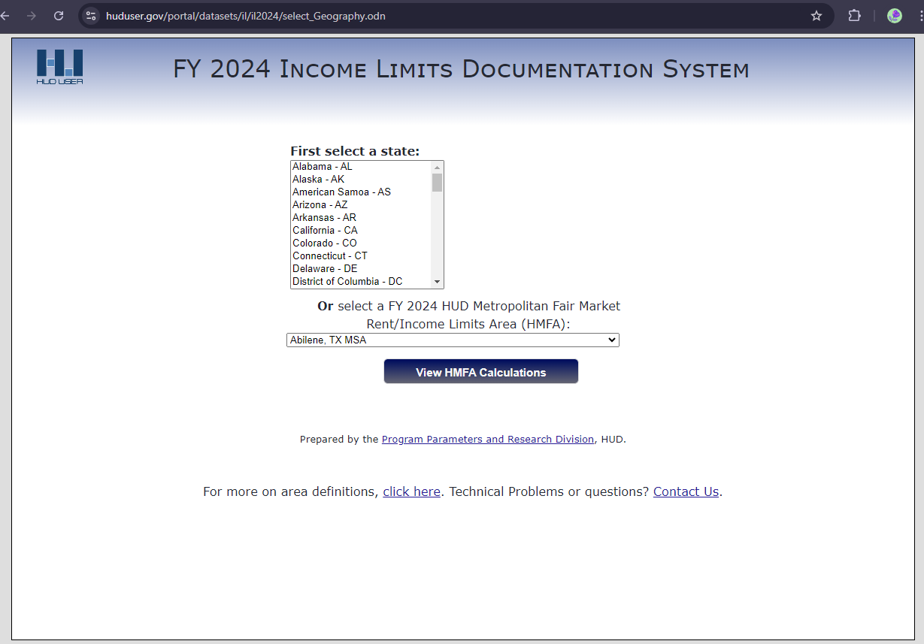

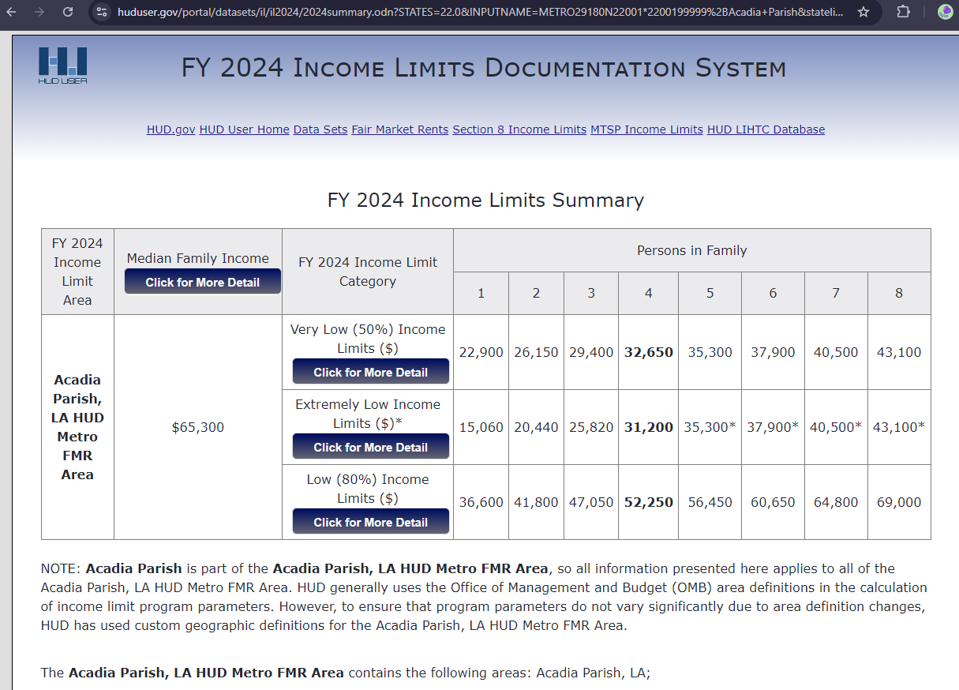

Analysis of Household Survey Data Form

Applicant:

Target Area #:

Above Income Moderate/Low/Extremely Low

1. Total number of persons in households:
2. Total number of households:
3. Average persons per household:

Target Area #:

Above Income Moderate/Low/Extremely Low

1. Total number of persons in households:
2. Total number of households:
3. Average persons per household:

Target Area #:

Above Income Moderate/Low/Extremely Low

1. Total number of persons in households:
2. Total number of households:
3. Average persons per household:

INSTRUCTIONS

Analysis of Household Survey Data Form

Due to the potential variance that can occur in data obtained during the Household Survey process, the applicant is required to complete this form if the percentage of low/moderate income persons for a target area is at least 51 but less than 56. Please remember that in order to be eligible, a target area must be at least 51 percent low/moderate income persons. Each target area must pass this test independently. If more than one target area has a percentage of low/moderate income persons of at least 51 but less than 56, then this form must be completed for each target area. For example, if Target Area 1 has a low/moderate income percentage of 53.2, Target Area 2 has a low/moderate income percentage of 54.9, and Target Area 3 has a low/moderate income percentage of 58.4; then the application must include analyses for Target Areas 1 and 2.

**MAPS**

The following maps are required:

1. A map(s) that delineates the census tract and/or block groups (by number) for each target area. The target area must also be indicated on this map.
2. A map indicating the location of concentrations of minorities and concentrations of low- and moderate-income persons, showing number and percent for both groups by jurisdiction, (if minorities and/or low- and moderate-income persons are evenly disbursed throughout the jurisdiction then the applicant must include such a statement on the map). All proposed target areas must be indicated on the map as well.
3. A map showing the boundaries of the beneficiary area with proposed improvements included.
4. A map of the entire utility system is required, if the entire water or sewer system is benefiting from the proposed improvements. This is a requirement for sewer and water applications.
5. Also, for projects that require a survey, a detailed field map identifying every structure on each street must be provided. **A customer utility list cannot be used to conduct a survey**. Each residential structure (occupied *and* vacant) must be identified by a number. The numbers must be in a consecutive order. Numbers 20 through 25 and number 213 identifying structures should not occur on the same street. The following two types of field maps will be acceptable.
   1. One map identifying all houses in the surveyed area. Each residential structure should be numbered in consecutive order, or
   2. One map of each street identifying all residential structures on the street and one map of the entire surveyed area. Each residential structure should be numbered in consecutive order

|  |
| --- |
| LCDBG PROGRAM  PUBLIC FACILITIES IMPROVEMENTS APPLICANT NAME: |
| PROJECT DESCRIPTION |
| (Use only one sheet per target area) |

INSTRUCTIONS

**Project Description Form**

Provide a concise description of the public facilities improvements project for which funds are being requested. The description should include the following:

* Identify the proposed improvements, location of the proposed improvements, current size/capacity of and area served by the system, etc.
* Indicate whether or not the project will require acquisition of easements or rights-of-way and the approximate number of parcels to be acquired. Also, indicate whether the proposed acquisition is to be paid for with LCDBG funds or not.
* Briefly explain the needs to be addressed with the proposed improvements.
* Describe how the project relates to the existing infrastructure. For example, if installing new sewerage collection lines, can the treatment plant handle the increase?
* Describe how people will benefit from the project and indicate whether there will be direct and/or indirect benefit. Direct benefit is defined as an activity that will take place on private property (such as hook-ups). Provide an estimate of the number of hook-ups, if applicable. This information should correlate with the number and information listed on the Engineer’s Cost Estimate.
* Identify the entity that will retain ownership of the system after the completion of the project. Please note that the applicant must retain ownership of the improvements, unless the system is owned by a political subdivision of the applicant; however, a cooperative endeavor agreement can be executed with another entity regarding operation and maintenance of the proposed improvements.
* Describe the method by which the applicant can ensure that adequate revenues will be available to operate and maintain the proposed project. The description must identify the source and the estimated amount of funds that will be generated for this purpose.
* If the applicant is proposing the installation of sewer or water service in areas where no service currently exists, then the project description must specifically state who will be financially responsible for providing the service connection lines. Please remember, LCDBG funds, local funds, or other state or federal funds must be used to pay for connection lines to residential structures that are occupied by low- and moderate-income persons. **The applicant must adopt and enforce a procedure that will ensure that all residences (regardless of income) will be connected to the utility system. Also, persons in households that are not connected to the system cannot be considered as beneficiaries of the project. If LCDBG funds will be used to finance the service connection lines, please remember that federal regulations mandate that the line be physically connected to the house.**
* Describe the physical boundaries of the target area(s) in relation to the beneficiaries of the project.

**System Information Form**

1. What kind of system does the project involve? Water Sewer Other

2. The system involved in this project is owned by:

- applicant (sewer or water district included)

- other municipal/parish (sewer or water district included)

- private (for-profit)

- private (non-profit)

- other ( )

Note: If the project is part of a system that is not owned by the applicant, please provide documentation from the entity that owns the system that acknowledges the entity will operate and maintain the improvements resulting from the project. If the project includes providing new water services to an area previously not connected to a water system, the documentation must also state that the owner of the system agrees to provide water to the new area, as well as to operate and maintain the improvements resulting from the project. **If funded and upon completion, the applicant (Village, Town, City, or Parish) can only donate the improvements to a sewer or water district that is a political subdivision of the applicant.**

3. Please provide a brief history of the system, explaining how and when it was established:

INSTRUCTIONS

Item1: Identify the type of system for which the applicant is seeking funds.

Item 2: Identify what type of entity owns the utility system.

Item 3: Provide a brief history of the system, including how and when the system was established and who governs the system.

Please remember that if the project involves improvements to a system that is not owned by the applicant, the application must include documentation from the entity that owns the system that acknowledges the entity will operate and maintain the improvements resulting from the project. If the project includes providing new water services to an area previously not connected to a water system, the documentation must also state that the owner of the system agrees to provide water to the new area, as well as to operate and maintain the improvements resulting from the project. **If funded and upon completion, the applicant (Village, Town, City, or Parish) can only donate the improvements to a sewer or water district that is a political subdivision of the applicant.**

|  |
| --- |
| ENGINEER’S COST ESTIMATE (Refer to the instructions for the specific information that must be included herein. Attach additional sheets if necessary.) |
| Estimated number of weeks of construction:  Estimated number of parcels to be acquired:    Signature of Date  Licensed Engineer |

INSTRUCTIONS

**Engineer’s Cost Estimate**

All proposed activities must be accompanied by a detailed cost estimate prepared, signed, and stamped by a Professional Engineer licensed in the State of Louisiana. The cost estimate shall contain the cost of construction, engineering fees, and any other project costs. The construction estimate shall be a listing of construction items (as a bid proposal), estimated quantity, unit of measure, unit price, amount, and applicability to Build America Buy America (BABA). A maximum of 10 percent is allowed for construction contingencies.

Engineering fees shall be identified by type in a line item format. Typical items include basic services, resident project representative, surveying (property acquisition), construction staking, geotechnical investigation, and testing. Written justification must be provided for all engineering services other than basic services and a resident project representative. The justification is to contain an explanation of why the service is needed and how the proposed fee was derived. Please refer to the document, “Engineering Fee Schedules and Policies,” located on OCD’s website for more information concerning eligible fees. Justification of other fees is not required if fees are not to be paid with LCDBG funds.

In order to be classified as a “system-wide” project for rating purposes, the project must have at least 35% of the construction funds in a “system-wide” activity. If less than 35% of the construction funds are being spent in a “system-wide” activity, then the project will be considered a “target area” project for rating purposes. The costs must be distinguished on the cost estimate as “system-wide” or “target area” in order for the Office of Community Development Staff to verify the applicant’s status.

**If the proposed project involves hook-ups (work conducted on private property), then the costs associated with hook-ups must be identified separately on the cost estimate.**

**If any other funds (federal, local, etc.) will be used to complete the project, then the cost estimate must identify the source and amount of those funds as well as the specific use of those funds.** For example, if $200,000 in local funds will be used to assist in the construction of a treatment facility for a new sewerage collection and treatment system, a specific identification of such must be shown on the cost estimate.

Resilience costs must be identified separately on the cost estimate.

Although acquisition is no longer its own activity, if the project requires acquisition the amounts required for all aspects of the acquisition process must be listed on the cost estimate.

The cost estimate must identify the estimated number of weeks of construction and the estimated number of parcels to be acquired.

Examples of cost estimates for sewer, water, and street improvements can be found on the following pages.

BABA Guidance available at https://www.doa.la.gov/doa/ocd-lga/lcdbg-programs/forms-and-information/

**Example of Cost Estimate - Sewer**

|  |
| --- |
| ENGINEER’S COST ESTIMATE (Refer to the instructions for the specific information that must be included herein. Attach additional sheets if necessary.) |
| CONSTRUCTION:   |  |  |  |  |  |  | | --- | --- | --- | --- | --- | --- | | DESCRIPTION | QUANTITY | UNIT OF  MEASURE | UNIT  PRICE | AMOUNT | BABA | | 8” PVC Sewer Main | 4,800 | Lin. Ft. | $ 20.00 | $ 96,000 | Yes | | Manholes | 19 | Each | $ 1,700.00 | $ 32,300 | Yes | | 8” x 8” x 4” Wye | 100 | Each | $ 45.00 | $ 4,500 | Yes | | 4” Cleanouts and bends | 100 | Each | $ 105.00 | $ 10,500 | Yes | | 4” Service Line | 500 | Lin. Ft. | $ 8.00 | $ 4,000 | No | | Jack or Bore 4” Service Line | 700 | Lin. Ft. | $ 18.00 | $ 12,600 | No | | Lift Station | Lump | Lump Sum | $ 65,600.00 | $ 65,600 | No | | 4” PVC Force Main | 2,800 | Lin. Ft. | $ 5.00 | $ 14,000 | No | | Maintenance Aggregate | 100 | Cu. Yd. | $ 35.00 | $ 3,500 | No |   Subtotal: $243,000  Contingencies: $24,300  Estimated Cost (Construction): $267,300  REHABILITATION LOANS AND GRANTS   |  |  |  |  |  |  | | --- | --- | --- | --- | --- | --- | | DESCRIPTION | QUANTITY | UNIT OF  MEASURE | UNIT  PRICE | AMOUNT | BABA | | 4” Service Line | 5,600 | Lin. Ft. | $ 8.00 | $ 44,800 | No | | 4” Cleanouts and bends | 140 | Each | $ 105.00 | $ 14,700 | No | | 4” Connections | 70 | Each | $ 100.00 | $ 7,000 | No | | Abandon Septic Tanks | 70 | Each | $ 300.00 | $ 21,000 | No |   Subtotal: $87,500  Contingencies: $8,750  Estimated Cost (Rehabilitation Loans and Grants): $96,250  TOTAL ESTIMATED CONSTRUCTION COST: $363,550 |

|  |
| --- |
| ENGINEER’S COST ESTIMATE (Refer to the instructions for the specific information that must be included herein. Attach additional sheets if necessary.) |
| TOTAL ESTIMATED CONSTRUCTION COST: $363,550  ENGINEERING:  Basic Services: $36,300  Resident Project Representative: $17,100    ACQUISITION:  Property Acquisition: $3,000  Property Surveying: $1,750  ADMINISTRATION: $35,000  TOTAL PROJECT COST: $456,700  Estimated number of weeks of construction: 25  Estimated number of parcels to be acquired: 1    Signature of Date  Licensed Engineer |

**JUSTIFICATION FOR ADDITIONAL ENGINEERING FEES (Sewer)**

Property Surveying:

Property surveying is needed for the acquisition of a site to construct the new lift station.

Survey Crew: 1 day at $1,000 per day = $1,000

Draftsman: 10 hours at $40 per hour = $ 400

Land Surveyor: 5 hours at $70 per hour = $ 350

Total = $1,750

**Example of Cost Estimate - Water**

|  |
| --- |
| ENGINEER’S COST ESTIMATE (Refer to the instructions for the specific information that must be included herein. Attach additional sheets if necessary.) |
| CONSTRUCTION:  (1) TARGET AREA   |  |  |  |  |  |  | | --- | --- | --- | --- | --- | --- | | DESCRIPTION | QUANTITY | UNIT OF  MEASURE | UNIT  PRICE | AMOUNT | BABA | | 4” PVC Waterline | 5,500 | Lin. Ft. | $ 6.00 | $ 33,000 | Yes | | 6” PVC Waterline | 8,500 | Lin. Ft. | $ 8.00 | $ 68,000 | Yes | | Jack or Bore 4” Waterline | 400 | Lin. Ft. | $ 15.00 | $ 6,000 | No | | Jack or Bore 6” Waterline | 500 | Lin. Ft. | $ 18.00 | $ 9,000 | No | | 4” Gate Valve & Box | 8 | Each | $ 400.00 | $ 3,200 | No | | 6” Gate Valve & Box | 10 | Each | $ 500.00 | $ 5,000 | No | | Fire Hydrants | 8 | Each | $ 1,500.00 | $ 12,000 | No | | C.I.M.J. Fittings | 3.000 | Ton | $ 3,500.00 | $ 10,500 | No | | Meter Reconnections | 150 | Each | $ 100.00 | $ 15,000 | No | | ¾” PE Service Line | 100 | Lin. Ft. | $ 3.00 | $ 300 | No | | Pavement Restoration | 100 | Sq. Yd. | $ 50.00 | $ 5,000 | No | | Maintenance Aggregate | 75 | Cu. Yd. | $ 40.00 | $ 3,000 | No |   Subtotal: $170,000  Contingencies: $17,000  Estimated Cost: $187,000  (2) SYSTEM-WIDE   |  |  |  |  |  |  | | --- | --- | --- | --- | --- | --- | | DESCRIPTION | QUANTITY | UNIT OF  MEASURE | UNIT  PRICE | AMOUNT | BABA | | 100,000 Gal. Elev. Storage Tank | Lump | Lump Sum | $276,000.00 | $ 276,000 | No | | Sitework | Lump | Lump Sum | $ 15,000.00 | $ 15,000 | No | | Electrical Controls | Lump | Lump Sum | $ 10,000.00 | $ 10,000 | No | | Piping Modifications | Lump | Lump Sum | $ 10,000.00 | $ 10,000 | No | | Fencing | 600 | Lin. Ft. | $ 15.00 | $ 9,000 | No |   Subtotal: $320,000  Contingencies: $32,000  Estimated Cost: $352,000  TOTAL ESTIMATED CONSTRUCTION COST: $539,000 |

|  |
| --- |
| ENGINEER’S COST ESTIMATE (Refer to the instructions for the specific information that must be included herein. Attach additional sheets if necessary.) |
| TOTAL ESTIMATED CONSTRUCTION COST: $539,000  ENGINEERING:  Basic Services: $49,100  Resident Project Representative: $23,000    ACQUISITION:  Property Acquisition: $5,000  Property Surveying: $2,000  ADMINISTRATION: $35,000  TOTAL PROJECT COST: $653,100  Estimated number of weeks of construction: 35  Estimated number of parcels to be acquired: 1    Signature of Date  Licensed Engineer |

**JUSTIFICATION FOR ADDITIONAL ENGINEERING FEES (Water)**

Property Surveying:

Property surveying is needed for the acquisition of a site to construct the elevated storage tank.

Survey Crew: 1 day at $1,000 per day = $1,000

Draftsman: 8 hours at $45 per hour = $ 360

Courthouse Research: 8 hours at $45 per hour = $ 360

Land Surveyor: 4 hours at $70 per hour = $ 280

Total = $2,000

|  |
| --- |
| PROJECT IMPACT CERTIFICATION – SEWER , WATER, AND STREETS PROJECTS |
| I certify, to the best of my knowledge and belief, that (check all boxes that apply):   * The funds requested herein for the proposed sewer or water project will completely remedy existing conditions that violate a state or federal standard (must be identified on the lines below) that has been established for the purpose of protecting public health and safety. * That all persons residing within the target area or connected to the utility system for system-wide activities as described in the Project Description are benefiting from the proposed project and have been included in the application beneficiary data. * That each street proposed for improvements has a Pavement Sufficiency Rating Range (PSR) of 3.0 or lower, based on the Sufficiency Rating Data Guide on page 61 of this Application Package or has an unpaved surface. * The improvements proposed for the streets in the application will improve the Pavement Sufficiency Rating to greater than a 4.1 and extend the service life of a minimum of 8 years.   Refer to the instructions for any specific statements that must be made on this form. |
|  |
|  |
|  |
|  |
|  |
|  |
|  |
| Signature and Stamp of Date  Licensed Engineer |

INSTRUCTIONS

**Project Impact Certification**

A Professional Engineer licensed in the State of Louisiana must sign and stamp this form certifying that if the proposed project is funded, those conditions that currently violate a state or federal standard established to protect public health and safety will be completely remedied and that all persons in the target area as described in the Project Description will benefit. The specific state or federal standard(s) that is currently being violated and will be addressed must be identified on this form.

The engineer must certify for all types of projects that all persons residing within the target area or connected to the utility system for system-wide activities as described in the Project Description will benefit from the proposed project and have been included in the application beneficiary data.

For street projects, the engineer must certify that the streets proposed for improvements have a Pavement Sufficiency Rating Range (PSR) of 3.0 or lower, based on the Sufficiency Rating Data Guide below, or has an unpaved surface. The engineer must further certify that the proposed improvements for the streets in the application will improve the Pavement Sufficiency Rating to greater than 4.1 and extend the service life of the streets for a minimum of 8 years.

The Pavement Sufficiency Rating Range is described as follows:

SUFFICIENCY RATING DATA GUIDE

FOR LCDBG STREET PROJECTS

CONDITION:

Very Good: Visually, pavement should show no deviations from a smooth surface.

PSR Range facilities should have no cracks or patches. Pavement was probably

4.1 - 5.0 recently constructed or reconstructed or pavement was resurfaced within the past year or two. No maintenance is required.

Good: Pavements in this category give a first-class ride and are beginning to show

PSR Range signs of surface deterioration. Flexible pavements show evidence of 3.1 - 4.0 slight rutting, random cracking, and possibly some raveling. Rigid pavements show evidence of minor joint spalling, scaling, or minor cracking. Pavements require minor to normal maintenance.

Fair: The riding qualities of pavement in this category are noticeably inferior to

PSR Range those of new pavements and may be barely tolerable for high-speed traffic.

2.1 - 3.0 Surface defects of flexible pavements may include moderate rutting, map cracking, raveling, and moderate patching. Surface defects of rigid pavements could include joint spalling, some faulting, moderate to heavy cracking, and frequent patching. Maintenance on these pavements has been normal to excessive.

Poor: Pavements in this category have deteriorated to a point where resurfacing

PSR Range at least or total reconstruction may be required. Ride-ability at any speed is

0.0 - 2.0 impaired to such a level that the motorist will experience discomfort. Traffic will slow down. Surface defects of flexible pavements will include frequent and severe rutting, cracking, patching and raveling. Rigid pavements will show frequent and severe scaling, joint spalling, pumping, faulting, cracking, and patching. Maintenance efforts have been extensive and have not been enough to keep the surface in an acceptable condition.

Source: Highway Needs and Priorities Manual published by the Louisiana Department of Transportation and Development.

Unpaved streets are eligible for improvement under the LCDBG Program, and must be paved if they are within the designated target area.

|  |
| --- |
| COST EFFECTIVENESS |
| a. Total LCDBG funds requested less administration,  resiliency and engineering costs $__________    b. Total number of persons benefiting (for streets, use number of  persons living in occupied houses on streets designated for work) _____  c. Average cost per person  (a / b = c) $ |

|  |
| --- |
| ENGINEERING COSTS CERTIFICATION |
| I certify that our local government will pay all of the engineering costs associated with the implementation of this LCDBG program. These costs will include but not be limited to basic design, resident inspection, testing, staking. etc.  **A resolution adopted by our local government is attached which identifies the firm hired and the proposed amount of their contract.**  Signature of Chief Elected Official Date |

|  |
| --- |
| CERTIFICATION OF OTHER FUNDS |
| Enter the amount of other cash funds  that the applicant will inject into the  proposed project’s construction costs. $  **Verification identifying the amount and source of other funds must be inserted behind this form.** **Do not identify any local funds that will be used to pay pre-agreement, administrative or engineering costs on this form. This form should involve cash contributions that will be used for the construction of the project.** |

INSTRUCTIONS

**Cost Effectiveness**

This form will be used to determine the project cost per person benefiting. In calculating the cost effectiveness, fill out the form using only the LCDBG funds requested for the project (less administration, resiliency and engineering costs).

a. On line a., indicate the total amount of LCDBG funds requested less administration, pre-agreement, and engineering costs. Do not include "other" funds on line a.

b. On line b., identify the total persons benefiting, not just the persons surveyed. For street projects, only identify the number of persons living in occupied houses located on streets designated for work. See page 9 of the application package for specifics on this calculation.

c. On line c., divide the monies shown on line a. by the total persons benefiting as shown on line b.

For example, if a total of $700,000 is required to construct a sewer project benefiting 1,000 people and $700,000 is requested from LCDBG funds, the average cost per person would be $700. Using the same example, if $300,000 in local funds and $400,000 in LCDBG funds will be used for that same $700,000 sewer project, the average cost per person would be $400.

**Engineering Costs Certification**

This form must be completed by those applicants that will pay all of the engineering costs associated with the implementation of the LCDBG Program. Such costs may include, but not be limited to, basic design, resident inspection, testing, staking, etc. However, property surveying and SSES costs can be paid with grant funds even if the applicant receives the rating points for paying the engineering costs.

To substantiate that the local government will pay the engineering costs associated with the LCDBG Program, this form must be completed and signed by the chief elected official. **A copy of the resolution passed by the local government identifying the engineering firm hired and the proposed amount of the contract must be included in the application. That resolution should also state that local funds will be used to pay the engineering fees and any other engineering costs incurred by the local government, (except property surveying and SSES costs).** **The applicant will not receive these points if the required information is not included in the application.**

For those applicants that receive the points for paying engineering costs (and are successful in receiving a grant), if there is an under-run in their project costs, the grantee will not be allowed to re-budget those monies for the purpose of reimbursing the local government for any engineering costs associated with the LCDBG Program.

**Certification of Other Funds**

**If no other funds are being used in conjunction with the LCDBG funds for construction purposes, it is not necessary to complete this form.** **Do not identify any local funds that will be used to pay pre-agreement, administrative or engineering costs on this form. This form should involve cash contributions that will be used for the construction of the project.**

Some projects may cost more than can be requested under the LCDBG Program. Therefore, the applicant may propose to use other funds in conjunction with the LCDBG funds. Applicants that want to use other funds in conjunction with LCDBG funds must have those funds **available** and **ready to spend**. If the other funds involve loans or grants from other state, federal, or private sources, the monies must have already been **awarded** or be **in the bank**. To substantiate the immediate availability of the other funds, one of the following items will be required: a letter and adopted resolution from the local governing body stating the specific source, amount, and location of local cash, a line of credit letter from a financial institution such as a bank stating the amount available as a loan, specific evidence of funds to be received from a tax or bond election that has already passed, or a letter from another funding agency stating that the funds have been awarded and are currently available for expenditure. **The supporting documentation must be attached to the application**.

If other funds are involved and that applicant is in a position to be funded, the LCDBG staff will contact the applicant prior to a grant award and request positive proof of the current availability of the other funds; if proof cannot be provided within the timeframe allowed by the Office of Community Development (approximately ten calendar days), then the project will not be funded at that time.  If additional LCDBG funds are made available and grants are awarded again in the same program year, the applicant will be reconsidered and given the opportunity to provide availability of additional funds; if the other funds are not available at that time, the applicant will no longer be considered for funding.

|  |
| --- |
| ADMINISTRATIVE COSTS CERTIFICATION |
| I certify that our local government will pay all of the pre-agreement and administrative costs associated with the implementation of this LCDBG program; such costs will include, but not be limited to application preparation fees, audit fees, advertising and publication fees, local staff time, workshop expenses, and/or administrative consultant fees. I have marked the following box which indicates who will be responsible for administering the LCDBG program. The documentation to support this is included in this application in accordance with the instructions.  The local government will utilize an administrative consultant to administer the LCDBG Program. The proposed consultant is . Attached is a copy of the required resolution by the local government.  The local government will utilize its own staff for the purpose of administering the LCDBG Program. Attached are a resolution and a sheet containing the required documentation requested in the instructions.    Signature of Chief Elected Official Date |

|  |
| --- |
| FEDERAL FUNDING ACCOUNTABILITY AND TRANSPARENCY ACT REPORTING |
| Please mark whether the following is accurate for your local government:  Did your local government receive both of the following in the most recent completed fiscal year?   1. 80 percent or more of your annual gross revenues in U.S. federal contracts, subcontracts, loans, grants, subgrants, and/or cooperative agreements; and 2. $25,000,000 or more in annual gross revenues from U.S. federal contracts, subcontracts, loans, grants, subgrants, and/or cooperative agreements?   Yes, the above statements are accurate for my local government.  No, the above statements are not accurate for my local government.    Signature of Chief Elected Official Date |

|  |  |
| --- | --- |
| PROOFS OF PUBLICATION | |
|  |  |
| Attach the two required public notices and proofs of publication. | |
|  |  |

INSTRUCTIONS

**Administrative Costs Certification**

This form must be completed by those applicants that will pay all of the administrative costs associated with the implementation of the LCDBG Program. To receive the points associated with this factor, the form must be completed and signed by the chief elected official and the corresponding documentation must be included in the application. Such administrative costs may include, but not be limited to, application preparation fees, audit fees, advertising and publication fees, local staff time, workshop expenses, administrative consultant fees, etc. It is not allowable for grantees to re-budget monies for the purpose of reimbursing the local government for any pre-agreement and/or administrative costs associated with the LCDBG Program if an under-run in project costs occurs. **The applicant will not receive these points if the required information is not included in the application. If the applicant is requesting LCDBG funds for administrative costs, this form should not be completed and no points will be assigned during the rating process.**

An applicant may intend to utilize the services of an administrative consultant, to utilize local staff, or to utilize both. The certification must identify which circumstances apply by marking one or both boxes. If the applicant plans to utilize the services of an administrative consultant, local funds must be pledged and allocated for such services. **A copy of the resolution passed by the local government identifying the administrative consultant hired and the proposed amount of the contract must be included in the application**. That resolution should also state that local funds will be used to pay the pre-agreement costs, administrative consultant fees and any other administrative costs incurred by the local government.

If the local government maintains full-time permanent staff for the sole purpose of administering LCDBG or other federal programs, such staff must have proved its capacity to administer LCDBG or other federal programs through previous program administration. A sheet should be attached that identifies the staff person(s) who will be responsible for program administration, their job title or position, and a brief listing of their previous experience in administering LCDBG or other federal programs. A copy of the resolution passed by the local government stating that local funds will be used to pay all pre-agreement and administrative costs incurred by the local government must be included in the application.

**Proofs of Publication**

A copy of the public notices and proofs of publication must be included in the application package (one for the Citizen Participation requirements and one making the application available for review).

**LOUISIANA CDBG PROGRAM STATEMENT OF ASSURANCES**

*This document* ***may not*** *be modified.*

This applicant hereby assures and certifies that:

**Legal Authority**

It possesses:

* 1. Legal authority to apply for the grant and to execute the proposed project, and its governing body has duly adopted or passed as an official act a resolution, motion or similar action authorizing the filing of the application, including all understandings and assurances contained therein, and directing and authorizing the applicant's chief executive officer and/or other designated official representatives to act in connection with the application and to provide such additional information as may be required; and
  2. Has developed its application, including its projected use of funds, so as to give maximum feasible priority to activities that will benefit low and moderate income persons or aid in the prevention or elimination of slums or blight. (The requirement for this certification will not preclude the State from approving an application where the applicant certifies and the State determines, that all or part of the proposed project activities are designed to meet other community development needs that have arisen during the preceding twelve-month period and have particular urgency because existing conditions pose a serious and immediate threat to the health or welfare of the community and where other financial resources are not available to meet such needs.)

**Citizen Participation**

It has or will comply with all citizen participation requirements, which include, at a minimum, the following:

Provides for and encourages citizen participation, with particular emphasis on participation by persons of low- and moderate-income who are residents of slum and blighted areas and of areas in which funds are proposed to be used;

Provides citizens with reasonable and timely ADA compliant access to local meetings, information, and records relating to the unit of local government's proposed and actual use of CDBG funds;

Provides for technical assistance to groups representative of persons of low and moderate income that request such assistance in developing proposals with the level and type of assistance to be determined by the grantee;

Provides for public hearings to obtain citizen views and to respond to proposals and questions at all stages of the community development program, including at least the development of needs, the review of proposed activities, and review of program performance, which hearings shall be held after adequate notice, at times and locations convenient to potential or actual beneficiaries, and with accommodations for the disabled. This shall include one public hearing prior to the submission of the CDBG application;

Solicit and provide for a timely written answer to written complaints and grievances, within fifteen (15) working days where practicable, and;

Identify how the needs of non-English speaking residents will be met in the case of public hearings where non-English speaking residents can be reasonably expected to participate.

**National Objective**

The applicant’s Community Development Block Grant program has been developed so as to give maximum feasible priority to activities that will benefit low- and moderate-income households, will aid in the prevention or elimination of slums or blight, or meet community development needs having a particular urgency.

It has determined that the proposed activity will meet the identified community development needs of its jurisdiction and will carry out its proposed activity in a manner that will significantly benefit the residents of its jurisdiction. Any CDBG expenditures that serve beneficiaries outside the jurisdiction will not be unreasonably disproportionate to the benefits to its residents.

**NEPA Environmental Review**

Its chief executive officer, chief elected official, or other officer of applicant approved by the State will consent to assume the status of a responsible entity as defined by 24 CFR 58.2(a)(7) in compliance with the National Environmental Policy Act of 1969 insofar as the provisions of such Act apply to the Louisiana Community Development Block Grant Program. With regard to environmental impact, it will comply with the National Environmental Policy Act of 1969 and Section 104(f) of the Housing and Community Development Act of 1974 (42 USC 5304(d). Also included in this requirement is compliance with Executive Order 11988 relating to the evaluation of flood hazards, Section 102(a) of the Flood Disaster Protection Act of 1973 (Public Law 93-234) regarding the purchase of flood insurance, the National Historic Preservation Act of 1966 (54 USC 300101), the Clean Air Act (42 USC 7401), the Farmland Protection Act of 1981 ( USC 4201), the Endangered Species Act of 1973 (16 USC 1531), the Wild and Scenic Rivers Act of 1968 (16 USC 1271), HUD Environmental Standards (24 CFR Part 51), and implementing regulations (36 CFR 800.8)

**Uniform Administrative Requirements**

It will comply with the applicable federal grant management regulations, policies, guidelines, and/or other requirements as they relate to the application, acceptance, and use of federal funds: 2 CFR Part 200 (Uniform Administrative Requirements, Cost Principles, and Audit Requirements for Federal Awards).

It has the ability to comply with the Financial Management requirements in Subpart D, the Cost Principles requirements in Subpart E and the Audit requirements in Subpart F. In particular it assures it will be responsible for the preparation of appropriate financial statements in accordance with the requirements of 2 CFR 200.508.

**Nondiscrimination/Equal Access**

It will comply with the following regarding nondiscrimination laws and practices:

* 1. **Title VI of the Civil Rights Acts of 1964** (Pub. L. 88-252) (42 U.S.C. 2000d) as amended, and the regulations issued pursuant thereto (24 CFR Part 1), which provides that no person in the United States shall on the grounds of race, color, or national origin, be excluded from participation in, be denied the benefits of, or be otherwise subjected to discrimination under any program or activity for which the applicant receives federal financial assistance and will immediately take any measures necessary to effectuate this assurance.
  2. **Title VIII of the Civil Rights Act of 1968** (Pub. L. 90-284) as amended; and will administer all programs and activities related to housing and community development in a manner affirmatively furthering fair housing.
  3. **Executive Order 11063 (1962)**, as amended by Executive Order 12259, requiring equal opportunity in housing by prohibiting discrimination on the basis of race, color, religion, sex or national origin in the sale or rental of housing built with federal assistance.
  4. **Executive Order 11246 (1965)**, as amended by Executive Orders 11375, prohibiting discrimination on the basis of race, color, religion, sex or national origin in any phase of employment during the performance of federal or federally-assisted contracts in excess of $2,000.
  5. **Section 109 of the Housing and Community Development Act of 1974**, as amended and the regulations issued pursuant thereto (24 CFR Part 570.602) which provides that no person in the United States shall, on the grounds of race, color, national origin, or sex, be excluded from participation in, be denied the benefits of, or be subjected to discrimination under, any program or activity funded in whole or in part with funds provided under this Part. The policies and procedures necessary to ensure enforcement of section 109 are codified in 24 CFR part 6.
  6. **Section 504 of the Rehabilitation Act of 1973**, as amended. Under Section 504, the requirement to make reasonable accommodations applies to any changes that may be necessary to provide equal opportunity to participate in any federally assisted program or activity. This includes a change, adaptation or modification to a policy, program, service, facility, or workplace which will allow a qualified person with a disability to participate fully in a program, take advantage of a service, live in housing, or perform a job. Reasonable accommodations also include any structural changes that may be necessary. Reasonable accommodations may include changes which may be necessary in order for the person with a disability to use and enjoy a dwelling, including public and common use spaces, or participate in the federally assisted program or activity.
  7. **The Americans with Disabilities Act of 1990** prohibits discrimination based on disability in programs and activities provided or made available by public entities.
  8. **The Age Discrimination Act of 1975** prohibits discrimination based on age in programs and activities receiving federal financial assistance.
  9. **The Fair Housing Act** (42 U.S.C. 3601-3619), Executive Order 12892, Section 104(b)(2) of Housing and Community Development Act of 1974, as amended, and implementing regulations at 24 CFR Subtitle B, Subchapter A prohibit discrimination in the sale, rental, and financing of dwellings, and in other housing-related transactions based on race, color, religion, sex (including gender identity and sexual orientation), familial status, national origin, and disability. It also requires that all programs and activities relating to housing and community development in a manner to affirmatively further fair housing.

1. **Anti-Displacement/Relocation**

It will:

1. to the greatest extent practicable under State law, comply with the acquisition and relocation requirements **Uniform Relocation Assistance and Real Property Acquisition Policies Act of 1970**, as amended, and will comply with the HUD implementing regulations at 24 CFR Part 42 the DOT implementing regulations at 49 CFR 24; and
2. Follow a residential anti-displacement and relocation assistance plan and it will comply with **Section 104(d) of the Housing and Community Development Act of 1974**, as amended in connection with any activity assisted with funding under the CDBG program; and
3. Minimize displacement of persons as a result of activities assisted with such LCDBG funds.
4. **Procurement**

That it will conduct all procurement activities utilizing Federal funds in a manner consistent with the procurement requirements of 2 CFR 200.318-326. In particular it assures that it will exclude from competition any contractor or vendor who assists the applicant in the development or drafting of specifications or scopes of work for such solicitations or any other actions that would confer an unfair competitive advantage in accordance with the requirements of 2 CFR 200.319(a).

1. **Conflict of Interest**

It will enforce standards for conflicts of interest which govern the performance of their officers, employees, or agents engaged in the award and administration, in whole or in part, of State CDBG grant funds ([24 CFR §570.611](https://www.law.cornell.edu/cfr/text/24/570.611)).

1. **Debarred Contractors**

It certifies that neither the applicant or its staff are presently debarred, suspended, proposed for debarment, declared ineligible, or voluntarily excluded from participation in federal assistance programs, in any proposal submitted in connection with the CDBG program, per the Excluded Party List System located at <https://www.sam.gov/SAM/>. In addition, the applicant will not award contracts to or otherwise engage the services of any contractor while that contractor (or its principals) is debarred, suspended, proposed for debarment, declared ineligible, or voluntarily excluded from participation from the covered transaction, in any proposal submitted in connection with the CDBG program under the provisions of [24 CFR Part 24](https://www.law.cornell.edu/cfr/text/2/part-2424).

1. **Architectural Barriers**

It will require every building or facility (other than a privately owned residential structure) designed, constructed, or altered with funds provided under this part to comply with the requirements of the Architectural Barriers Act of 1968 (42 U.S.C. 4151-4157) and the Americans with Disabilities Act (42 U.S.C. 12131; 47 U.S.C. 155, 201, 218 and 225).

1. **Section 3**

It will comply with Section 3 of the Housing and Urban Development Act of 1968 (24 CFR part 75), as amended, requiring that to the greatest extent feasible opportunities for training and employment be given to lower-income residents of the project area and contracts for work in connection with the project be awarded to eligible Section 3 business concerns.

1. **Access to Records**

It will provide access to (1) the State, Representatives of HUD, the Inspector General, and the General Accounting Office to all books, accounts, records, reports, files, and other papers, or property pertaining to the administration, receipt and use of CDBG funds and necessary to facilitate such reviews and audits, and (2) It shall provide citizens with reasonable access to records regarding the past use of CDBG funds and ensure that units of general local government provide citizens with reasonable access to records regarding the past use of CDBG funds consistent with State or local requirements concerning the privacy of personal records.

1. **Cost Recovery**

It will not attempt to recover any capital costs for public improvements financed in whole or in part with LCDBG funds, through assessments against properties owned and occupied by low and moderate income persons including any fees charged or assessed made as a condition of obtaining access to such public improvements.

1. **Excessive Force**

It will adopt and enforce a policy prohibiting the use of excessive force by law enforcement agencies within its jurisdiction against any individual engaged in non-violent Civil Rights demonstrations in accordance with 42 U.S.C. 5304 (l).

1. **Anti-Lobbying**

It certifies its compliance with restrictions on lobbying required by [24 CFR Part 87](https://www.ecfr.gov/current/title-24/part-87), together with disclosure forms, if applicable. It will comply with the **Hatch Act** ([5 U.S.C. §1501, et seq](https://www.law.cornell.edu/uscode/text/5/part-II/chapter-15).) regarding political activity of employees.

1. **Program Income**

It acknowledges that proceeds recovered from a charge filed as a lien against a parcel of real estate improved as a direct result of benefit derived from this program shall constitute program income as defined by 24 CFR 570.489(e) and shall be returned to the State if received less than 5 years after expiration of the grant agreement between the State and the unit of general local government.

1. **Labor Standards**

It will comply with the following regarding labor standards:

1. **Section 110 of the Housing and Community Development Act of 1974**, as amended.
2. **Davis-Bacon and Related Acts** as amended (40 USC 276(a)) regarding the payment of prevailing wage rates.
3. **Contract Work Hours and Safety Standards Act** (40 USC 3702) regarding overtime compensation.
4. **Copeland Act of 1934** (41 USC 51-58) prohibiting “kickbacks” of wages in federally assisted construction activities.
5. **Domestic Preference Requirements for Federal Financial Assistance to Non-Federal Entities**

This agreement is subject to the Build America, Buy America Act (BABAA) requirements under Title IX of the Infrastructure Investment and Jobs Act (“IIJA”), [Pub. L. 177-58](https://www.congress.gov/117/plaws/publ58/PLAW-117publ58.pdf). Absent an approved waiver, all iron, steel, manufactured products, and construction materials used in this project must be produced in the United States, as further outlined by the Office of Management and Budget’s Memorandum M-22-11, Initial Implementation Guidance on Application of Buy America Preference in Federal Financial Assistance Programs for Infrastructure, April 18,2022.

1. **Right to Report**

It will comply with the requirements of the [Violence Against Women Act Reauthorization Act of 2022](https://www.govinfo.gov/content/pkg/PLAW-117publ103/pdf/PLAW-117publ103.pdf) for U.S. Department of Housing and Urban Development (HUD) recipients to support an individual’s right to seek law enforcement or emergency assistance. This includes:

1. Reporting on the existence of laws or policies they have adopted that impose penalties based on requests for law enforcement or emergency assistance or based on criminal activity that occurred at a covered property.
2. Certify that they are in compliance or describe the steps they will take to comply within 180 days of the report to HUD.
3. **Lead Based Paint**

It will, as necessary, devise, adopt and carry out procedures with respect to CDBG assistance that fulfill the objectives and requirements of the **Lead-Based Paint Poisoning Prevention Act** (42 U.S.C. 4821-4846), the Residential Lead-Based Paint Hazard Reduction Act of 1992 (42 U.S.C. 4851-4856), and implementing regulations at 24 CFR Part 35, subparts A, B, J, K, and R of this title.

Signing these assurances means that the municipality/parish agrees to implement its program in accordance with these provisions. Applicant further acknowledges in addition to the previous cited provisions that if it is awarded funds it will be responsible for compliance and enforcement of applicable Federal laws (42 U.S.C. 5301-5320) and regulations (24 CFR Part 570) including the Subpart K requirements (24 CFR 570.601-614) of the Community Development Block Grant program and such provisions for the proper administration of the program made by this Office of Community Development, Division of Administration as allowed by 24 CFR 570.480(f).

Failure to comply can result in serious audit and/or monitoring findings that require repayment of funds to the State or expending municipality/parish funds to correct deficiencies. A training session will be held to describe these requirements to all funded applicants. Municipality/parish staff attendance will be mandatory. Failure to attend this session, as required, will result in a monetary penalty assessed against the municipality/parish.

SIGNATURE OF CHIEF ELECTED OFFICIAL

TYPED/NAME AND TITLE OF CHIEF ELECTED OFFICIAL

DATE

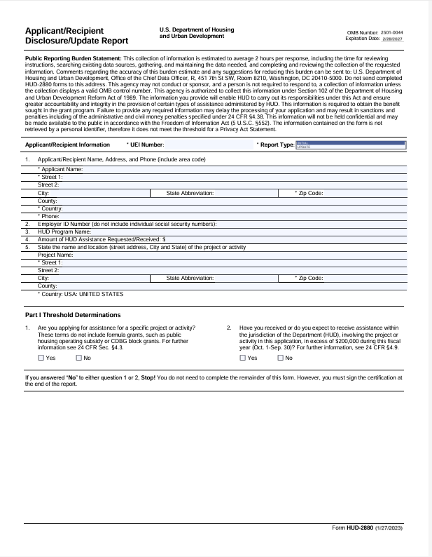

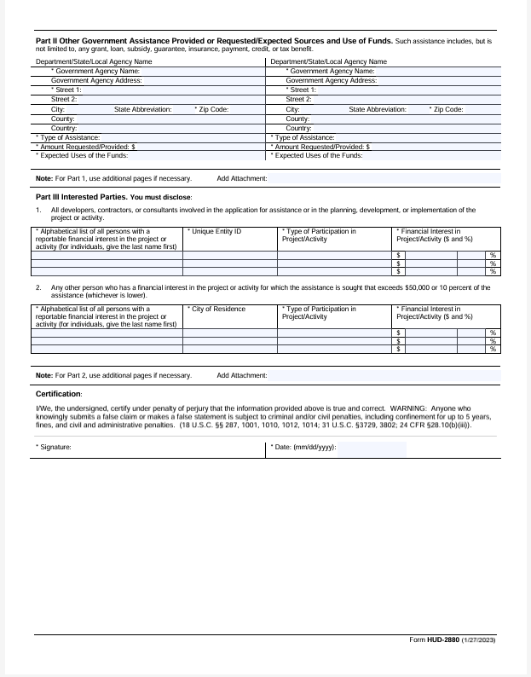

**Instructions—Disclosure Report**

All applicants for LCDBG funding must include a Disclosure Report as part of the application for funding. Instructions for completing the Disclosure Report, as prepared by HUD, are on the following two pages. The Disclosure Report form, along with instructions, can be found on the HUD Clips website located at: https://www.hud.gov/sites/dfiles/OCHCO/documents/2880.pdf /.

Also: The answer to Part I, Question 1 should be checked “No”. The applicant must check Question 2 as appropriate, then sign and date the bottom of the form.

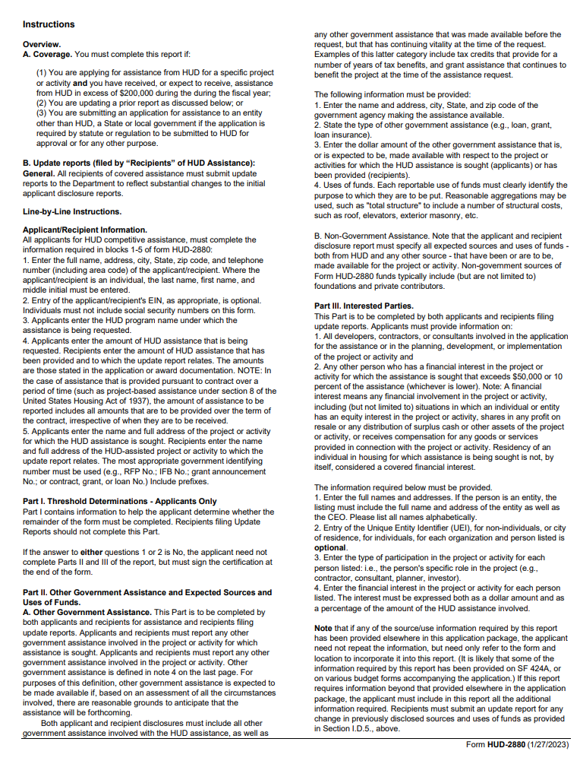

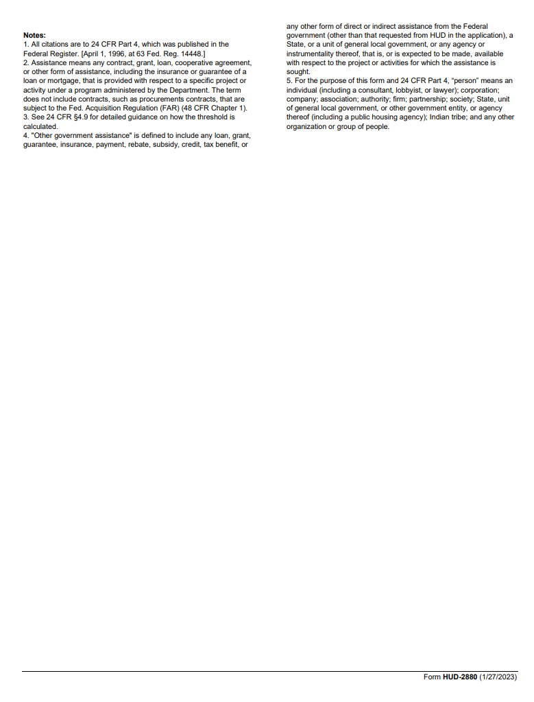

**STREET SUMMARY TABLE**

|  |  |  |  |  |  |  |  |  |
| --- | --- | --- | --- | --- | --- | --- | --- | --- |
| Name of Street or  Portion of Street | Proposed  Work * | # of  Occupied  Houses | Existing Width  (Average) (Ft.) | Existing Length  (Ft.) | Existing  Surface Area  (Sq. Ft.) | Proposed Width  (Ft.) | Proposed Length  (Ft.) | Construction  Cost |
|  |  |  |  |  |  |  |  |  |
|  |  |  |  |  |  |  |  |  |
|  |  |  |  |  |  |  |  |  |
|  |  |  |  |  |  |  |  |  |
|  |  |  |  |  |  |  |  |  |
|  |  |  |  |  |  |  |  |  |
|  |  |  |  |  |  |  |  |  |
|  |  |  |  |  |  |  |  |  |
|  |  |  |  |  |  |  |  |  |
|  |  |  |  |  |  |  |  |  |
|  |  |  |  |  |  |  |  |  |
|  |  |  |  |  |  |  |  |  |
|  |  |  |  |  |  |  |  |  |
|  |  |  |  |  |  |  |  |  |
|  |  |  |  |  |  |  |  |  |

**\*** Identify the type of work proposed for each street: New construction, rehabilitation, or reconstruction.

**Notice of Application to the Division of Administration for a CDBG Sewer Project**

All LCDBG applicants who are (1) proposing a “new” sewerage treatment facility, (2) planning a treatment plant upgrade that will increase the design capacity, or (3) operating an existing facility without a permit or under an expired permit must prepare a “Notice of Application to the Division of Administration for a Community Development Block Grant Sewer Project” form.  **Submit the form directly to DEQ.  The form and instructions are included at** [**https://www.doa.la.gov/doa/ocd-lga/lcdbg-programs/forms-and-information/**](https://www.doa.la.gov/doa/ocd-lga/lcdbg-programs/forms-and-information/)**.  The deadline to submit the forms to DEQ is September 30, 2024.  Forms received by DEQ after the established deadline will not be considered.**  It is strongly recommended that the notice be submitted as early as possible in order to receive the information in a timely manner.

All applicants that are proposing to construct a “new” sewerage treatment facility or who have an existing facility operating without a permit or under an expired permit must also apply for a Louisiana Pollutant Discharge Elimination System (LPDES) permit through DEQ.  Additionally, applicants who have an existing facility and whose proposed project will cause a change in the facility’s design capacity or discharge location must apply for a modification to their present permit.

VI. Displacement Policy

The State will review and determine whether any subgrantee activity will cause temporary or permanent displacement as a result of the operation of its LCDBG program. If the State determines that an individual, family, or business will be displaced as a result of any activity, then the locality will insure that reasonable benefits will be provided.

Reasonable benefits include but are not limited to:

(1) counseling and referral services;

(2) providing assistance in obtaining suitable living quarters/business location whether renting or purchasing;

(3) provide some form of benefits for moving expenses consisting of the cost of the actual move or a fixed payment based on the number of rooms as allowed by the U. S. Department of Transportation's moving schedule.

In accordance with federal regulations, the State requires each recipient locality to prepare and implement a residential antidisplacement and relocation assistance plan. That plan must include:

(a) A requirement that all low/moderate income dwelling units that are demolished or converted to a use other than low/moderate income housing as a direct result of the use of LCDBG assistance will be replaced and

(b) A relocation assistance component.

**Guide for Residential Antidisplacement and Relocation Assistance**

**Plan under Section 104(d) of the Housing and Community**

**Development Act of 1974, as Amended**

Consistent with the goals and objectives of activities assisted under the Housing and Community Development Act of 1974, the (jurisdiction) will take the following steps to minimize the displacement of persons from their homes.

1. All public facilities projects (water, sewer, gas, et cetera) will be designed so that there will be no displacement of any residences or businesses;

2. No homes will be demolished that can be rehabilitated;

3. There will be no displacement of any residential or business occupants on LCDBG projects.

If displacement does occur, then the following requirements apply:

In the event the activities of this program shall result in displacement of any person(s), the (jurisdiction) shall provide the displaced person(s) as defined by 24 CFR 570.606(b)(2)(i) with relocation assistance at the levels described in, and in accordance with the requirements of 49 CFR part 24. The contact person for antidisplacement in (jurisdiction) is ________________ who can be reached at (address and telephone number).

All replacement housing will be provided within three years of the commencement of the demolition or rehabilitation relating to conversion. Before obligating or expending funds that will directly result in such demolition or conversion, the (jurisdiction) will make public and submit to the State the following information in writing:

1. A description of the proposed assisted activity;

2. The general location on a map and approximate number of dwelling units by size (number of bedrooms) that will be demolished or converted to a use other than as low/moderate income dwelling units as a direct result of the assisted activity;

3. A time schedule for the commencement and completion of the demolition or conversion;

4. The general location on a map and approximate number of dwelling units by size (number of bedrooms) that will be provided as replacement dwelling units;

5. The source of funding and a time schedule for the provision of replacement dwelling units; and

6. The basis for concluding that each replacement dwelling unit will remain a low/moderate income dwelling unit for at least ten years from the date of initial occupancy.

The (jurisdiction) will provide relocation assistance, as described in 570.606(b)(2), to each low/moderate income household displaced by the demolition of housing or by the conversion of a low/moderate income dwelling to another use as a direct result of assisted activities.

1. If other funds are being injected in a public facilities project, refer to the “Certification of Other Funds” form on page 63 and the corresponding instructions.