LA Community Development Block Grant Coronavirus (CDBG-CV) Public Facilities –  Love Louisiana Outdoors Program (LLOP)  General Information Form |  |  | 1. Applicant Name
2. Mailing Address |  |  | 3. Physical Address
4. Name of Contact Person |  |  | 5. Contact Email Address
6. Name and Phone Number of Administrative Consultant Preparing Application |  |  | 7. Name and Phone Number of Engineering/  Architectural Firm Preparing Application
8. Administrative Consultant Email Address |  |  | 9. Engineering Firm Email Address
10. Legislative Districts: State Senate: State Rep.: U.S. Congress:
11. Funds | Amount | Source of Funds | Fund Status | State Use Only
CDBG-CV | $
Local Funds | $
Private Funds | $
State Funds | $
Federal Funds | $
Other Funds | $
TOTAL COST | $
12. Signature (Chief Elected Official)  By signing, you are attesting that all information contained in this application is true and correct. |  |  | 13. Date
14. Typed Name/Title |  |  | 15. Telephone Number
16. Email Address

INSTRUCTIONS
General Information Form
Item 1: Enter applicant name (municipality or parish).
Item 2: Enter mailing address of applicant (P.O. Box or street address, name of city, and zip code plus the four-digit number). (Note: For the four-digit number, please contact your local post office).
Item 3: If Physical Address differs from the Mailing Address, enter Physical Address of applicant (same information as Item 2).
Item 4: Enter the name of the person that OCD should contact at the applicant entity regarding this application.
Item 5: Enter the email address of the contact person included in Item 4.
Item 6: Enter the name and phone number of the Administrative Consultant preparing the application, if applicable. If the Consultant is self-employed, enter the individual’s name; otherwise, enter the name of the firm.
Item 7: Enter the name and phone number of the engineering firm preparing the application. Enter the name of the firm, not the name of the individual.
Item 8: Enter the email address for the Administrative Consultant preparing the application. If the Administrative Consultant does not have an email address, enter “Not Applicable”.
Item 9: Enter the email address for the Engineer preparing the application. If the Engineer does not have an Email address, enter “Not Applicable”.
Item 10: Enter the district number of each State Senator, State Representative, and U.S. Congressman representing the applicant.
Item 11: Identify all funds that will be used for completion of the project. Include funds requested through this application and any other funding sources to be utilized. List amount of funds in each category and specific source of these funds. For example, “Local Funds” are any funds included in total project costs contributed by the unit of local government submitting the application. “Private Funds” are those from sources other than governmental entities such as private businesses, banks, etc. Any funds received though other state programs that are used for this specific project would be listed under “State Funds”. Any federal funds, such American Rescue Plan Act, USDA Rural Development, etc., should be listed “Federal Funds”. Any other funds not previously identified to be used for the project should be listed under “Other” and the source specified. For each funding source, indicate the status of the funds.
Item 12: The chief elected official must sign on line 12, attesting that all information in the application is true and correct.
ATTACH A RESOLUTION FROM THE COUNCIL AUTHORIZING APPLICATION FOR LLOP FUNDING AND SIGNATORY AUTHORITY FOR THE OFFICIAL SIGNING DOCUMENTS.
Item 13: Enter the date the application was signed by the chief elected official.
Item 14: Type or print the name and title of the chief elected official signing the application.
Item 15: Enter the phone number of the chief elected official.
Item 16: Enter the email address of the chief elected official.

CDBG-CV Love Louisiana Outdoors Program
Budget/Cost Summary Form Applicant Name:
I. Costs by Activity (Read Instructions Before Completing)
Activity (A) | CDBG-CV  (B) | Other (C) | Total (D) | Source of Other Funds **  (E)
1. Public Facilities
2. Acquisition
3. Clearance & Demolition
4. Administration
TOTAL
**Attach documentation supporting availability of all “Other” sources of funds.
II. Line Item Budget – CDBG-CV Funds Only |  |  |  |  | For State Use Only
1. Public Facilities (24 CFR 570.201(c)) – Outdoor Facility (Total) |  |  | $ |  | $
a. Construction Costs |  |  | $ |  | $
b. Engineering Costs |  |  | $ |  | $
2. Acquisition Costs (24 CFR 570.201(a)) |  |  | $ |  | $
3. Clearance & Demolition Costs (24 CFR 570.201(d)) |  |  | $ |  | $
4. Administration (24 CFR 570.206) |  |  | $ |  | $
5. TOTAL |  |  | $ |  | $

III. Contract Execution Dates (only if scheduled to be paid using CDBG-CV funds)
Name of Administrative/Engineering/  Architectural Firm | Contract Execution Date | Contract Amount

INSTRUCTIONS
Budget/Cost Summary Form
Enter Name of Applicant
SECTION 1: COSTS BY ACTIVITY
Column A: Each activity is listed on separate lines. Administration costs are identified separately.

Columns B,
C, D, & E: For each activity, complete the cost columns. Indicate the CDBG-CV money requested in Column B. Sum all other funds that will be used to accomplish the activity and show these costs in Column C. Add together CDBG-CV (B) and Other (C) and record the result in Column D. In Column E, identify all other sources of funds listed in Column C.
SECTION II: LINE ITEM BUDGET
Include CDBG-CV costs only in this section. In this section, the costs shown in the Column B of Section I should be broken down by the type of cost.
SECTION III: CONTRACT EXECUTION DATES
If CDBG-CV funds will be used to cover engineering or administrative costs, the contractors must have been procured in accordance with State and Federal procurement requirements. OCD must review all solicitations for professional services before they are issued. Enter the name of the engineering/administrative firm that the applicant has contracted with to perform services for the proposed project, the date the contract between the applicant and the firm was executed, and the dollar amount of the contract. An executed contract must be in place prior to services being performed for the project when using CDBG-CV funds to pay for these services. The program cannot reimburse the applicant for expenditures that are incurred prior to the existence of an executed contract between the applicant and the firm.

JURISDICTIONAL MAP

A map indicating the location(s) of concentrations of minorities and concentrations of low- and moderate- income persons, showing number and percent for both groups by jurisdiction is needed (if minorities and/or low- and moderate-income persons are evenly disbursed throughout the jurisdiction then the applicant must include such a statement on the map). All proposed project locations must be indicated on the map as well.

CDBG-CV LLOP Facility Form
1. | Facility Type:
2. | Facility Physical Address:
3. | National Objective (Choose One): Low/Mod Area __________ or Limited Clientele _________;  _______ Total Beneficiaries _______ # of LMI Individuals _______ LMI %
4. | Census Tracts Block Groups Zip Codes  ___________ ___________  ___________ ___________ ______________________________  ___________ ___________  ___________ ___________
5. | Facility Owner:
6. | Facility Operator:
7. | If the applicant is not the facility owner and will not acquire the property, either a long term lease agreement or in the case of the owner being a political subdivision, an intergovernmental agreement must be attached.
8. | Facility Contact Person:
9. | Contact Phone Number:
10. | Contact Email Address:
11. | Project Description: Attach separate narrative.
12. | Attach documentation of ownership.
13. | Engineer/Architect Cost Estimate: Attach separate cost estimate.

INSTRUCTIONS
LLOP Facility Form
A separate form must be completed for each facility proposed for improvements.
Item 1: Enter type of facility proposed for improvement. For example, playground, walking trail, picnic area, fishing pond, etc. For further guidance concerning eligible and ineligible facilities, see the LLOP CDBG-CV Guidelines. If there are questions about eligibility, contact our office prior to submission.
Item 2: Enter physical address of facility proposed for improvement.
Item 3: Select one of the National Objectives: Either Low Mod Area (LMA) – which is applicable if the public facility or improvement will be used for a purpose that benefits all of the residents in the Municipality or Parish, since at least 51% of those residents are Low to Moderate Income persons, or Limited Clientele (LMC) – which is applicable if the public facility or improvement will be used for an activity designed to benefit a particular group of persons at least 51% of whom are Low to Moderate income persons. If LMC IS USED, notify us prior to completing the application.
Also enter the total number of beneficiaries of the project, the number of low to moderate income individuals (LMI) benefiting from the project, and the percentage of beneficiaries that are LMI individuals.
Item 4: Enter all of the Census Tract and Block Group numbers, and all of the Zip Code(s) for the service area of the facility.
Item 5: Enter the name of the entity that owns the facility or property proposed for improvement.
Item 6: Enter the name of the entity that operates the facility proposed for improvement.
Item 7: If the applicant is not the owner of the facility or property, the applicant must either acquire the property or documentation of the agreement with the property owner is needed. In the case of private ownership, a long-term lease agreement is required. In the case of ownership by a political subdivision (ex. UGLG or recreational district), an intergovernmental agreement allowing the applicant to carry out the program on the property is required.
Item 8: Enter the name of the contact person at the facility proposed for improvements.
Item 9: Enter the phone number of the contact person at the facility proposed for improvements.
Item 10: Enter the email address of the contact person at the facility proposed for improvements.
Item 11: Attach a separate narrative including a concise description of the proposed development or improvements. The narrative should include the following:
- Identify the facility proposed for improvements, the location of the facility, size/capacity of the facility.
- Briefly explain the plans for use of the facility.
- Describe the options for handicap/disabled persons that are to be included in the design and construction of the facility.
- Identify any fees to be charged for use of the facility. If fees will be charged, submit an estimate of annual revenue expected from these fees, and a breakdown of estimated annual costs, by category, for maintaining the facility. The calculation used for estimating annual revenue must be provided.
- Address ownership of the facility and whether acquisition is required. If acquisition is necessary, indicate the approximate number of parcels to be acquired, and whether acquisition will be paid for with CDBG-CV funding.
- Identify the entity(ies) that will own and operate the facility after the completion of the project.
- Address whether an entity other than the applicant will carry out the program. This entity will be considered a subrecipient and a subrecipient agreement, provided by our office, must be executed. If a subrecipient will be participating in this project, complete the Subrecipient Information Form.
- Address any blighted structures located on the property and any demolition needed.
- Describe the plan for sustaining the facility for a minimum of five years. Annual reporting will be required each year after final closeout for a minimum of five years to certify revenue generated and expenses incurred for each facility. The reports will also certify current ownership of each facility and the current entity responsible for maintaining each facility.
Item 12: Document current ownership of the property to be developed or improved.
Item 13: Attach a separate document to identify a detailed cost estimate prepared, signed, and stamped by a Professional Engineer or Architect licensed in the State of Louisiana, verifying that costs have been reviewed to ensure accuracy. The cost estimate shall contain the cost of construction, design fees, and any other project costs. The construction estimate shall be a listing of construction items (as a bid proposal), estimated quantity, unit of measure, unit price, and amount. A maximum of 10 percent is allowed for construction contingencies. The number of weeks of construction that is anticipated should be included as well.
Design fees shall be identified by type in a line item format. Typical items include basic services, resident project representative. Written justification must be provided for all design services other than basic services and a resident project representative. The justification is to contain an explanation of why the service is needed and how the proposed fee was derived. Please refer to the document, “Engineering Fee Schedules and Policies,” located on OCD’s website for more information concerning eligible fees.

SUBRECIPIENT INFORMATION FORM
1. | Name of Subrecipient:
2. | Qualification of Subrecipient per 24 CFR 570.500(c) (Select One):  _____Political Subdivision  _____Private Non-profit
3. | Current Public Purpose or Function of the Organization:
4. | Facility Name:
5. | Identify Service Area of the facility:
6. | Describe the Public Facility:
7. | Will the use of this funding continue the current public purpose or function of the organization?  _____YES _____NO
8. | A copy of the Statement of Assurances must be signed by the subrecipient and attached to the application.

INSTRUCTIONS
Subrecipient Information Form
The Subrecipient Information Form is required if an entity other than the applicant will carry out the program for a particular facility. Please note that the subrecipient will be subject to the same regulations as the applicant, with a few exceptions. A Subrecipient Information Form should be completed for each subrecipient.
A subrecipient agreement will be provided to grantees by the Office of Community Development after awards are made.
Item 1: Enter the name of the Subrecipient.
Item 2: Select the appropriate qualification of the Subrecipient as per 24 CFR 570.500(c).
- Political Subdivisions are public agencies, commissions, or authorities that are independent of the grantee’s government (for example, a recreation district).
- Private Non-profits are usually, but not always, corporations, associations, agencies, or faith-based organizations with non-profit status under the Internal Revenue Code (Section 501(c)(3)), usually with a board of directors and an executive director in charge of daily administration.
Item 3: Enter the public purpose or function of the subrecipient organization, and describe the services provided.
Item 4: Enter the name of the facility.
Item 5: Describe the boundaries of the area that the facility serves.
Item 6: Describe the physical facility and what the use of the facility will be.
Item 7: Select the appropriate answer to whether the use of CDBG-CV funding will continue the current public purpose or function of the facility/organization.
Item 8: If a subrecipient is involved, then an additional copy(ies) of the Statement of Assurances is needed. One will be executed by the applicant and one will be executed by each subrecipient.

APPLICATION CERTIFICATION – LOVE LOUISIANA OUTDOORS PROJECT
I certify, to the best of my knowledge and belief, that (check all that apply):
_____The funds requested herein for the proposed outdoor recreation facility development or improvement are to reduce and/or respond to COVID-19.
_____The proposed facilities will be open and available for public use by all residents of the jurisdiction.
_____No undisclosed federal funds have been or will be received by our local government for the proposed project.
_____All “Other” funding, as disclosed on the Budget/Cost Summary Form, are available for use. Documentation of availability of funds is attached.
_____Excessive fees, which will have the effect of precluding low and moderate income persons from using the facilities, will not be charged.

Signature of Chief Elected Official Date

INSTRUCTIONS
Application Certification
The Chief Elected Official must sign and date this form certifying the following:
- Proposed purpose of costs is to reduce and/or respond to COVID-19.
- Facilities must be open and available for public use by all residents of the jurisdiction, with the exception of facilities owned by the jurisdiction that are exclusive to a population defined by HUD regulations as Limited Clientele. If the facility will not be open and available for all residents of the jurisdiction, notify us prior to completing the application.
- No other federal funds have been or will be received by the applicant for the proposed project (other than those disclosed on the General Information and Budget/Cost Summary Forms).
- All other funds included in this application are available for use. Documentation of availability of funds must be attached.
- Excessive fees will not be charged.

PERFORMANCE THRESHOLD CRITERIA VERIFICATION FORM
Applicant must meet the following performance threshold criteria in order to be eligible for funding.
Select all that apply:
_____In compliance with financial requirements (not included on Louisiana Legislative Auditor’s Non-Compliance list or list of Fiscally Distressed Municipalities).
_____Current on year-end financial audit reports.
_____Auditor of most recent year-end financial report was able to obtain sufficient and appropriate evidence to provide a basis for their audit opinions.
_____In good standing with the LCDBG Program (not included on OCD-LGA Sanction List).

INSTRUCTIONS
Performance Threshold Criteria Verification Form
- Select each performance threshold criteria that applies to the applicant.
All performance threshold criteria will be verified prior to awarding funds. If any of the criteria are not met, the applicant will not be awarded funding under this program.

SCORING CRITERIA VERIFICATION FORM
Select all that apply:
_____Applicant currently owns all property to be developed.
_____Blighted structures currently located on property to be developed.
_____Applicant currently has no public recreation parks or facilities.
_____Administration costs to be paid by the applicant.
_____All design and construction administration costs to be paid by the applicant.

Attach documentation to support each of the selections made above. Points will only be awarded for documented selections.
Please also note that if the application deviates from the selections made on the Eligibility Form to the extent of having an effect on scoring, the application may be disqualified.

INSTRUCTIONS
Scoring Criteria Verification Form
Depending on the effect on scoring, deviations from selections made on the Eligibility Form may result in the application being disqualified from consideration for funding.
- Select each scoring criteria that applies to the project as documented in this application.
- Attach appropriate documentation to verify and support each of the scoring criteria selected on this form. If documentation is not included, the applicant will not receive points for that criteria.

ENGINEERING/ARCHITECTURAL COSTS CERTIFICATION
I certify that our local government will pay all of the engineering/architectural costs associated with the implementation of this CDBG-CV program. These costs will include but not be limited to basic design, resident inspection, testing, staking. etc.

A resolution adopted by our local government is attached which identifies the firm hired and the proposed amount of their contract.

Signature of Chief Elected Official Date

ADMINISTRATIVE COSTS CERTIFICATION
I certify that our local government will pay all of the administrative costs associated with the implementation of this CDBG-CV program; such costs will include, but not be limited to audit fees, advertising and publication fees, local staff time, workshop expenses, and/or administrative consultant fees. I have marked the following box which indicates who will be responsible for administering the CDBG-CV program. The documentation to support this is included in this application in accordance with the instructions.

The local government will utilize an administrative consultant to administer the CDBG-CV Program. The proposed consultant is . Attached is a copy of the required resolution by the local government.

The local government will utilize its own staff for the purpose of administering the CDBG-CV Program. Attached are a resolution and a sheet containing the required documentation requested in the instructions.

Signature of Chief Elected Official Date

PROOFS OF PUBLICATION
Attach the two required public notices and proofs of publication.

INSTRUCTIONS

Engineering/Architectural Costs Certification
This form must be completed by those applicants that will pay all of the engineering/architectural costs associated with the implementation of the CDBG-CV Program. Such costs may include, but not be limited to, basic design, resident inspection, testing, staking, etc. However, property surveying can be paid with grant funds even if the applicant receives the rating points for paying the engineering costs.
To substantiate that the local government will pay the engineering costs associated with the CDBG-CV Program, this form must be completed and signed by the chief elected official. A copy of the resolution passed by the local government identifying the engineering/architectural firm hired and the proposed amount of the contract must be included in the application. That resolution should also state that local funds will be used to pay the engineering fees and any other engineering costs incurred by the local government, (except property surveying costs). The applicant will not receive these points if the required information is not included in the application.
For those applicants that receive the points for paying engineering costs (and are successful in receiving a grant), if there is an under-run in their project costs, the grantee will not be allowed to re-budget those monies for the purpose of reimbursing the local government for any engineering costs associated with the CDBG-CV Program.

Administrative Costs Certification
This form must be completed by those applicants that will pay all of the administrative costs associated with the implementation of the CDBG-CV Program. To receive the points associated with this factor, the form must be completed and signed by the chief elected official and the corresponding documentation must be included in the application. Such administrative costs may include, but not be limited to, audit fees, advertising and publication fees, local staff time, workshop expenses, administrative consultant fees, etc. It is not allowable for grantees to re-budget monies for the purpose of reimbursing the local government for any administrative costs associated with the CDBG-CV Program if an under-run in project costs occurs. The applicant will not receive these points if the required information is not included in the application.
An applicant may intend to utilize the services of an administrative consultant, to utilize local staff, or to utilize both. The certification must identify which circumstances apply by marking one or both boxes. If the applicant plans to utilize the services of an administrative consultant, local funds must be pledged and allocated for such services. A copy of the resolution passed by the local government identifying the administrative consultant hired and the proposed amount of the contract must be included in the application. That resolution should also state that local funds will be used to pay the administrative consultant fees and any other administrative costs incurred by the local government.
If the local government maintains full-time permanent staff for the sole purpose of administering CDBG-CV or other federal programs, such staff must have proved its capacity to administer CDBG-CV or other federal programs through previous program administration. A sheet should be attached that identifies the staff person(s) who will be responsible for program administration, their job title or position, and a brief listing of their previous experience in administering CDBG-CV or other federal programs. A copy of the resolution passed by the local government stating that local funds will be used to pay all administrative costs incurred by the local government must be included in the application.

Proofs of Publication
A copy of the public notices and proofs of publication must be included in the application package (one for the Citizen Participation requirements and one making the application available for review).

LOUISIANA CDBG-CV PROGRAM
STATEMENT OF ASSURANCES
This applicant hereby assures and certifies that:
- It possesses legal authority to apply for the grant and to execute the proposed program.
- Its governing body has duly adopted or passed as an official act a resolution, motion, or similar action authorizing the filing of the application, including all understandings and assurances contained therein, and directing and authorizing the person identified as the official representative of the applicant to act in connection with the application and to provide such additional information as may be required.
- It has facilitated citizen participation (in accordance with 42 U.S.C. 5304[a]) by:
- Providing adequate notices that provide the information specified on the Office of Community Development’s website.
- Holding a hearing to obtain citizens’ views on housing and community development needs and to provide citizens with the information specified on the Office of Community Development’s website.
- It has adopted a detailed written citizen participation plan that:
- Provides for and encourages citizen participation, with particular emphasis on participation by persons of low and moderate income who are residents of slum and blighted areas and of areas in which funds are proposed to be used;
- Provides citizens with reasonable and timely access to local meetings, information, and records relating to the State's proposed method of distribution, as required by regulations of the Secretary, and relating to the actual use of funds under Title I of the Housing and Community Development Act of 1974, as amended, and the unit of local government's proposed and actual use of CDBG funds;
- Provides for technical assistance to groups representative of persons of low and moderate income that request such assistance in developing proposals with the level and type of assistance to be determined by the grantee;
- Provides for public hearings to obtain citizen views and to respond to proposals and questions at all stages of the community development program, including at least the development of needs, the review of proposed activities, and review of program performance, which hearings shall be held after adequate notice, at times and locations convenient to potential or actual beneficiaries, and with accommodations for the disabled;
- Provides for a timely written answer to written complaints and grievances, within fifteen working days where practicable, and; Identifies how the needs of non-English speaking residents will be met in the case of public hearings where a significant number of non-English speaking residents can be reasonably expected to participate.
- Its chief executive officer, chief elected official, or other officer of applicant approved by the State will consent to assume the status of a responsible entity as defined by 24 CFR 58.2(a)(7) in compliance with the National Environmental Policy Act of 1969 insofar as the provisions of such Act apply to the Louisiana Community Development Block Grant Program.
- The applicant’s Community Development Block Grant program has been developed so as to give maximum feasible priority to activities that will benefit low and moderate income households, will aid in the prevention or elimination of slums or blight, or meet community development needs having a particular urgency.
- It will comply with the regulations of 2 CFR Part 200, the Uniform Administrative Requirements, Cost Principles, and Audit Requirements for Federal Awards.
- That it will conduct all procurement activities utilizing Federal funds in a manner consistent with the procurement requirements of 2 CFR 200.318-326. In particular it assures that it will exclude from competition any contractor or vendor who assists the applicant in the development or drafting of specifications or scopes of work for such solicitations or any other actions that would confer an unfair competitive advantage in accordance with the requirements of 2 CFR 200.319(a) and (b).
- That it has the ability to comply with the Financial Management requirements in Subpart D, the Cost Principles requirements in Subpart E and the Audit requirements in Subpart F. In particular it assures it will be responsible for the preparation of appropriate financial statements in accordance with the requirements of 2 CFR 200.508.
- It will require every building or facility (other than a privately owned residential structure) designed, constructed, or altered with funds provided under this part to comply with the requirements of the Architectural Barriers Act of 1968 (42 U.S.C. 4151-4157) and the Americans with Disabilities Act (42 U.S.C. 12131; 47 U.S.C. 155, 201, 218 and 225).
- It will comply with:
- Title VI of the Civil Rights Acts of 1964 (Pub. L. 88-252) (42 U.S.C. 2000d) as amended, and the regulations issued pursuant thereto (24 CFR Part 1), which provides that no person in the United States shall on the grounds of race, color, or national origin, be excluded from participation in, be denied the benefits of, or be otherwise subjected to discrimination under any program or activity for which the applicant receives federal financial assistance and will immediately take any measures necessary to effectuate this assurance. If any real property or structure thereon is provided or improved with the aid of federal financial assistance extended to the applicant, this assurance shall obligate the applicant, or in the case of any transfer of such property, any transferee, for the period during which the property or structure is used for another purpose involving the provision of similar services or benefits.
- The Fair Housing Act (42 U.S.C. 3601-3619) and implementing regulations (24 CFR Subtitle B, Subchapter A). And further it will comply with section 104(b)(2) of Housing and Community Development Act of 1974, as amended, administering all programs and activities relating to housing and community development in a manner to affirmatively further fair housing.
- Section 109 of the Housing and Community Development Act of 1974, and the regulations issued pursuant thereto (24 CFR Part 570.602), which provides that no person in the United States shall, on the grounds of race, color, national origin, or sex, be excluded from participation in, be denied the benefits of, or be subjected to discrimination under, any program or activity funded in whole or in part with funds provided under this Part. Section 109 further prohibits discrimination to an otherwise qualified individual with handicap as provided under Section 504 of the Rehabilitation Act of 1973, as amended, and prohibits discrimination based on age as provided under the Age Discrimination Act of 1975. The policies and procedures necessary to ensure enforcement of section 109 are codified in 24 CFR part 6.
- It will comply with Section 3 of the Housing and Urban Development Act of 1968 (24 CFR part 75), as amended, requiring that to the greatest extent feasible opportunities for training and employment be given to lower-income residents of the project area and contracts for work in connection with the project be awarded to eligible Section 3 business concerns.
- It will:
- To the greatest extent practicable under State law, comply with the acquisition and relocation requirements Uniform Relocation Assistance and Real Property Acquisition Policies Act of 1970, as amended, and will comply with the HUD implementing regulations at 24 CFR Part 42 the DOT implementing regulations at 49 CFR 24; and
- Follow a residential anti-displacement and relocation assistance plan and it will comply with the acquisition and relocation requirements in connection with any activity assisted with funding under the CDBG program; and
- Minimize displacement of persons as a result of activities assisted with such CDBG-CV funds.
- It will provide access to (1) the State, Representatives of HUD, the Inspector General, and the General Accounting Office shall have access to all books, accounts, records, reports, files, and other papers, or property pertaining to the administration, receipt and use of CDBG funds and necessary to facilitate such reviews and audits, and (2) It shall provide citizens with reasonable access to records regarding the past use of CDBG funds and ensure that units of general local government provide citizens with reasonable access to records regarding the past use of CDBG funds consistent with State or local requirements concerning the privacy of personal records.
- It will not attempt to recover any capital costs for public improvements financed in whole or in part with CDBG-CV funds, through assessments against properties owned and occupied by low and moderate income persons including any fees charged or assessed made as a condition of obtaining access to such public improvements.
- It will, as necessary, devise, adopt and carry out procedures with respect to CDBG assistance that fulfill the objectives and requirements of the Lead-Based Paint Poisoning Prevention Act (42 U.S.C. 4821-4846), the Residential Lead-Based Paint Hazard Reduction Act of 1992 (42 U.S.C. 4851-4856), and implementing regulations at 24 CFR Part 35, subparts A, B, J, K, and R of this title.
- It has determined that the proposed activity will meet the identified community development needs of its jurisdiction and will carry out its proposed activity in a manner that will significantly benefit the residents of its jurisdiction. Any CDBG expenditures that serve beneficiaries outside the jurisdiction will not be unreasonably disproportionate to the benefits to its residents.
- It will adopt and enforce a policy prohibiting the use of excessive force by law enforcement agencies within its jurisdiction against any individual engaged in non-violent Civil Rights demonstrations in accordance with 42 U.S.C. 5304 (l).
- It certifies that no federally appropriated funds will be paid for any lobbying purposes regardless of the level of government.
Signing these assurances means that the municipality/parish agrees to implement its program in accordance with these provisions. Applicant further acknowledges in addition to the previous cited provisions that if it is awarded funds it will be responsible for compliance and enforcement of applicable Federal laws (42 U.S.C. 5301-5320) and regulations (24 CFR Part 570) including the Subpart K requirements (24 CFR 570.601-614) of the Community Development Block Grant program and such provisions for the proper administration of the program made by this Office of Community Development, Division of Administration as allowed by 24 CFR 570.480(f).
Failure to comply can result in serious audit and/or monitoring findings that require repayment of funds to the State or expending municipality/parish funds to correct deficiencies. A training session will be held to describe these requirements to all funded applicants. Municipality/parish staff attendance will be mandatory. Failure to attend this session, as required, will result in a monetary penalty assessed against the municipality/parish.

SIGNATURE OF CHIEF ELECTED OFFICIAL OR CHIEF EXECUTIVE OFFICER

TYPED/NAME AND TITLE OF CHIEF ELECTED OFFICIAL OR CHIEF
EXECUTIVE OFFICER

DATE

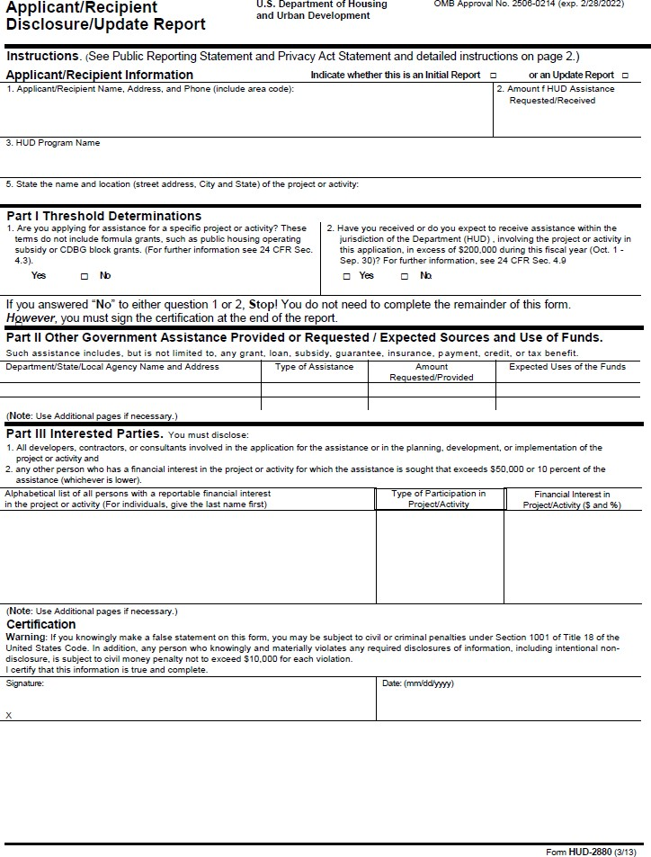
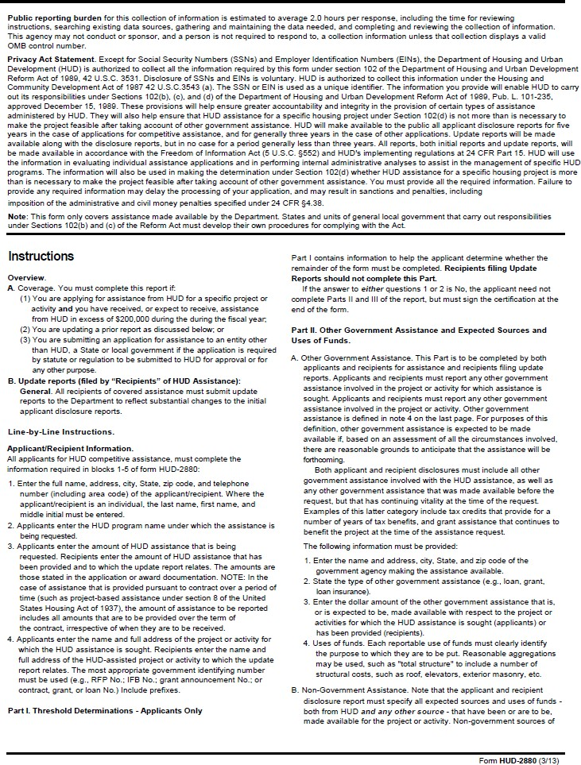
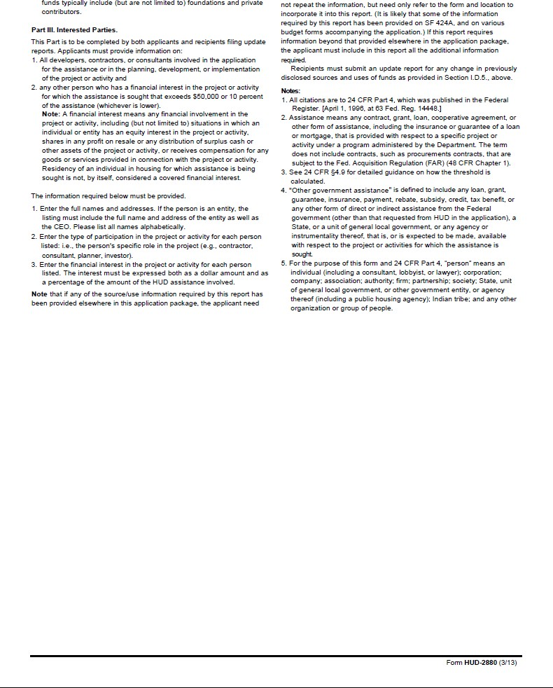

Instructions—Disclosure Report

All applicants for CDBG-CV funding must include a Disclosure Report as part of the application for funding. Instructions for completing the Disclosure Report, as prepared by HUD, are on the following two pages. The Disclosure Report form, along with instructions, can be found on the HUD Clips website located at: https://www.hudexchange.info/resource/293/hud-form-2880/.

Also: The answer to Part I, Question 1 should be checked “No.” The applicant must check Question 2 as appropriate, then sign and date the bottom of the form.

