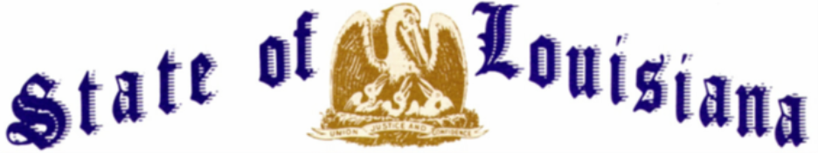
EXECUTIVE DEPARTMENT
OFFICE OF THE GOVERNOR
EXECUTIVE ORDER NUMBER JML 26-100
_____________________________________________________________________________
FLAGS AT HALF-STAFF
WILLIAM PERSHING “BILLY” BUTLER
______________________________________________________________________________

WHEREAS, Technician Fourth Grade William Pershing “Billy” Butler made the ultimate sacrifice for our country on December 27, 1942;
WHEREAS, he was born to William Albert Butler, Jr. and Mary Elizabeth Wright Butler on May 10, 1920, in Parkdale, Arkansas, and came of age during the Great Depression;
WHEREAS, he graduated near the top of his class from Bonita High School and later moved to Bastrop, where he worked as a grocery store clerk before World War II;
WHEREAS, at the age of twenty, he answered his nation’s call with unwavering resolve, enlisting in the United States Army Air Corps from Louisiana on August 15, 1940;
WHEREAS, he was assigned to the Air Corps Detachment, Weather, Philippines, later the 5th Air Corps Squadron, Weather, and served at Nichols Field on Luzon, providing critical weather support for military operations;
WHEREAS, after Japanese forces invaded the Philippines in December 1941, he and his fellow service members resisted enemy forces under desperate conditions until United States forces surrendered on the Bataan Peninsula on April 9, 1942;
WHEREAS, following the surrender, he was taken as a prisoner of war;
WHEREAS, he was among the approximately 75,000 American and Filipino prisoners of war forced into the brutal 65-mile Bataan Death March, one of the most horrific trials of World War II;
WHEREAS, he met this profound cruelty with a courage that continues to inspire and humble us;
WHEREAS, following the Bataan Death March, he was imprisoned at the Cabanatuan Prisoner of War Camp #1, where more than 2,500 prisoners perished during the war;
WHEREAS, enduring starvation, disease, and the brutal realities of captivity, he died on December 27, 1942, at the age of twenty-two;
WHEREAS, he was buried with fellow prisoners in Common Grave 837 of the Cabanatuan Camp Cemetery;
WHEREAS, in recognition of his service and bravery, he was posthumously awarded both the Purple Heart and the Prisoner of War Medal;
WHEREAS, for more than eight decades he remained unaccounted for, and his name is inscribed on the Walls of the Missing at the Manila American Cemetery and Memorial;
WHEREAS, on December 22, 2025, the Defense POW/MIA Accounting Agency identified his remains and accounted for him;
WHEREAS, under the leadership of President Donald J. Trump, Technician Fourth Grade William Pershing Butler is coming home on October 16, 2026, nearly 84 years later, to be laid to rest;
WHEREAS, he was followed in death by his parents, William Albert Butler, Jr. and Mary Elizabeth Wright Butler; and his siblings, Iris Odessa Butler Dean and William O’Neal Butler;
WHEREAS, he is survived by his nephews, Dennis Dean of Bossier City and Dale Dean of Sterlington; his niece, Dixie York of Sterlington; along with numerous great nieces and nephews; and
WHEREAS, his death in service to our country remains a solemn reminder of the price paid by those who fought for freedom, and the State of Louisiana honors him with the profound gratitude he so deeply earned.
NOW, THEREFORE, I, JEFF LANDRY, Governor of the State of Louisiana, by virtue of the authority vested by the Constitution and the laws of the State of Louisiana, do hereby order and direct as follows:
Section 1: As an expression of respect and to honor Technician Fourth Grade William Pershing “Billy” Butler, the flags of the United States and the State of Louisiana shall be flown at half-staff over the State Capitol and all state buildings from sunrise until sunset on Friday, October 16, 2026.
Section 2: This Order is effective upon signature and shall remain in effect until sunset, Friday, October 16, 2026.
IN WITNESS WHEREOF, I have set my hand officially and caused to be affixed the Great Seal of Louisiana, at the Capitol, in the City of Baton Rouge, on this 15th day of October, 2026.

__________________________________________
Jeff Landry
GOVERNOR OF LOUISIANA

ATTEST BY THE
SECRETARY OF STATE

__________________________________
Nancy Landry
SECRETARY OF STATE

