# Creating a Sourcing Request in LESA

This document describes the procedure for creating a Sourcing Request.

1. [Log into LESA](http://louisiana.sourcing.ariba.com). On the left side of the screen, click “Sourcing Request” under Common Actions.

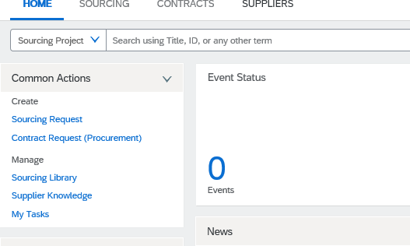

1. On the Create Sourcing Request screen, required fields are marked by a red asterisk (*). Some fields include Help Tips, which may be accessed by clicking on the circled “i” at the end of the field.

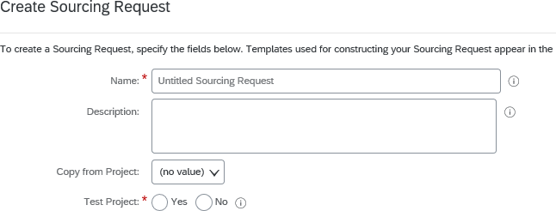

1. Enter the name of the project in the Name field and a brief description of the project in the Description field.

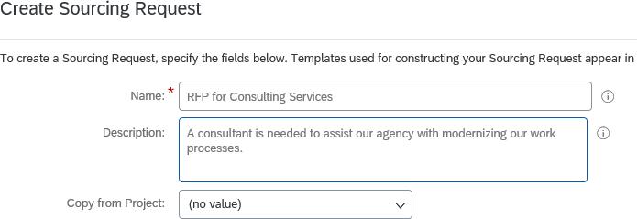

1. The next field, Copy from Project, should be ignored. This field copies information from another Sourcing Request in LESA, including all fields, such as submittal date. Since the dates will change from one Sourcing Request to another, the field must be left blank.
2. If you are training or practicing how to create and submit a Sourcing Request, select Yes for Test Project. Otherwise select No.

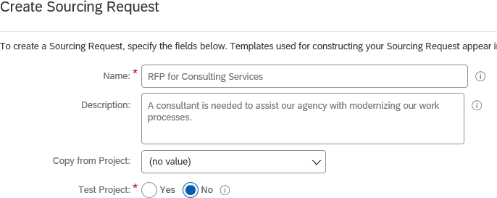

1. For Statewide/Region(s)/Parish(es), click the down arrow on the field. If you have previously created a Sourcing Request, the system will present a list of previously selected items that can be chosen by clicking on them. If this is your first Sourcing Request, or the item needed is not included in the previously selected items list, choose “Search more”. Select the location(s) where the work will be performed or the goods will be delivered. Individual parishes, regions, or statewide may be chosen by selecting the box to the left of the appropriate item. Click on the arrow next to the region to expand the list to include the individual parishes within that region. Multiple selections may be made.

Note: The regions correspond to the GOHSEP and Department of Military Affairs regions, which may differ from a region map regularly used by your agency.

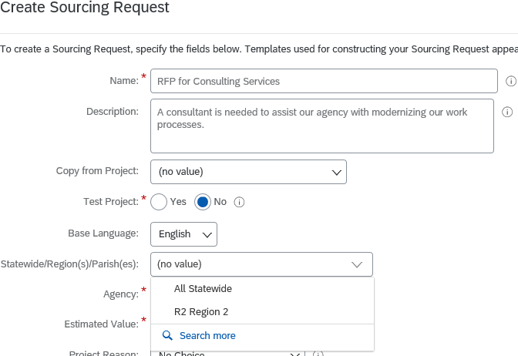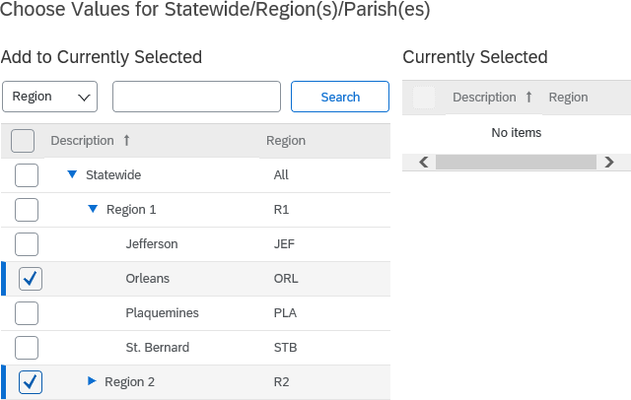

1. Choose the appropriate Agency(ies) by clicking the down arrow on the field. If you have previously created a Sourcing Request, the system will present a list of previously selected items that can be chosen by clicking on them. If this is your first Sourcing Request, or the item needed is not included in the previously selected items list, choose “Search more”. Agencies may be selected by selecting the box next to the agency name. Click the arrow next to the Department to show the agencies within that Department. Multiple selections may be made. Note: The agency level must be chosen, not the department.

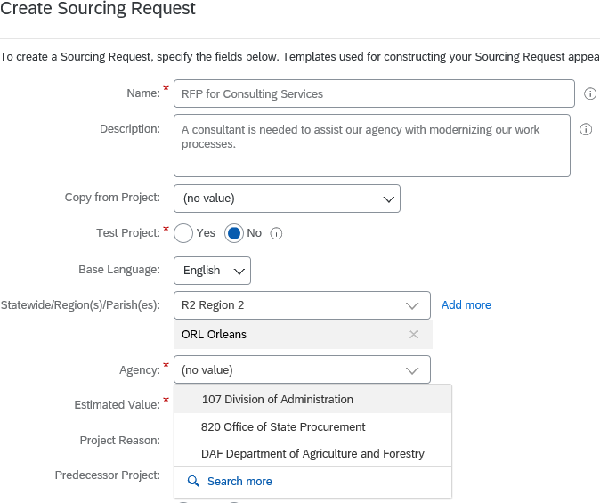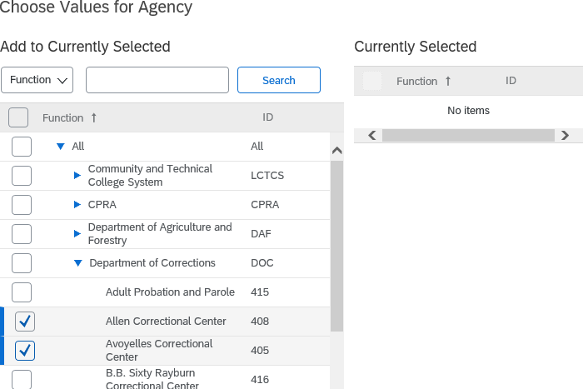

1. In the Estimated Value field, enter the project budget or estimated value of the resulting contract(s). For multiple awards, it is the combined value of all expected contracts.

If the contract will result in a no-cost contract for the State, the agency should enter the estimated value of the contract for the total contract term (e.g. the value of the contract to the Contractor).

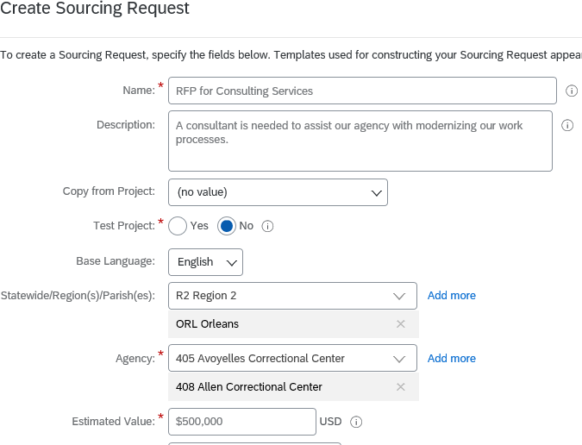

1. In the Project Reason field, select one of the choices by clicking the down arrow.

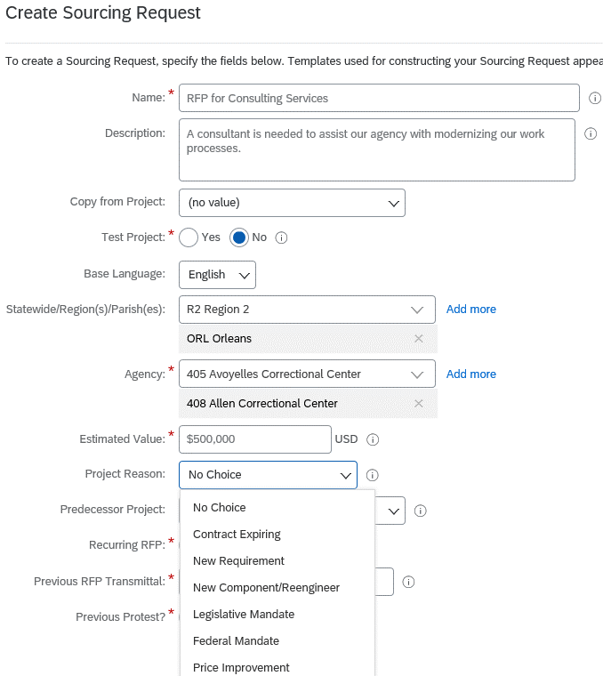

1. The Predecessor Project field does not need to be completed.
2. In the Recurring RFP field, select Yes if this project is a recurring RFP. Select No if the project is for a new service.

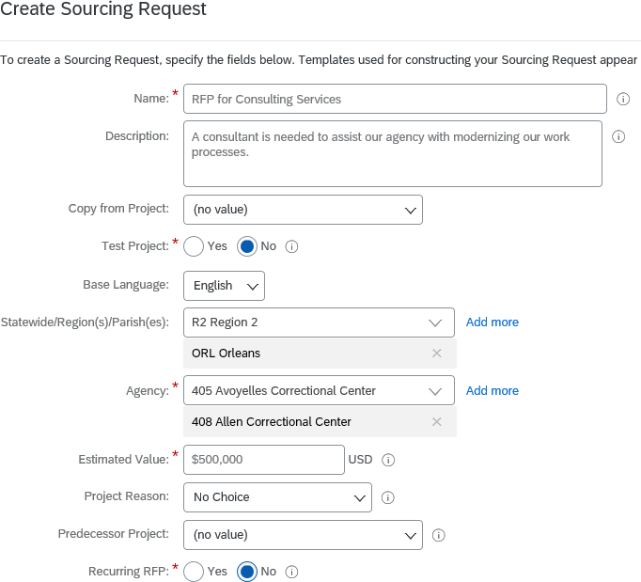

* 1. If Recurring RFP is Yes, two (2) additional fields will appear: Previous RFP Transmittal and Previous Protest.

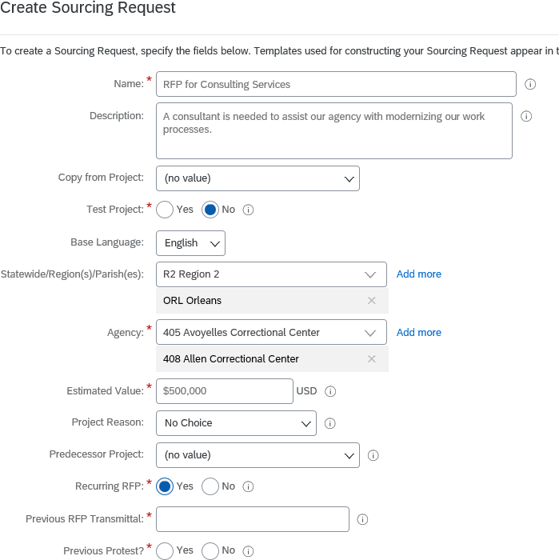

* 1. In Previous RFP Transmittal, enter the Sourcing Request ID of the previous RFP that was processed in LESA, the ProAct Transmittal number of the previous RFP that was processed in ProAct, or the Shopping Cart number of the previous RFP that was processed in DocTracking.
  2. For Previous Protest, select Yes if the immediately preceding RFP was protested.

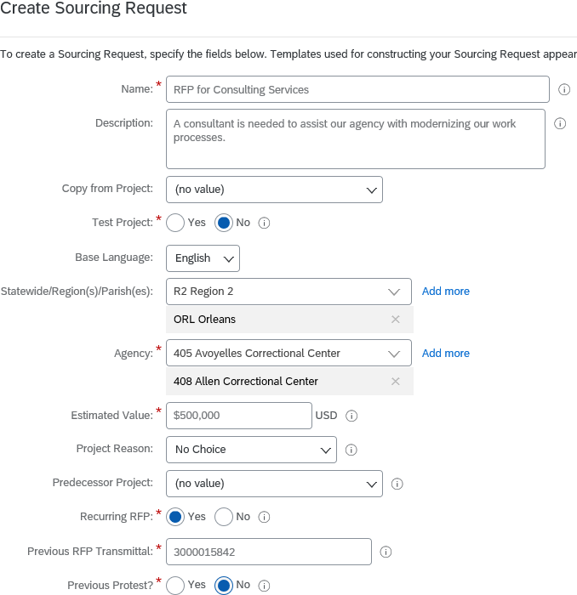

1. In the Commodity field, select the appropriate commodity code(s) by clicking the down arrow on the field. If you have previously created a Sourcing Request, the system will present a list of previously selected items that can be chosen by clicking on them. If this is your first Sourcing Request, or the item needed is not included in the previously selected items list, choose “Search more”. Select the box next to the appropriate commodity code(s). You may search for the appropriate commodity code(s) by Name or by ID. Multiple selections may be made. Note: Commodity code(s) chosen must have six (6) or more digits. This is at least two (2) levels down on the hierarchy.

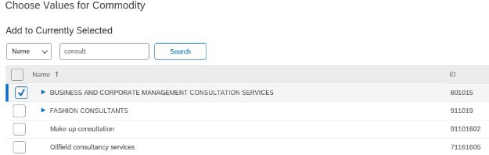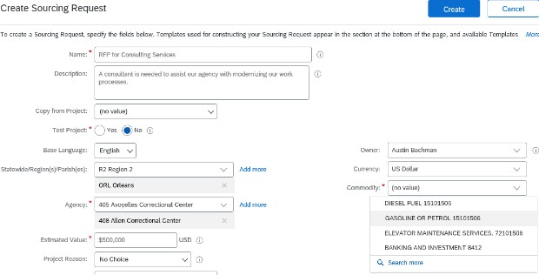

1. At the bottom of the create screen, answer the questions posed.
   1. For the first question, answer Yes if your agency legal section needs to review the Sourcing Request prior to submittal to OSP. This will insert your legal section in the approval workflow.
   2. For the second question, answer Yes if your agency budget section needs to review the Sourcing Request prior to submittal to OSP. This will insert your budget section in the approval workflow.

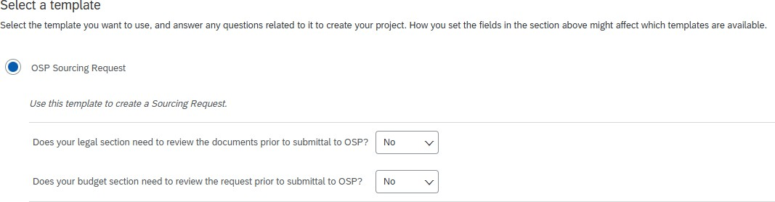

1. Click the blue Create button at the top or bottom of the screen to create the Sourcing Request.

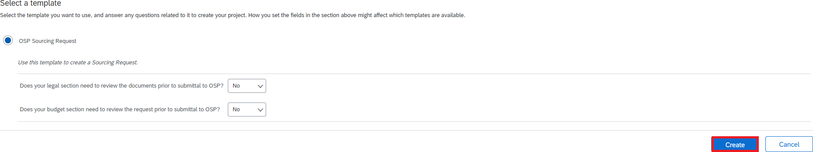

1. Now that you have created the Sourcing Request, the activities to be completed in order to submit the Sourcing Request to OSP may be found below.

# Submitting a Sourcing Request

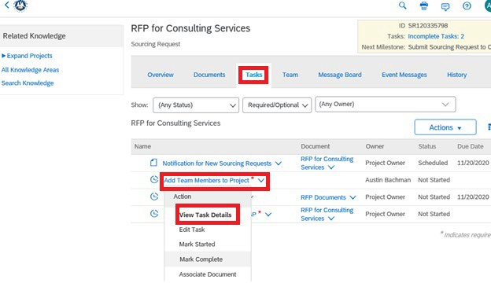

Starting with step 16, this process describes the procedure for adding the necessary documents to a Sourcing Request and submitting the Sourcing Request to OSP.

1. Log into LESA and access your already created Sourcing Request.
2. In the Sourcing Request, click on the “Tasks” tab. This displays the tasks that must be completed in order to submit the Sourcing Request to OSP.

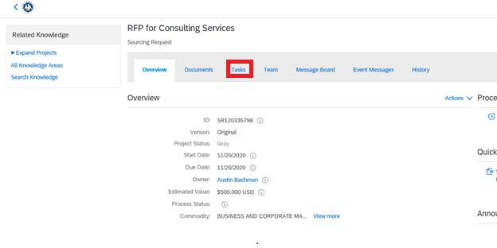

1. Click on the “Add Team Members to Project” task and choose “View Task Details”.
2. Each task contains a description of the action to be taken in that task. Read the description and then click the “Mark Started” button.

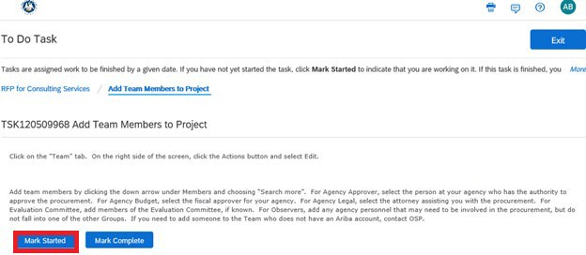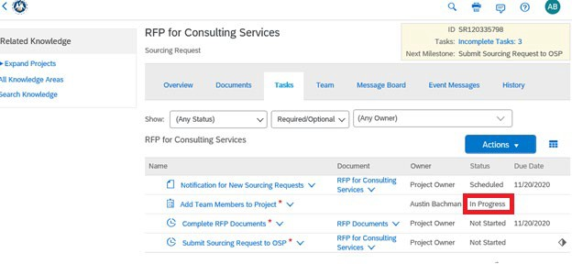

1. Returning to the Tasks tab, you will see the icon has changed for the “Add Team Members to Project” task and the status now shows “In Progress”.
2. To complete the “Add Team Members to Project” task, click on the “Team” tab. On the right side of the screen, click the Actions button and select Edit.

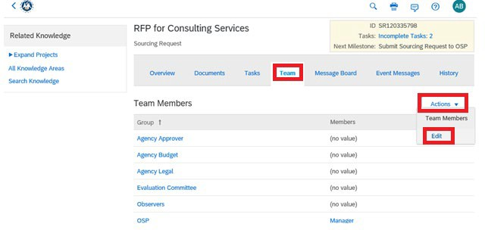

1. Add team members by clicking the down arrow under Members and choosing “Search more”.
   1. For Agency Approver, select the person at your agency who has the authority to approve the procurement.
   2. If your internal agency policy requires agency budget to approve the project prior to sending to OSP, select the fiscal approver for your agency in the Agency Budget group.
   3. If your internal agency policy requires agency legal to approve the Scope of Work prior to sending to OSP, select the attorney assisting you with the procurement in the Agency Legal group.
   4. For Observers, add any agency personnel that may need to be involved in the procurement, but do not fall into one of the other Groups.
   5. If you need to add someone to the Team who does not have a LESA account, contact [LESA@la.gov.](mailto:LESA@la.gov)

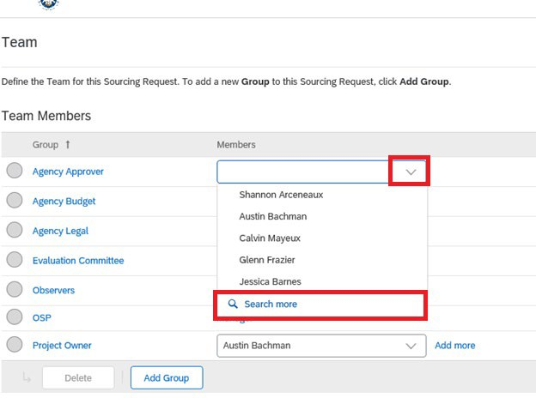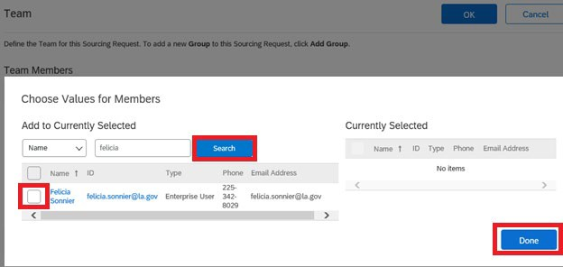

1. Once all Team Members have been added, return to the Tasks tab. Click on the “Add Team Members to Project” task and select “Mark Complete”.

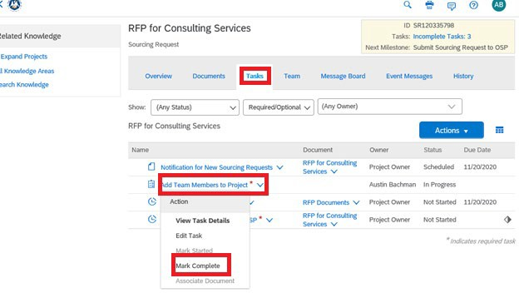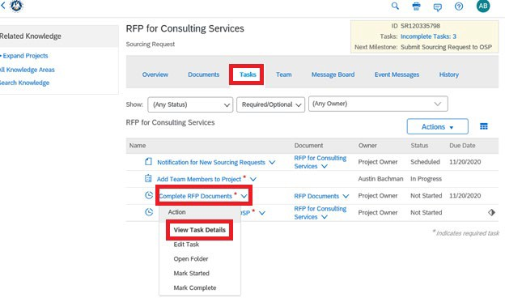

1. Next click on the “Complete RFP Documents” task and select View Task Details.
2. Read the task description. The referenced document templates can be downloaded within the task or from the RFP Documents folder on the Documents tab. Click Cancel to return to the Tasks tab.

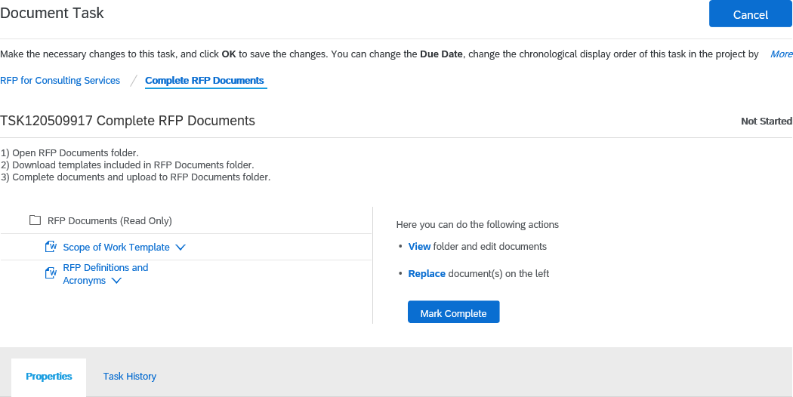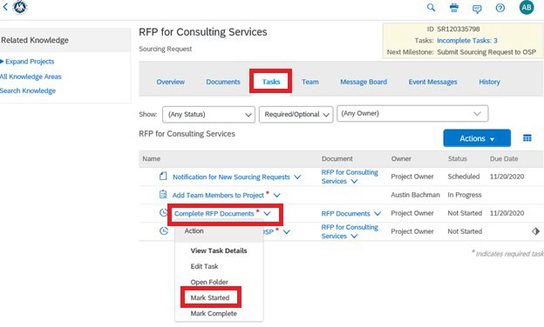

1. Click on the “Complete RFP Documents” task and select Mark Started.
2. Click on the Documents tab. Open the RFP Documents folder by clicking on it. Click on Scope of Work Template and select Download.

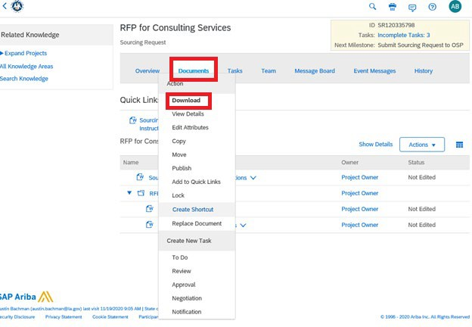

1. Download the remaining documents in the folder using the same process.
2. Complete the Scope of Work Template and the other documents. Once the Scope of Work is complete, return to the Documents tab. Click on Scope of Work Template and select Replace Document.

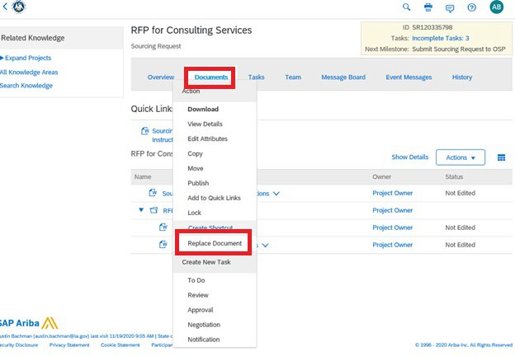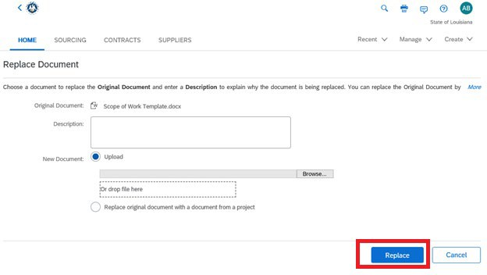

1. The completed Scope of Work can be uploaded by clicking Browse or by dragging and dropping the file into the denoted box. Next click Replace.
2. You should receive a message stating the file you are uploading does not match the file you are trying to replace. Select “Replace document by the uploaded file” and then click OK.

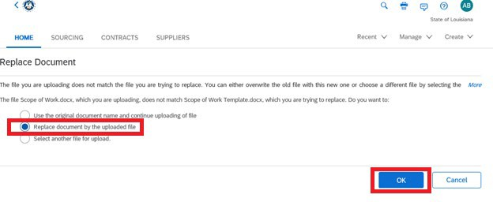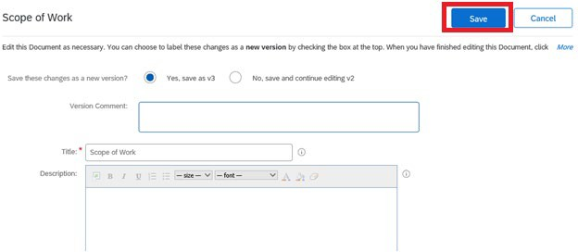

1. On the next screen, click Save.
2. Follow the same process to upload the other documents.
3. Return to the Tasks tab. Click on the Complete RFP Documents task and select Mark Complete.
4. The final task to perform is the “Submit Sourcing Request to OSP” task. This task is an approval task that will route a simultaneous approval to the Team Members designated as Agency Budget and Agency Legal, if applicable. Once the task is approved by Agency Budget and Agency Legal, the approval routes to Agency Approver. Once the Agency Approver approves the task, the Sourcing Request is submitted to OSP. To begin the approval workflow, click on the task and select View Task Details.

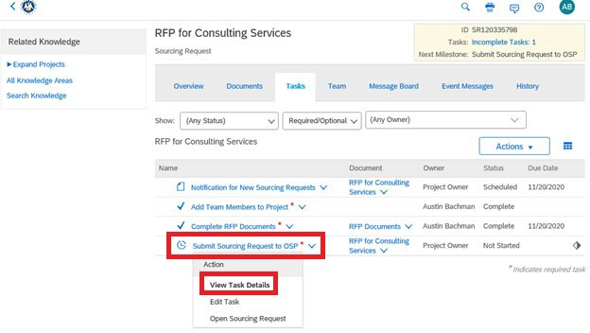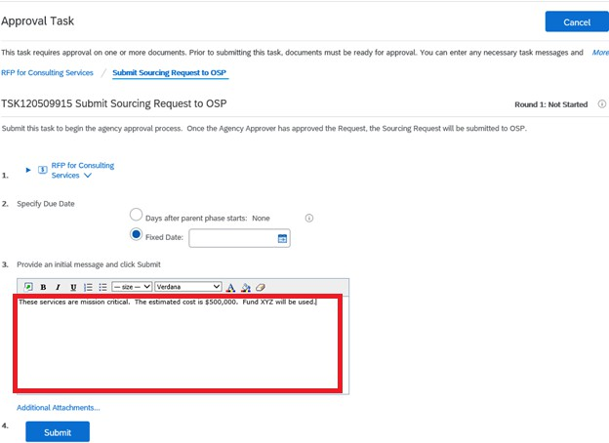

1. An initial message may be entered to provide additional information to the approvers.
2. To view the approvers, scroll to the bottom and click on Approval Flow. The specific approvers may be seen by clicking on each group name.

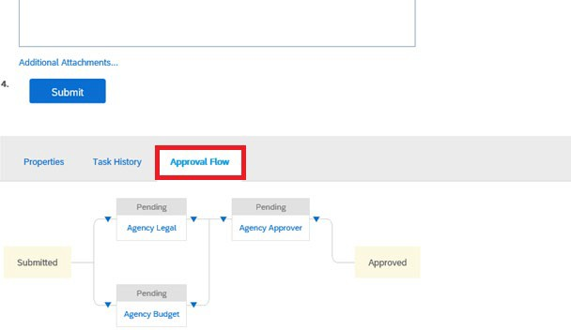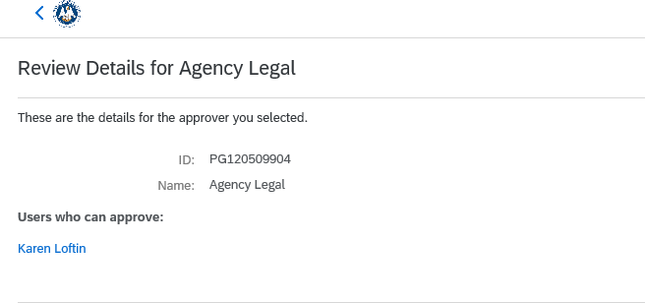

1. If additional approvers need to be added to the workflow, this can be accomplished by clicking the appropriate blue arrow and choosing whether the new approver is a serial approver or parallel approver. A serial approver is sequential whereas a parallel approver receives the approval simultaneously with other approvers.

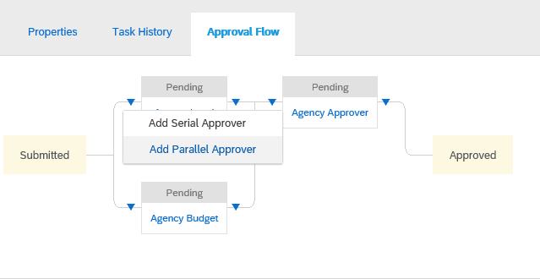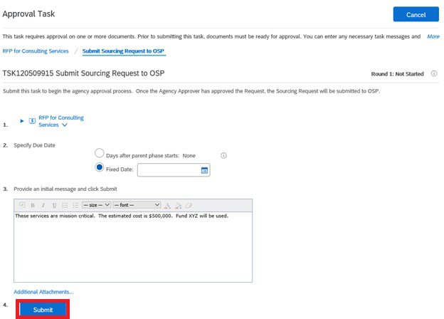

1. To begin the approval flow, click Submit.
2. You can monitor the approval progress by returning to the task and viewing the Approval Flow.

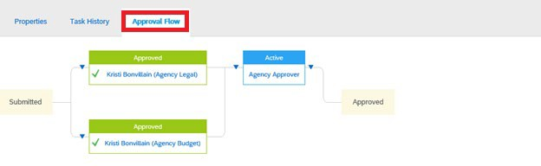

1. When the Agency Approver approves the task, the Sourcing Request is submitted to OSP. It will be assigned to an OSP Analyst who will contact you regarding the next steps.