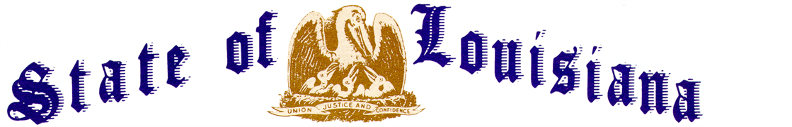
Executive Department
Office of the Governor
Executive Order Number 24-11
__________________________________________________________________________

Actions to Mitigate the State’s Impending Fiscal Cliff
__________________________________________________________________________

WHEREAS, on January 17, 2024, the Five Year Baseline Projection was presented to the Joint Legislative Committee on the Budget documenting the projected revenues based on the adopted Revenue Estimating Conference forecast and the projected expenditures for the current fiscal year and the ensuing four fiscal years.
WHEREAS, the Five Year Baseline Projection is commonly used to determine if the state is expected to have a surplus or deficit in future years.
WHEREAS, the Five Year Baseline Projection shows the incoming administration is facing a ($64,770,901) deficit for Fiscal Year 2024-2025 for which it is responsible for preparing a balanced Governor’s Executive Budget by February 9, 2024.
WHEREAS, the Five Year Baseline Projection also shows a large deficit (commonly called a fiscal cliff) in Fiscal Year 2025-2026 of ($558,784,913), growing to a deficit of ($733,381,780) in Fiscal Year 2027-2028.
WHEREAS, the fiscal cliff in Fiscal Year 2025-2026 is caused by projected revenues decreasing by (3.47%) or ($416,200,000) as compared to projected expenditures increasing by 0.65% or $77,814,012.
WHEREAS, one month after taking office, the new administration will address the Fiscal Year 2024-2025 deficit of ($64,770,901) in the Governor’s Executive Budget presented on February 9, 2024.
WHEREAS, it is advantageous to begin addressing the future fiscal cliffs as early as possible in order to provide a balanced budget for all ensuing fiscal years.

NOW THEREFORE, I, JEFF LANDRY, Governor of the State of Louisiana, by virtue of the authority vested by the Constitution do hereby order and direct as follows:
Section 1: Every department shall review the following areas through the end of the current fiscal year in order to identify savings that can be implemented in Fiscal Year 2024-2025 to begin preparing for the fiscal cliff in Fiscal Year 2025-2026:
  - Review expenditures planned for the remainder of the current fiscal year and identify opportunities for reductions. The savings identified in the current year will result in annualized savings in future fiscal years.
  - Evaluate contracts, especially those that are expiring, to determine if they are necessary to renew or if they can be reduced or terminated going forward.
  - Evaluate staffing and determine where funded vacancies can be eliminated.
  - Evaluate all large acquisitions to determine if there are more cost-effective alternatives or if the acquisition is necessary at all.
  - Review all programs that are not statutorily required to determine if they can be eliminated, reduced, or phased out.
  - Review all activities to identify areas of duplication within the department or across departments.
  - Determine any other discretionary State General Fund spending that can be reduced or eliminated.
  - Determine any other efficiencies that can be implemented to save State General Fund dollars or improve delivery of services without increasing costs.

Section 2: Each department’s November 1, 2024 budget request shall include the savings identified in accordance with Section 1 of this Order.
Section 3: This Order is effective upon signature and shall remain in effect until November 2, 2024.

IN WITNESS WHEREOF, I have set my hand officially and caused to be affixed the Great Seal of Louisiana in the City of Baton Rouge, on this 24th day of January, 2024.

__________________________________________
Jeff Landry
GOVERNOR OF LOUISIANA
ATTEST BY THE
SECRETARY OF STATE

_____________________________________
Nancy Landry
SECRETARY OF STATE

