Executive Summary

AP-05 Executive Summary - 24 CFR 91.200(c), 91.220(b)
1. Introduction
As set forth in 24 CFR Part 91, the U.S. Department of Housing and Urban Development (HUD) requires state agencies which administer certain HUD programs to incorporate their planning and application requirements into one master plan called the Consolidated Plan. In Louisiana, the three state agencies participating in this consolidated planning process and the HUD-funded programs administered by each agency include the Division of Administration/Office of Community Development (Community Development Block Grant Program), the Louisiana Housing Corporation (HOME Investment Partnerships Program, National Housing Trust Fund and Emergency Solutions Grants Program), and the Louisiana Department of Health, Office of Public Health, STD/HIV/Hepatitis Program (State Formula Housing Opportunities for Persons With AIDS (HOPWA) Program).
The Consolidated Plan for the State of Louisiana is in effect from April 1, 2020 – March 31, 2024. The plan was developed through a comprehensive statewide effort that included a needs assessment leveraging existing data, input sessions and surveys, quantitative and qualitative assessments of current consumer housing needs and barriers to services, and consultations with housing and social service agencies, local governments, and other entities. An update or action plan for the distribution of funds received in each of the subsequent four (4) program years is prepared and publicized annually. Presented herein is the State of Louisiana’s FY 2024 Consolidated Annual Action Plan which identifies the method of distribution of FY 2024 funds under the HUD programs. The resulting plan and document will be used to allocate Community Development Block Grant (CDBG), Emergency Solutions Grants (ESG), HOME Investment Partnership (HOME), National Housing Trust Fund (NHTF) and Housing Opportunities for People With AIDS (HOPWA) program funds within the State of Louisiana.
2. Summarize the objectives and outcomes identified in the Plan
This could be a restatement of items or a table listed elsewhere in the plan or a reference to another location. It may also contain any essential items from the housing and homeless needs assessment, the housing market analysis or the strategic plan.

An assessment of the housing and homeless needs of the State of Louisiana is included in the FY 2020 – FY 2024 Consolidated Plan; the needs are substantial and complex. The State of Louisiana is extremely diverse in its racial and ethnic composition. There are numerous areas across the state with concentrated populations, including African American, Hispanic, Asian, and others. In addition, the State has multiple and varying housing and non-housing challenges following Hurricanes Laura and Delta in 2020 and Hurricane Ida in 2021. All three hurricanes; rated as Category 4 storms, proved to be both deadly and destructive. The latest major storm, Hurricane Ida made landfall in August 2021 and impacted thousands of homes throughout the southwestern portion of the State. Although these lingering challenges vary substantially from region to region, the needs assessment and market analysis identified four priority needs:
• Lack of affordable housing
• Lack of housing for special needs populations
• Individuals and families experiencing homelessness
• Barriers to competitive and sustainable communities
The State of Louisiana will utilize these federal resources (CDBG, ESG, HOME, NHTF and HOPWA) and leverage other federal, private and state resources to address these needs by:
• Increasing the number of affordable housing units
• Increasing the number of affordable units for special needs populations
• Decreasing the numbers of individuals and families experiencing homelessness
• Decreasing the number of owner occupied units with housing problems
• Creating competitive and sustainable communities
The State will work with many partners to accomplish these goals. These partners include units of local government, other state and federal agencies, housing developers, CHDOs, nonprofit organizations, and various advocate groups.
As the State continues its efforts with regards to attaining these goals, it will also incorporate other specific strategies to help meet these goals. These include a plan to address the barriers to fair housing, a plan to end homelessness, measures to address lead based paint hazards, and anti-poverty measures.
Please also see the section entitled "AP 20 - Annual Goals and Objectives".
3. Evaluation of past performance
This is an evaluation of past performance that helped lead the grantee to choose its goals or projects.

The information below is for HOME, ESG, CDBG, HOPWA and the National Housing Trust Fund (NHTF) for the 2023 Program Year (April 1, 2023 to March 31, 2024) hereafter referred to as FY 2024.
CDBG: Program regulations require that no less than seventy percent of the aggregate of the fund expenditures shall be for activities that meet the national objective of benefiting low and moderate income persons. The State met this percentage as 79% of the non-administrative funds awarded were used for activities that benefited low and moderate income persons. Overall, the FY 2023 LCDBG monies awarded as of March 31, 2023, benefited 64,610 persons and 56 househoholds received direcct benefit. HUD requests that states annually request funds on their letters of credit in an amount at least equal to its annual grant, and to eventually reach a ratio of the unexpended grant balance (just prior to the receipt of the next grant award) to the most recent annual grant amount of not more than 2.5 and to try to achieve 2.0 or less. The average of the State's ratio of unexpended funds to its grant amount was 2.53. This delay is attributed to the influx of additional federal funds and the supply chain shortage. The Office of Community Development will continue to strive to attain the expenditure goals established by HUD. It is required that each state obligate and award 95% of the non-administrative annual allocation within twelve months of the grant award. Within the twelve-month period, the State had obligated and announced 100% of its non-administrative funds.
HOME: The State affordable housing goals and funding priorities were based on housing needs that are supported by market data. The State continues monitoring the progress of projects that have been funded but not closed and those underway but delayed due to various plausible reasons. The "CR -20" Affordable Housing 91.520 (b) section of the FY 2023 Consolidated Annual Performance and Evaluation Report (CAPER) provides a complete summary of the goals and accomplishments. The referenced section may be viewed at: https://www.doa.la.gov/doa/ocd-lga/lcdbg-ptograms/lcdbg-plans-and-reports/2020-2024/.
HOPWA: The overall housing goal of the State Formula HOPWA Program is to increase the availability and accessibility of appropriate and affordable housing options for persons living with HIV in order to prevent homelessness. This goal is achieved through a mix of community based initiatives in the largely rural areas outside of the New Orleans and Baton Rouge metropolitan areas. A total of 817 HOPWA-eligible individuals were assisted with HOPWA funding during the FY 2023 reporting period; as well as 214 household members- of which at least 15 were also persons living with HIV. As in previous years, the majority of program households (n=504) sought assistance for Short Term Rent, Mortgage and/or Utility assistance (STRMU). There were 215 households that accessed Tenant Based Rental Assistance (TBRA), 0 households accessed transitional/short term units, 26 households accessed permanent facility-based housing support, and 205 households received Permanent Housing Placement (PHP) services.
National Housing Trust Fund: The intent of the National Housing Trust Fund (NHTF) is to increase and preserve the supply of decent, safe, sanitary, and affordable housing, primarily rental housing, for extremely low-income and very low-income households. During the FY 2023 program year, a combined total of $13,462,741 in NHTF funds were awarded to eleven (11) proposed projects leveraging an additional $145,013,224 in other resources; total proposed units - 671; NHTF set-aside units - 66.
4. Summary of Citizen Participation Process and consultation process
Summary from citizen participation section of plan.

CDBG:
The State held a virtual/In-person public hearing on June 6, 2023 for the purpose of obtaining views on community development and housing needs throughout the state. A notice of the hearing was published in the May 19, 2023 issue of The Advocate. Written invitations were mailed to all interested parties for all four programs. No one was in attendance at the public hearing. Comments could be submitted through June 21, 2023, but none were received. Following the public hearing and comment period, the proposed FY 2024 Consolidated Annual Action Plan was drafted.
Consultations:
CDBG - The Office of Community Development surveyed all potential applicants for LCDBG throughout the State. The survey gathered information regarding community and parish priorities and perceived needs. The anticipated outcomes of the survey are: a) prioritization of LCDBG basic eligible activities, b) prioritization of public facilities (infrastructure) projects, c) prioritization of fund distribution by program category, d) maximum grant amounts needed by type of project, e) amount to be allowed for local administrative costs, and f) suggestions for improving the LCDBG program. Also, a public hearing was held and followed by a comment period to receive additional input.
CDBG, HOME, National Housing Trust Fund, HOPWA and ESG - A FY 2024 Consolidated Annual Action Plan Input Session was held on June 6, 2023. Public notices regarding citizen participation and comments were sent to the following participants:
- Private and public housing providers
- Homeless service and prevention providers
- Nonprofit and government service providers
- Advocates
The input sessions focused on gathering feedback on priorities and strategies to address the homelessness, housing and community development needs in the State.
In addition to the efforts noted above, the biennial statewide needs assessment survey was administered to low income persons living with HIV during the summer of 2021 to document the needs (met and unmet) of this population in order to assist with planning for both State Formula HOPWA- and Ryan White-funded services. A copy of this final report available here: https://ldh.la.gov/assets/oph/HIVSTD/2021-PLWH-Needs-Assessments/PLWH_Statewide_NeedsAssessmentReport_22Sept26.pdf . An update of this assessment survey, which will inform future services planning, is in progress.
NHTF: The state held a public hearing on June 6, 2023 in conjunction with the FY 2022 CAPER and FY 2024 Annual Action Plan to solicit comment regarding the development of the FY 2023 National Housing Trust Fund Allocation Plan. The final plan summary was emailed to all known interested parties and the summary was published in the major newspapers of the state on May 19, 2023. A summary of the Citizen Participation Process and consultation is included in this plan.
Upon completion of the proposed Action Plan, which included actual FY 2024 allocations, a notice was published in The Advocate on June 3, 2024, allowing for a 30-day comment period from June 3, 2024 through July 3,2024.
5. Summary of public comments
This could be a brief narrative summary or reference an attached document from the Citizen Participation section of the Con Plan.

No comments were received for CDBG, HOME, HTF, ESG, or HOPWA.
In addition to the efforts to obtain public comments, the biennial statewide needs assessment survey was administered to low income persons living with HIV during the summer of 2021 to document the needs (met and unmet) of this population in order to assist with planning for both State Formula HOPWA- and Ryan White-funded services. A copy of this final report available here: https://ldh.la.gov/assets/oph/HIVSTD/2021-PLWH-Needs-Assessments/PLWH_Statewide_NeedsAssessmentReport_22Sept26.pdf . An update of this assessment survey, which will inform future services planning, is in progress.
6. Summary of comments or views not accepted and the reasons for not accepting them

There were no comments specific to State Formula HOME, HTF, HOPWA, CDBG or ESG.
7. Summary
Based on the State's past performance, experience of staff, citizen participation and consultation input from all interested parties, the State of Louisiana has drafted the proposed FY 2024 Annual Action Plan.

PR-05 Lead & Responsible Agencies - 91.300(b)
1. Agency/entity responsible for preparing/administering the Consolidated Plan
The following are the agencies/entities responsible for preparing the Consolidated Plan and those responsible for administration of each grant program and funding source.
Agency Role | Name | Department/Agency
Lead Agency | LOUISIANA

CDBG Administrator | LOUISIANA | DOA, Office of Community Development
HOPWA Administrator | LOUISIANA | LDH, OPH, STD/HIV/Hepatitis Program
HOME Administrator | LOUISIANA | Louisiana Housing Corporation
ESG Administrator | LOUISIANA | Louisiana Housing Corporation
HOPWA-C Administrator
 | LOUISIANA | Louisiana Housing Corporation
Table 1 – Responsible Agencies

Narrative
The three state agencies participating in the consolidated planning process and the HUD-funded programs administered by each include the Division of Administration/Office of Community Development-Local Government Assistance, the Louisiana Housing Corporation (HOME Investment Partnerships, National Housing Trust Fund and Emergency Solutions Grant Programs), and the Louisiana Department of Health (LDH)/Office of Public Health (OPH) STD/HIV/Hepatitis Program (SHHP) Housing Opportunities for Persons With AIDS (HOPWA) program. The lead agency for the Consolidated Planning Process and the Consolidated Plan is the State of Louisiana's Division of Administration/Office of Community Development.
The primary objective of the Louisiana Community Development Block Grant (LCDBG) Program is to provide assistance to units of general local government in non-entitlement areas for the development of viable communities by providing a suitable living environment and expanding economic opportunities, principally for persons of low and moderate income. The HOME Program objectives are: to expand the supply of decent and affordable housing for low and very low income persons, to stabilize the existing deteriorating homeowner occupied and rental housing stock through rehabilitation, to provide financial and technical assistance to recipients/sub-recipients (including the development of model programs for affordable low income housing), to extend and strengthen partnerships among all levels of government and the private sector (including for-profit and nonprofit organizations) in the production and operation of affordable housing). The intent of the National Housing Trust Fund is to increase and preserve the supply of decent, safe, sanitary, and affordable housing, primarily rental housing, for extremely low-income and very low-income households. The purpose of the Emergency Solutions Grants (ESG) Program is to help local governments and community organizations to improve and expand shelter facilities serving homeless individuals and families, to meet the costs of operating homeless shelters, to provide essential services, and to perform homeless prevention and rapid re-housing activities. The purpose of the Housing Opportunities for Persons with AIDS (HOPWA) Program is to provide localities with the resources and incentives to devise and implement long term comprehensive strategies to provide housing assistance and related supportive services for low income people living with HIV and their families. Unstable housing and homelessness decrease the ability of persons living with HIV to achieve or maintain viral suppression, and leads to suboptimal health outcomes for the client as well as increased opportunities for HIV transmission to potential partners.
Consolidated Plan Public Contact Information
CDBG: Division of Administration, Office of Community Development (Lead Agency)
Traci Watts
P.O. Box 94095
Baton Rouge, LA 70804-9095
traci.watts@la.gov
HOME and NHTF: Louisiana Housing Corporation
Brenda L. Evans
2415 Quail Dr.
Baton Rouge, LA 70808
bevans@lhc.la.gov
ESG: Louisiana Housing Corporation
Winona Connor
2415 Quail Dr
Baton Rouge, LA 70808
wconnor@lhc.la.gov
State Formula HOPWA: Louisiana Department of Health (LDH), Office of Public Health (OPH) - STD/HIV/Hepatitis Program (SHHP)
Erika Sugimori, Services Manager
1450 Poydras Street, Suite 2136
New Orleans, LA 70112
erika.sugimori@la.gov

AP-10 Consultation - 91.110, 91.300(b); 91.315(l)
1. Introduction
CDBG - The Office of Community Development surveyed all potential applicants for LCDBG throughout the State. The survey gathered information regarding community and parish priorities and perceived needs. The anticipated outcomes of the survey are: a) prioritization of LCDBG basic eligible activities, b) prioritization of public facilities (infrastructure) projects, c) prioritization of fund distribution by program category, d) maximum grant amounts needed by type of project, e) amount to be allowed for local administrative costs, and f) suggestions for improving the LCDBG program. Also, a public hearing was held, followed by a comment period to receive additional input. No other comments were received.
State Formula HOPWA - The Office of Public Health within the Louisiana Department of Health (LDH) partners with community-based organizations and clinical providers that offer medical care and supportive services to persons living with, or at risk of acquiring HIV. These groups assist in the development of the Statewide Coordinated Statement of Need (SCSN) and the Louisiana HIV Strategy for Integrated Prevention and Care, which allows input regarding the allocation of all resources of funding. Additionally, the State conducts a Needs Assessment survey of people living with HIV every two years to assess their met and unmet needs related to housing, medical care, and supportive services.
HOME and NHTF - The state, through a cooperative endeavor agreement between the Louisiana Housing Corporation (LHC) and the Louisiana State University Public Administration Institute, conducted a statewide housing needs assessment. Phase one of the housing needs assessment may be viewed at: http://www.lhc.la.gov/assets/docs/HousingNeedsAssessmentReduced.pdf. The anticipated outcomes are: a) an assessment of various housing and community development needs, b) prioritization of the distribution of HOME and NHTF funds according to the identified housing needs and eligible program activities, c) suggestions for improving the HOME and NHTF programs.
The state also conducts monthly meeting through the LHC regarding housing programs and activities that are widely publicized and open to the public in addition to participation in community meetings and forums. The state provided technical workshops for developers, nonprofit entities, commercial lending institutions, public housing authorities, and local governments in order that those entities would have opportunities to provide dialogue and data that are useful in assessing and prioritizing the housing, homeless and community development needs of the state. A public hearing was also held in Baton Rouge on June 6, 2023 and followed by a comment period to receive additional input. All required agency types were contacted.
Provide a concise summary of the state's activities to enhance coordination between public and assisted housing providers and private and governmental health, mental health and service agencies
State Formula HOPWA - The Office of Public Health STD/HIV/Hepatitis Program does not work with units of local government. Instead, project sponsors demonstrating an ability to address the housing needs of low income persons living with HIV are selected during a competitive Request for Proposals (RFP) process. The successful proposers (i.e., project sponsors) are contractually required to develop both formal and informal collaborations with other housing providers in their jurisdiction, as well as private and government-funded community partners that provide medical, housing, mental health and supportive services to address the clients' needs and assist the eligible program participants to access and be maintained in HIV-related medical care.
Describe coordination with the Continuum of Care and efforts to address the needs of homeless persons (particularly chronically homeless individuals and families, families with children, veterans, and unaccompanied youth) and persons at risk of homelessness
The State coordinates with the CoCs when determining how to allocate ESGP funding. The State consults with each CoC in regards to making funding decisions, to review the local homeless needs of each region, and to ensure funding is used to provide services to the most vulnerable individuals/ families experiencing homelessness.
Describe consultation with the Continuum(s) of Care that serves the State in determining how to allocate ESG funds, develop performance standards for and evaluate outcomes of projects and activities assisted by ESG funds, and develop funding, policies and procedures for the operation and administration of HMIS
ESG coordinates with the LA BOSCOC and other Reginoal CoCs in implementing HMIS, determining resource needs and utilizing that input in resource allocation decisions, supporting ESG funded projects in abiding by the CoC’s Written standards (which were written in collaboration with the ESG lead), leveraging resources in disaster impacted areas in conjunction with local governments, ESG Housing Projects for Cat1 and 4 PEH participate in Coordinated Entry.
2. Agencies, groups, organizations and others who participated in the process and consultations

Table 2 – Agencies, groups, organizations who participated
1 | Agency/Group/Organization | Non-Entitlement Cities, Towns, & Villages
 | Agency/Group/Organization Type | Other government - Local
 | What section of the Plan was addressed by Consultation? | Economic Development  Community Development
 | Briefly describe how the Agency/Group/Organization was consulted. What are the anticipated outcomes of the consultation or areas for improved coordination? | LCDBG surveyed all potential applicants for LCDBG throughout the State. The survey gathered information regarding community and parish priorities andperceived needs. The anticipated outcomes of the survey are: a) prioritization of LCDBG basic eligible activities, b) prioritization of public facilities (infrastructure) projects, c) prioritization of fund distribution by program category, d) maximum grant amounts needed by type of project, e) amount to be allowed for local administrative costs, and f) suggestions for improving the LCDBG program. Also, a public hearing was held, followed by a comment period to receive additional input.
2 | Agency/Group/Organization | Non-Entitlement Parishes
 | Agency/Group/Organization Type | Other government - Local
 | What section of the Plan was addressed by Consultation? | Economic Development  Community Development
 | Briefly describe how the Agency/Group/Organization was consulted. What are the anticipated outcomes of the consultation or areas for improved coordination? | LCDBG surveyed all potential applicants for LCDBG throughout the State. The survey gathered information regarding community and parish priorities andperceived needs. The anticipated outcomes of the survey are: a) prioritization of LCDBG basic eligible activities, b) prioritization of public facilities (infrastructure) projects, c) prioritization of fund distribution by program category, d) maximum grant amounts needed by type of project, e) amount to be allowed for local administrative costs, and f) suggestions for improving the LCDBG program. Also, a public hearing was held, followed by a comment period to receive additional input.
3 | Agency/Group/Organization | Central Louisiana Homeless Coalition
 | Agency/Group/Organization Type | Housing  Services - Housing  Agency - Managing Flood Prone Areas  Regional organization
 | What section of the Plan was addressed by Consultation? | Housing Need Assessment  Public Housing Needs  Homeless Needs - Chronically homeless  Homeless Needs - Families with children  Homelessness Needs - Veterans  Homelessness Needs - Unaccompanied youth  Homelessness Strategy
 | Briefly describe how the Agency/Group/Organization was consulted. What are the anticipated outcomes of the consultation or areas for improved coordination? | Housing needs assessment for individuals/ families
4 | Agency/Group/Organization | Balance of State Continuum of Care
 | Agency/Group/Organization Type | Housing  Services - Housing  Regional organization  Planning organization
 | What section of the Plan was addressed by Consultation? | Housing Need Assessment  Public Housing Needs  Homeless Needs - Chronically homeless  Homeless Needs - Families with children  Homelessness Needs - Veterans  Homelessness Needs - Unaccompanied youth  Homelessness Strategy
 | Briefly describe how the Agency/Group/Organization was consulted. What are the anticipated outcomes of the consultation or areas for improved coordination? | Housing needs assessment for individuals/ families.
5 | Agency/Group/Organization | NORTHLAKE HOMELESS COALITION
 | Agency/Group/Organization Type | Housing  Services - Housing  Regional organization
 | What section of the Plan was addressed by Consultation? | Housing Need Assessment  Public Housing Needs  Homeless Needs - Chronically homeless  Homeless Needs - Families with children  Homelessness Needs - Veterans  Homelessness Needs - Unaccompanied youth
 | Briefly describe how the Agency/Group/Organization was consulted. What are the anticipated outcomes of the consultation or areas for improved coordination? | Housing needs assessment for individuals/ families.
6 | Agency/Group/Organization | Unity of Greater New Orleans
 | Agency/Group/Organization Type | Housing  Services - Housing  Regional organization
 | What section of the Plan was addressed by Consultation? | Housing Need Assessment  Public Housing Needs  Homeless Needs - Chronically homeless  Homeless Needs - Families with children  Homelessness Needs - Veterans  Homelessness Needs - Unaccompanied youth  Homelessness Strategy
 | Briefly describe how the Agency/Group/Organization was consulted. What are the anticipated outcomes of the consultation or areas for improved coordination? | Housing needs assessment for individuals/ families.
7 | Agency/Group/Organization | HOPE Connections
 | Agency/Group/Organization Type | Housing  Services - Housing  Regional organization
 | What section of the Plan was addressed by Consultation? | Housing Need Assessment  Public Housing Needs  Homeless Needs - Chronically homeless  Homeless Needs - Families with children  Homelessness Needs - Veterans  Homelessness Needs - Unaccompanied youth  Homelessness Strategy
 | Briefly describe how the Agency/Group/Organization was consulted. What are the anticipated outcomes of the consultation or areas for improved coordination? | Housing needs assessment for individuals/ families.
8 | Agency/Group/Organization | HOME Coalition
 | Agency/Group/Organization Type | Housing  Services - Housing  Regional organization
 | What section of the Plan was addressed by Consultation? | Housing Need Assessment  Public Housing Needs  Homeless Needs - Chronically homeless  Homeless Needs - Families with children  Homelessness Needs - Veterans  Homelessness Needs - Unaccompanied youth  Homelessness Strategy
 | Briefly describe how the Agency/Group/Organization was consulted. What are the anticipated outcomes of the consultation or areas for improved coordination? | Housing needs assessment for individuals/ families.

Identify any Agency Types not consulted and provide rationale for not consulting
CDBG - Local governments (entitlements) that are not eligible for LCDBG funding were not contacted. LCDBG focused on the priorities and perceived needs of those local units of government eligible to receive its funding.

Other local/regional/state/federal planning efforts considered when preparing the Plan
Name of Plan | Lead Organization | How do the goals of your Strategic Plan overlap with the goals of each plan?
Continuum of Care | Louisiana Housing Corporation | The State partners with each Continuum of Care (Unity of Greater New Orleans, ARCH, Hope Connections, HOME Coalition, Northlake Homeless Coalition, LA BOSCOC and Central LA) to determine goals to address homelessness in Louisiana. Through collaborative efforts funding sources are identified and resources are aligned.
Table 3 - Other local / regional / federal planning efforts

Narrative

AP-12 Participation - 91.115, 91.300(c)
1. Summary of citizen participation process/Efforts made to broaden citizen participation
Summarize citizen participation process and how it impacted goal-setting

The State held a public hearing on June 6, 2023 for the purpose of obtaining views on community development and housing needs throughout the state. A notice of the hearing was published in the May 19, 2023 issue of The Advocate. Comments could be submitted through June 21, 2023, but none were received. Following the public hearing and comment period, the proposed FY 2024 Consolidated Annual Action Plan was drafted. A notice of the availability of the proposed plan was published in The Advocate. A memorandum announcing the availability of the proposed plan was sent to interested parties for the programs. Copies of the proposed plan could be reviewed in the offices of any of the three state agencies involved. The proposed plan has also been available for viewing and copying on the internet. No comments were received.

Citizen Participation Outreach
Sort Order | Mode of Outreach | Target of Outreach | Summary of  response/attendance | Summary of  comments received | Summary of comments not accepted and reasons | URL (If applicable)
1 | Newspaper Ad | Non-targeted/broad community | No comments were received as a result of the newspaper advertisement. | No comments were received as a result of the newspaper advertisement. | Not applicable
2 | Public Hearing | Non-targeted/broad community | no attendees | No comments were received as a result of the newspaper advertisement. | Not applicable
3 | Memorandum | Non-targeted/broad community | No attendees | No comments were received as a result of the newspaper advertisement. | Not applicable
4 | Internet Outreach | Non-targeted/broad community | No attendees | No comments were received as a result of the newspaper advertisement. | Not applicable | https://www.facebook.com/search/top?q=louisiana%20office%20of%20community%20development%20-%20local...
Table 4 – Citizen Participation Outreach

Expected Resources

AP-15 Expected Resources – 91.320(c)(1,2)
Introduction
The FY 2024 funding allocations for each program area are as follows: Community Development Block Grant Program (CDBG) $22,499,042, HOME Investment Partnerships Program - $9,401,383, National Housing Trust Fund (NHTF) - $3,144,833, Emergency Solutions Grants (ESG) Program - $2,613,163, and Housing Opportunities for Persons with AIDS (HOPWA) Program - $3,526,968.
The primary needs of the State which are addressed by these HUD-funded programs are infrastructure, housing and tenant based rental assistance. The majority of the CDBG funds address infrastructure and other community development needs. The primary focus of the other programs is in the area of housing.
Anticipated Resources
Program | Source of Funds | Uses of Funds | Expected Amount Available Year 1 |  |  |  | Expected Amount Available Remainder of ConPlan  $ | Narrative Description
 |  |  | Annual Allocation: $ | Program Income: $ | Prior Year Resources: $ | Total:  $
CDBG | public - federal | Acquisition  Admin and Planning  Economic Development  Housing  Public Improvements  Public Services | 22,499,042 | 25,002 | 2,709,017 | 25,233,061 | 0 | These funds will be allocated to theClearanceProgram, Make a Difference Program, Economic Development, and The Public Facilities Program.Street, Water, and Sewer projects are the priority for FY 2024.
HOME | public - federal | Acquisition  Homebuyer assistance  Homeowner rehab  Multifamily rental new construction  Multifamily rental rehab  New construction for ownership  TBRA | 9,401,383 | 1,798,405 | 0 | 11,199,788 | 0 | HOME funds may be allocated according to eligible uses of funds and may be combined or leveraged with other sources of funds to make housing more affordable for low-income households. Unexpended funds from completed activities may be allocated to other eligible priorities.
HOPWA | public - federal | Permanent housing in facilities  Permanent housing placement  Short term or transitional housing facilities  STRMU  Supportive services  TBRA | 3,602,051 | 0 | 0 | 3,602,051 | 7,000,000 | HOPWA funds will be allocated according to eligible use of funds to increase availability and accessibility of appropriate and affordable housing options for people living with HIV in order to prevent homelessness and promote housing stability. Unexpended funds may be allocated to other eligible priorities determined by assessment of need.
ESG | public - federal | Conversion and rehab for transitional housing  Financial Assistance  Overnight shelter  Rapid re-housing (rental assistance)  Rental Assistance  Services  Transitional housing | 2,613,163 | 0 | 0 | 2,613,163 | 0 | The ESG funding will be allocated statewide in accordance with local, state, and federal guidelines.
HTF | public - federal | Acquisition  Admin and Planning  Homebuyer assistance  Multifamily rental new construction  Multifamily rental rehab  New construction for ownership | 3,144,833 | 0 | 0 | 3,144,833 | 0 | The minimum funding amount is $3,000,000 annually. These funds may be allocated according to eligible uses of funds and may be combined or leveraged with other sources of funds to make housing more affordable for low-income households. Unexpended funds from completed activities may be allocated to other eligible priorities.
Table 1 - Expected Resources – Priority Table

Explain how federal funds will leverage those additional resources (private, state and local funds), including a description of how matching requirements will be satisfied
CDBG: While a match is not required for LCDBG, funds available through LCDBG are leveraged with other federal, state and local government funds. The additional funds are primarily used for administration and planning of projects, property acquisition and a portion of project construction costs.
ESG: The Louisiana Housing Corporation requires all ESG funded programs to secure matching funds in an amount at least equal to its ESGP grant amount. All programs must compile and document the match requirements per the HUD regulations 24 CFR 85.24.
HOME: Funds available through the HOME Program are usually leveraged with the resources from commercial lenders, cooperative, or other private lenders to make housing more affordable for low-income households. Specifically, the Louisiana Housing Corporation is able to leverage HOME Funds with the Department of Energy Weatherization funds, Mortgage Revenue Bonds, National Housing Trust Funds and Low-Income Housing Tax-Credits. Other resources made available through other governmental agencies and private nonprofit organizations should leverage additional resources to support the integration of supportive services. The State will support funding applications by any other entity which will assist in the delivery of housing and housing support services. The Louisiana Housing Corporation will fulfill the HOME Program requirement of a matching contribution relative to its drawn amount of HOME Program funds through the following sources:
- Cash or cash equivalents from a non-federal source;
- Value of waived taxes, fees or charges associated with HOME projects;
- The present value of interest reductions of below-market-rate loans, where a project also receives HOME assistance;
- State general revenue funds that are contributed to housing projects assisted with HOME funds and meet the HOME affordability requirements;
- Value of donated land and real property;
- Cost of infrastructure improvements associated with HOME projects;
- A percentage of the proceeds of single- or multi-family housing bonds issued by state, state instrumentality or local government;
- Value of donated materials, equipment, labor and professional services;
- Sweat equity;
- Direct costs of supportive services to residents of HOME projects;
- Direct cost of homebuyer counseling to families purchasing homes with HOME assistance; and
- Any other match contribution as specified in 24 CFR 92.220.
Additionally, the State will continue to carry forward excess match credit to the next federal fiscal year.
National Housing Trust Fund (NHTF): NHTF may be leveraged with resources from commercial lenders, cooperative, other private lenders, HOME funds, Mortgage Revenue Bonds, and Low-Income Housing Tax-Credits. Other resources through the Department of Children and Family Services, Louisiana Department of Health and private nonprofit organizations should leverage additional resources to support the integration of supportive services. The State will support funding applications by any other entity which will assist in the delivery of housing and housing support services.
The statute does not have a match requirement for NHTF. The statute does include as one priority factor that states and sub-grantees should consider the extent to which a project will make use of non-federal funding when allocating NHTF dollars.

If appropriate, describe publically owned land or property located within the jurisdiction that may be used to address the needs identified in the plan
The Louisiana Housing Corporation "Louisiana Housing Conference" held September 24-26, 2023 brought together housing professionals from all over the state and across the nation to discussion various issues related to the provision of affordable housing. The state anticipates continuing its efforts in engaging all interested parties regarding public owned land or property located within the state. The State is committed to assisting local governments in returning properties acquired through the adjudication processes back to the market as affordable housing when determined to be feasible and viable.
Discussion

Annual Goals and Objectives
AP-20 Annual Goals and Objectives – 91.320(c)(3)&(e)
Goals Summary Information
Sort Order | Goal Name | Start Year | End Year | Category | Geographic Area | Needs Addressed | Funding | Goal Outcome Indicator
1 | Rental Assistance | 2020 | 2024 | Affordable Housing  Homeless  Non-Homeless Special Needs | HOPWA-State of Louisiana  HOME-State of Louisiana | Homeless Prevention and Rapid Rehousing  Rental Assistance | HOPWA: $2,186,720  HOME: $125,000 | Tenant-based rental assistance / Rapid Rehousing: 900 Households Assisted  Homelessness Prevention: 250 Persons Assisted  HIV/AIDS Housing Operations: 18 Household Housing Unit
2 | Planning | 2020 | 2024 | Non-Housing Community Development | CDBG-State of Louisiana  HOPWA-State of Louisiana  HOME-State of Louisiana  National Housing Trust Fund - State of Louisiana | Affordable Housing Development  Homeowner Housing Rehabilitation  Homebuyer Assistance  Rental Assistance  Planning | HOME: $1,119,978  HTF: $314,483
3 | Public Facilities-New Infrastructure | 2020 | 2024 | Non-Housing Community Development | CDBG-State of Louisiana | Public Facilities Infrastructure Projects | CDBG: $27,204,071
4 | PF - Existing Infrastructure/Service Connections | 2020 | 2024 | Non-Homeless Special Needs  Non-Housing Community Development | CDBG-State of Louisiana | Public Facilities Infrastructure Projects | CDBG: $10,000,000
5 | ED - New Business | 2020 | 2024 | Non-Housing Community Development | CDBG-State of Louisiana | Economic Development | CDBG: $1,000,000
6 | ED - Local Government Loan to Business | 2020 | 2024 | Non-Housing Community Development | CDBG-State of Louisiana | Economic Development
7 | ED - Existing Business | 2020 | 2024 | Non-Housing Community Development | CDBG-State of Louisiana | Economic Development | CDBG: $1,000,000
8 | Affordable Housing Development | 2020 | 2024 | Affordable Housing | CDBG-State of Louisiana  HOPWA-State of Louisiana  HOME-State of Louisiana  National Housing Trust Fund - State of Louisiana | Affordable Housing Development  Homeowner Housing Rehabilitation  Homebuyer Assistance  Rental Assistance | CDBG: $1,000,000  HOPWA: $423,236  HOME: $9,609,741  HTF: $2,830,349 | Rental units constructed: 9 Household Housing Unit  Rental units rehabilitated: 9 Household Housing Unit  Homeowner Housing Added: 22 Household Housing Unit  Homeowner Housing Rehabilitated: 20 Household Housing Unit  Direct Financial Assistance to Homebuyers: 10 Households Assisted  Tenant-based rental assistance / Rapid Rehousing: 913 Households Assisted  Housing for People with HIV/AIDS added: 15 Household Housing Unit
9 | Homeless Prevention and Rapid Rehousing | 2020 | 2024 | Homeless  Non-Homeless Special Needs | HOPWA-State of Louisiana  ESG-State of Louisiana | Homeless Prevention and Rapid Rehousing | HOPWA: $811,202  ESG: $584,040 | Homelessness Prevention: 2400 Persons Assisted
10 | Street Outreach | 2020 | 2024 | Homeless | ESG-State of Louisiana | Homeless Street Outreach | ESG: $117,330 | Other: 15000 Other
11 | Homeless Shelters | 2020 | 2024 | Homeless | ESG-State of Louisiana | Homeless Shelters | ESG: $1,124,965 | Homeless Person Overnight Shelter: 10000 Persons Assisted
12 | HMIS Reporting | 2020 | 2024 | Homeless | ESG-State of Louisiana |  | ESG: $100,000 | Other: 3000 Other
13 | Clearance/ Demolition | 2023 | 2025 | Non-Housing Community Development | CDBG-State of Louisiana | Clearance/ Demolition | CDBG: $6,000,000
Table 2 – Goals Summary

Goal Descriptions

1 | Goal Name | Rental Assistance
 | Goal Description | HOPWA Housing Assistance: The State Formula HOPWA Grantee oversees the provision of Tenant Based Rental Assistance (TBRA), Short Term Rent/Mortgage/Utility assistance (STRMU), Permanent Housing Placement services (PHP), and Facility Based Housing Assistance (FBHA) to low income persons living with HIV who reside in parishes outside of the New Orleans and Baton Rouge MSAs. During the FY 2024 program year, it is anticipated that two hundred fifty-six (256) households will be assisted with Tenant Based Rental Assistance; and eighteen (18) households will be assisted with Permanent Facility Based Housing Assistance including operations costs. It is projected six hundred fifteen (615) households will be assisted with Short Term Rent/Mortgage/Utility assistance in order to prevent homelessness; and, two hundred sixty-one (261) households will receive assistance establishing permanent housing through Permanent Housing Placement services. During the FY 2024 program year the Grantee will begin to fund HOPWA Supportive Services in the form of Housing-Based Case Management to ensure the housing stability of HOPWA clients through utilization of low barrier principles, including: trauma-informed care, motivational interviewing, harm reduction, and housing first; the goal is for seven hundred thirty-four (734) households to utilize this service.  HOME: Tenant Based Rental Assistance (TBRA) is an essential element of the State's consolidated plan. During the FY 2024 program year, it is anticipated that at least ten (10) households will be assisted with HOME funds in conjunction with the Tenant-based rental assistance / Rapid Rehousing efforts.
2 | Goal Name | Planning
 | Goal Description | HOPWA Resource Identification is broad and flexible. Resource Identification (RI) involves planning and related systems-level capacity building activities to develop and enhance community housing resources for persons living with HIV.
3 | Goal Name | Public Facilities-New Infrastructure
 | Goal Description | Public Facility or Infrastructure Activities other than Low/Moderate Income Housing Benefit: 500 Persons Assisted
4 | Goal Name | PF - Existing Infrastructure/Service Connections
 | Goal Description
5 | Goal Name | ED - New Business
 | Goal Description
6 | Goal Name | ED - Local Government Loan to Business
 | Goal Description
7 | Goal Name | ED - Existing Business
 | Goal Description
8 | Goal Name | Affordable Housing Development
 | Goal Description
9 | Goal Name | Homeless Prevention and Rapid Rehousing
 | Goal Description
10 | Goal Name | Street Outreach
 | Goal Description
11 | Goal Name | Homeless Shelters
 | Goal Description
12 | Goal Name | HMIS Reporting
 | Goal Description
13 | Goal Name | Clearance/ Demolition
 | Goal Description | Clearance grants will be awarded to eligible applicants for clearance/demolition activities based on a competitive selection process to the extent that the funds are available.

AP-25 Allocation Priorities – 91.320(d)
Introduction:
The primary needs of the State which are addressed by these HUD-funded programs are infrastructure and housing.
Funding Allocation Priorities
 | Rental Assistance (%) | Planning (%) | Public Facilities-New Infrastructure (%) | PF - Existing Infrastructure/Service Connections (%) | ED - New Business (%) | ED - Local Government Loan to Business (%) | ED - Existing Business (%) | Affordable Housing Development (%) | Homeless Prevention and Rapid Rehousing (%) | Street Outreach (%) | Homeless Shelters (%) | HMIS Reporting (%) | Clearance/ Demolition (%) | Total (%)
CDBG | 0 | 0 | 12 | 59 | 1 | 0 | 1 | 1 | 0 | 0 | 0 | 0 | 26 | 100
HOME | 90 | 10 | 0 | 0 | 0 | 0 | 0 | 0 | 0 | 0 | 0 | 0 | 0 | 100
HOPWA | 69 | 0 | 0 | 0 | 0 | 0 | 0 | 3 | 28 | 0 | 0 | 0 | 0 | 100
ESG | 0 | 0 | 0 | 0 | 0 | 0 | 0 | 0 | 35 | 5 | 40 | 20 | 0 | 100
HTF | 90 | 10 | 0 | 0 | 0 | 0 | 0 | 0 | 0 | 0 | 0 | 0 | 0 | 100
Table 3 – Funding Allocation Priorities

Reason for Allocation Priorities
State Formula HOPWA: In order to promote housing stability and prevent homelessness of low income persons living with HIV, the STD/HIV/Hepatitis Program has allocated all of the program resources to Tenant Based Rental Assistance (TBRA), Short Term Rent/Mortgage/Utility assistance (STRMU), Facility Based Housing Assistance and Development (FBHSA), Permanent Housing Placement services (PHP) in order to place eligible clients in appropriate and affordable rental housing, Resource Identification (RI) to build capacity for additional access to rental housing, and HOPWA Supportive Services: Housing-Based Case Management to ensure the housing stability of HOPWA clients.
CDBG: In order to determine the non-housing community development needs of the non-entitlement units of general local government, the State conducts a Needs Assessment in the form of a survey. The survey forms are distributed by mail, email, and in-person to local governments eligible for funding under the CDBG program. In the State's LCDBG Survey, the respondents were asked to identify the priorities of their jurisdictions regarding the following specific activities: Sewer treatment, sewer collection, potable water, streets/drainage, water for fire protection, natural gas, drainage, parks, bridges, and solid waste. The Make a Difference program, allows local governments to complete any eligible CDBG activity as defined by HUD, helping communities identify individual needs outside of the identified needs of the state as a whole. Through the survey and conducting listening sessions throughout the state, it has been determined that Public Facilities ranks as a higher priority than Public Services. Due to the threat posed to the health, safety, and well-being of the public by inadequate, substandard water and sewer systems, the LCDBG program remains focused on addressing those critical needs. OCD will continue to reassess the priorities and needs of local governments through its biennial LCDBG Survey.
HOME and National Housing Trust Funds: The Louisiana Housing Corporation (LHC) conducted a statewide housing need assessment through a cooperative endeavor agreement with the Louisiana State University Public Administration Institute. The housing need assessment may be viewed at: https://www.lhc.la.gov/2019-louisiana-housing-needs-assessment. The assessment and comments from public hearings with regards to the planned use of HOME and NHTF funds are used to assist the state in the prioritization of the distribution of HOME and NHTF funds among eligible program activities. It is anticipated that 10% of the allocation from the HOME and NHTF will be used for administrative purposes. In addition, 5% of the state annual allocation may be used to provide operating assistance to eligible state designated community housing development organizations.
ESGP- The State continues to provide funding to homeless programs statewide. In an effort to reduce homelessness statewide the State's priority is to rapidly re-house homeless individuals and families, and to reduce the amount of time an individual or family is homeless. The funding is utilized to support homeless shelters in effort to immediately house individuals and families and families that are literally homeless.
How will the proposed distribution of funds will address the priority needs and specific objectives described in the Consolidated Plan?
State Formula HOPWA: All resources from this award will go toward 1) decreasing the number of individuals living with HIV and their families that experience homelessness, 2) increasing the number of affordable units, and 3) increasing the number of affordable housing units for special needs populations.
State Formula HOPWA funds will continue to support the operational costs of group living facilities that are dedicated to persons living with HIV who are unable to live independently or to live alone—or would simply prefer increased social support and interaction with others. Annual awards will be made to community based organizations for Resource Identification efforts to assist their staff to develop or increase rental agreements with landlords and identify newly available housing that is affordable and appropriate for their clients. These community project sponsors will also receive funding for Short Term Rent Utility and Mortgage (STRMU) assistance in order to prevent eviction and/or a lack of essential utilities, and Tenant Based Rental Assistance (TBRA) to help maintain housing stability while supporting client choice and independence. Additionally, State Formula HOPWA resources will be dedicated to Permanent Housing Placement Services (PHP) to assist low income persons living with HIV make deposits for essential utilities, first month’s/last month’s rent, and/or similar allowable costs in order to increase independent living in units that are appropriate for the clients’ needs. Funding for HOPWA Supportive Services: Housing-Based Case Management will be implemented this year to ensure the housing stability of HOPWA clients and bolster the impact of the existing funded housing services. Other service needs as indicated by needs assessment data may also be considered for funding, such as additional Support Services and master-leasing options.
HOME and National Housing Trust Funds: The proposed distribution of HOME and NHTF funds address the affordable housing needs of the state as identified in the Housing Needs Assessment and the Market Analysis sections of the Consolidated Plan. HOME and NHTF funds are equitably distributed through a competitive and non-competitive funding application method to address the priority of needs as identified in the Consolidated Plan that are supported by an assessment of neighborhood market demands during the application process. The objective is the production and preservation of decent affordable housing. The specific objectives are as follow:
- Increase the number of affordable housing units,
- Increase the number of affordable units for special needs populations,
- Decrease the numbers of individuals and families experiencing homelessness,
- Decrease the number of owner occupied units with housing problems and
- Creating competitive and sustainable communities

AP-30 Methods of Distribution – 91.320(d)&(k)
Introduction:
The State of Louisiana's FY 2024 CPS Annual Action Plan includes a separate method of distribution description for the HUD programs administered by three state agencies. These methods of distribution are described below.
Distribution Methods
Table 4 - Distribution Methods by State Program
1 | State Program Name: | Community Development Block Grant Program
 | Funding Sources: | CDBG
 | Describe the state program addressed by the Method of Distribution. | The State of Louisiana's Community Development Block Grant Program is designed to serve all nonentitlement areas throughout the state. The program is administered by the Division of Administration's Office of Community Development.  Most of the State's allocation is distributed to small units of local government (Villages, Towns, and Cities) and rural parishes for public infrastructure projects and other community development needs as identified by the State. The distribution for most of the funds is based on a competitive process with some funds being distributed on an as-needed basis for projects of an emergency nature and other funds being distributed for communities that can accomplish a project using self-help methods.
 | Describe all of the criteria that will be used to select applications and the relative importance of these criteria. | Public Facilities: Applications are rated on a point scale. Criteria include: 1) Benefit to Low-to-Moderate-Income persons – 5 point; 2) Consolidation of Systems - 4 point; 3) Cost Effectiveness - 10 points; 4) Project Severity - 50 points; 5) Engineering Costs Paid with Non-CDBG Funds – 2 points; 6) Pre-Agreement and Administrative Costs Paid with Non-CDBG Funds – 2 points; 7) Application Completeness (2 points total), as follows: a) All Application Forms and Required Documents/Information Included in the Application – 1 point; b) No Revisions to Application Needed – 1 point. 8) Resilency - 2 point 9) Past performance - 2 point  Clearance Program: Applications are rated based on a point scale. Criteria include: 1) Benefit to low/moderate income persons - 100 points; 2) Prior Approval to demolish structures - 10 points; 3) Legal Fees - 2 points 4) Application Completeness -2 points 5) Administrative Costs - 2 points
 | If only summary criteria were described, how can potential applicants access application manuals or other  state publications describing the application criteria? (CDBG only) | Public Facilities & Clearance: Potential applicants can access the FY 2024 Application Package and the FY 2024 Method of Distribution document on the Office of Community Development's website at https://www.doa.la.gov/doa/ocd-lga/lcdbg-programs/lcdbg-plans-and-reports/2020-2024/ The application package and Method of Distribution document can also be obtained from the office's physical location at 1201 N. 3rd Street, Claiborne Building, Suite 3-150, Baton Rouge, LA, 70802, or a copy can be requested by mail from the Office of Community Development, P.O. Box 94095, Baton Rouge, LA, 70804-9095. Additionally, an email requesting the package may be sent to heather.paul@la.gov.
Describe the process for awarding funds to state recipients and how the state will make its allocation available
to units of general local government, and non-profit organizations, including community and faith-based
organizations. (ESG only)
Identify the method of selecting project sponsors (including providing full access to grassroots faith-based and other
community-based organizations). (HOPWA only)
 | Describe how resources will be allocated among funding categories. | CDBG Funds will be allocated as follows: Economic Development – $2,000,000 will be allocated for projects that assist local units of government in the creation and/or retention of jobs and/or businesses within their jurisdictions. Make A Difference - $2,000,000 will be allocated to assist a local government with any eligible CDBG activity. Clearance will be allocated $6,000,000 for clearance/demolition activities based on a competitive selection process. Public Facilities – The remaining available grant funds from the annual allocation will be utilized for public facilities projects.
 | Describe threshold factors and grant size limits. | Public Facilities: The State has established a funding ceiling of $1,00,000 for street grants and a funding ceiling of $2,000,000 for sewer treatment, sewer rehabilitation, new sewer, and potable water grants, including multi-jurisdictional applications. The threshold requirements are: a. Units of general local government will not be eligible to receive funding for a public facilities grant unless past LCDBG programs awarded by the State prior to FY 2023 have been conditionally closed out. CDBG-CV funds willnot be considered in making the determination of meeting the threshold requirements for FY 2024 and FY 2025 Public Facilities Program. b. Audit and monitoring findings made by the State or HUD have been cleared. c. All required reports, documents, and/or requested data have been submitted within timeframes established by the State. Also see Criteria for Disapproval of Application section below. d. Any funds due to HUD or the State have been repaid or a satisfactory arrangement for repayment of the debt has been made and payments are current. e. The unit of general local government cannot be on the list of sanctioned communities that is maintained by the Office of Community Development.  Economic Development: New businesses $700,000 and Existing businesses $1,100,000  Clearance: $250,000 for towns and villages; $500,000 for Cities/Parishes The threshold requirements are: a. Units of general local government will not be eligible to receive funding for a public facilities grant unless past LCDBG programs awarded by the State prior to FY 2023 have been conditionally closed out. CDBG-CV funds willnot be considered in making the determination of meeting the threshold requirements for FY 2024 and FY 2025 Public Facilities Program. b. Audit and monitoring findings made by the State or HUD have been cleared. c. All required reports, documents, and/or requested data have been submitted within timeframes established by the State. Also see Criteria for Disapproval of Application section below. d. Any funds due to HUD or the State have been repaid or a satisfactory arrangement for repayment of the debt has been made and payments are current. e. The unit of general local government cannot be on the list of sanctioned communities that is maintained by the Office of Community Development.  Make a Difference: $2,000,000 funding ceiling
 | What are the outcome measures expected as a result of the method of distribution? | CDBG Outcome measures expected include:  Improving existing public infrastructure – To assist local governments in providing suitable living environments by making sewer, water, and street systems sustainable.  New public infrastructure – To assist local governments in creating suitable living environments by making new water, sewer, and street systems available.  New service connections - To assist local governments in creating sustainable living environments by making the connection to water and sewer systems affordable.  Improving existing connections - To assist local governments in providing suitable living environments by rehabilitatinf sewer or water service connections for sustainability.  Sustainable Water Management Consolidation – To assist local governments in planning for the consolidation of water and sewer systems to create systems that are sustainable, financially solvent, and stable.  Economic Development – To assist local units of government in the creation and/or retention of jobs and/or businesses within their jurisdictions  Clearance Program - To assist eligible applicants for clearance/demolition activities based on a competitive selection process to the extent that the funds are available.  Make a Difference- To assist local governments in completing any eligible CDBG activity.
2 | State Program Name: | State of Louisiana ESG Program
 | Funding Sources: | ESG
 | Describe the state program addressed by the Method of Distribution. | The LHC will continue to use the geographic allocation formula in the distribution of the State's ESG funding, to ensure that each region of the State is allotted a specified minimum of State ESG grant assistance for eligible ESGP projects. The population figures outlined in the 2020 census will be used for the 2024 funding. Based on national and state studies linking homelessness to conditions of poverty, regional ESG allocations are formulated based on factors for poverty (very low income) populations in the parishes of each region according to U.S. Census Bureau data. Within each region, grant distribution shall be conducted through a competitive grant award process previously described.
 | Describe all of the criteria that will be used to select applications and the relative importance of these criteria. | - Organizational Capacity  - Project Proposal Narrative  - Approach  - Performance Measurement  - Budget Justification
If only summary criteria were described, how can potential applicants access application manuals or other
state publications describing the application criteria? (CDBG only)
 | Describe the process for awarding funds to state recipients and how the state will make its allocation available  to units of general local government, and non-profit organizations, including community and faith-based  organizations. (ESG only) | The LHC will continue to use the geographic allocation formula in the distribution of the State's ESG funding, to ensure that each region of the State is allotted a specified minimum of State ESG grant assistance for eligible ESFP projects. The population figures for 2020 census will be utilized for the 2024 funding. Based on national and state studies linking homelessness to conditions of poverty, regional ESG allocations are formulated based on factors for poverty (very low income) populations in the parishes of each region according to U.S. Census Bureau data. Within each region, grant distribution shall be conducted through a competitive grant award process previously described. All prospective applicants are encouraged to submit an application.
Identify the method of selecting project sponsors (including providing full access to grassroots faith-based and other
community-based organizations). (HOPWA only)
 | Describe how resources will be allocated among funding categories. | ESG funds may be used for six program components:  - Street Outreach  - Emergency Shelter  - Homelessness Prevention  - Rapid Re-housing Assistance  - Homeless Management Information System (HMIS)  - Administrative Activities  All applicants are required to allocate at least 40% of their award to homeless prevention or rapid re-housing activities.
 | Describe threshold factors and grant size limits. | All qualified applications will be ranked based on the scoring criteria identified in the Notice of Funding Availability (NOFA). The highest scoring applicants will receive a funding commitment for the LHC based on project needs, up to the available amount of funding for that fiscal year.
 | What are the outcome measures expected as a result of the method of distribution? | The ESG expected outcomes:  - Decent affordable housing  - Create suitable living environments
3 | State Program Name: | State of Louisiana Formula HOPWA Program
 | Funding Sources: | HOPWA
 | Describe the state program addressed by the Method of Distribution. | The State of Louisiana receives State Formula HOPWA funding annually to promote housing stability and prevent homelessness among low income persons living with HIV who reside in the parishes outside of the New Orleans and Baton Rouge Metropolitan Statistical Areas (MSAs). These two metropolitan areas are qualifying cities and receive an annual HOPWA award specifically for the parishes that comprise the MSA. The State Formula HOPWA program is administered by the Louisiana Department of Health (LDH), Office of Public Health (OPH), STD/HIV/Hepatitis Program (SHHP). Most of the State's allocation is distributed to small, community-based organizations that provide comprehensive support services and referrals to low income clients living with HIV and are able to assess client need on an individual basis. A smaller percentage of the annual award is dedicated to the operational support of existing community homes for people living with HIV. The distribution for most of the funds is based on a competitive Request for Proposal (RFP) application process, and is informed by client service utilization, information reported through the bi-annual client needs assessments and a variety of on-going performance monitoring.
 | Describe all of the criteria that will be used to select applications and the relative importance of these criteria. | The project sponsors collect the information necessary to make a program eligibility determination. The Grantee Service Standards dictate Project Sponsors must assess all prospective clients for service needs, including housing and related services, on intake. Per Service Standards client needs should be reassessed at minimum every twelve months or as dictated by a change in circumstances. Prospective and current clients may also present directly to a Project Sponsor for a service if they decline a full assessment. The Service Standards current eligibility requirements are: the qualifying household member (QM) must be a Louisiana resident, be living with HIV, be screened for other housing assistance programs including Section 8, and household income must not exceed the 80% Area Median Income (AMI) established by HUD. The Grantee is in the process of revising these standards to align with the modernization principle of, “screen in, not out.” Therefore the most important criteria are those mandated by the legislation- QM be living with HIV and household not exceed 80% AMI.
If only summary criteria were described, how can potential applicants access application manuals or other
state publications describing the application criteria? (CDBG only)
Describe the process for awarding funds to state recipients and how the state will make its allocation available
to units of general local government, and non-profit organizations, including community and faith-based
organizations. (ESG only)
 | Identify the method of selecting project sponsors (including providing full access to grassroots faith-based and other  community-based organizations). (HOPWA only) | Notices of all RFPs released by the Louisiana Department of Health, including competitive applications for HOPWA and Ryan White Part B funding, are sent to all vendors on the Pre-Qualified List (PQL) and posted on the La PAC and the LDH websites. An evaluation teams reviews each application submitted by the posted deadline and scores the proposal for both programmatic and cost integrity. In past two decades, all of the project sponsors that have been funded were community based organizations (CBOs), AIDS service organizations (ASOs) and/or grassroots community housing providers. Some of these project sponsors have been, or currently are, faith-based entities/agencies.
 | Describe how resources will be allocated among funding categories. | Although some percentages may vary based on the changing needs of persons living with HIV and the availability of complimentary resources in each geographic service area, generally 81% of the annual State Formula HOPWA award is allocated to community based organizations that provide Tenant Based Rental Assistance (TBRA), Short-Term Rent/Mortgage/Utility Assistance (STRMU), Resource Identification (RI), Permanent Housing Placement (PHP), and, beginning this year, HOPWA Support Services: Housing-Based Case Management. The allocations to TBRA and STRMU typically make up the majority of those awards. An additional 19% of the annual award is allocated to support the operating costs of three permanent supportive facilities or units for low income persons living with HIV, while 3% is dedicated LDH to cover all of the Administrative Costs associated with this grant award.
 | Describe threshold factors and grant size limits. | There are no required contract thresholds or grant size limits for State Formula HOPWA.
 | What are the outcome measures expected as a result of the method of distribution? | At a minimum, project sponsors are expected to meet or exceed the federal HOPWA goal of achieving stable housing at the end of each program year for 80% or greater of the clients who accessed services. The actions taken to meet this goal should promote housing stability and reduce homelessness among low income persons living with HIV and increase the number of individuals who are connected to HIV-related medical care, medications, and other supportive services.
4 | State Program Name: | State of Louisiana HOME Program
 | Funding Sources: | HOME
 | Describe the state program addressed by the Method of Distribution. | Each year, the U.S. Department of Housing and Urban Development (HUD) allocates HOME program funds to state governments as well as to local participating jurisdictions (PJs). State governments may use their HOME allocations to establish programs and to fund eligible activities throughout the state. The State of Louisiana Home Program is administered by the Louisiana Housing Corporation (LHC). The LHC designs various housing programs and awards funds to local governments (referred to as state recipients), Community Housing Development Organizations (CHDOs) and non-profits (both referred to as sub-recipients), and to for-profit developers on an annual basis through a competitive and non-competitive application process. The non-competitive funding process is open to eligible non-profit organization and state designated community housing development organizations. If awards are made more frequently, a notice will be published. HOME funds are used to provide flexible, below-market-rate loans to projects that create or preserve affordable housing for lower-income households. Eligible activity types include homeownership development, homebuyer assistance, rental development (acquisition and/or rehabilitation and new construction), homeowner rehabilitation, and rental assistance. Funds are distributed statewide.
 | Describe all of the criteria that will be used to select applications and the relative importance of these criteria. | HOME PROGRAM GUIDELINES/ELIGIBILITY CRITERIA:  - Proposals will be evaluated in accordance with the established evaluation criteria for each type of project;  - Priority will be given to projects located in non-HOME entitlement localities, CHDO projects, and special needs projects in accordance with the housing needs assessment and market analysis;  - The eligibility of projects/ households for HOME assistance varies with the type of funded activity;  - Rental housing and rental assistance: at least 90% of benefiting families must have incomes that are no more than 60% of the HUD-adjusted area median income (AMI);  - Rental projects with five or more assisted units: at least 20% of the units must be occupied by families with incomes that do not exceed 50% of the HUD-adjusted AMI;  - HOME assisted households income must not exceed 80 percent of the AMI;  - HOME income limits are published each year by HUD.  Applicants that have outstanding audits or monitoring findings, unresolved IRS findings, and/or applicants not in compliance with previous LHC agreements are ineligible for funding. Eligible applicants must be qualified developers of affordable housing, including certified CHDOs undertaking CHDO-eligible activities throughout the State of Louisiana. All HOME funds must leverage other types of funding sources including, but not limited to, low income housing tax credits, bond financing, and other public and private funds. Please note that HOME compliance requirements apply. Other funding source requirements must be compatible with HOME program requirements.
If only summary criteria were described, how can potential applicants access application manuals or other
state publications describing the application criteria? (CDBG only)
Describe the process for awarding funds to state recipients and how the state will make its allocation available
to units of general local government, and non-profit organizations, including community and faith-based
organizations. (ESG only)
Identify the method of selecting project sponsors (including providing full access to grassroots faith-based and other
community-based organizations). (HOPWA only)
 | Describe how resources will be allocated among funding categories. | Resources will be allocated in accordance with the funding priorities per the housing and community development needs assessment, citizen participation, Request for Proposals (RFP), Notice of Funding Availability (NOFA) or Specified Funding Mechanism (SFM) applications and the availability of funds. Resources from prior year program income (PI) and FY 2023 HOME funds will be allocated as follows:  - Rental housing (acquisition and or/ rehabilitation or new construction) - $3,718,897;  - Homebuyer activities (acquisition and or/ rehabilitation or new construction for homebuyers/ Direct Financial Assistance to Homebuyers) - $4,765,844;  - Homeowner rehabilitation – $1,000,000;  - Tenant based rental assistance (TBRA) - $125,000;  - Community Housing Development Organization (CHDO) development activities - $1,410,207;  - CHDO Operating – $470,069;  Ten percent (10%) of the HOME Investment Partnerships Program grant funds from the annual allocation and PI will be utilized for administration.
 | Describe threshold factors and grant size limits. | All qualified applications will be ranked in accordance with the scoring criteria published in the applicable Request for Proposals (RFP), Notice of Funding Availability (NOFA) or Specified Funding Mechanism (SFM). The highest scoring applicants will receive a funding commitment from the LHC based on project needs, up to the amount of funds available for the funding round. Per-project funding limitations are published in the applicable application, RFP, NOFA or SFM.
 | What are the outcome measures expected as a result of the method of distribution? | The expected outcome measures are affordability and availability of safe, decent affordable, energy-efficient housing for lower-income households.
5 | State Program Name: | State of Louisiana National Housing Trust Fund Program
 | Funding Sources: | HTF
 | Describe the state program addressed by the Method of Distribution. | Each year, the U.S. Department of Housing and Urban Development (HUD) allocates National Housing Trust Funds (NHTF) to state governments. National Housing Trust Funds will complement existing federal, state, and local efforts to increase the production and preserve the supply of decent, safe, and sanitary affordable housing for extremely low and very low-income households, including homeless families and individuals. The State is responsible for distributing NHTF funds throughout the State according to its housing priority needs. The Louisiana Housing Corporation (LHC) has been designated as the State Designated Entity (SDE) for purposes of administering the State's National Housing Trust Fund Program. NHTF funds will be distributed by selecting applications submitted by eligible applicants.
 | Describe all of the criteria that will be used to select applications and the relative importance of these criteria.
If only summary criteria were described, how can potential applicants access application manuals or other
state publications describing the application criteria? (CDBG only)
Describe the process for awarding funds to state recipients and how the state will make its allocation available
to units of general local government, and non-profit organizations, including community and faith-based
organizations. (ESG only)
Identify the method of selecting project sponsors (including providing full access to grassroots faith-based and other
community-based organizations). (HOPWA only)
 | Describe how resources will be allocated among funding categories. | National Housing Trust Fund (NHTF) resources will be allocated in accordance with the funding priorities per the housing and community development needs assessment, citizen participation, the request for proposals (RFP), notice of funding availability (NOFA), or specified funding mechanism (SFM) applications and the availability of funds. FY 2024 National Housing Trust Funds will be allocated as follows:  Rental housing (acquisition and or/ rehabilitation or new construction) - 90% of NHTF funding. The remaining available grant funds from the annual allocation will be utilized for administration.
 | Describe threshold factors and grant size limits. | All qualified applications will be ranked based on the scoring criteria published in the request for proposals (RFP) notice of funding availability (NOFA) or Specified Funding Mechanism (SFM). The highest scoring applicants will receive a funding commitment from the LHC based on project needs, up to the amount of funds available for the funding round. Per-project funding limitations are published in the applicable RFP, NOFA or SFM.
 | What are the outcome measures expected as a result of the method of distribution? | The expected outcome measures are affordability and availability of safe, decent affordable, energy-efficient housing for extremely low and very low-income households.

Discussion:
The methods of distribution for the four (4) HUD programs and the National Housing Trust Fund were designed as a result of the State's citizen participation process, and past experiences in program administration by the three agencies involved. The methods of distribution were each developed to assist state recipients and local governments in addressing basic services and housing needs of the citizens of the State of Louisiana.

AP-35 Projects – (Optional)
Introduction:
HOME: HOME projects are awarded after the receipt of the annual HUD allocation.
NHTF: NHTF projects are awarded after the receipt of the annual award.
CDBG: No grants have been awarded prior to the publication of the proposed Annual Action Plan.
HOPWA: HOPWA projects are awarded after the receipt of the annual HUD allocation.
# | Project Name
Table 5 – Project Information

Describe the reasons for allocation priorities and any obstacles to addressing underserved needs
HOME: The priority allocations of HOME funds are according to the housing and community development need assessment in the FY 2020-2024 Consolidated Plan, subsequent updates and comments from the community received during the various public input sessions.
NHTF: The State of Louisiana plans to use FY 2024 NHTF program funds exclusively for rental housing to meet the priority needs identified by the states ConPlan and to be consistent with the priorities in the QAP. This is due to the amount of available resources, the extremely low income targeting requirements of the NHTF program and the need for rental housing that is affordable to extremely low income households in the state.
CDBG: Based on the stated priorities of Louisiana's current administration, input from local governments and citizens, and the fact that public facilities infrastructure in many communities across the state is advanced in age, deteriorating, and in some cases failing entirely, the majority of CDBG funds are prioritized to address public infrastructure needs (specifically water, sewer, and street projects), including economic development and clearance.
HOPWA: Based on housing priorities of People Living with HIV and input from stakeholders, HOPWA funds are focused on rental assistance to promote housing stability and prevent homelessness of low income persons living with HIV and affordable housing development.

AP-38 Project Summary
Project Summary Information
Project Name | Target Area | Goals Supported | Needs Addressed | Funding | Description | Target Date | Estimate the number and type of families that will benefit from the proposed activities | Location Description | Planned Activities
<TYPE=[pivot_table] REPORT_GUID=[54A4ED67473EDAEE248792836A1D83B0]>

AP-40 Section 108 Loan Guarantee – 91.320(k)(1)(ii)
Will the state help non-entitlement units of general local government to apply for Section 108 loan funds?
No
Available Grant Amounts
N/A
Acceptance process of applications
N/A

AP-45 Community Revitalization Strategies – 91.320(k)(1)(ii)
Will the state allow units of general local government to carry out community revitalization strategies?
No
State’s Process and Criteria for approving local government revitalization strategies
N/A

AP-50 Geographic Distribution – 91.320(f)
Description of the geographic areas of the state (including areas of low-income and minority concentration) where assistance will be directed
HOPWA: These resources will be dedicated to promoting housing stability and preventing homelessness among low income persons living with HIV who reside in the parishes of the state outside of the New Orleans and Baton Rouge MSAs. These parishes are predominantly rural, with high rates of poverty and limited affordable or appropriate housing stock. African Americans bear a disproportionate burden of HIV in Louisiana and continue to be the majority (greater than 70%) of the recipients of services and assistance through State Formula HOPWA funding.
ESG: The state's ESGP funding will be awarded statewide using a geographic formula for distribution. Based on national and state studies linking homelessness to conditions of poverty, regional ESGP allocations are formulated based on factors for poverty (very low income) populations in the parishes of each region according to U.S. Census Bureau data. Within each region, grant distribution is determined through a competitive grant award process.
HOME and NHTF: HOME funds administered by the Louisiana Housing Corporation will be used statewide for all activities undertaken during this program year. Activities to increase first time home ownership opportunities with down payment and closing cost assistance through HOME funds will be promoted statewide in metropolitan and non-metropolitan areas through local and statewide media mediums. The Single Family Mortgage Revenue Bond Program is administered through a network of participating financial institutions that are accessible statewide. LHC will seek to expand the number of participating financial institutions in order to increase the number of branch locations accepting mortgage applications throughout the State.
All multi-family rental new construction, acquisition and/ or rehabilitation and homeowner rehabilitation activities engaged in by the State for extremely low, very low and low income households through the use of HOME and NHTF Program funds will be geographically dispersed throughout the State, with special focus given to non-entitlement rural areas. The State’s plan does not target any specific area of the State in connection with its overall investment plan for these priorities. However, with regards to homeowner rehabilitation, priority is given to households at or below 60% of the HUD adjusted AMI and households with special need households. NHTF program funds will be used for projects that target extremely low-income and very low-income households. Tenant Based Rental Assistance will be offered on a statewide basis.

Geographic Distribution
Target Area | Percentage of Funds
CDBG-State of Louisiana | 97
HOPWA-State of Louisiana | 97
ESG-State of Louisiana | 100
HOME-State of Louisiana | 90
National Housing Trust Fund - State of Louisiana | 90
Table 6 - Geographic Distribution

Rationale for the priorities for allocating investments geographically
HOPWA: Resources are allocated geographically in accordance with the overall HIV burden reported for each of the seven LDH regions. Within each region, allocations to various activities are based on documented client need, the goals in the Louisiana HIV Strategy for Integrated Prevention and Care, and client responses to the bi-annual Statewide Needs Assessment.
ESG: The LHC intends to continue the use of a geographic formula in the distribution of ESGP funding. This ensures each region of the State receives a specified minimum of State ESGP grant assistance for eligible ESGP projects. Determining factors for allocations will include population figures, rate of poverty, performance history, and available funding.
LCDBG: The State's CDBG Program serves all of the non-entitlement areas of the state through a competitive grant process. The low-moderate income populations and minority populations are distributed throughout that service area. Therefore, Louisiana does not set geographic priority areas for its CDBG Program.
HOME: An assessment of the housing and homeless needs of the State of Louisiana is included in the FY 2020 – FY 2024 Consolidated Plan. The assessment shows that the needs are substantial and complex. The State of Louisiana is extremely diverse in its racial and ethnic composition, and there are numerous areas across the state with concentrated populations, including African American, Hispanic, Asian, and others. In addition the state has multiple and varying housing and non-housing challenges. These challenges vary substantially from region to region. Therefore, the State’s plan for FY 2024 does not target any specific area of the State in connection with its overall investment plan for these priorities. Funds will be geographically dispersed throughout the State, with special focus given to non-entitlement rural areas.
NHTF: NHTF funds will be distributed statewide primarily with Low Income Housing Tax Credits (LIHTC). Funds will be awarded on a competitive and non-competitive basis to projects that address the priority housing needs as identified in the state’s ConPlan, and the priorities established in the QAP in force at the time of application. During the 2024 program year, the State will give preferences to projects located in: a) Qualified Census Tract, and b) rural area (as defined by the QAP).

Discussion
HOME and NHTF: There are concentrations of poverty in every region of the state. The concentration varies based on local factors. Maps of the areas of poverty and minority concentration are identified in this plan as Areas of Poverty Concentration Map (Attachment B) and Areas of Minority Concentration Map (Attachment C). The State of Louisiana’s method of distribution will select projects and proposals that are supported by a current market analysis as part of the application for funding process which identifies the need for each project within the context of local and regional needs.

Affordable Housing

AP-55 Affordable Housing – 24 CFR 91.320(g)
Introduction:
The following table present the FY 2024 Action Plan affordable housing goals by household and project type.
One Year Goals for the Number of Households to be Supported
Homeless | 30
Non-Homeless | 164
Special-Needs | 0
Total | 194
Table 8 - One Year Goals for Affordable Housing by Support Requirement

One Year Goals for the Number of Households Supported Through
Rental Assistance | 30
The Production of New Units | 50
Rehab of Existing Units | 25
Acquisition of Existing Units | 89
Total | 194
Table 9 - One Year Goals for Affordable Housing by Support Type

Discussion:
The State will use its FY 2024 HOME and National Housing Trust Fund (NHTF) allocations for the provision of affordable housing. Both funding sources will be distributed on a competitive and non-competitive basis to projects that address the priority housing needs as identified in the state's ConPlan, and the priorities established in the QAP in force at the time of application. Request for Proposals (RFP) may cover a combination of funding sources and include Low Income Housing Tax Credits (LIHTC). RFPs projects selection are based on scoring criteria which gives preferences to those projects which leverage non-federal funds and those providing additional special need units. HOME funds may also be distributed on a non-competitive basis to non-profits and state designated CHDOs through several open cycle funding programs.

AP-60 Public Housing - 24 CFR 91.320(j)
Introduction:
The State of Louisiana does not manage public housing authorities, as each have their own charter with HUD.
Actions planned during the next year to address the needs to public housing
The State of Louisiana does not manage public housing authorities, as each have their own charter with HUD. However, the state assist public housing authorities through providing to all PHAs a Certification of Consistency with the Consolidated and Annual Action Plan for their agency plan. Specific requirements of the certification will address the following topics:
• Compliance to Section 504
• Participation in the Continuum of Care
• Activity to alleviate homelessness
The state will continue to provide appropriate resources to public housing authorities to modernize their public housing units or build new units through their Tax Credit Program, and HOME allocations.
Actions to encourage public housing residents to become more involved in management and participate in homeownership
The local PHAs must adhere to this requirement; therefore, the state has no input.
If the PHA is designated as troubled, describe the manner in which financial assistance will be provided or other assistance
If HUD identifies a troubled public housing agency, the state will assess the need and consider viable options regarding the provision of available assistance and resources. The state will continue to provide appropriate resources to public housing authorities to modernize their public housing units or build new units through their Tax Credit Program or HOME allocation.
Discussion:

AP-65 Homeless and Other Special Needs Activities – 91.320(h)
Introduction
The LHC, in partnership with other state agencies will work with the Continuums of Care, nonprofit agencies and other identified stakeholders to achieve the goals of ending homelessness in Louisiana. Ending homelessness means that every community has a system in place to quickly respond to those experiencing homelessness and to quickly rehouse them.
Describe the jurisdictions one-year goals and actions for reducing and ending homelessness including
Reaching out to homeless persons (especially unsheltered persons) and assessing their individual needs

Addressing the emergency shelter and transitional housing needs of homeless persons

Helping homeless persons (especially chronically homeless individuals and families, families with children, veterans and their families, and unaccompanied youth) make the transition to permanent housing and independent living, including shortening the period of time that individuals and families experience homelessness, facilitating access for homeless individuals and families to affordable housing units, and preventing individuals and families who were recently homeless from becoming homeless again
LHC has worked to align the resources by prioritizing the use of "Rapid Re-housing" (RRH) with ESGP funding. The focus of RRH is to decrease the length of time an individual or family spends in homelessness, as well as giving them access to sustainable affordable housing options. The LHC will continue to work with the CoC's and service providers to align resources in their communities to maximize the services made available to homeless and at risk of homelessness populations.
Rapid re-housing has become a tooled used to provide services that allow for a family or individual to exit homelessness and not return. This model has help communities to decrease the number homeless. The goal of rapid re-housing is to assist those that are already homeless; either sleeping in places not meant for human habitation or a homeless shelter. Rapid re-housing places a priority on moving a homeless family or individual experiencing homelessness into permanent housing as quickly as possible. The participants are assisted with housing search and placement, rental, utility assistance and case management services. The services are individualized: however, assistance is usually for a period of four to six months.
Helping low-income individuals and families avoid becoming homeless, especially extremely low-income individuals and families and those who are: being discharged from publicly funded institutions and systems of care (such as health care facilities, mental health facilities, foster care and other youth facilities, and corrections programs and institutions); or, receiving assistance from public or private agencies that address housing, health, social services, employment, education, or youth needs

Discussion
The Louisiana Department of Health and Hospitals (LDH) has collaborated with LHC a project SAMSHA funded project. The project will focus on SSI and SSDI benefits working with local CoCs to ensure eligible individuals/ households’ receive Social Security Benefits. This project will focus on all regions throughout the State of Louisiana. These efforts will help individuals and families served obtain housing stability.

AP-70 HOPWA Goals – 91.320(k)(4)
One year goals for the number of households to be provided housing through the use of HOPWA for:
Short-term rent, mortgage, and utility assistance to prevent homelessness of the individual or family | 615
Tenant-based rental assistance | 256
Units provided in permanent housing facilities developed, leased, or operated with HOPWA funds | 18
Units provided in transitional short-term housing facilities developed, leased, or operated with HOPWA funds | 0
Total | 889

AP-75 Barriers to affordable housing – 91.320(i)
Introduction:
The effects of public policies on affordable housing and residential investment can cause increases to the cost of housing or be a disincentive to develop, maintain, or improve affordable housing. The cost of affordable housing development in Louisiana are affected by its policies, including tax policies affecting land and other property, land use controls, zoning ordinances, building codes, fees and charges, growth limits, and policies that affect the return on residential investment. In Louisiana, the Fair Market Rent (FMR) for a two-bedroom apartment is $1,008. According to the a study by the National Low Income Housing Coalition (NLIHC) entitled Out of Reach: 2023, in order to afford this level of rent and utilities — without paying more than 30% of income on housing — a household must earn $3,362 monthly or $40,338 annually. Assuming a 40-hour work week, 52 weeks per year. This level of income translates into an hourly “Housing Wage” of: $19.39 for a two bedroom unit while the minimum wage remains $7.25/hour and average renter wage is $16.99/hour. Some of the most common barriers to affordable housing include:
• Local zoning barriers – including a lack of multi-family zones, and difficult rezoning as apprehensive property owners resist efforts to rezone because of fear of increased traffic, building scale and design, noise and overall devaluation of their own property;
• A lack of support for mass transportation and an unwillingness to use resources to promote greater access between affordable housing and needed services;
• The general lack of an existing affordable housing inventory;
• The refusal of many property owners to accept Section 8 subsidies;
• The building industry’s preference for market rate single family housing production, rather than government assisted affordable housing, as well as the demand for low density single-family housing developments as values for homes with larger lots have remained high and not very affordable;
• A tendency toward making “high-end” mortgages;
• Reluctance to engage in any portfolio lending rather than selling all homes on the secondary market;
• The high costs associated with developing affordable housing, and the lack of provision for social services;
• Lack of affordable rental units, particularly over three bedrooms in suburban and rural communities;
• Property tax rollback policies that decreases the percent of tax revenues a city can collect, thus limiting funds that could otherwise be applied to development and/or providing incentives for low-income housing and supportive services;
• Deed restrictions, including minimum home square footage requirements, the type of construction materials or design to be used, requirements for amenities, such as stone fences, landscaping, etc., are used to protect neighborhood property values by ensuring that certain minimum standards are met; and environmental regulations, passed at the national or state level, and designed to protect the environment, increases the cost of development.
Actions it planned to remove or ameliorate the negative effects of public policies that serve as barriers to affordable housing such as land use controls, tax policies affecting land, zoning ordinances, building codes, fees and charges, growth limitations, and policies affecting the return on residential investment
All agencies administering Housing and Urbam Development (HUD) programs in the state encourage, but cannot mandate, local governments to adopt policies, procedures, and processes that will reduce barriers to affordable housing. These include land use controls, tax policies affecting land, zoning ordinances, building codes, fees and charges, growth limitations, and policies affecting the return on residential investment. The state, through the Louisiana Housing Corporation (LHC), encourages partnerships between for-profit developers, non-profit organizations, local governmental units, commercial lending institutions and State and federal agencies in an effort to reduce barriers and garner community support for affordable housing.
The State continues to develop strategies that will remove or ameliorate negative effects that its policies may have that serve as barriers to affordable housing. LHC’s Louisiana Housing Conference held September 24-26, 2023 brought together housing professionals from all over the state and nation to discuss various issues related to the provision of affordable housing. One of the outcomes of the Louisiana Housing Conference was a broaden relationships with state, units of local governments and affordable housing partners to identify and ameliorate policies that have a negative effect on affordable housing.
Discussion:

AP-85 Other Actions – 91.320(j)
Introduction:

Actions planned to address obstacles to meeting underserved needs
All of the activities which will be funded under the State’s Community Development Block Grant Program (CDBG), HOME Investments Partnerships Program (HOME), National Housing Trust Fund (NHTF), Emergency Solutions Grants Program (ESG), and State Formula Housing Opportunities for Persons With AIDS Program (HOPWA) will address the goal of improving the living conditions of the State’s extremely low, very low, low and moderate income citizens in all regions of the State including underserved small cities and rural areas.
The NHTF is statutorily targeted to primarily assist extremely low income and very low income households. NHTF will reduce the housing costs of extremely low and very low income families and increase the resources available to meet other consumer needs.
The State Formula HOPWA is specifically dedicated to preventing homelessness among low income persons who are living with HIV. These individuals struggle with the stigma of their medical condition when seeking medical care, housing, employment and supportive services, in addition to the challenges that come with poverty. State Formula HOPWA is an integral component of preventing homelessness in this priority population.
The Louisiana Community Development Block Grant (LCDBG) Program will provide funding for infrastructure improvements which will improve the quality of life and raise the living standards of all of the citizens being served. The LCDBG Program also allocates monies for the expansion of economic opportunities with the primary purpose of creating jobs which are accessible to low and moderate income persons. Funds are available for local governments to use to make public improvements which support a private industrial expansion effort.
The HOME, NHTF, ESG, and State Formula HOPWA programs will assist in the provision of decent housing units by the preservation of existing housing stock through acquisition/ rehabilitation and the production of additional units through new construction.

Actions planned to foster and maintain affordable housing
The state allows all types of housing initiatives, so as to provide opportunities to units of local government to use housing funding in the manner most conducive to their needs. HOME and CDBG funds may be used to provide grants to local governments to eliminate hazards that pose a threat to thehealth and safety of very low income and/or elderly/handicapped families who own and occupy substandard housing. NHTF will be used in combination with other available resources to increase the number of affordable and available housing units for extremely low and very low income households (including homeless individuals and families) statewide.
The state will continue to offer funding initiatives to for-profit developers, units of local government, experienced non-profit organizations and CHDOs interested in undertaking homeownership and rental development across the state. The goal is to use soft funds to expand the supply of affordable housing throughout the state; especially in non-entitlement areas. Selection criteria points are awarded to projects evidencing the leverage of soft funds and local governmental funding and support.
Actions planned to reduce lead-based paint hazards
The lead-based paint regulations described in 24 CFR Part 35 require that the lead hazard evaluation and reduction activities be carried out for all proposed NHTF and HOME-assisted projects constructed before 1978. Applications for rehabilitation funds for existing buildings constructed before 1978 must include a lead hazard evaluation by appropriate lead-certified personnel. In addition, if necessary, developers must provide relocation of any occupants from units or buildings where rehabilitation has the potential to create or disturb lead paint hazards. For owner-occupied rehabilitation projects using HOME assistance, a lead paint inspection will be required on pre-1978 homes. If lead paint is found, mitigation measures are required when the cost of mitigation and rehabilitation are within the per project limits established for the program. The HOME program requires lead screening in housing built before 1978 for their Owner Occupied Rehabilitation Assistance Program.
Actions planned to reduce the number of poverty-level families
The state CDBG, HOME, NHTF, ESG, SF HOPWA and other federal grants will continue to support programs and organizations that provide assistance and economic opportunities for homeless, extremely low, very low, low and moderate income persons and for populations with special needs. Funds will continue to be used to support subsidized housing, food and healthcare programs, and emergency services.
The state will continue to use Weatherization Assistance Program and Low-Income Home Energy Assistance Program funds to assist low-income households to reduce energy costs; particularly the elderly, persons with a disability and households with children. Increasing the energy efficiency of homes has been an effective mean to reduce the number of poverty-level families by increasing the amount of funds that may be used for other household needs.
Actions planned to develop institutional structure
The State plan to continue and promote collaborative efforts with local governments and housing authorities in the state. The State will also continue to partner with non-profit housing developers; especially state certified Community Housing Development Organizations (CHDOs) to develop, own and sponsor affordable housing projects. In addition, the State will continue to coordinate its efforts with local banks, mortgage lenders, and financial institutions in the development of affordable housing and economic development projects.
Actions planned to enhance coordination between public and private housing and social service agencies
In 2019, the State through its lead housing agency, the Louisiana Housing Corporation, initiated and coordinated the Louisiana Housing Conference. The purpose of this conference is to bring together housing professionals from all over the state and nation to discuss various issues related to the provision of affordable housing. The State plans to continue this collaborative endeavor to broaden relationships with local governments, affordable housing partners, and service provider agencies to identify and ameliorate policies that have a negative effect on affordable housing and enhance coordination. The housing conference was canceled in 2020 - 2022 due to the COVID -19 health care pandemic. The annual housing conference resumed in 2023 and was held September 24 - 26, 2023 at the Hilton Baton Rouge Capitol Center.
The State has also executed a Memorandum of Understanding (MOU) with the U.S. Department of Agriculture Rural Development to coordinate efforts promoting affordable housing. All affordable rental housing applications utilizing HOME funds are required to submit a certification that the local offices of HUD and Rural Development were contacted concerning the construction of the proposed project. Developers must hold public hearings to gather feedback on development plans and acknowledge in writing that the construction of the proposed project will not have an adverse impact on existing developments. All projects seeking points for providing special need services are required to have agreements with service providers in place prior to commitment agreements are executed.
In addition, the State has launched the "Louisiana Homeownership Think Tank". The Louisiana Homeownership Think Tank provides an opportunity for stakeholders including nonprofits, employers, HBCUs, other colleges and universities, major civil rights organizations, real estate practitioners, financial institutions, foundations, and state and local governments to develop actionable concepts to address access to affordable homeownership.
Discussion:

Program Specific Requirements
AP-90 Program Specific Requirements – 91.320(k)(1,2,3)
Introduction:

Community Development Block Grant Program (CDBG)
Reference 24 CFR 91.320(k)(1)
Projects planned with all CDBG funds expected to be available during the year are identified in the Projects Table. The following identifies program income that is available for use that is included in projects to be carried out.

1. The total amount of program income that will have been received before the start of the next program year and that has not yet been reprogrammed | 0
2. The amount of proceeds from section 108 loan guarantees that will be used during the year to address the priority needs and specific objectives identified in the grantee's strategic plan. | 0
3. The amount of surplus funds from urban renewal settlements | 0
4. The amount of any grant funds returned to the line of credit for which the planned use has not been included in a prior statement or plan | 0
5. The amount of income from float-funded activities | 0
Total Program Income: | 0

Other CDBG Requirements
1. The amount of urgent need activities | 0

2. The estimated percentage of CDBG funds that will be used for activities that benefit persons of low and moderate income.Overall Benefit - A consecutive period of one, two or three years may be used to determine that a minimum overall benefit of 70% of CDBG funds is used to benefit persons of low and moderate income. Specify the years covered that include this Annual Action Plan. | 70.00%

HOME Investment Partnership Program (HOME)
Reference 24 CFR 91.320(k)(2)
- A description of other forms of investment being used beyond those identified in Section 92.205 is as follows:
The State of Louisiana utilizes only forms of investment that are included in Section 92.205 (b).

- A description of the guidelines that will be used for resale or recapture of HOME funds when used for homebuyer activities as required in 92.254, is as follows:
Resale/or Recapture Provisions- Federal regulations for the HOME Program specify certain requirements for resale restrictions or recapture provisions when HOME funds are used to assist with a homeownership purchase, whether the purchase is with or without rehabilitation. These provisions are imposed for the duration of the period of affordability on all HOME assisted homebuyer projects through a written agreement with the homebuyer. Enforcement mechanisms are liens, deed restrictions, or covenants running with the land. The HOME written agreement shall accurately disclose the resale or recapture provisions and the enforcement mechanism with the homebuyer before or at the time of sale. The HOME assisted unit must be the principal residence of the homebuyer throughout the period of affordability. The “Resale or Recapture Provisions” (see Appendix D) are triggered by the non-owner occupancy (either voluntary or involuntary) of the HOME assisted unit or any transfer of title, during the HOME period of affordability (see Appendix D).

- A description of the guidelines for resale or recapture that ensures the affordability of units acquired with HOME funds? See 24 CFR 92.254(a)(4) are as follows:
The period of affordability is determined by the amount of the HOME fund investment in accordance with 24 CFR 92.254(a) (4); (see Appendix D). To ensure affordability, the State will, at its option, impose either resale or recapture requirements conforming to the standards of 24 CFR 92.254. The minimum amount of HOME Funds authorized to be recaptured by the State shall be the principal amount of the blended first mortgage times the percentage of the principal amount of such loans representing HOME Funds, as specified in the Agency’s Arbitrage Certificate for the series of bonds which financed such loan. In cases where the homebuyer assistance is provided through a CHDO or State Recipient or other non-profit directly using HOME funds that are not part of a bond issue, the State will apply the recapture provision during the period of affordability to HOME funds that are used to enable the homebuyer to purchase the unit. The Recapture period shall be that which is required by the federal regulations at the time the assistance was provided. Prior to the funding of homebuyer assistance, a written loan agreement will be required between the State (LHC) or its administrating sub-recipient (CHDO, State Recipient, etc.) and the homebuyer. The written agreement will specify all recapture provisions as well as all other applicable requirements of the program (see Appendix D).
It shall be the policy of the State to prohibit the subordination of its lien interest on a property subsidized with HOME Funds unless the residual equity available after the new debt is placed on the property is sufficient to allow recapture of the HOME subsidy. If the residual equity available is sufficient to allow for recapture, the State shall give written permission to the homeowner to allow for the refinancing. During the period of affordability, no such homeowner will be permitted to refinance the property without the prior written approval of the State. It shall be the policy of the State to use its authority to forgive a portion or all of a HOME-funded loan made through the Single Family Homebuyer Program with good reason, consistent with the HOME rules and regulations, and with the approval of the Executive Director of the Louisiana Housing Corporation.

- Plans for using HOME funds to refinance existing debt secured by multifamily housing that is rehabilitated with HOME funds along with a description of the refinancing guidelines required that will be used under 24 CFR 92.206(b), are as follows:
The State does not intend to use FY 2024 HOME funds to refinance existing debt secured by multifamily housings. If the State of Louisiana uses HOME funds to refinance existing debt secured by multifamily housing, it will only be provided in accordance with 24 CFR 92.206 (b).

- If applicable to a planned HOME TBRA activity, a description of the preference for persons with special needs or disabilities. (See 24 CFR 92.209(c)(2)(i) and CFR 91.220(l)(2)(vii)).
During the FY 2024 Program Year, the state will continue to use HOME funds for TBRA. The use of HOME funds for tenant-based rental assistance is an essential element of the approved FY 2020 - 2024 Consolidated Plan. The state will continue to use HOME funds for security and utility assistance for the Section 811 PRA Demo program.

- If applicable to a planned HOME TBRA activity, a description of how the preference for a specific category of individuals with disabilities (e.g. persons with HIV/AIDS or chronic mental illness) will narrow the gap in benefits and the preference is needed to narrow the gap in benefits and services received by such persons. (See 24 CFR 92.209(c)(2)(ii) and 91.220(l)(2)(vii)).
The state does not have a planned HOME TBRA activity with a preference for a specific category of individuals with disabilities (e.g. persons with HIV/AIDS or chronic mental illness).

- If applicable, a description of any preference or limitation for rental housing projects. (See 24 CFR 92.253(d)(3) and CFR 91.220(l)(2)(vii)). Note: Preferences cannot be administered in a manner that limits the opportunities of persons on any basis prohibited by the laws listed under 24 CFR 5.105(a).
The state has not established a preference or limitation for rental housing projects that target individuals with special needs in it consolidated plan. Owners and developers of HOME assisted rental projects must comply with the affirmative marketing requirements pursuant to 24 CFR 92.351 (a). Owners and developers must also adopt and follow written tenant selection policies and criteria in accordance with applicable HOME Program rules and regulations.

Emergency Solutions Grant (ESG)
Reference 91.320(k)(3)

- Include written standards for providing ESG assistance (may include as attachment)
Each Continuum of Care must develop written standards to ensure that ESG providers are coordinating services with the objective of assisting those persons experiencing homelessness to rapidly regain housing. All recipients of ESG funding must adhere to the local CoC standards.
As part of the program requirements for implementation of the Emergency Solutions Grant Program, recipients are required develop policies and procedures for coordination of service delivery.
- If the Continuum of Care has established centralized or coordinated assessment system that meets HUD requirements, describe that centralized or coordinated assessment system.
In an effort to meet requirements from HUD to establish a centralized or coordinated assessment system, the state has worked with the Louisiana Network Data Consortium (LSNDC) and each CoC to development and implement a standard assessment process. The assessment process is effective and helps with implementation of an effective approach to access and assessment. The tools used by each will be incorporated and all homeless service providers receiving funding will be required to use coorduinated datatbases that align with HUD rules and regulations for entry. Access to services differs in each region however within a CoC everyone will be assessed in the same manner and services are coordinated, therefore a client can present at any access point and be assessed for housing needs and placement.
Applicants for the ESG Program shall be required to incorporate into their proposal plans a description of the “coordination and linkage of the proposed project with available community resources” and “the extent to which the proposed activities will complete the development of a comprehensive system of services which will provide a continuum of care to assist homeless persons to achieve independent living.”
- Identify the process for making sub-awards and describe how the ESG allocation available to private nonprofit organizations (including community and faith-based organizations).
The State LHC shall continue use of a geographic allocation formula in the distribution of the State's ESG funding to ensure that each region of the State is given a specified minimum of State ESG grant assistance for eligible ESGP projects. The State will issue a request for proposals upon notification of the state ESG allocation, each jurisdiction electing to submit an application will solicit for proposals from the public. The local government or Continuum of Care can submit an application to the state for funding. Private and faith-based nonprofit organizations are eligible to apply for funding. All applications must demonstrate collaboration with local mainstream service providers and homeless provider groups. Competing applications for each region's allocated grant amounts will be evaluated and scored. Each governmental applicant will receive written notification of the award.
Previous recipients of State Grant amounts are eligible to apply, however, expenditure patterns and deliverable performance will be reviewed in evaluating such applicant’s ability to implement and complete Program activities on a timely basis.
Regional funding amounts for which applications are not received shall be subject to statewide competitive award to applicants from other regions and/or shall be reallocated among other regions in accordance with formulations consistent with regional allocation factors.
- If the jurisdiction is unable to meet the homeless participation requirement in 24 CFR 576.405(a), the jurisdiction must specify its plan for reaching out to and consulting with homeless or formerly homeless individuals in considering policies and funding decisions regarding facilities and services funded under ESG.

- Describe performance standards for evaluating ESG.
LHC has implemented performance based contracts system allows the state to track program performance both positive and negative. Performance-based contracting methods are intended to ensure that required performance quality levels are achieved and that total payment is related to the degree that services performed or outcomes achieved meet contract standards. The performance based contract will motivate contractors to perform at optimal levels and to encourage contractors to increase efficiency and maximize performance.
The ESG performance standards are based on the programs activities. The state works diligently with providers to ensure quality level data is entered into HMIS, producing quality data reports. The programs are continually evaluated for performance based on number of clients and services and expenditure rates.

Housing Trust Fund (HTF)
Reference 24 CFR 91.320(k)(5)
1. How will the grantee distribute its HTF funds? Select all that apply:

Applications submitted by eligible recipients

2. If distributing HTF funds through grants to subgrantees, describe the method for distributing HTF funds through grants to subgrantees and how those funds will be made available to state agencies and/or units of general local government. If not distributing funds through grants to subgrantees, enter “N/A”.
N/A

3. If distributing HTF funds by selecting applications submitted by eligible recipients,
a. Describe the eligibility requirements for recipients of HTF funds (as defined in 24 CFR § 93.2). If not distributing funds by selecting applications submitted by eligible recipients, enter “N/A”.
Eligibility to apply for NHTF funds will generally be the same as required by NHTF regulations with modifications, where allowed, to conform to the adopted QAP and general LHC policies. Eligible applicants/recipients of NHTF funds include nonprofit and for-profit developers, public housing agencies, and municipalities. In accordance with the definition at 24 CFR 93.2, recipients must:
(1) Make acceptable assurances to the grantee (LHC) that it will comply with the requirements of the NHTF program during the entire period that begins upon selection of the recipient to receive NHTF funds, and ending upon the conclusion of all NHTF-funded activities; (2) Demonstrate the ability and financial capacity to undertake, comply, and manage the eligible activity; (3) Demonstrate its familiarity with the requirements of other Federal, State, or local housing programs that may be used in conjunction with NHTF funds to ensure compliance with all applicable requirements and regulations of such programs; and (4) Have demonstrated experience and capacity to develop an eligible NHTF activity as evidenced by its ability to own, construct, rehabilitate, manage and operate an affordable multifamily rental housing development.

b. Describe the grantee’s application requirements for eligible recipients to apply for HTF funds. If not distributing funds by selecting applications submitted by eligible recipients, enter “N/A”.
(1) Program funds allocated annually to the State by HUD shall be awarded to eligible applicants through a formal NOFA application process. Submission requirements for project applications will be developed annually by LHC for a joint Application for both National Housing Trust Fund and Low Income Housing Tax Credits funding. (2) Program funds will be awarded according to the Housing and Economic Recovery Act of 2008, federal regulations and guidelines, and the final approved QAP. The Selection Criteria for the final approved FY 2024 QAP are included in this annual plan as Appendix E. In addition to the specific requirements of the QAP, the following threshold criteria must exist in any Application to be considered for a NHTF award: 1) the project must include the creation or preservation of permanent rental housing (transitional housing and shelters are not eligible); 2) the housing must remain affordable via deed restrictions for at least 30 years; 3) at least one of the State’s Consolidated Plan housing priorities must be addressed and 4) there must be a reasonable expectation that the project will be ready to proceed within 12 months.

c. Describe the selection criteria that the grantee will use to select applications submitted by eligible recipients. If not distributing funds by selecting applications submitted by eligible recipients, enter “N/A”.
The Selection Criteria for the final approval 2024 QAP are included in this plan as Appendix E. Under the selection criteria points will be awarded to the degree that the application meets or exceeds the minimum requirements that are established. Scores are reflective of the priorities established for the current year. Funding awards will be based on project scores after satisfying threshold requirements. The highest scoring project will be funded first and each successive score will be funded until the available funds are exhausted. The annual application packet shall be made available to eligible applicants and interested parties upon request at the same time and manner as applications for low income housing tax credits.

d. Describe the grantee’s required priority for funding based on geographic diversity (as defined by the grantee in the consolidated plan). If not distributing funds by selecting applications submitted by eligible recipients, enter “N/A”.
Projects that conform to a governmental priority will receive preference when:
- Project Located in Difficult Development Area (DDA), or Qualified Census Tract (QCT);
- Project located in a parish that has not received an award of LIHTC within the last 20 years.

e. Describe the grantee’s required priority for funding based on the applicant's ability to obligate HTF funds and undertake eligible activities in a timely manner. If not distributing funds by selecting applications submitted by eligible recipients, enter “N/A”.
The State considers readiness to proceed in a timely manner to be a threshold matter. Therefore no preference will be given to projects based on the readiness to proceed. LHC will not fund any project that does not indicate in its application the ability to start construction within 12 months of the date of contract between the recipient and the State. Furthermore, the State will continue to follow its established practice of putting benchmarks in written agreements and imposing sanctions up to and including canceling the project if they are not met.

f. Describe the grantee’s required priority for funding based on the extent to which the rental project has Federal, State, or local project-based rental assistance so that rents are affordable to extremely low-income families. If not distributing funds by selecting applications submitted by eligible recipients, enter “N/A”.
For the 2024 program year, the State is considering project based rental assistance as a threshold item. The State may award project based vouchers through the Louisiana Housing Authority (LHA) to all recipients of HTF funding. Louisiana Housing Authority is the State Public Housing Authority (PHA) entity. If all available LHA project based vouchers are exhausted, the State may revise this item to require that applicants have firm commitments from another PHA or HUD to provide project based vouchers or the State may revise its plan so as to provide operating cost assistance that is designed to make up the difference in operating income lost by the project making units available to extremely low-income families.

g. Describe the grantee’s required priority for funding based on the financial feasibility of the project beyond the required 30-year period. If not distributing funds by selecting applications submitted by eligible recipients, enter “N/A”.
The State will distribute National Housing Trust Funds by selecting applications submitted by eligible recipients. The State will prioritize projects that are located in Difficult Development Area (DDA) or Choice Neighborhood Initiative (CNI) Development and/or which have characteristics that support long term affordability (such as green building). The priority will be exhibited through the awarding of points during the application process. The following areas will be considered:
Neighborhood Features: Points in this section are capped by the applicant's selection and verified through the commissioned market study. Points will be awarded for services located within the specified distance of the site inclusive of but not limited to accessibility to grocery, public library, hospital/doctor office or clinic, bank/credit union (must have live tellers), elementary school, post office, pharmacy/drug store, public transportation (shuttle services excluded), etc.

h. Describe the grantee’s required priority for funding based on the merits of the application in meeting the priority housing needs of the grantee (such as housing that is accessible to transit or employment centers, housing that includes green building and sustainable development features, or housing that serves special needs populations). If not distributing funds by selecting applications submitted by eligible recipients, enter “N/A”.
NHTF priority preference will be evidenced by the State awarding the following points to project applicants:
Extended Affordability Agreement (Lease to own projects ineligible*) (Only one selection allowed - Maximum 5 points allowed)
Project will execute agreement in which Owner irrevocably waives its rights under the provisions of I.R.C. §42(h)(6)(E) and (F) until after the:
- (i) 35th year 5 Points
- (ii) 40th year 6 Points
- (iii) 45th year 7 Points
Lease to own projects ineligible; not eligible if executing Corporation's Option to Purchase and Right of First Refusal Agreement.

i. Describe the grantee’s required priority for funding based on the extent to which the application makes use of non-federal funding sources. If not distributing funds by selecting applications submitted by eligible recipients, enter “N/A”.
The State will give priority to projects that have non-federal funding. This will be exhibited through the awarding of the following points to applicants: A. Leverage for Disability Funding (Non-Governmental Support) with support documentation from the funding entity and calculations supporting the selection must be included in the application submission. Leverage must consist of a specified amount of non-governmental funds used for persons with disabilities throughout the project’s compliance period. B. Project’s TDC per unit is at least 15% below the maximum TDC/unit. Calculations supporting the selection must be included in the application submission.
Local governmental support that is evidenced by a signed commitment of the award of funds to the project such as the following will receive a preference for NHTF funds:
- Waiving water and sewer tap fees;
- Waiving building permit fees;
- Foregoing real property taxes during construction;
- Contributing land for project development;
- Providing below market rate construction and/or permanent financing;
- Providing an abatement of real estate taxes, PHA contributions or other governmental contributions.

4. Does the grantee’s application require the applicant to include a description of the eligible activities to be conducted with HTF funds? If not distributing funds by selecting applications submitted by eligible recipients, select “N/A”.
Yes
5. Does the grantee’s application require that each eligible recipient certify that housing units assisted with HTF funds will comply with HTF requirements? If not distributing funds by selecting applications submitted by eligible recipients, select “N/A”.
Yes
6. Performance Goals and Benchmarks. The grantee has met the requirement to provide for performance goals and benchmarks against which the grantee will measure its progress, consistent with the grantee’s goals established under 24 CFR 91.315(b)(2), by including HTF in its housing goals in the housing table on the SP-45 Goals and AP-20 Annual Goals and Objectives screens.
Yes
7. Maximum Per-unit Development Subsidy Amount for Housing Assisted with HTF Funds. Enter or attach the grantee’s maximum per-unit development subsidy limits for housing assisted with HTF funds.
The limits must be adjusted for the number of bedrooms and the geographic location of the project. The limits must also be reasonable and based on actual costs of developing non-luxury housing in the area.
If the grantee will use existing limits developed for other federal programs such as the Low Income Housing Tax Credit (LIHTC) per unit cost limits, HOME’s maximum per-unit subsidy amounts, and/or Public Housing Development Cost Limits (TDCs), it must include a description of how the HTF maximum per-unit development subsidy limits were established or a description of how existing limits developed for another program and being adopted for HTF meet the HTF requirements specified above.
Maximum Per-Unit Development Subsidy for housing assisted with HTF funds as of 5/13/2024 is included in this submission as "Attachment G" (Maximum HOME and HTF Per Unit Investment); please see the attachment below.

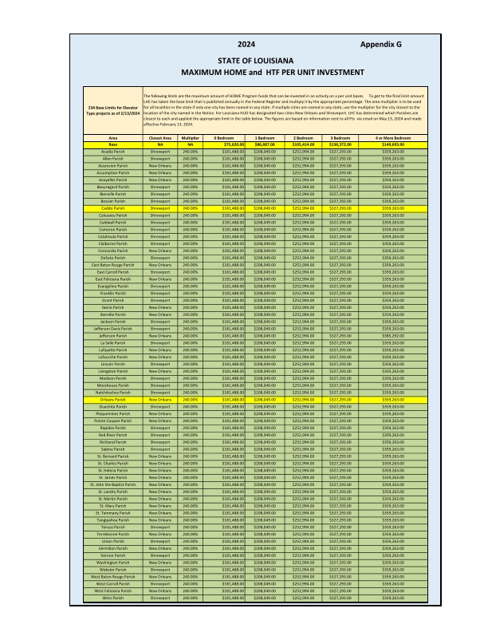

8. Rehabilitation Standards. The grantee must establish rehabilitation standards for all HTF-assisted housing rehabilitation activities that set forth the requirements that the housing must meet upon project completion. The grantee’s description of its standards must be in sufficient detail to determine the required rehabilitation work including methods and materials. The standards may refer to applicable codes or they may establish requirements that exceed the minimum requirements of the codes. The grantee must attach its rehabilitation standards below.
In addition, the rehabilitation standards must address each of the following: health and safety; major systems; lead-based paint; accessibility; disaster mitigation (where relevant); state and local codes, ordinances, and zoning requirements; Uniform Physical Condition Standards; Capital Needs Assessments (if applicable); and broadband infrastructure (if applicable).

Written Rehabilitation Standards are included in this submission as "Attachment F"; please see the attachment below.

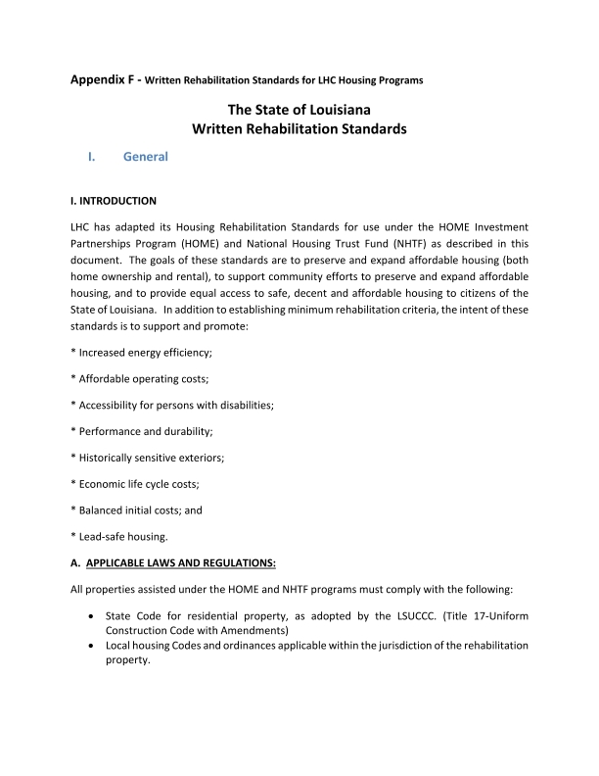
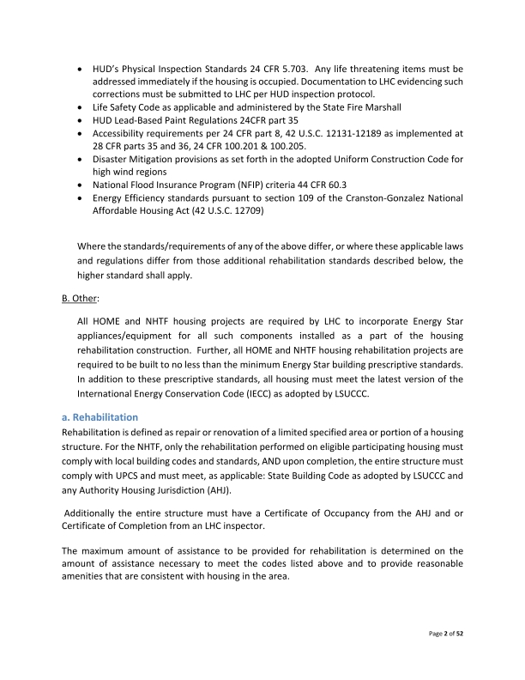
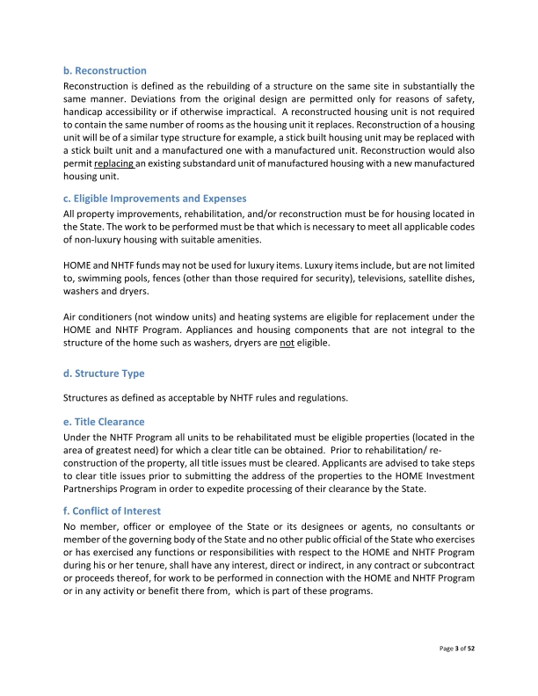
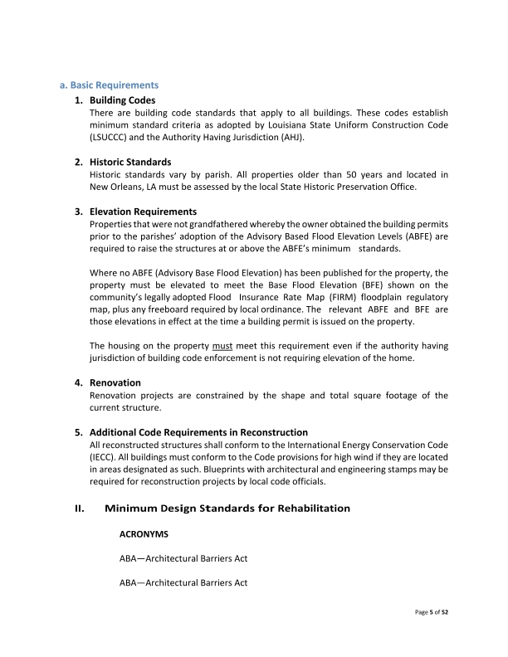
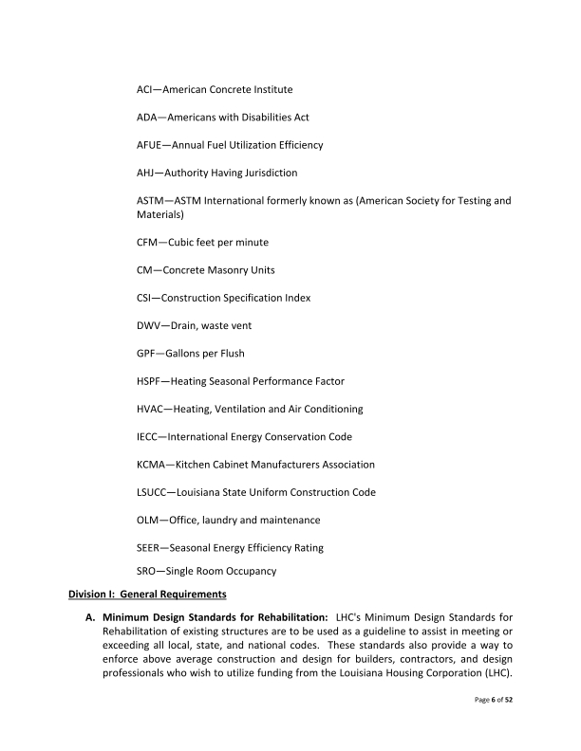
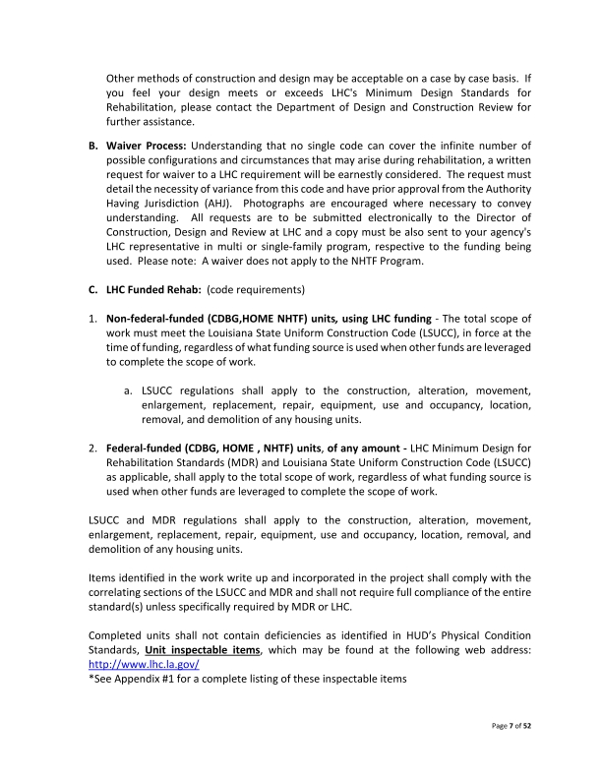
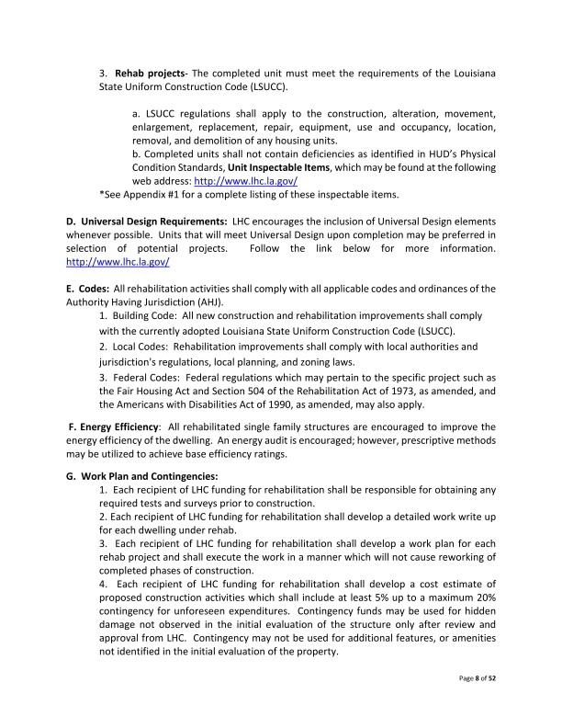
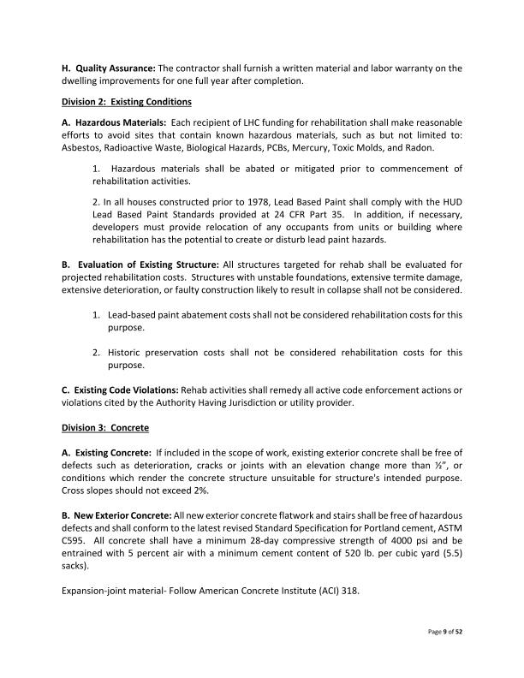
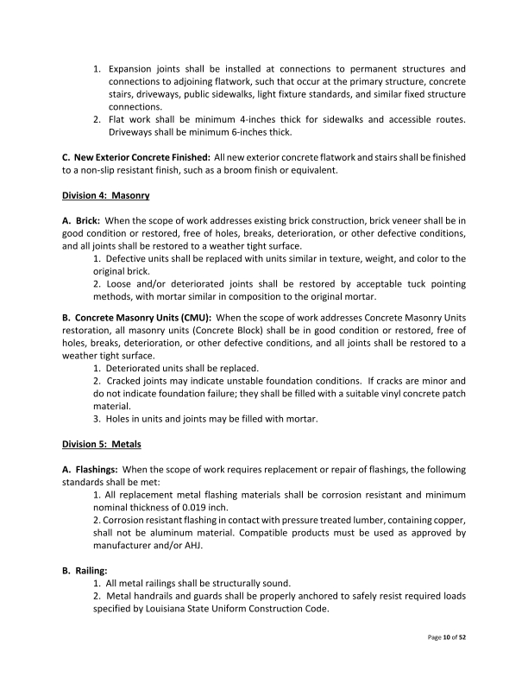
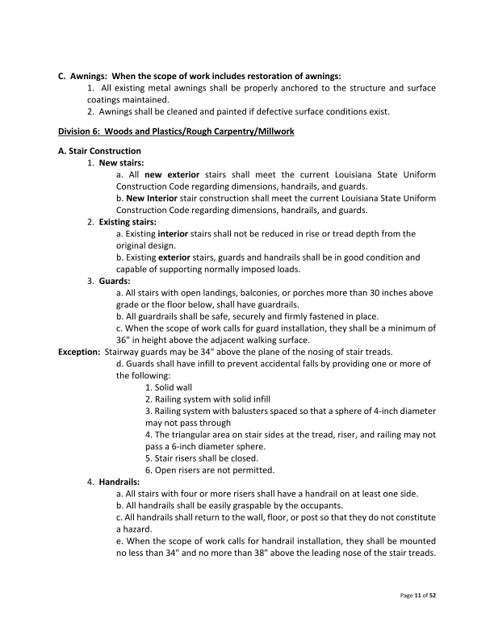
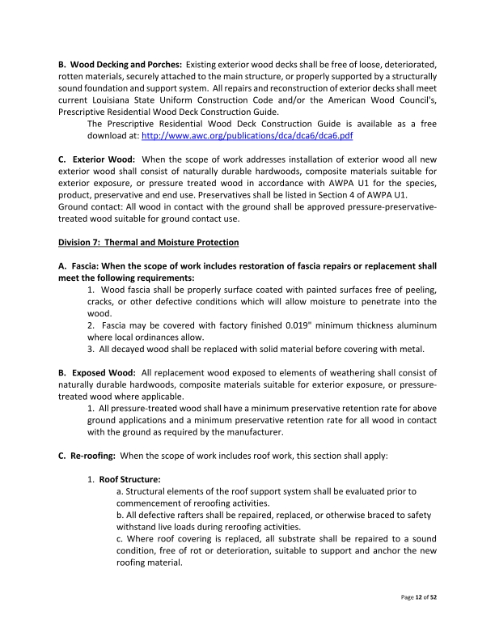
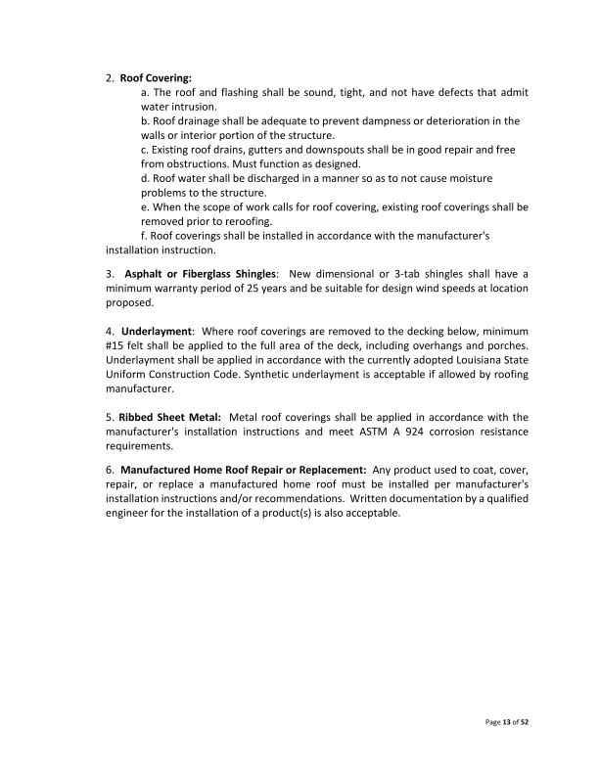
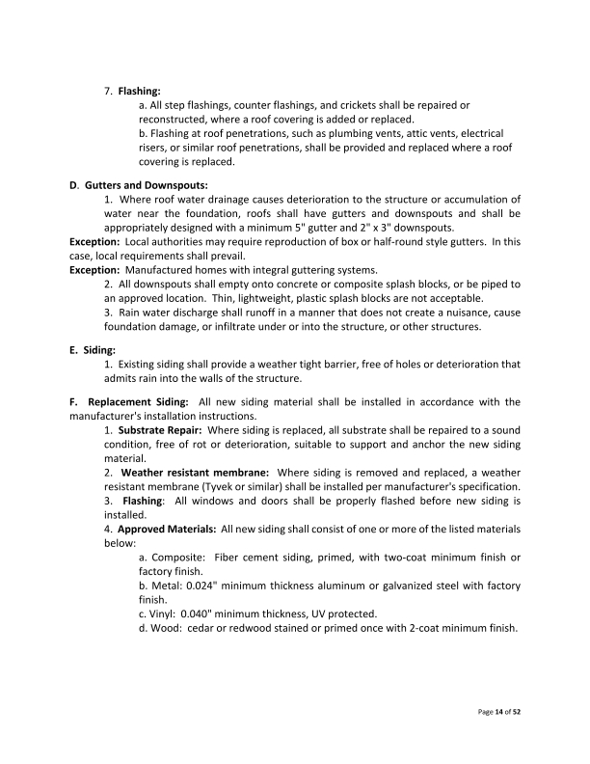
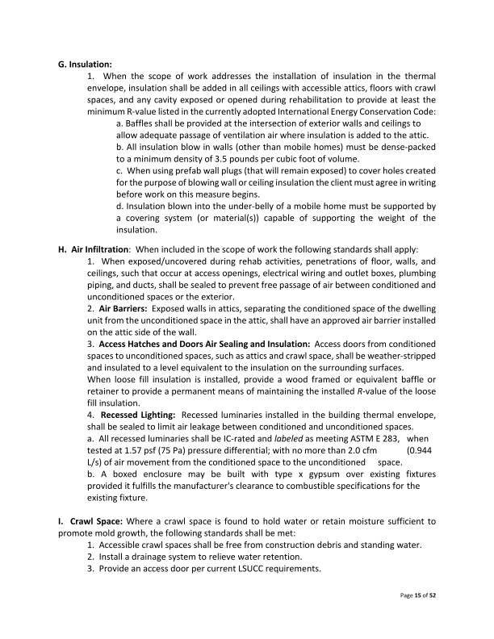
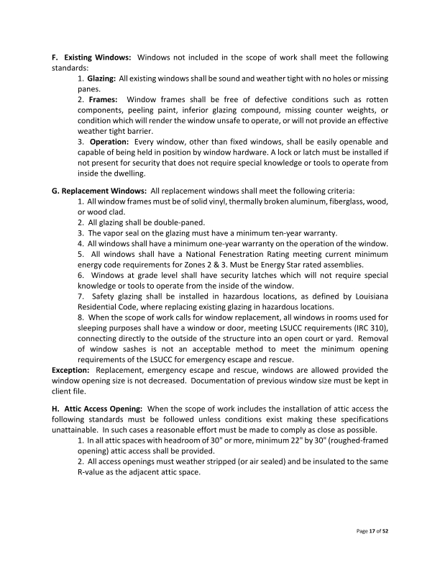
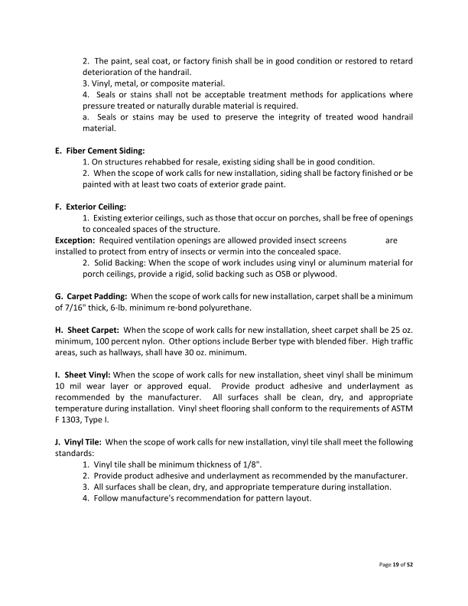
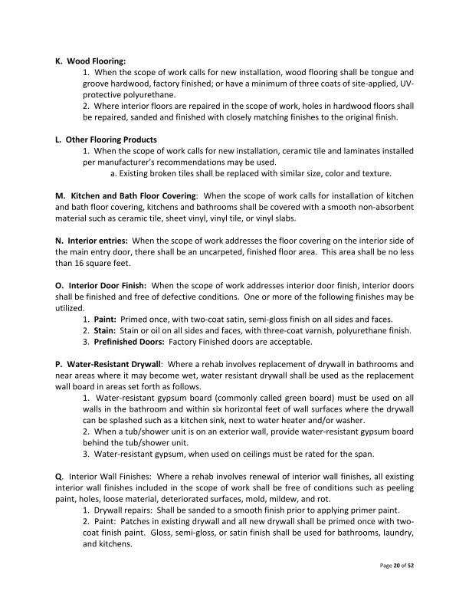
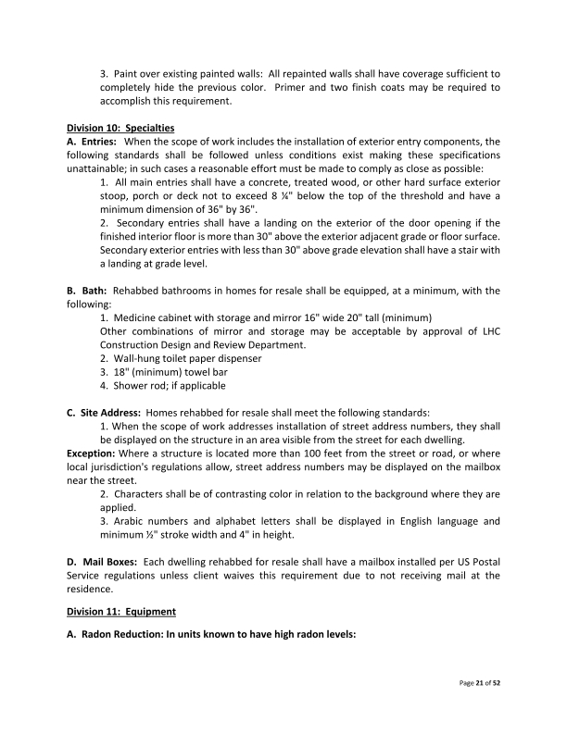
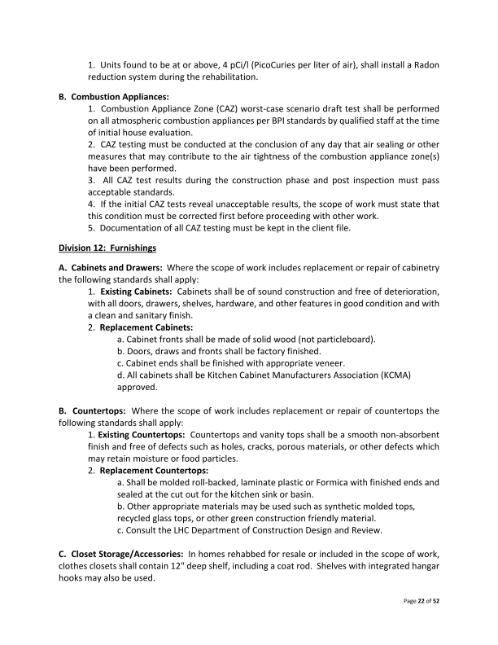
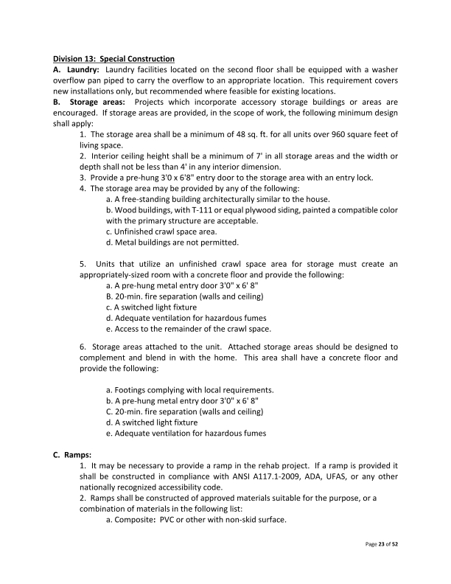
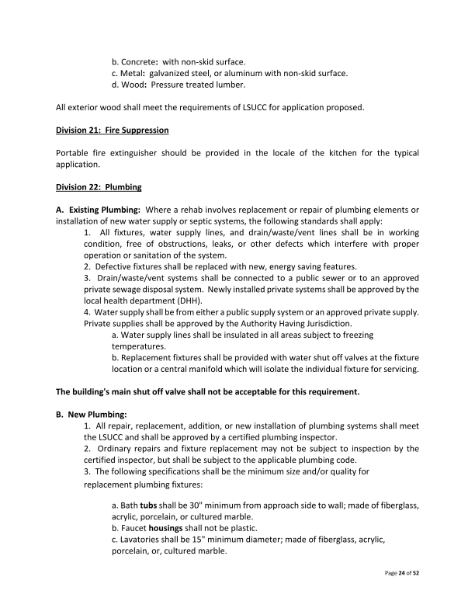
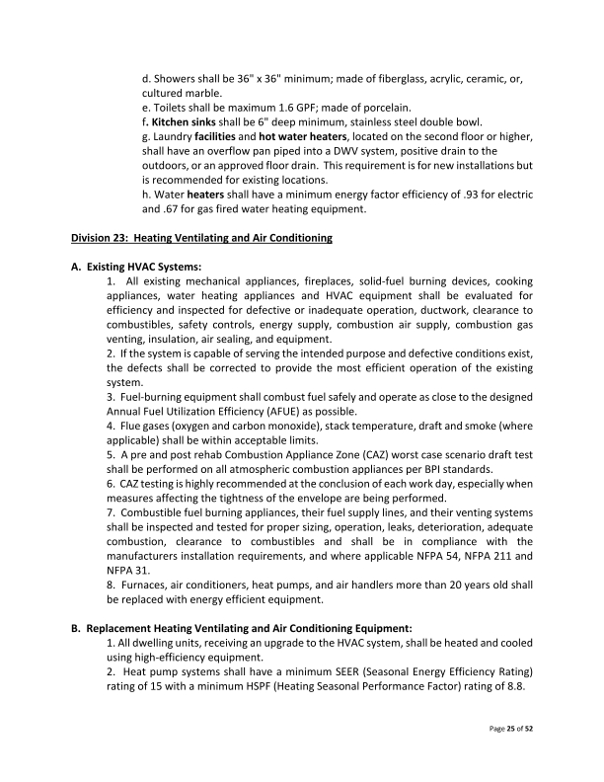
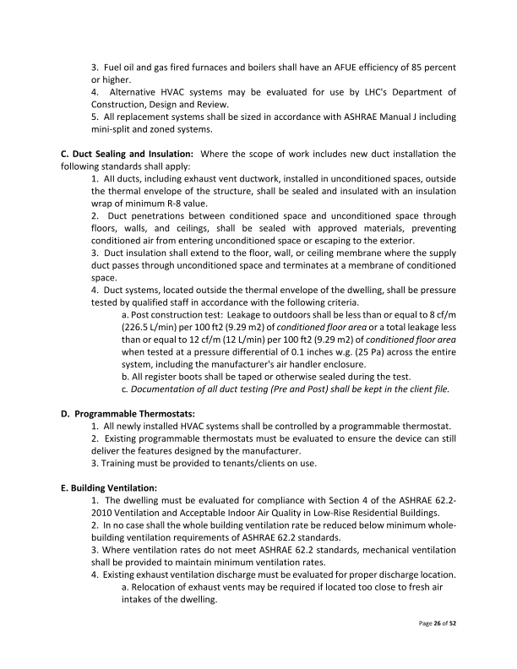
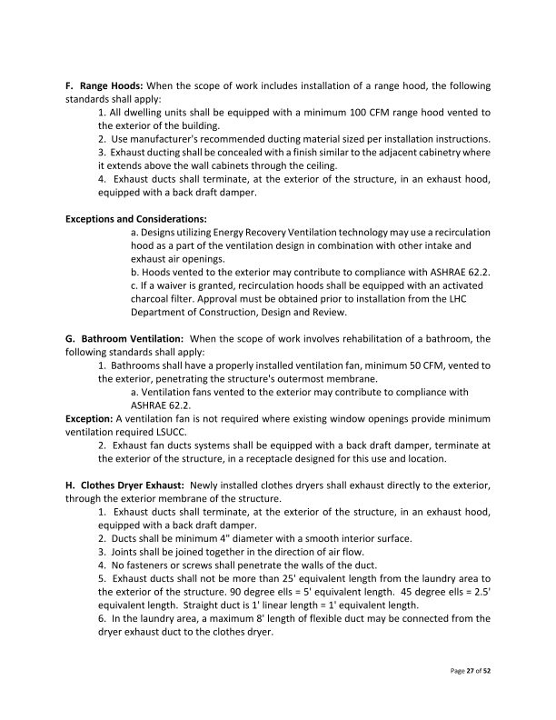
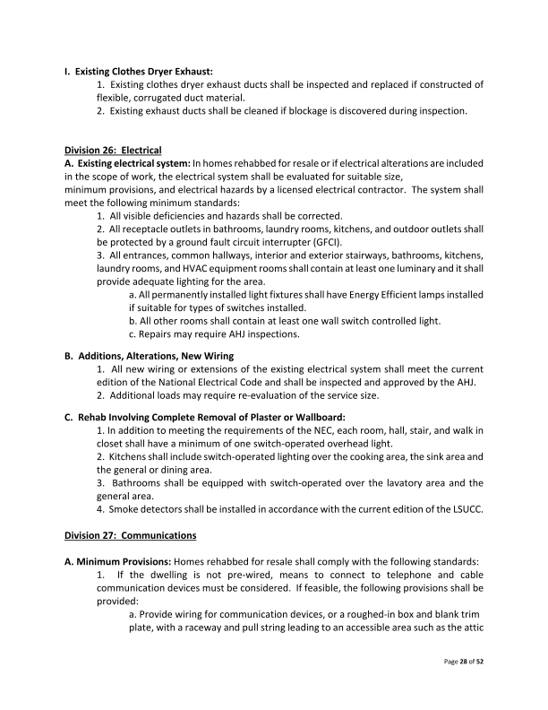
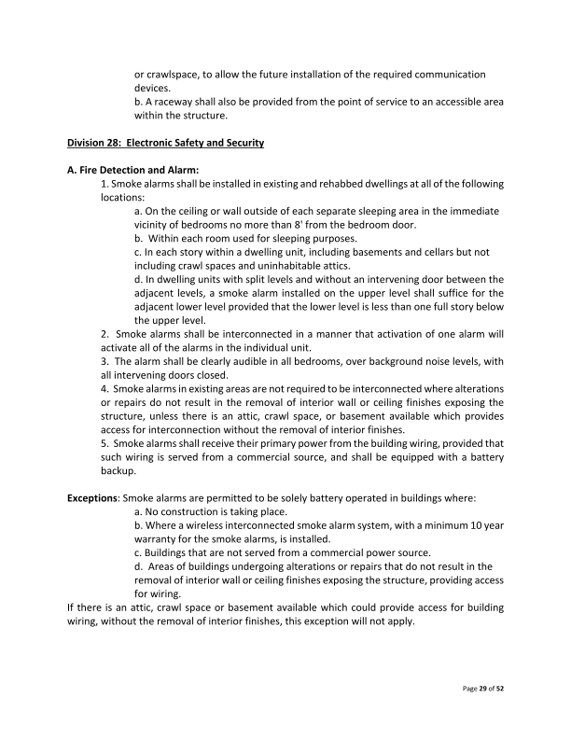
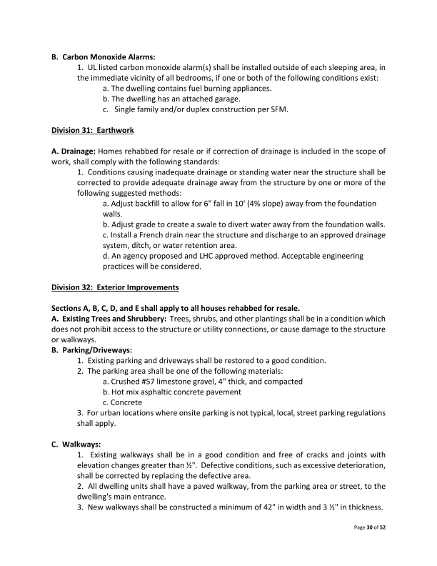
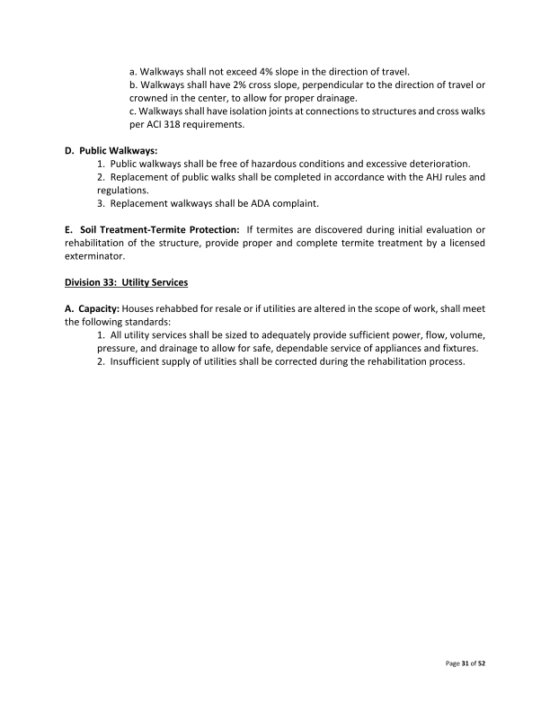
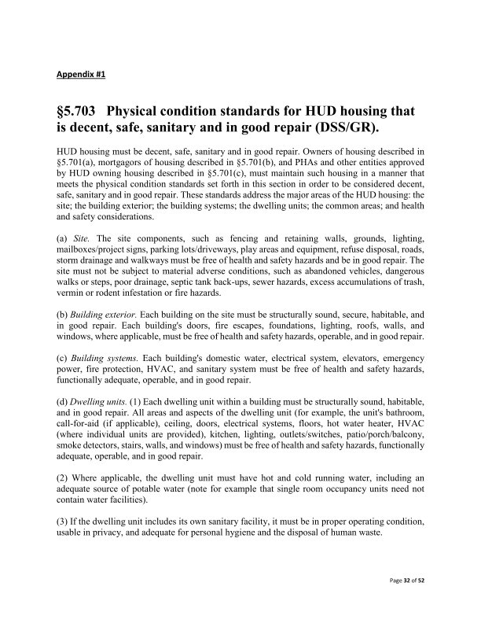
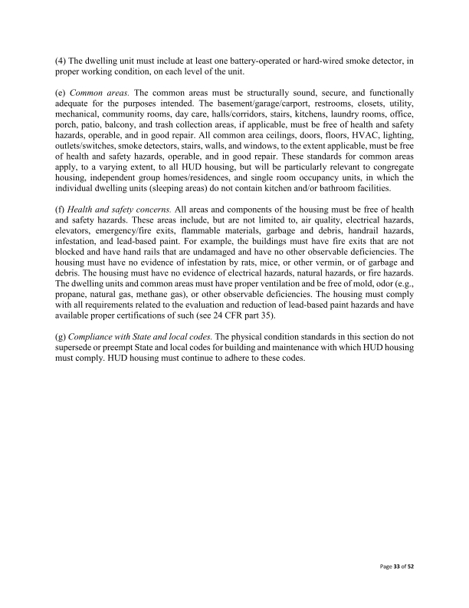
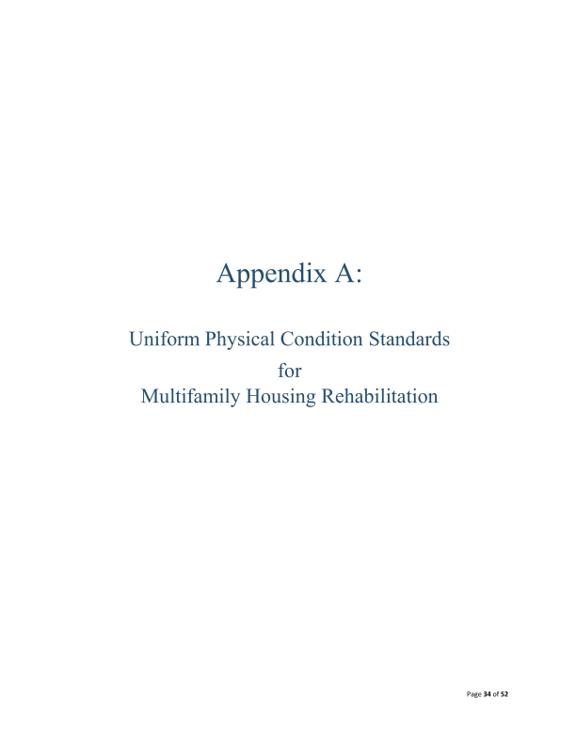
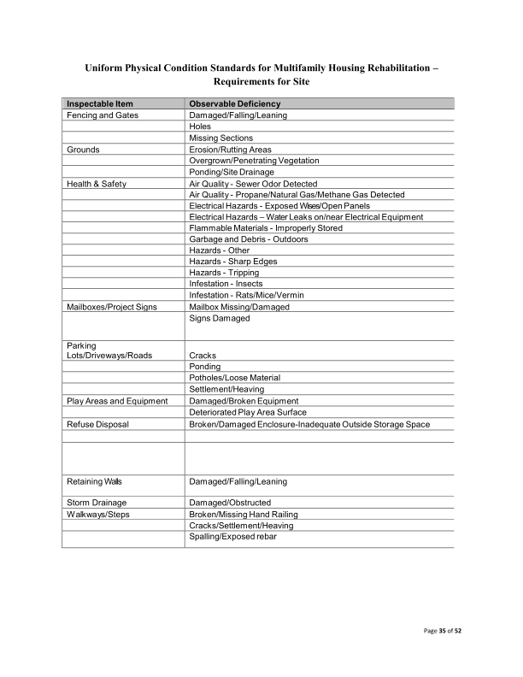
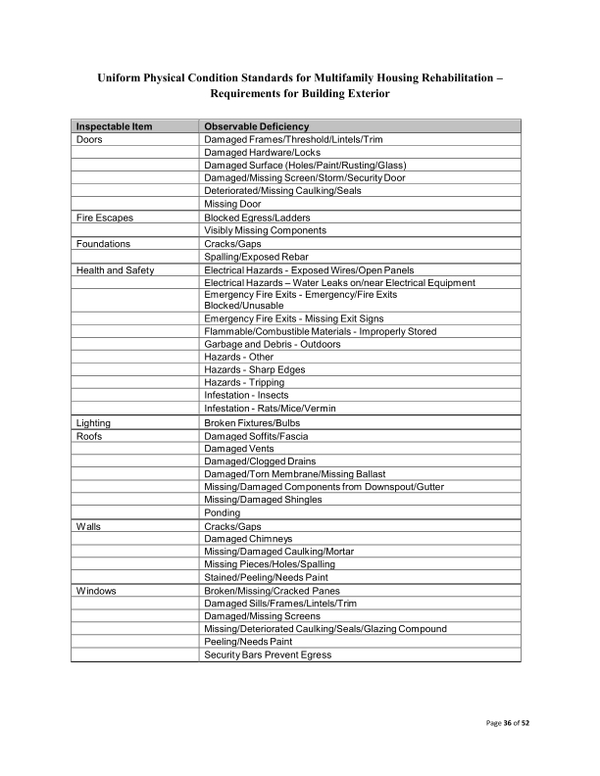
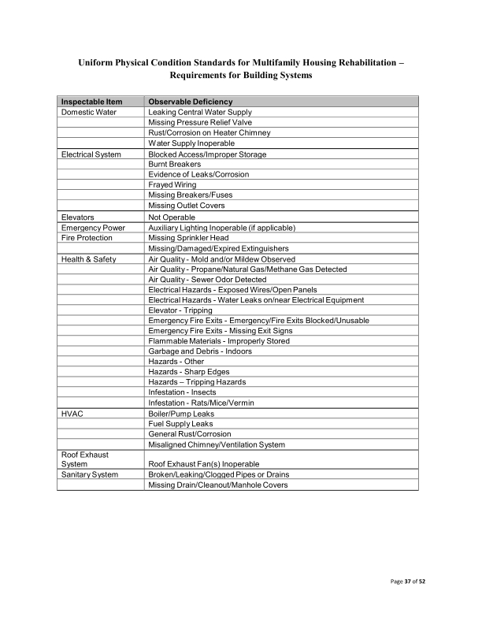
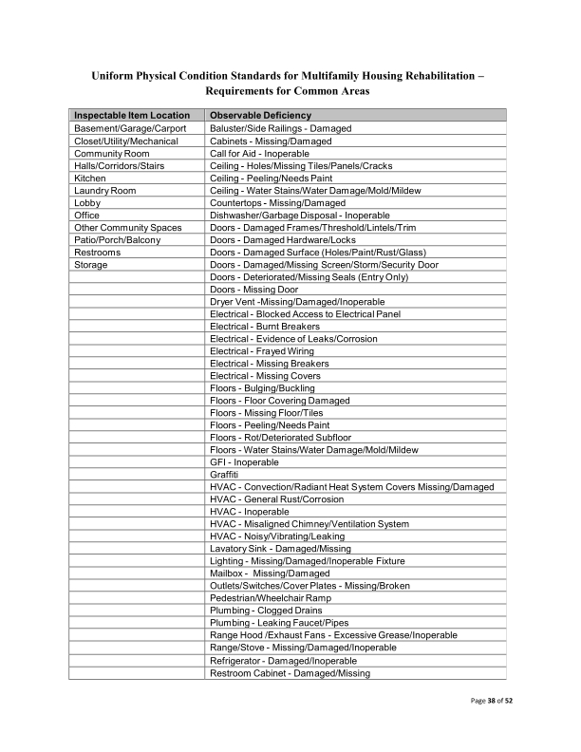
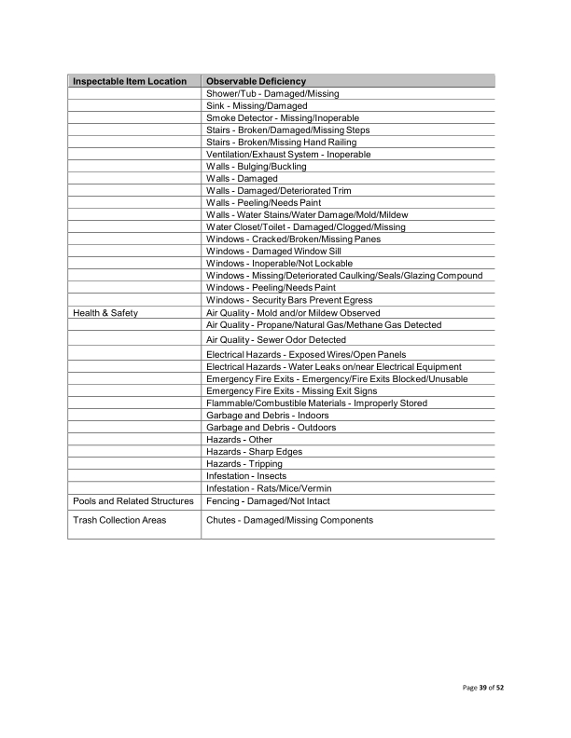
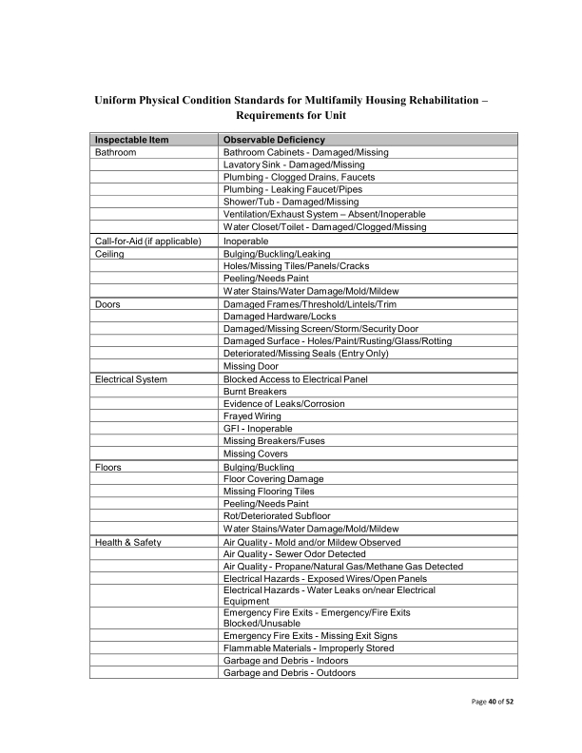
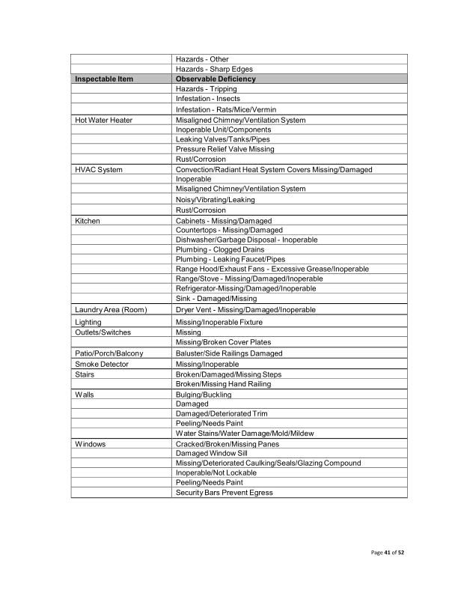
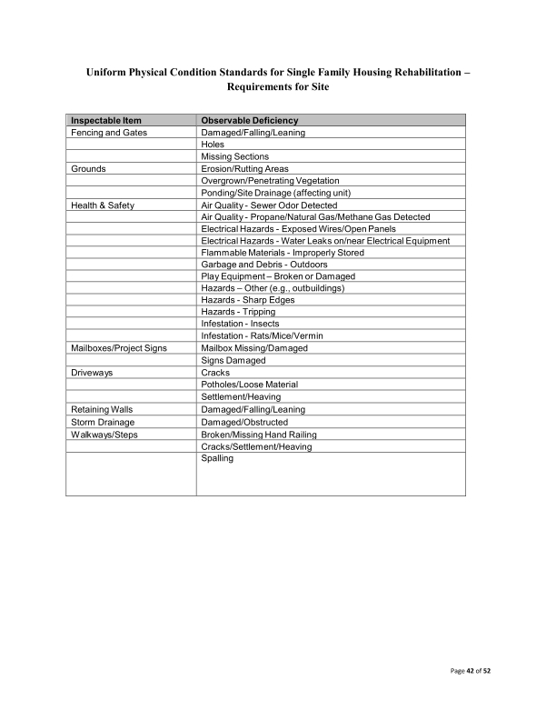
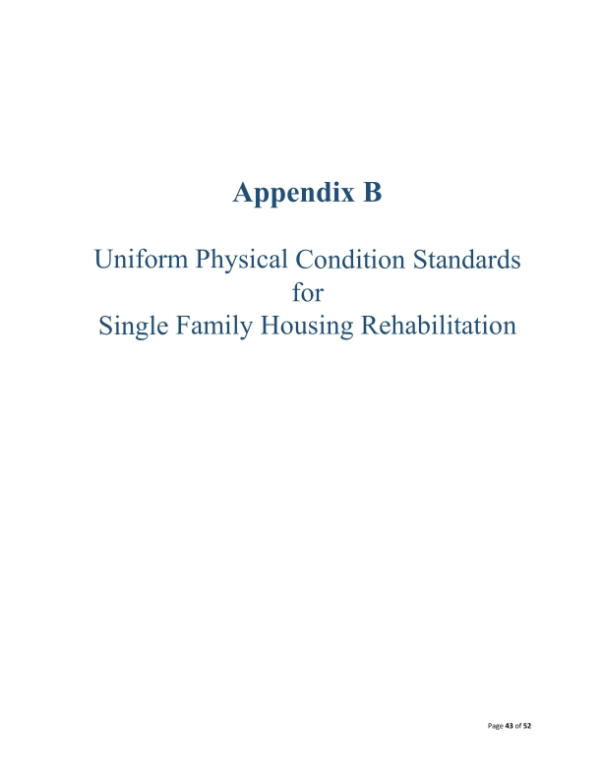
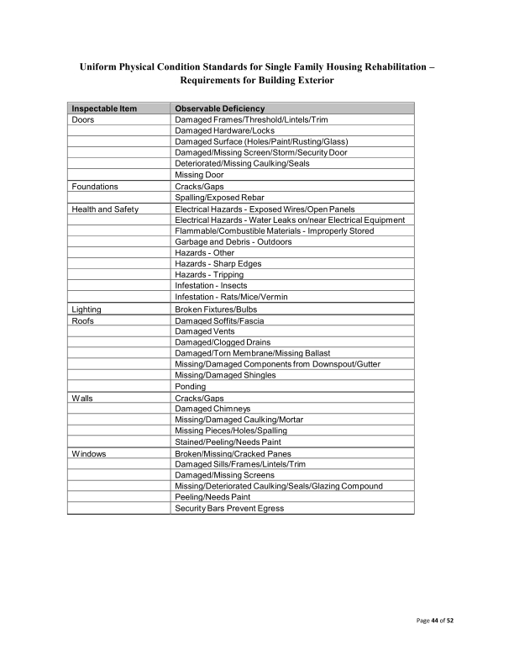
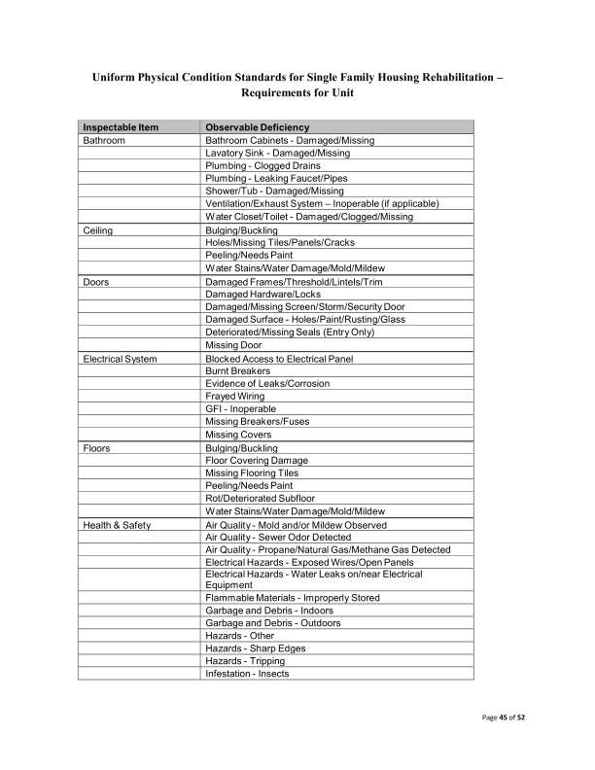
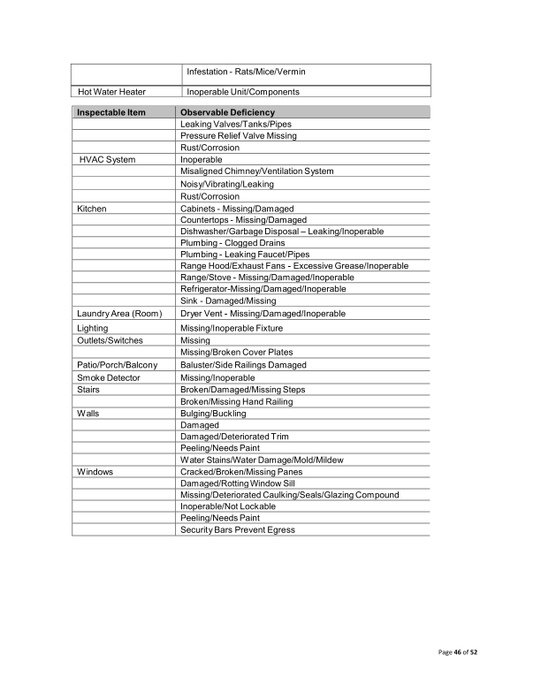
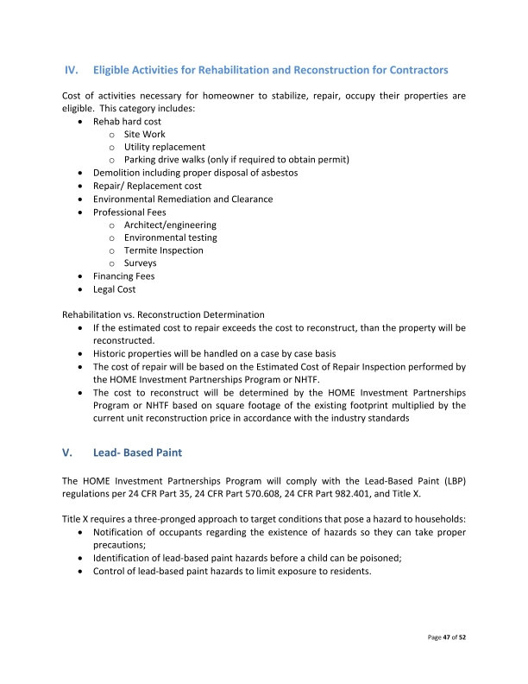
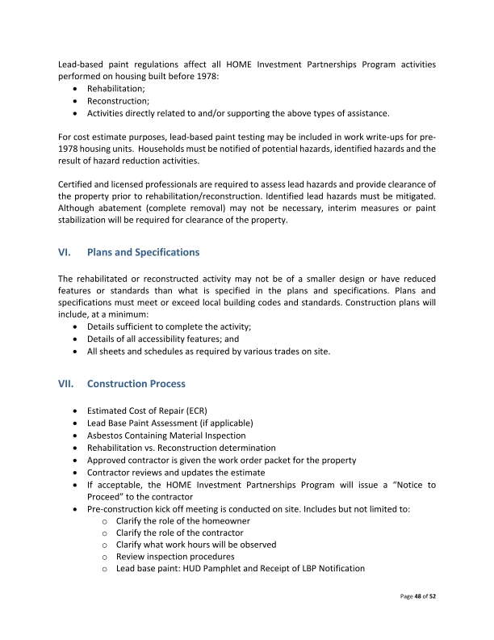
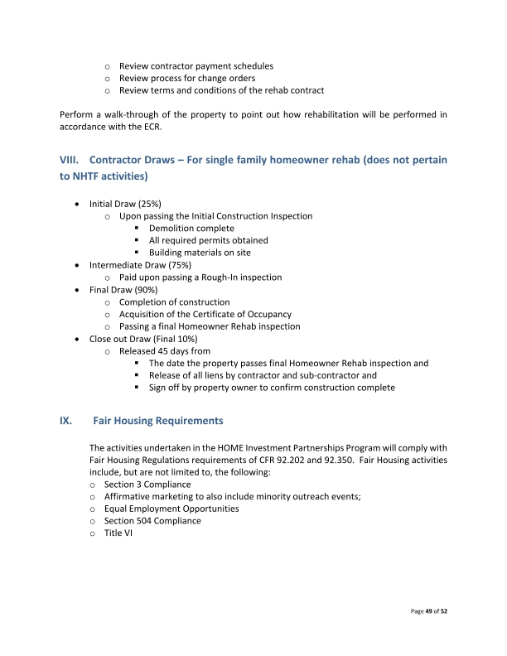
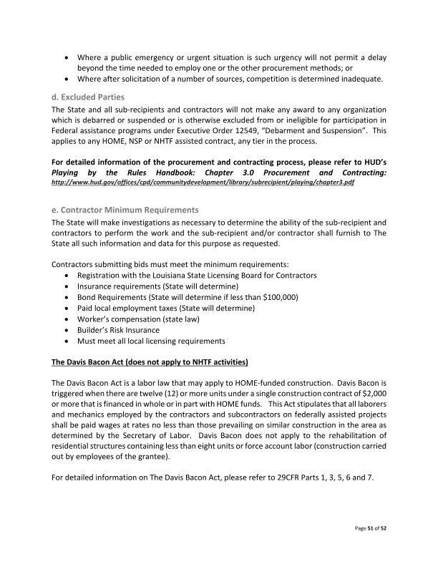
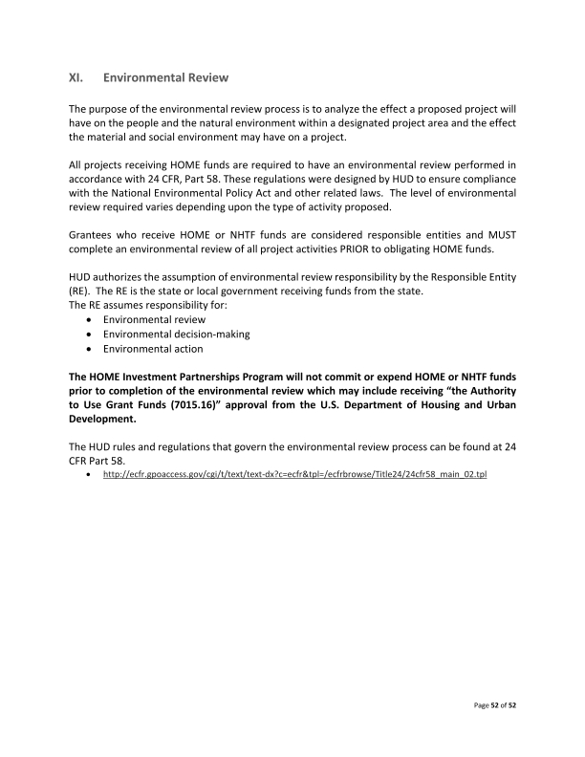

9. Resale or Recapture Guidelines. Below, the grantee must enter (or attach) a description of the guidelines that will be used for resale or recapture of HTF funds when used to assist first-time homebuyers. If the grantee will not use HTF funds to assist first-time homebuyers, enter “N/A”.
N/A

10. HTF Affordable Homeownership Limits. If the grantee intends to use HTF funds for homebuyer assistance and does not use the HTF affordable homeownership limits for the area provided by HUD, it must determine 95 percent of the median area purchase price and set forth the information in accordance with §93.305. If the grantee will not use HTF funds to assist first-time homebuyers, enter “N/A”.
Any limitation or preference must not violate nondiscrimination requirements in § 93.350, and the grantee must not limit or give preferences to students. The grantee may permit rental housing owners to limit tenants or give a preference in accordance with § 93.303(d)(3) only if such limitation or preference is described in the action plan.
N/A
12. Refinancing of Existing Debt. Enter or attach the grantee’s refinancing guidelines below. The guidelines describe the conditions under which the grantee will refinance existing debt. The grantee’s refinancing guidelines must, at minimum, demonstrate that rehabilitation is the primary eligible activity and ensure that this requirement is met by establishing a minimum level of rehabilitation per unit or a required ratio between rehabilitation and refinancing. If the grantee will not refinance existing debt, enter “N/A.”
Multifamily projects that receive NHTF funds for rehabilitation may utilize those funds to refinance existing debt consistent with 24 CFR 93.201(b) if they meet the following guidelines: 1. Refinancing is necessary to reduce the overall housing costs and to make the housing more affordable and proportional to the number of HTF- assisted units in the rental project. 2. Rehabilitation is the primary eligible activity (at a minimum, greater than 51% of the rehabilitation activity). A minimum of $7,500 of rehabilitation per unit is required. The proportional rehabilitation cost must be greater than the proportional amount of debt that is refinanced. 3. The grantee must demonstrate management capacity and practices that ensure that the long term needs of the project can be met and the targeted population can be served over an extended affordability period. 4. The grantee must demonstrate that the new investment is being made to maintain current affordable units, to create greater affordability in current affordable units, to create additional affordable units, or to continue the affordability of units that could be lost. 5. Refinancing will be limited to projects that have previously received an investment of public funds. 6. The minimum NHTF affordability period shall be thirty (30) years. 7. NHTF funds cannot be used to refinance multifamily loans made or insured by any Federal program, including CDBG. 8. Refinancing will only be allowed for projects that can produce estoppel letters from all current debt or lien holders. The estoppel letters must state clearly that there is not currently an instance of default or any condition that, if persisting, would lead to an instance of default over the next two years. Also, the letter must state that the current debt/ lien holders have no plans to seek remedy for any existing condition by means of foreclosure, deed in lieu of foreclosure or a dation en paiement.

Discussion:
N/A

Attachments

