Navigating the Sourcing Project

Adding to Watched Projects 1

Overview Tab 2

Documents Tab 4

Tasks Tab 6

Teams Tab 10

Message Board 11

Event Messages 12

History Tab 12

Publish Date 9/1/22

# Adding to Watched Projects

## On the Overview tab of the Sourcing Project click on ‘Actions’ and select ‘Add to Watched Projects’ from the dropdown menu.

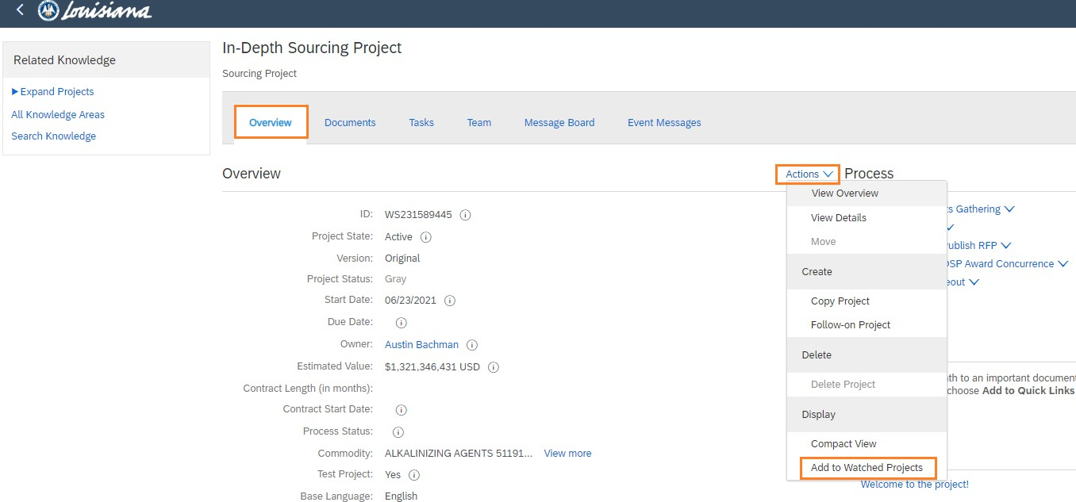

* Notice on your dashboard that this project is now listed under ‘Watched Projects’. From here, you can easily access the project by clicking on the name.

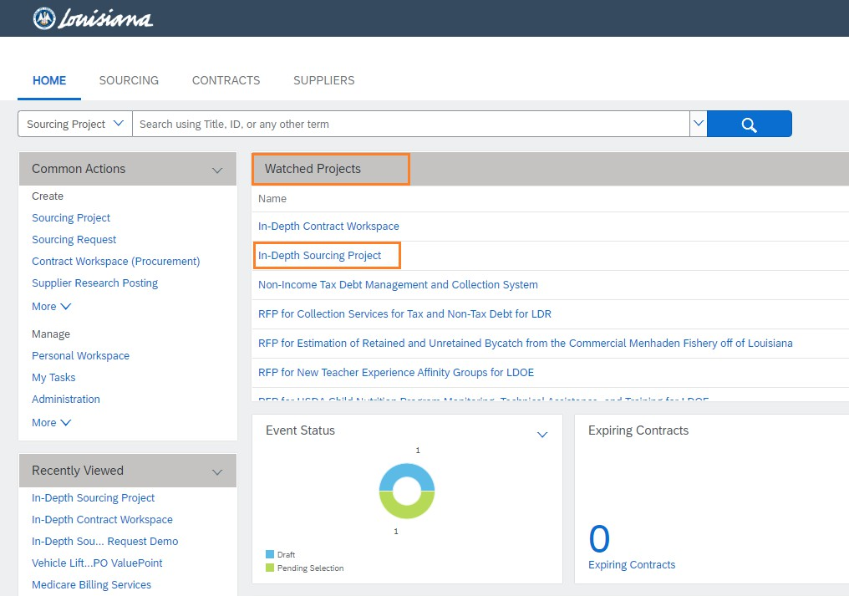

* Once you finish with the project if you can easily remove it from your ‘Watched Projects’ by following the same steps as above and selecting ‘Remove from Watched Projects’ from the drop down.

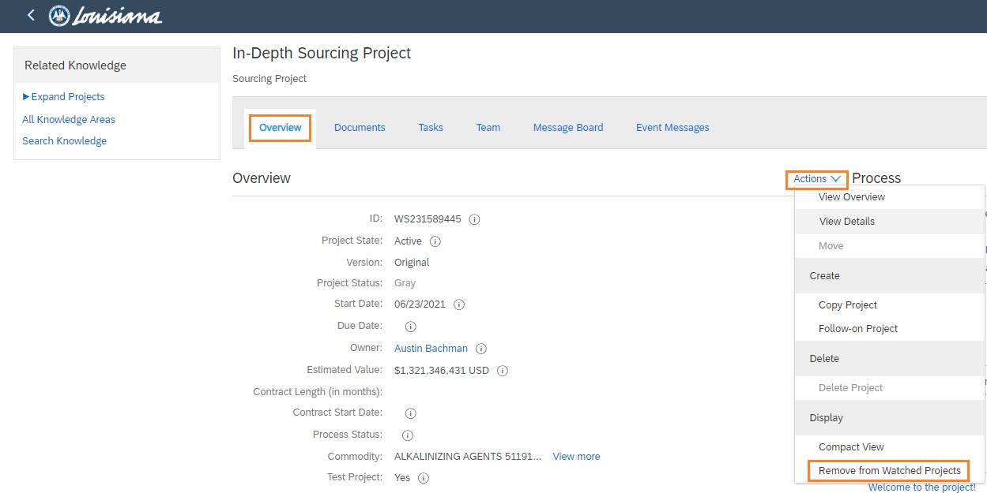

# Overview Tab

* This tab shows the information that was added while creating the Sourcing Request.

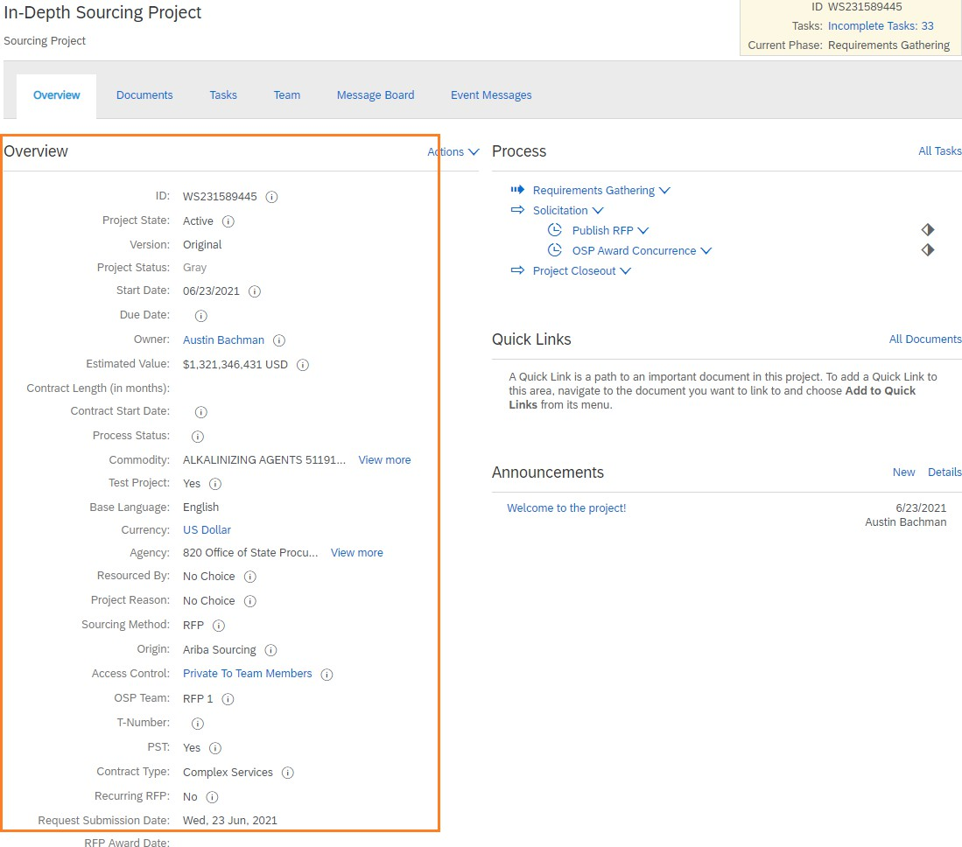

* The ‘Process’ section shows a list of the upcoming tasks for the project.

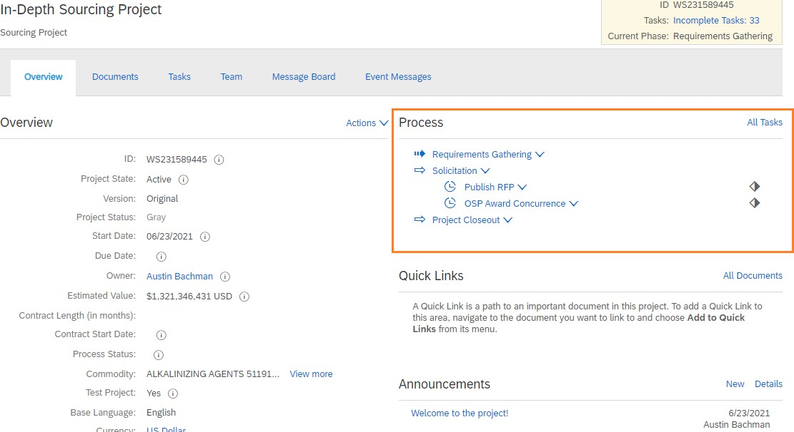

* The ‘Quick Links’ section allows you to add certain documents that you can easily access from the Overview Tab.

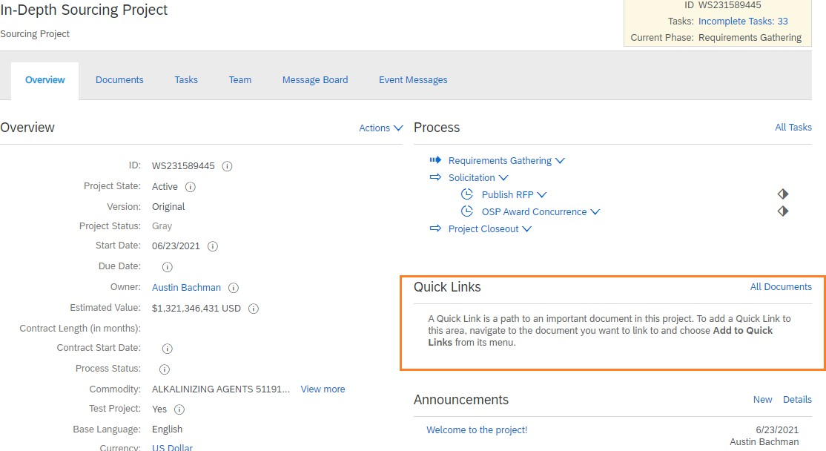

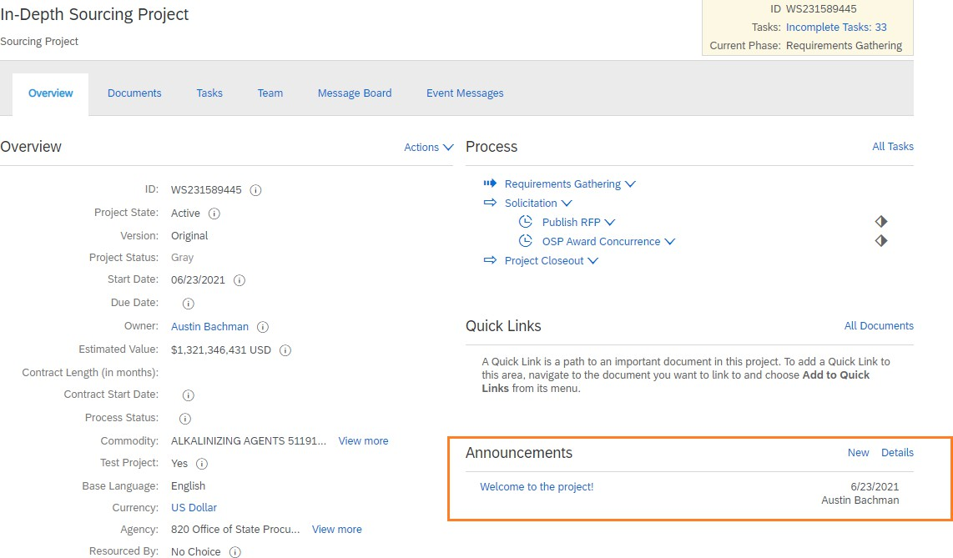

# Documents Tab

* This tab holds all the documents needed in order to create and publish the RFP.
* The documents are stored in their appropriate folders.

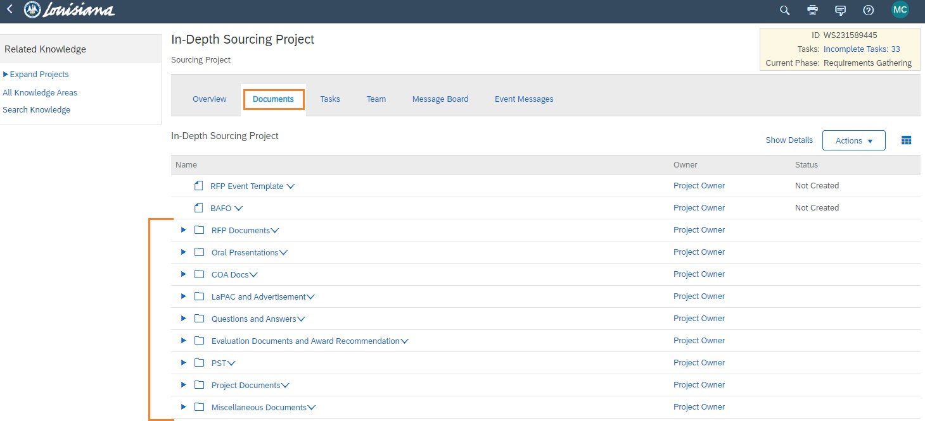

* To access the documents click the arrow to expand the folder.

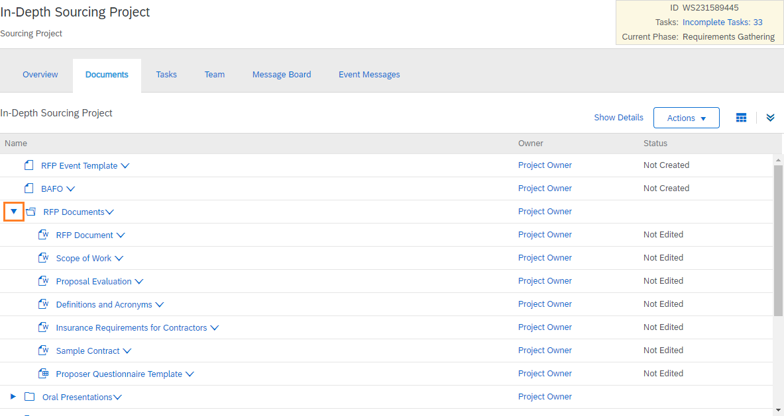

* You may also click on the Table Options Menu and select ‘Expand All’ to expand all of the document folders at once.

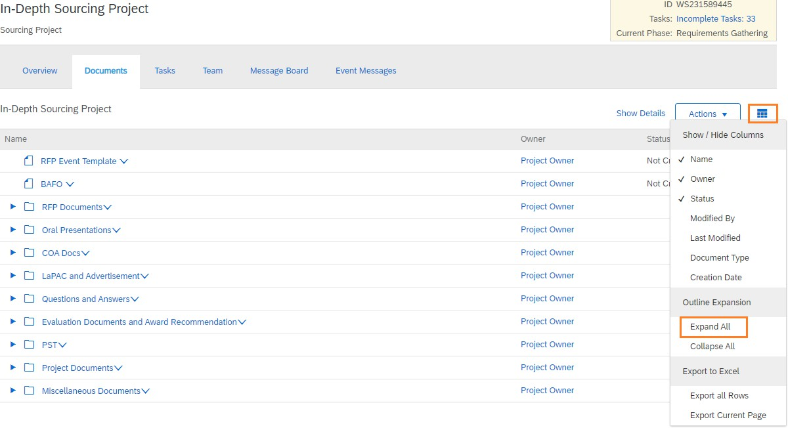

* To open a document click on the drop down arrow next to the file name and select ‘Download’.

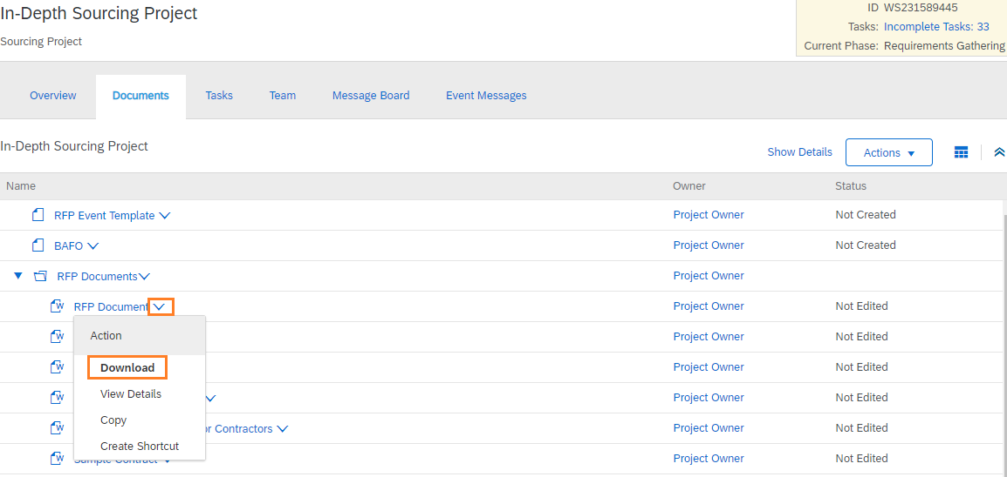

# Tasks Tab

* This tab breaks up the procedures into individual tasks to allow for a high level view of where we are in the process.
* There are three (3) phases within each project: Requirements Gathering, Solicitation, and Project Closeout.

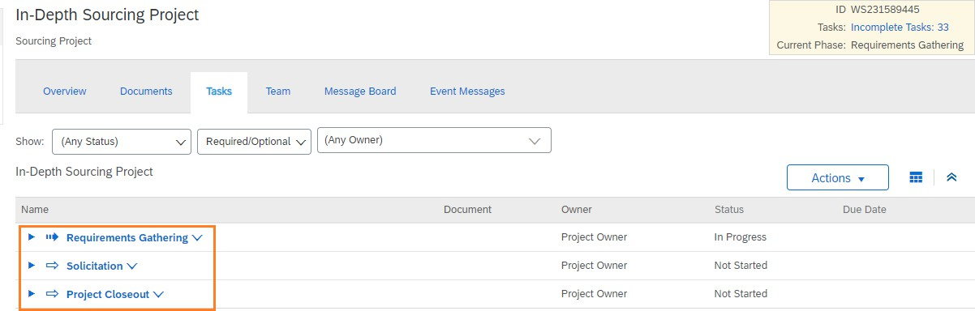

* + Requirements Gathering Phase deals with all of the tasks that are required to finalize the documents needed to develop the RFP.
  + Solicitation Phase is where the RFP event comes together. It contains all the tasks starting with final OSP approval of the RFP event, goes through publication, any required addenda, evaluations, and ends with consensus and the award recommendation.
  + Project Closeout Phase is the final phase that includes administrative tasks to document lessons learned and complete the RFP.
* Within each phase are a list of tasks that will need to be completed. Those tasks with a red asterisks indicate it is a required task.

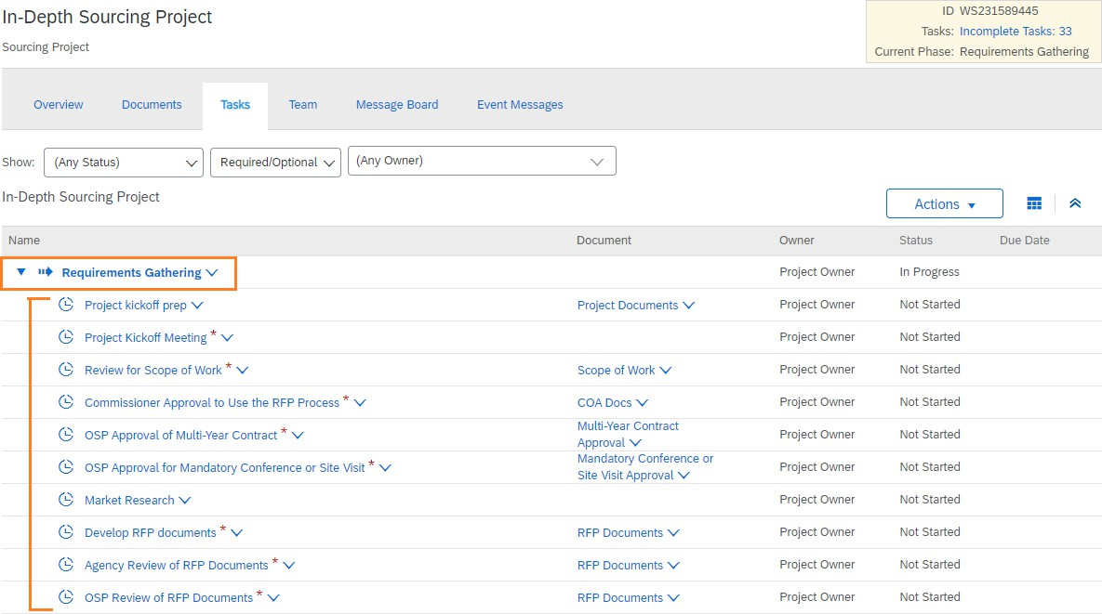

* To know the status of the task you can look at the icon next to the project name as well as the status column.
  + The checkmark indicates that the task has been completed.
  + The notepad indicates that the task is in progress/review and the due date can be found in the ‘Due Date’ column.
  + The clock indicates that the task has not yet been started.

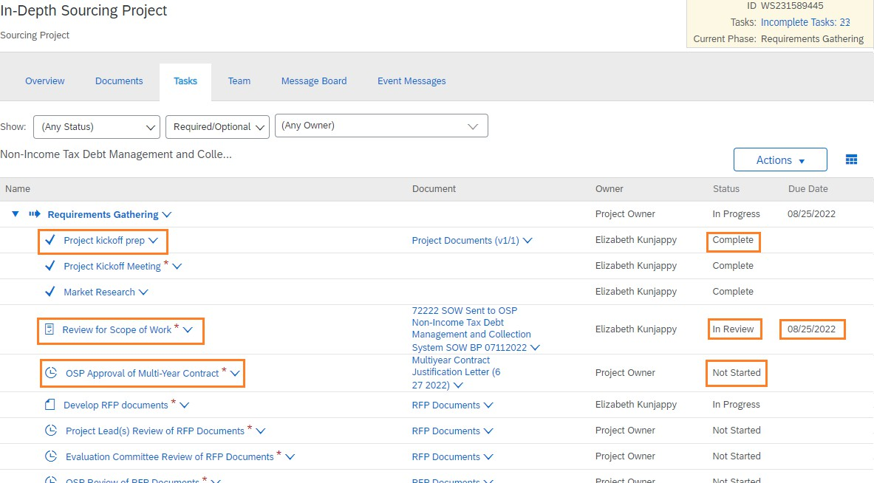

* If you are unsure of what is required of the task click the drop down arrow next to the task name and select ‘View Task Details’.

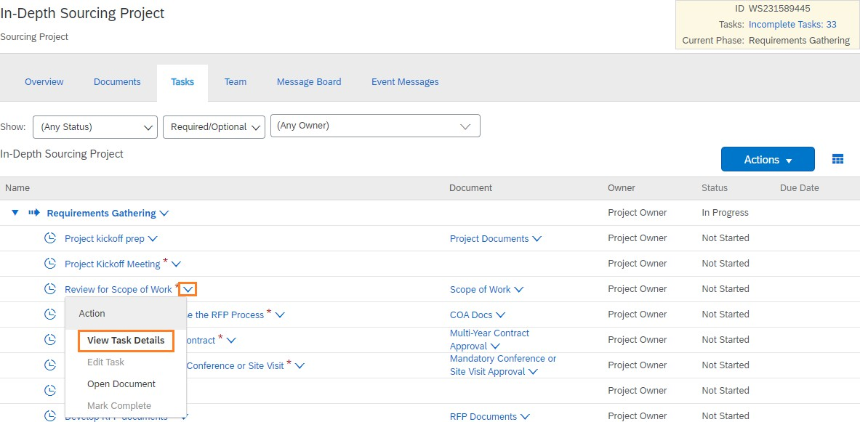

* + Here on the Properties tab you can read what is required of this task along with the documents associated with it. You can also see if there is a due date to complete this task.

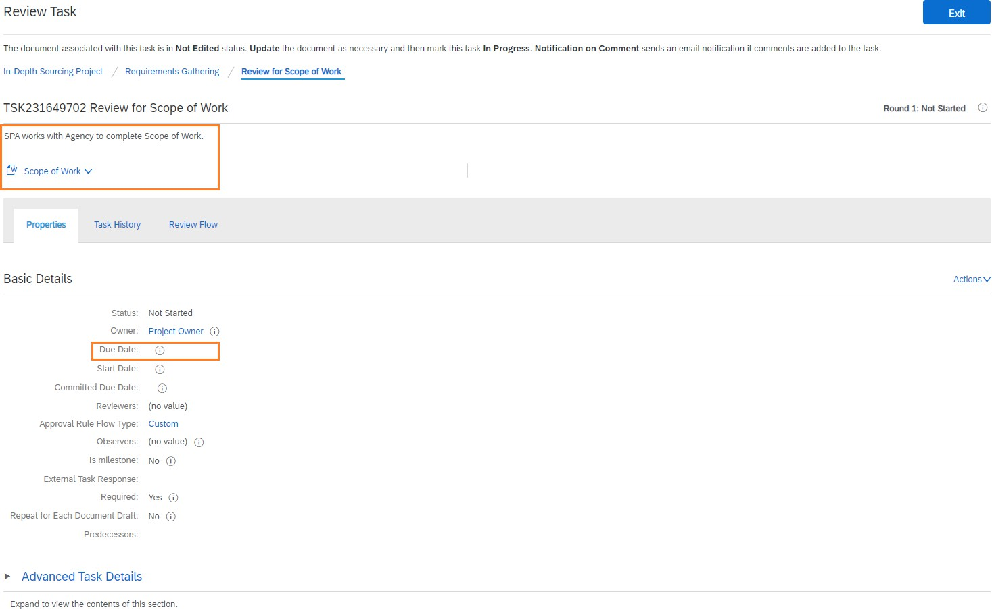

* + The Task History tab will show the comments between the agency and OSP regarding this task in either a threaded or a chronological order. To change this select ‘Threaded’ and choose your preference.

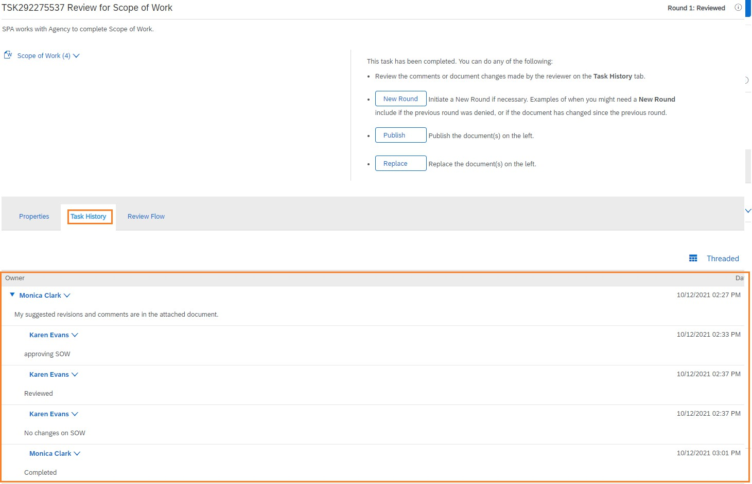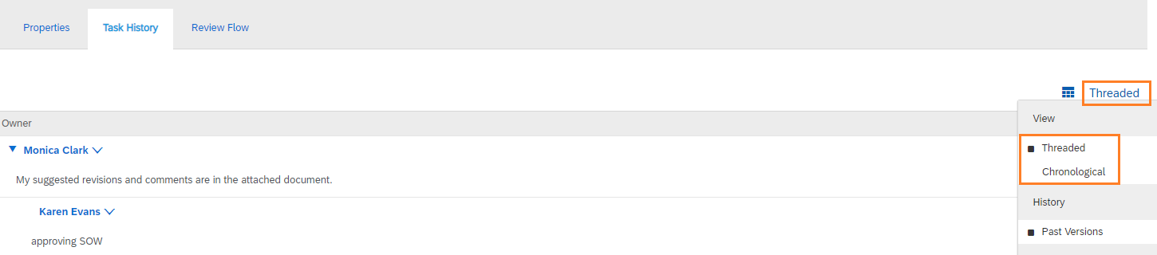

* + The Review Flow tab will show everyone who needs to review the task.
    - 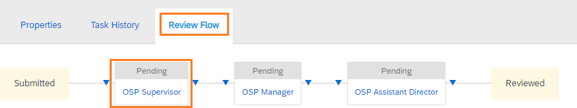Gray indicates the task has not yet been sent to the person.
    - Blue indicates the task has been sent to the person and they are reviewing it.

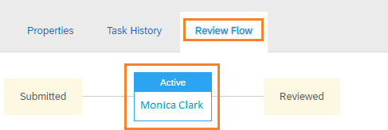

* + - Green indicates the task has been completed by the person.

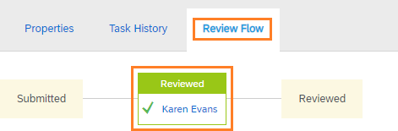

# Teams Tab

* In order to view the project you must be listed on this tab.

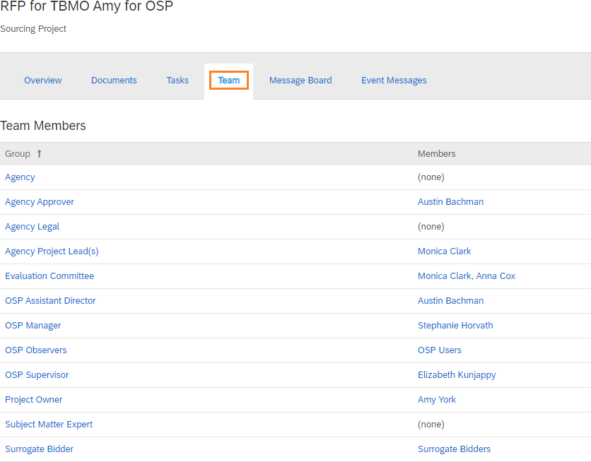

* Agency Approver is not necessarily the person who has the delegation to make purchases for the agency. It is someone at the agency that is above the level of the end user.
* Agency budget and legal are conditional groups. These can be selected when creating the Sourcing Request.
* Observers – anyone at the agency that needs access that is not assigned a specific role.

# Message Board

* Each Message Board in LESA has a unique email address associated with it.
* You can send an email to the unique email address and CC the person you want to communicate with and LESA will capture the entire email chain and add it to the Message Board.
* 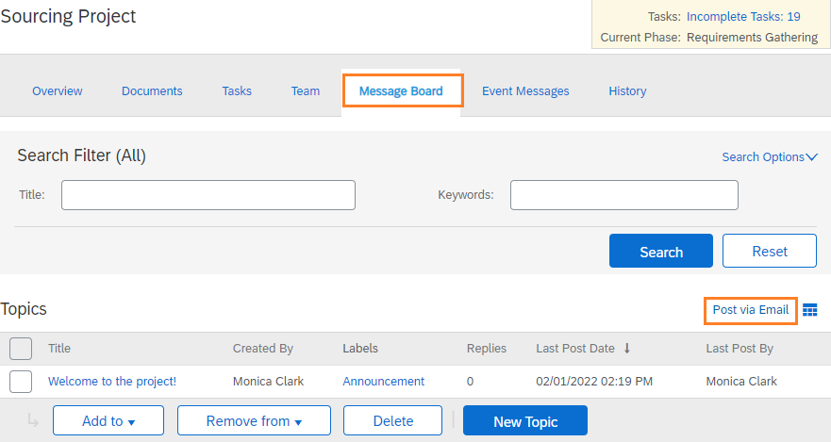To find the unique email address click on the Message Board tab and ‘Post via Email’
* The email address will then appear. You can click on the hyperlink or copy and paste it into your email message and send as you normally would.

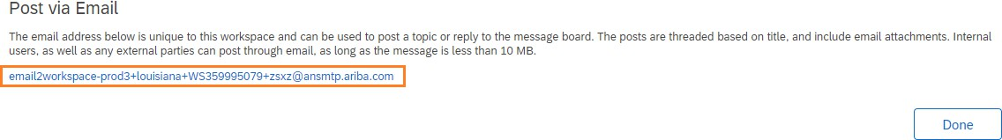

* Once the email is sent it can now be found in the Message Board

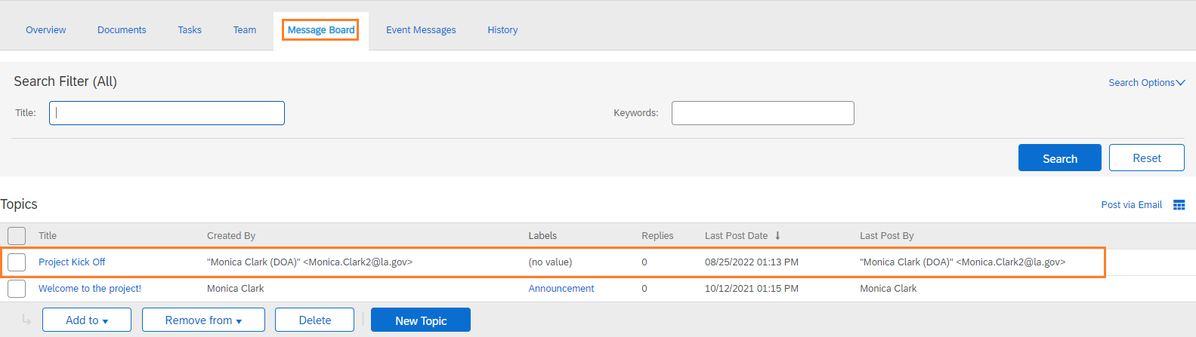

# Event Messages

* Messages will only populate once the event is published.
* Once published messages regarding the published event will show here.

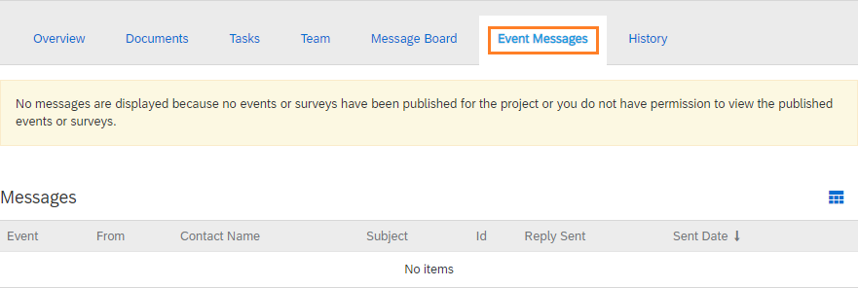

# History Tab

* This is an audit log from creation to completion.
* This tab may or may not show depending on the permissions the user has.