Responding to Review Tasks

What are Review Tasks? 1

How is the Agency Notified of a Review Task? 1

Responding to a Review Task with Changes 2

Responding to a Review Task with No Changes 4

Navigating Review Tasks from the LESA Dashboard 5

# What are Review Tasks?

* Review Tasks request one or more users or groups to review one or more documents.
* This will replace sending the ProAct transmittal or LaGov shopping cart back and forth with documents attached.

# How is the Agency Notified of a Review Task?

* When the State Procurement Analyst (SPA) has completed their review of a document, they will initiate a review task in LESA. LESA will send an email to notify the agency person listed in the workflow that a document needs their review.
* The agency should open the attachment and address any comments from OSP.

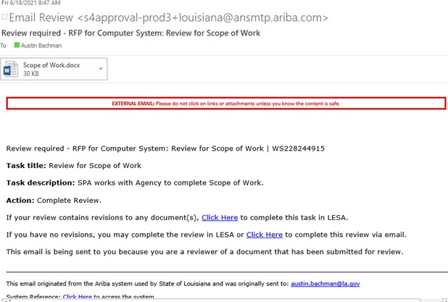

* Once OSP’s comments have been addressed, if necessary, save the document to your computer.
* Return to the email to complete the review task.

# Responding to a Review Task with Changes

* If your review contains revisions to any document(s), select ‘Click Here’ on the first option. Please note that replying to the email and attaching your revisions will not upload to LESA. You must select ‘Click Here’ to complete the task.

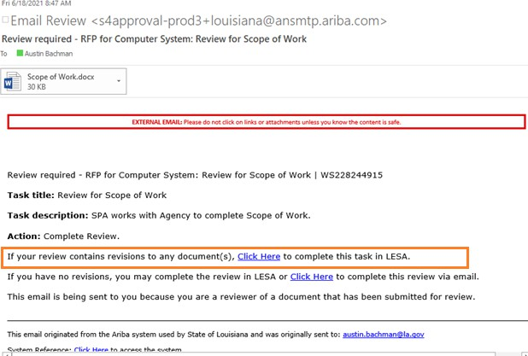

* + You will be prompted to log into LESA. After you log in, LESA will bring you directly to the task. Select ‘Complete Review’.

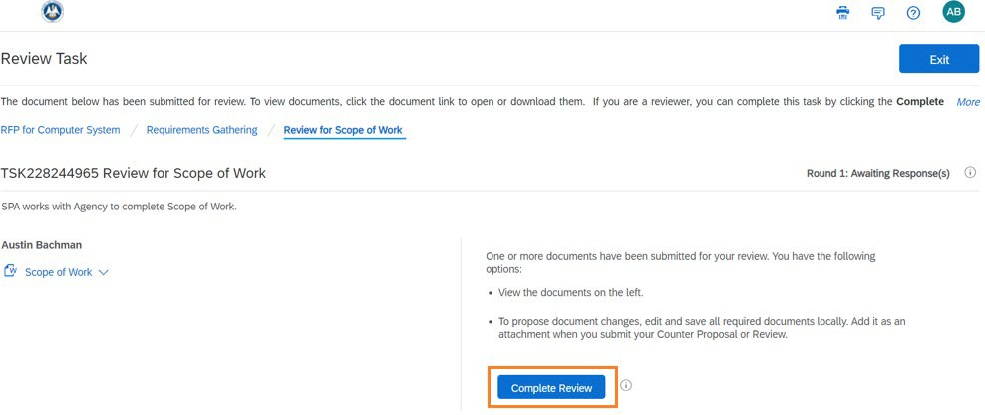

* + Enter a message, attach the file, and select OK to complete your review.

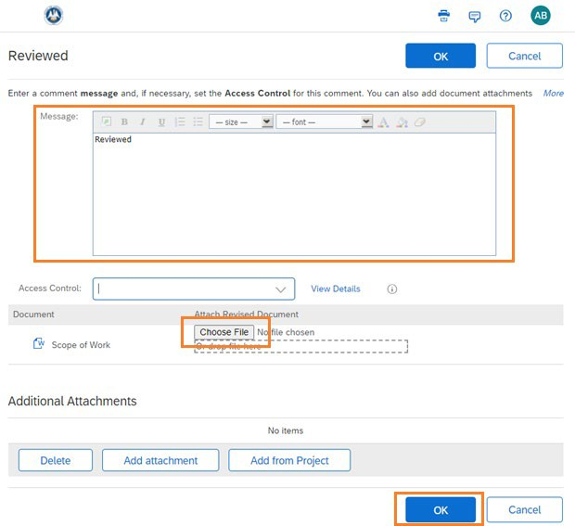

# Responding to a Review Task with No Changes

* 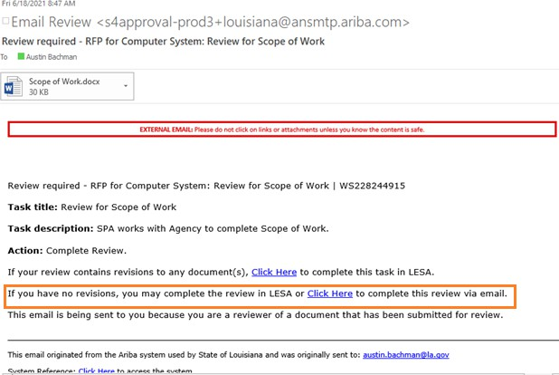If there are no revisions to the attachment select ‘Click Here’ on the second option and you may complete the review via email.
  + 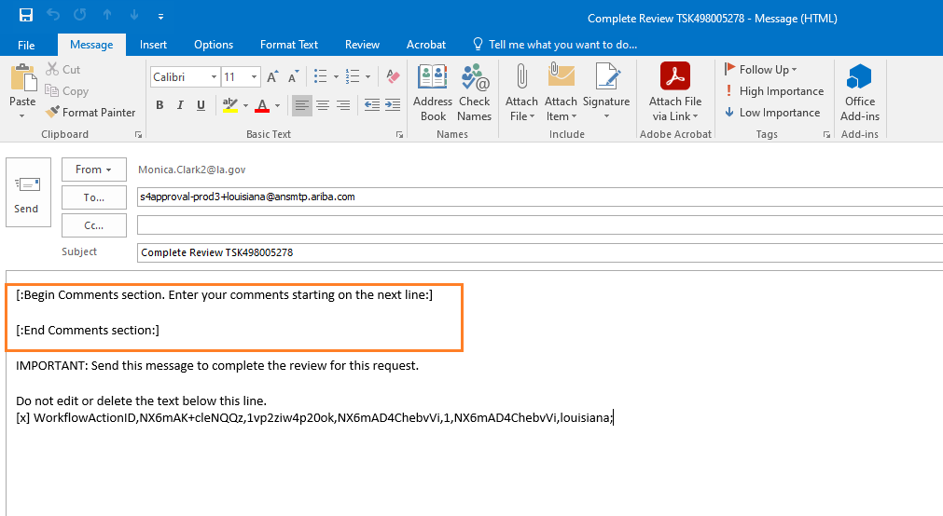Once you select ‘Click Here’ a new email message will appear. Notice the instructions in the body of the email.
  + If you have no revisions to the attachment you may enter your comments **in between** the sections as seen below. Once complete, hit Send.

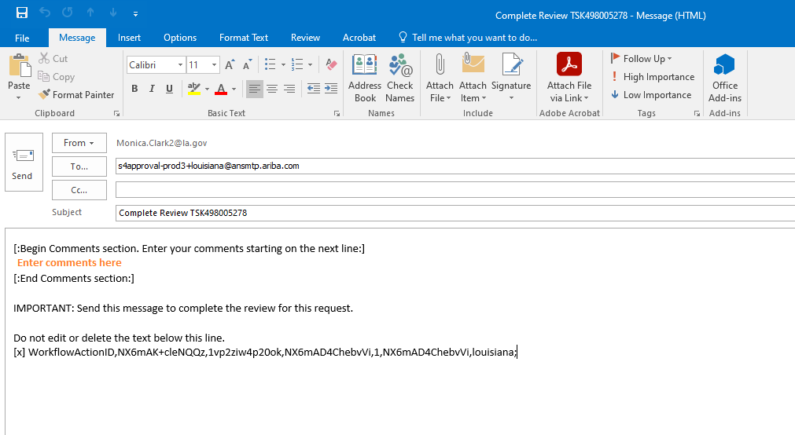

# Navigating Review Tasks from the LESA Dashboard

* You may also access any pending review tasks in the ‘Needs Review’ section of your LESA Dashboard.

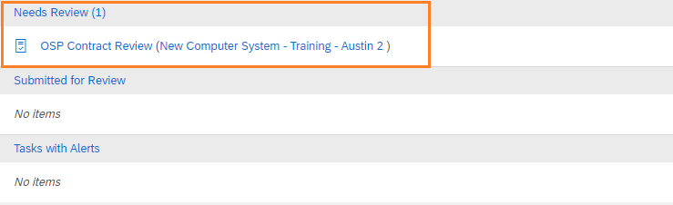

* + The task name is listed followed by the name of the project in parenthesis.
    - If you click on the task name, it will bring you directly to the task (recommended).
    - If you click on the project name inside the parenthesis, it will bring you to the Sourcing Project. From there you will need to then go to the Tasks Tab to select the task that needs review.
* Once the agency review is complete the SPA will be notified by LESA.